Linux Admin Lab 2

1. Create a user account with the following attribute (islam)

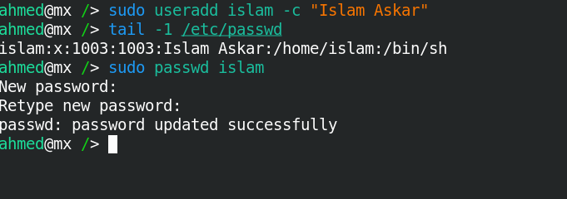

1. Create a user account with the following attribute (baduser)

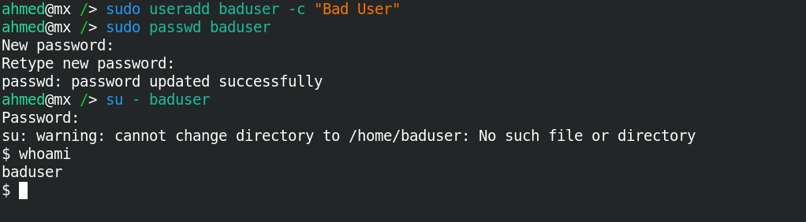

1. Create a supplementary (Secondary) group called pgroup with group ID of 30000

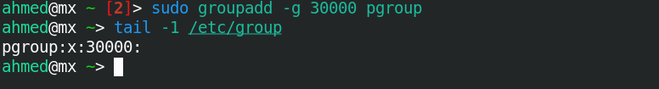

1. Create a supplementary group called badgroup

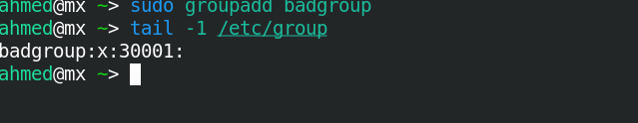

1. Add islam user to the pgroup group as a supplementary group

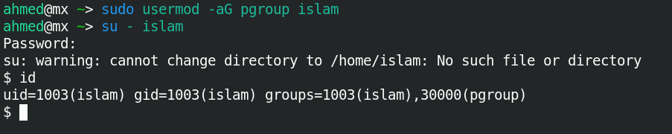

1. Modify the password of islam's account to password

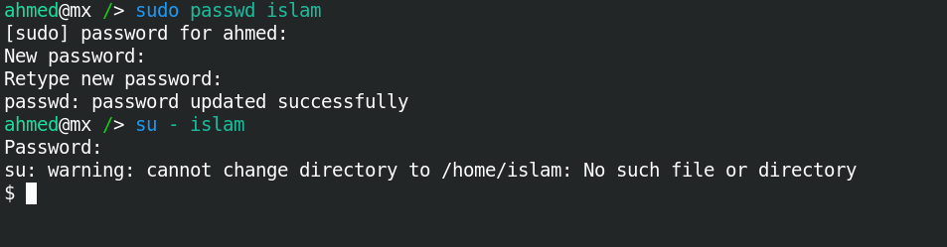

1. Modify islam's account so the password expires after 30 days

Must change maximum with sudo chage –M 30 islam

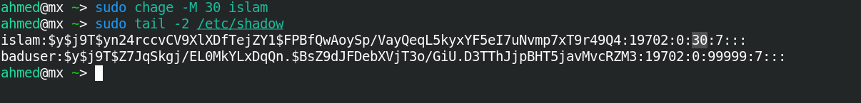

1. Lock bad user account so he can't log in

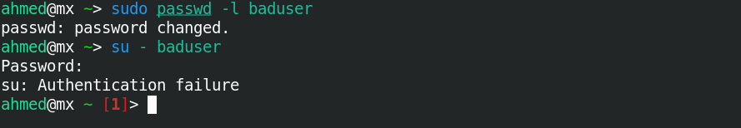

1. Delete bad user account

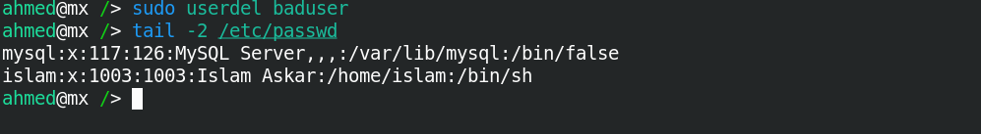

1. Delete the supplementary group called badgroup.

