**Lab 4**

1. **List the user commands and redirect the output to /tmp/commands.list**

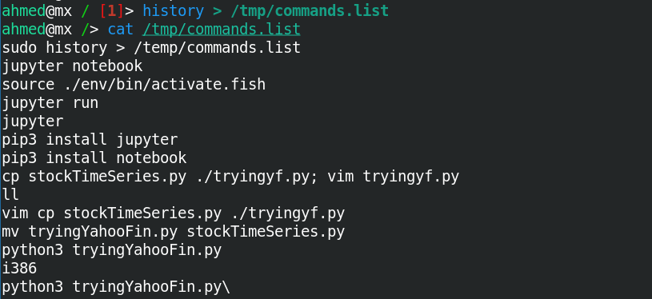

1. **Count the number of user commands**

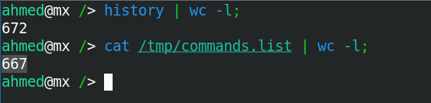

Note: 672 commands because of added commands after redirecting history output to /tmp/commands.list

1. **Get all the users names whose first character in their login is ‘g’.**



1. **Get the logins name and full names (comment) of logins starts with “g”.**



1. **Save the output of the last command sorted by their full names in a file.**





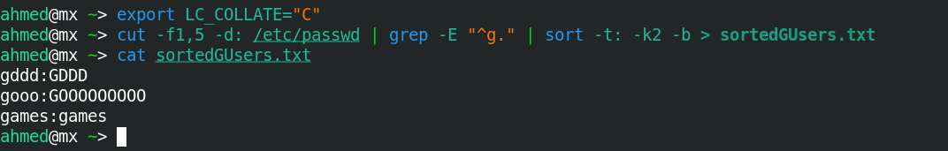

1. **Write two commands:** 
   1. **first: to search for all files on the system that named .bash_profile.**



* 1. **Second: sorts the output of ls command on / recursively, Saving their output and error in 2 different files and sending them to the background.**



1. **Display the number of users who is logged now to the system.**

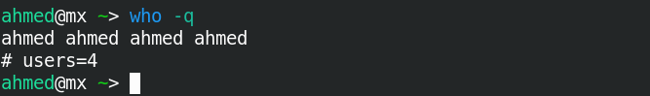

Note: same user is logged in multiple shells

1. **Display lines 7 to line 10 of /etc/passwd file**

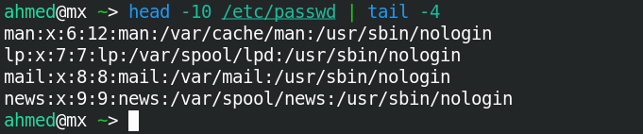

1. **What happens if you execute:**
   * **cat filename1 | cat filename2:**

cat takes no input and the output is the contents of filename2.

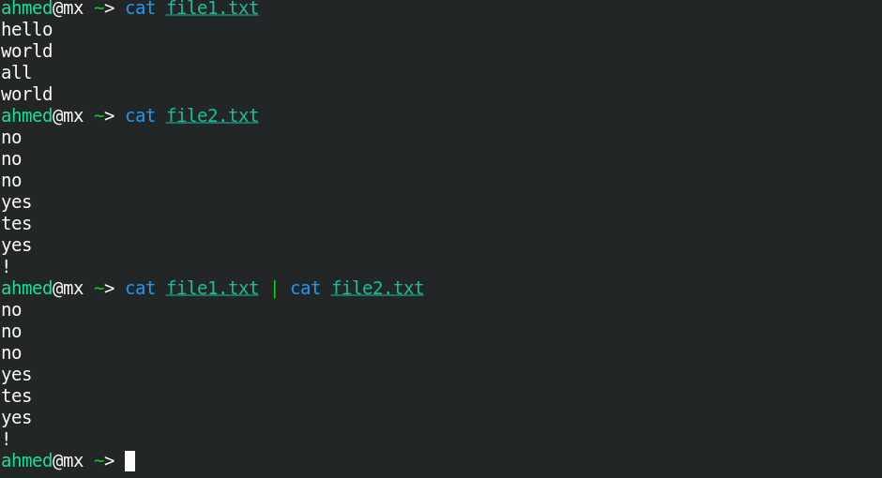

* + ls | rm

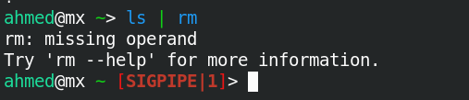

ls error output is not shown in terminal gives SIGPIPE

* ls /etc/passwd | wc –l



1. **Issue the command sleep 100.**

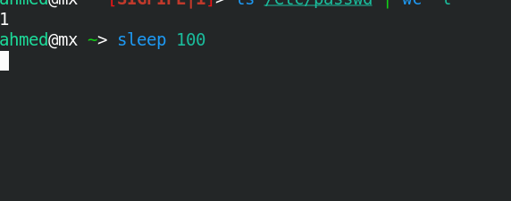

1. **Stop the last command.**



1. **Resume the last command in the background**

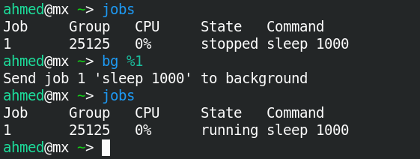

1. **Issue the jobs command and see its output.**

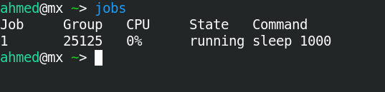

1. **Send the sleep command to the foreground and send it again to the background.**

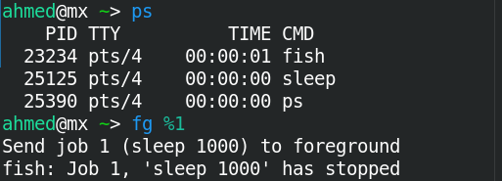



1. **Kill the sleep command.**



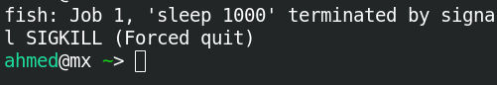

1. **Display your processes only**

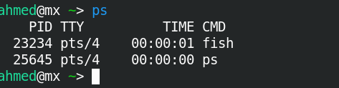

1. **Display all processes except yours**

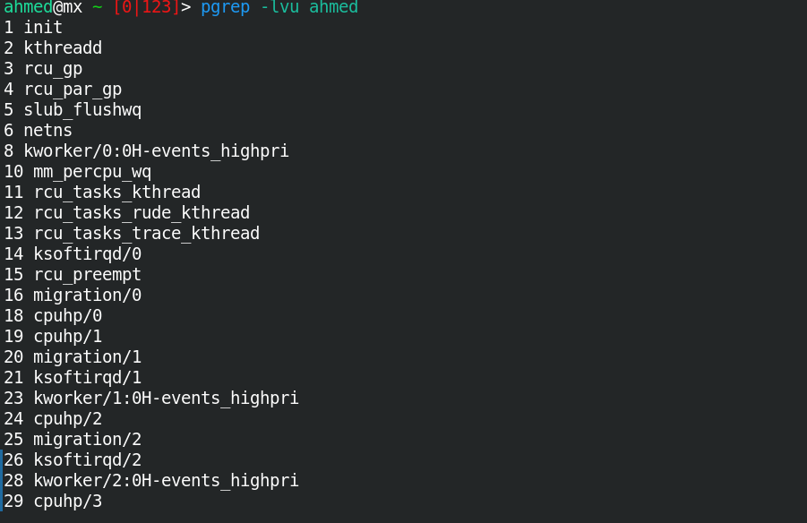

1. **Use the pgrep command to list your processes only**

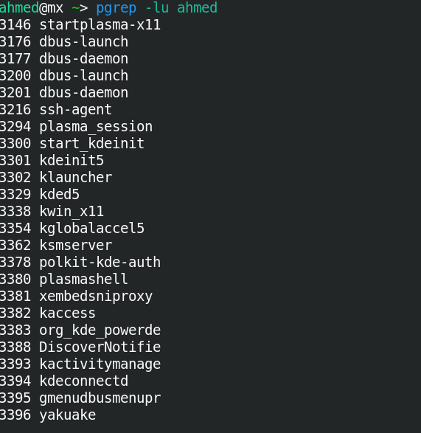

**19- Kill your processes only**

