Lab 5

1. **Compress a file by compress, gzip, zip commands and decompress it again.** 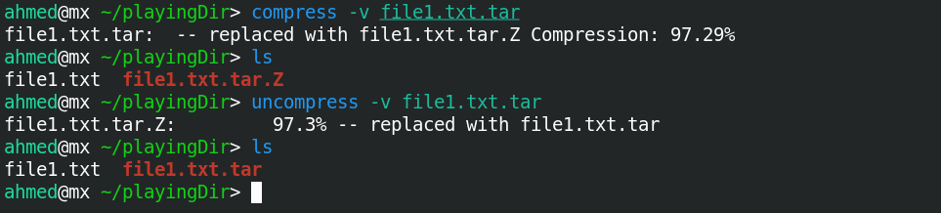

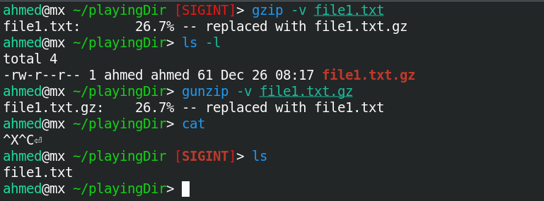

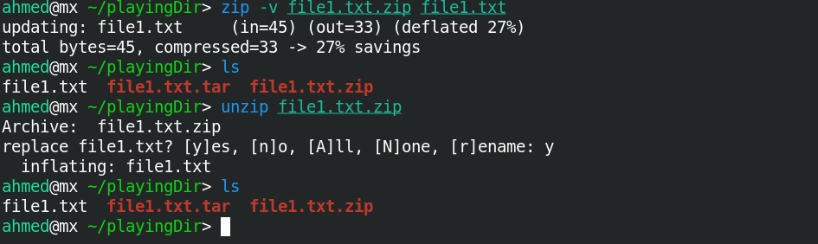

* + **State the differences between compress and gzip commands.**

The difference is that compress uses an old algorithm while gzip uses a new and more efficient algorithm.

**2- What is the command used to view the content of a compressed file.**

zcat

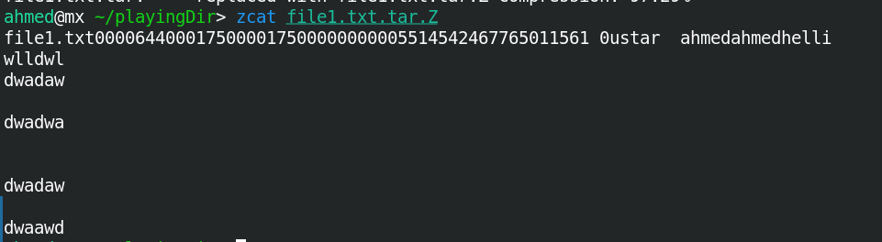

**3- Backup /etc directory using tar utility.**





**4- Starting from your home directory, find all files that were modified in the last two day.**



**5- Starting from /etc, find files owned by root user.**



**6- Find all directories in your home directory.**



**7- Write a command to search for all files on the system that, its name is “.profile”.**



**8- Identify the file types of the following: /etc/passwd, /dev/pts/0, /etc, /dev/sda.**









**9- List the inode numbers of /, /etc, /etc/hosts.**

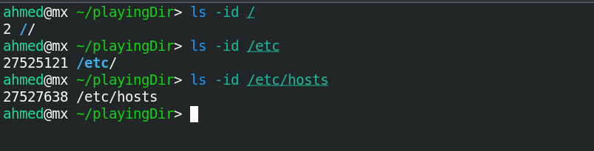

**10- Copy /etc/passwd to your home directory, use the commands diff and cmp, and Edit in the file you copied, and then use these commands again, and check the output.**



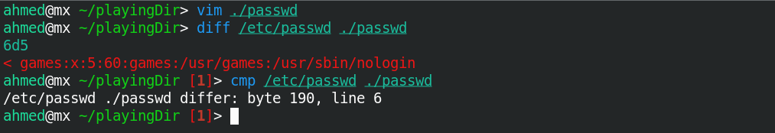

**11- Create a symbolic link of /etc/passwd in /boot.**

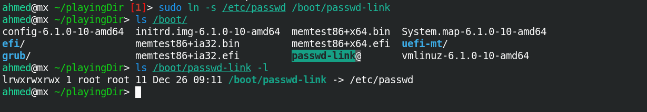

**12- Create a hard link of /etc/passwd in /boot. Could you? Why?**

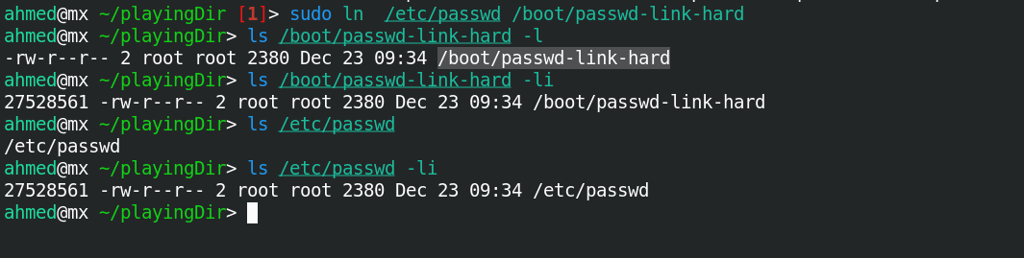

You can but it does mean that they are linked because inode numbers can be the same for files on different partitions. Not linked I think if one file is updated the other won’t, but I can’t test it.