CV Builder — Mobile Responsiveness Testing & Improvement Report
Tested on: aicvbuilder.wasimdev.com, mobile viewport (~490–535px wide)

1. Purpose
This report covers mobile-width testing of the admin panel and CV builder, separate from the earlier desktop testing report. The goal is the same: find and document every issue before the next round of fixes, so nothing gets missed and the team can divide up frontend work clearly.
Issues are grouped by severity. Critical issues make core screens hard or impossible to use on a phone; these should be fixed first.

2. Critical Issues
2.1 Data tables overflow off-screen — most columns are hidden with no obvious way to see them [CRITICAL] (Frontend)
In plain terms: On every list/table screen (Recent CVs, Manage Users, Subscriptions, Transactions, Plan Management), only the first column or two fit on the phone screen. The rest of the table (dates, status, actions, price, etc.) is pushed off the right edge, and the only way to see it is a thin, easy-to-miss horizontal scrollbar.
- This affects nearly every admin table in the app — not a one-off screen.
- Most mobile users will not realize they can scroll sideways inside a table, since that isn't a common mobile pattern — they'll assume the missing columns simply aren't there.
- Fix direction: on mobile, either switch these tables to a stacked “card per row” layout (label: value pairs), or pick 2–3 priority columns to show by default and put the rest behind a “view details” tap.
Screenshot 1 — Dashboard — Recent CVs table Screenshot 2 — Dashboard — Recent CVs, scrolled
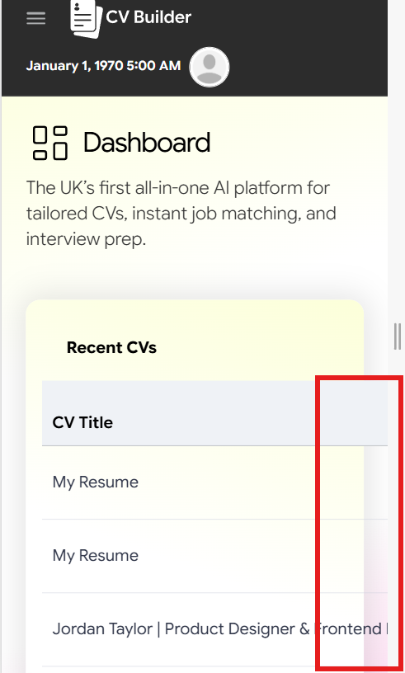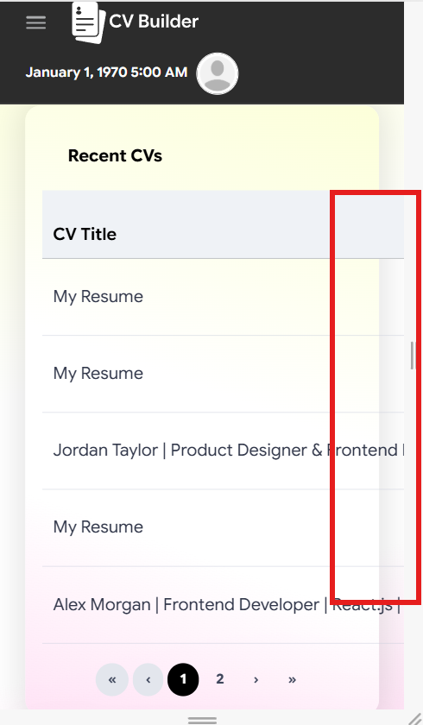
Red box: only “CV Title” is visible; Date Created, Last Update, and Actions are cut off past this line. Same cut-off continues through the pagination controls.
Screenshot 3 — Manage Users table
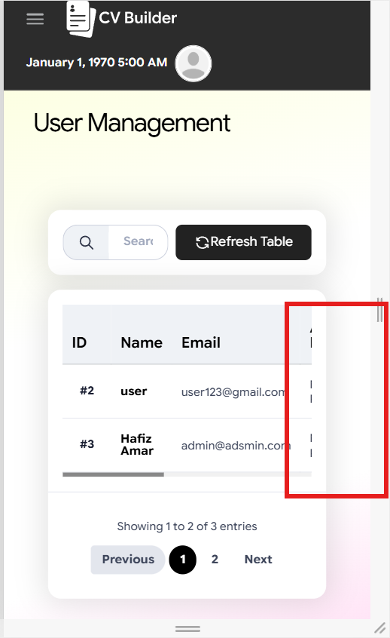
Red box: Active Plan, Created At, Role, Subscription, and Actions are all hidden past this line.
Screenshot 4 — Subscriptions list Screenshot 5 — Subscriptions list, scrolled
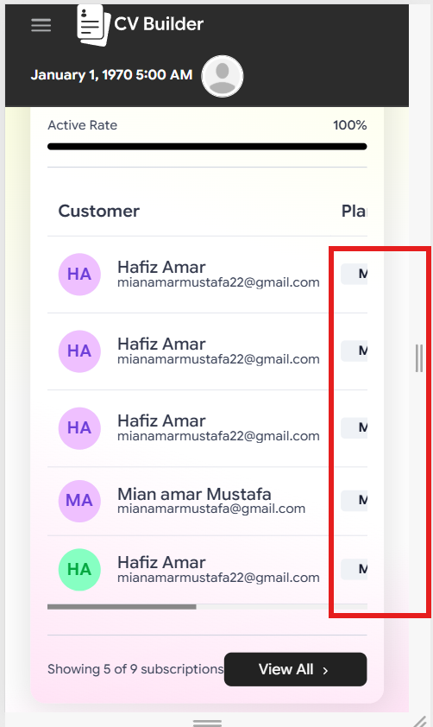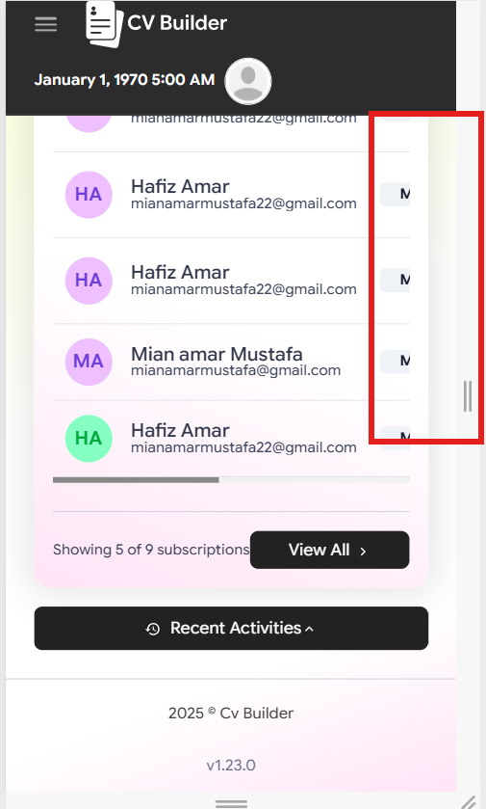
Red box: the “Plan” column and everything after it is cut off; only a sliver (“M…”) is visible. Same cut-off continues through the “View All” row.
Screenshot 6 — Transactions table
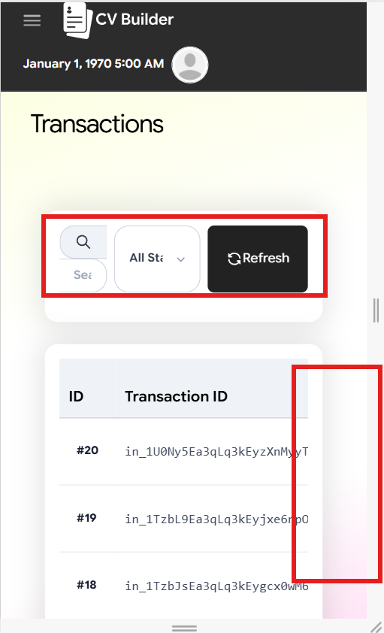
Red boxes: the data table (Subscription ID, User ID, Type, Amount, Status, Gateway, Created) is pushed off-screen, and the search/filter row above it is also cramped/truncated.
Screenshot 7 — Plan Management table
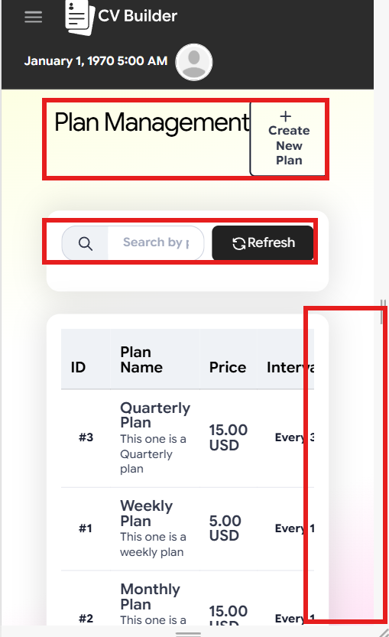
Red boxes: (top) the “Plan Management” heading overlaps the “Create New Plan” button; (middle) the search bar is truncated; (right) Status, Created, and Actions columns are cut off past “Interval.”
Screenshot 8 — Dashboard, later session (correct date)
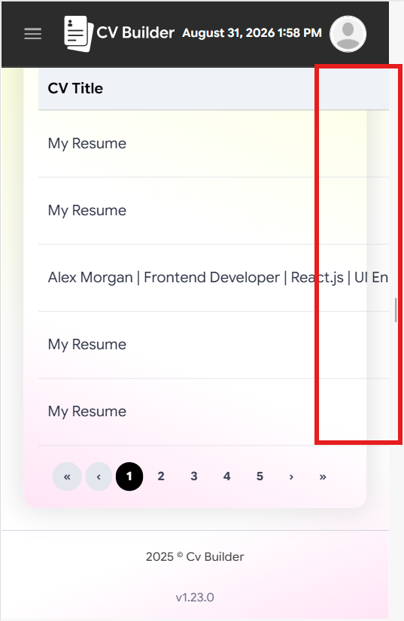
Red box: the same Recent CVs cut-off persists even once the date bug isn't present, confirming it's a separate, ongoing issue.
2.2 The CV editor and CV preview don't fit the phone screen at all [CRITICAL] (Frontend)
In plain terms: This is the most serious mobile issue found. When actually editing or viewing a CV on a phone, the section tabs (Personal, Experience, Education, etc.) run off the right edge, and the CV preview itself is wider than the screen — so the user has to scroll sideways just to read their own name and email, on top of scrolling up and down.
- Since building/editing the CV is the core feature of the whole product, this makes the main workflow difficult to use on mobile as it stands today.
- Fix direction: the CV preview needs to scale down to fit the viewport width (e.g. render at a reduced zoom/scale on small screens, the way the desktop version has a 100% zoom control) instead of rendering at full desktop width inside a narrow container.
Screenshot 9 — CV editor — tabs and CV content cut off Screenshot 10 — CV editor, scrolled further
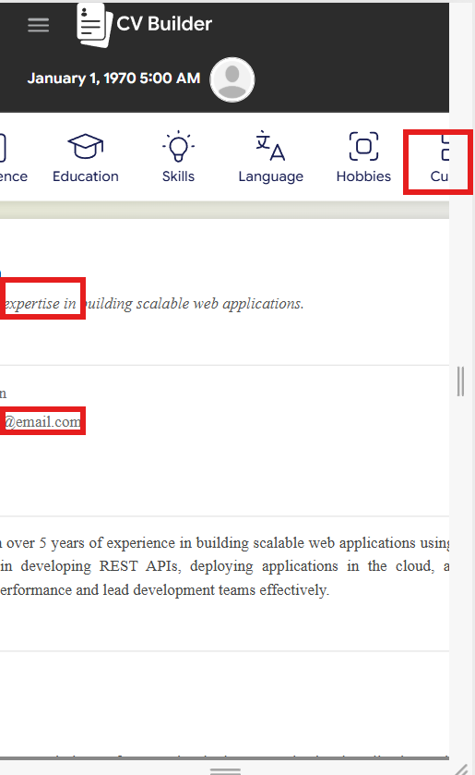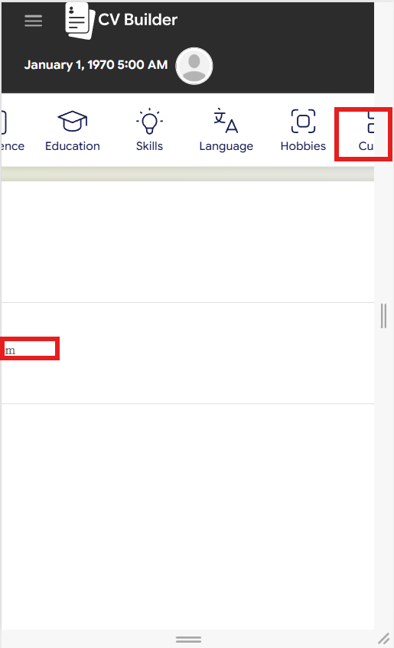
Red boxes: the “Custom”/“Design” tabs run off the right edge, and the CV's own text is cut off mid-word at the left edge. Same cut-off continues lower down the CV preview.

3. High-Priority Issues
3.1 Payment Analytics controls overflow off-screen [HIGH] (Frontend)
In plain terms: On the admin Dashboard's Payment Analytics card, the Daily/Weekly/Monthly/Yearly toggle and the chart-type/Refresh buttons don't wrap onto a new line — they just run off the right edge, so “Yearly” and the Refresh button are unreachable without scrolling.
- Fix direction: let this control row wrap onto two lines on narrow screens, or turn it into a dropdown.
Screenshot 11 — Payment Analytics card
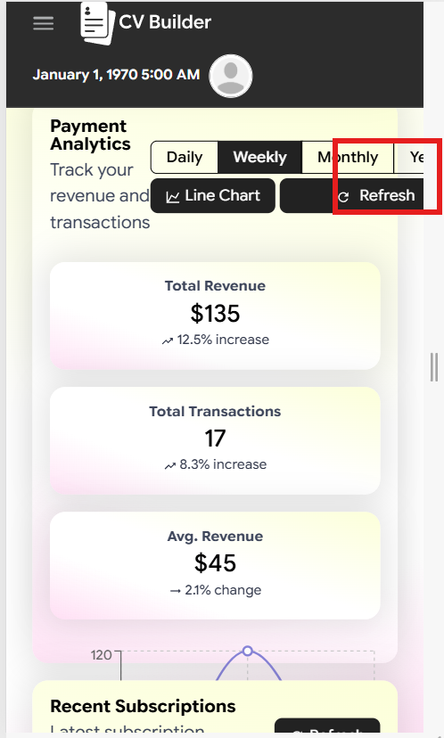
Red box: the “Yearly” tab and the Refresh button are cut off past the right edge.
3.2 Search and filter bars are cramped and truncated [HIGH] (Frontend)
In plain terms: On Manage Users, Subscriptions, and Transactions, the search box placeholder text is cut short (“Sear…”) and the status filter dropdown text is also cut off (“All Sta…”). On Subscriptions/Transactions the search bar and dropdown don't fit on one line and end up cramped.
- Fix direction: stack the search box, filter dropdown, and refresh button vertically on narrow screens instead of forcing them onto one row.
Screenshot 12 — Subscriptions — search/filter row
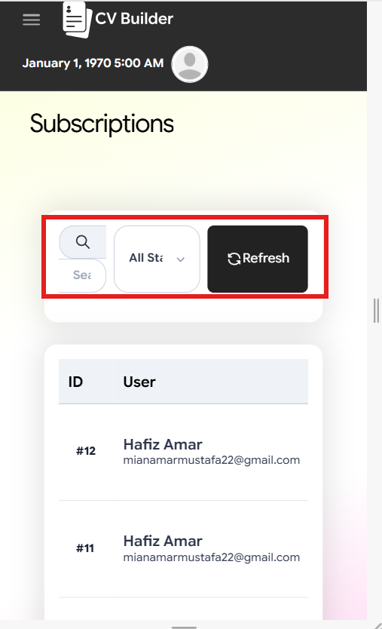
Red box: search box and “All Status” filter are both truncated and cramped onto too little space.
The Transactions and Plan Management screenshots earlier in this report (Section 2.1) show the same truncated search bar — boxed in red there as well.

4. Medium Issues
4.1 Page title overlaps the action button [MEDIUM] (Frontend)
In plain terms: On Plan Management, the “Plan Management” heading text runs directly into the “+ Create New Plan” button instead of wrapping onto its own line above it — the two visually collide.
See Screenshot 8 in Section 2.1 (Plan Management) — the top red box there marks exactly where the heading and button collide.
4.2 Header layout is inconsistent between pages [MEDIUM] (Frontend)
In plain terms: On most pages, the date sits on its own line under the “CV Builder” logo. On the Payment Plans page (and the regular-user dashboard in the later session) the date is squeezed onto the same line as the logo and avatar instead, giving two different header layouts depending on which page you're on.
Screenshot 13 — Payment Plans page header
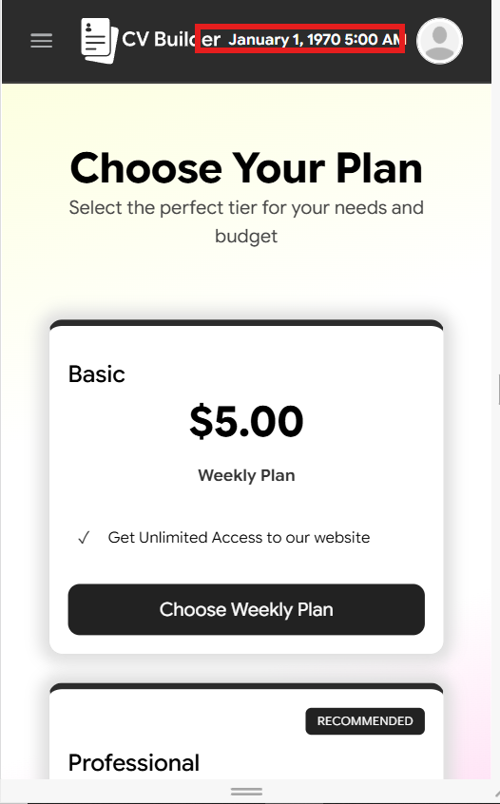
Red box: the date is inline with the logo/avatar here, unlike the two-line header used on every other page shown in this report.

5. Also Confirmed on Mobile (already known from desktop testing)
- The broken header date (“January 1, 1970”) reproduces on mobile too — confirms it's not related to screen size, just load timing, as covered in the desktop report.
- The same duplicate-subscription data (multiple active “Hafiz Amar” subscriptions) is visible here as well — this is the backend billing issue from the desktop report, just visible again from a different screen.
- The “My Resume” default-title issue is visible again in the Recent CV list on mobile.

6. What's Already Working Well on Mobile
Worth noting so these aren't accidentally “fixed” or touched unnecessarily:
- The Sign In page is fully responsive and reads cleanly.
- The CV Builder landing page (Upload / Build from Scratch / Recent CV cards) stacks correctly.
- The “Upload CV Details” modal and the upload/processing loading state both work well.
- The “Recent CV” modal already adapts for mobile — it drops the Last Update and Actions columns and only shows CV Title and Date Created, which is exactly the kind of simplification the other tables need.
- The “Create New Plan” form modal is fully responsive with no cut-off fields.
- The Support page reflows correctly with no overflow.
Screenshot 14 — Recent CV modal
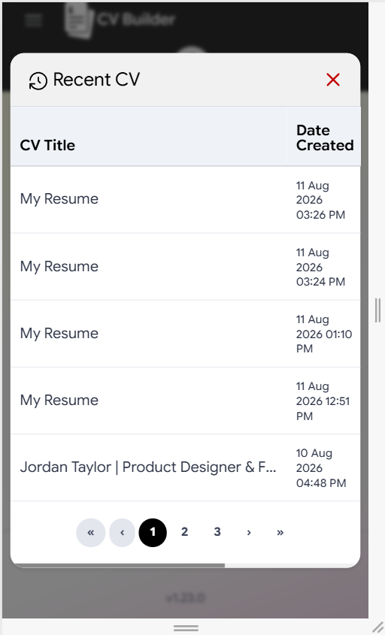
A good example of a table that's already been simplified correctly for mobile — no red box needed.
Screenshot 15 — Create New Plan modal
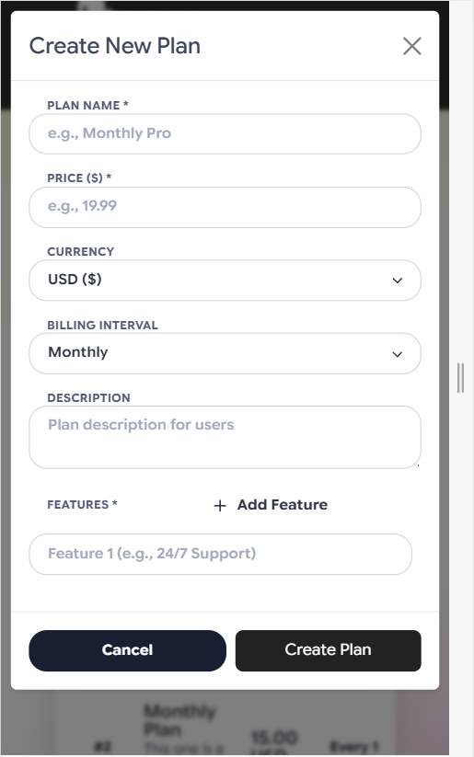
Fully responsive, no cut-off fields — no red box needed.

