|  |  |  |
| --- | --- | --- |
| NAME | ID NUM | SEC |
| 1. أحمد عبد الله جبر القرم | 11819195 | 3/8:00-11:00 |
| - | - | - |

**Experiment 2**: 4-bit Adder with Structural and Behavioral Implementation

**Introduction** :

In this experiment I will try to design an 4 Bit Adder using (vhdl) and Zboard from Xilinx

Step by step in tow part :

1. Structural Implementation: starting from half adder .
2. Behavioral Implementation : using IEEE library.

**Tools used in Lap** :

1. Computer lap.
2. Vivado software .
3. Zboard from Xilinx.
4. VHDL

**Part 1** : Structural Implementation.

Procedure :

At first build the half adder that contain (XOR) and (AND) gate

|  |  |  |  |
| --- | --- | --- | --- |
| A | B | S | has.pngCout |
| 0 | 0 | 0 | 0 |
| 0 | 1 | 1 | 0 |
| 1 | 0 | 1 | 0 |
| 1 | 1 | 0 | 1 |

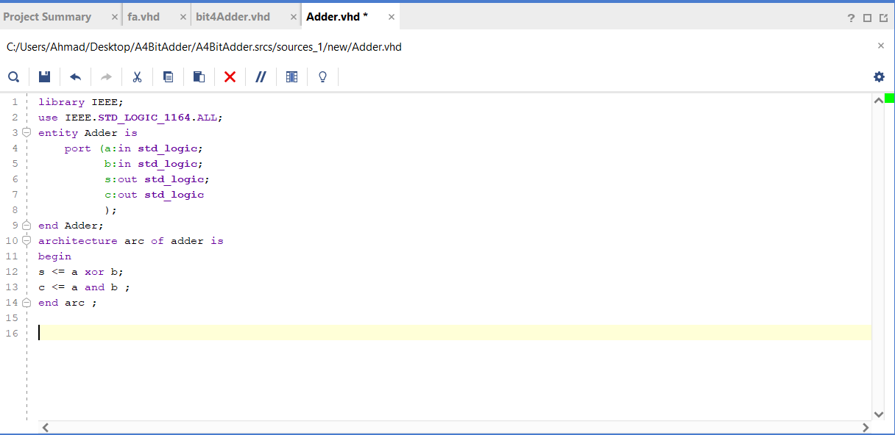

Simulation for Half Adder:

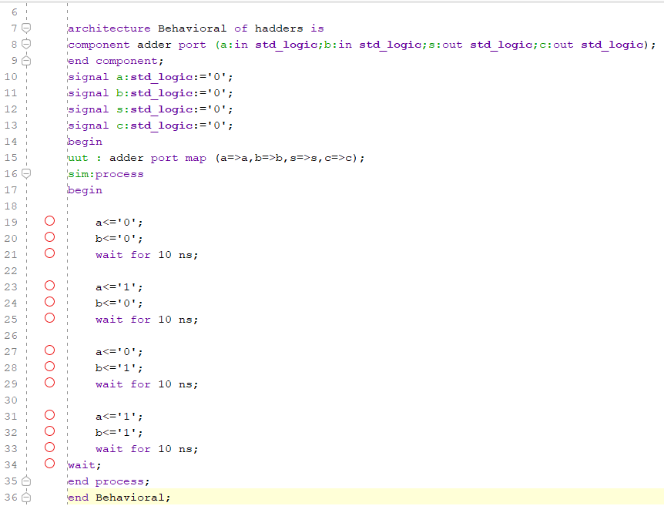Testbench code:

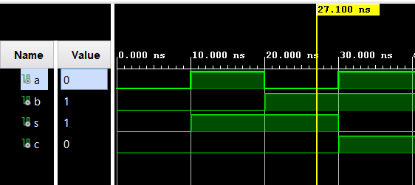

Then build Full Adder where Composed of 2 (Half Adder) and (OR) gate as shown :

|  |  |  |  |  |
| --- | --- | --- | --- | --- |
| A | B | Cin | S | Cout |
| 0 | 0 | 0 | 0 | fa.gif0 |
| 0 | 0 | 1 | 1 | 0 |
| 0 | 1 | 0 | 1 | 0 |
| 0 | 1 | 1 | 0 | 1 |
| 1 | 0 | 0 | 1 | 0 |
| 1 | 0 | 1 | 0 | 1 |
| 1 | 1 | 0 | 0 | 1 |
| 1 | 1 | 1 | 1 | 1 |

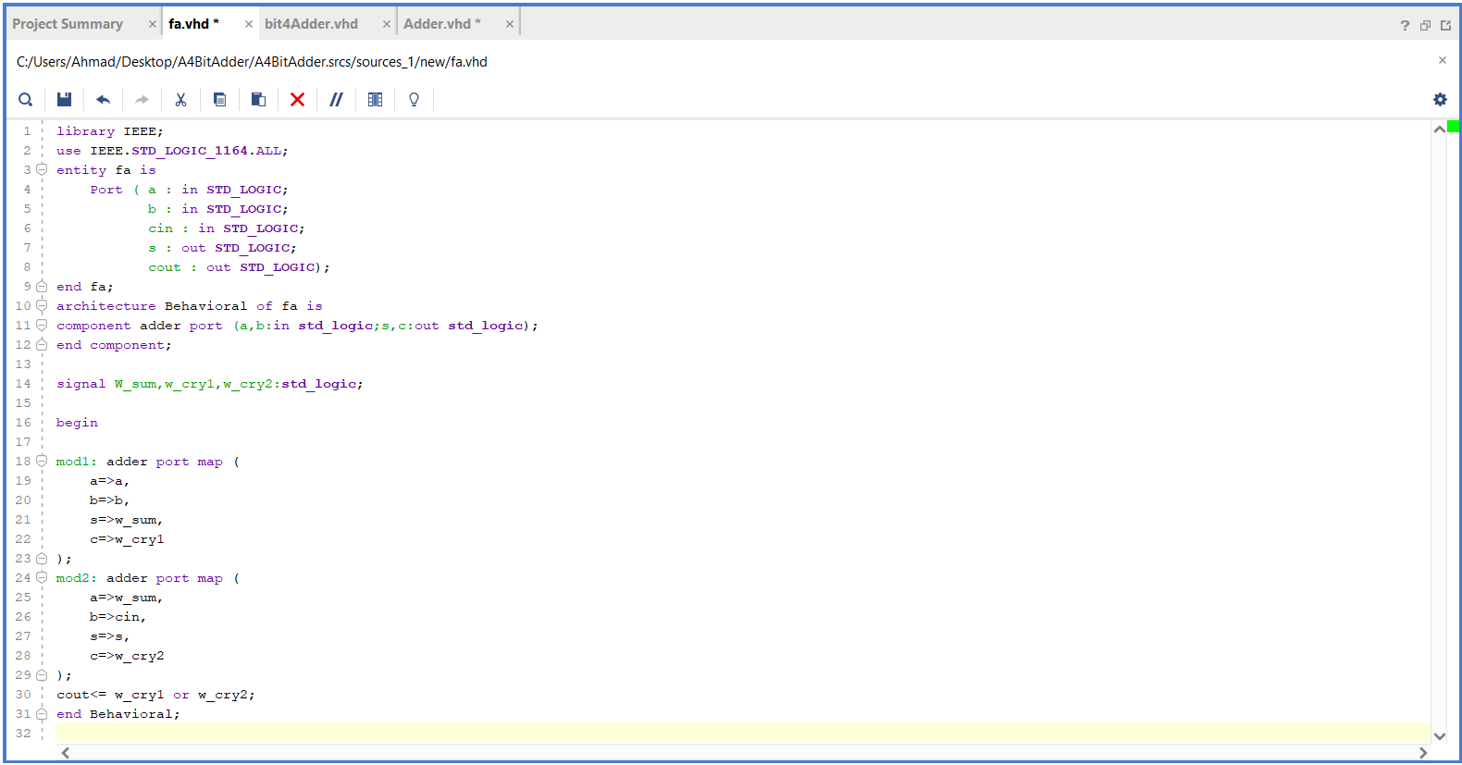

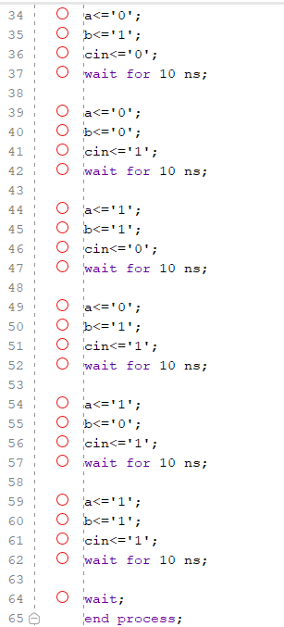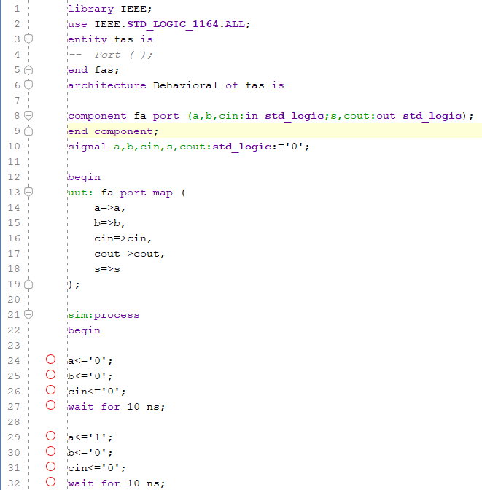Simulation and testbench code :

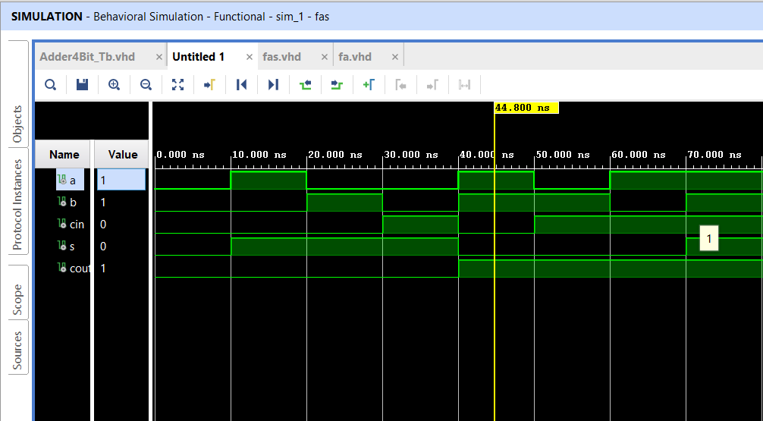

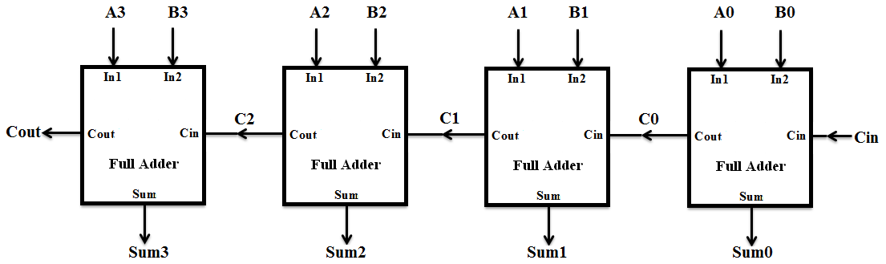After that i used 4 Full Adder to build the 4 bit Adder

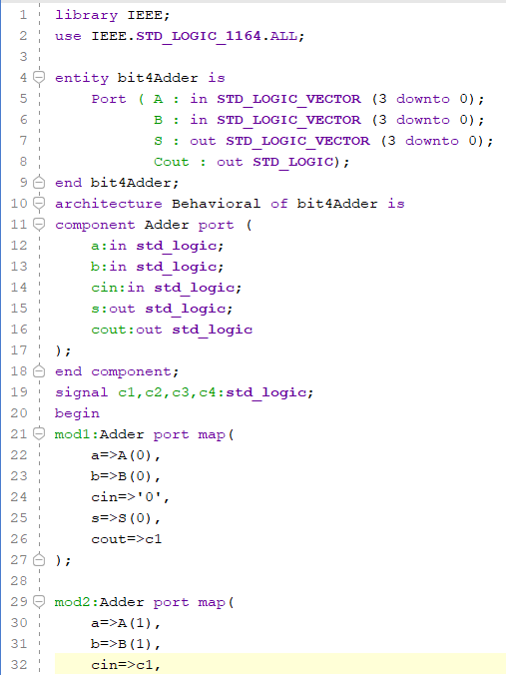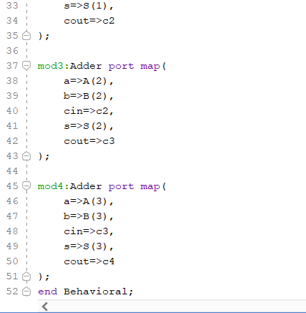

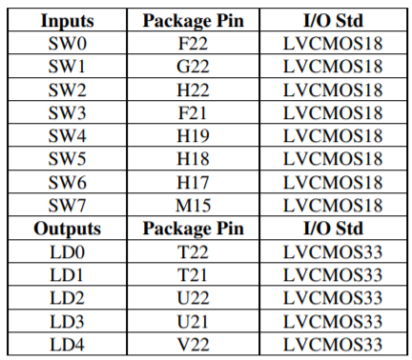After check simulation if running right

add constraint file and choose ports in

the board .

Synthesis, Implementation, and

Bitstream Generation thin program

the Zboard and I had checked the circuit .

**Part two** : Behavioral Implementation

Procedure :

Write Behavioral code in vivado as shown :

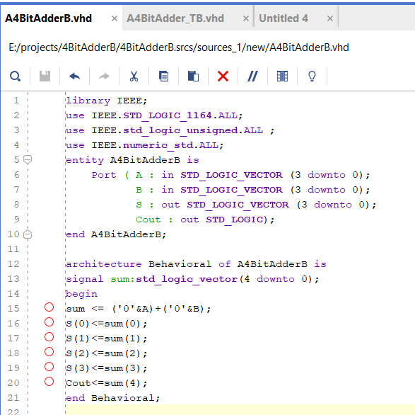

**Simulation :**

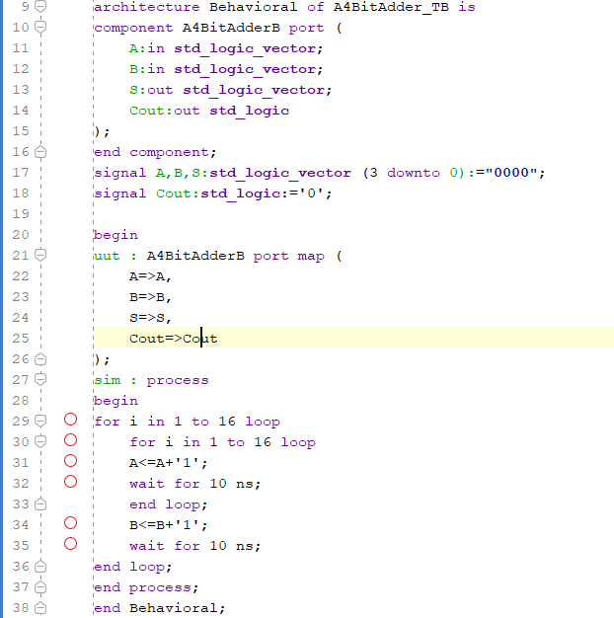There is the testbench code :

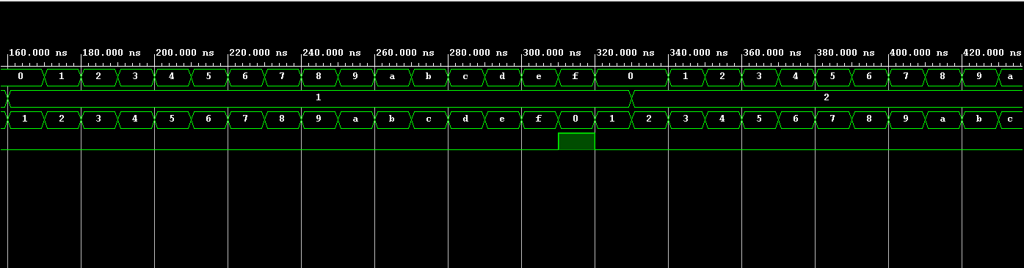

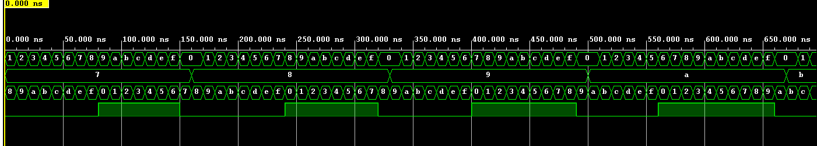

After Simulate my design . i used the same constraint file from part1

Run the Synthesis, Implementation, and Bitstream Generation processes

Use the Hardware Manger to program your FPGA.

Use the switches and notice the LEDs to verify that your circuit functions correctly.

**Conclusion:**

In this experiment i learned that i can use switches on the kit as a binary input by specifying in the (.XDC) file. In the same file we can specify the LEDs to show the binary output of our operations.

I got familiar with Zboard kit and i implemented a simple 4BitAdder circuit using VHDL. This helped me learn about the design, simulation and synthesizing processes.