|  |  |  |
| --- | --- | --- |
| NAME | ID NUM | SEC |
| 1. أحمد عبد الله جبر القرم | 11819195 | 3/8:00-11:00 |
| - | - | - |

**Experiment 6**: IP cores (Multiplier)

**Introduction :**

In this lab I will learn how to use and integrate IP cores in my design.

**Objectives:**

* Lern how to integrate IP cores (a Multiplier ).

**Tools used in Lap :**

1. 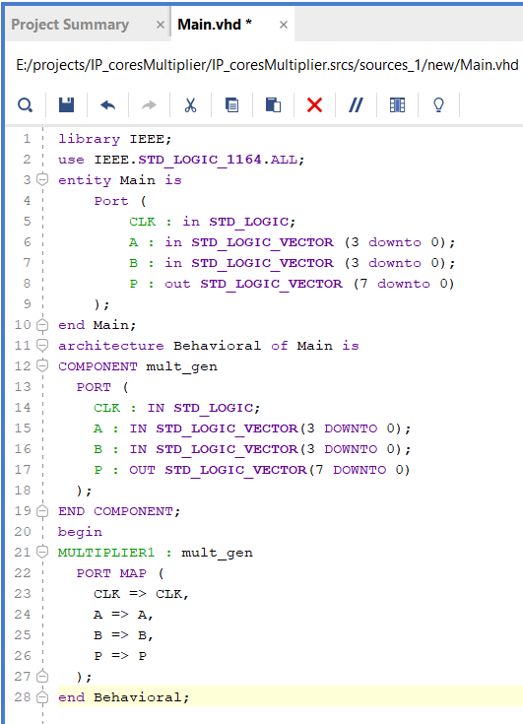Computer lap.
2. Vivado software .
3. Zboard from Xilinx.
4. VHDL

**Procedure :**

I had followed the Lab Procedure in

manual and Instantiated IP into my

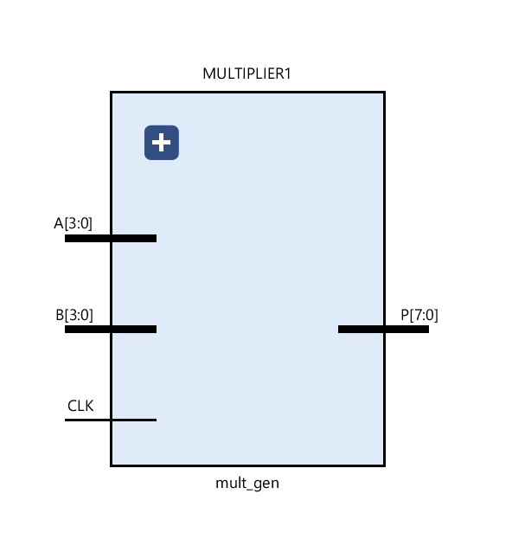 main Design as shown :

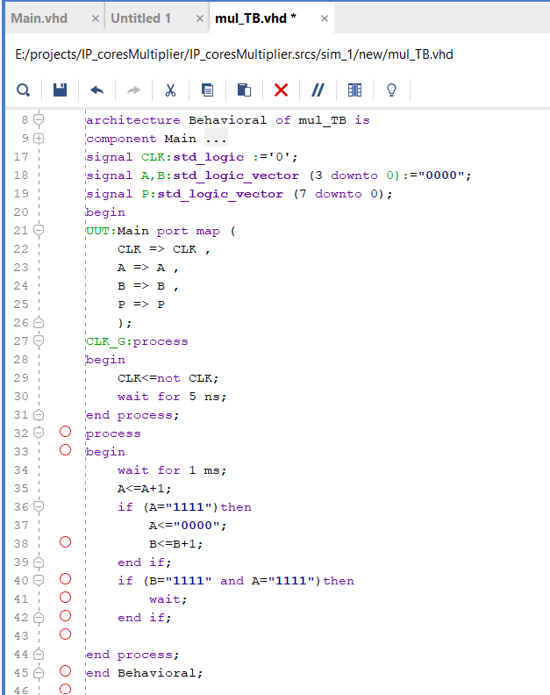**Simulation Code TestBench :**

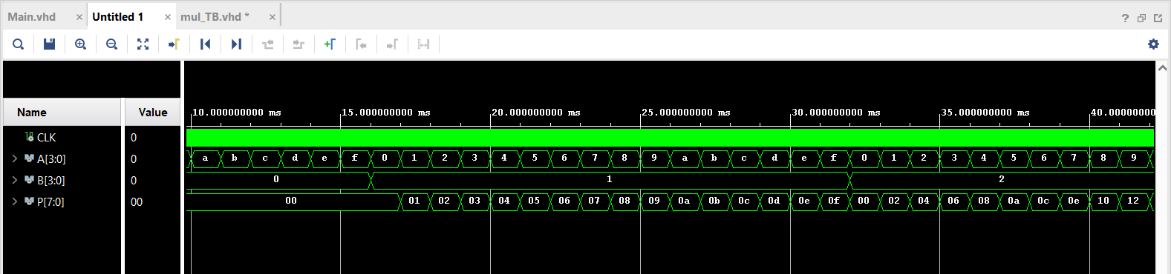**Simulation:**

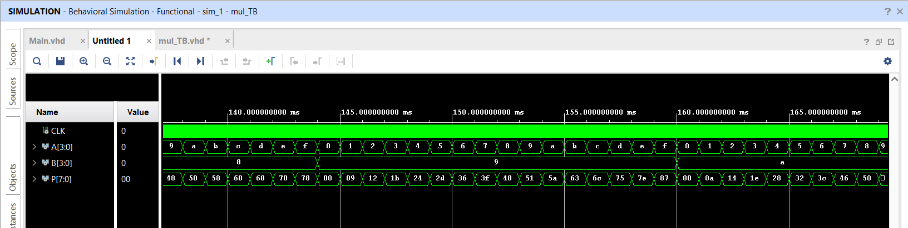

**Synthesis, Implementation, and Bitstream Generation :**

I had connected Pins in the board as shown in the Table

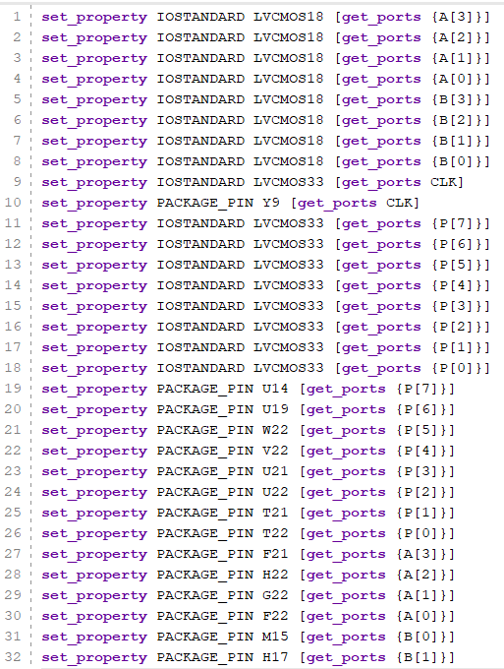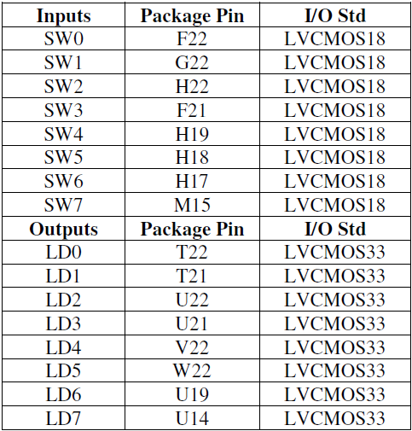



**Conclusion:**

In this experiment, I learned how to deal with IP cores .And how to integrate IP cores in my design .Also I'm now aware how much is IP core subject important in reduce cost ,time ,and efforts .