Experiment # 1: Network cables
Name : Ahmad Abdullah AL – Qerem . ID : 11819195 .
2st semester 2022/2023 .
Report’s Outcomes
ILO __ =( ) % | ILO __ =( ) % | ILO __ =( ) % | ILO __ =( ) % | ILO __ =( ) %
Evaluation Criterion |  |  |  |  | Grade | Points
Abstract  answers of the questions: “What did you do? How did you do it? What did you find?” |  |  |  |  | 0.5
Introduction and Theory  Sufficient, clear and complete statement of objectives. In addition to Presents sufficiently the theoretical basis. |  |  |  |  | 1.5
Apparatus/ Procedure  Apparatus sufficiently described to enable another experimenter to identify the equipment needed to conduct the experiment. Procedure sufficiently described. |  |  |  |  | 2
Experimental Results and Discussion (In-Lab Worksheet)  Crisp explanation of experimental results. Comparison of theoretical predictions to experimental results, including discussion of accuracy and error analysis in some cases. |  |  |  |  | 4
Conclusions and Recommendations  Conclusions summarize the major findings from the experimental results with adequate specificity. Recommendations appropriate in light of conclusions. Correct grammar. |  |  |  |  | 1
Appearance  Title page is complete, page numbers applied, content is well organized, correct spelling, fonts are consistent, good visual appeal. |  |  |  |  | 1
Total |  |  |  |  | 10

Abstract :
In this experiment I had Built a crossover Ethernet patch cable to (T568-B & T-568-A) standards for connection from PC to PC or from PC to router . Using lap tools According to the procedures mentioned in the lap .

Introduction and Theory:
UTP “unshielded twisted pair” Ethernet Cabling : is one of the most important areas of network design and implementation. The cabling is expected to last from 10 to 15 years.
The quality of cable and connections is a major factor in reducing network problems and time spent troubleshooting.

There are various Categories (CAT 3, CAT 5, CAT 5e CAT 6, etc.) but all of them contain 8 wires or conductors and use RJ-45 connectors. A UTP patch cable in a network is usually wired as a straight-thrugh or crossover. In order to follow proper specifications, all 8 conductors must be used even though with earlier versions of Ethernet, not all 8 conductors were used.

Objectives :
- Build a cable (T568-B & T-568-A) with female and male connectors.
- learn how to use Cable Testers to examine cable connectivity.

Tools used in the experiment:
- twisted pair wires cable .
- RJ-45 female and male connectors .
- Corona.
- Wire cutter.
- Cable tester .
Procedure :
Part 1 : (male - male cable )
At first I had cut about 1 m of FTP cable then stripped 3 cm of it .after that I arranged them according to T568-B protocol as shown below in the table :
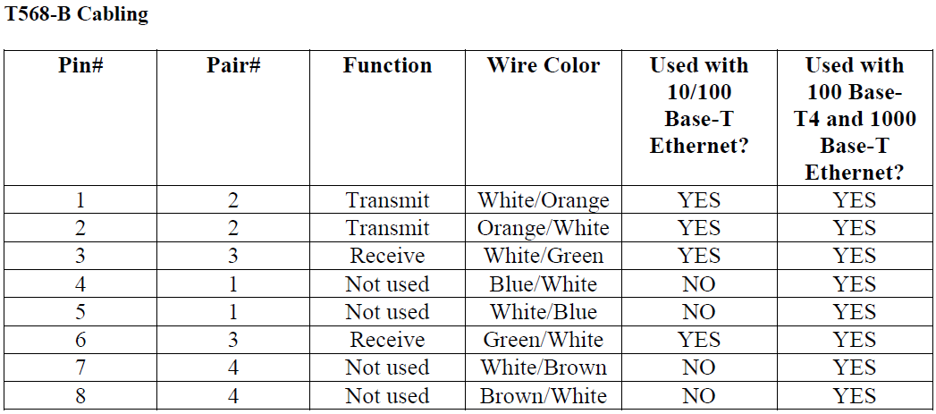
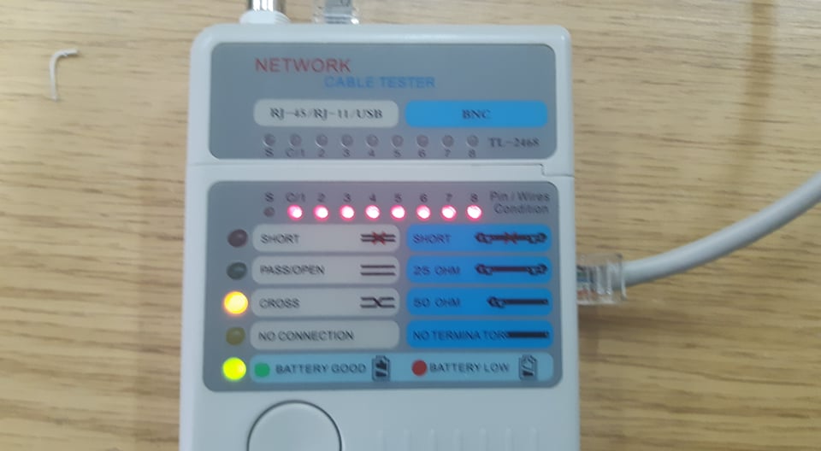
Then cut the wires to get an equal length for all . pushed the wires inside the RJ-45 male connector . finally i crimped the plug to got the first head ready .
Doing the same for other side but using T568-A protocol to got a crossover cable .

Testing the cable :

Part 2 : (female - female cable )
Doing the same step as part 1 but instead I used RJ-45 female connector .inserting the wires according to the colors shown in the RJ-45 .and use the corona tool to strip the excess wire.
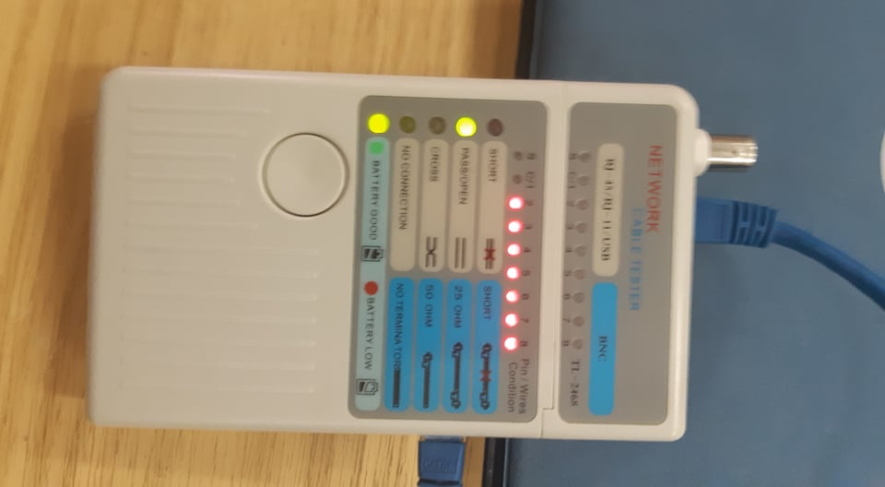
Testing the cable :

Questions :
1. Which cable is created to connect PC with PC ? Crossover cables.
2. Which pins are crossed of the RJ-45 cable? 1,2 with 3,6.
3. Which cable is created to connect PCs with Router Ethernet? Crossover cables.
4. Which cable is created to connect switch with switch? Crossover cables.
6. What would happen if pin 3 is not connected with a straight-thru cable? why?
pins 3 and 6 are used for receiving data so if pin 3 is not connected correctly then some of the received data will be lost which will increase the error rate.

Conclusion:
- There is two types of cables ( crossover and Straight-through ) for each are used for deferent device connection . we can build the first type by using deferent protocol for each side of the cable (T568-A or T568-B ) . and the second using the same protocol .

- A shield used in twisted cable to perform a protection from external noise . divided to some categories due to the protection level .

- They are twisted to reduce the capacitance noise .

- Female - Female cables are used for connecting workstations together.

- Male - Male cables are used for connecting devices together( a pc with a switch… etc ).

