Experiment # 2: Simple Network
Name : Ahmad Abdullah AL – Qerem . ID : 11819195 .
Name : Obada Youssef Qasrawi . ID : 11822431 .
2st semester 2022/2023 . Date : 2022/2/15 Thursday .
Report’s Outcomes
ILO __ =( ) % | ILO __ =( ) % | ILO __ =( ) % | ILO __ =( ) % | ILO __ =( ) %
Evaluation Criterion |  |  |  |  | Grade | Points
Abstract  answers of the questions: “What did you do? How did you do it? What did you find?” |  |  |  |  | 0.5
Introduction and Theory  Sufficient, clear and complete statement of objectives. In addition to Presents sufficiently the theoretical basis. |  |  |  |  | 1.5
Apparatus/ Procedure  Apparatus sufficiently described to enable another experimenter to identify the equipment needed to conduct the experiment. Procedure sufficiently described. |  |  |  |  | 2
Experimental Results and Discussion (In-Lab Worksheet)  Crisp explanation of experimental results. Comparison of theoretical predictions to experimental results, including discussion of accuracy and error analysis in some cases. |  |  |  |  | 4
Conclusions and Recommendations  Conclusions summarize the major findings from the experimental results with adequate specificity. Recommendations appropriate in light of conclusions. Correct grammar. |  |  |  |  | 1
Appearance  Title page is complete, page numbers applied, content is well organized, correct spelling, fonts are consistent, good visual appeal. |  |  |  |  | 1
Total |  |  |  |  | 10

Abstract :
In this experiment we had established a local area network ( two PC connected via CISCO switch ) , using Ethernet switch and two straight-thru cables to connect the PCs, then shared a text file in between .

Introduction and Theory:
A workgroup is a small group of networked computers that work together and where centralized administration is not required. Resources, administration, and authentication are required for workgroup , each PC has its own account ( user name and password ).

Objectives :
- Create a simple LAN with two PCs using a single crossover cable to connect the Workstations ( skipped ).
- Create a simple LAN with two PCs using an Ethernet switch or hub and two straight-thru cables to connect the workstations.
- Use the Control Panel / Network utility to verify and configure the network settings
- Use the ICMP Ping command to verify the TCP/IP connection between the two
Workstations.
- Use the IPCONFIG.EXE utility to verify all IP configuration settings.
Tools used in the experiment:
- Two twisted pair straight-thru cable .
- Two PCs.
- CISCO switch.
Procedure :
Establish connection :
At first we checked the cables to guarantee a reliable physical layer . then we had connected two PCs into CISCO switch after that we turn the switch on (second layer performed ).
Finally we Checked the Network Adapter Using Control Panel System Device Manager Utility to verify that the Network Adapter is functioning properly for both workstations. Double click on Network Adapters Right click the NIC adapter in use. Properties to see if the device is working properly.

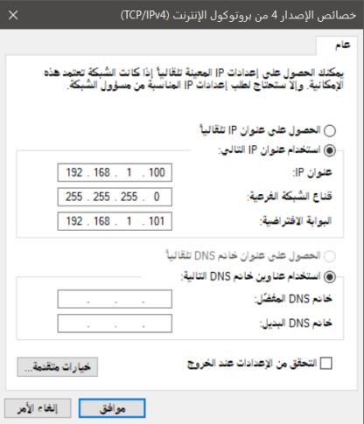
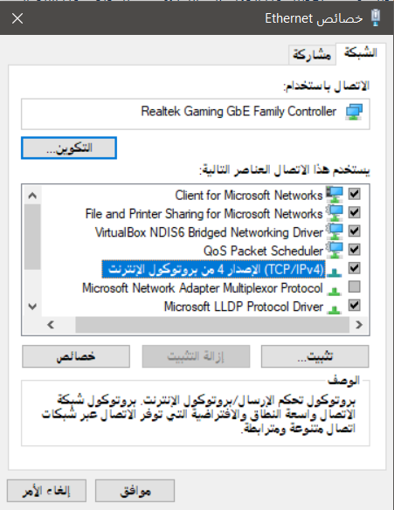
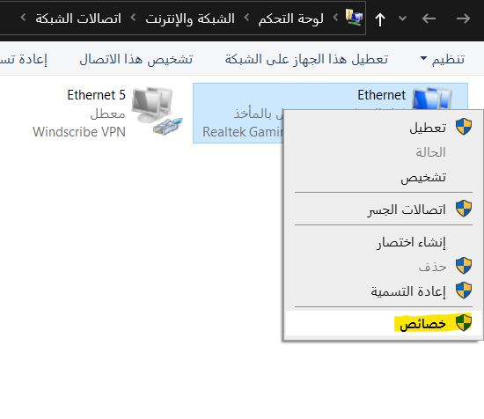
1 2 3

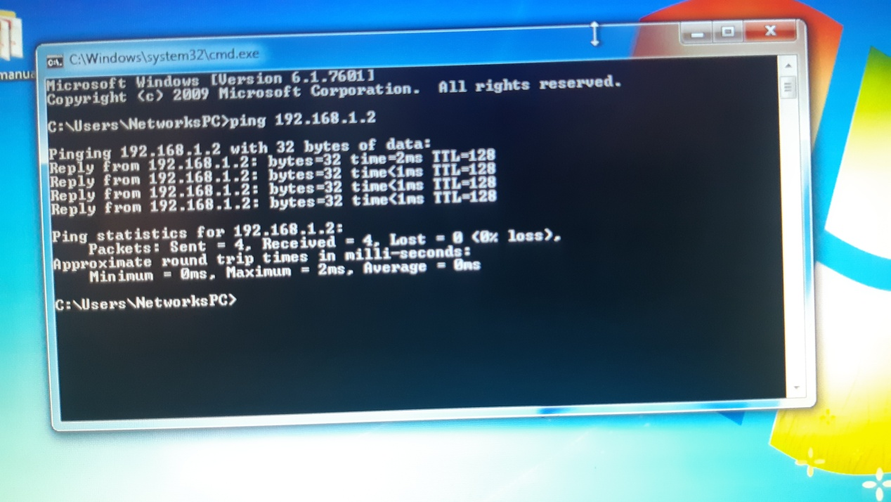
After the network has connected correctly I disabled firewall ,protected sharing , and enabled device discovery and some other configuration from "Change advanced sharing settings" . we tested the connection using ping command as shown in CMD :

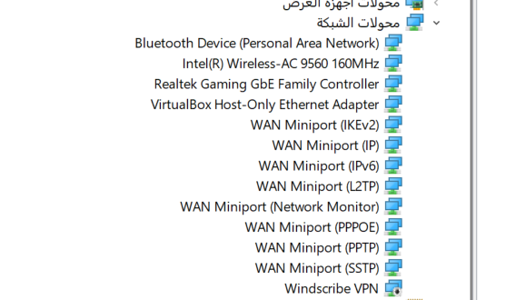
Questions :
What is the type and name of NIC is as referred to the
device manager?
I hadn’t the chance to check it in the lap so I will use
my laptop as reference. as shown its intel(R) Wireless-
Ac 9560 160 MHz.

Is there more than one NIC, describe?
Yes of course , the computer may have several NIC such as WIFI card or Ethernet …etc .
Sharing a file :
To share a file at first we had to give access for the person who want to reach this file . doing the following steps :
1 2
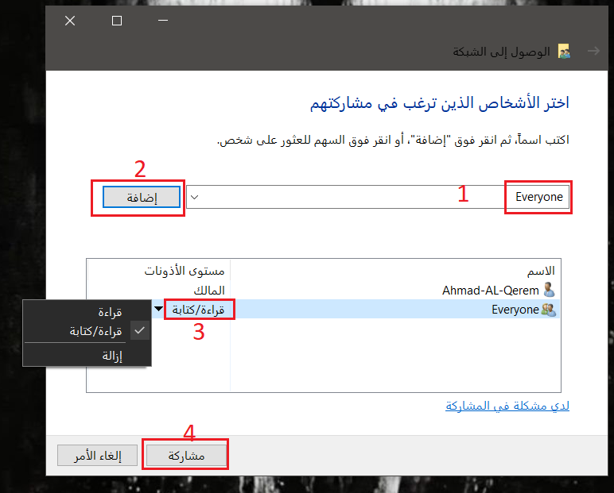
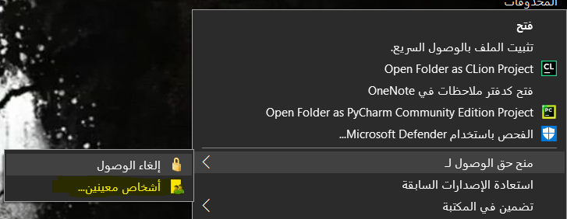

We managed to share a file between two PCs as shown :
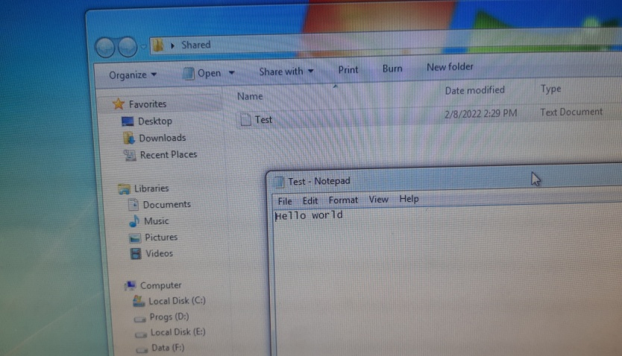
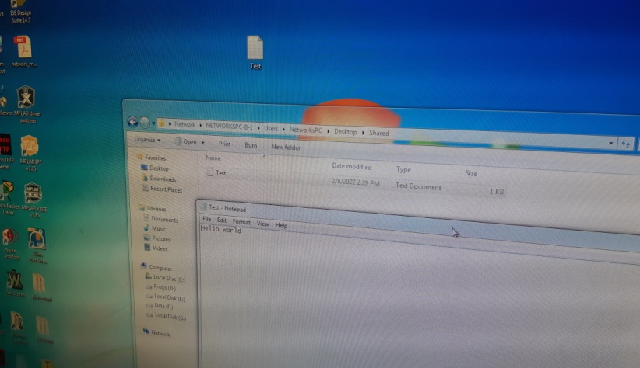
1 2

Conclusion:
- We use crossover cable to connect the workstations .
- We use straight-thru cables to connect the PCs with switch or hub .
- Local area network very useful to transmit large files .
- Local network is the base for wide area network .

