Experiment # 3: Routers Basic Setup and Configuration
Name : Ahmad Abdullah AL – Qerem . ID : 11819195 .
Name : Obada Youssef Qasrawi . ID : 11822431 .
2st semester 2022/2023 . Date : 2022/2/15 Thursday .
Report’s Outcomes
ILO __ =( ) % | ILO __ =( ) % | ILO __ =( ) % | ILO __ =( ) % | ILO __ =( ) %
Evaluation Criterion |  |  |  |  | Grade | Points
Abstract  answers of the questions: “What did you do? How did you do it? What did you find?” |  |  |  |  | 0.5
Introduction and Theory  Sufficient, clear and complete statement of objectives. In addition to Presents sufficiently the theoretical basis. |  |  |  |  | 1.5
Apparatus/ Procedure  Apparatus sufficiently described to enable another experimenter to identify the equipment needed to conduct the experiment. Procedure sufficiently described. |  |  |  |  | 2
Experimental Results and Discussion (In-Lab Worksheet)  Crisp explanation of experimental results. Comparison of theoretical predictions to experimental results, including discussion of accuracy and error analysis in some cases. |  |  |  |  | 4
Conclusions and Recommendations  Conclusions summarize the major findings from the experimental results with adequate specificity. Recommendations appropriate in light of conclusions. Correct grammar. |  |  |  |  | 1
Appearance  Title page is complete, page numbers applied, content is well organized, correct spelling, fonts are consistent, good visual appeal. |  |  |  |  | 1
Total |  |  |  |  | 10

Abstract :
In this experiment we had learnt how to use command line to enter several modes and basic setup by using Hyper Terminal software for serial communication with router using rollover cable connected with RJ-45 to DB-9 adapter, and following lab manual instructions .

Introduction and Theory:
The router contain a basic component as PC ( RAM , NVRAM , and ROM). Each of these memories is responsible for a specific functionality. The startup configuration is stored in the NVRAM, and when it’s loaded to the RAM the startup- configuration becomes a running configuration. and have its own operation system ( Cisco IOS ) . this router has two main functions ( path determination ,and packet switching ) ,the router runs in several modes such as :
2. Privileged Mode .
3. Global Configuration Mode.
4. Router Configuration Mode.
5. Interface Configuration Mode.
6. Sub-interface Configuration Mode.
Cisco router uses lines in general for configuration.

Objectives :
● Learn how to connect router with PC and Login to a router by HyperTerminal.
● Learn how to configure router.
● Learn how to identify router’s in multiple modes.
● Editing and using the router Command Line Interface ( CLI ).
● Learn how to configure a router for the first time. (using the setup mode).
● Learn how to configure a router using a command per line.

Tools used in the experiment:
- Rollover cable.
- RJ-45 to DB-9 adapter.
- CISCO router.
- Hyper Terminal software.

Procedure :
- Router user interface modes:
Part 1 : (User EXEC Mode )
After we had connected the router with PC using rollover cable and set the port configuration as shown below :
- 9600 baud
- 8 data bits
- 1 stop bit
- No parity
- No flow control

we had logged in ,then we skipped system configuration dialog ,and we got the following :
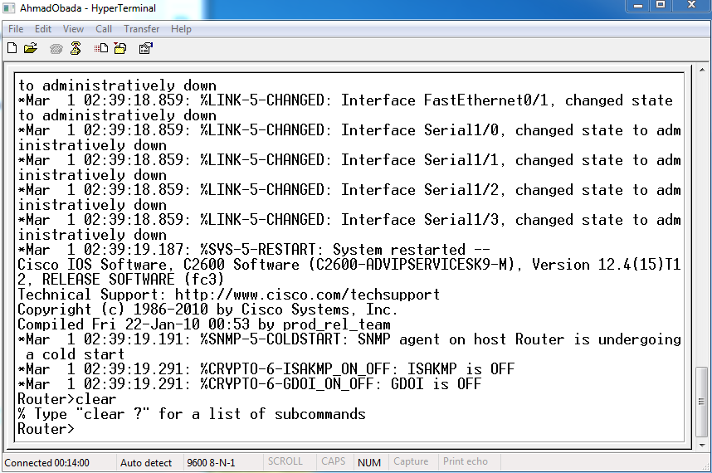

1: We entered " ? " command and got the following :
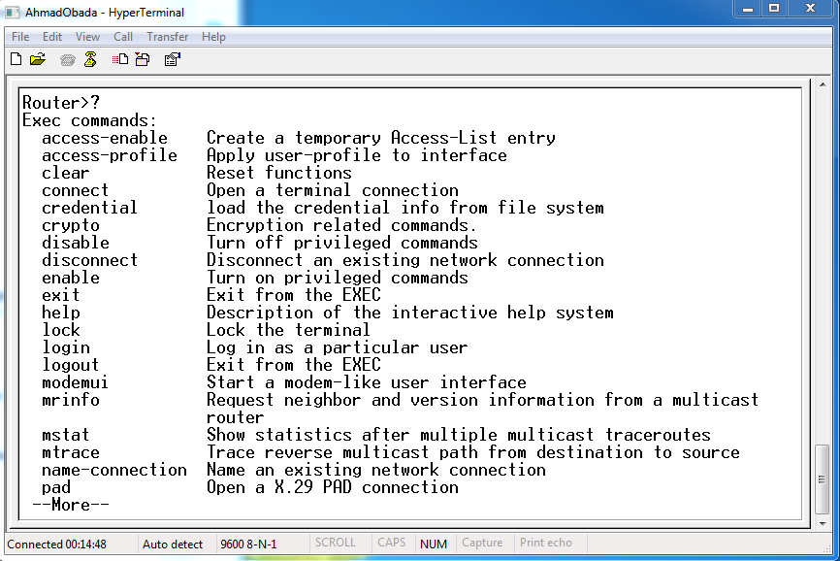
The router will respond with all of the available commands for User Mode. In
general, this mode to see simple configuration of router.
Here a commands that might be more commonly used:
- Clear / 2- connect / 3- login / 4- logout / 5- exit / 6- help / 7-enable / 8- lock .
Q) Was " enable " one of the commands available? Yes .

2: We entered the command " show version " and we got the following .
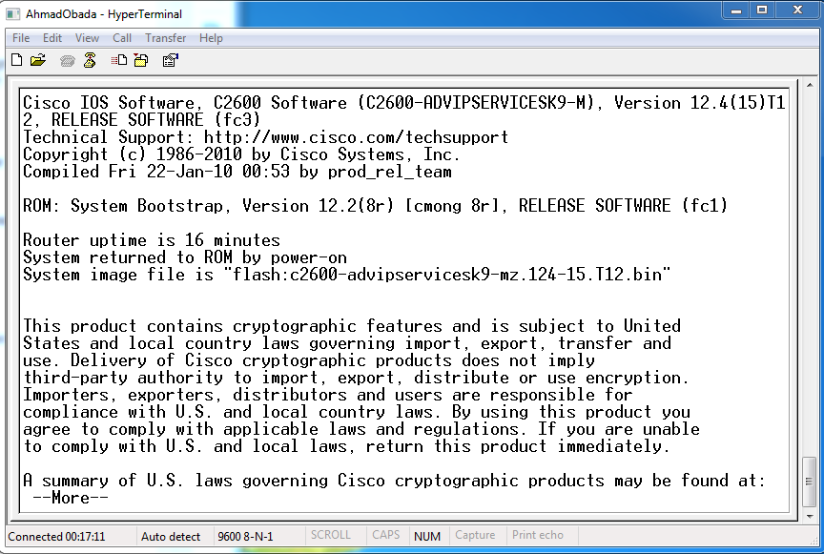
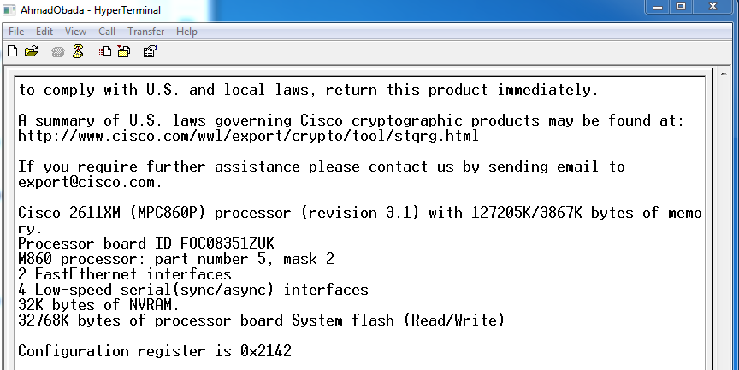
As shown we can answer the following questions :
- Q) What is the number of Cisco router ? 2611XM
- Q) What is the version of IOS software? 12.4
- Q) What is the system image file name? " flash:c2600-advipservicesk9-mz.124-15.T12.bin ".
- Q) How much of Flash memory? 32768K bytes.
- Q) How much of NVRAM? 32K bytes.

Part 2 : (Privileged EXEC Mode)
3: We entered enable mode using " enable " command from user mode and we got the following :
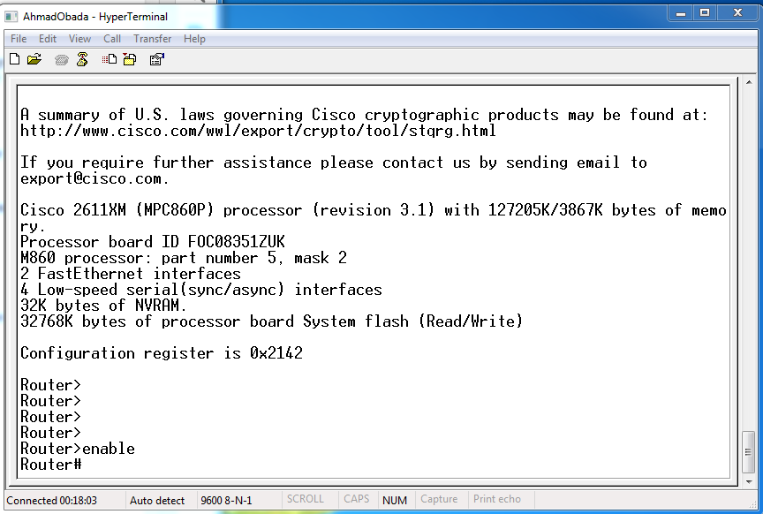
Q) What changed in the router prompt display and what does it mean? " > " changed into " # "
Its mean that we are now at privileged mode.

4: then we entered the help command " ? " .
The router respond with all of the available commands for Privileged-Mode as shown :
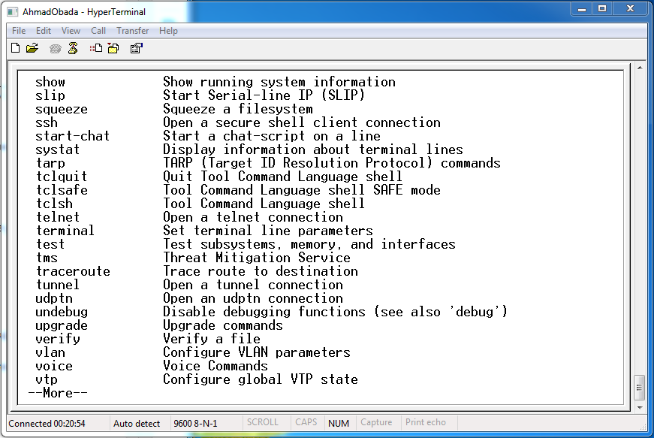
Here a commands that might be more commonly used:
- show / 2- slip / 3- trap / 4- verify / 5- vlan / 6- test / 7-telnet / 8- terminal
/ 9- tms / 10- ssh .
5: We continue looking at the configuration .
Q) What happened when you hit the Enter? Shows one more line
Q) What happened when you hit the space bar? Shows one more page
6: We entered " show ? " then The router respond with the available subcommands for show as the following :

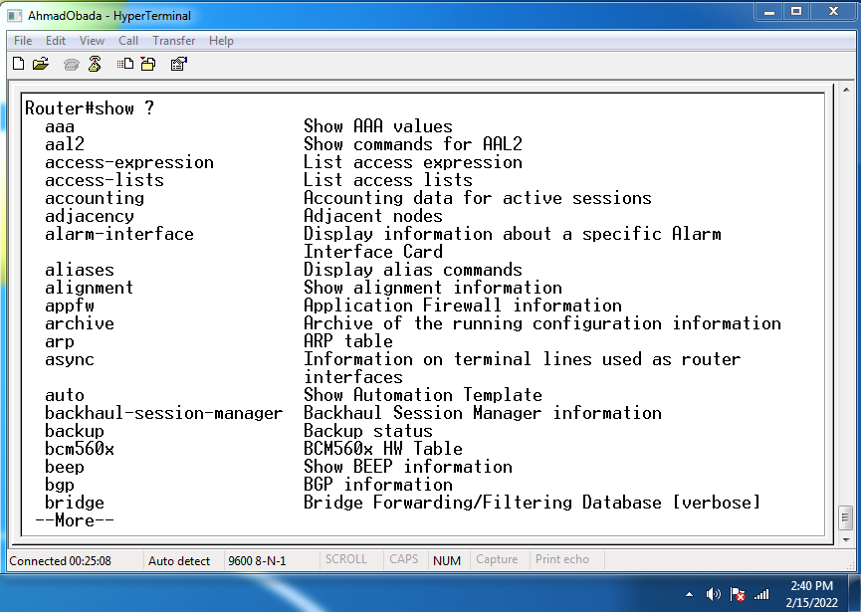
Q) Is " running-config " one of the available commands? Yes its
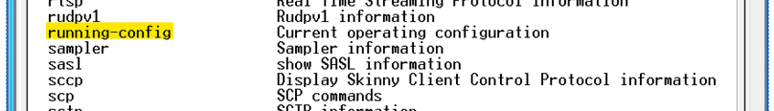

7: We Look at the running router configuration , so we entered " show running-config " at the router prompt . we got the following :
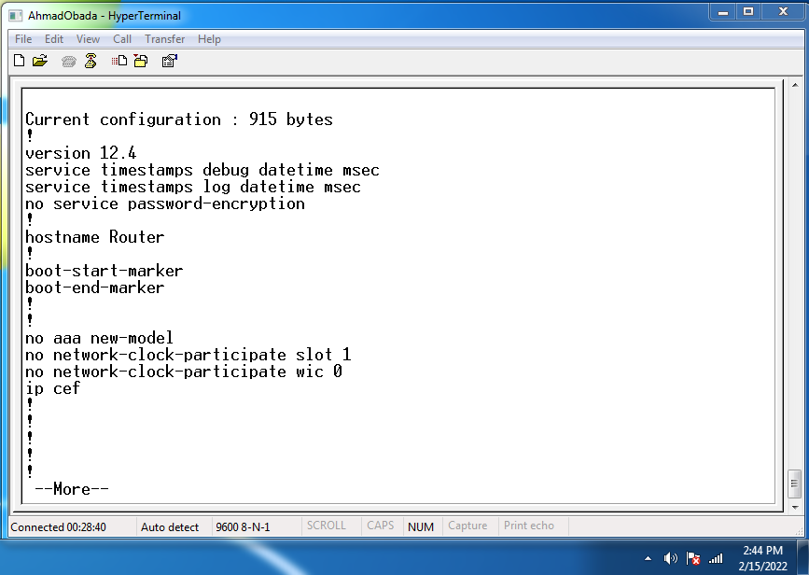
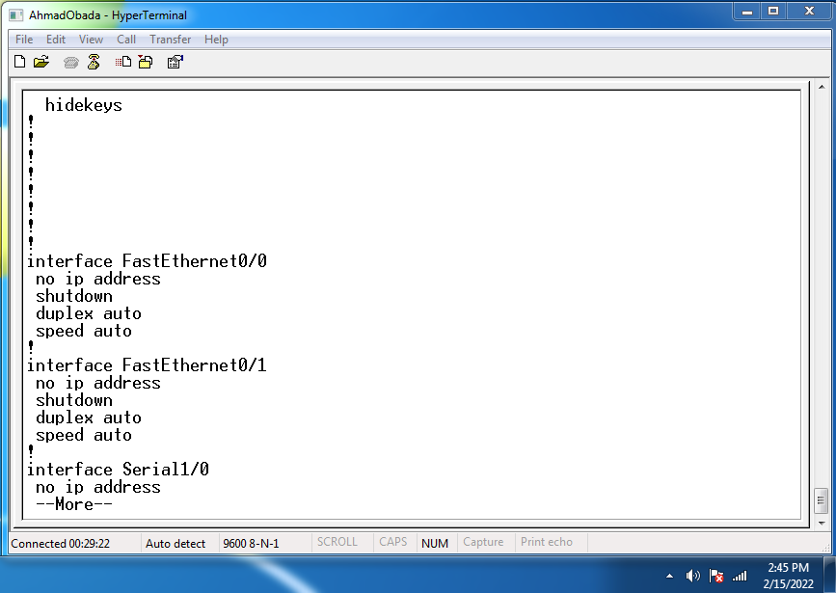
Q) Is there any password or encrypted one? No
8: We used the command history.
Q) What happened at the router prompt when you press up arrow?
When we pressed up arrow or Ctrl-P we got the following :
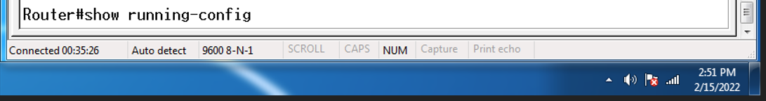
Which mean the last entered command " show running-config " .
Q) Press (?) to see command list, is there config command? what this command? Yes
We use this command to enter configuration mode .
Q) Press (config ?) is there terminal command? Yes
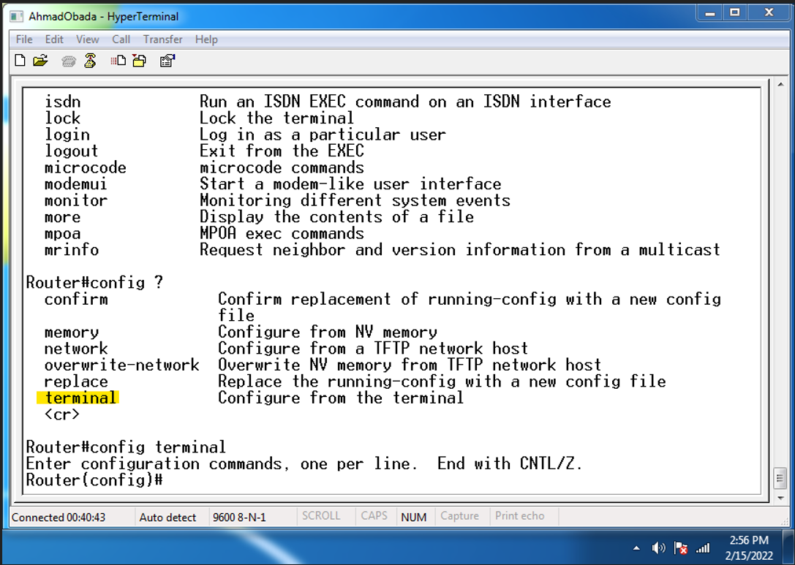

Part 3 : (Global Configuration Mode)
9: We enter global config mode , from user mode we entered " enable " here we entered privilege mode then we entered " config terminal " here we entered global Configuration Mode as shown below :
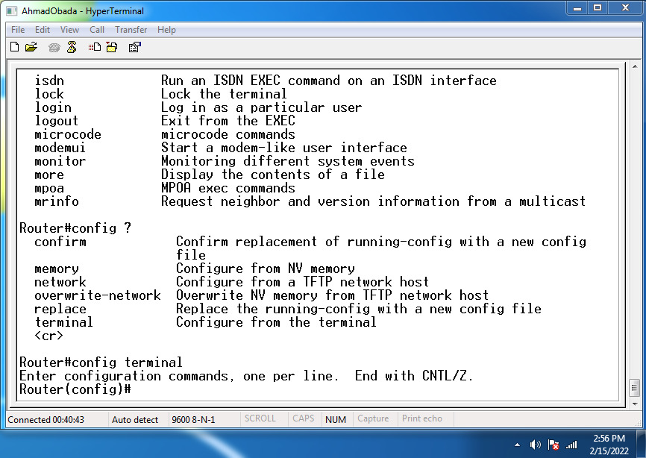
9.1: We Pressed (?) and we got the following :
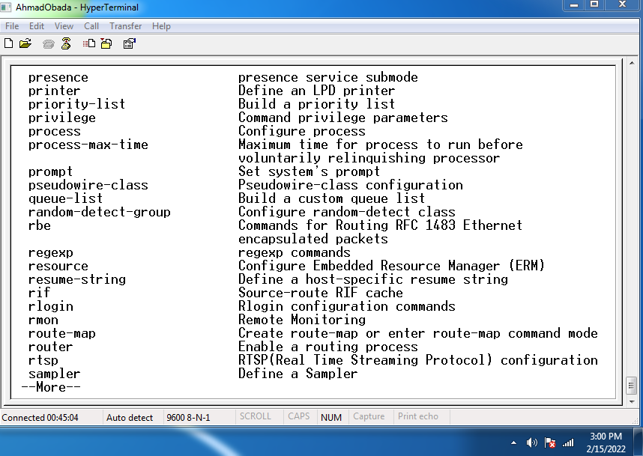
9.2: We entered " router ? " and we got 8 command here we mansion two of them
1- rip : routing information protocol.
- BGP: Border Gateway Protocol .

9.3: We entered " router rip " command and we got the following :
We enter one step ahead from config to config-router .
9.4: We pressed " exit " and its go back one step back to config window .
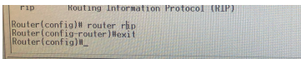
9.5: We pressed " int " then tab, its complete the command by itself as shown :
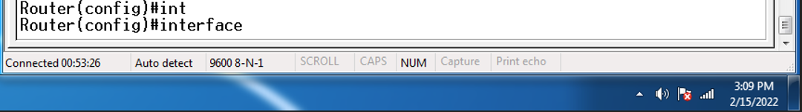
9.6: We pressed " interface ? " we got the following :
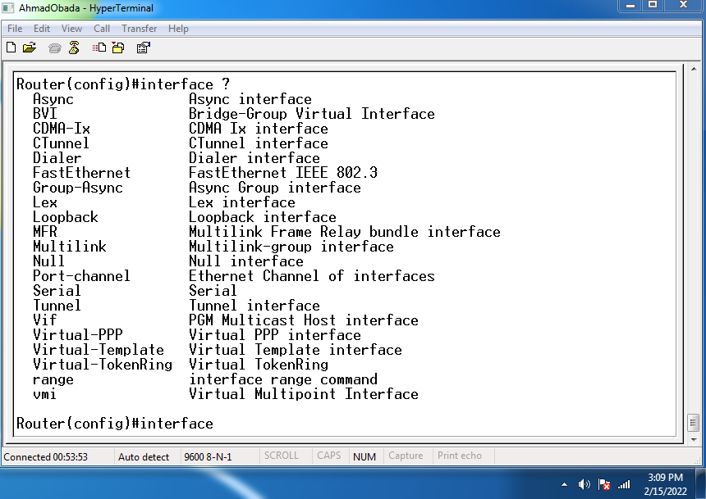

- Async : Async interface .
- BVI :Bridge-Group Virtual Interface .
- Lex : Lex interface .
- Vif : PGM Multicast Host interface .
9.7: We pressed " interface fastethernet 0/0 as shown below the terminal goes ahead one step into " config-if ".
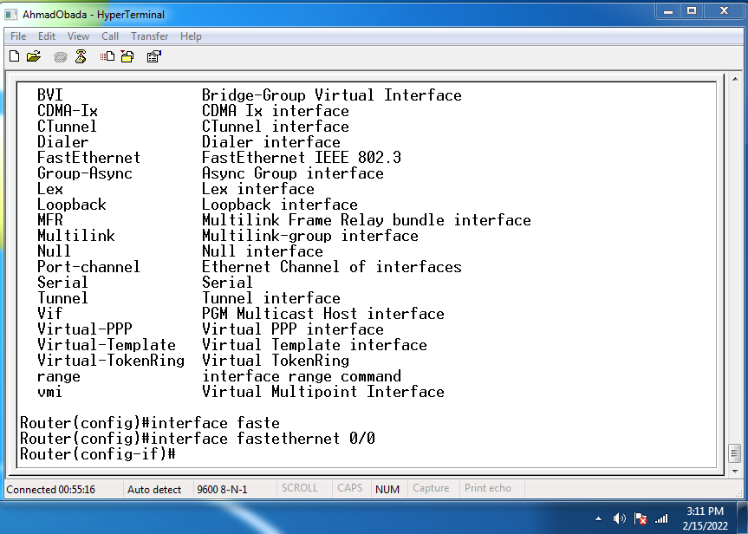
9.8: We finally pressed " exit " to exit the current mode .
Q) what is the difference between commands:
● exit: exit the current mode .
● ctrl-c: exit all modes only keep user mode .
● logout: exit all modes and logout .

- Router setup mode

1: We logged in to the router .
2: Then we entered privilege mode by typing " enable " command.
3: Searching at help command for " setup " command as shown below :
Q) Was setup command one of the commands available? Yes
4: We entered " setup " command in the prompt ,and we got the following :
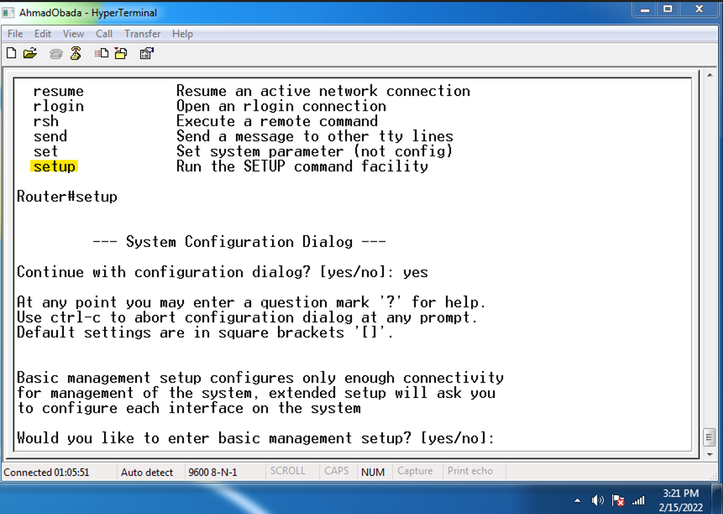
5: We didn't enter basic management setup
Q) What is the importance of the word in the square brackets? Shows the default answer

6: To show the current interface summary we pressed [ yes ] as shown below :
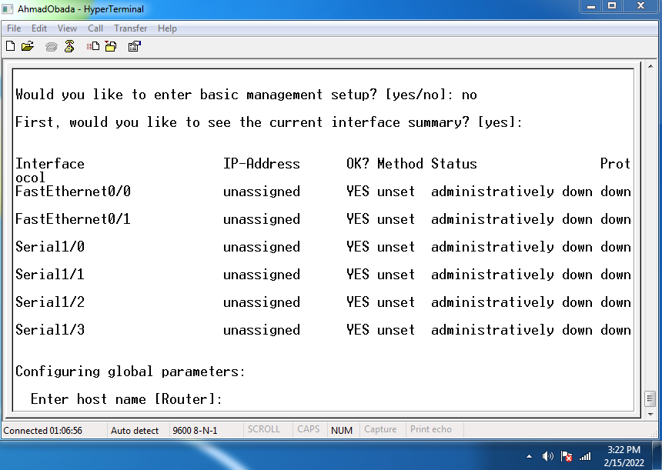
7: We entered " network-lab " as host name for the router , and the secret password to (cisco) and the enable password to (router).

8: Configure interface parameters, and following to the instruction we changed the ip address of fastethernet 0/0 to 192.168.0.10 And serial 1/0 to 192.168.1.11
After that we saved this configurations at nvram and exit .
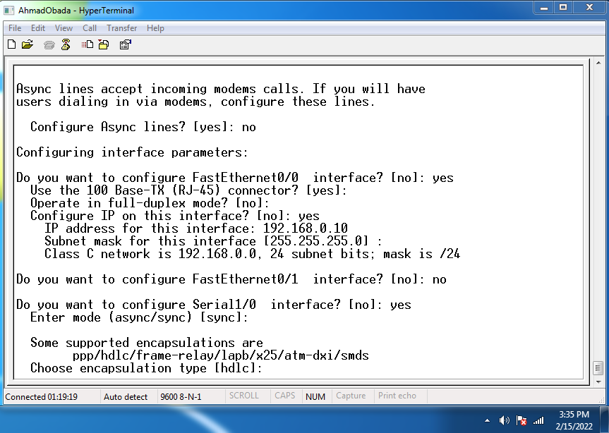
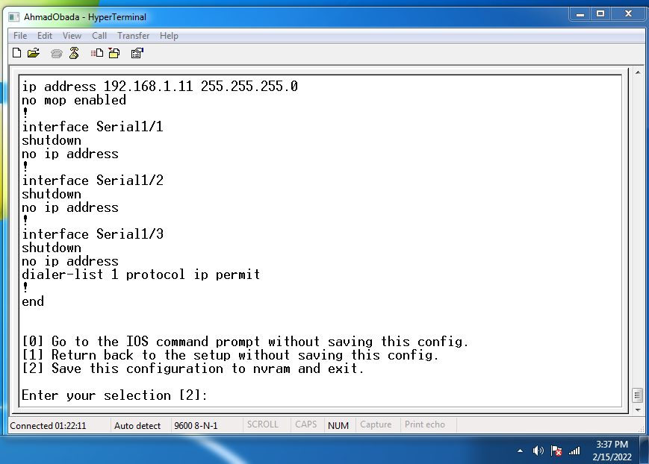
Now we entered " show running-config " at enable mode , and we got the following :
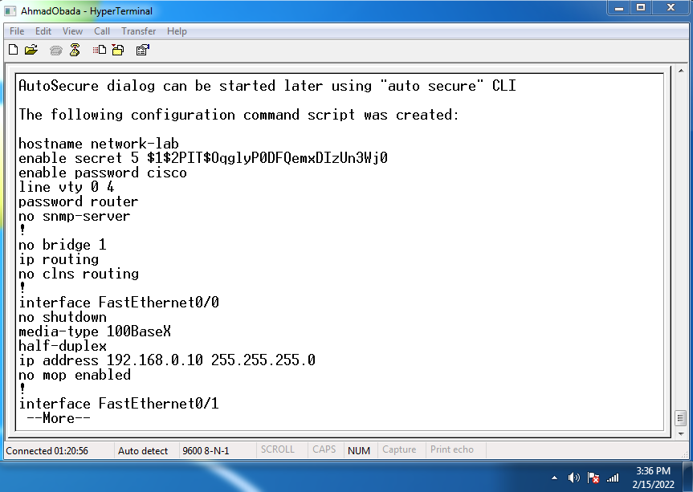
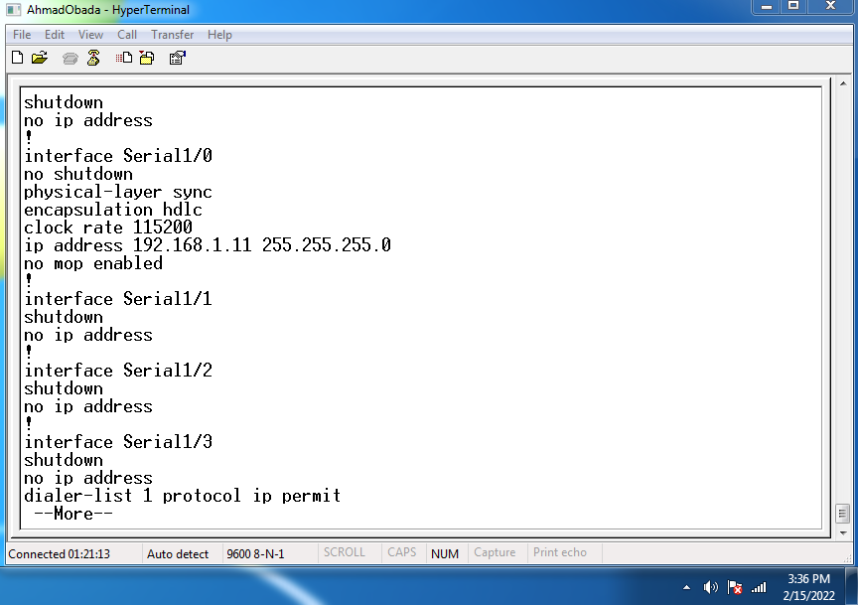
We can notice that the hostname is configured to " network-lab ", and the IP addresses that we have set are also configured . and the secret password is encrypted.
9: Look at passwords , after we logout we tried to login but its ask for password as shown :
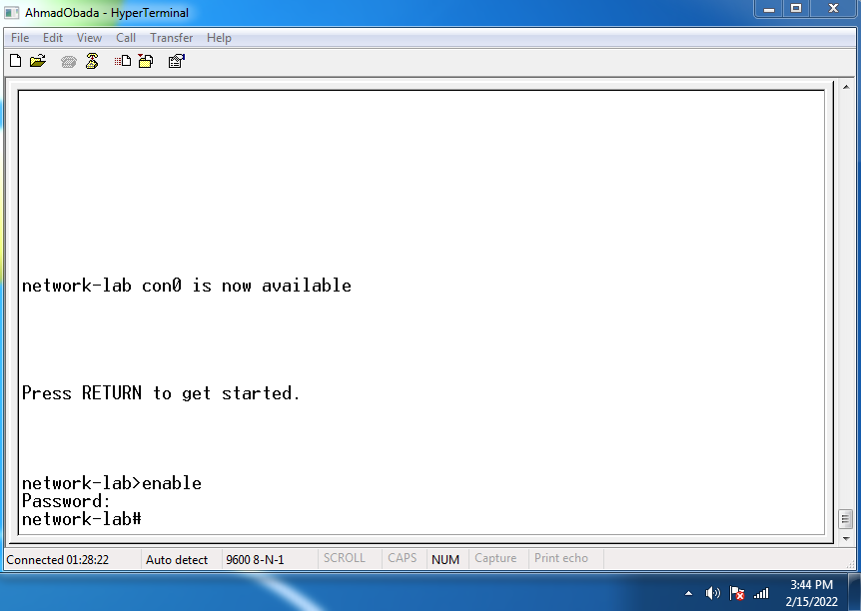
We entered the password and logged in successfully
Experimental Procedures: Write down the Router prompt for each of the following modes
● User EXEC Mode . router>
● Privileged EXEC Mode. router#
● Global configuration mode. router(config)#
● Router configuration mode. router(config-router)#
● Interface configuration mode. router(config-if)#

Conclusion:
- We learnt about routers and how to configure them using command lines,
- help (?) command is very useful to deal with something new .
- we become familiar with different modes for routers such as :
  - user mode is usually used for reading general configurations of the router.
  - setup mode can be used for basic configurations of the router.

