Experiment # 4: Routers Configuration
Name : Ahmad Abdullah AL – Qerem . ID : 11819195 .
Name : Obada Youssef Qasrawi . ID : 11822431 .
2st semester 2022/2023 . Date : 2022/3/8 Thursday .
Report’s Outcomes
ILO __ =( ) % | ILO __ =( ) % | ILO __ =( ) % | ILO __ =( ) % | ILO __ =( ) %
Evaluation Criterion |  |  |  |  | Grade | Points
Abstract  answers of the questions: “What did you do? How did you do it? What did you find?” |  |  |  |  | 0.5
Introduction and Theory  Sufficient, clear and complete statement of objectives. In addition to Presents sufficiently the theoretical basis. |  |  |  |  | 1.5
Apparatus/ Procedure  Apparatus sufficiently described to enable another experimenter to identify the equipment needed to conduct the experiment. Procedure sufficiently described. |  |  |  |  | 2
Experimental Results and Discussion (In-Lab Worksheet)  Crisp explanation of experimental results. Comparison of theoretical predictions to experimental results, including discussion of accuracy and error analysis in some cases. |  |  |  |  | 4
Conclusions and Recommendations  Conclusions summarize the major findings from the experimental results with adequate specificity. Recommendations appropriate in light of conclusions. Correct grammar. |  |  |  |  | 1
Appearance  Title page is complete, page numbers applied, content is well organized, correct spelling, fonts are consistent, good visual appeal. |  |  |  |  | 1
Total |  |  |  |  | 10

Abstract :
In this experiment we built a small network which consisted of 2 routers and 2
PCs, and we used static and dynamic routing .

Introduction and Theory:
The configuration file contains commands to customize router operation. The router uses this information when it starts up. If there is no configuration file available, the system configuration dialog setup guides you through the process of creating one.

Objectives :
- To understand the concept of static routing
- To understand the concept of a default route and use it.
- Configure the IP addresses on each interface on the router.
- To apply static routing using Cisco routers.
- Learn how to configure the router’s global parameters using per line commands.
- Use utilities available to test a router operation.
- To practice troubleshooting problems with static routing.

Tools used in the experiment:
- Rollover cable.
- Two CISCO router.
- Hyper Terminal software.
- Two PCs.
- Serial cable.
- Patch cords .
Procedure :
Part 1 : ( Static Routing )
We had connected two PCs and two
Router as shown below :

Then we opened HyperTerminal on both PCs, we entered the configuration
mode, we configured each router name and message of the day:
router1: DCE, router2: DTE
Ahmad
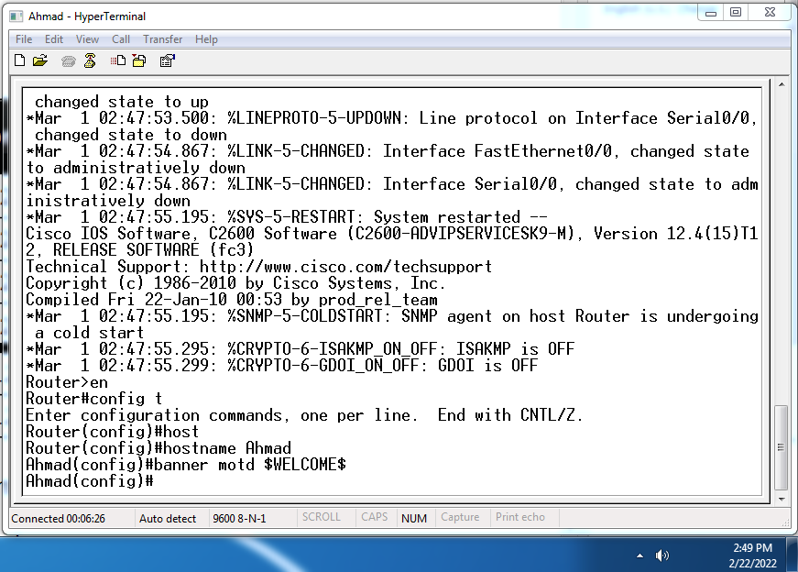
Obada
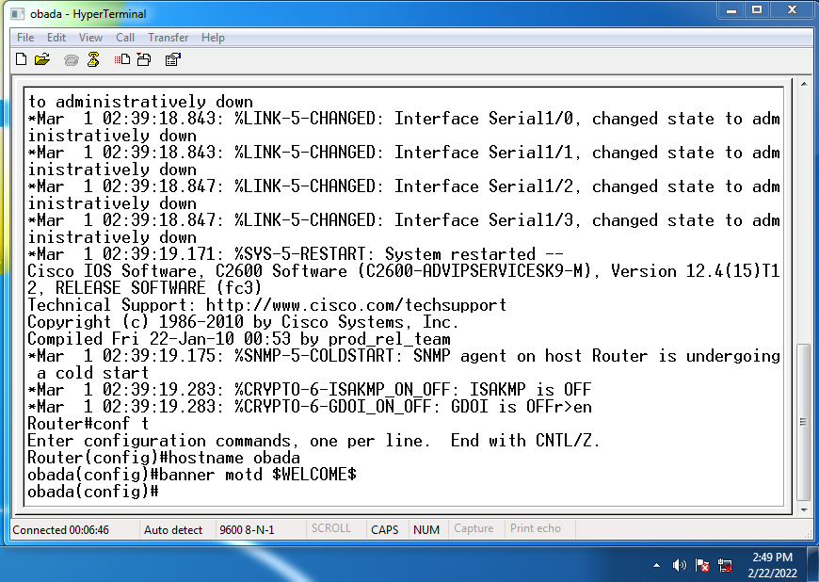

We configured each interface as shown in the table :
Ahmad
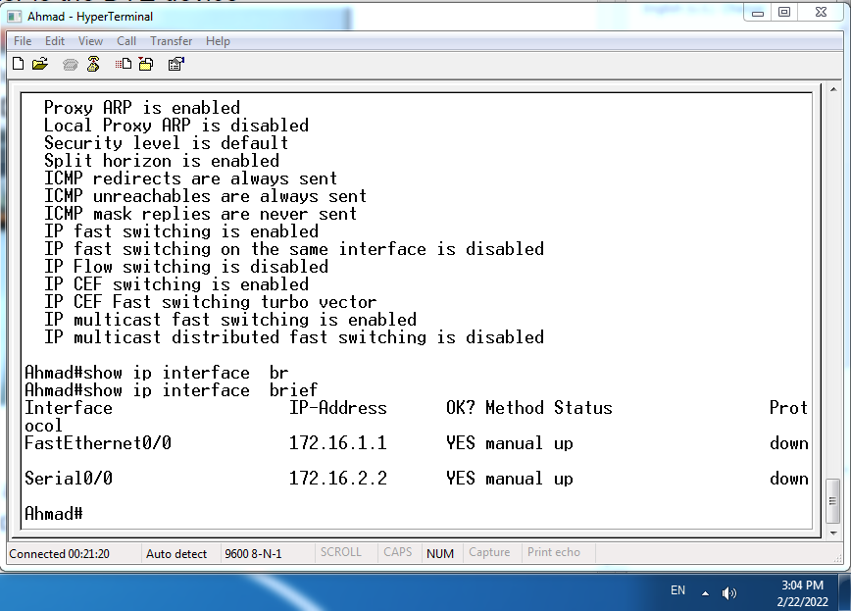
Obada
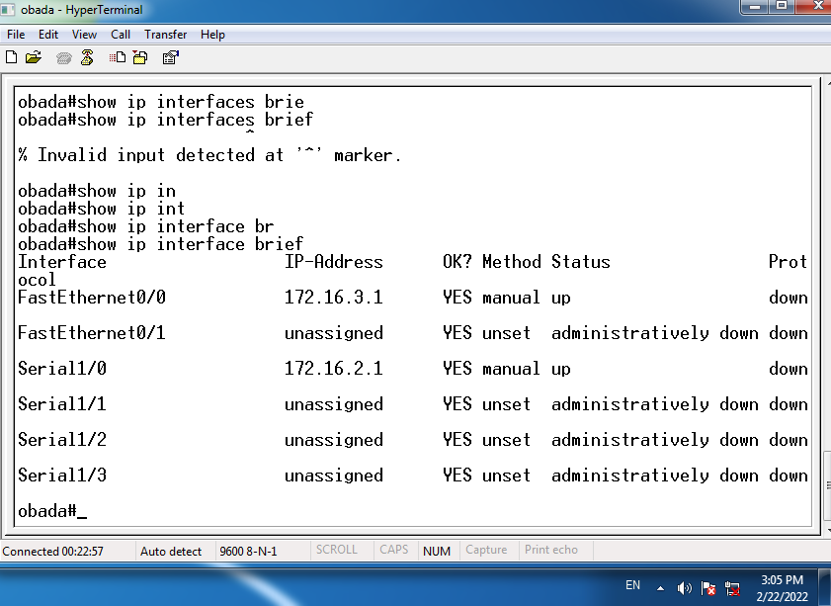
For Obada Router we interfaced serial 1/0 at clock rate 64000 as shown in the command :
And for Ahmad Router we interfaced serial 0/0 at bandwidth 64 as shown :
Configuring a Static Route:
For each we entered " show ip route " and we got the following :

Ahmad
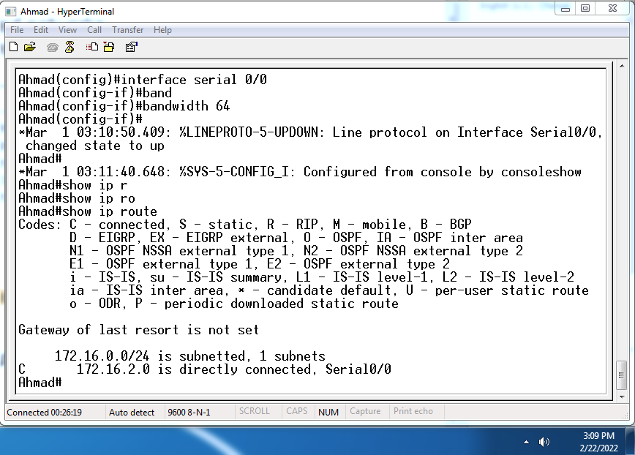
Obada
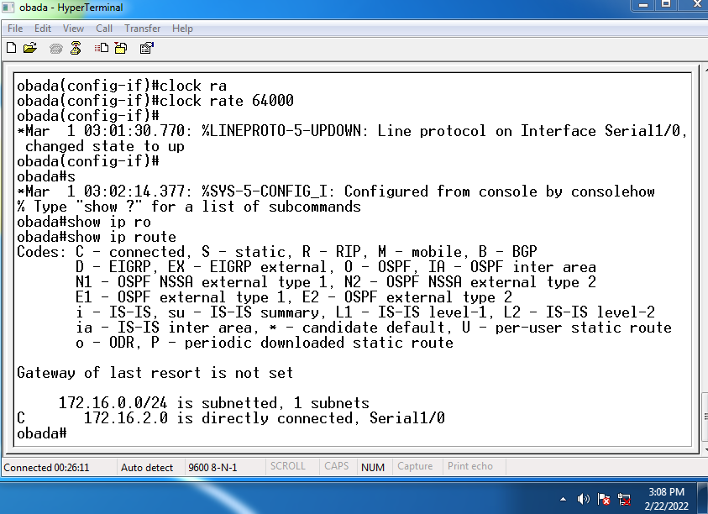
To let router 1 know about the other lans we use the following command :
Ahmad
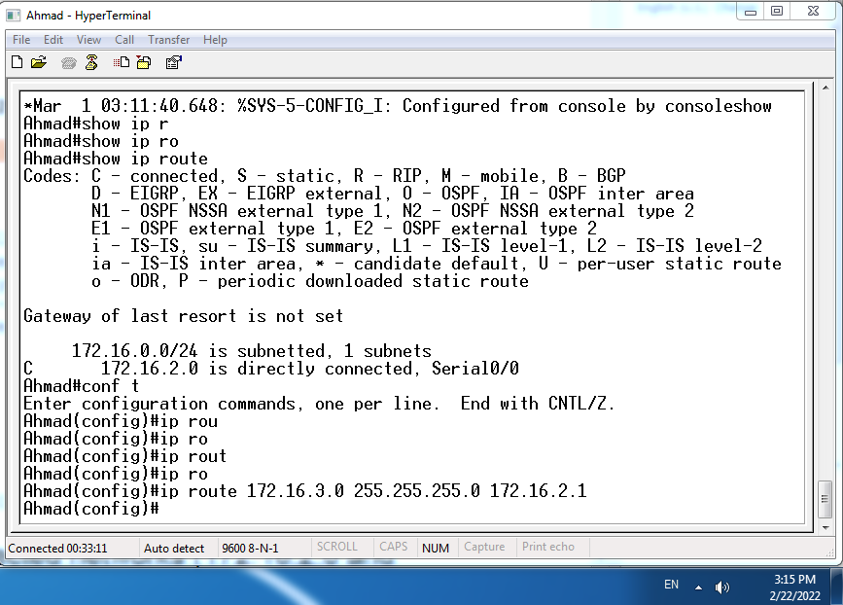
Obada
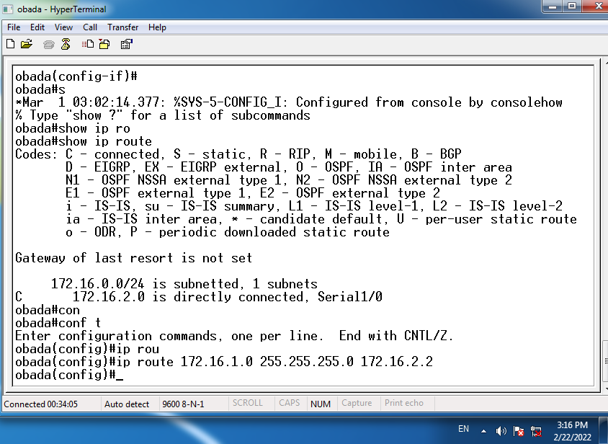
For both we configured a default static route as shown below :

Now let's check routing table for both using " show ip route " command :
Obada
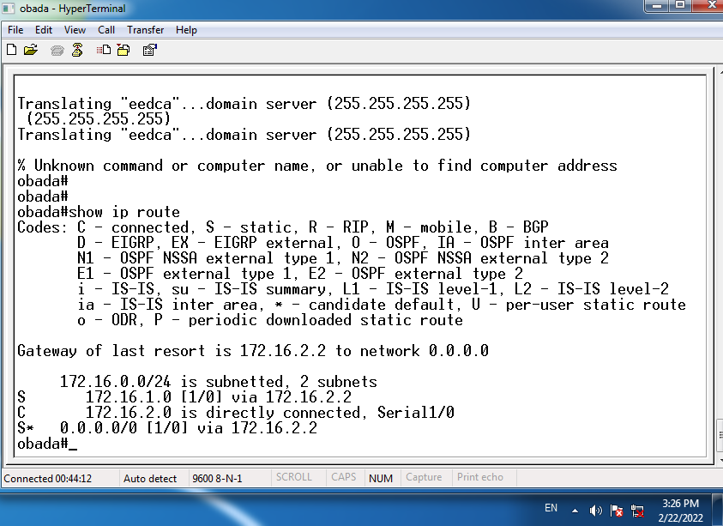

Ahmad
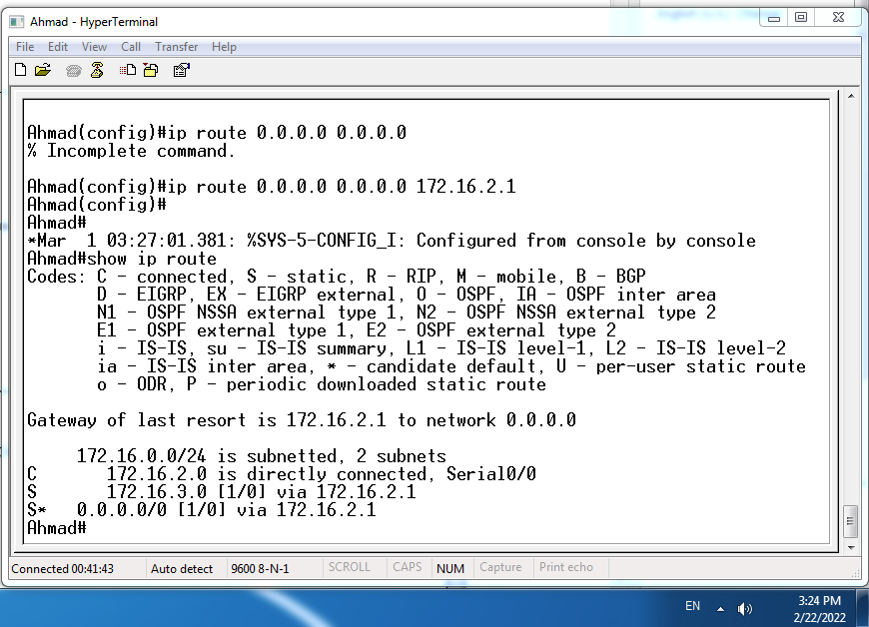
Finally we set ip address for both PCs as shown :
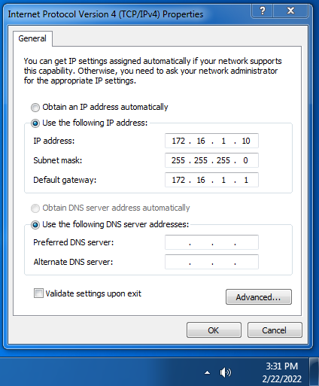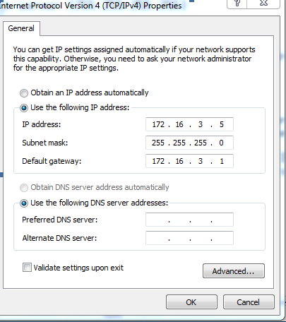
Ping test before and after setting the ip routing tables :
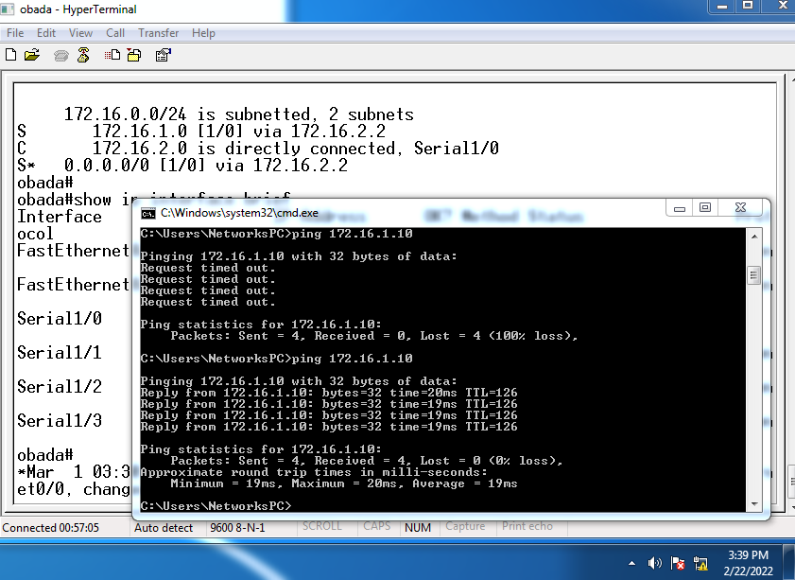
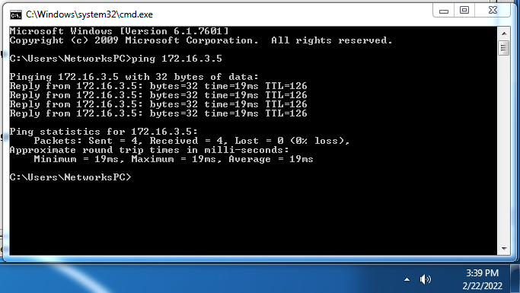
Then we used Traceroute–to discover all of the hops (routers) along the path between 2 points as shown bellow :
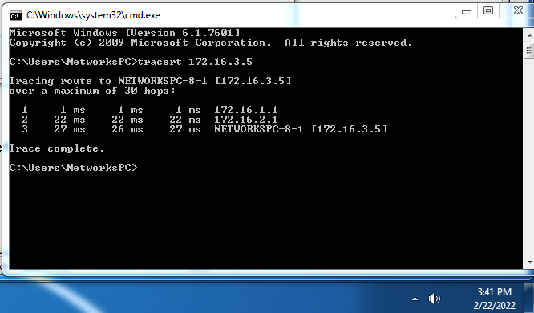
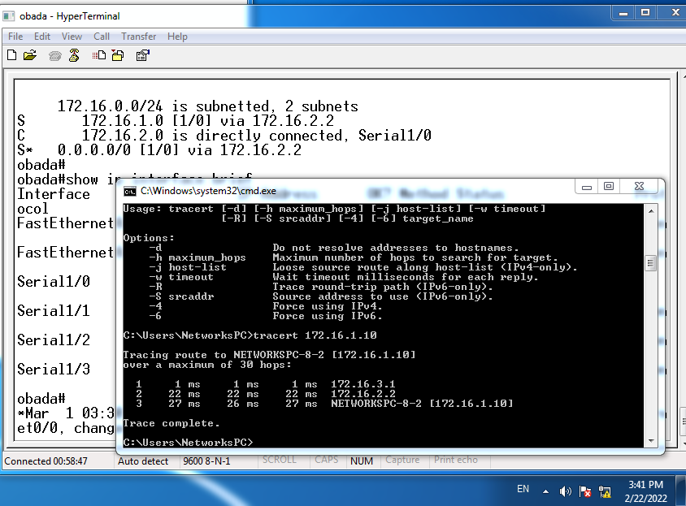
Part 2 : ( Dynamic Routing )
For this part we connected the PC as shown in the past part and configured there IPs as it was , put instead of static routing command we used dynamic routing command as show below :
Then we ping between PCs as shown :

Telnet configuration :

Conclusion:
We got familiar with the dynamic and static protocol, we concluded that the every protocol has its pros and cons, and each one of them could be used in different situations.
Advantages of static routing
-It can backup multiple interfaces/networks on a router
-Easy to configure
-No extra resources are needed
-More secure
Disadvantages of static routing
-Network changes require manual reconfiguration
-Does not scale well in large topologies

