Experiment # 5: Vlan
Name : Ahmad Abdullah AL – Qerem . ID : 11819195 .
Name : Obada Youssef Qasrawi . ID : 11822431 .
2st semester 2022/2023 . Date : 2022/3/15 Thursday .
Report’s Outcomes
ILO __ =( ) % | ILO __ =( ) % | ILO __ =( ) % | ILO __ =( ) % | ILO __ =( ) %
Evaluation Criterion |  |  |  |  | Grade | Points
Abstract  answers of the questions: “What did you do? How did you do it? What did you find?” |  |  |  |  | 0.5
Introduction and Theory  Sufficient, clear and complete statement of objectives. In addition to Presents sufficiently the theoretical basis. |  |  |  |  | 1.5
Apparatus/ Procedure  Apparatus sufficiently described to enable another experimenter to identify the equipment needed to conduct the experiment. Procedure sufficiently described. |  |  |  |  | 2
Experimental Results and Discussion (In-Lab Worksheet)  Crisp explanation of experimental results. Comparison of theoretical predictions to experimental results, including discussion of accuracy and error analysis in some cases. |  |  |  |  | 4
Conclusions and Recommendations  Conclusions summarize the major findings from the experimental results with adequate specificity. Recommendations appropriate in light of conclusions. Correct grammar. |  |  |  |  | 1
Appearance  Title page is complete, page numbers applied, content is well organized, correct spelling, fonts are consistent, good visual appeal. |  |  |  |  | 1
Total |  |  |  |  | 10

Abstract :
In this experiment we had learnt how to use switch to create VLANS, using switch
commands , and how to connect two switches with trunk .

Introduction and Theory:
A virtual LAN (VLAN) is a switched network that is logically segmented by function, project team, or application, without regard to the physical locations of the users. Any switch port can belong to a VLAN, and unicast , broadcast, and multicast packets are forwarded and flooded only to stations in the VLAN. Each VLAN is considered a logical network, and packets destined for stations that do not belong to the VLAN must be forwarded through a router or bridge

Objectives :
- Learn how to configure a switch layer2 cisco routers.
- Learn how to configure a switch layer3 cisco routers.
- Learn how to configure VLANs and Trunking.
- Learn how to connect two VLANs using Cisco devices.
Tools used in the experiment:
- Rollover cable.
- 2 PC.
- 2 CISCO Switches .
- Hyper Terminal software.
- 2 Straight patch cords .
- 1 cross-over cord .

Procedure :
Part 1 : ( connect two PC in one VLAN via one switch )
We connected two PCs with the first switch , PC1 ( 192.168.8.101/24 ) , and PC2 ( 192.168.8.102/24 ).
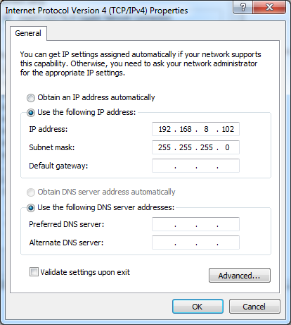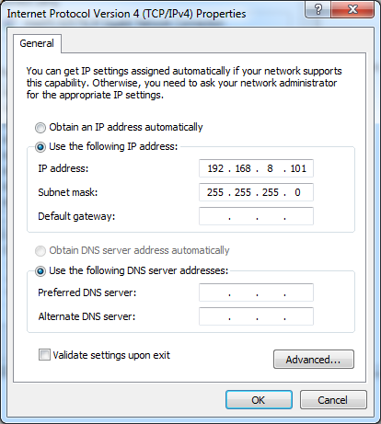

Then we pinged to each other as show below :
Ahmad to obada
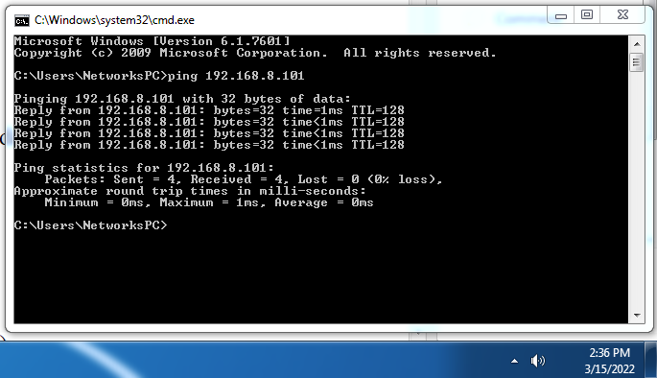

obada to Ahmad
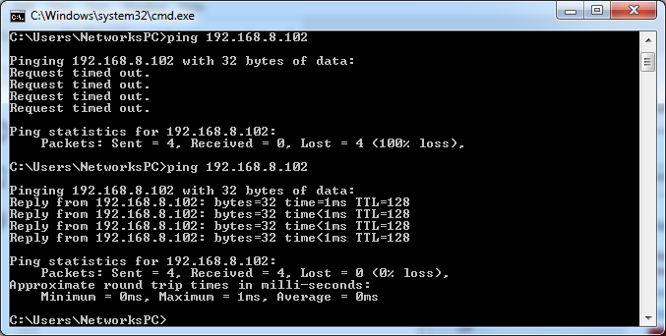
We Erased configuration , including VLANs after check VLAN table , with " Sh vlan " as shown below : Ahmad
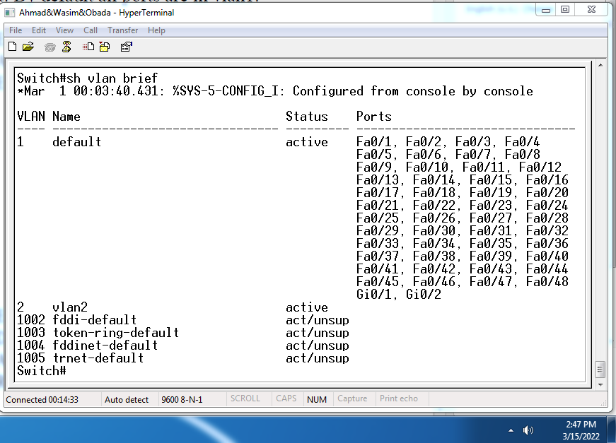

Obada
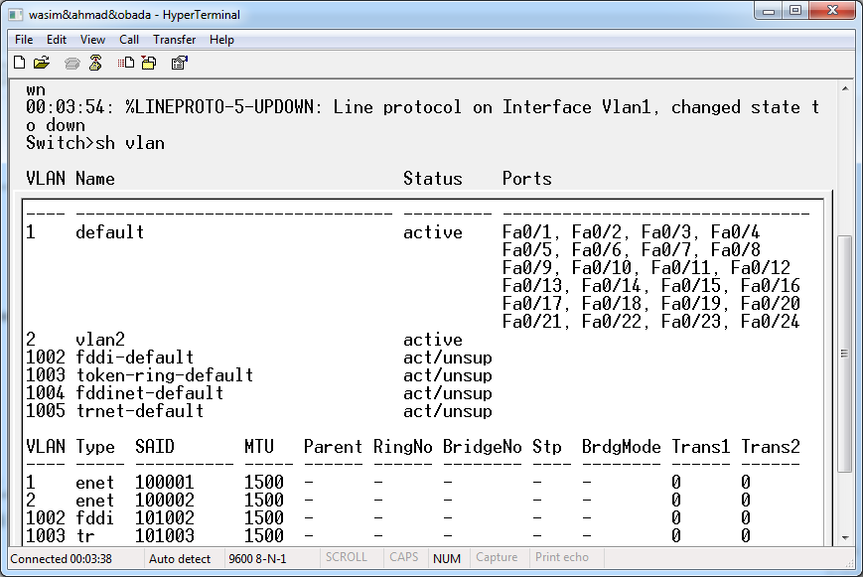
To delete all VLANs we entered the following command :
Switch#vlan database
Switch (vlan) #no vlan 2
Switch (vlan) #reload
Switch (vlan) exit

Then we changed switch name to vlan2 via the following commands :
Switch #vlan database
Switch (vlan) vlan 2 name vlan2
Switch (vlan)#exit

Switch #sh vlan brief
- Describe the previous step? Shows all VLANs and their related ports
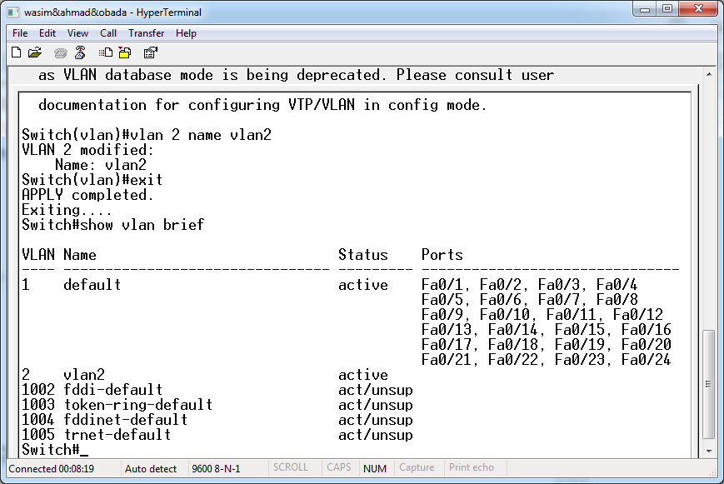
Switch #sh vlan name vlan2
- Describe the previous step? Shows only the VLAN2 ports
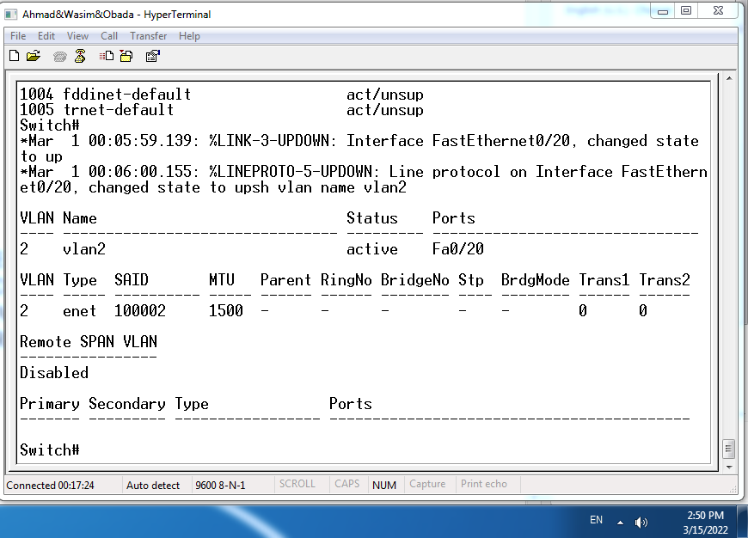

Then we tried to ping to each other again as shown :
Ahmad to Obada
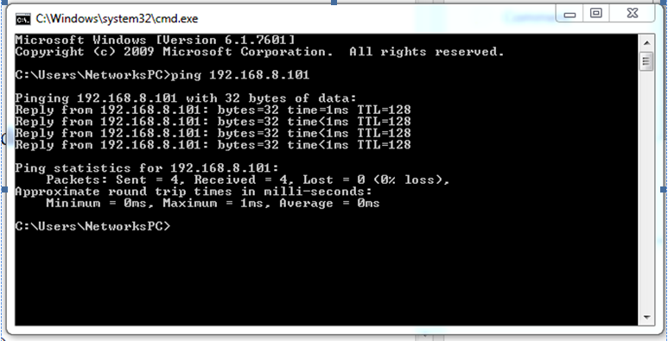
Obada to Ahmad
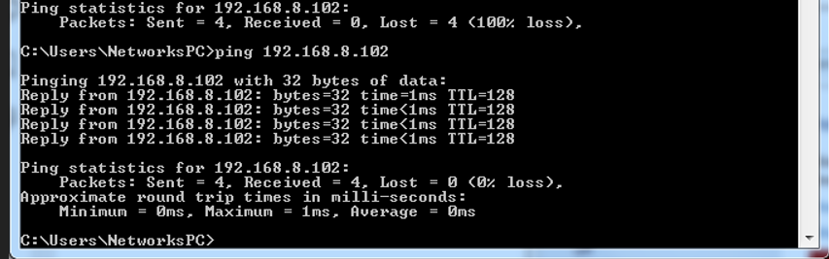
Both PCs are connected at the same lan via switch .

Then we assigned port f0/2 to vlan2 for PC1 using the following commands :
Switch (conifg)# interface f0/2
Switch (config-if)#switchport mode access
Switch (config-if)#switchport access vlan 2
Switch (config-if)#exit

And the other pc at any port

To see the changes at ports we entered the following command :
Switch #sh vlan brief
Obada
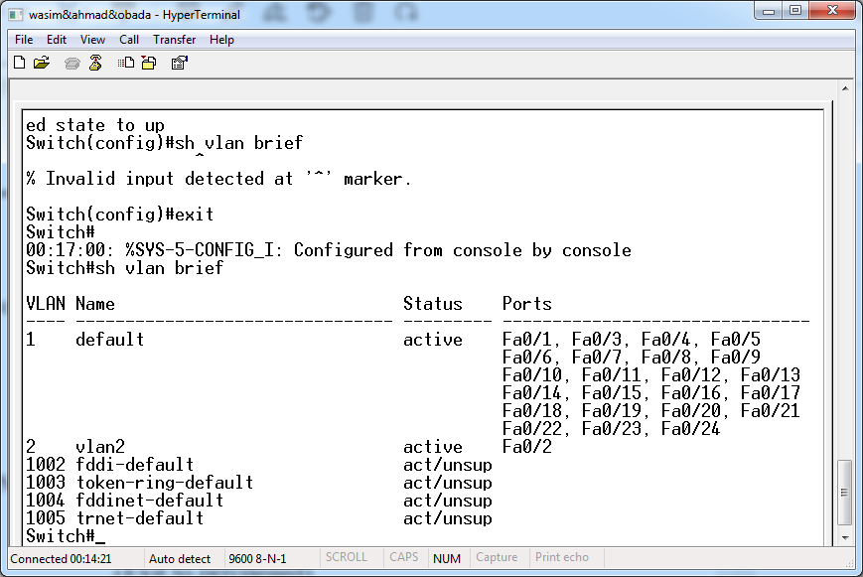

Describe the previous step?
We connected PC1 on switch 1 at port 2 and PC2 on switch 1 at port 1 , here both are not at the same LAN ( deferent VLANs ) then we Ping between PC1 and PC2 as shown :
Ahmad to Obada
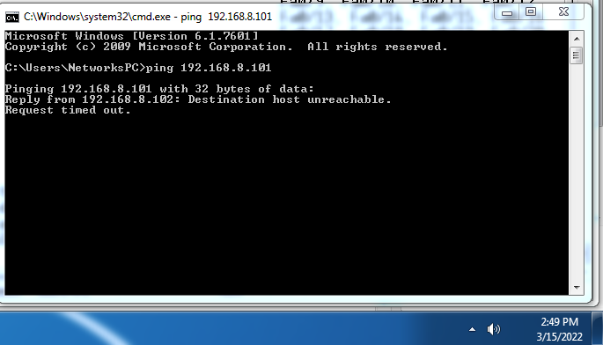

Obada to Ahmad
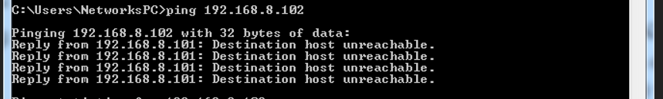
Part 2 : ( connect two PC in one VLAN via two switches )
After we assigned port 2 from both switches for VLAN2 we connected them via trunk at port 20 from both switches , and connected them with crossed cable ( because they are from the same type ) , using the following commands :
Switch # config t
Switch (config)#Interface f0/20
For 3660 switch For 2950 switch
Switch (config_if)#Switchport trunk encap dot1q | Switch (config_if)#Switchport trunk allowed vlan all
Switch (config_if)#Switchport mode trunk | Switch (config_if)#Switchport mode trunk
(Configure the port as a VLAN trunk
for 3660 switch)
Switch (config_if)#exit
Switch #sh vlan brief
Ahmad
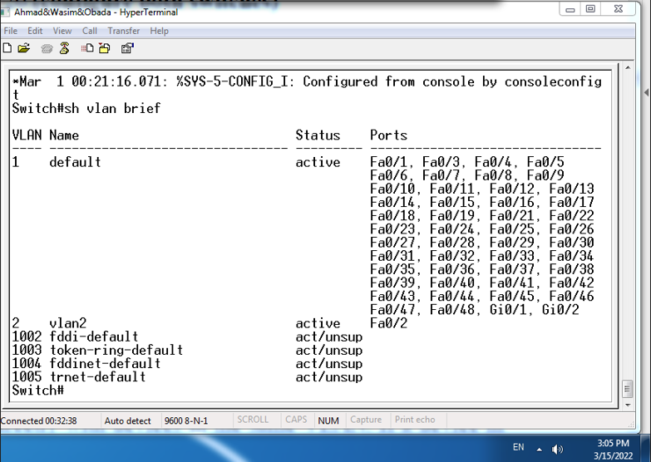

Obada
Ping between PC1 and PC2:
Ahmad to Obada
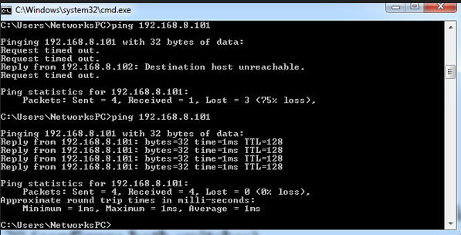

Obada to Ahmad
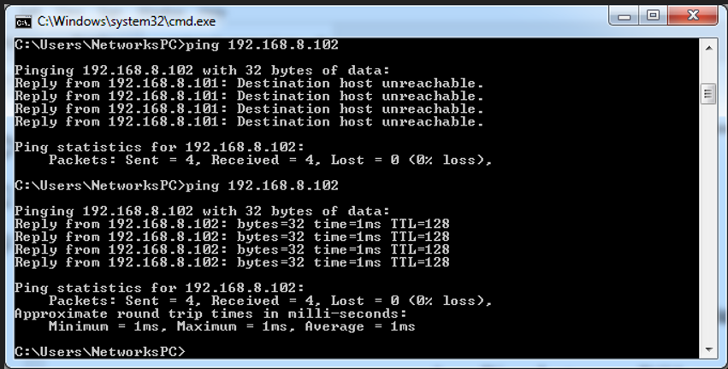
So both PCs are connected via trunk from switch 1 to switch 2 and both are at the same VLAN , when we ping between them its shows that they are connected each other .

Conclusion:
- We learned about VLANs and how to create them
- We learned about trunk and its fetchers:
- Backup cable .
- Fix storming in switches .
- Higher bandwidth .
- Connect port from the same VLANs at several switches .

