Experiment # 6: DHCP
Name : Ahmad Abdullah AL – Qerem . ID : 11819195 .
Name : Obada Youssef Qasrawi . ID : 11822431 .
2st semester 2022/2023 . Date : 2022/3/22 Thursday .
Report’s Outcomes
ILO __ =( ) % | ILO __ =( ) % | ILO __ =( ) % | ILO __ =( ) % | ILO __ =( ) %
Evaluation Criterion |  |  |  |  | Grade | Points
Abstract  answers of the questions: “What did you do? How did you do it? What did you find?” |  |  |  |  | 0.5
Introduction and Theory  Sufficient, clear and complete statement of objectives. In addition to Presents sufficiently the theoretical basis. |  |  |  |  | 1.5
Apparatus/ Procedure  Apparatus sufficiently described to enable another experimenter to identify the equipment needed to conduct the experiment. Procedure sufficiently described. |  |  |  |  | 2
Experimental Results and Discussion (In-Lab Worksheet)  Crisp explanation of experimental results. Comparison of theoretical predictions to experimental results, including discussion of accuracy and error analysis in some cases. |  |  |  |  | 4
Conclusions and Recommendations  Conclusions summarize the major findings from the experimental results with adequate specificity. Recommendations appropriate in light of conclusions. Correct grammar. |  |  |  |  | 1
Appearance  Title page is complete, page numbers applied, content is well organized, correct spelling, fonts are consistent, good visual appeal. |  |  |  |  | 1
Total |  |  |  |  | 10

Abstract :
In this experiment we learnt about an important servers ( DHCP ), their importance and
the way of using them. which is a network server which automatically provides and assigns IP addresses for devices.
Introduction and Theory:
A DHCP Server uses a lease generation process to assign IP addresses to client computers
for a specific period of time. IP address leases are normally temporary, so DHCP clients
must periodically attempt to renew their leases with the DHCP server. DHCP is an Internet Engineering Task Force (IETF) standard designed to reduce the administration burden and complexity of configuring hosts on a TCP/IP-based network, such as a private intranet. Using the DHCP Server service, the process of configuring TCP/IP on DHCP clients is automatic. Understanding the details of the DHCP lease generation and renewal process provides a foundation for effectively implementing dynamic IP addressing in your network environment. Windows Server 2012 is one of the servers that provide DHCP service.

Objectives :
- Install the DHCP Server service.
- Authorize a DHCP server.
- Create a DHCP scope, and Configure DHCP scope options
- Configure a DHCP reservation.
Tools used in the experiment:
- 2 PC.
- CISCO Switch .
- 3 cross-over cord .
- DHCP server .

Procedure :
We set our IP addresses on the same network as the DHCP server as shown below :
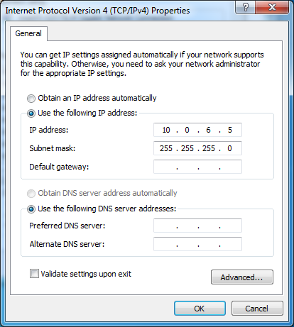
Then we need to access and installing the server from Remote Control ( already installed at windows 7 ).
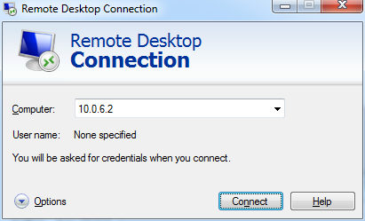

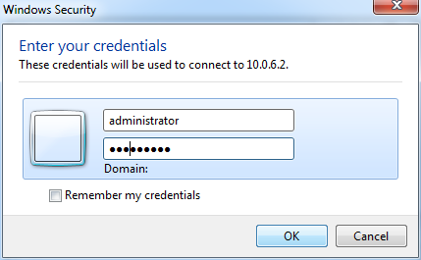
We entered "Administrator" as user name and "Net123456" as password .

After we accessed the server successfully we click start and then Server Manager as shown :
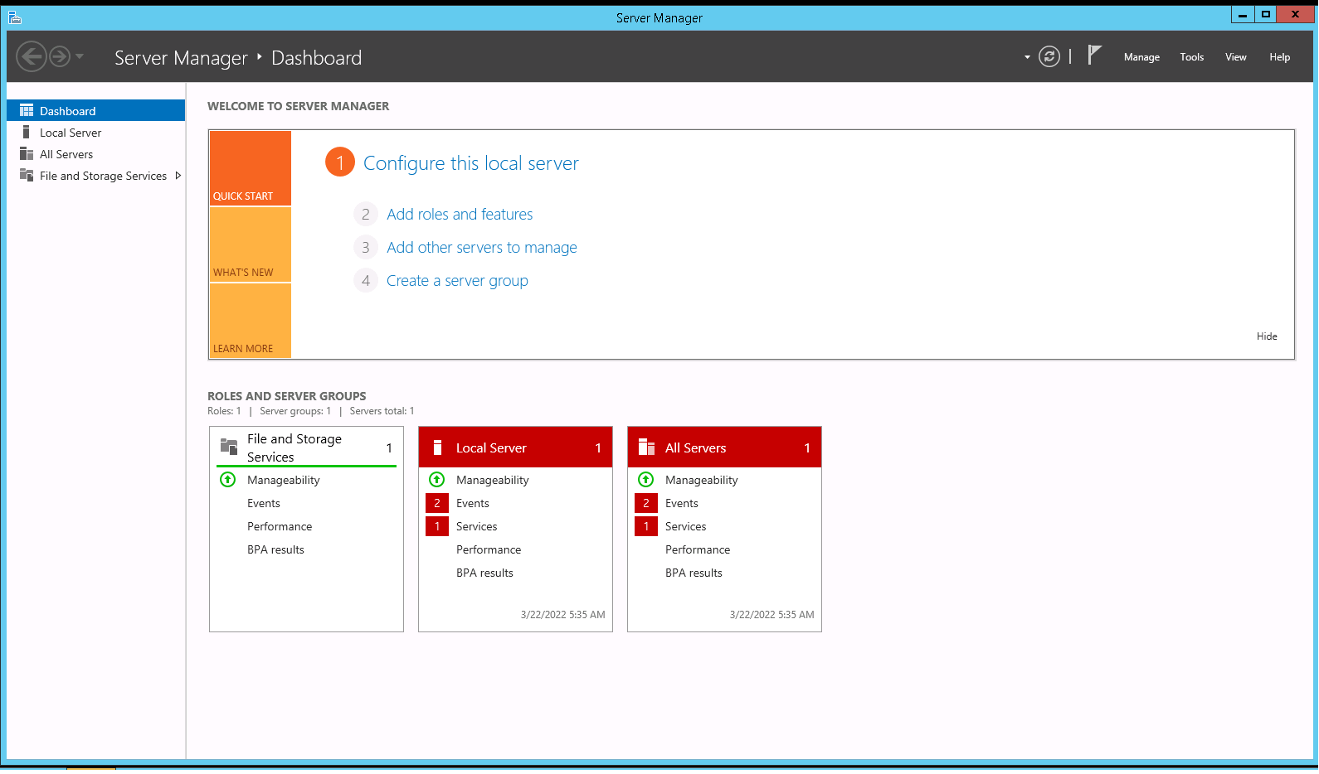
Then we added new rule to add DHCP rule :

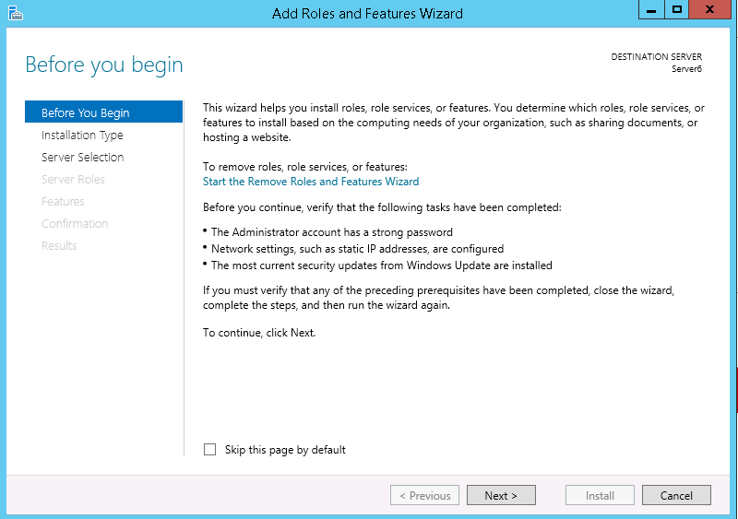
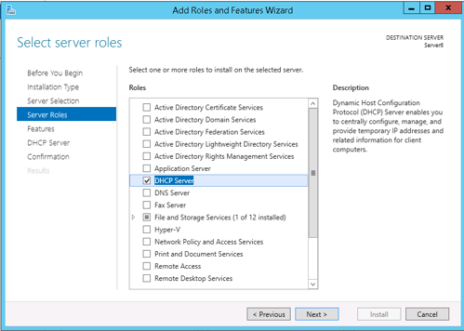
1 2

After commpleat installing the rule ( DHCP )
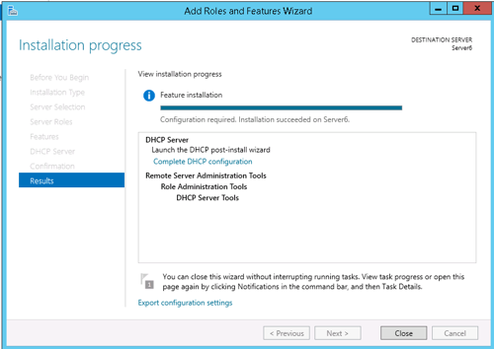

To grantee if its installed correctly we can check Tools as shown below :
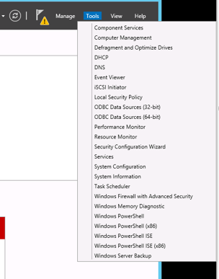
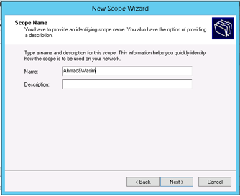
We opened DHCP server to set its configuration
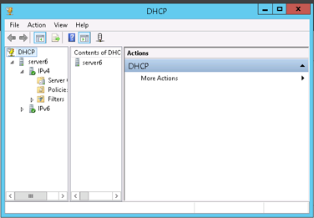

We set the Name as " Ahmad&Wasim ".

And we set IP Address Range from 10.0.6.10 – 10.0.6.250 ( about 240 IP )
And we kept " Add Exclusions and Delay " empty as shown bellow :
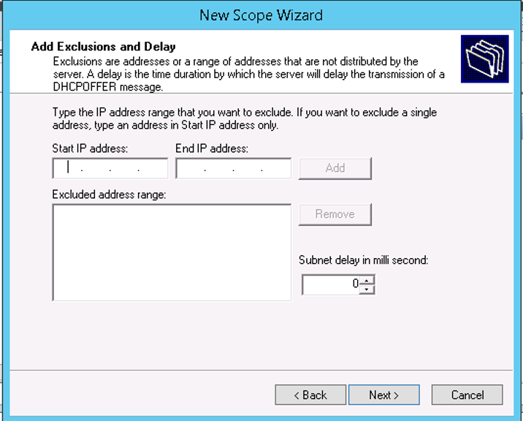
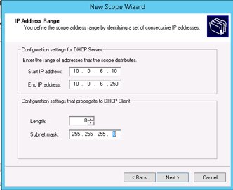

We set Lease Duration to 3 days
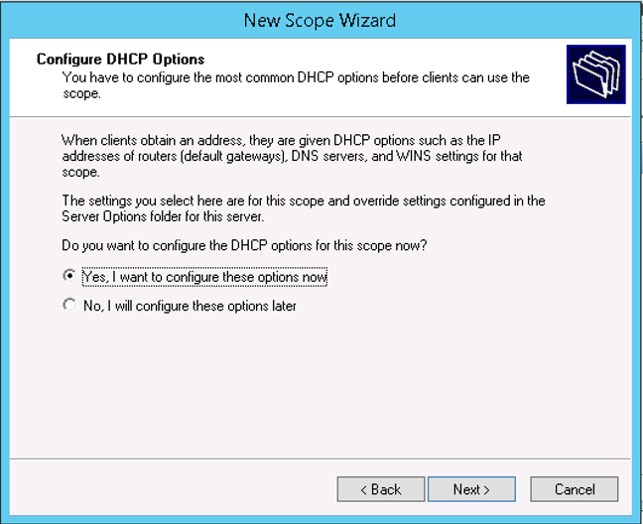
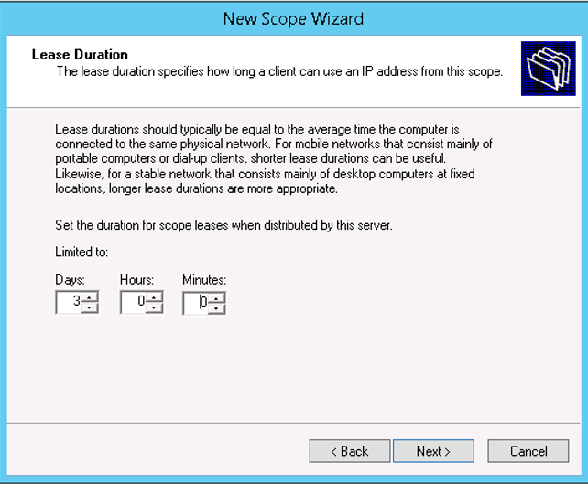

We set the default gateway " 10.0.6.1 " and skip DNS step
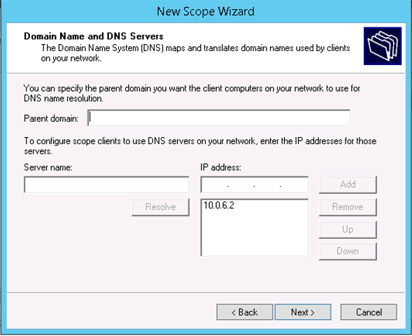
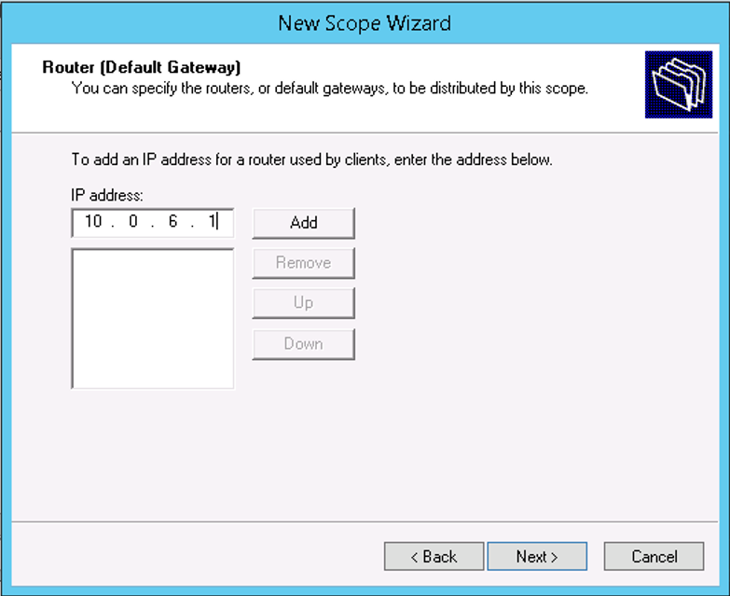

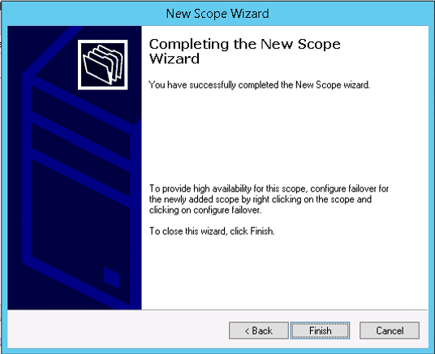
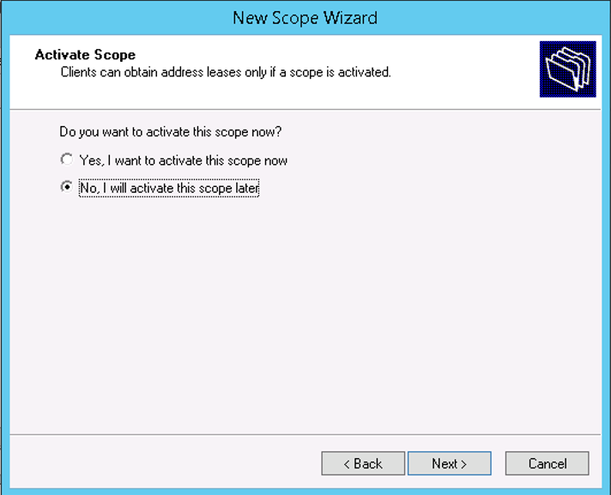
Final step :

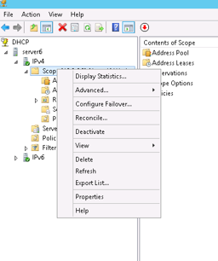
Now we need to create and configure our scope.

We tried to release the ip addresses of both PCs and then to renew
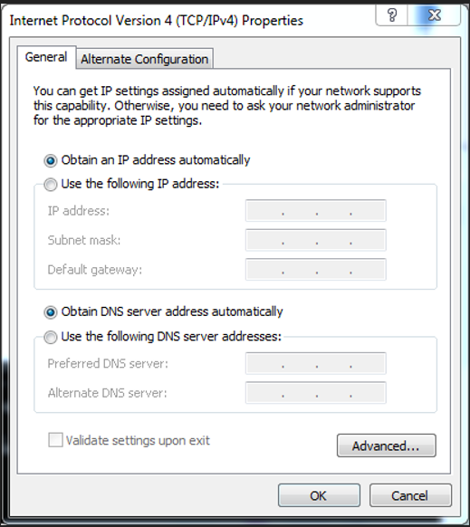
them (get a new ip address from the DHCP server) but first we need to set IP auto as shown bellow .

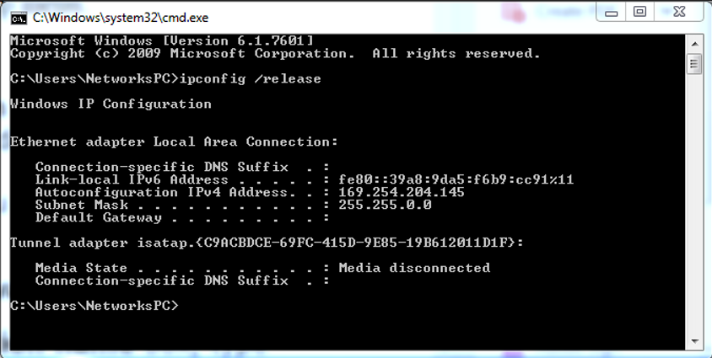
Release command :

Renew command :
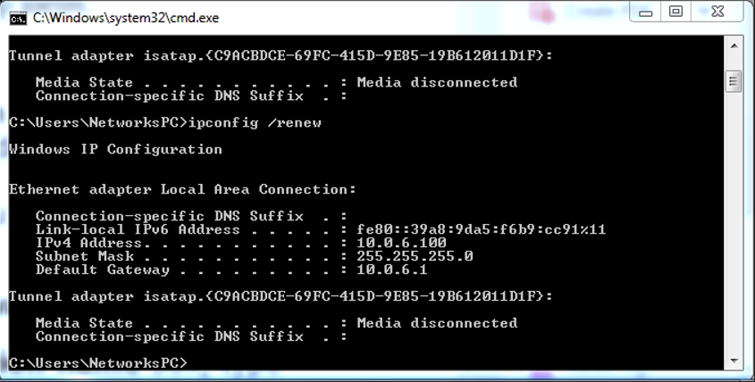
As shown the pc got 10.0.6.100 IP as new IP from DHCP server
For second PC :
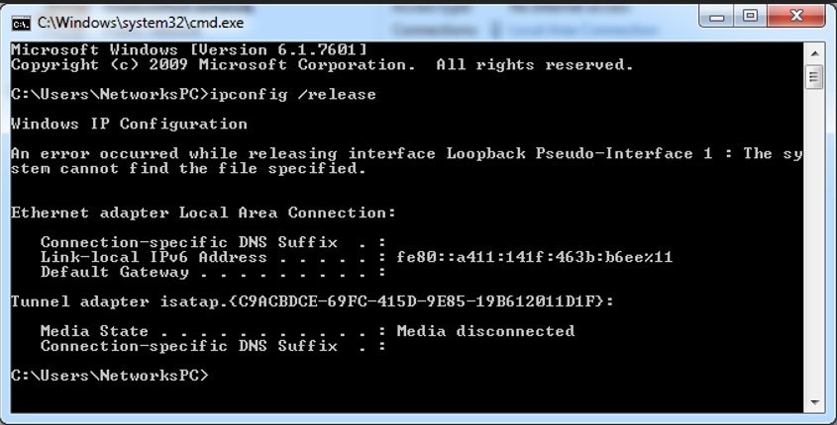

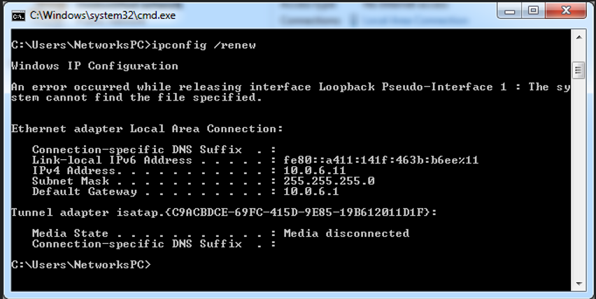
To check MAC address we entered " config /all " command :
PC1
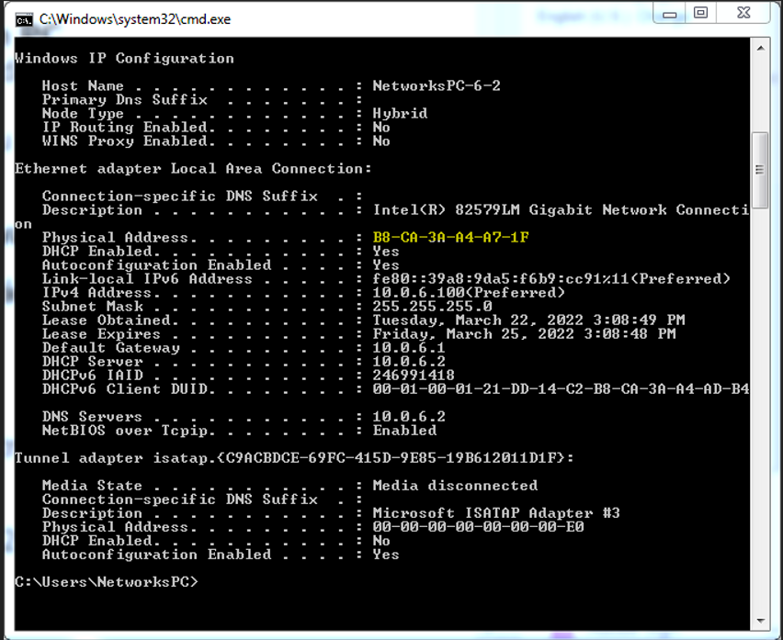

PC2
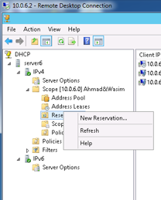
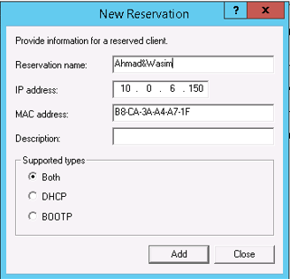
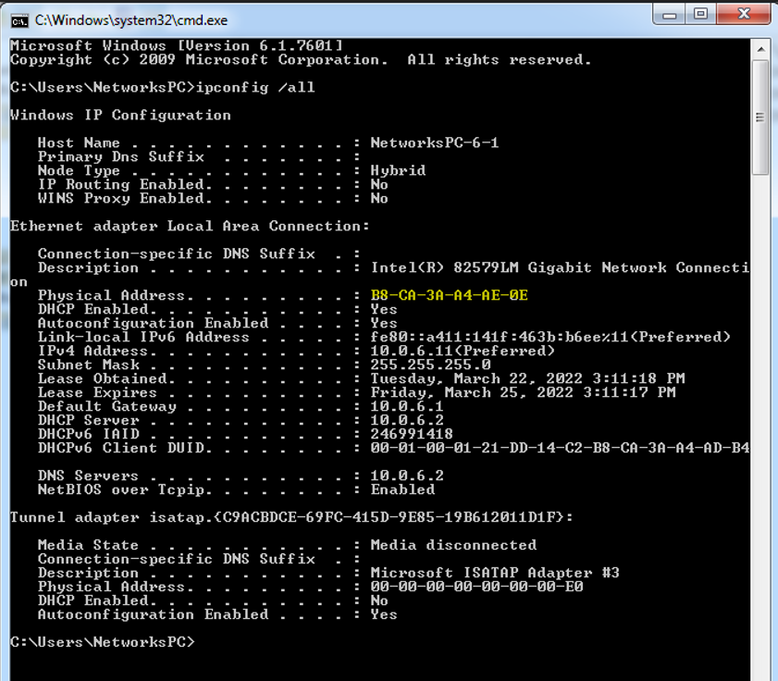
We reserved an IP
address for each PC.

Then release and renew
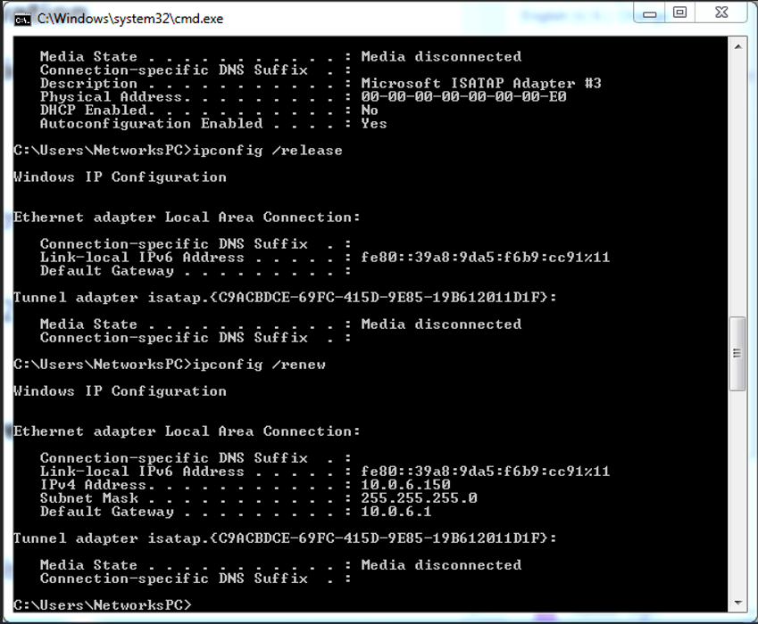
The same for second PC put 200 instead of 150 as shown bellow :
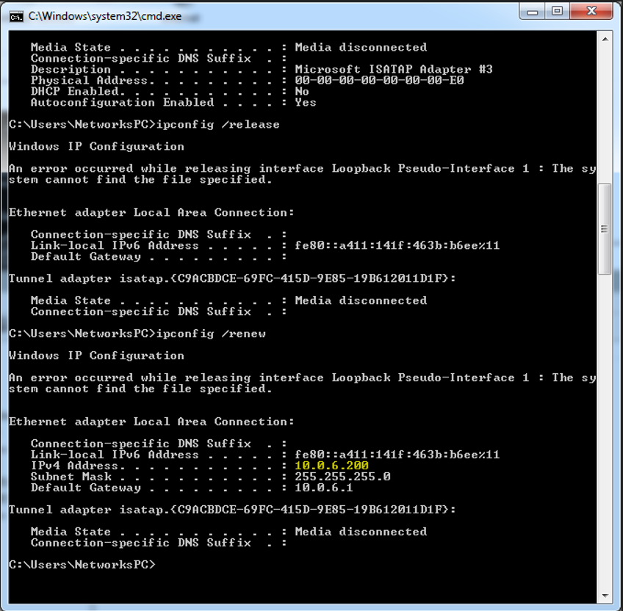

Finally we need to delete all configurations
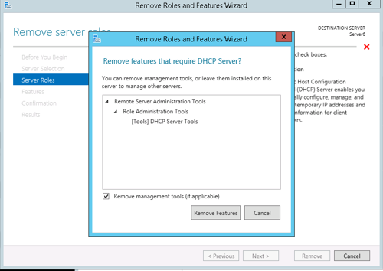
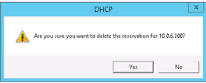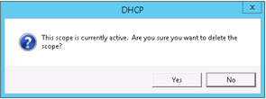
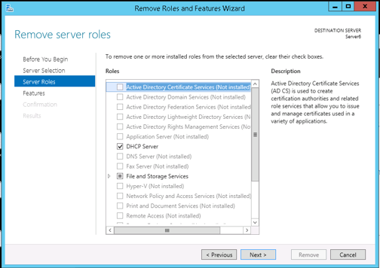

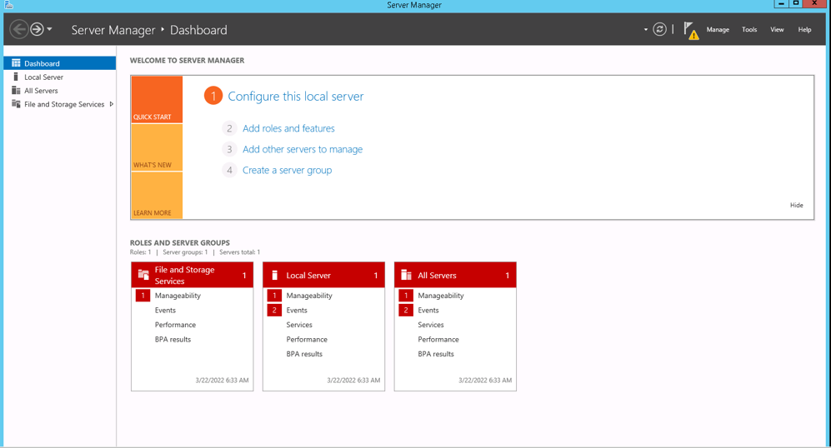

Conclusion:
DHCP servers are very used for assigning IP addresses for clients automatically.

[Homework]Connecting 2 VLANs via router:
I had connected the following network as shown bellow using Cisco packet tracer :
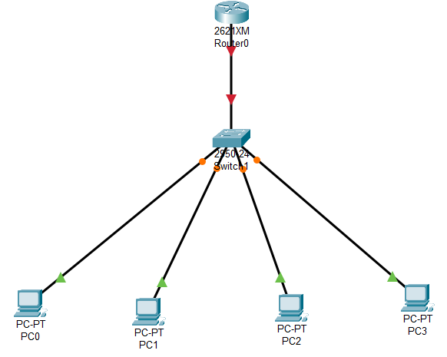
To configuring the switch I had added VLAN2 and added two interfaces to it.

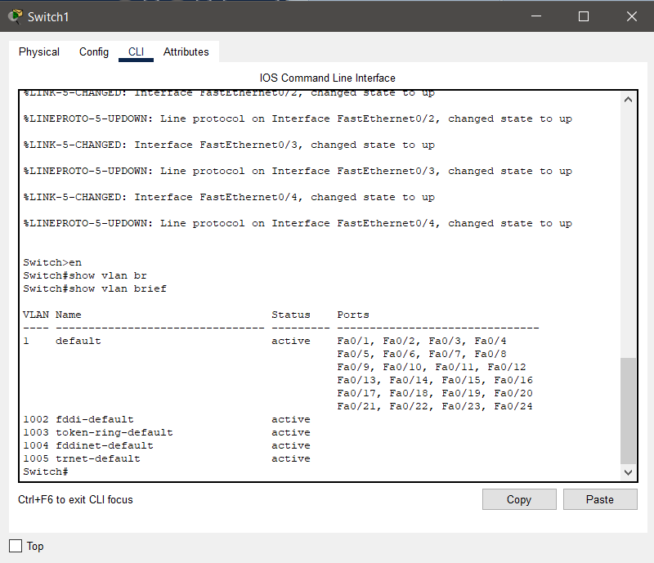
Set vlan 2 name to vlan2
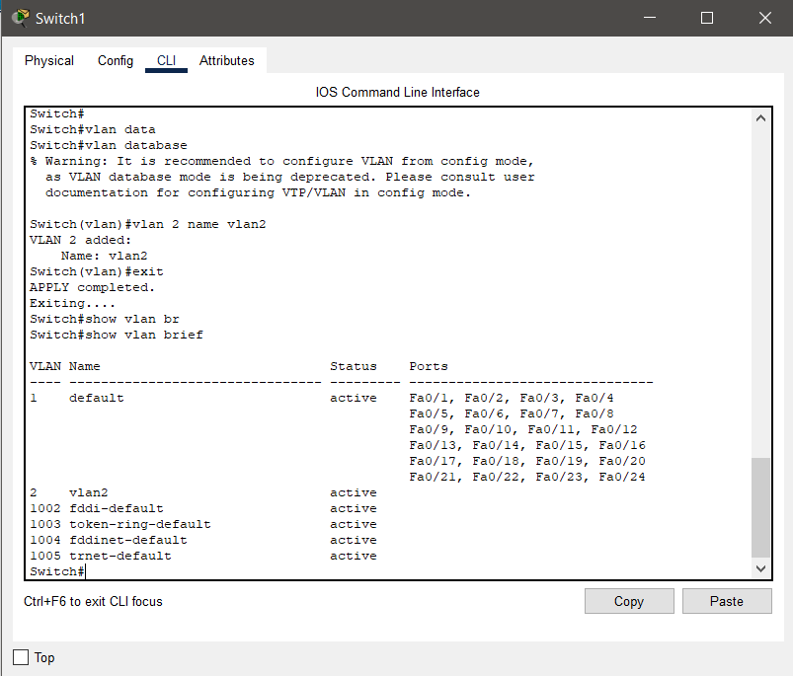

I had assigned port 3 and 4 for vlan 2
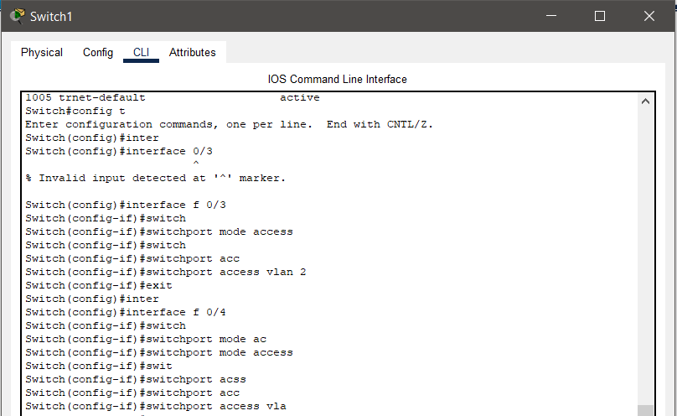

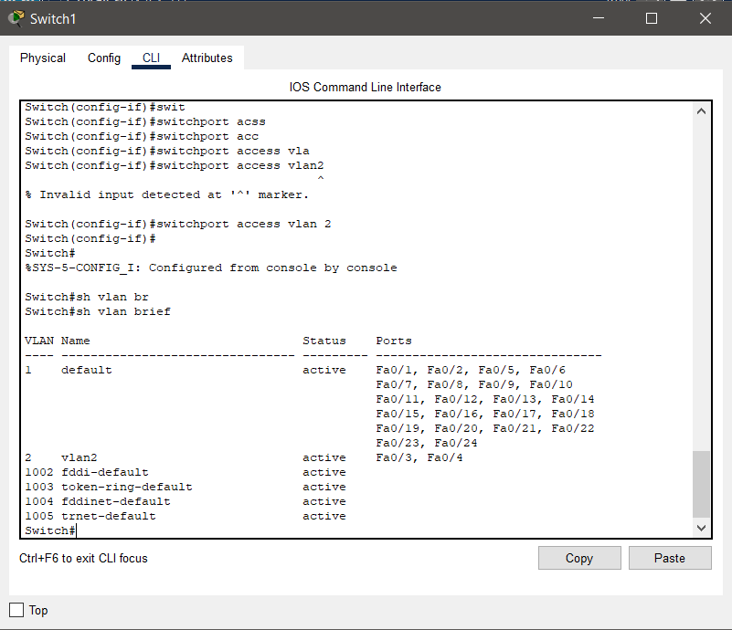

Setting port 24 as trunk as shown bellow
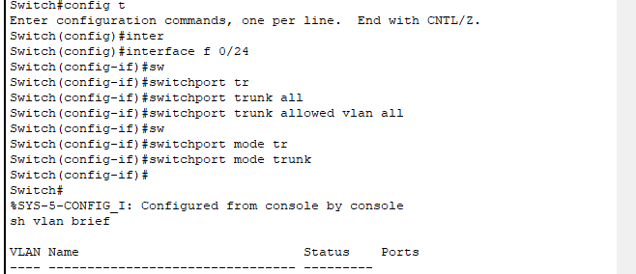

Setting the IP address and default gateway for each PC

Configuring the router as shown :
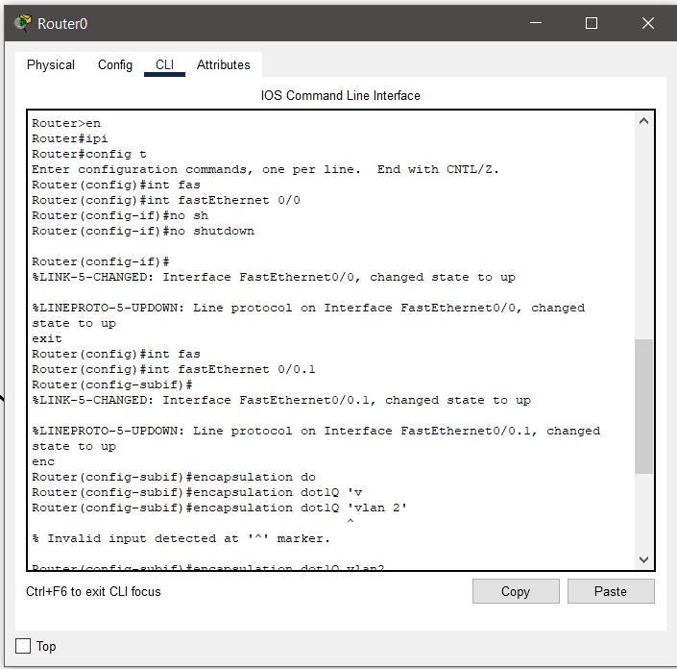

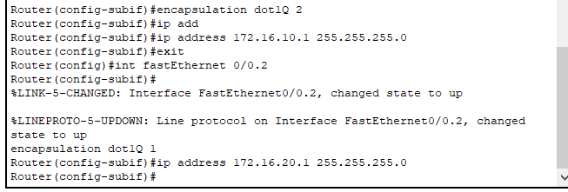

Ping from PC0 to PC2
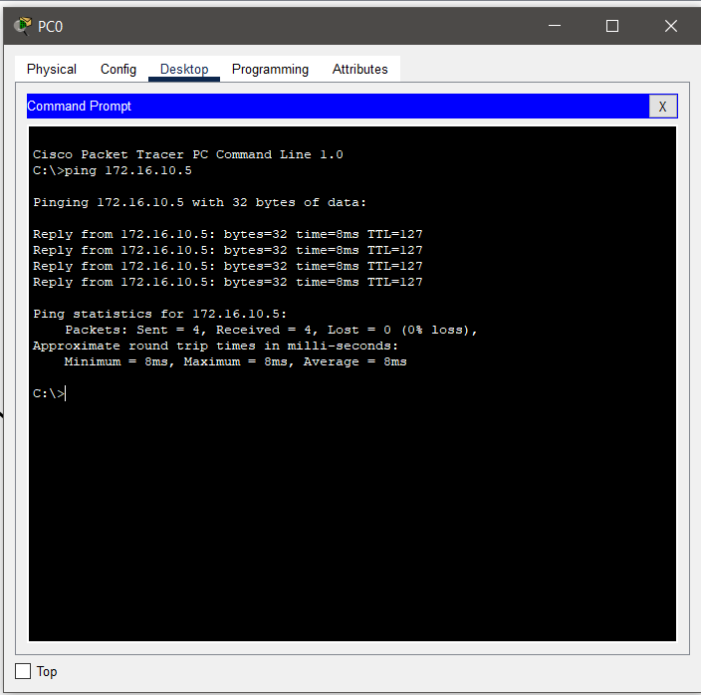

Ping from PC0 to PC1
