Computer Engineering Department
Course Name: Networks Lab Course No.: 10636594
Lab Report Grading Sheet

Instructor: Dr. hnal abo zant | Experiment #: 6
Academic Year: 2022/2023 | Experiment Name: DNS Servers

Students
1- Ahmad Abdullah AL – Qerem |  |  | ID : 11819195 .
2- Obada Youssef Qasrawi |  |  | ID : 11822431 .
3- Mujahed Mohammad |  |  | ID :NAN
Report’s Outcomes
ILO _1 =( 33) % | ILO _2 =( 33) % | ILO _3 =(34) % |  | ILO =( ) % |  | ILO =( ) %
Evaluation Criterion |  |  |  |  | Grade |  | Points
Abstract  answers of the questions: “What did you do? How did you do it?  What did you find?” |  |  |  |  | 0.5
Introduction and Theory  Sufficient, clear and complete statement of objectives. In addition to Presents sufficiently the theoretical basis. |  |  |  |  | 1.5
Apparatus/ Procedure  Apparatus sufficiently described to enable another experimenter to identify the equipment needed to conduct the experiment. Procedure sufficiently described. |  |  |  |  | 2
Experimental Results and Discussion (In-Lab Worksheet)  Crisp explanation of experimental results. Comparison of theoretical predictions to experimental results, including discussion of accuracy and error analysis in some cases. |  |  |  |  | 4
Conclusions and Recommendations  Conclusions summarize the major findings from the experimental results with adequate specificity. Recommendations appropriate in light of conclusions. Correct grammar. |  |  |  |  | 1
Appearance  Title page is complete, page numbers applied, content is well  organized, correct spelling, fonts are consistent, good visual appeal. |  |  |  |  | 1
Total |  |  |  |  | 10

DNS Server

In Internet Protocol (IP) networks, the Domain Name System (DNS) is an essential component of client/server communication. DNS is a distributed database used in IP networks to translate computer names into IP addresses or resolve them.

Installing the DNS Server Service.

All the steps are written in order and detail inside the manual, so there is no need to re-mention them here. But there are some screenshots we should include here. Forward and Reverse Lookup Zone:

- set fixed ip address for each pc
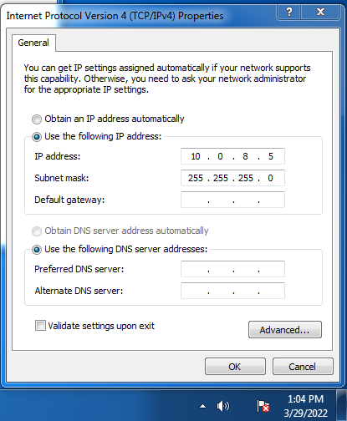
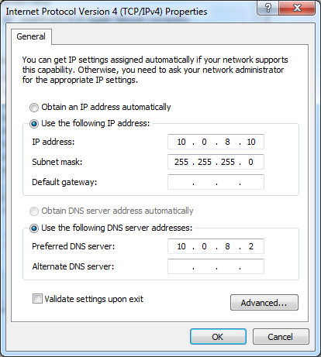

2.create and configure DNS server

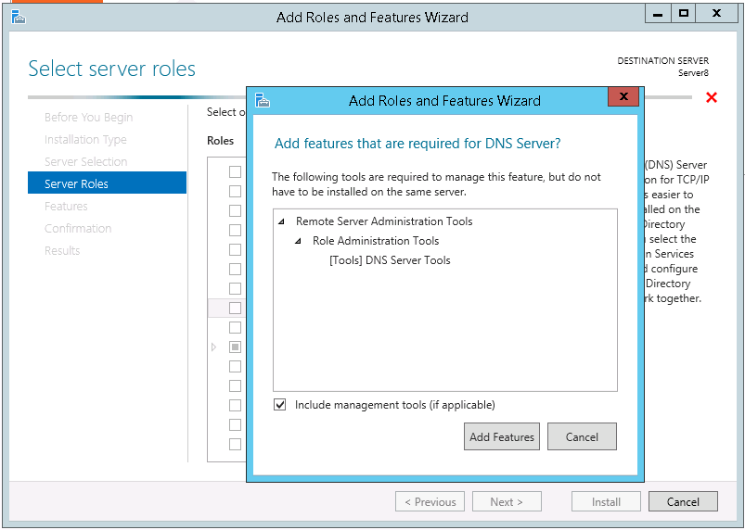
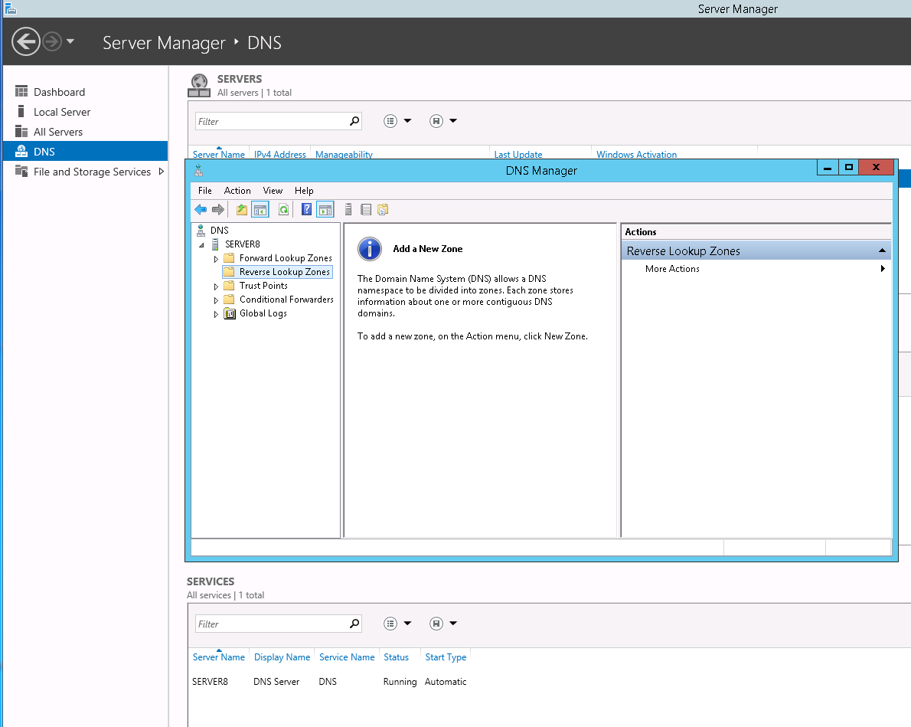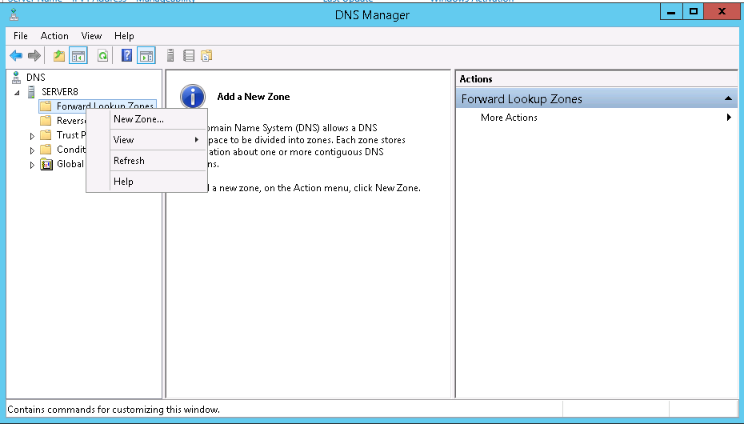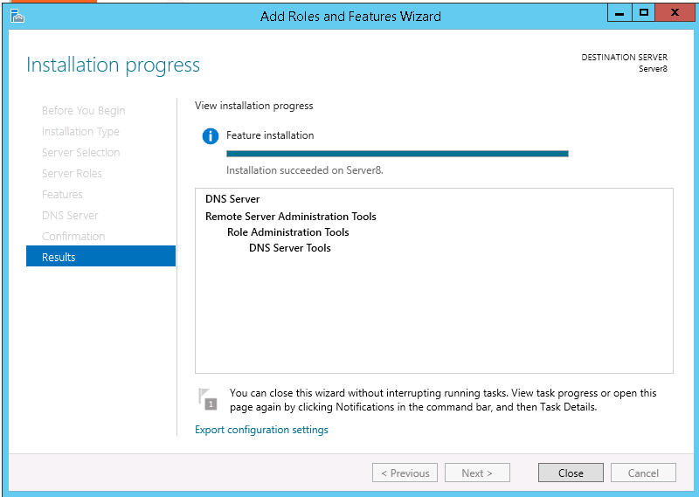

create host we use our names in this sec

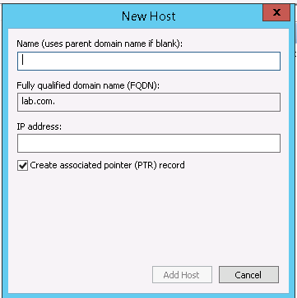
Ping PC1 and PC2 and Server:

PC 1
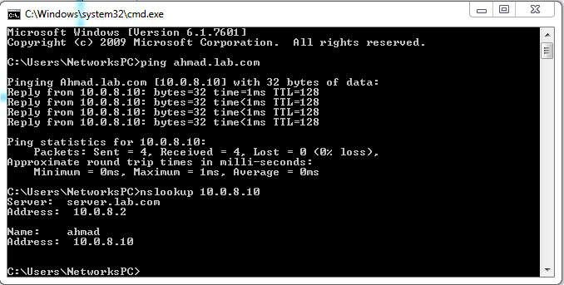

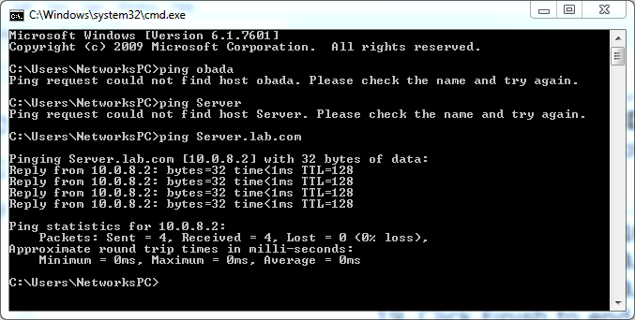

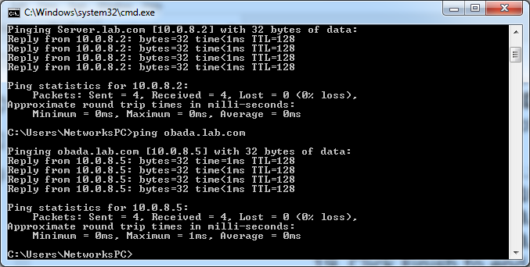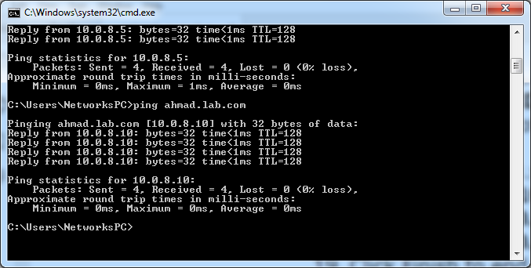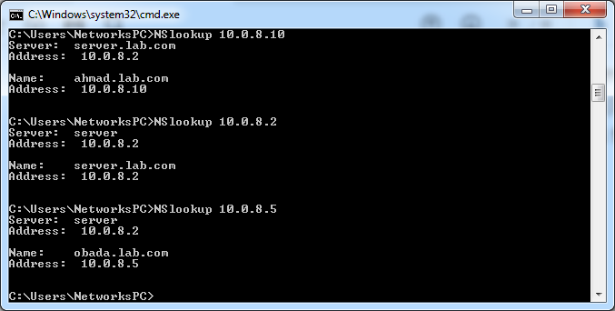

Conclusion:

we learned how to set up a DNS server and configure it to convert IP addresses to domain names and vice versa automatically. We also learn how to construct a DNS forward and reverse lookup zoon and authorize a DNS server

