Experiment # 8: Wireless Networks (WLAN)
Name : Ahmad Abdullah AL – Qerem . ID : 11819195 .
Name : Obada Youssef Qasrawi . ID : 11822431 .
2st semester 2022/2023 . Date : 2022/4/5 Tuesday.
Report’s Outcomes
ILO __ =( ) % | ILO __ =( ) % | ILO __ =( ) % | ILO __ =( ) % | ILO __ =( ) %
Evaluation Criterion |  |  |  |  | Grade | Points
Abstract  answers of the questions: “What did you do? How did you do it? What did you find?” |  |  |  |  | 0.5
Introduction and Theory  Sufficient, clear and complete statement of objectives. In addition to Presents sufficiently the theoretical basis. |  |  |  |  | 1.5
Apparatus/ Procedure  Apparatus sufficiently described to enable another experimenter to identify the equipment needed to conduct the experiment. Procedure sufficiently described. |  |  |  |  | 2
Experimental Results and Discussion (In-Lab Worksheet)  Crisp explanation of experimental results. Comparison of theoretical predictions to experimental results, including discussion of accuracy and error analysis in some cases. |  |  |  |  | 4
Conclusions and Recommendations  Conclusions summarize the major findings from the experimental results with adequate specificity. Recommendations appropriate in light of conclusions. Correct grammar. |  |  |  |  | 1
Appearance  Title page is complete, page numbers applied, content is well organized, correct spelling, fonts are consistent, good visual appeal. |  |  |  |  | 1
Total |  |  |  |  | 10

Abstract :
In this experiment we had learned how to configure and setup wireless network and secure it with WPA / WPA2 encryptions .
Introduction and Theory:
Wireless Local area networks WLAN is common as WIFI networks. It is a network between
computer hosts or mobile host. That networks is wireless and don’t need wires to transmit
data. For each network we must configure an encryption method ( password )to secure the connection between hosts and grantee no one will reach the data ,this will achieve data integrity .

Objectives :
- Install the wireless networks.
- Configure the WLAN in infrastructure mode.
- Secure WLAN
Tools used in the experiment:
- Two PCs.
- Cisco Access Point .
- Straight-forward Ethernet cable.
- Console cable .

Procedure : ( Implementing Infrastructure for WLAN )
Configure access point IP :
After we plugged powered on the access point and connected it with PC using consol cable
At first we had set IP for both PCs as shown bellow :
For PC1 IP: 10.0.8.4 /255.255.255.0
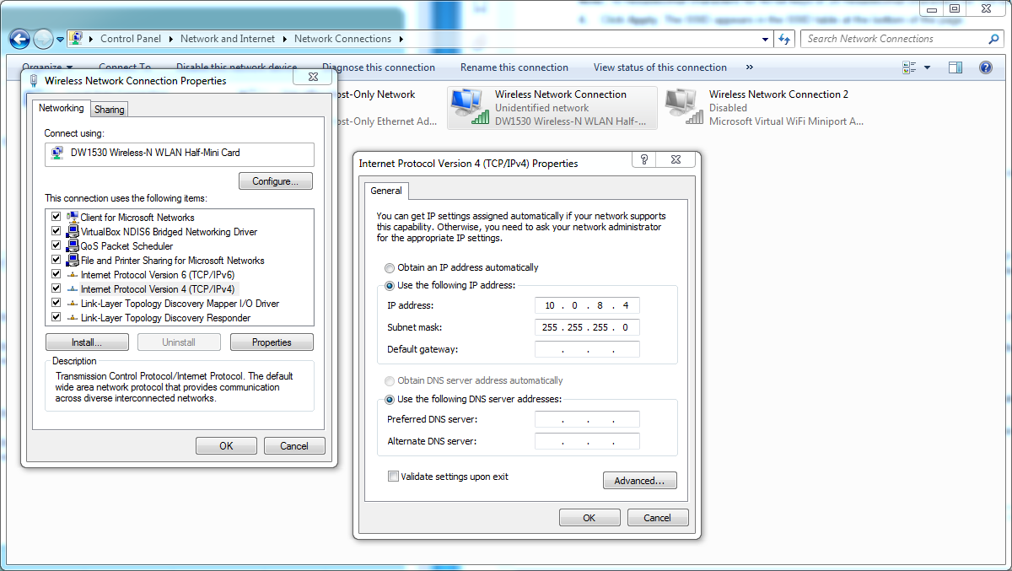
For PC2 IP: 10.0.8.6 /255.255.255.0
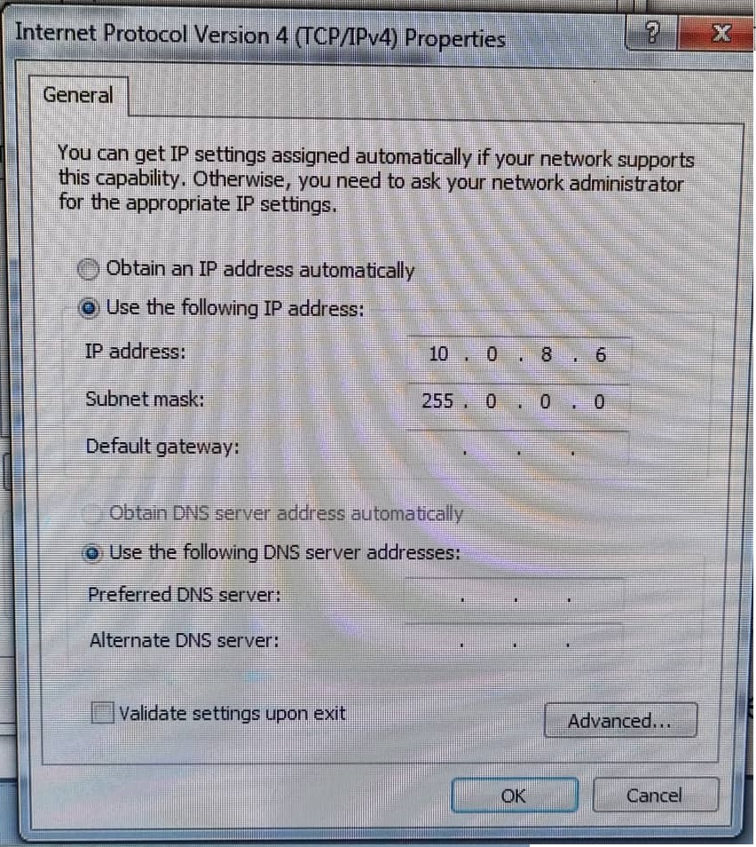

Now we need to Configure basic settings using (CLI and GUI) the same as we was configure routers before using hyper terminal as shown bellow :
- We entered " show interface bvi1 " command to display the IP address (there is no IP).
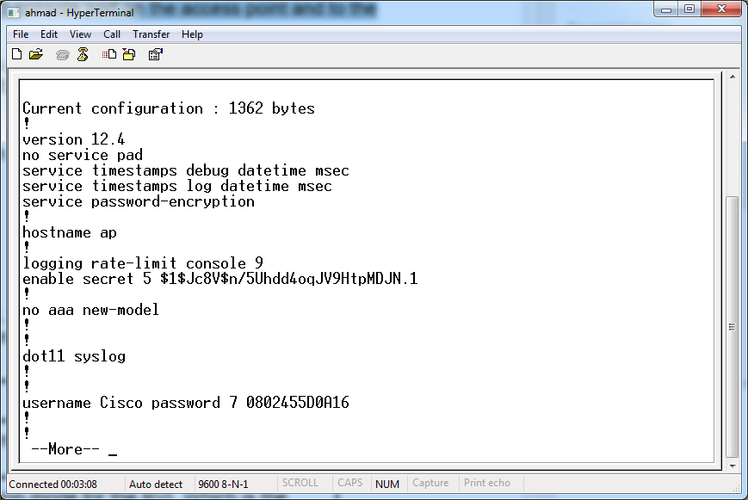
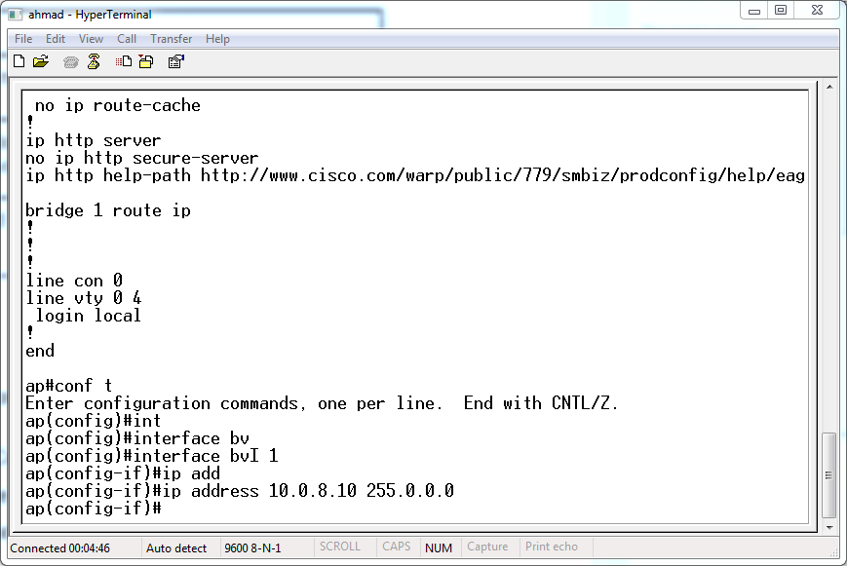

- To set and IP for the access point we entered the following commands as shown bellow :
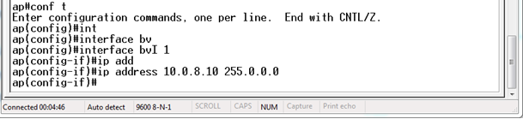
- To check if we set the IP correctly we entered " show interface bvi1 " again and we got the following :
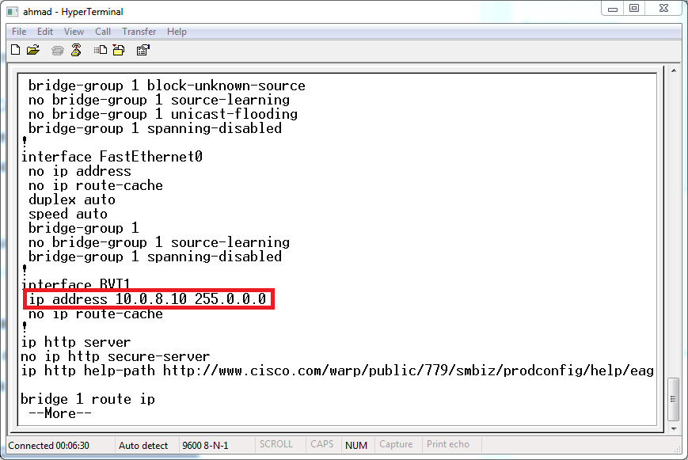
Configuring Basic Settings:
We opened the browser and entered the BVI, then we entered the username (Cisco) and the password (Cisco) and opened Express Setup page and changed the Host name to
" AP-Ahmad&Obada&Mujahed " as shown bellow :

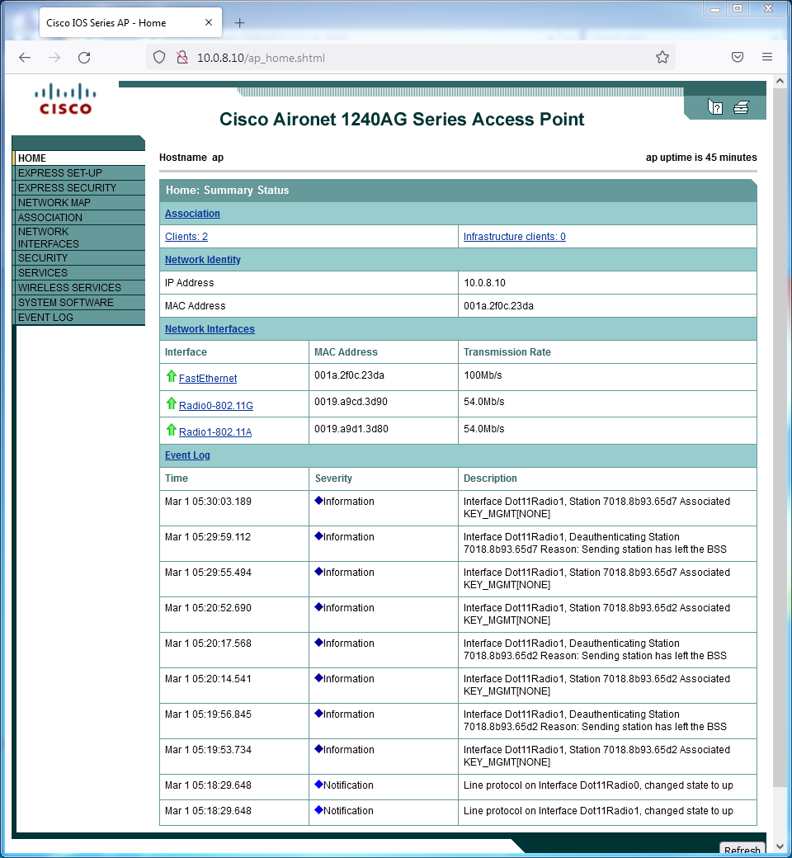

Configuring Security Settings:
From Express Security page we entered SSID " AP-Ahmad&Obada&Mujahed "

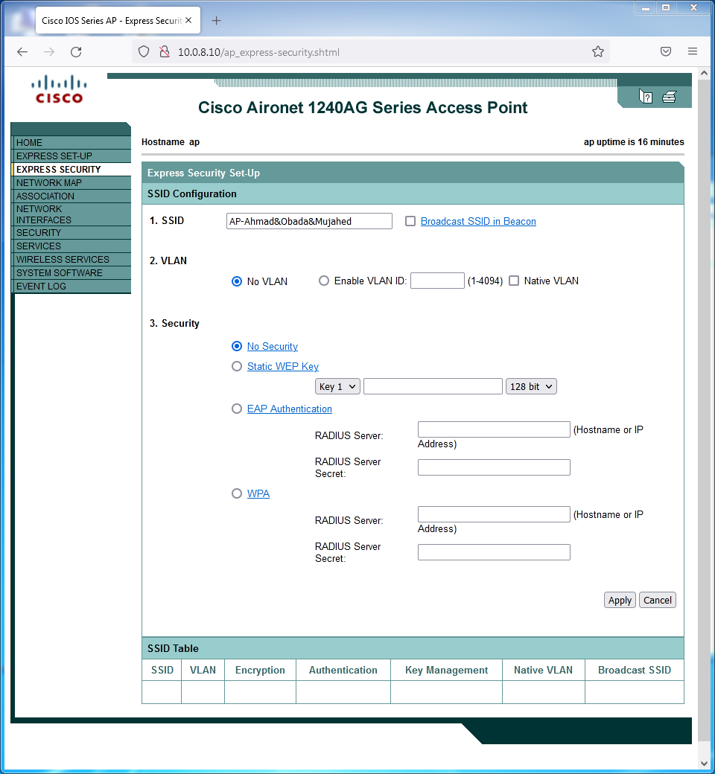

We checked the" Broadcast SSID in Beacon " check box .

And static WEP key with 40 bit encryption password "1234567890" as shown bellow :
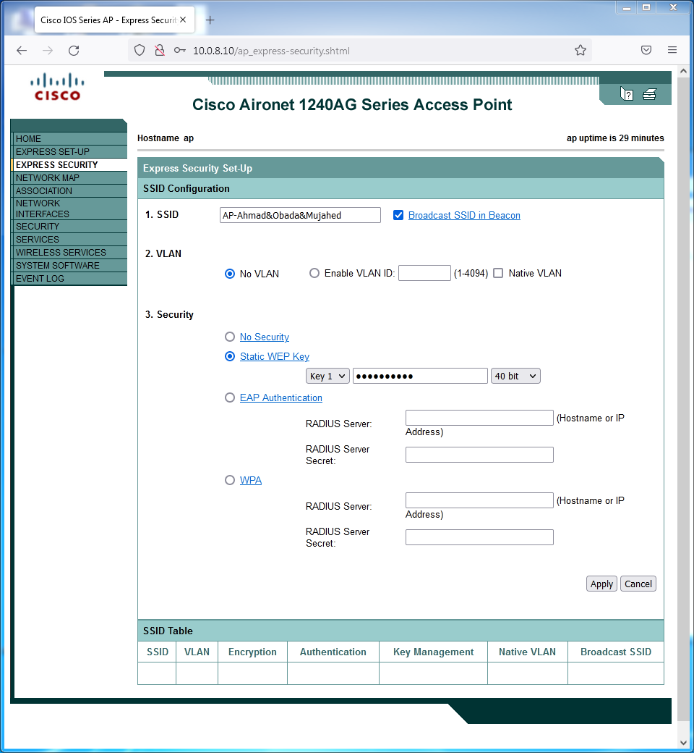
Then Apply button .

Enabling the Radio Interfaces
We clicked on Radio0-802.11G from " NETWORK INTERFACES " ,then we choose the Settings tab at the top of the page, we clicked Enable in the Enable Radio field. and finally we clicked Apply
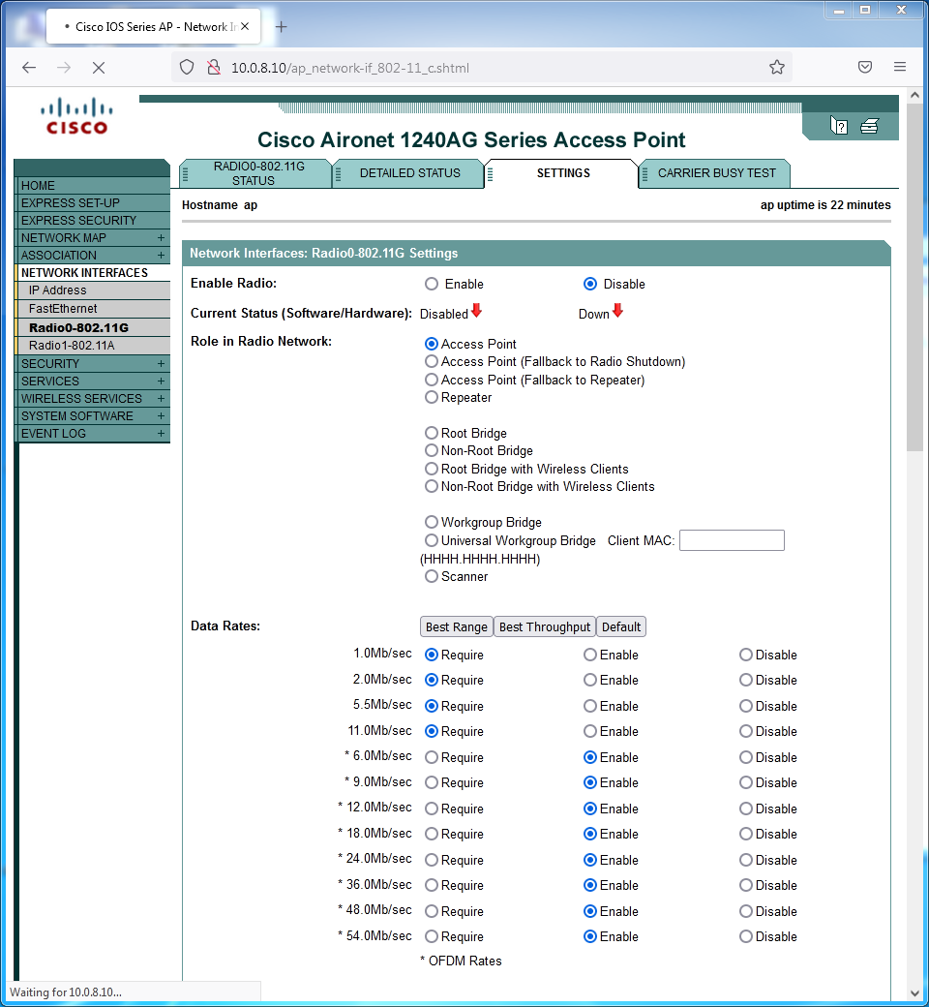

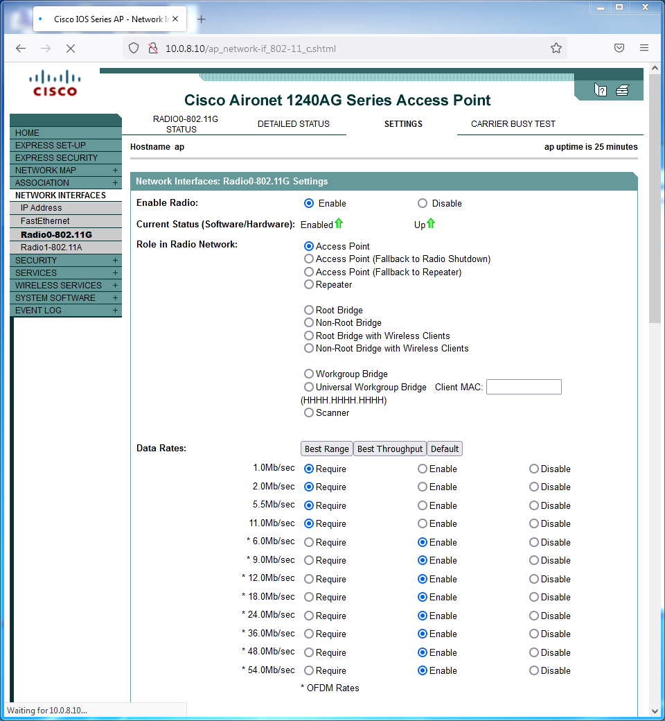
As shown the arrow now is green and up

.

We clicked on Radio0-802.11A from " NETWORK INTERFACES " ,then we choose the Settings tab at the top of the page, we clicked Enable in the Enable Radio field. and finally we clicked Apply
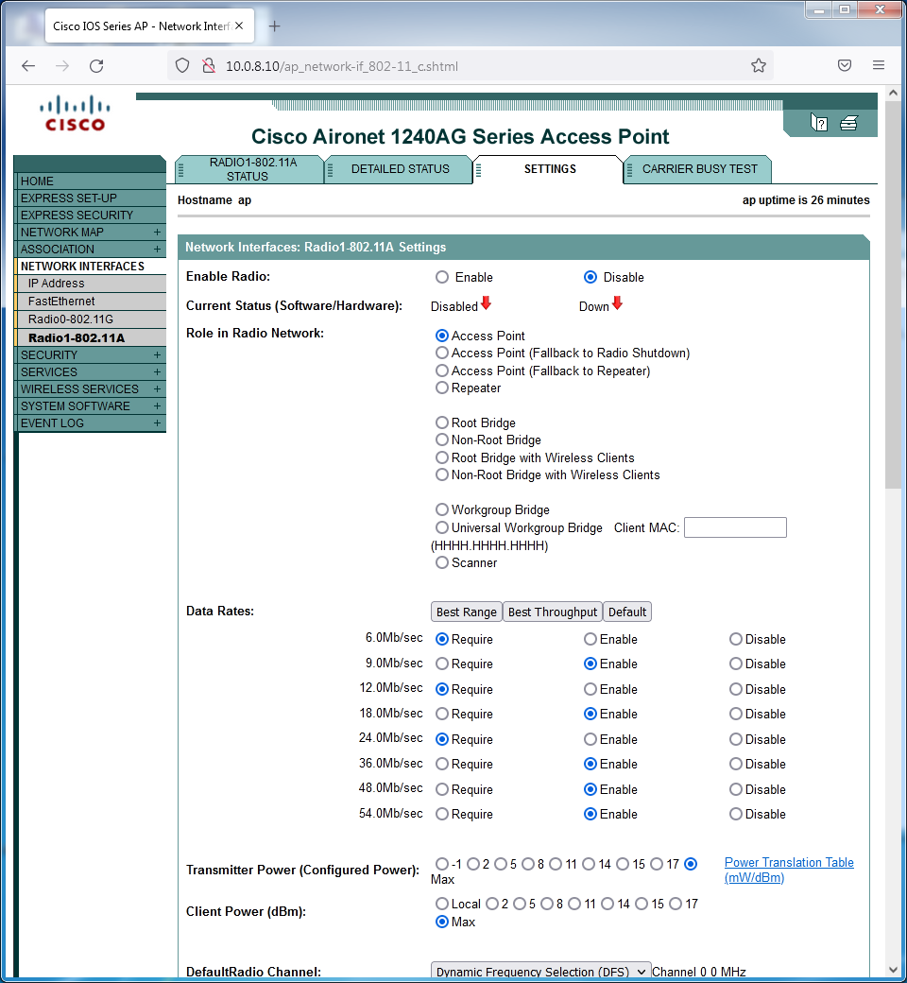

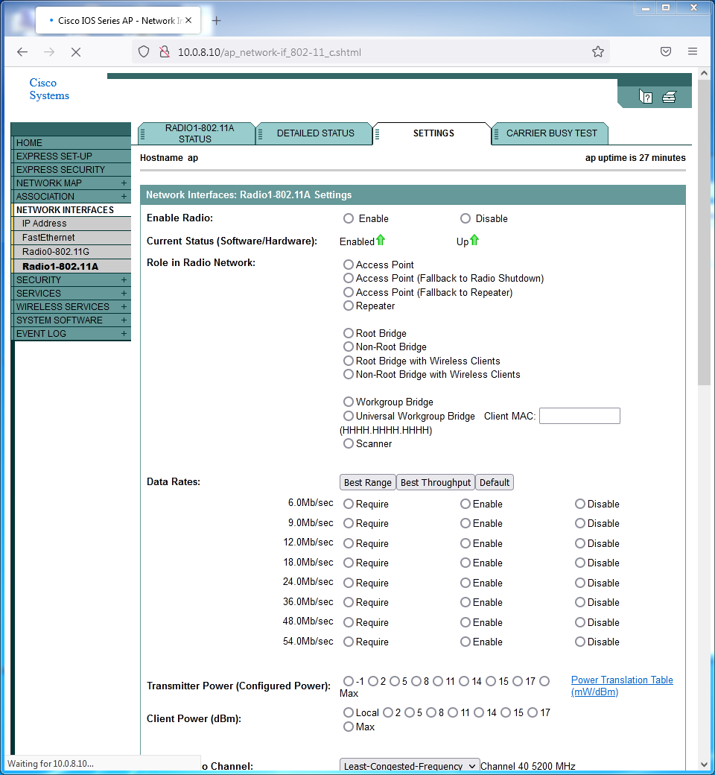
As shown the arrow now is green and up

Configuring Wireless Settings for the PCs
We chose the access point that has SSID: " AP-Ahmad&Obada&Mujahed " then we entered the key: "1234567890" as shown bellow :
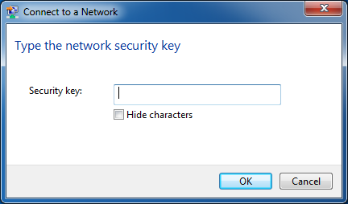
PC1 PC2
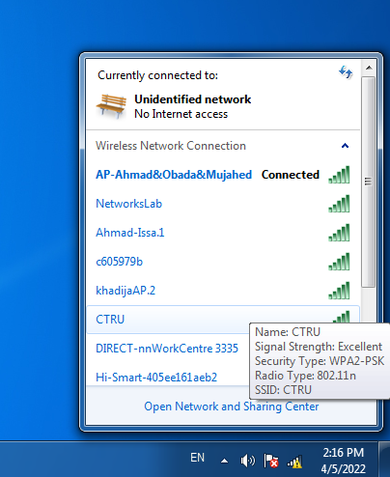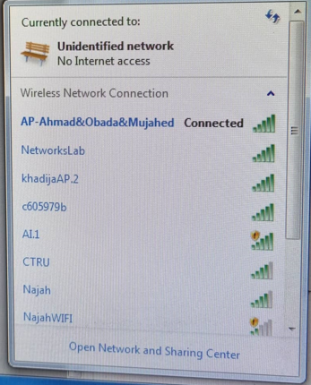

To check if they are connected to each other we pinged from PC1 to PC2
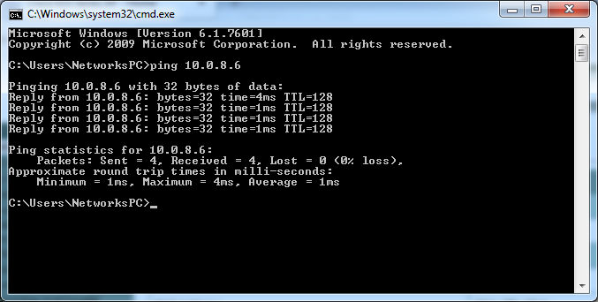
And from PC2 to PC1
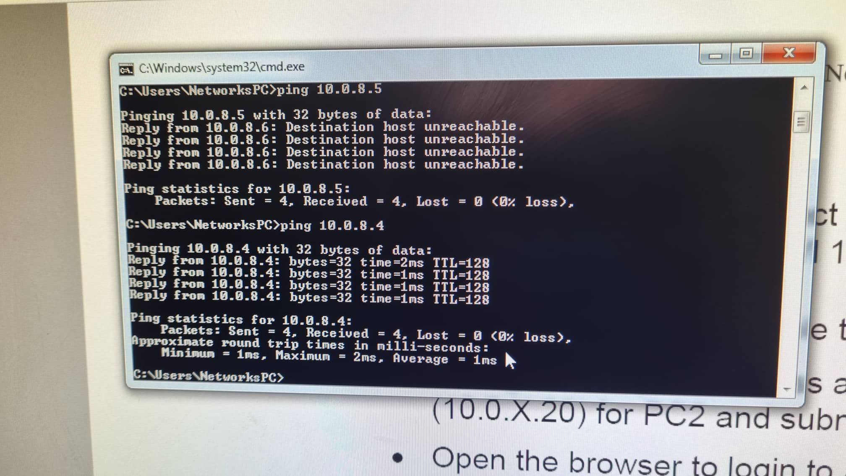

Resetting to Default Configuration
We need at first to save configuration as text file From System Software. The System Software screen appears. We clicked config.txt
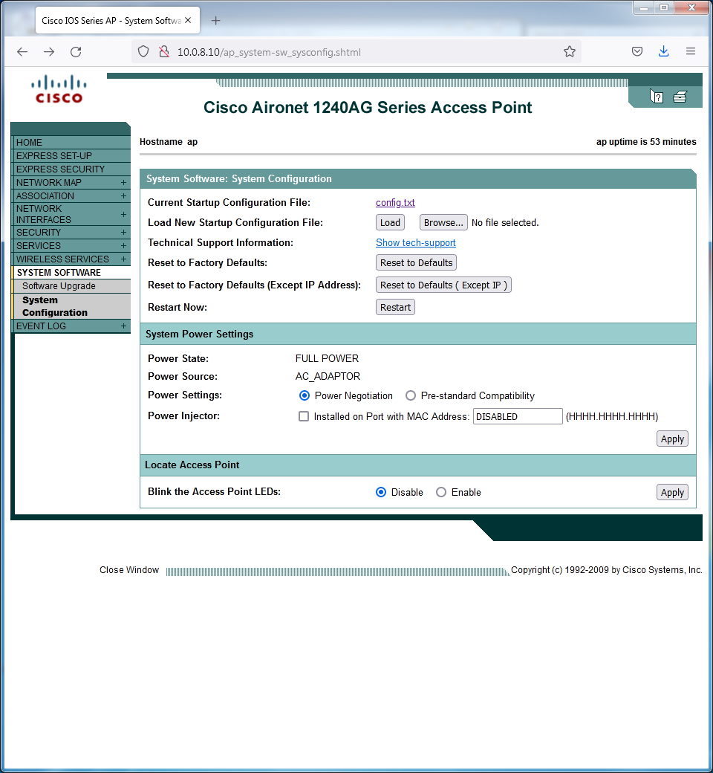

We got the following txt file:

!
version 12.4
no service pad
service timestamps debug datetime msec
service timestamps log datetime msec
service password-encryption
!
hostname ap
!
logging rate-limit console 9
enable secret 5 $1$Jc8V$n/5Uhdd4oqJV9HtpMDJN.1
!
no aaa new-model
!
!
dot11 syslog
!
dot11 ssid AP-Ahmad&Obada&Mujahed
authentication open
guest-mode
!
!
!
username Cisco password 7 0802455D0A16
!
!
bridge irb
!
!
interface Dot11Radio0
no ip address
no ip route-cache
!
encryption key 1 size 40bit 7 403EC038BBEA transmit-key
encryption mode wep mandatory

!
ssid AP-Ahmad&Obada&Mujahed
!
station-role root
bridge-group 1
bridge-group 1 subscriber-loop-control
bridge-group 1 block-unknown-source
no bridge-group 1 source-learning
no bridge-group 1 unicast-flooding
bridge-group 1 spanning-disabled
!
interface Dot11Radio1
no ip address
no ip route-cache
!
encryption key 1 size 40bit 7 6E78330C1A84 transmit-key
encryption mode wep mandatory
!
ssid AP-Ahmad&Obada&Mujahed
!
no dfs band block
channel dfs
station-role root
bridge-group 1
bridge-group 1 subscriber-loop-control
bridge-group 1 block-unknown-source
no bridge-group 1 source-learning
no bridge-group 1 unicast-flooding
bridge-group 1 spanning-disabled
!
interface FastEthernet0
no ip address
no ip route-cache
duplex auto
speed auto

bridge-group 1
no bridge-group 1 source-learning
bridge-group 1 spanning-disabled
!
interface BVI1
ip address 10.0.8.10 255.0.0.0
no ip route-cache
!
ip http server
no ip http secure-server
ip http help-path http://www.cisco.com/warp/public/779/smbiz/prodconfig/help/eag
bridge 1 route ip
!
!
!
line con 0
line vty 0 4
login local
!
end

to reset sittings We clicked System Configuration. Then we clicked Reset to Defaults button.
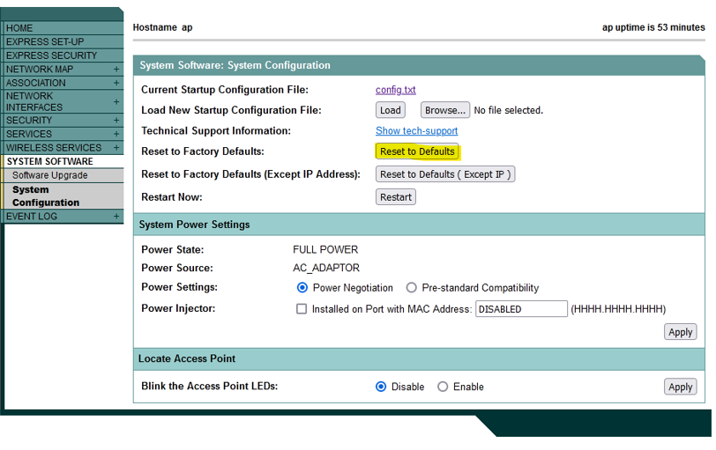

Conclusion:
We gained a good background about WLANs and 802.11 protocol. And we learned how to install wireless networks. Also We learned how to configure a Cisco BVI in infrastructure mode using both GUI and CLI. finally we learned how to set an SSID and password for the wireless network.

