Experiment # 7: Managing Traffic with Access Lists.
Name : Ahmad Abdullah AL – Qerem . ID : 11819195 .
Name : Obada Youssef Qasrawi . ID : 11822431 .
2st semester 2022/2023 . Date : 2022/4/29 Tuesday.
Report’s Outcomes
ILO __ =( ) % | ILO __ =( ) % | ILO __ =( ) % | ILO __ =( ) % | ILO __ =( ) %
Evaluation Criterion |  |  |  |  | Grade | Points
Abstract  answers of the questions: “What did you do? How did you do it? What did you find?” |  |  |  |  | 0.5
Introduction and Theory  Sufficient, clear and complete statement of objectives. In addition to Presents sufficiently the theoretical basis. |  |  |  |  | 1.5
Apparatus/ Procedure  Apparatus sufficiently described to enable another experimenter to identify the equipment needed to conduct the experiment. Procedure sufficiently described. |  |  |  |  | 2
Experimental Results and Discussion (In-Lab Worksheet)  Crisp explanation of experimental results. Comparison of theoretical predictions to experimental results, including discussion of accuracy and error analysis in some cases. |  |  |  |  | 4
Conclusions and Recommendations  Conclusions summarize the major findings from the experimental results with adequate specificity. Recommendations appropriate in light of conclusions. Correct grammar. |  |  |  |  | 1
Appearance  Title page is complete, page numbers applied, content is well organized, correct spelling, fonts are consistent, good visual appeal. |  |  |  |  | 1
Total |  |  |  |  | 10

Abstract :
In this lab, we learned how to create a standard access list to prevent a specific host from reaching a specific network. Also we created an extended access list to prevent a specific host from making a telnet a specific router.
Introduction and Theory:
In this experiment we learned the mean of the access list and how to control it. We find out that:
Access lists are essentially a set of conditions that control that has access to what information. They're capable of controlling access to and from network segments. They can be used to filter undesirable packets and to enforce security policies. Network administrators will be able to implement practically any access policy they can think of with the appropriate combination of access lists. In this experiment, we'll look at two different types of ACLs.
Standard access lists: These use only the source IP address in an IP packet to filter the network. This basically permits or denies an entire suite of protocols.
Extended access Lists: These check for both source and destination IP address, protocol field in the Network layer header, and port number at the Transport layer header
Objectives :
Students will understand how to use the Standard/Extended Access lists to control access
both to/and from network segments .
-On The Source .
-On the Destination.
-Filter specific IP services
Tools used in the experiment:
- Two PCs.
- 2 Cisco router .
- 2 Switches .
- Straight-forward Ethernet cable .
- One Server .
- Console cable .

Procedure : ( Implementing Infrastructure for WLAN )
We built the following network shown in figure and configured the routers
And set the routing configurations to dynamic for both routers as shown below :

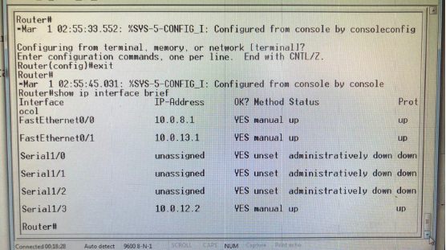

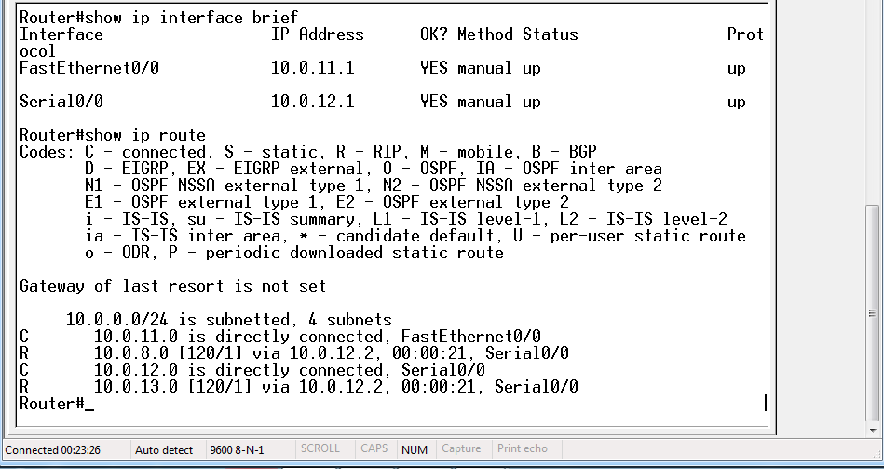
Part 1 : Standard IP Access Lists
We will allow only Host PC1 from network 10.0.11.0 to enter Network 10.0.8.0
Ping from pc1 to the server :
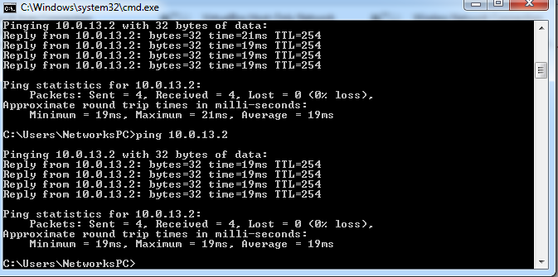
As shown its reachable from pc 1

Q: why you choose router 2611xm?
A: Because it’s the nearest router to the destination.

We entered access-list ?
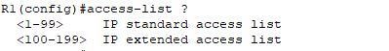
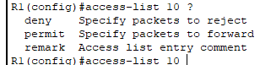
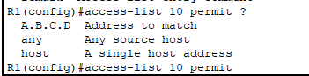
Now to set access list we entered :
Access-list 10 permit host 10.0.13.2
Note That : the result by ping from PC1 to the server, that should have access

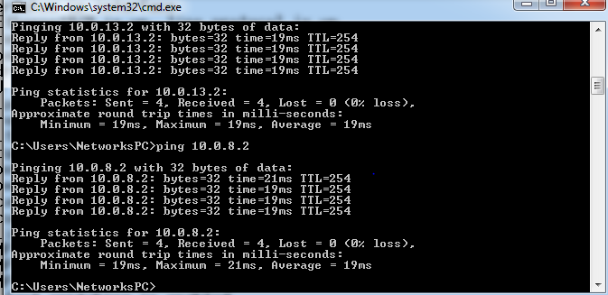
Other PCs can't access the server
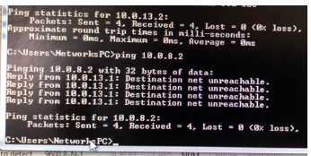

Part 2 : Extended IP Access Lists
We need to deny pc1 to telnet on pc2 at first we configured telnet for both PCs and test it as shown :
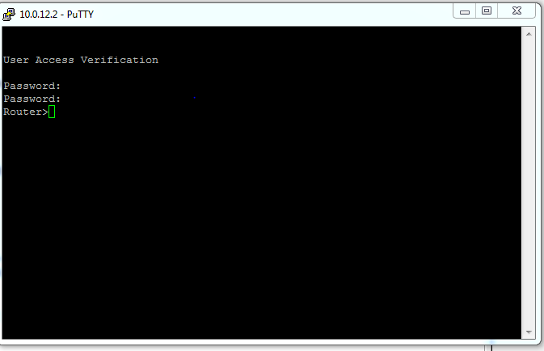
Then we entered the following commands to deny pc1 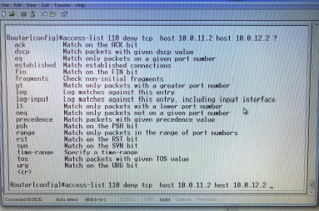

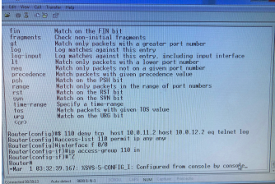
After that test one more time we got the following
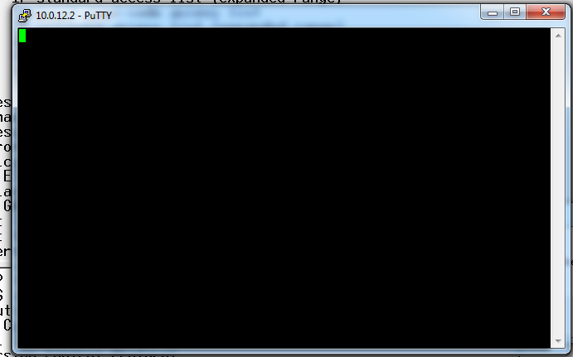

That mean it can't use telnet .
Conclusion:
In this experiment, we learned about a new network concept called an access list. It's used to allow or disallow particular devices from transferring data and to establish a connection to a specific router. We learned the differences between the standard and extended IP access . We put everything we learned in Network2 to use..

