Experiment # 9: Network metrics by simulator
Name : Ahmad Abdullah AL – Qerem . ID : 11819195 .
Name : Obada Youssef Qasrawi . ID : 11822431 .
2st semester 2022/2023 . Date : 2022/4/19 Tuesday.
Report’s Outcomes
ILO __ =( ) % | ILO __ =( ) % | ILO __ =( ) % | ILO __ =( ) % | ILO __ =( ) %
Evaluation Criterion |  |  |  |  | Grade | Points
Abstract  answers of the questions: “What did you do? How did you do it? What did you find?” |  |  |  |  | 0.5
Introduction and Theory  Sufficient, clear and complete statement of objectives. In addition to Presents sufficiently the theoretical basis. |  |  |  |  | 1.5
Apparatus/ Procedure  Apparatus sufficiently described to enable another experimenter to identify the equipment needed to conduct the experiment. Procedure sufficiently described. |  |  |  |  | 2
Experimental Results and Discussion (In-Lab Worksheet)  Crisp explanation of experimental results. Comparison of theoretical predictions to experimental results, including discussion of accuracy and error analysis in some cases. |  |  |  |  | 4
Conclusions and Recommendations  Conclusions summarize the major findings from the experimental results with adequate specificity. Recommendations appropriate in light of conclusions. Correct grammar. |  |  |  |  | 1
Appearance  Title page is complete, page numbers applied, content is well organized, correct spelling, fonts are consistent, good visual appeal. |  |  |  |  | 1
Total |  |  |  |  | 10

Abstract :
In this experiment we tried to simulate Network metrics using NS2 using Lenox OS , divided to two parts
- Ethernet
- WIFI
Introduction and Theory:
Wireless networks can be classified as follows :
- Infrastructure Networks:
This mode bridges a wireless network to a wired Ethernet network. A wireless access point is required for infrastructure mode wireless networking, which serves as the central WLAN communication station to which the mobile clients attach. The mobile client can move geographically out of range of one base station to the range of another while it is communicating. When it goes, it connects with new base station and starts communicating through it. This results in handoff.
- Ad Hoc (Infrastructure less) Networks:
This mode is a method for wireless devices to directly communicate with each other. Operating in ad-hoc mode allows wireless devices within range of each other to discover and communicate in peer-to-peer fashion without involving central access points. This is typically used by two PCs to connect to one another as well as for wireless mesh networks.

Objectives :
- Familiar with routing protocols used in ad hoc networks .
- See the performance of DSDV protocol
Tools used in the experiment:
- Ubuntu 14.04 (O.S.).
- Ns2 (application).
- Nam (application).
- Xgraph (application).

Procedure
Part 1( wired Ethernet network ):

At first, we are going to create a simple network topology and simulator scenario with DropTail queue mechanism as in the following figure:

We had created new node named N2 with new color . linked with the other nodes as shown in the figure above, and specified the destination which was N4, and a new cbr object was created for the new node.
Before :
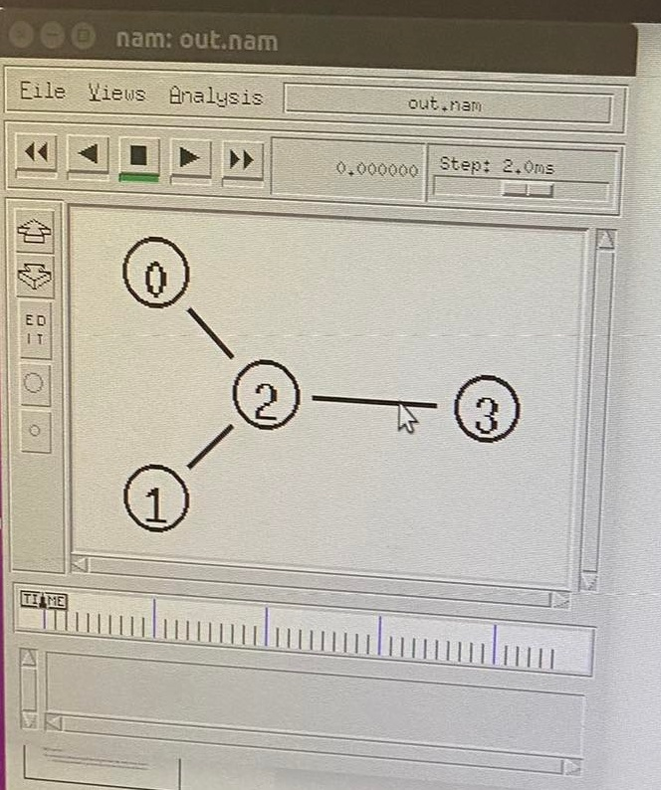

After :
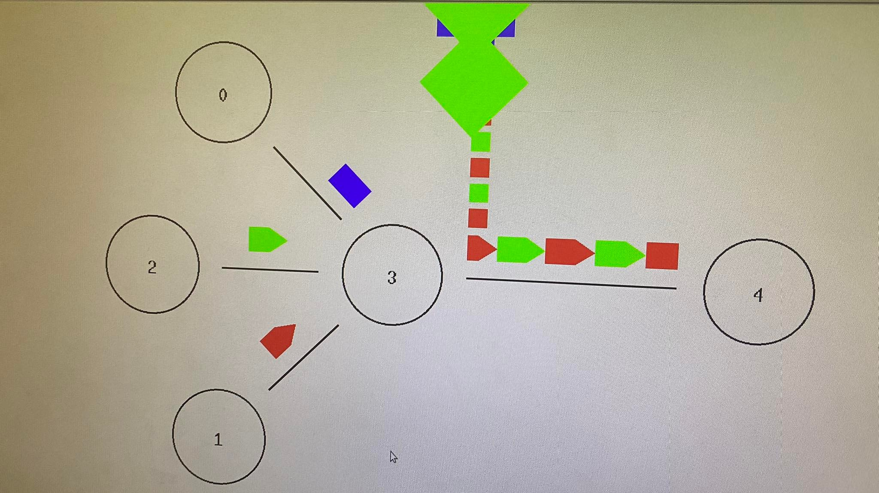

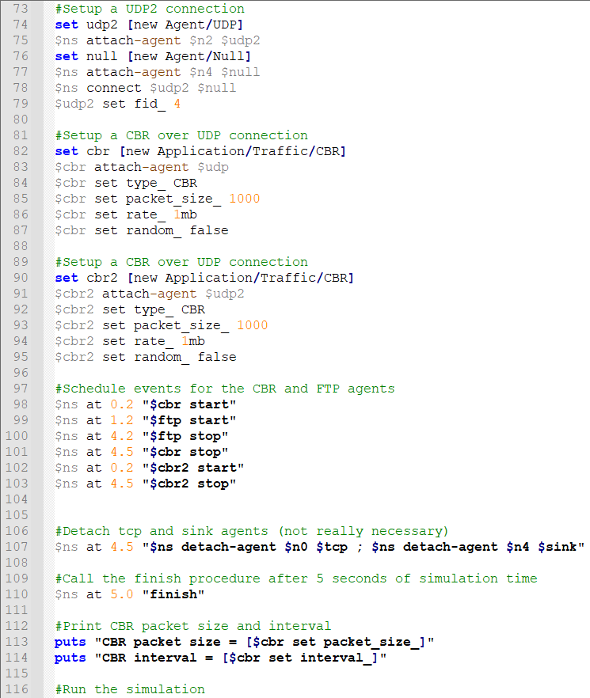
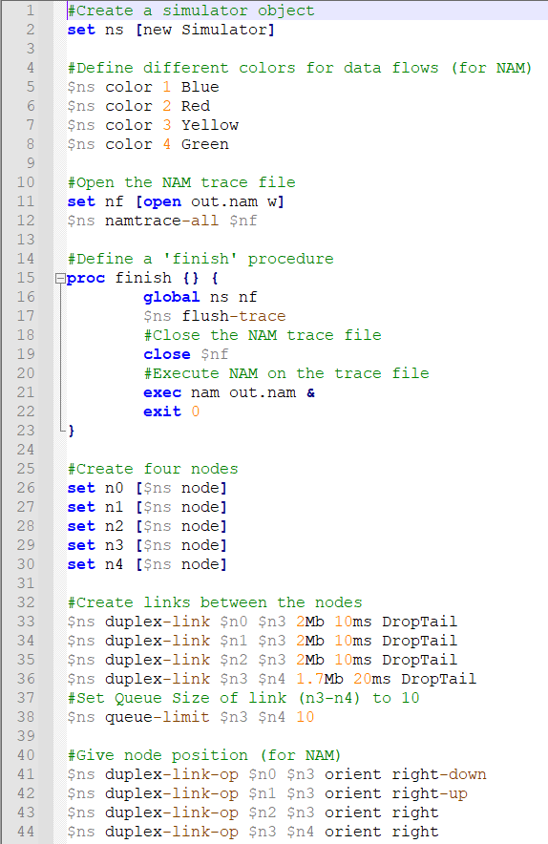
Code :

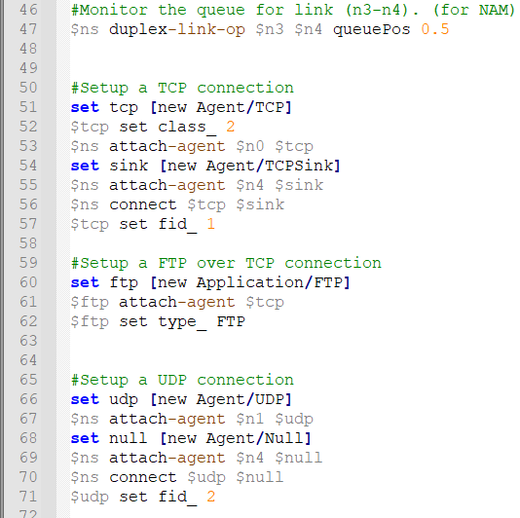
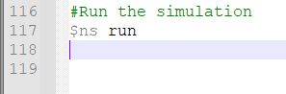

We set the time to start sending as shown :
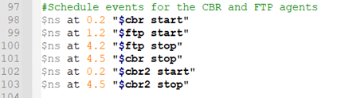
And then we calculated how many packets are dropped as shown bellow :
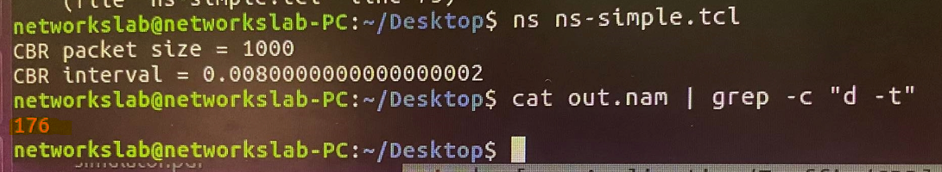
And how many packets are received :
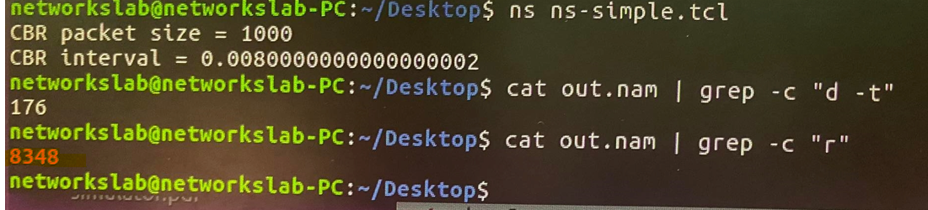____________________________________________________________________________
Part 2 ( WIFI ):
In this part we are going to create a 3-nodes (WiFi mobile Nodes) example for ad-hoc simulation with DSDV as shown bellow :

We managed to get the following statuses using commands :
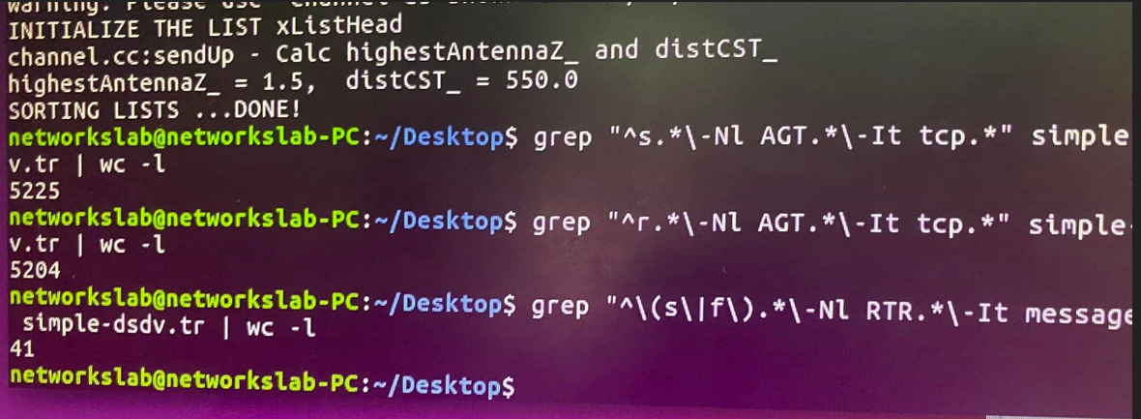
Total 5225 sent packets.
Total 5204 received packets.
The packet delivery fraction = $\frac{received packets}{sent packets}=0.995$
Total number of routing packets sent = 41 packets.
Routing load = $\frac{routing packets}{received packets}=0.0078$
_______________________________________________________________
Conclusion:
we learned how to simulate different types of networks using software. As from part 1 ( Ethernet ) , and from part 2 ( WIFI ).
And we got familiar with NS2( Network Simulator 2 ).

