

**Human Computer Interaction**

**Project Task #2**

**POV’s, HMW’s, Solutions and Experience Prototype**

Umer Ahmad – BSCS, 13075

Saqib Javed – BSCS, 13064

Faisal Noor – BSCS, 13021

Ahmad Yousaf – BSCS, 13063

**Problem Domain:**

We are working in the category of Art t and Design and specifically on “Handi -crafts”. Handicraft is the dying art in Pakistan which needs to be re-established. In our project we are working on making a platform in which we will be able to show the products available in the market. This gap will cover the needs of the customers and the artisan’s products. We named this “Dasti-Crafts”. According to the survey people mostly don’t know about the products.

**POV-I:**

We met Ms. Ayesha, we were amazed to realize that there is no proper platform to buy the variety of handicrafts.

It would be the game changing to provide such a platform in which people can easily find and get handmade product.

**HMW’s:**

* How might we easily get handicrafts?
* How might we insure the quality of handmade products?
* How might we get order from consumer?
* How might we manage order from customers?
* How might we deliver order to customer?
* How might we make attractive things for customers?
* How might we provide reliable things to the customers?
* How might we increase the number of customers?
* How might we build trust of our customers?
* How might we make the categories of the products?
* How might we engage customer to buy product from our platform?
* How might we market our product?

**POV-II:**

We met artisan Mr. Riaz, we were amazed to realize that the margin income of artisan is too much when we compared their work with income.

It would be game changing to provide such a platform in which they can generate more income from their product.

**HMW’s:**

* How might we contact with artisans?
* How might we purchase product from the artisan?
* How might we reduce the production cost for the artisans?
* How might we help to increase profit of artisan?
* How might we find the cheap shops from where we will buy the products?
* How might we give order to the artisan?
* How might we mange time with the artisan?
* How might we increase the sale of artisan?

**POV-III:**

We met Mr. Hamza, we were amazed to realize that It is difficult to find a desired design of different handicrafts.

It would be game changing if we provide them with the desired design of different handicrafts.

* How might we make the categories to get the order of customized products?
* How might we provide our customers the customize products?
* How might we build trust of our customers?
* How might we make user interface adaptable for users?
* How might we get order for customize products?
* How might we engage customer to buy product from our platform?
* How might we market our customize product?
* How might we deliver order to the artisan for customized products?
* How might we insure the quality of customize products?

**3 Best HMW’s:**

1. How might we take orders and deliver it the customers?
2. How might we help increase the profit of artisans?
3. How might we make a better user interface for getting orders for customized products?

**HMW-1 Solutions:**

* Make categories of different products to make them easily accessible to the customers.
* We will take order through online portal and in the start we will deliver it by ourselves.
* We can take order via contact numbers.
* We can take orders and deliver via courier services.
* We will take order by attracting customer to our social media.
* We will take order when customer will sign-in our app (web) and we will deliver them personally.
* We will take order by marketing our website so that the more people can be engaged with us.
* For better interface we’ll use logos with every product category so that low literate person can understand just by looking at the image.
* When people will use our website. We will offer them discounts so that they can refer more people, after getting the order we will deliver them.

**HMW-2 Solutions:**

* Increasing profit by giving them more orders.
* By providing more margin on products as compared to market.
* By increasing our price online portal.
* By decreasing our margin in each product.
* We can increase margin of artisans by promoting the platform.
* Purchasing goods from artisans in bulk.
* By giving order of customized product whose price will be suggested by artisans.
* We can increase the profits by providing them raw material which will cut their cost of transportation and their profit will increase.
* Once will get orders from our customers we’ll ask the artisan for large scale development of a product which will increase their profit.
* We can also give them extra bonus with respect to the time completion of the product.

**HMW-3 Solutions:**

* Customer will provide us with the desired design of product he/she wants to have by sending us an image of the product?
* Providing adaptable interface in which customers can choose their design.
* By making our portal simple and reliable where anyone can easily place order out there.
* By offering of customized product in main page.
* We will make an option of in order section.
* We can make user interface simple by using the better color scheme it will attract the users to the product for customization.
* Customer can also send the suggestion via email.

**3 Best solutions from each HMW:**

1. We will take order through online portal and make categories of different products which are easily accessible.
2. We can increase margin of artisans by promoting the platform.
3. Customer will provide us with the desired design of product he/she wants to have by sending us an image of the product

**Experience Prototype:**

**Prototype for 1ST solution:**

Start of an app..

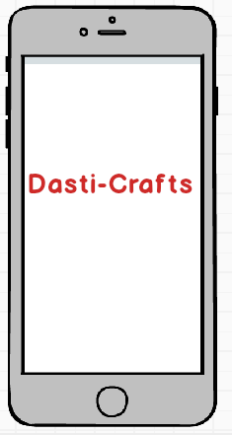

After start of an app we show the trending products.

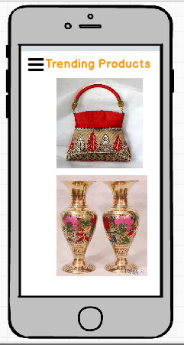

After clicking on the menu button we get this window.

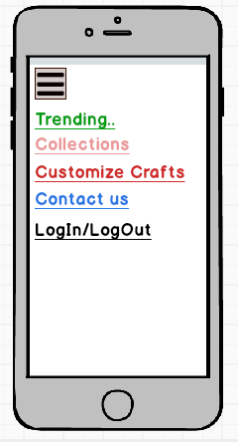

Select an option of collections.

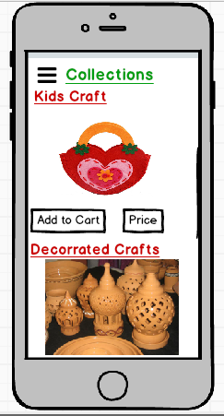

In this collection, customer can easily choose their desired crafts and add it to the cart.

**Prototype for 2nd solution:**

There is no specific prototype for 2nd solution which is related to the profit of the artisan. While it is dependent on the promotion of the platform. More people use this platform, more benefit artisans can get.

**Prototype for 3rd solution:**

By selecting the Customize Crafts from the menu we get this window.

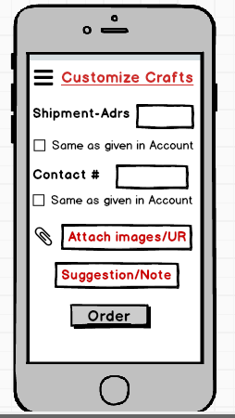

In this customize section, customer can upload the image of product which he/she wants. Customer can also give us the URL which contains the image of product and he/she wants to modify it.

Customer can also change the shipment address and contact number. We add this feature because the person who give the order and the person who receives it may be at different places.

--------------------------------------