**System Analysis** 

**Produced by : Ahmed Hesham – Mohamed Tarek – Mahomoud Nabil – Kareem Saeed –Mosab - Ahmed Fouad**

Gear Factory System Development

Dr.Hessen Omran – Eng.Islam

**Contents:**

1. Abstract------------------------------------------------------2
2. Requirements
   1. User Requirements----------------------3
   2. System Requirements-------------------3
   3. Functional Requirements---------------4
   4. Non-Functional Requirement----------4
3. Analysis Stage
   1. Entity Relationship Diagram (ERD) ---5
   2. Data Flow Diagram (DFD) --------------
4. Design Stage
   1. SQL Schema -------------------------------
   2. Use Case Diagram------------------------
5. Implementation-------------------------------------------
6. References--------------------------------------------------

**Abstract:**

Here we want to describe briefly about our project, it is about Gears and the system provide control on all operations and actions could be occur the system take care with customer orders and supervisor all operations happening after that until the orders shipped to the customers in this system you have your security as you wish only your staff of employees could use the system we provide for you to add update search and remove any thing from your data which are stored in your Database at the end of this short description there is a feature which is very important for the managers it is that managers could monitor all employees when they using the system the system the date and time of sign in for each employee.

**Requirements:**

UserRequirement:

The system provide for user manipulation with data such as (add, search, update, remove) helps you to get on time information of (customers, employees ...etc.) and this information helping for produce reports.

SystemRequirement:

The system should have forms that provides the following

1-registration (sign in) form to going into system and form for who want to make new account (sign up) for sign up there is some constraints.

*First you cannot let the text boxes empty and make register and then you cannot make new account with (Username, Password) which is already exist in the database and checking the textbox for confirm password with password textbox if they are same or not.

2-from registration user must going to form which is a menu have the ability to enter all other forms in the system you can from menu sign out and going back to sign in form.

3-each form in the menu is a form for which can interact directly with database and provide the following (add, search, update, remove, back to menu, close).

4-in the database we need tables for (customers, orders, suppliers, raw material, employees, department, work schedule, gears, machines, gear knifes, shippers) the attributes and relationships for the tables are discussed later.

Functional Requirements:

*Each user: can join in the system but with authorized name and pass and looking for all information he/her needed and also can modify or remove on this data.

*The system: have to check the registration for all users want join in the system and if the user want to make new account the system have to check that his username and password are not inserted before.

*The manager: have to see the date and time of the sign in for all users in the system.

Non-Functional Requirements:

Product requirement:

The Gear-Factory System shall be available to all users during normal working hours (Sat–wed, 08:30 – 17:30). Downtime within normal working hours shall not exceed five seconds in any one day.

Organizational requirement:  
Users of the Gear-Factory System shall authenticate themselves using their usernames and passwords.

External requirement:  
The system shall implement privacy for users that only the staff in the company can enter the system.

**Analysis Stage:**

ERD (Entity Relationship Diagram):

1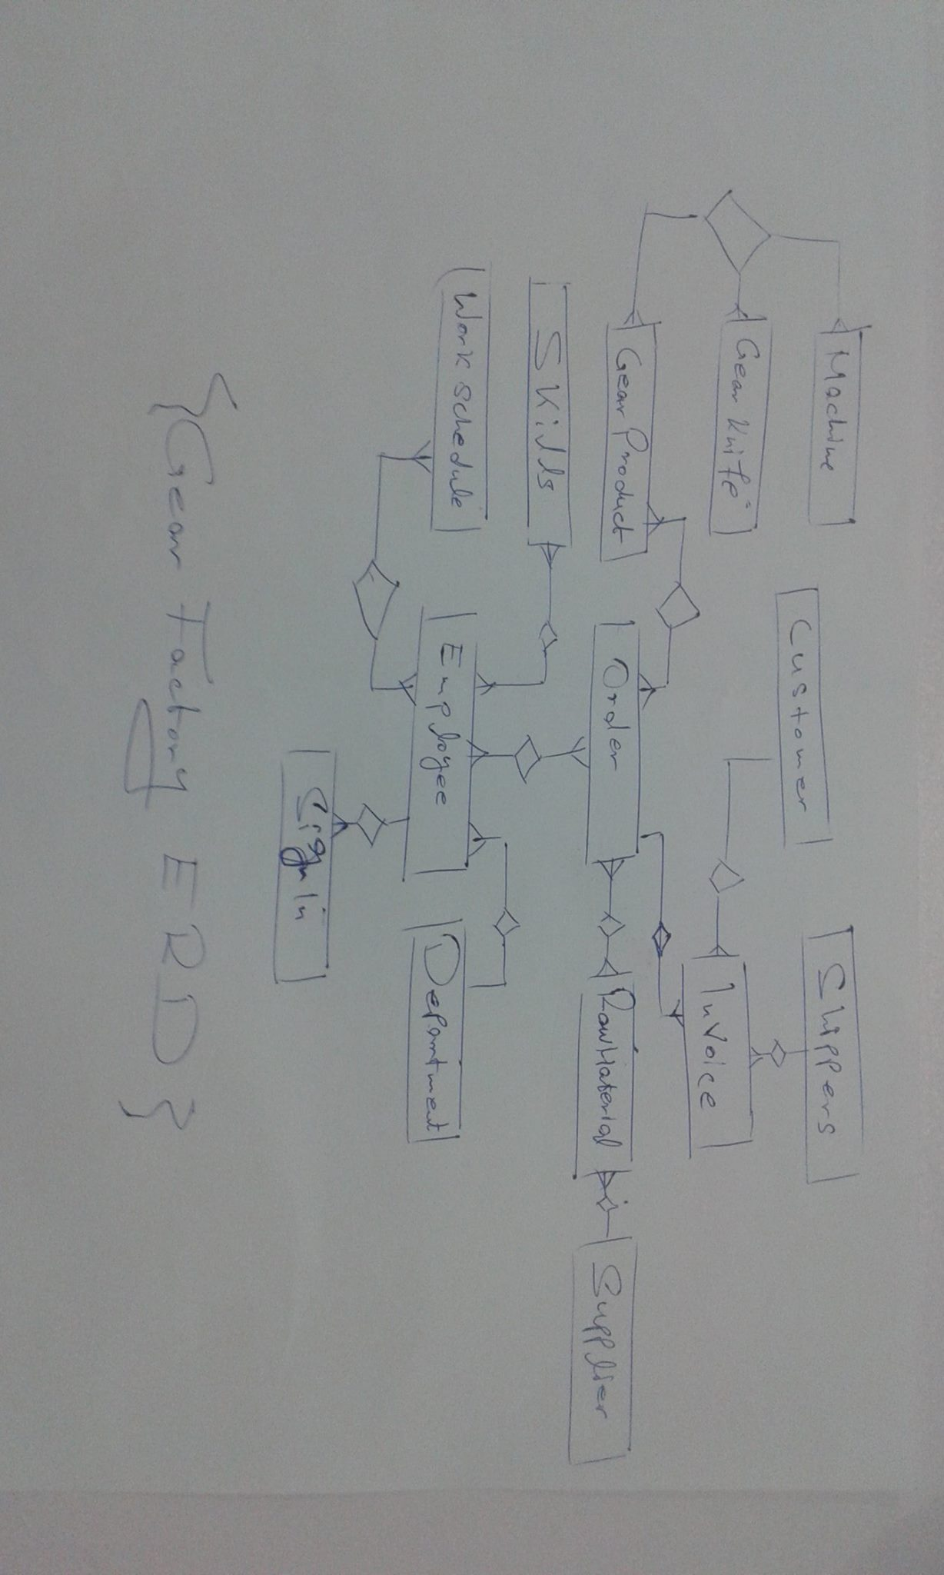

DFD (Data Flow Diagram):

Context Diagram(Level 0):

`

***Pacage The Final Product***

***P***

***Shipping order***

***Gear Factory***

***System***

***Manufacture***

***Customer***

***Manager***

0

***REPORTS***

***Order***

***Issue message***

***CHECK Request***

***Issue _ Request***

***Pay***

***Prepare Raw***

***Raw machine***

***Heating Process***

***Bill***

**DFD (Level 1):**

Issue State

***Check***

***Message***

***Manufacture***

***Customer***

***Managers***

***Reports***

***Accounts***

***Accounts***

1

2

8

7

*Reports*

***Order***

***Bill***

3

***Prepare***

***Shape***

***Prepare***

***Raw***

***Check***

***Requestt***

***Message state***

*Order*

*Data*

***Raw***

***Machine***

4

***Make gear***

***Orders***

5

***Pay***

***Finished Product***

***Heating***

***Process***

***Make it tough***

***Confirm***

***Shipping***

***Shpping***

6

***Start***

***Shipping***

***Accounts***

***Data***

**Design Stage:**

SQL Schema:

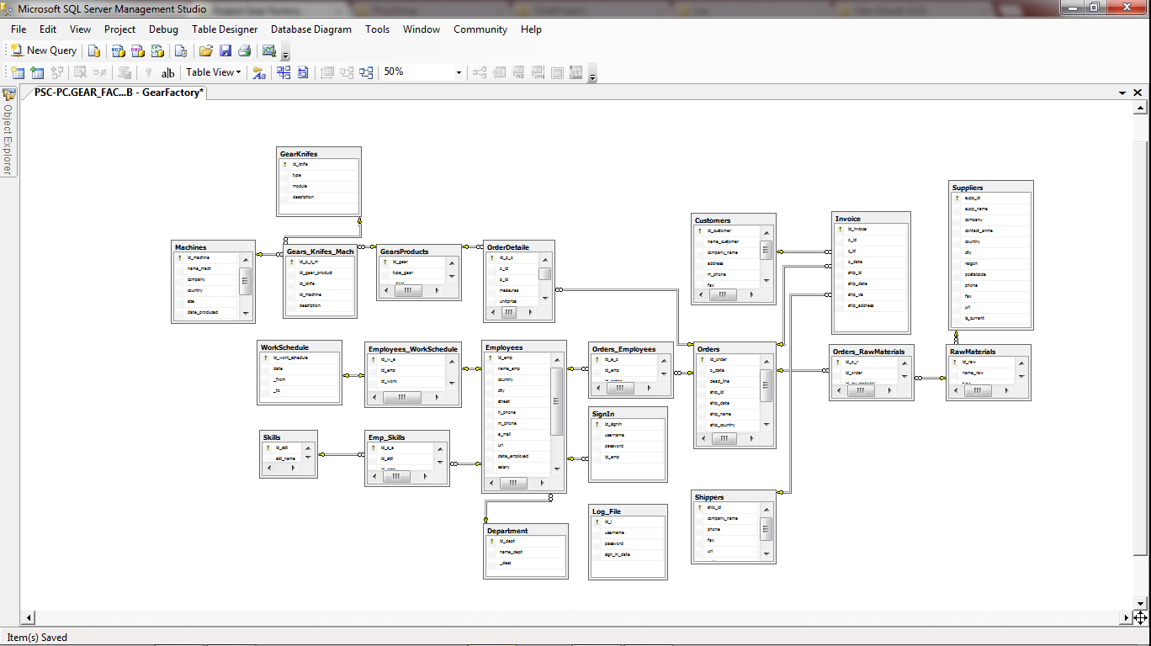

Use Case Diagram

***Suppliers***

***Grinding Gear***

***Making Gear***

***Product***

***Heating***

***Process***

***Manager***

Include

Include

Include

Includee

***Customer***

extend

***Proper***

***shape***

***Manufacture***

**Implementation:**

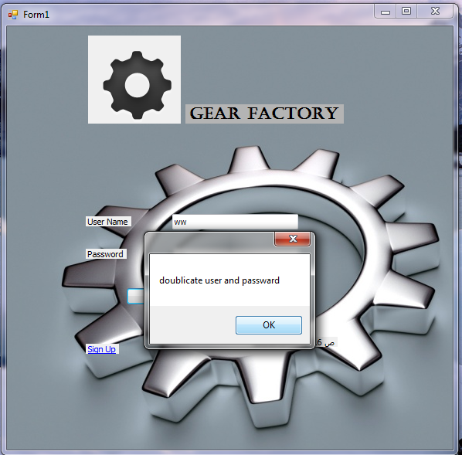

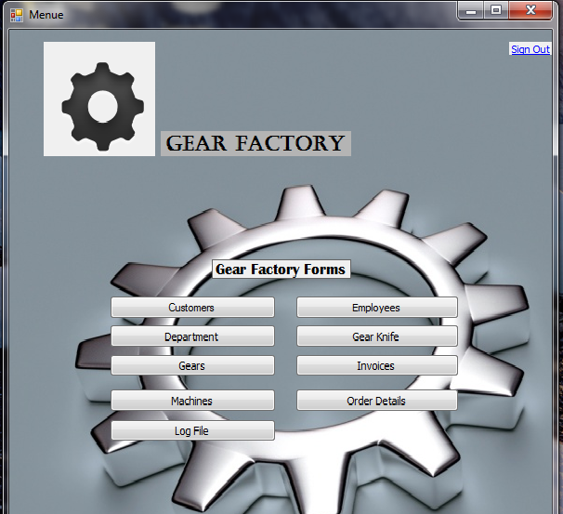

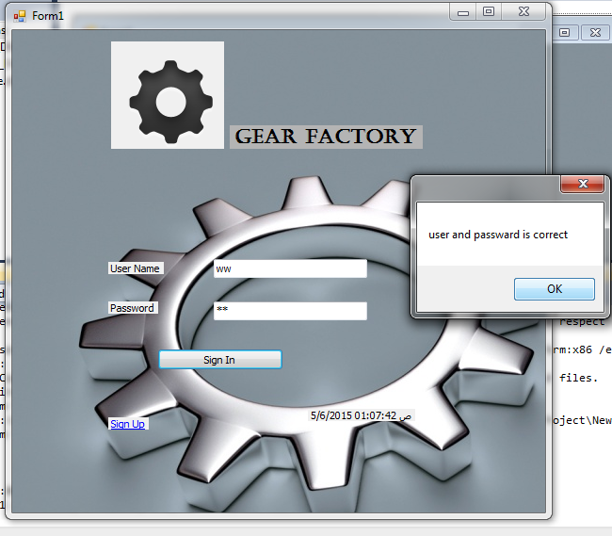

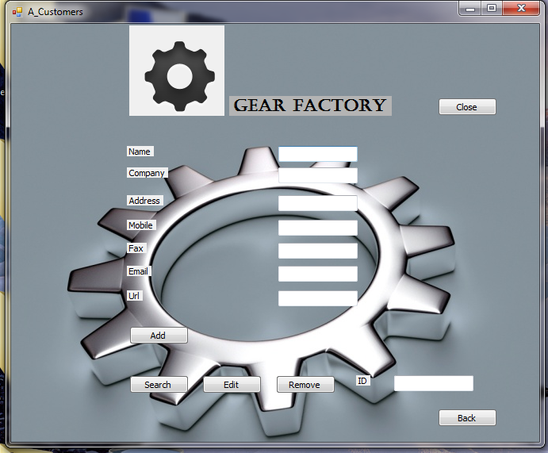

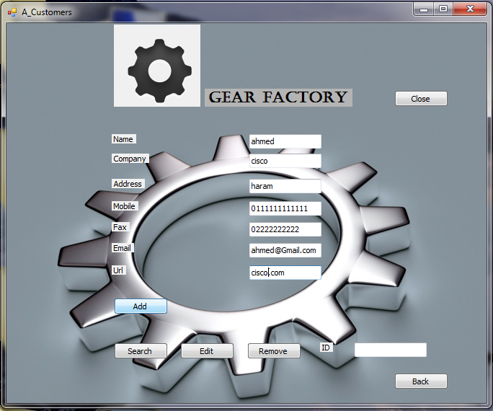

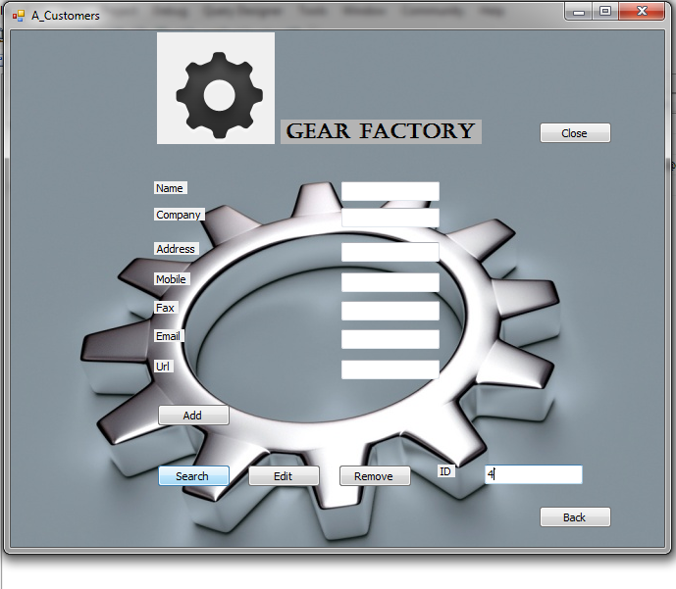

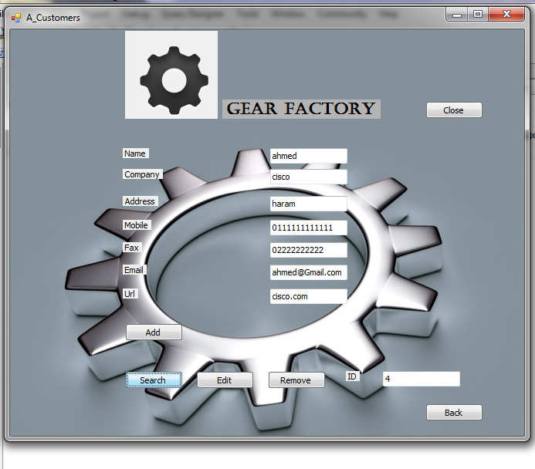

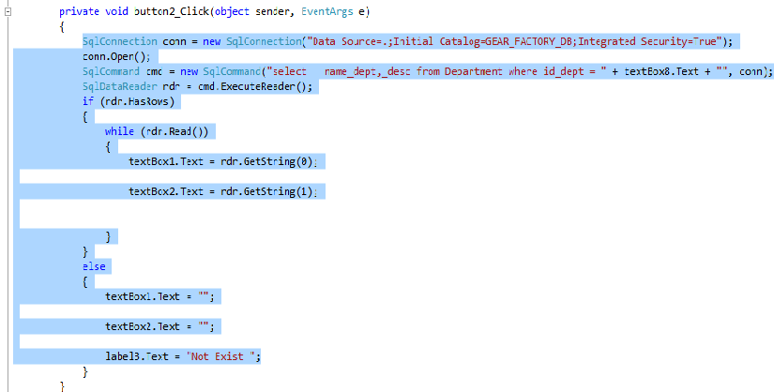

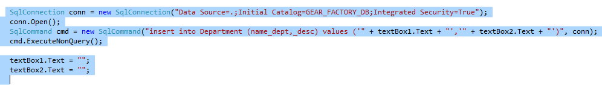

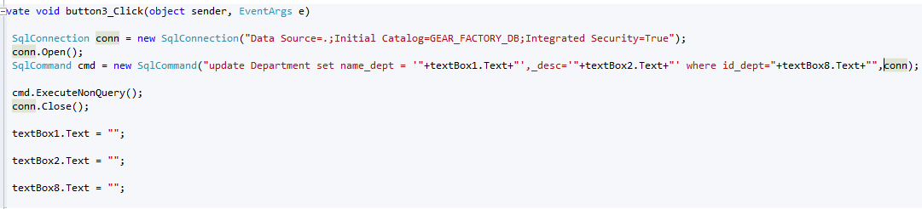

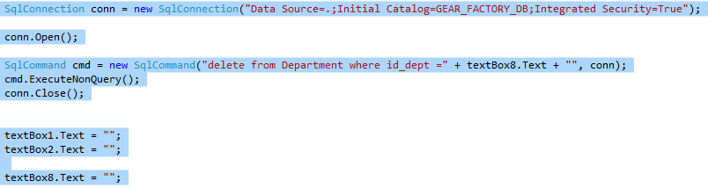

**References:**

1-final homran_SAD_lectues2015

2-<http://www.aoua.com/vb/showthread.php?t=38174&page=2>

3-http://www.ddegjust.ac.in/studymaterial/pgdca/ms-04.pdf

4-http://www.prenhall.com/behindthebook/0132240858/pdf/Kendall_Feature1_Why_We_Wrote_This_Book.pdf

5-http://www.saigontech.edu.vn/faculty/huynq/SAD/Systems_Analysis_Design_UML_5th%20ed.pdf