**VOLUNTEEN Product Document**

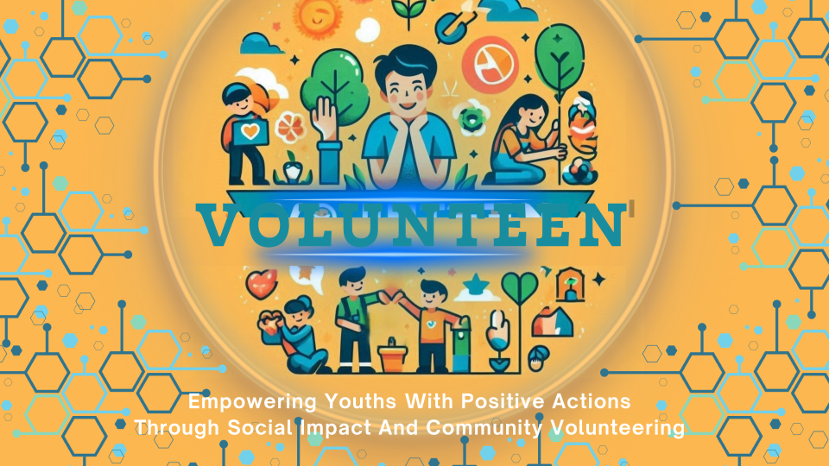

**Ahmad Danaf**

**Adam Takrury**

# Table of Contents

1. תמונה שמכילה טקסט, סרט מצויר, צעצוע

   התיאור נוצר באופן אוטומטיThe Opportunity
2. What is VOLUNTEEN?
3. How it works
4. The Benefits
5. The Innovation
6. Collaborations
7. Market & Market Potential Value
8. Business & Market Penetration Strategy
9. VOLUNTEEN Roadmap
10. About Us

# Overview

# VOLUNTEEN is a community-driven initiative aimed at transforming the lives of young individuals through positive actions and mentorship. By engaging the youth in meaningful activities, we strive to create a safer and more positive environment, ultimately helping the youth in Tel Aviv-Yaffo to grow and improve.

# The Opportunity

Addressing the unproductive free time for teenagers in Tel Aviv-Yaffo and the lack of encouragement for entrepreneurship and responsibility among the youth.

# What is VOLUNTEEN?

VOLUNTEEN is a web application built on Python and Django that allows kids to earn TeenCoins by completing tasks that benefit the community. These points can be redeemed for rewards at local businesses.

# How it works

User Registration and Login: Secure system for user authentication.

Task Management: Users receive, perform, and log community tasks.

Points and Rewards: Earn points for tasks and redeem them for rewards.

## Mentor Portal

The Mentor Portal provides mentors with comprehensive tools to manage tasks and monitor their assigned children’s progress.

1. **Mentor Dashboard**:
   * The dashboard provides an overview of tasks and their completion status.
   * It includes a pie chart that visually represents the distribution of tasks (completed, pending, etc.).
   * Mentors can see individual performance metrics of the children they supervise, making it easier to track progress and provide necessary guidance.
2. **Task Management**:
   * This section allows mentors to create, assign, and manage tasks.
   * Mentors can set start and end dates for tasks and view the list of tasks along with their corresponding TeenCoins.
   * The interface shows detailed information about each task, including its target completion date and the number of TeenCoins that can be earned.
3. **Kids Details**:
   * Mentors can view detailed profiles of the children they oversee.
   * Each child’s profile includes their total earned TeenCoins and a history of tasks completed.
   * This section allows mentors to keep track of each child's activities and ensure they are on the right path.

# 

## Kid Portal

The Kid Portal empowers children by allowing them to track their tasks, earn TeenCoins, and redeem rewards.

1. **Home Page**:
   * The home page welcomes the child and provides an overview of their current TeenCoins balance.
   * Children can see their progress and upcoming tasks, with motivational messages encouraging them to continue their efforts.
   * Notifications inform them of new tasks and important updates.
2. **Wall of Fame**:
   * This section lists the top performers among the children, fostering a healthy competitive spirit.
   * Children can see where they rank compared to their peers and strive to improve their standings.
   * The leaderboard is updated in real-time, reflecting the latest task completions and TeenCoins earnings.
3. **Rewards**:
   * The rewards section displays the various rewards available for redemption.
   * Children can browse through different categories of rewards and see how many TeenCoins are required for each.
   * This interface encourages children to set goals and work towards earning their desired rewards, promoting a sense of accomplishment and financial literacy.

# 

## Shop Portal

The Shop Portal enables local businesses to engage with the community by providing rewards that children can redeem using their earned TeenCoins.

1. **Shop Dashboard**:
   * The dashboard offers a summary of the shop’s interactions with the VOLUNTEEN system.
   * Shops can see the total TeenCoins available for redemption and the history of previous redemptions.
   * A pie chart visually displays the proportion of redeemed versus available TeenCoins.
2. **Redemption History**:
   * This section provides a detailed history of all the redemptions made at the shop.
   * Shops can track which children have redeemed rewards and the specific rewards they have chosen.
   * A bar chart summarizes monthly redemption statistics, helping shops understand engagement trends.
3. **Redemption Process**:
   * Shops can manage the redemption process by adding or removing items from the redemption list.
   * The interface shows available rewards and their TeenCoins cost, allowing shops to update their offerings easily.
   * This section streamlines the process of redeeming rewards, ensuring a smooth transaction for both the shop and the children.

# The Benefits

* Strengthening self-confidence through rewards and recognition.
* Development of essential life skills such as time management and teamwork.
* Promoting financial independence and personal initiative.
* Increasing social involvement and community engagement.

# The Innovation

Combining technology with social and educational goals, focusing on young people, and integrating community and economic support through local businesses.

# Collaborations

VOLUNTEEN thrives on strong collaborations with various stakeholders, ensuring a wide-reaching impact and sustainable growth. Here are some key collaborations:

1. **TI-Space Career Accelerator**:
   * Provides guidance, code reviews, and mentoring.
   * Played a significant role in selecting the project's idea.
2. **Tel Aviv-Jaffa Municipality**:
   * High likelihood of collaboration, including financial support to help the youth of the city.
3. **The Academic College of Tel Aviv-Yaffo**:
   * Part of a workshop with lecturer Dror, aiding in performance algorithms and logistics.
4. **Yaffa Almustakbal High School**:
   * Enthusiastic participation from the principal and students, with the pilot conducted at the school.
5. **The Growth Association for Good Deeds Jaffa**:
   * Provided an annual budget of 20,000 NIS for community support.
6. **Roma Pizza Restaurant**:
   * Offers free meals to children earning points in the first month.
   * Other local restaurants also collaborate to support youth engagement.

# Market & Market Potential Value

VOLUNTEEN has the potential to significantly impact the youth and community of Tel Aviv-Yaffo and other cities. By focusing on engaging youth aged 12-17 in meaningful activities and providing tangible rewards through local businesses, VOLUNTEEN can create a ripple effect of positive change. The market potential can be measured through several key metrics:

1. **Youth Engagement**:
   * Target Audience: Youth aged 12-17.
   * Estimated Number of Target Users in Tel Aviv-Yaffo: 1,000.
   * Projected User Growth: 50% annual increase over the next 5 years.
2. **Community Involvement**:
   * Local Businesses: Engaging 50 local businesses in the first year.
   * Community Organizations: Partnering with 10 community organizations to provide tasks and mentorship.
3. **Economic Impact**:
   * Projected Revenue from Local Businesses: 20,000 NIS annually through partnership fees and advertising.
   * Community Investment: Annual community investment of 20,000 NIS from various stakeholders to support youth activities.

# Business & Market Penetration Strategy

* Technology and Application Development Companies: Partnering with firms specializing in social or educational apps.
* Civil Society and Youth Organizations: Collaborating with organizations promoting values education and community contribution.
* Local Businesses and Multinational Companies: Engaging businesses to offer rewards and support.
* Educational and Research Institutions: Working with schools and universities for research and program integration.
* Social Media and Communication Platforms: Using social media to increase awareness and engagement.

# VOLUNTEEN Roadmap

## Idea Selection

Ti-Space played a significant role in idea selection, having a major part in choosing the project idea.

## Preparation of Offer Document

Created a document detailing collaborations, project goals, target audience, project specifics, goals, and main problems the project aims to solve.

## POC

Developed user registration and login, task management system, points and rewards system, and rewards demonstration.

## MVP

Enhanced user authentication and security measures, advanced task management features.

## Future Expansion Plans

Expand collaborations with non-profits and local organizations. Potential future use to encourage employee performance, starting with a pilot for young children and expanding based on success.

# About Us

We, Ahmad Danaf and Adam Takrury, are the developers behind VOLUNTEEN. As computer science students at the Academic College of Tel Aviv-Yaffo, our mission is to empower teenagers through positive actions and community service. VOLUNTEEN is designed to provide young individuals with a constructive way to use their free time, develop essential skills, and contribute to their community. Through our project, we aim to foster a sense of responsibility, encourage volunteerism, and build a stronger, more connected community.

### Work Distribution

**Ahmad Danaf**:

* Developed the **Shop Portal**, including:
* **Shop Dashboard**: Overview of shop interactions with the VOLUNTEEN system.
* **Redemption History**: Tracking rewards redeemed by the children.
* **Redemption Process**: Redeeming points for rewards at participating shops.
* Handled both backend and frontend development of shop portal.

**Adam Takrury**:

* Developed the **Kid Portal**, including:
* **Home Page**: Overview of points, tasks, and notifications for children.
* **Wall of Fame**: Displaying top performers and their achievements.
* **Rewards**: Viewing and redeeming available rewards using earned points.
* Handled both backend and frontend development of kid portal.
* Managed communications with local businesses.

**Both Ahmad and Adam**:

* Collaborated on developing the **Mentor Portal**, including:
* **Mentor Dashboard**: Overview of assigned tasks, progress tracking, and performance metrics.
* **Task Management**: Assigning, managing, and tracking tasks assigned to the children.
* **Kids Details**: Displaying detailed information about the children, including their progress and earned points.
* Trained children on how to use the platform and guided them through the process.

#### Our Mission

Our mission is to provide the youth of Tel Aviv-Yaffo with meaningful opportunities to engage in positive actions that benefit the community. By leveraging technology, we aim to create a platform that not only encourages volunteerism and social responsibility but also fosters the development of essential life skills among young people.

#### Our Vision

We envision a future where VOLUNTEEN expands beyond Tel Aviv-Yaffo, reaching youth in various cities and communities. Our goal is to create a global network of young volunteers who are empowered to make a difference. We believe in the potential of our platform to transform lives, promote social cohesion, and foster a culture of giving back.

#### Our Commitment

We are committed to continuous improvement and innovation. Our platform is designed to be scalable and adaptable, allowing us to incorporate new features and respond to the evolving needs of our users. We actively seek feedback from our community and partners to enhance the user experience and maximize the impact of our program.

By combining our technical expertise with a deep commitment to social change, VOLUNTEEN is poised to create a lasting positive impact on the lives of young people and the communities they serve. Join us on this journey to empower the next generation of leaders and change-makers.

Market & Market Potential Value

## User Growth Projection

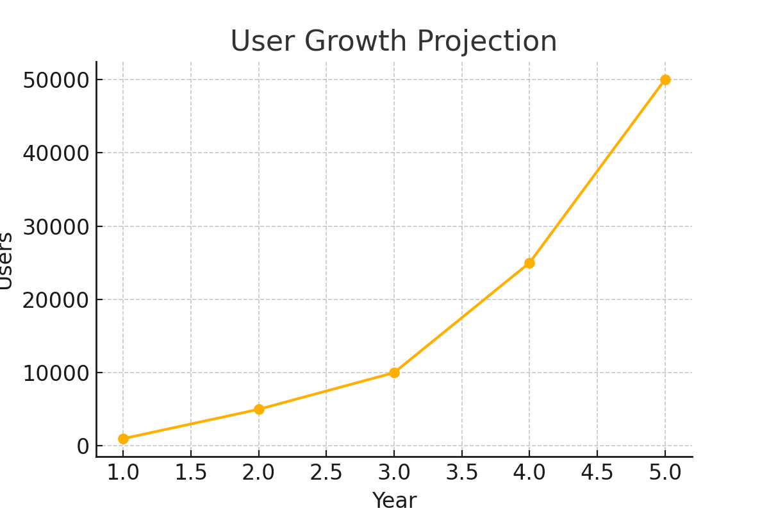

#### User Growth Projection

The User Growth Projection chart provides an estimated increase in the number of users over the next five years. This prediction is based on the assumption of a 50% annual increase in the user base, starting with an initial user count of 1,000. The projected growth is as follows:

* Year 1: 1,000 users
* Year 2: 5,000 users
* Year 3: 10,000 users
* Year 4: 25,000 users
* Year 5: 50,000 users

This exponential growth reflects the increasing engagement and awareness of the VOLUNTEEN platform among the youth and their communities.

## Task Completion Rate

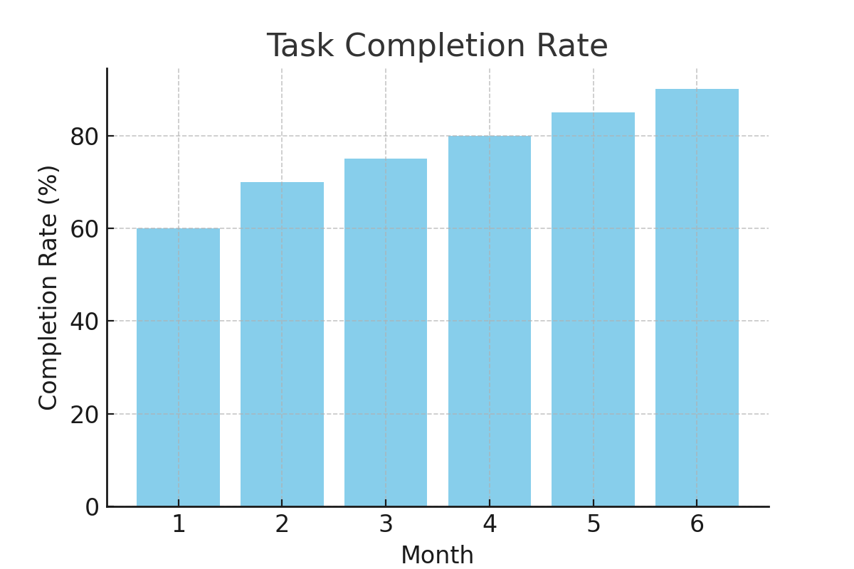

The Task Completion Rate chart shows the expected monthly completion rates of tasks by users over a six-month period. The completion rate is projected to improve as users become more familiar with the platform and more motivated to earn TeenCoins. The predicted completion rates are:

* Month 1: 60%
* Month 2: 70%
* Month 3: 75%
* Month 4: 80%
* Month 5: 85%
* Month 6: 90%

This steady increase highlights the effectiveness of the VOLUNTEEN platform in engaging users and encouraging task completion.

## Points Redemption

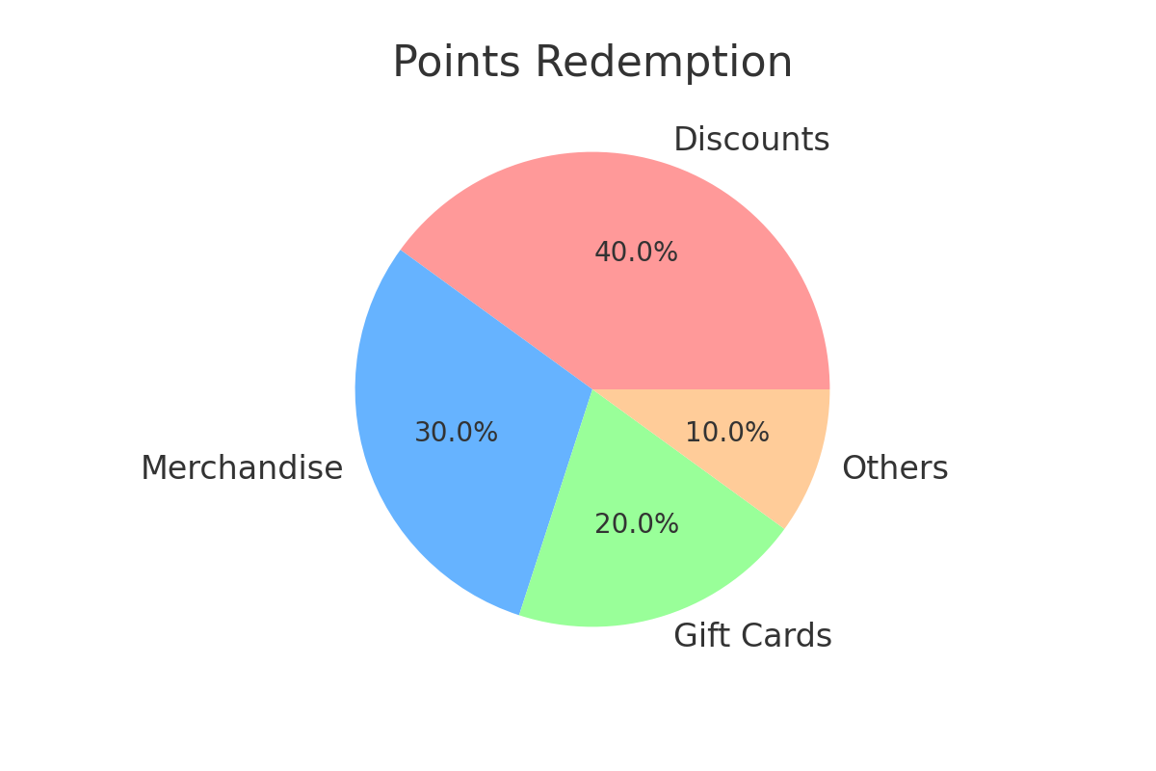

The Points Redemption chart illustrates how users are expected to redeem their TeenCoins for various rewards. The projected distribution is as follows:

* Discounts: 40%
* Merchandise: 30%
* Gift Cards: 20%
* Others: 10%

This prediction is based on user preferences and historical data from similar reward-based platforms.

## Funding and Revenue Projection

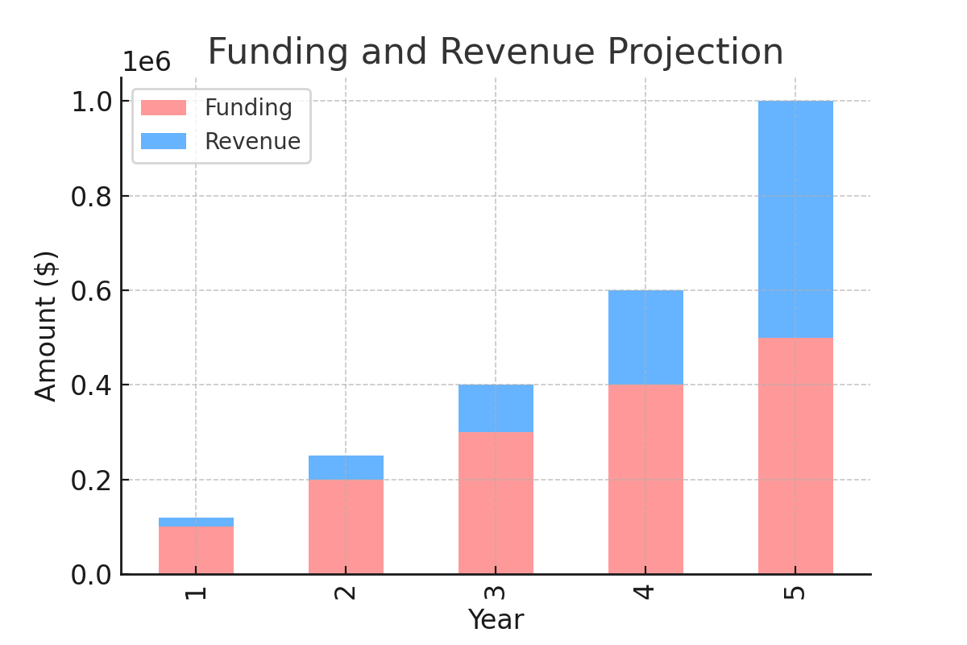

The Funding and Revenue Projection chart presents a forecast of the required funding and expected revenue generation over the next five years. The projection assumes continuous growth in both funding and revenue, driven by increased user engagement and partnerships with local businesses. The projected figures are:

* Year 1: Funding - $10,000, Revenue – 1500 NIS
* Year 2: Funding - $20,000, Revenue - 3,000 NIS
* Year 3: Funding - $30,000, Revenue - 5,000 NIS
* Year 4: Funding - $40,000, Revenue - 7500 NIS
* Year 5: Funding - $50,000, Revenue - 10000 NIS

This projection underscores the financial viability of the VOLUNTEEN project as it scales.