# Volunteen Product Concept Description

## Need

Youth involvement in community service is essential for fostering empathy, leadership, and social responsibility. However, existing platforms often fail to effectively engage younger users or provide a structured, motivating environment that aligns with their interests. Volunteen aims to address this by creating a dynamic, points-based community service platform specifically designed to encourage and reward youth participation in community-oriented tasks.

## Innovation

Volunteen integrates a unique points-based system that gamifies community service tasks, enhancing motivation and sustained engagement among youth. This system allows children to earn points for completing various tasks assigned by mentors or parents, which can then be redeemed for rewards. The platform leverages a comprehensive database structure to manage users, groups, tasks, rewards, and redemptions while enabling detailed tracking of progress, mentorship interactions, and reward management. The innovative combination of gamification with real-time tracking and mentoring support distinguishes Volunteen from existing solutions.

## Offering

Volunteen offers a comprehensive platform that includes:

- **User Authentication**: A secure user authentication system to protect user data and ensure privacy. Each user, whether a parent, mentor, or child, has a unique login credential with role-based access control to maintain data integrity and personalized experiences.  
- **Task Management**: Parents and mentors can create, assign, and track tasks for children.  
- Points System: Children earn points for completing tasks, which they can redeem in the platform’s integrated reward shop.  
- **Mentorship and Guidance**: Mentors can guide children through assigned tasks, providing feedback and encouragement.  
- Progress Tracking: A transparent tracking system that allows children, parents, and mentors to monitor task completion, points earned, and rewards redeemed.

## Market (Customers and Competitors)

**- Customers**: The primary target market includes families with children, educational institutions, and youth organizations looking to promote community service and social responsibility.  
- **Competitors:** Existing competitors may include platforms like ClassDojo, which offers a classroom-based reward system, and GoFundMe Charity, which engages youth in fundraising activities. However, Volunteen's unique focus on structured community service tasks combined with an engaging points-based reward system differentiates it from these alternatives.

## Technical Description and Design

The Volunteen platform relies on a structured relational database to manage its operations. Here's a detailed overview of the database design:

1.User Table: Stores information about all users, including their ID, username, password, and email.  
2. Group Table: Represents groups that users can be a part of, linked by a foreign key to the User table.  
3. Child Table: Tracks children using the platform, associating each child with a user ID, unique identifier, secret code, and points.  
4. Mentor Table: Manages mentors, linking each mentor to a user ID.  
5. Task Table: Contains task details, including ID, description, deadline, status, title, image, points, and additional details, as well as whether the task is new or viewed and the total points.  
6. Task Completion Table: Records the completion status of tasks by children, with fields for child ID, task ID, completion date, and bonus points.  
7. Child-Mentor Relationship: Managed by the `ChildMentors` table, which maps children to their respective mentors.  
8. Shop Table: Defines the shop items available for redemption, linked to users, with maximum points and item details.  
9. Reward Table: Lists available rewards, their requirements, and related shop items.  
10. Redemption Table: Tracks the redemption of points by children, recording child ID, points used, and date redeemed.  
11. Task Assignment Tables: `TaskAssignedChildren` and `TaskAssignedMentors` manage which tasks are assigned to children and mentors, respectively.

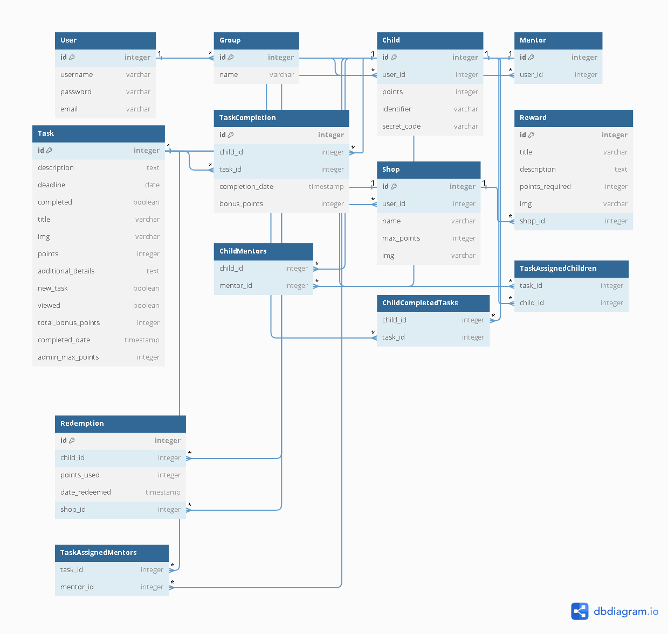

## Additional Technical Description

Volunteen's platform is designed following Uncle Bob's Clean Architecture principles, which ensures a clear separation of concerns and makes the system highly maintainable, scalable, and testable. The architecture is structured into multiple layers, including Presentation, Domain, Application, and Infrastructure layers, promoting decoupling and flexibility for future enhancements.

The platform leverages an API-first approach, using a RESTful API to communicate between the front-end and back-end components. The database is managed using SQLite, chosen for its simplicity and ease of deployment in the initial stages of development. This choice allows for rapid development and local testing, with the flexibility to scale to more robust database solutions in the future if needed.

Additionally, Volunteen is designed with cloud deployment in mind, particularly leveraging AWS services for scalability, storage, and security. AWS services such as AWS S3 for storing images, AWS Lambda for serverless functions, and AWS RDS for potential future database needs provide a robust foundation for future growth and scalability.