# **VOLUNTEEN**

­­

**Alpha – Concept demonstration**

**Ahmad Danaf**

**Adam Takrury**

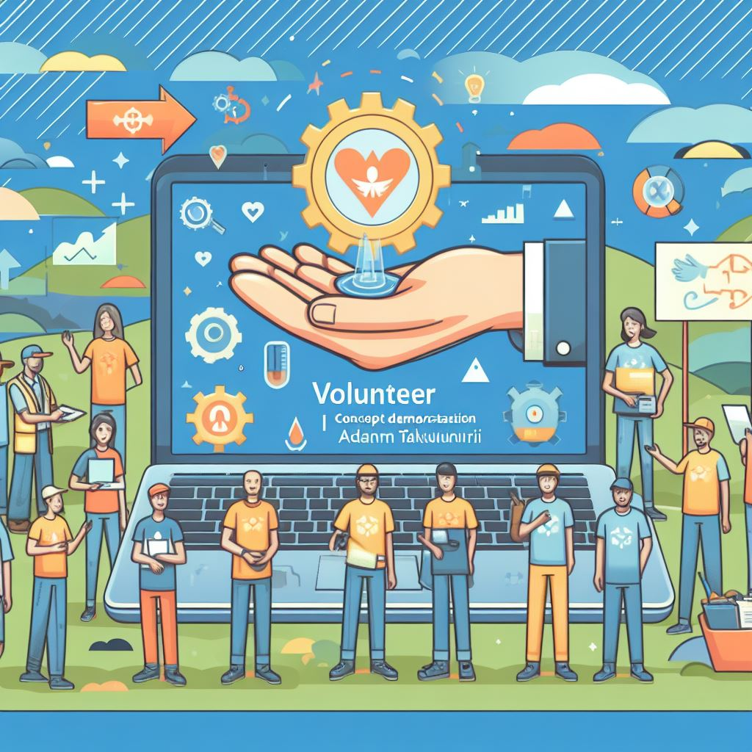**­­**

## **תמונה שמכילה טקסט, צילום מסך התיאור נוצר באופן אוטומטיTask List**

The screenshot presents a task list from a website targeting the empowerment of Jaffa's youth through community service.

It outlines various tasks assigned to young participants, each with its own deadline and point value reflecting the task's difficulty.

This system encourages timely engagement in activities like assembling care packages and environmental projects, supporting the initiative's broader aim of nurturing responsibility and effecting social change.

**Reward List**

The screenshot depicts a reward list from our project, showcasing various incentives available to children for earning points through community service.

The list includes rewards like sports equipment gift cards, meal vouchers for local eateries, symbolic cash amounts for discretionary use, ice cream and shakes gift certificates, pizza or dessert packages, and cinema ticket vouchers.

Each reward is associated with a specific point requirement, indicating the effort needed to earn it.

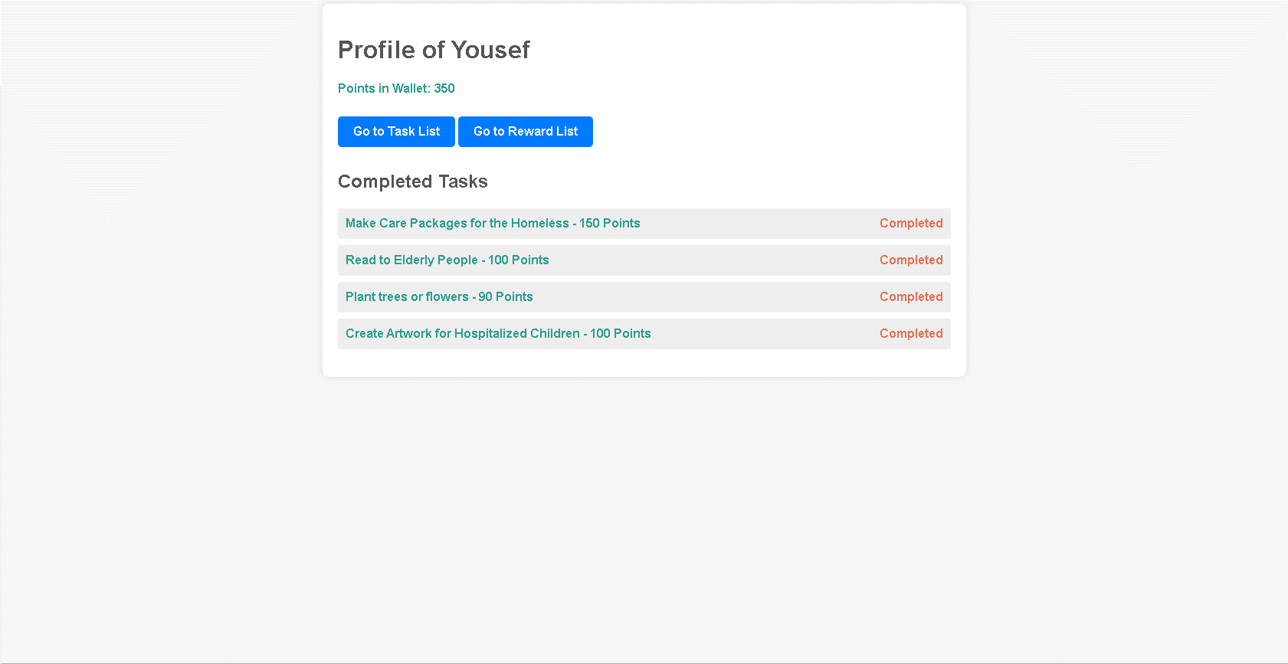**Profile of Yousef**

The screenshot shows the profile page of a participant named Yousef, detailing his accomplishments in a community service program.

He has 350 points in his wallet. The page lists the completed tasks, which include making care packages for the homeless, reading to elderly people, planting trees or flowers, and creating artwork for hospitalized children, each task with designated points.

Two buttons, "Go to Task List" and "Go to Reward List," allow navigation to page of tasks and rewards.