📘 Documentation: Agentic RFP Proposal Generator System

📌 Overview
This system automates the generation of proposal documents from RFP PDFs using Azure-based agents, powered by OpenAI. It includes:
- Azure Function App: Backend for document parsing and solution generation.
- LLM Agents: Master-slave orchestration for content generation.
- Markdown Agent: Converts solution JSON to formatted Markdown.
- Streamlit UI: Frontend interface to upload PDF and download .md or .docx.
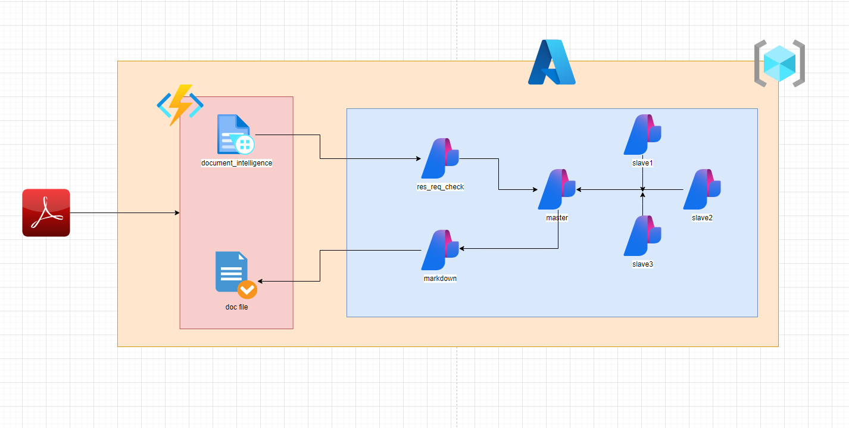

🗂️ System Components
1. 📤 PDF Upload (Streamlit UI)
- Users upload an RFP .pdf file.
- The file is sent to the Azure Function via an HTTP POST request.
2. ⚙️ Azure Function App
Route: /api/proposal
Steps:
- Step 1: Uses Azure Document Intelligence to extract text from the PDF.
- Step 2: Extracts:
  - rfp_headings
  - requirements
- Step 3: Master agent distributes work to 3 parallel slave agents.
- Step 4: Aggregated solutions are sent to a Markdown agent.
- Step 5: Markdown agent returns a structured Markdown document.
3. 🧠 LLM Agent Structure
- document_intelligence: Extracts full text.
- res_req_check: Parses headings and sections from text.
- master: Divides work among slaves.
- slave1, slave2, slave3: Generate section-wise content.
- markdown: Converts solutions into Markdown.
4. 📄 Markdown & DOCX Output
- Final Markdown is returned by the backend.
- Frontend:
  - Displays Markdown.
  - Offers two download buttons:
    - Download Markdown (.md)
    - Download Proposal (.docx) (converted in real-time)

🔄 API Endpoint (Azure Function)
Route
bash
CopyEdit
POST /api/proposal
Request
- multipart/form-data
  - file: RFP PDF file
Response
json
CopyEdit
{
"status": "success",
"rfp_status": "yes",
"rfp_headings": { ... },
"requirements": { ... },
"solutions": { ... },
"markdown": "## 1. Introduction\n..."
}

🎨 Streamlit Frontend UI
Features
- Upload PDF
- View generated Markdown
- Download as .md or .docx
Flow
- Upload PDF
- Call Azure Function /api/proposal
- Parse JSON response
- Show Markdown content
- Convert to DOCX using python-docx
- Download buttons shown to user

📁 Folder Structure
css
CopyEdit
project-root/
│
├── utils/
│ ├── document_intelligence_main.py
│ ├── res_req_from_rfp_main.py
│ ├── orchestrate_main.py
│ ├── markdown_main.py
│
├── src/
│ ├── agents/
│ │ ├── master_agent.py
│ │ ├── slave_1_agent.py
│ │ ├── slave_2_agent.py
│ │ ├── slave_3_agent.py
│ │ └── markdown_agent.py
│ └── prompts/
│ ├── slave_prompt.py
│ ├── markdown_prompt.py
│ └── res_req_from_rfp_prompt.py
│
├── streamlit_app.py
├── function_app.py
└── requirements.txt

🧪 Agent Interaction Flow
mermaid
CopyEdit
graph TD
A[PDF Upload (UI)] --> B[Azure Function]
B --> C[Document Intelligence]
C --> D[res_req_check Agent]
D --> E[Master Agent]
E --> F1[Slave 1 Agent]
E --> F2[Slave 2 Agent]
E --> F3[Slave 3 Agent]
F1 --> G[Master Aggregation]
F2 --> G
F3 --> G
G --> H[Markdown Agent]
H --> I[Return Markdown to UI]
I --> J[Show + Download as DOCX]

🧾 Logging & Files
All stages log JSON files in the log/ folder with timestamp:
pgsql
CopyEdit
log/
├── docintell_2025/07/07_121212.json
├── extraction_2025/07/07_121215.json
├── solutions_2025/07/07_121217.json
├── markdown_2025/07/07_121220.json

🔐 Security Suggestions
- Add Azure AD authentication or API key validation for the Function App.
- Secure blob storage if storing PDFs.
- Limit file size and type in frontend.

🚀 Deployment Notes
Backend
- Deploy Azure Function to:
  - Windows/Linux with Python 3.10
  - Bind to API Management or public HTTPS endpoint
Frontend
- Deploy Streamlit via:
  - Azure Web App for Containers
  - Streamlit Community Cloud
  - Docker + Nginx for production

✅ Summary
Component | Role
PDF (User) | Raw input
Streamlit UI | Uploads PDF, displays output
Azure Function | Orchestrates the full pipeline
Agents | Generate structured solutions
Markdown Agent | Converts JSON to Markdown
DOCX Generator | Builds downloadable Word file

