Technical Proposal for
Dubai Justice Initiative
Document number: Dubai/DC/DJI/TP/06/25/1

Submitted by:
IdealSoft Emirates

To | Dubai Courts | From | Jalal AbdelQader  Chief Executive Officer
 |  | Phone | +971 50 6174982
 |  | Fax | +971 2 6775589
Date | 30TH of June 2025 | Valid to | 29TH of September 2025

Confidentiality

This document contains confidential material proprietary to IdealSoft Emirates (hereafter I-SOFT). The material, ideas, and concepts contained herein are to be used exclusively to evaluate the capabilities of I-SOFT to provide assistance to Dubai Courts to develop the Dubai Justice initiative.
This information and the ideas herein may not be disclosed to anyone outside an employee of client including any external agencies partnering with Dubai Courts or be used for purposes other than the evaluation of I-SOFT capabilities, without the prior written consent of I-SOFT.

Abbreviations

I-SOFT | IdealSoft Emirates
EA | Enterprise Architecture
SOAP | Simple Object Access Protocol
REST | Representational State Transfer
API | Application Programming Interface
JTA | Java Transaction API
HTTP | Hypertext Transfer Protocol
HTTPS | Hypertext Transfer Protocol Secure
DMD | Data Model Design
XML | Extensible Markup Language
SQL | Structured Query Language
POJO | Plain Old Java Object
BFF | Backends for Frontends
PaaS | Platform as a Service
IaaS | Infrastructure as a Service
QoS | Quality of Service
TDD | Test Driven Development
BDD | Behavior Driven Development
e2e | End-to-end
JMX | Java Management Extensions
JSON | JavaScript Object Notation
JVM | Java Virtual Machine
DX | Digital Transformation
CTS | Centralized Training System
ID | Identification
System components | All system components including devices, programs, required licenses, cables, and conductor and semi-conductor (including all components).
AWS | Amazon Web Services
SLA | Service level Agreement
TOGAF | The open group architecture framework
AE | Automation Engineer

Table Of Content
1 Abbreviations 3
2 Introduction 7
3 Executive Summary 8
4 Our Understanding of Dubai Courts Requirements 9
4.1 Project Context and Objectives 9
4.2 Scope of Work 9
4.3 Key Challenges 9
4.4 Our Commitment 10
5 Proposed Solution 10
5.1 Proposed Solution – High-Level Architecture 10
5.2 Mobile App Development (Flutter) 10
5.3 Web Portal 10
5.4 APIs & Integrations 10
5.5 CMS Platform 10
5.6 Hosting and Infrastructure 10
6 Implementation Approach & Timeline 10
7 Solution Components 10
8 Training and Knowledge Transfer 10
9 Assumptions 11
10 Support and Maintenance Plan 12
10.1 Support Model & Tiers 12
10.2 Service Level Agreements (SLAs) 14
10.3 Roles & Responsibilities 15
10.4 Maintenance Activities 16
10.5 Monitoring & Incident Management 17
10.6 Tools & Processes 18
10.7 Handover & Knowledge Transfer 19
10.8 Continuous Improvement & Change Management 20
11 Quality Assurance and Testing 22
11.1 Lifecycle and Deliverables 22
11.2 QA and Testing Scope 22
11.2.1 Functional Testing 23
11.2.2 System Integration Testing 23
11.2.3 Performance Testing 23
11.2.4 User Acceptance Testing 24
12 Company Profile and Experience 25
12.1 I-SOFT Profile 25
12.1.1 About I-SOFT 25
12.1.2 Our Team 25
12.1.3 Our Clients 26
12.1.4 References 27
12.2 Digifloat 28
12.2.1 About Digifloat 28
12.2.2 Clientele 28
12.2.3 Reference Projects 30

Introduction
Dear Esteemed Members of the Procurement Committee,
I-SOFT Emirates L.L.C., in strategic partnership with HCLTech, we are delighted to submit our proposal for the Dubai Justice Initiative Request for Proposal (RFP). Our collaboration combines I-SOFT’s extensive experience in delivering digital solutions for UAE government entities with HCLTech’s global expertise in cloud, AI, and digital transformation, positioning us to deliver the transformative Dubai Justice App—a unified platform that enhances judicial accessibility, transparency, and efficiency.
The Dubai Justice Initiative aligns with Dubai Courts’ vision to consolidate all judicial services into a single, user-centric digital platform, serving diverse stakeholders including the public, advocates, and government entities. Our proposed solution, powered by I-SOFT’s Flutter-based mobile and web development expertise and HCLTech’s Experience (X) Data (D) Operations (O) (XDO) framework, microservices architecture, and MORO Hub cloud deployment, ensures scalability, security, and compliance with UAE regulations. Key features such as biometric authentication, AI-powered search, and integrations with UAE Pass and Dubai Pay will drive a seamless user experience.
I-SOFT’s proven track record with clients like RTA, Dubai Police and Dubai Municipality demonstrates our ability to deliver complex, localized solutions in the UAE. HCLTech complements this with their regional presence in Dubai and Abu Dhabi, leveraging their expertise in public sector projects to provide robust backend systems, AI-driven analytics, and secure API management. Our Agile methodology, led by I-SOFT with onsite presence at Dubai Courts’ headquarters, and supported by HCLTech’s technical innovation, guarantees iterative delivery and stakeholder alignment.
This proposal details our technical approach, project methodology, and commitment to meeting Dubai Courts’ evaluation criteria, including experience, compliance, cost-effectiveness, and delivery strategy. We are confident that our partnership will deliver a platform that not only meets the RFP’s objectives but also contributes to Dubai’s Services 360 Vision and Digital City Strategy by 2027.
Thank you for considering our proposal, and we look forward to collaborating with Dubai Courts to redefine judicial service excellence.

Jalal AbdelQader
CEO
IdealSoft Emirates L.L.C

Executive Summary

Our Understanding of Dubai Courts Requirements

Project Context and Objectives
We understand that the Dubai Justice Initiative is a strategic endeavor by Dubai Courts to transform judicial services through a unified, user-centric digital platform. the initiative aims to consolidate all judicial services into a single mobile and web application, enhancing accessibility, transparency, and efficiency for diverse user groups, including the public, advocates, typing offices, and government entities. This aligns with Dubai Courts’ broader vision of innovation and digital transformation, reinforcing its role as a judicial authority delivering fair and efficient justice across the Emirate.

Scope of Work
The scope encompasses the development, implementation, and long-term support of the Dubai Justice App, covering:
- Web and Mobile Development: Native iOS/Android apps and a responsive web portal using Flutter, adhering to Dubai Government’s unified design system
- CMS and Content Management: A robust CMS for managing dashboards and service content
- Integrations and APIs: Secure, scalable APIs hosted on Digital Dubai infrastructure, supporting multi-tenancy and integrations with UAE Pass, Dubai Pay, and legacy systems
- Support and Maintenance: A 12-month post-launch support model with defined SLAs for bug fixes, updates, and minor enhancements.
The platform must serve as a cornerstone for Dubai’s shared digital channels, integrating services from nine or more entities by 2027 and complying with standards like DEGP, Digital Maturity Policy, and WCAG.

Key Challenges
We recognize the following challenges inherent in the project:
- Scalability and Performance: The platform must handle growing user demand and ensure 99.9% uptime.
- Security and Compliance: Strict adherence to Dubai Cyber Security Strategy, TDRA standards, and data privacy laws.
- User Diversity: Catering to varied personas (public users, advocates, typing offices) with multilingual support and accessibility features.
- Integration Complexity: Seamless integration with legacy systems, third-party services (e.g., UAE Pass, Happiness Meter), and shared channels requires robust API design.

Our Commitment
Our team is committed to delivering a scalable, secure, and innovative solution that aligns with Dubai Courts’ digital vision. Leveraging our expertise in UAE government projects, Flutter development, and Agile methodologies, we will:
- Develop a user-centric platform that enhances access to justice.
- Ensure compliance with all technical, security, and regulatory standards.
- Provide comprehensive support and knowledge transfer to empower Dubai Courts’ team.
- Collaborate closely with stakeholders to achieve the Services 360 Vision and Digital City Strategy by 2027.
We are confident that our proposed solution will meet and exceed the expectations outlined in the RFP, delivering a transformative digital experience for Dubai’s judicial ecosystem.

Proposed Solution

Proposed Solution – High-Level Architecture

Mobile App Development (Flutter)

Web Portal

APIs & Integrations

CMS Platform

Hosting and Infrastructure

Implementation Approach & Timeline

Solution Components

Training and Knowledge Transfer

Assumptions

Support and Maintenance Plan
Our Support and Maintenance Plan ensures that, once the system is live, Dubai Courts enjoys continuous availability, rapid incident resolution, and proactive improvement. The plan covers:
- Support Model & Tiers
- Service Level Agreements (SLAs)
- Roles & Responsibilities
- Maintenance Activities (Routine & Preventive)
- Monitoring & Incident Management
- Tools & Processes
- Handover & Knowledge Transfer
- Continuous Improvement & Change Management

Support Model & Tiers
We propose a three‐tiered support model that aligns with Dubai Courts’s operational structure and ensures issues are routed to the appropriate expertise quickly:
- Tier 1 (Help Desk / Service Desk)
  - Responsibility: First point of contact for all user‐facing issues (e.g., “Cannot log in,” “Dashboard not loading,” “Error submitting application”).
  - Staffing: Dubai Courts’s Service Desk Liaisons (2 FTE) handle ticket intake, basic troubleshooting (password resets, connectivity checks), and perform initial classification and prioritization.
  - Escalation Triggers:
    - If a user cannot resolve after standard scripts (e.g., “Clear cache and retry”), the ticket is escalated to Tier 2.
    - SLAs: Response within 1 hour for P1/P2, 8 business hours for P3.
- Tier 2 (Functional & Technical Support)
  - Responsibility: Addresses functional defects, configuration questions, and mid‐level technical issues.
  - Staffing:
    - VoltMX & BI Functional Analysts (Vendor and Dubai Courts business‐process experts)
    - Informatica/ETL Specialist (Vendor)
    - DevOps Engineer (Vendor) for container or infrastructure issues not requiring DBA escalation.
  - Examples of Issues:
    - A “Performance KPI not updating” after ETL job completes.
    - “Portal workflow incorrectly routing investor applications.”
    - “Unable to export PDF from a MicroStrategy report.”
  - Escalation Triggers:
    - If the root cause is a database or infrastructure failure, escalate to Tier 3.
    - If the resolution requires code changes or configuration that may impact compatibility or SLAs, schedule a fix in the next maintenance window.
  - SLAs: Response within 2 hours for P1, resolution within 4 hours or scheduled patch for P2; P3 resolved in next regular release cycle.
- Tier 3 (Architectural / Vendor Engineering)
  - Responsibility: Deep‐dive, “white‐glove” handling of complex issues—performance bottlenecks at scale, data‐integrity defects in ETL, security vulnerabilities, or unplanned infrastructure outages.
  - Staffing:
    - Solution Architect (Vendor)
    - Senior DevOps / Cloudera/Actian DBA (Vendor/Dubai Courts)
    - Security Engineer (Vendor) for critical vulnerabilities
  - Examples of Issues:
    - “High CPU load on Kubernetes nodes causing portal timeouts.”
    - “Severe data ingestion failure due to schema changes in Qmatic.”
    - “Critical security flaw discovered in VoltMX container image.”
  - SLAs: P1 (system down) response in 1 hour, resolution or mitigation plan within 4 hours; P2 within 1 business day; P3 in the next major release unless critical.

Service Level Agreements (SLAs)
Priority | Impact | Response Time | Resolution Time | Description
P1 (Critical) | System Unavailable (e.g., portal down, ETL broken) | ≤ 1 hour | ≤ 4 hours (or workaround) | Entire user base affected; immediate action required to restore core functionality.
P2 (High) | Major Function Degraded (e.g., key KPI not updating) | ≤ 2 hours | ≤ 1 Business Day | Affects significant functionality or subset of users; workaround may be acceptable temporarily.
P3 (Medium) | Minor Functionality Impact (e.g., report export error) | ≤ 8 Business Hours | Next Scheduled Release (≤ 2 Weeks) | Non‐critical defects; no immediate business disruption; scheduled patch or hotfix.
P4 (Low/Enhancement) | Cosmetic/Enhancement (e.g., UI tweak, new filter) | ≤ 2 Business Days | Next Quarterly Release | Low‐impact requests or future feature enhancements; prioritized in roadmap.
- Business Hours: Sunday–Thursday, 8 AM–6 PM (Asia/Karachi timezone).
- Out‐of‐Hours Support: P1 issues escalate to on‐call Tier 3 engineer 24×7 for resolution or mitigation.

Roles & Responsibilities
Role | Responsibilities
Service Desk Liaison | • Triage incoming tickets  • Perform initial troubleshooting (password resets, basic connectivity)  • Escalate to Tier 2 as needed
VoltMX / BI Functional Analyst (Vendor) | • Investigate functional defects in portal and dashboards  • Apply configuration fixes  • Coordinate with business owners
Informatica / ETL Specialist (Vendor) | • Diagnose ETL job failures  • Apply mapping corrections or parameter adjustments  • Troubleshoot CDC and data‐quality issues
DevOps Engineer (Vendor) | • Monitor and troubleshoot Kubernetes, container issues  • Scale resources as needed  • Handle CI/CD pipeline failures
Senior DBA (Dubai Courts/Vendor) | • Monitor SQL Server AG and Actian Vector health  • Resolve database failovers, backup/restore issues  • Tune queries for performance
Cloudera Administrator | • Monitor HDFS, Hive, Ranger policies  • Address HDFS space or permission issues  • Execute DR drills for Cloudera cluster
Security Engineer (Vendor) | • Conduct vulnerability scans  • Address any security incidents  • Ensure ongoing compliance with TCS and AGF
Solution Architect (Vendor) | • Provide Tier 3 support for complex architectural or integration issues  • Lead root‐cause analysis for systemic failures
Project Manager (Vendor) | • Oversee support performance  • Track SLA adherence  • Manage escalations and reporting to Dubai Courts leadership

Maintenance Activities
- Routine (Weekly/Monthly)
  - VoltMX / Kubernetes
    - Patch container images (OS, runtime libraries) monthly; perform rolling updates to avoid downtime.
    - Verify health checks: pod liveness/readiness probes, Kubernetes control-plane metrics.
  - Informatica
    - Apply monthly bug‐fix patches per Informatica’s release schedule; back up repository and parameter files.
    - Review job logs weekly for any warnings/errors, tune problematic mappings.
  - Cloudera & Hive
    - Run HDFS data balancing and clean-up during off‐peak hours (e.g., weekend nights).
    - Review Ranger policy changes weekly and update as roles evolve.
  - Actian Vector
    - Monitor node health and disk usage daily; run automatic snapshot backups nightly.
    - Check for skewed clusters and re‐distribute data as needed.
  - SQL Server AG
    - Weekly integrity checks, transaction log backups, and failover drills.
    - Rebuild or reorganize indexes monthly on high‐transaction tables (e.g., InvestorApplications).
  - MicroStrategy & Qube AI
    - Validate scheduled cache refresh jobs and semantic metadata reload nightly.
    - Verify that burst distributions (PDF/Excel) were delivered successfully.
- Preventive & Quarterly
  - Security
    - Quarterly vulnerability scans on all containers, OS, and network devices; remediate critical/high findings within 30 days.
    - Penetration test of VoltMX APIs and Kubernetes cluster once per quarter; track and close findings.
  - Performance Tuning
    - Quarterly load tests: simulate 500–1,000 concurrent VoltMX sessions, 200 simultaneous BI queries; adjust autoscaler thresholds, database indexes, or resource limits as needed.
    - Review ETL job durations quarterly; refactor heavy transformations or shift computations upstream.
  - Data Integrity & Quality Audits
    - Quarterly reconciliation between Bronze, Silver, and Gold layers to detect missing or duplicate records; resolve data‐quality issues.
    - Audit lineage via Atlas for any transformation changes that might affect KPI accuracy.

Monitoring & Incident Management
- Monitoring Architecture
  - Kubernetes & VoltMX:
    - Prometheus scrapes kube‐state‐metrics, node_exporter, and custom VoltMX exporters (CPU, memory, request rates).
    - Grafana dashboards visualize cluster health, pod restarts, and API latencies; alerts for CPU > 80% for > 10 minutes.
  - Informatica:
    - Prometheus Exporter for Informatica workflow metrics (job success/failure, average run time).
    - Email Alerts: Informatica email notifications for any mapping failures or high row‐rejection counts.
  - Cloudera & Hive:
    - Cloudera Manager monitors HDFS capacity, NameNode memory, and DataNode heartbeats; alerts when HDFS usage > 75%.
  - Actian Vector:
    - Vector Monitor for query performance (percentile latencies), node CPU, and I/O; triggers email/SMS if query latencies exceed 2 seconds for 5 minutes.
  - SQL Server AG:
    - SQL Server Agent jobs report backup success/failure; Database Health Advisor alerts on high wait times or failover events.
  - MicroStrategy:
    - Usage Analytics tracks report execution failures; triggers alert if > 5% of dashboards fail over 1 hour.
  - Qube AI:
    - Custom monitoring of Q&A query success rates and model latencies; alert if success < 90% or latency > 3 seconds.
- Incident Management Workflow
  - Detection: Alerts generate via Prometheus, Cloudera Manager, or scheduled health check scripts; Service Desk may also receive user‐reported issues.
  - Ticket Creation (Tier 1): Service Desk logs incident in ITSM (e.g., JIRA or ServiceNow) and assigns a priority (P1–P4) based on impact.
  - Initial Triage & Troubleshooting (Tier 1 → Tier 2):
    - Verify if incident is reproducible.
    - Gather logs (VoltMX, Informatica, OS) and attempt basic fixes (restart pod, clear cache, re‐run failing ETL job).
  - Escalation (Tier 2 → Tier 3): If unresolved within SLA, Log, categorize, and escalate to the appropriate senior specialist (e.g., root‐cause for ETL failures, cluster scaling issues, or architectural defects).
  - Root‐Cause Analysis & Resolution: Tier 3 resolves the issue—code fix, configuration change, or infrastructure adjustment—and updates the incident ticket with actions taken.
  - Closure & Post‐Mortem: Confirm resolution with the user, document lessons learned, and update runbooks or knowledge base to prevent recurrence.

Tools & Processes
- ITSM / Ticketing
  - ServiceNow (or JIRA): Central repository for all incidents, service requests, change requests, and Problem Records. Automated SLA tracking and escalation rules ensure timely responses.
- Monitoring & Logging
  - Prometheus & Grafana: For real‐time metrics collection, visualization, and alerting.
  - Fluentd → ELK (ElasticSearch, Logstash, Kibana): Centralized log aggregation from VoltMX containers, Kubernetes events, and database logs. Kibana dashboards for quick root‐cause analysis.
- Knowledge Base & Documentation
  - Confluence (or SharePoint): Houses runbooks, standard operating procedures, configuration diagrams, and troubleshooting guides.
  - Runbooks Include:
    - “VoltMX Pod Recovery Steps”
    - “Informatica Workflow Resubmission”
    - “Cloudera Safe Mode Recovery”
    - “Actian Vector Node Replacement”
- Backup & DR Tools
  - SQL Server Backups: Managed via SQL Server Agent; transaction log backups and full backups stored on Dubai Courts’s SAN with off‐site replication.
  - HDFS Snapshots: Automated via Cloudera Manager; Snapshots scheduled hourly for Silver, daily for Bronze; replicated to secondary cluster in DR site.
  - Actian Vector: Native backup utility for full and incremental dumps; stored on separate storage arrays with regular restore drills.

Handover & Knowledge Transfer
- Handover Documentation Package
  - Runbooks & Playbooks: Step-by-step guides for all routine maintenance tasks, backup/restore procedures, and incident handling.
  - Configuration Baselines: Versions of Kubernetes manifests, Helm charts, SQL Server and Actian configuration files.
  - Contacts & Escalation Matrix: Up‐to‐date roster of support contacts (Vendor and Dubai Courts), with 24×7 on‐call rotation details.
- Training & Workshops
  - Week 1 (Operations & Admins):
    - VoltMX administration (deployments, role management)
    - Informatica mapping maintenance and scheduling
    - Cloudera & Actian administration (table creation, performance tuning)
    - MicroStrategy admin (object security, bursting configuration)
  - Week 2 (End Users & Analysts):
    - Self‐service MicroStrategy reporting (creating ad‐hoc grids, exporting)
    - Qube AI natural‐language querying (English/Arabic)
    - Portal/mobile workflows (Investor Onboarding, KPI monitoring)
- Shadowing & Pairing
  - Read‐Only Ops Access: Dubai Courts DBAs, Cloudera Ops, and VoltMX admins granted time-limited “read-only” access to production logs and metrics for hands-on familiarization.
  - Pairing Sessions: Vendor support engineers pair with Dubai Courts staff during the hypercare period to jointly troubleshoot live incidents, transferring tacit knowledge.

Continuous Improvement & Change Management
- Post‐Implementation Review
  - After the first month of hypercare, hold a “Lessons Learned” workshop to gather feedback on support effectiveness, pain points, and process gaps.
  - Update runbooks, refine SLAs, and adjust support tier responsibilities as needed.
- Quarterly Health Checks
  - Review system metrics (uptime, ETL success rates, incident counts, SLA adherence) with Dubai Courts’s Steering Committee.
  - Propose and schedule any necessary architecture optimizations, performance tuning tasks, or product version upgrades.
- Change Request Handling
  - Tiered Change Process: Minor enhancements (e.g., new report filter) can be rolled into the next monthly maintenance window. Major changes (e.g., adding a new source system) require CCB evaluation.
  - Impact Analysis: Every CR is accompanied by a high-level estimate (effort, cost, schedule impact) before approval.
- Roadmap & Future Features
  - Maintain a “Support & Enhancement Roadmap” highlighting prioritized backlog items—such as advanced AI/ML use cases or integration with third-party mobility providers.
  - Align roadmap reviews with business planning cycles to ensure continuous alignment with Dubai Courts’s strategic goals.

Quality Assurance and Testing

Lifecycle and Deliverables
Quality Assurance (QA) and Testing are embedded throughout the software development lifecycle. Our approach emphasizes early defect detection, continuous verification, and rigorous validation to ensure a stable, secure, and high-performance solution. Testing deliverables for each phase include test plans, test cases, test scripts, defect logs, traceability matrices, and test summary reports.
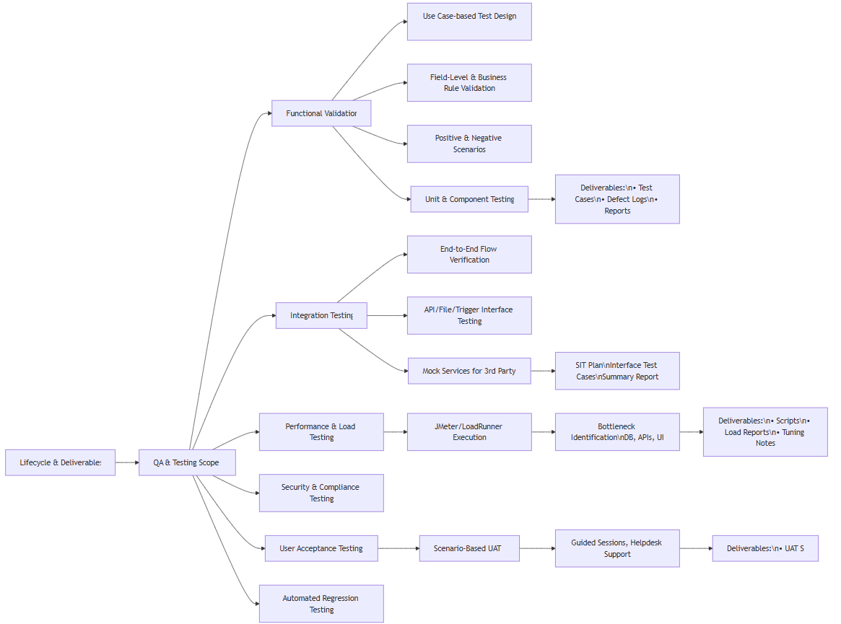

QA and Testing Scope
Our comprehensive testing scope includes:
- Functional validation against business requirements.
- Integration testing of data flows between internal modules and third-party systems.
- Performance and load testing.
- Security and compliance testing (aligned with OWASP and EA standards).
- User acceptance and usability testing.
- Automation of regression and critical business scenarios.
We follow a shift-left strategy, ensuring testing begins early in the development process, with CI/CD integration for test automation and defect traceability.

Functional Testing
Functional testing ensures each module meets specified functional requirements. This includes:
- Test case design based on use cases.
- Positive and negative test scenarios.
- Automated unit and component testing.
- Validation against business rules and field-level validations.
Deliverables: Functional Test Cases, Execution Reports, Defect Logs.

System Integration Testing
SIT validates the interactions across integrated components including workflow engines, APIs, external systems like Qmatic and e-Traffic, and internal modules.
- End-to-end business flow verification.
- Interface validation (APIs, file-based, and real-time triggers).
- Mock services for third-party systems during pre-integration phases.
Deliverables: SIT Plan, Interface Test Cases, SIT Summary Report.

Performance Testing
We conduct load and stress testing to validate system responsiveness and scalability under expected peak loads.
- Use of tools such as JMeter or LoadRunner.
- Identification of bottlenecks in DB queries, API performance, or UI responsiveness.
- Testing for response times, concurrent users, and resource utilization.
Deliverables: Performance Test Scripts, Load Test Results, Tuning Recommendations.

User Acceptance Testing

UAT is conducted in collaboration with the Environment Authority team to validate real-world scenarios:
- UAT test cases derived from business process flows.
- Guided UAT sessions with issue tracking support.
- Helpdesk and walkthroughs for non-technical users.
Deliverables: UAT Test Scenarios, UAT Environment Setup, Defect Resolution Log, UAT Sign-Off.

Company Profile and Experience

I-SOFT Profile

About I-SOFT
I-SOFT is the leading software house and solution integrator in the Middle East focusing on software development, integrating IT requirements, managing IT environments; and utilizing state of the art tools, frameworks, and methodologies to fulfill the constantly changing needs and requirements of clients.
I-SOFT thrives on bringing together technology and design to create innovative solutions. With numerous technical specialties and an in-house design department, I-SOFT is known for taking a cutting-edge approach to our work. We think creatively and critically to build business-driven solutions that seamlessly solve your everyday problems. We incorporate a full-stack data platform into our solutions, enabling quick and efficient data analysis that is pertinent to business problems or queries, allowing actionable insights to inform internal and external business decisions, and strategic planning.
We take the time to carefully listen to your business problems and work closely with you to envision and create solutions tailored to your specific requirements. We strongly believe in a lifelong partnership; therefore, once the solution is delivered, we work closely with you to transfer knowledge and best practices to maximize return on investment.
I-SOFT was founded 1998 in Abu Dhabi United Arab Emirates, and We have long history delivering IT development projects, IT support and managed services for clients in UAE like (but not limited to), UAE Armed forces, Dubai Police, Roads and traffic Authority, Dubai Municipality, Dubai Naturalization & Residency Department, National Emergency & Crisis Management Authority (NECMA), Ministry of Finance – Abu Dhabi, and clients outside UAE like Goplus and Ministry of Interiors in Egypt, and Thiqah and Saudi Standards, Metrology and Quality Organization (SASO) in Saudi Arabia.

Our Team
Our team is our most valuable strength, continuously contributing their expertise, enthusiasm, professionalism, and creativity to achieve the best solutions and deliver supreme services.
Across our offices, we have more than 200 professionals, consisting of:
- Development Managers and Directors
- Performance Improvement and QA Director
- Infrastructure Manager
- Implementation Manager
- Program and Project Managers
- Devops engineers
- UX/UI Manager
- Business/System Analysts
- Senior Designers
- Technical Team Leaders
- Senior Developers (Back End, Front End, Mobility)
- UX/UI Developers
- QC and QA Engineers
- Database Administrators
- Implementation and Training Engineers
- Technical Writers

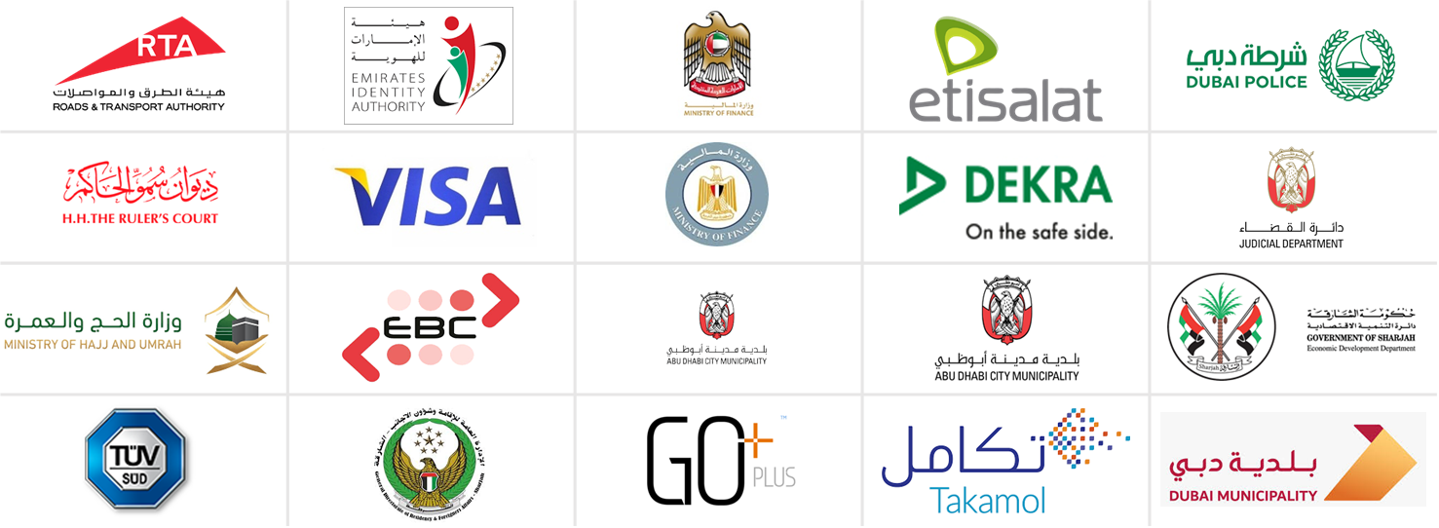





Our Clients
Figure 1: I-SOFT Clients List

References

Organization | Name | Designation | email
SASO, KSA | Eng. Majed AlHazzany | CEO, Vehicle Safety Center | m.hazzany@saso.gov.sa
GoPlus – MOI, Egypt | Mr. Hesham ElSayed | Chairman, GoPlus | helsayed@goplus-eg.com
RTA – Dubai, UAE | Salah Bader | Licensing Systems Department, Program Manager | salah.bader@rta.ae
Dubai Police | General Khalid Nasser Al Razooqi | Director of the General Department of AI | kalrazooqi@dubaipolice.gov.ae
Dubai Municipality | Eng. Mohamed Khalid | Buildings Regulation & Permits Agency, Expert | mohammedkh@dm.gov.ae

Digifloat

About HCLTech
Why Us?
What we Do?

Clientele

Reference Projects

