University of Agriculture, Fsd
Lab Submission
Software Configuration Management - Lab (SE 503)
Name: | Muhammad Ahmad

Ag-no:  Course : | 2022-ag-8042  Nabeela Ashraf
Instructor
Semester : Fall 2024


Lab # 1
Introduction to GitHub for Configuration Management
Task:
1. Sign Up a GitHub account
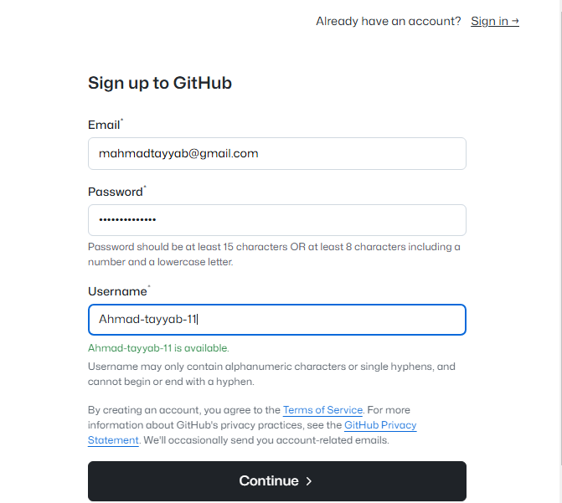

2. | Create a repository named Ahmad-ag-8042
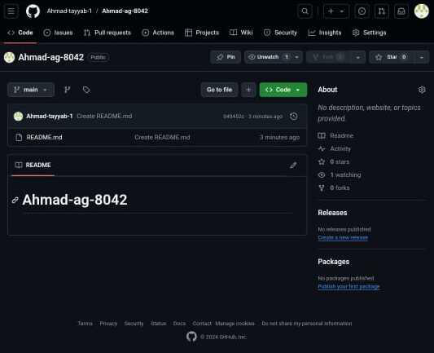

Lab # 2
Setting Up a Development Environment and Working with Git
Task 1: Creating and Managing Commits.
● Create a New Local Repository:
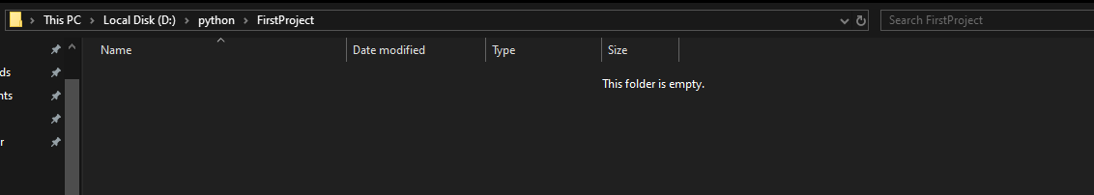
● | Make changes and stage files
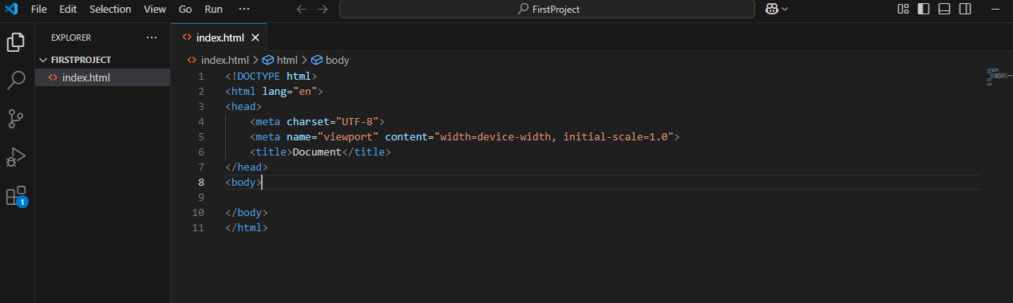
● Commit the changes
Use the git add cmd to add files to commit
Use the git commit -m “initial message” to commit the files

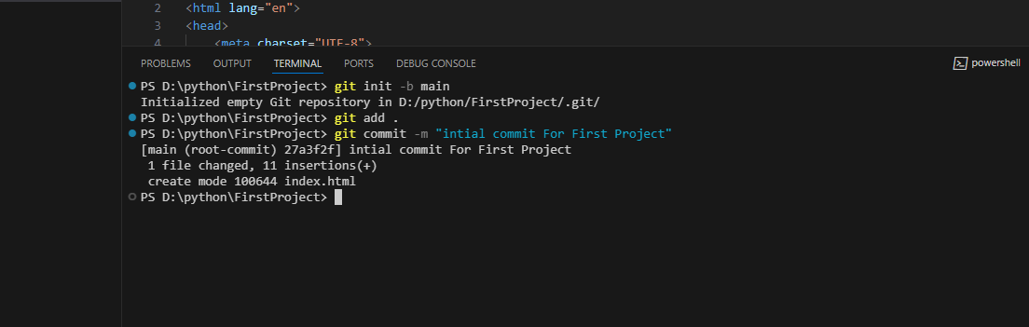
● Push the changes to GitHub
Use the git push-u origin main to Push the changes to GitHub
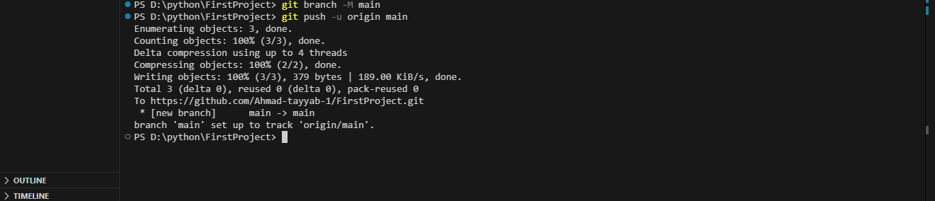
● View commit history
Using the git log cmd to check commit history to verify
Task 2:
1.Create a New Branch
Use git branch <new-branch-name>
Navigate to new branch use git checkout - b <branch-name>

2.Make Changes in the New Branch
Use git add and git commit -mto make changes in the new branch
3.Switch Back to the Master Branch
Use git checkout main to switch back to main branch
4.Merge the Feature Branch into Master
Use git merge <branch-name> to merge the new branch to main branch
5.Push the Merged Changes to GitHub
Use git push -u origin main to push the changes to github
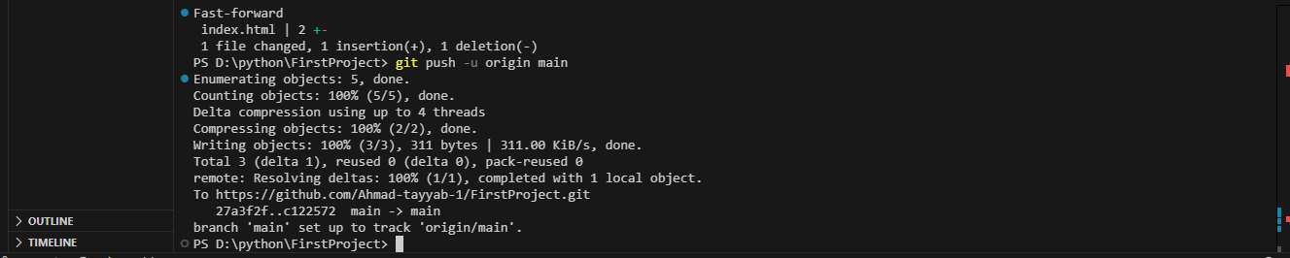

Lab # 3
Advanced GitHub Features
Task 1: Creating and Managing Issues
1.Create an Issue:
○  ○  ○  ○ | Open a repository on GitHub.  Navigate to the Issues tab and click on New Issue.  Fill in the issue title and description to specify a task or bug. Click Submit new issue.
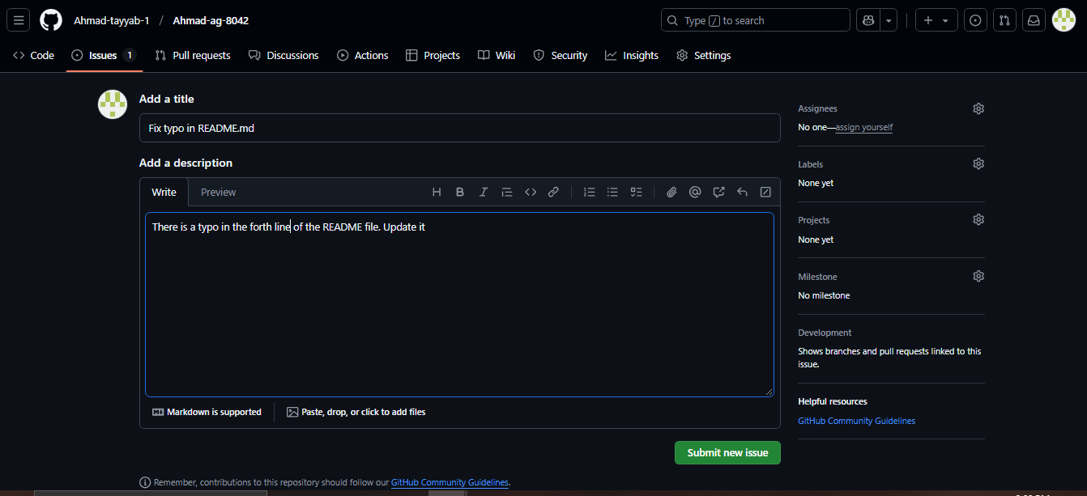
2.Assign the Issue and labels:
○ Assign the issue to yourself or another team member.
○ Add a due date if necessary.
○ Apply labels like bug, enhancement, or help wanted to categorize the issue.
○ | Labels help in filtering and prioritizing tasks.

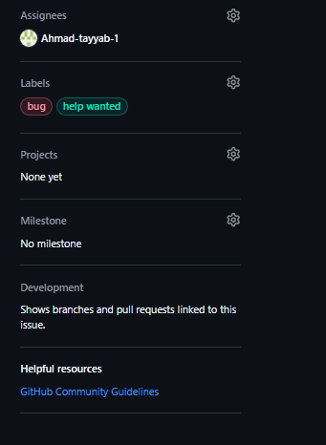
3.Close the Issue:
○ After completing the task, reference the issue in a commit by including Fixes #<issue-number> in the commit message.
○ Example: I fixes issue #1.

Task 2: Planning with Milestones
1.Create a Milestone:
○ Set a title, description, and due date for the milestone.
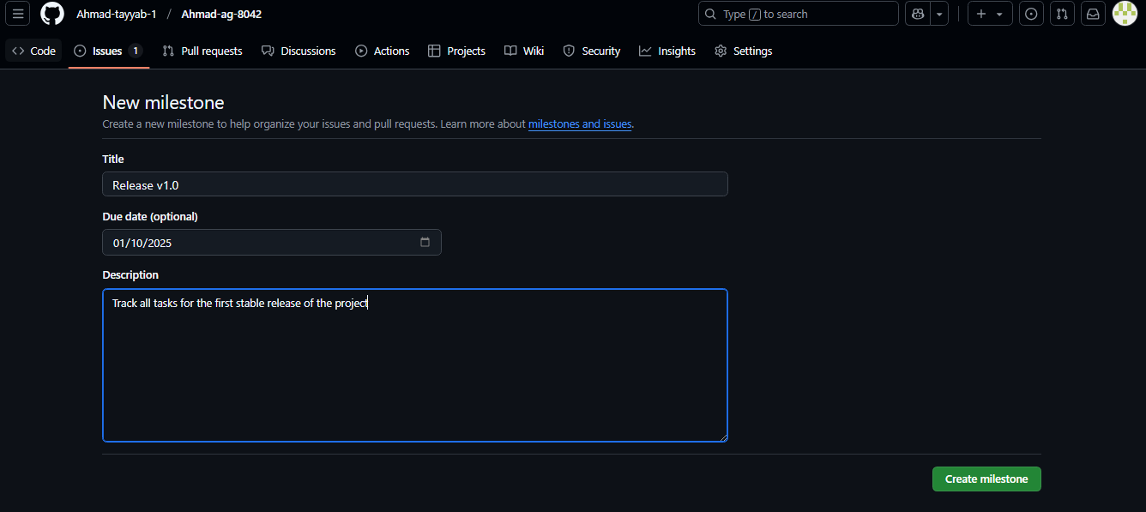

2.Add Issues to Milestone:
○ Open an issue and assign it to the milestone.
○ Use multiple issues to plan tasks related to the milestone.
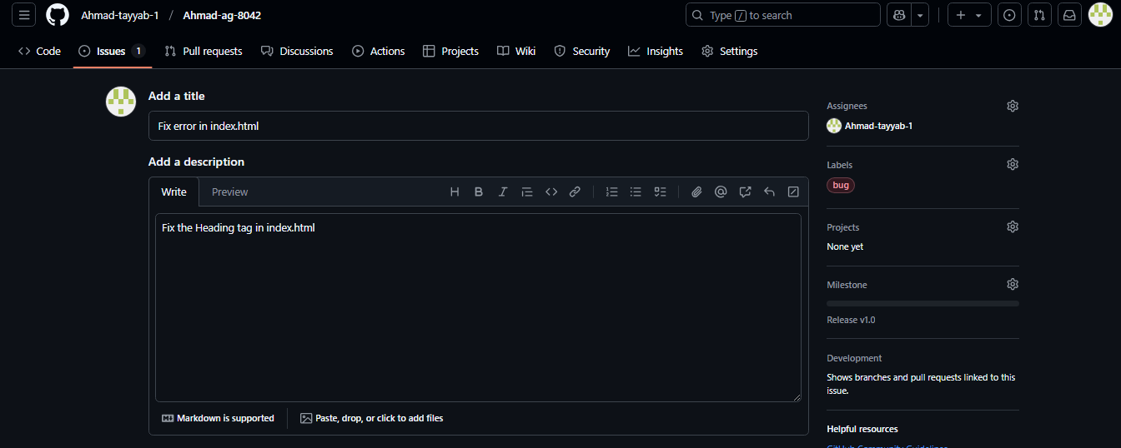
3.Track Milestone Progress:
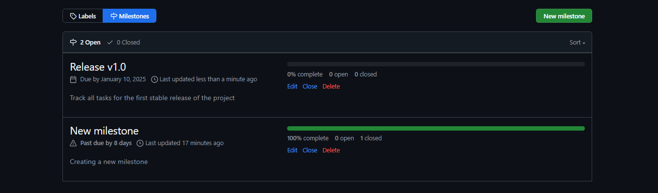
Task 3: Collaborating with GitHub Discussions
1.Enable Discussions (if not already enabled) in repository setting:


2.Start a Discussion:
○ Navigate to the Discussions tab and click New Discussion.
○ Select the discussion category (e.g., General, Q&A).
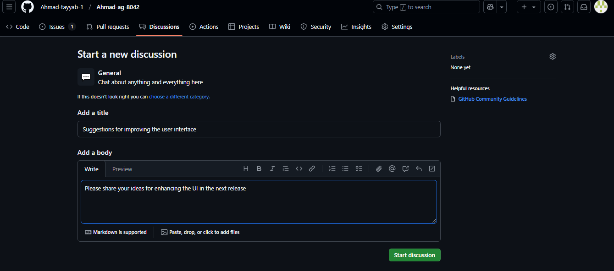
3.Participate in Discussions:
○ Reply to existing discussion topics.
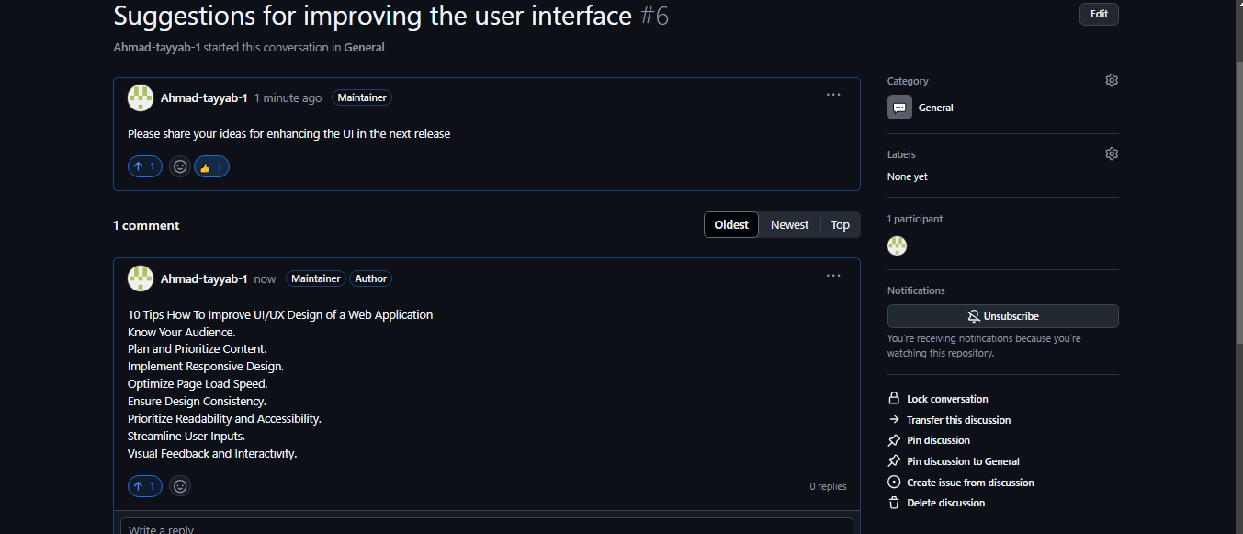

Lab # 4
Setting Up a Development Environment and Working with Git
Task 1: Download and Install VS Code and Git
● Downloaded Visual Studio Code from the official website.
● Downloaded Git from the official Git website.
● verified the installation using commands like git --version and code
--version
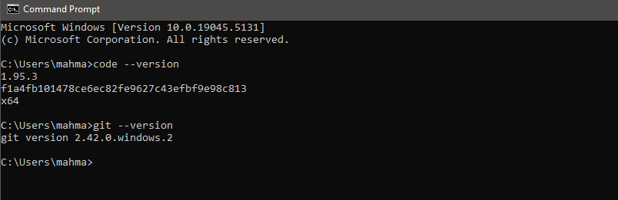
Task 2: Configure Git
●  ●  ● | Configured Git with my name and email using the commands: git config --global user.name "Your Name"  git config --global user.email "Your Email"
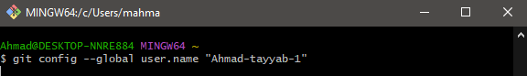

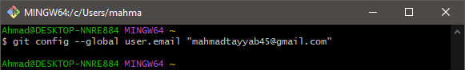
● Verified the configuration using git config --list.
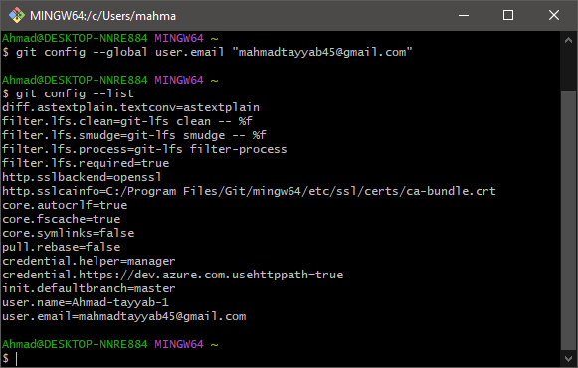
Task 4: Create a Folder and Open in VS Code:
●Created a folder named Ahmad-AG-8042 and opened it in VS Code.

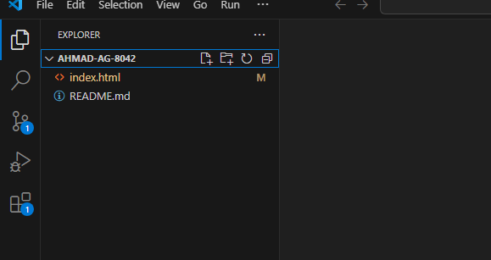
Task 5: Clone a Repository from GitHub:
○ Open Integrated Terminal in VS Code:
○ Cloned a GitHub repository by using the git clone <repo link>
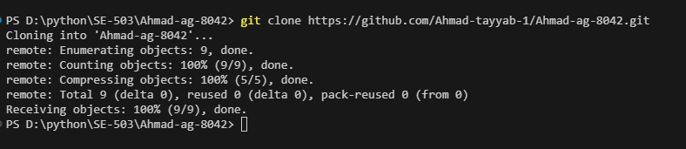
Task 6:Open and Modify Files:
• Opened a file from the cloned repository, made some changes, and saved them.
Task 7: Check Git Status:
• Use the git status command to check the status of files.
• Observed the file states such as untracked, modified, staged, or deleted.
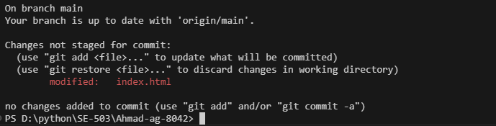

Lab # 5
Version Control with Git: Managing Changes, Uploading Projects to
GitHub, and Working with Branches
Task 1: Stage and Commit Changes
1. Open the terminal in the cloned repository folder (from the previous lab).
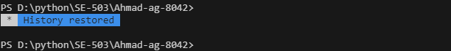
2. View the status of your repository:
Use git status cmd to check the status

3. Stage the modified or new files:
● git add <index.html>
To stage all changes at once: use git add .
4. Commit the staged changes with a descriptive message:
● git commit -m "Updated the index .html"
Task 2: Push Changes to GitHub

1. | If someone has updated the repository on GitHub, your local copy may be outdated, and
Git prevents you from pushing to avoid overwriting others. Execute the following commands to update the local repo:
git fetch origin
git pull origin <branch_name>
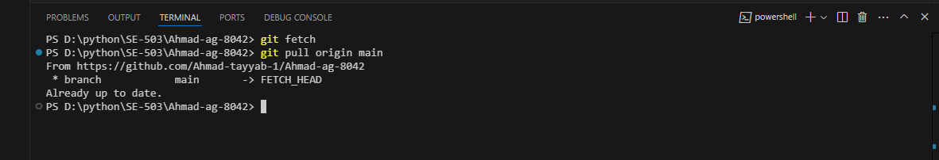
2.Push your committed changes to the GitHub repository:
git push origin <branch_name>
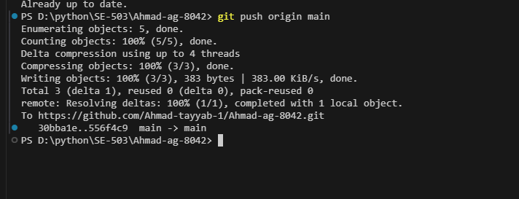
3.Verify the changes on the GitHub repository by visiting the repository page in yourbrowser

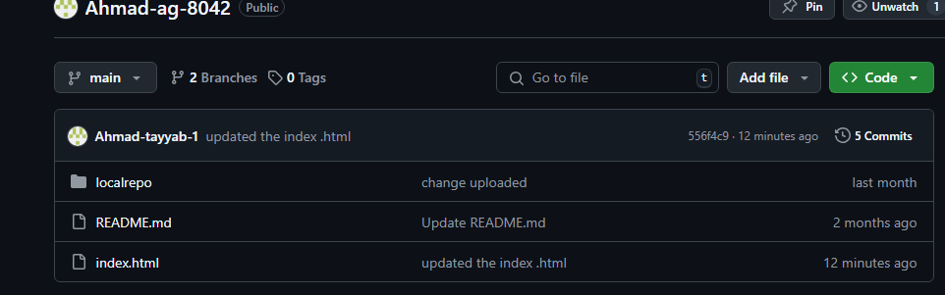
Task 3: Create a New Project on Your Desktop and Upload it to GitHub
Create a New Project Locally
1. Create a new folder on your desktop (e.g., FirstProject).

2. Inside the folder, create files for your project (e.g., .txt, .html, .py, etc.).

Step 2: Initialize Git in the Folder
1. | Initialize Git in this folder using the git init command

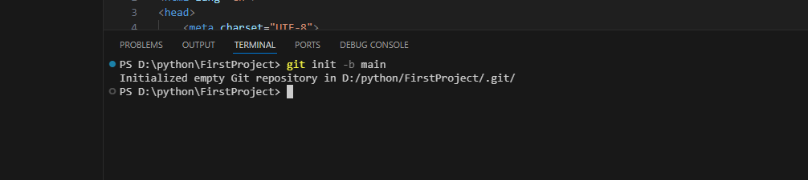
Step 3: Add and Commit Files
1. Add all files to the staging area using the git add .
2.Commit the files with a descriptive message:
git commit -m "Initial commit for FirstProject"

Step 4: Create a New GitHub Repository
1.  2.  3.  4.  5. | Log in to .  Click the New button to create a repository.  Provide a repository name (e.g., FirstProject) and description (optional). Leave the repository empty (do not initialize with a README).  Click Create Repository.

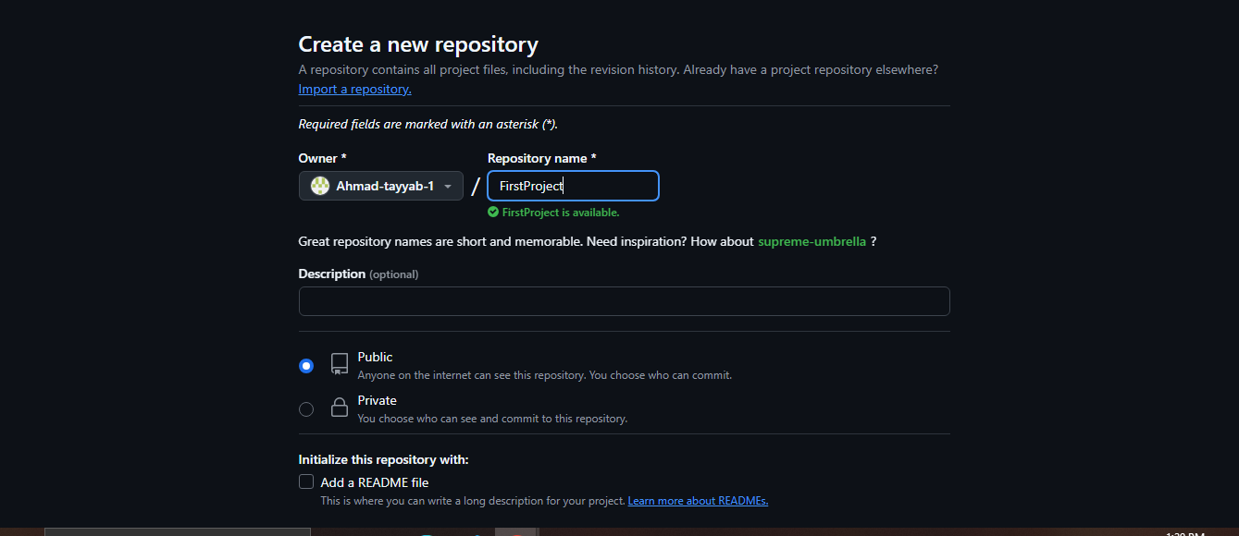
Step 5: Link the Local Repository to GitHub
1. Copy the repository's URL (e.g., https://github.com/username/FirstProject.git).
2. Link your local repository to the GitHub repository:
git remote add origin
3. Verify either remote command worked or not
git remote -v
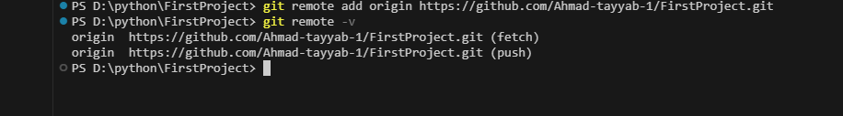
4. Check the current branch using git branch
Rename the branch from master to main (the conventiongithub follows) Using branch -M main

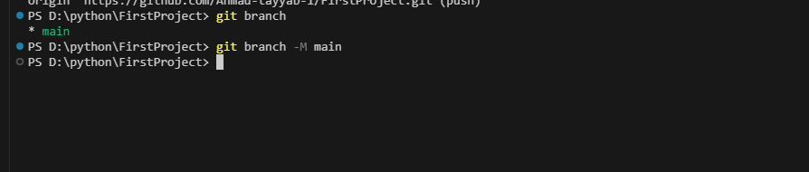
6. Push the project to GitHub:
git push -u origin main

Verify the Upload Files on Github by opening the “FirstProject Repository” in your github account
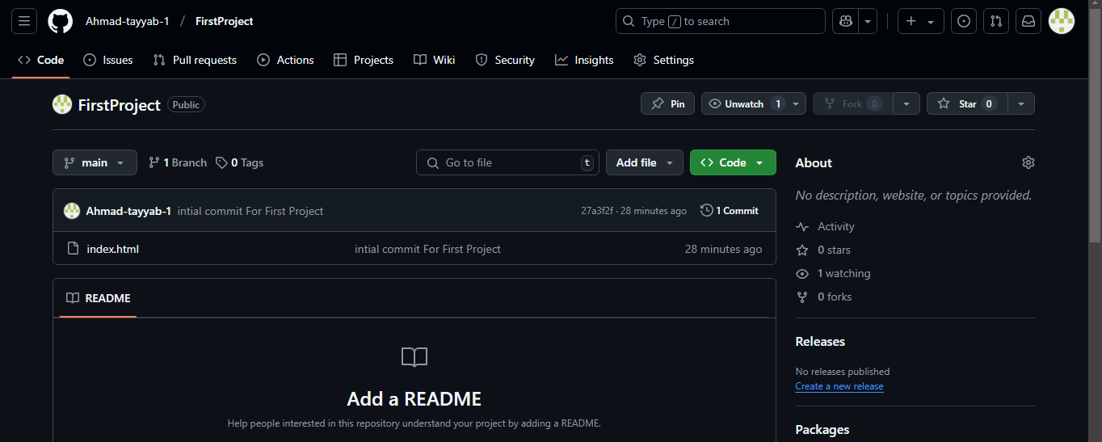

Lab # 6
Working with Branches: Creating, Modifying, Merging, Simulating, and Resolving Conflicts
Task 1 :Resolving Merge Conflict
● Create a new branch “feature1”
Using git branch feature1
● Navigate to feature1 branch
Using git checkout feature1
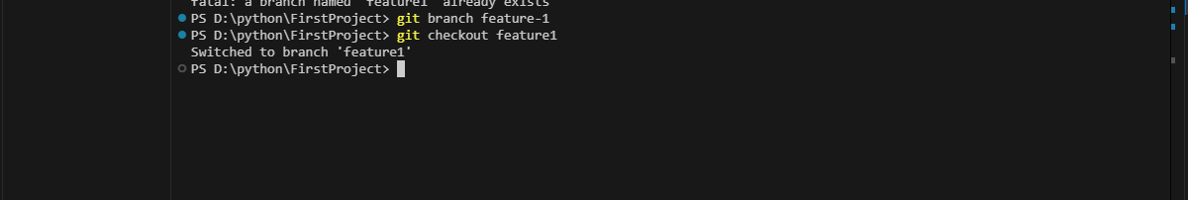
● Make changes in the feature branch and commit them
Using git add index.html and git commit -m “feature1 edit”
● Navigate back to main branch and make changes in the same file as feature1 branch
Using git checkout main

● | Merge the feature1 branch to main branch

● | Resolve the merge conflict by manually editing the file of conflict
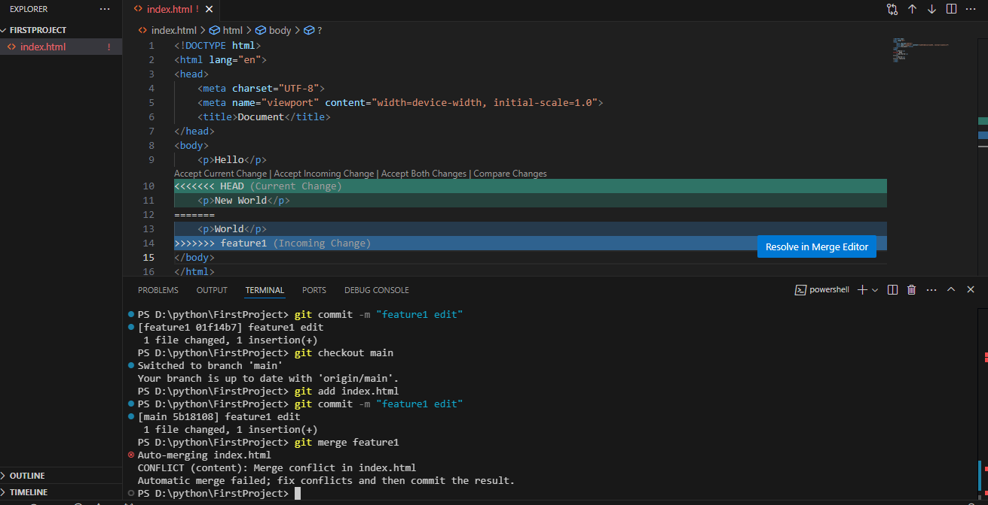
● After resolving the issue merge the branch
Task 6: Undo Mistake in Git
1.Modify a file and add it to the staging area:
○ | Using git add index.html

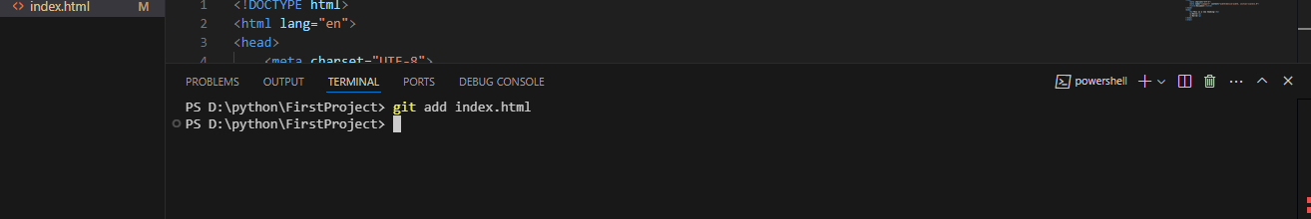
2.Commit the add:
○ Usinggit commit -m “New h1 tag added”
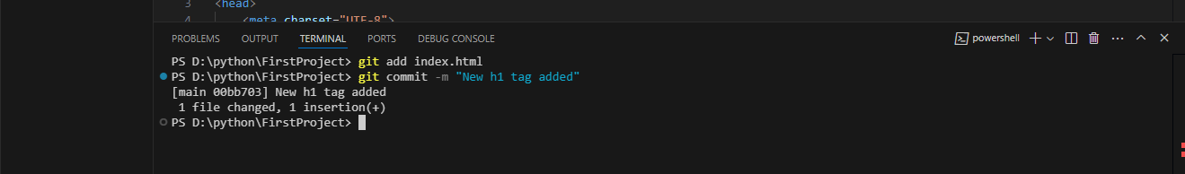
3.Undo the last commit while keeping the changes:
○ | Using git reset --hard HEAD~1
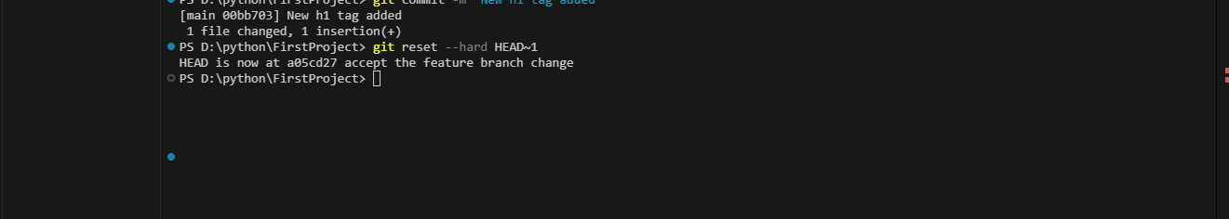

Lab # 7
Advanced GitHub Features (Including Forking)
Task 1: Forking a Repository
1.Fork a Repository:
○ Navigate to any public repository on GitHub (e.g., an open-source project or a provided practice repository).
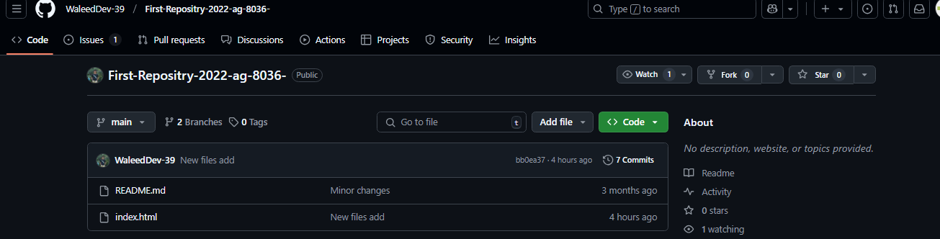
○ Click the Fork button in the top-right corner to create your own copy of the repository.
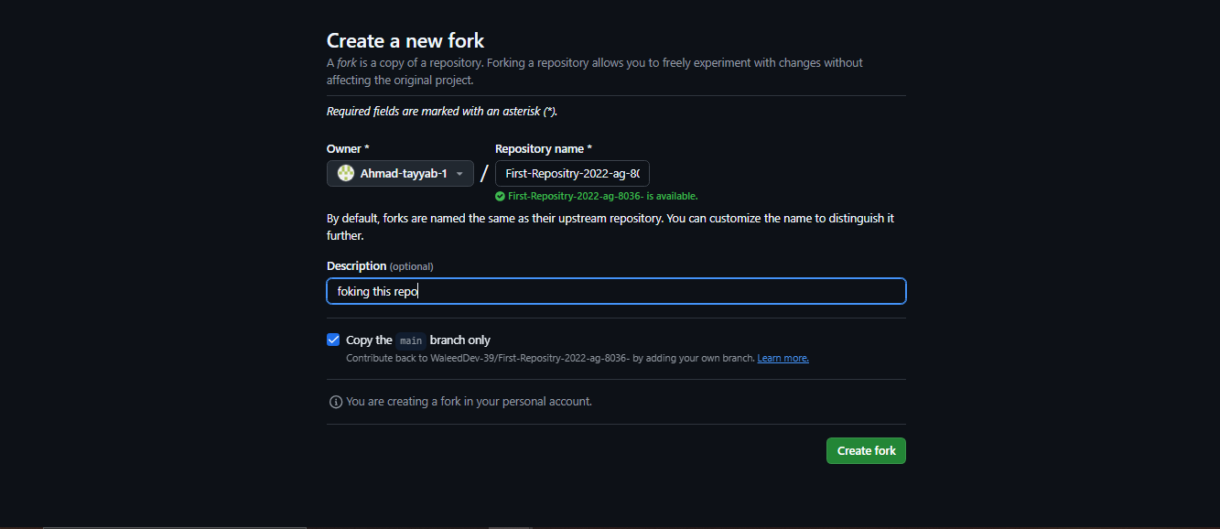

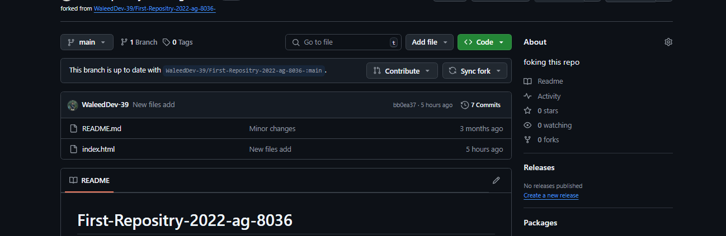
2.Clone the Forked Repository Locally:
○ Clone your forked repository to your local machine:
https://github.com/Ahmad-tayyab-1/First-Repositry-2022-ag-8036-.git
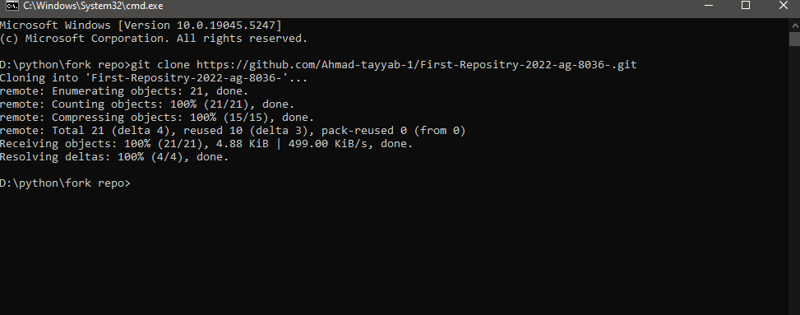
3.  4. | Make Changes in Your Fork:
 | · | Edit files or add new features in the forked repository.
 | Commit and Push Changes:
 | · | Stage and commit your changes:

git add index.html
git commit -m "Added new tag in index.html"
Push changes to your fork on GitHub:
git push -u origin main
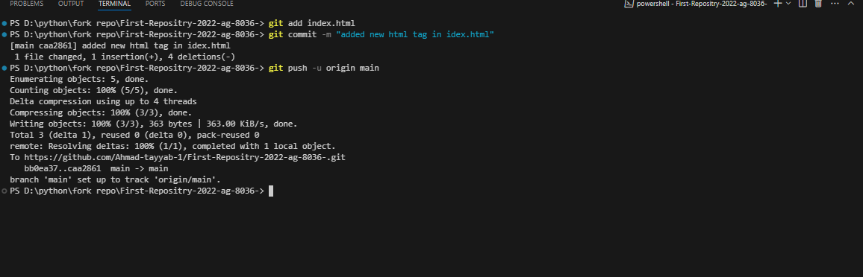
5. | Propose Changes to the Original Repository (Pull Request):
 | · | Navigate to your forked repository on GitHub.
 | · | Click Pull Requests > New Pull Request.
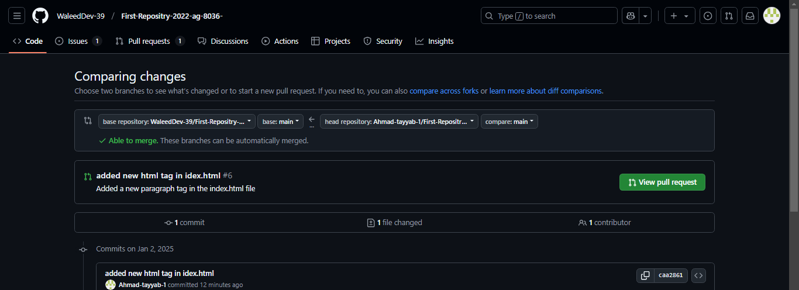

Compare your changes with the original repository and submit the pull request.
· Add a title and description to explain your changes.
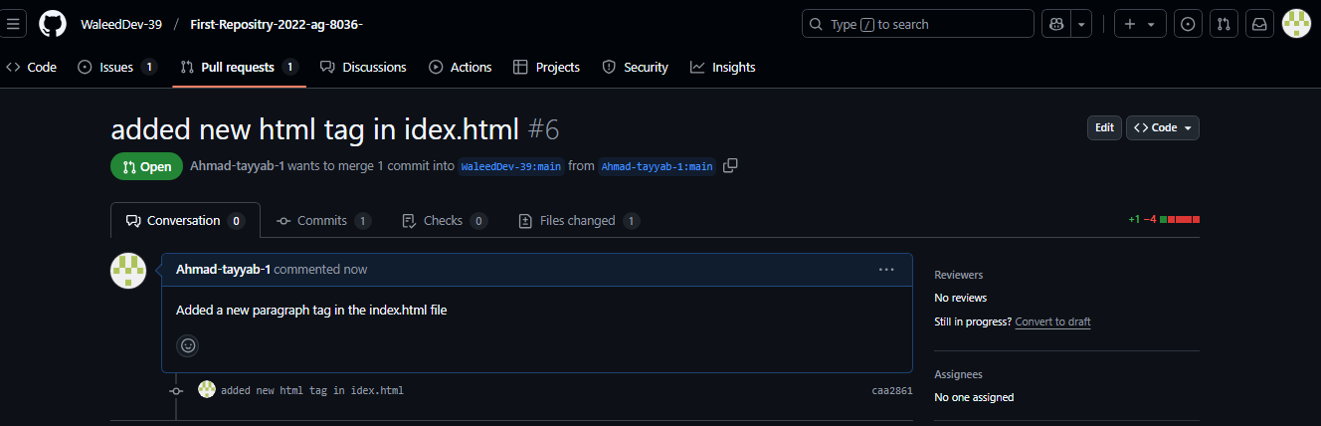
·
6. Track and Respond to Pull Request Reviews:
· Respond to comments or suggestions made by the original repository's maintainers.
· If changes are requested, update your branch and the pull request.
