AI Document Analyzer

Research Report I



Supervisor

Dr. M. Milhan Afzal

Submitted by

Muhammad Ahmad
AG #2022-AG-8042

BS Software Engineering
Department of Computer Science
University of Agriculture, Faisalabad.

Table of Contents

INTRODUCTION 4
1.1 Background 4
1.2 Description 4
1.3 Scope 4
1.4 Objectives 4
2. REQUIREMENTS 5
2.1 Functional Requirements 5
FR01: User Authentication and Login 5
FR02: User Account Registration 5
FR03: Document Upload 5
FR04: Text Extraction from Documents 5
FR05: Document Analysis 5
FR06: Document Summarization 6
FR07: Interactive Chatbot 6
FR08: MCQ and Quiz Generation 6
FR09: Question and Answer Generation 6
FR10: User Interaction and Navigation 6
FR11: Logout Functionality 6
2.2 Non- Functional Requirements 7
2.3 Hardware Requirements 8
2.4 Software Requirements 8
3. METHODOLOGY 8
3.2 Significance of the Iterative and Incremental Model 9
3.2 How the Model Fits the Project 9
3.2 Tools & Technologies 10
4. Gantt Chart Timeline 12

List of Figures

Figure 1: Iterative and Incremental Development Model for an AI-Based System 7
Figure 2: Gantt Chart of the project activities 9

INTRODUCTION

1.1 Background
With the rapid growth of digital content, students and professionals are required to process large volumes of documents such as books, research papers, and presentations. Manual reading and analysis of such documents is time-consuming and inefficient. The need for intelligent systems that can automatically understand and transform document content into interactive knowledge has become increasingly important.

Description
The AI-Powered Learning Support System is a sophisticated Django-based educational platform that leverages AI to help students and researchers interact with their learning materials. The system supports a wide range of document formats including PDF (with full text extraction and page tracking), Word documents (DOC/DOCX with automatic conversion to searchable PDF), PowerPoint presentations (PPTX with slide-by-slide extraction), Excel spreadsheets (XLSX), and plain text files (TXT). In addition to documents, the system supports YouTube learning by extracting transcripts directly from YouTube URLs, enabling users to chat with video content as if it were a document and generate study materials from lectures and tutorials. The AI assistant is powered by Groq Llama 3 (llama-3.3-70b-versatile) and provides context-aware chat with page and timestamp citations, smart text explanations, automatic flashcard generation, and both Multiple Choice and Short-Answer quiz generation. The platform is built on Django 6.0+ and uses PyMuPDF for high-performance PDF processing, LibreOffice (headless) for Office document conversion, and the youtube-transcript-api for reliable video caption fetching. Interactive study tools include an integrated PDF viewer, text highlighting for saving important sections, and full persistence of chat history and generated questions per document.

1.3 Scope
The scope of this project includes document upload, text extraction, semantic understanding, and interactive learning features. The system supports multiple document formats and provides AI-powered chat, summaries, and MCQ generation. It is intended for academic and professional use.

1.4 Objectives
Goals and objectives define what has to be done. A goal is simply a broad statement of what you want to do. The objectives are sub-goals, more detailed, that explain what must be done to achieve the goal. The project has one main goal and several specific objectives.
- Extract and clean textual content from uploaded documents using appropriate document processing techniques.
- Apply artificial intelligence and natural language processing techniques to analyze and understand the document content.
- Develop an interactive chatbot that answers user questions based on the uploaded document.
- Automatically generate summaries, quizzes, MCQs, and question–answer sets from the document content.

REQUIREMENTS

2.1 Functional Requirements
Any requirement which precisely specifies what the system should do is called a functional requirement of the system. A functional requirement describes the behavior or function of the system when certain conditions are met

FR01: User Authentication and Login
FR01-01 | System shall provide a login interface to the user.
FR01-02 | System shall get username and password from the user.
FR01-03 | System shall validate the entered username and password.
FR01-04 | System shall allow the user to log in if credentials are valid.
FR01-05 | System shall display an error message if login credentials are invalid.

FR02: User Account Registration
FR02-01 | System shall allow new users to create an account.
FR02-02 | System shall collect required information such as name, email, and password.
FR02-03 | System shall validate user input during registration.
FR02-04 | System shall store user account information securely.

FR03: Document Upload
FR03-01 | System shall allow users to upload documents.
FR03-02 | System shall support document formats including PDF, DOCX, and PPTX.
FR03-03 | System shall validate document format before upload.
FR03-04 | System shall store uploaded documents for processing.

FR04: Text Extraction from Documents
FR04-01 | System shall extract text from uploaded PDF documents.
FR04-02 | System shall extract text from uploaded DOCX documents.
FR04-03 | System shall extract text from uploaded PPTX documents.
FR04-04 | System shall clean and preprocess extracted text.

FR05: Document Analysis
FR05-01 | System shall analyze extracted text using AI and NLP techniques.
FR05-02 | System shall identify key topics from the document.
FR05-03 | System shall divide document content into logical sections.

FR06: Document Summarization
FR06-01 | System shall generate a summary of the document content.
FR06-02 | System shall present the summary in readable form to the user.

FR07: Interactive Chatbot
FR07-01 | System shall provide a chatbot interface to the user.
FR07-02 | System shall accept user questions related to the uploaded document.
FR07-03 | System shall generate answers based on document content.
FR07-04 | System shall display responses in real time.

FR08: MCQ and Quiz Generation
FR08-01 | System shall provide a user-friendly interface.
FR08-02 | System shall allow users to navigate between document, chatbot, and quiz modules.
FR-03 | System shall display system messages and notifications clearly.

FR09: Question and Answer Generation
FR09-01 | System shall generate short questions from document topics.
FR09-02 | System shall generate answers corresponding to the questions.

FR10: User Interaction and Navigation
FR10-01 | System shall provide a user-friendly interface.
FR10-02 | System shall allow users to navigate between document, chatbot, and quiz modules.
FR10-03 | System shall display system messages and notifications clearly.

FR11: Logout Functionality
FR11-01 | System shall allow users to log out from the system.
FR11-02 | System shall terminate user session after logout.

2.2 Non- Functional Requirements
Any requirement which specifies how the system performs a certain function is called a non-functional requirement. A non-functional requirement describes how a system should behave and what constraints or limits exist on its functionality. These requirements define the system’s quality attributes such as performance, availability, security, usability, reliability, and scalability.

ID | Category | Core Requirement
NFR1 | Availability | The system must remain accessible 24/7 and handle multiple requests without service interruption.
NFR2 | Performance | Queries and document processing must be completed within acceptable time limits without noticeable delay.
NFR3 | Usability | The interface must be intuitive, providing clear tooltips and helpful error/success messages.
NFR4 | Security | Access must be restricted by user roles, with secure authentication and protection of credentials.
NFR5 | Reliability | The system must function consistently and possess the ability to recover gracefully from unexpected errors.
NFR6 | Scalability | The architecture must support an increasing user base and future feature enhancements without losing speed.
NFR7 | Maintainability | The system must use a modular design to allow developers to apply updates and fixes with minimal impact.
NFR8 | Compatibility | Full functionality must be maintained across all major web browsers and different operating systems.
NFR9 | Data Integrity | The system must ensure data accuracy and prevent any loss or corruption during processing.
NFR10 | Interoperability | The system must integrate smoothly with external libraries and AI frameworks.

2.3 Hardware Requirements
Processor: Intel Core i3 CPU or above
Hard Disk: 5GB or more
RAM: 4GB or more

2.4 Software Requirements
Operating System: Windows10, Windows 8.1, Windows 8, Windows 7
Backend Technology: Python(Django or FastAPI)
Frontend Technology:Html,CSS JavaScript
DataBase: MySQL
Libraries and Frameworks:PyMuPDF, python-docx, python-pptx, NLP and AI libraries
Browser: Google Chrome, Firefox, Mozilla etc

METHODOLOGY

(For the development of the AI-Based Document Reader, Analyzer, and Learning Assistant, I have chosen the Iterative and Incremental Development Model. This approach allows the system to be developed through repeated cycles (iterative) and in small, manageable portions (incremental), ensuring that each functional module is refined and perfected before the next is added.

3.2 Significance of the Iterative and Incremental Model
The significance of choosing this model lies in its ability to handle complexity and uncertainty, which are inherent in AI-driven applications. Its key advantages include:
- Risk Management: By breaking the project into smaller increments, technical risks—such as difficulties in text extraction or AI response accuracy—can be identified and addressed early in the development lifecycle.
- Continuous Improvement: Unlike the traditional Waterfall model, this model allows for "loops." If the results from the AI analysis phase (Step 5) are not satisfactory, we can go back and refine the Preprocessing phase (Step 4) without disrupting the entire project.
- Operational Flexibility: It allows us to deliver a functional "core" (the document reader) while still working on the more advanced "enhancements" (the quiz and MCQ generator).
- Enhanced Quality Control: Testing is not a final step but an ongoing process. Each module is validated individually, leading to a more robust and error-free final system.

3.2 How the Model Fits the Project
The Iterative and Incremental model is uniquely suited for an AI Learning Assistant for the following reasons:
- Logical Dependency: The project has a strict hierarchy. The AI cannot analyze text until the Extraction module is perfect. By using an incremental approach, we ensure that the "foundation" (Steps 3 & 4) is stable before building the "intelligent" features (Steps 5, 6, & 7) on top of it.
- Handling AI Variability: AI models often require "prompt tuning" and adjustments. The iterative nature allows us to refine the Chatbot’s responses (Step 6) through multiple cycles of testing and feedback until the accuracy meets the user's needs.
- Feature Integration: This model allows for the progressive addition of features. We can first ensure the user can upload and read a document, then add the summary feature, then the chatbot, and finally the quiz generator. This prevents the development team from being overwhelmed by the complexity of the entire system at once.

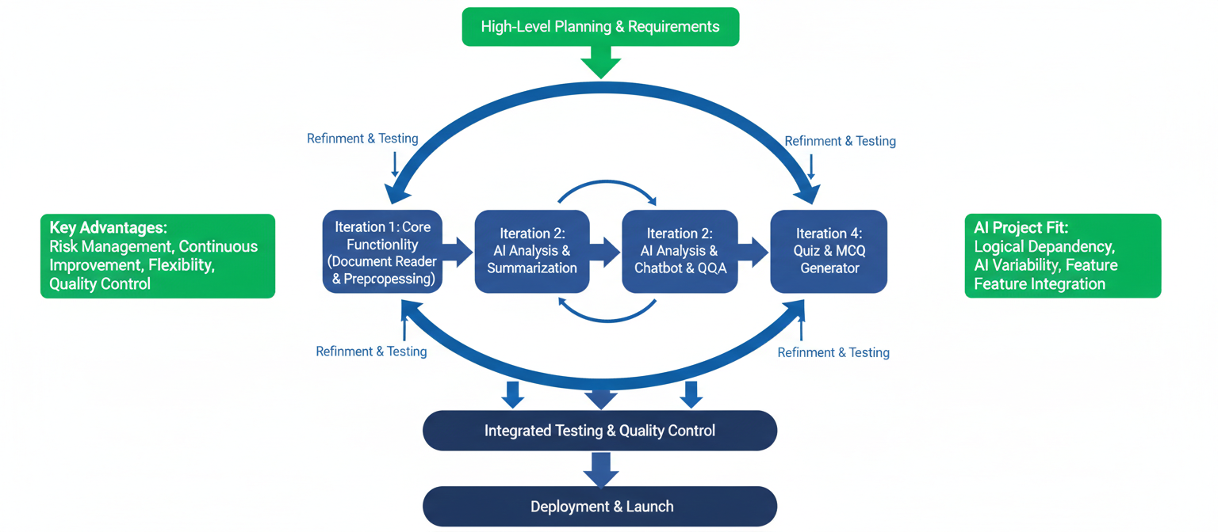

Figure 1: Iterative and Incremental Development Model for an AI-Based System

Tools & Technologies
The following tools and technologies are used for the development and implementation of the system:
Python
Python is used as the primary programming language due to its simplicity, flexibility, and strong support for AI and NLP libraries.
Django / FastAPI
Django or FastAPI is used as the backend framework to manage server-side logic, API handling, authentication, and system integration.
HTML, CSS, JavaScript
These technologies are used to design and develop the frontend user interface, ensuring an interactive and user-friendly experience.
MySQL
MySQL is used as the database management system to store user information, document metadata, and system records.
PyMuPDF
PyMuPDF is used for extracting text from PDF documents efficiently.
python-docx
This library is used to extract textual content from Microsoft Word documents.
python-pptx
This library is used to extract text from PowerPoint presentation files.
Natural Language Processing (NLP) Libraries
NLP libraries are used to analyze document content, generate summaries, and understand user queries.
AI Models (LLMs)
AI models are used to understand document semantics, generate answers, summaries, and quizzes.
Web Browser
Web browsers such as Google Chrome and Mozilla Firefox are used to access and test the system.

4. Gantt Chart Timeline
A Gantt chart is a timeline view that makes it easy to see how a project is tracking. You can visualize project tasks and see how they relate to each other as projects progress over time. Use this tool to simplify your tasks and details with a visual project timeline by transforming task names, start dates, durations, and end dates into cascading horizontal bar charts.
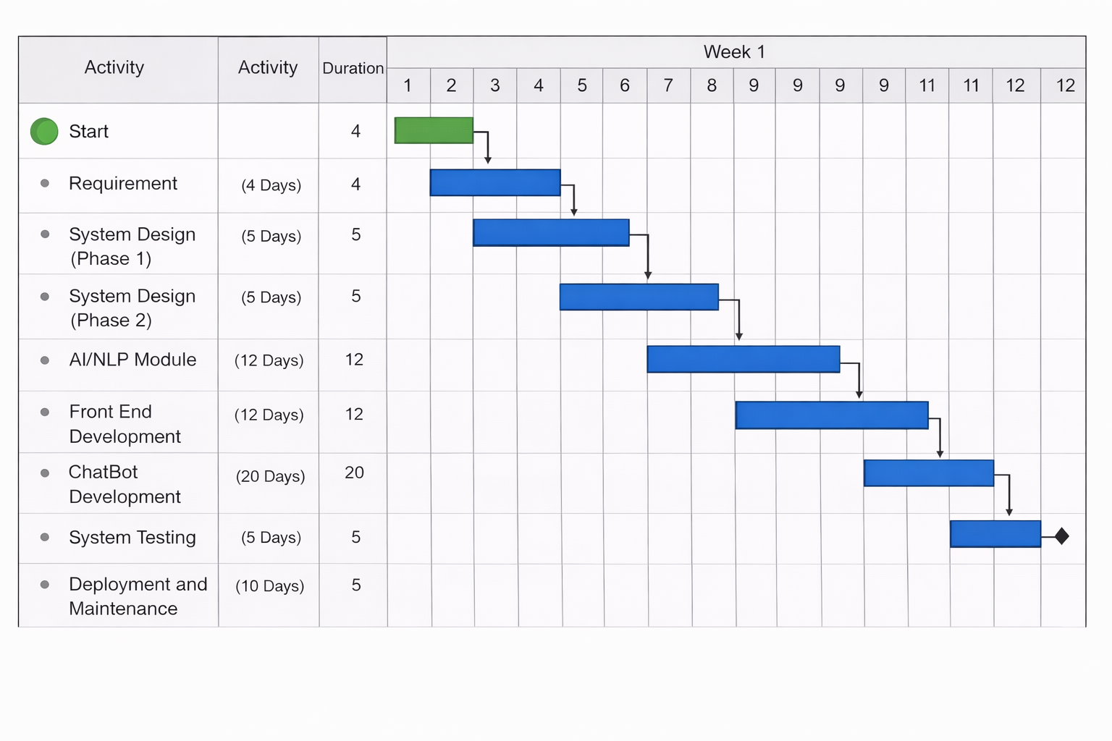

Figure 2: Gantt Chart of the project activities

