**GEMINDZ-EMS Task2 Solution**

**Software Requirements:**

1. Monitoring System:

* Collect real-time energy consumption data from the electric panel.
* Transmit data securely over Wi-Fi to the backend system by a frequency 1 reading / sec.

2. Web Interface Application:

* Receive and display energy consumption data.
* Provide visualization tools for users to understand their expenses.
* Implement budgeting features including setting, tracking, and alerting for overspending.

**Recommended Technologies:**

1. Monitoring System:

* Microcontroller (Raspberry Pi)
* Wi-Fi module for connectivity

2. Backend:

* Python for server-side logic
* Flask for RESTful API
* MySQL for database

3. Frontend:

* React.js for web interface and dynamic UI
* HTML,CSS and Javascript for building Frontend Components (eg. Dashboard Component,Budget Tracker Component,Alerts Component and Settings Component)

4. Cloud Services:

* AWS or Google Cloud for hosting backend services
* Firebase for authentication and real-time database

**Potential Dependencies:**

* Availability of Wi-Fi connectivity for data transmission.
* Compatibility of chosen Microcontroller with monitoring system requirements.
* API integration for visualization and budgeting features.
* Security and privacy compliance.

**MVP for Frontend:**

* Utilize React.js for web interface.
* Implement basic UI components for displaying real-time energy consumption data.
* Develop simple budgeting features such as setting budget limits and displaying current expenses.
* Time needed: 2-3 weeks.

**Software Architecture Graph:**

**Link : https://s.icepanel.io/UEycLc8MgqZDQb/b8y4**

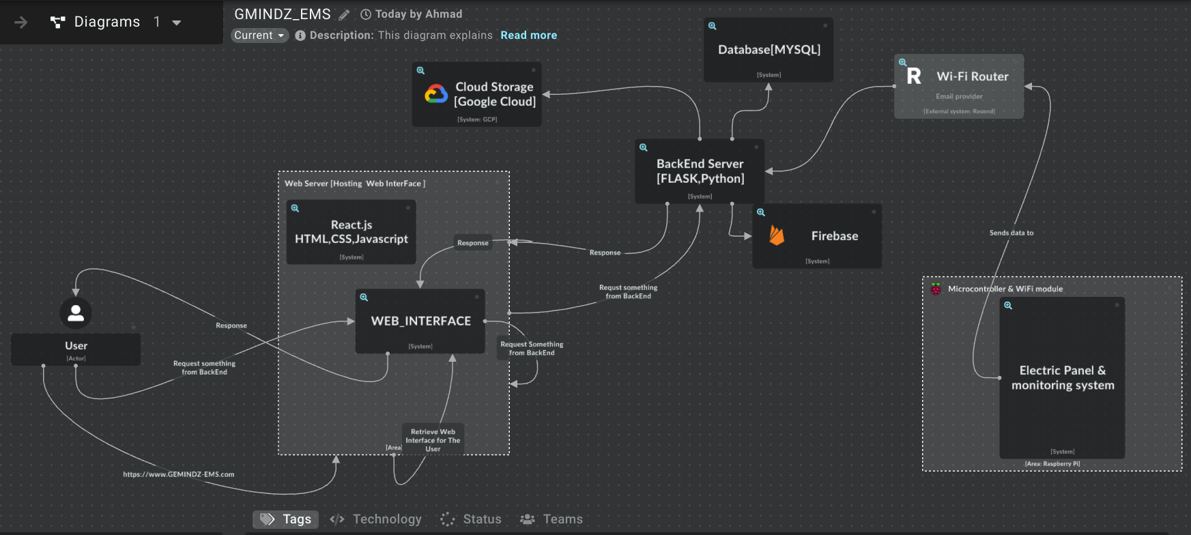

**Task Breakdown:**

1. Backend Development:

* Set up server and database: 1 week
* Implement RESTful API: 2 weeks
* Integrate with monitoring system: 1 week

2. Frontend Development:

* Design UI/UX: 1 week
* Develop real-time data visualization: 2 weeks
* Implement budgeting features: 2 weeks

3. Testing and Deployment:

* Unit testing and debugging: 1 week
* Integration testing: 1 week
* UAT & Deployment to production: 1 week

**Timeline and Milestones:**

* Week 1-2: Backend setup and API development
* Week 3-4: Frontend UI/UX design and real-time data visualization
* Week 5-6: Implementing budgeting features and testing
* Week 7 : Integration testing and deployment

Milestones:

* Backend API ready for integration(Week 2)
* Frontend UI/UX design finalized (Week 4)
* Budgeting features implemented (Week 6)
* Application deployed to production (Week 7)

**Storage Considerations:**

* Cloud storage is recommended for scalability and accessibility from web or mobile platforms.
* Local storage can be used for caching data on devices but may not be suitable for long-term storage or cross-platform access.

**Security and Privacy Considerations:**

* Implement HTTPS for secure data transmission.
* Use encryption for sensitive user data.
* Implement user authentication and authorization mechanisms.
* Regular security audits and updates to address vulnerabilities.

**Limitations and Challenges:**

* Dependency on stable Wi-Fi connectivity for real-time data transmission.
* Compatibility issues between monitoring hardware and software components.
* Ensuring data accuracy and reliability in real-time monitoring.
* Compliance with privacy regulations (e.g., GDPR) regarding user data collection and storage.

**To address limitations and challenges:**

1. Stable Wi-Fi Dependency:

* Implement robust error handling for network disruptions.
* Provide offline functionality for local data storage and synchronization.

2. Compatibility Issues:

* Standardize communication protocols and data formats.
* Conduct thorough compatibility testing between hardware and software.

3. Data Accuracy and Reliability:

* Implement sensor calibration procedures.
* Introduce error-checking mechanisms for data transmission.

4. privacy Compliance:

* Integrate privacy controls into the system architecture.
* Obtain explicit user consent for data collection.
* Encrypt sensitive data in transit and at rest.
* Implement access controls and authentication mechanisms.
* Conduct regular audits for ongoing compliance.