**Air University Multan campus**

**Department of Computer Science and Engineening**

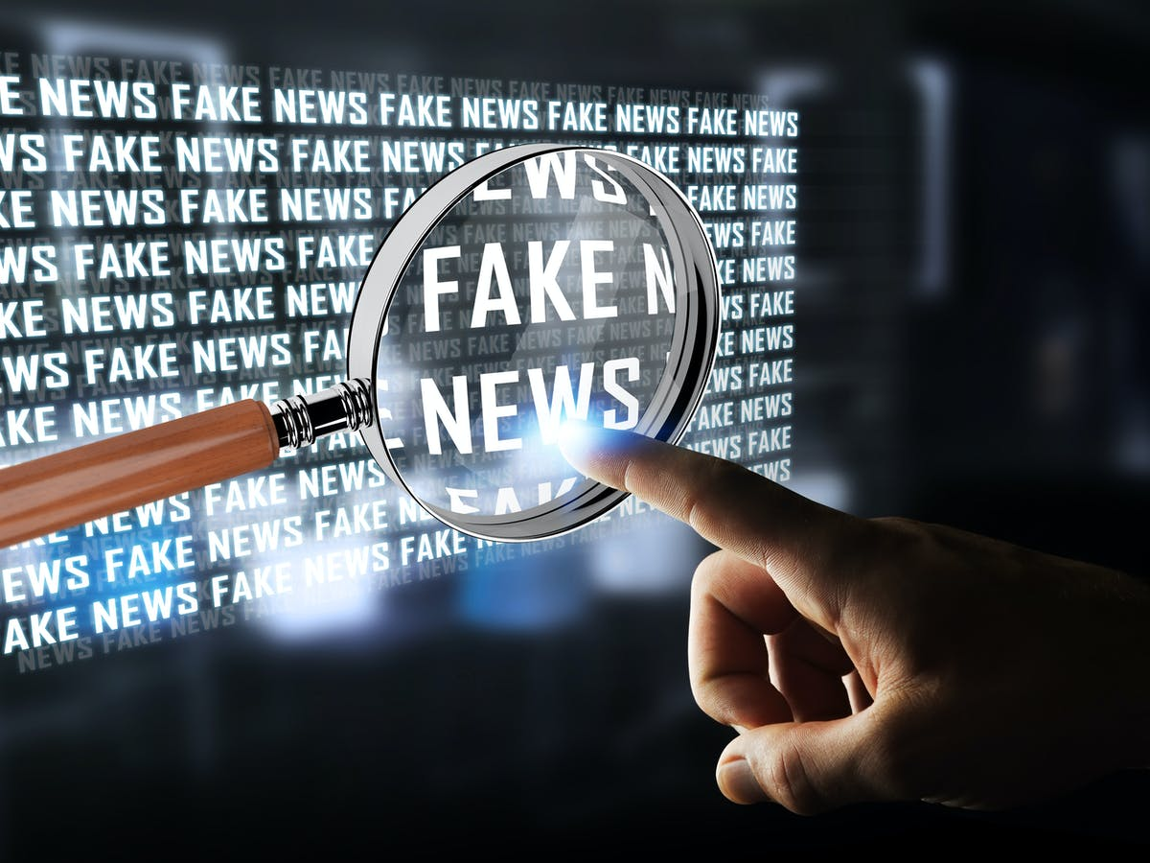

Fake News Detection

**Project Proposal**

Prepared by

|  |  |
| --- | --- |
| Group#: | Grade: |
| Group Email: | |
| Group members: | |
| *Muhammad Ahmad Ali, 183232, Role>* |  |
| *Syed Abdul Hanan, 183204, Role>* |  |
| *Muhammad Hamza Danish, 183164, Role>* |  |
| *Muhammad Adnan Ameen, 183166, Role>* |  |
| *Muhammad Saad Naeem, 183176, Role>* |  |

Supervised by

Faculty member

6th Semester Spring 2021

**Revision Table**

|  |  |  |  |
| --- | --- | --- | --- |
| **Page#** | **Section#** | **Reviewer** | **Corrected by (Reviewer, Author)** |
|  |  |  |  |
|  |  |  |  |
|  |  |  |  |
|  |  |  |  |
|  |  |  |  |
|  |  |  |  |
|  |  |  |  |

**Table of Contents**

1. Introduction 4

2. The Problem 4

3. Project Goals and Objectives 4

3.1. Goals 4

3.2. Objectives 4

4. The Solution 4

5. Project Scope 4

6. Hardware and Software Tools 4

6.1.Hardware 4

6.2.Software 4

7. Cost (if applicable) 5

8. Timeline 5

8.1.Activity Network 5

8.2.Bar Chart

9. Roles and Responsibilities 5

# **Introduction**

Fake news is a society problem as it creates big confusion in our society. These fake news have a lot of negative effect on conspiracy minded people. We have seen in the past how UK elections were rigged through social media by giving false news about the candidates. The most common type of fake news is done by rigging facts and confusing people.

1. **The Problem**

Fake news detection online is critical in today's society, as new news content is generated at a rapid rate due to the common availability of technology. Although many of these strategies for detecting fake news are generally effective, they are not without flaws.

1. **Project Goals and Objectives**

The main goal is to identify fake news, which is a standard text classification issue with a simple solution. It is necessary to develop a model that can distinguish between "true" and "fake" news. The aim of this project is to use machine learning algorithms to determine the truthfulness and limitations of language-based techniques for detecting false news.

# **The Solution**

We will use the Linguistic Cue approaches for or software. It is a supervised machine learning algorithm that teaches itself things as it goes through different detections. Essentially, Linguistic Cue approaches detect fake news by catching the information manipulators in the writing style of the news content.

# **Project Scope**

The main audience that is going safe by using our software is the Social media user whether it be the Facebook user, Twitter user, Instagram user etc. These users will have a substantial progress in their current affairs because now they will be getting fair and true news.

# **Cost**

Cost of our software will be determined as we proceed further but we can only tell the final price when we are done with the project.

# **Timeline**

We will achieve our first milestone by 30th April:

By this milestone, we would turn in our project proposal on GitHub. Our project's details will likely change throughout the semester, but it's important to have some starting point.

We will achieve our second milestone by 21st of May:

By this milestone, we would have implemented the “a” part of your Web application: Our application would be registered, optionally, to add some persistent data of their own such as user profile information or preferences.

We will achieve our third milestone by 28th May:

We must be able to open up several different Web browsers on a single computer, create independent user accounts, log in, remain logged in even after closing and re-opening their browser, do something in your app, and then log out.

We will achieve our fourth milestone by 5th June:

By this milestone, we would implement,

1. Frontend with React
2. Use Bootstrap for Styling
3. READ, CREATE, UPDATE, and DELETE tasks

# **Roles and Responsibilities**

Roles and responsibilities of project members are not yet decided but we are working as a team and right now. The little we know is:

|  |  |  |
| --- | --- | --- |
| **Role** | **Responsibilities** | **Participant(s)** |
| Project Leader |  |  |
| Analysis |  |  |
| Design |  |  |
| Implementation |  |  |
| Testing |  |  |
| Domain Experts |  |  |