
Final Year Project
UniVoy
Web Based


Department Of Computer Science & Information Technology
Project ID- COMP-4110

Project Advisor:
MS. ARJMAND MAJEED
Submitted By:
AHMAD AFAQ | LEF21EBSIT076
AMMAR AZHAR | LEF21EBSIT088
TATHEER ZAHRA | LEF21EBSIT002

Punjab College

31-C Muslim Town, Noon Avenue, Lahore

University of Education Lahore

UniVoy

BS in Information Technology-2025

A project submitted in partial fulfillment of the requirements
for the award of the degree of
BS in information Technology

PUNJAB GROUP OF COLLEGES
UNIVERSITY OF EDUCATION
LAHORE

July,2025

© Copyright UniVoy, 2025

“I hereby declare that I have read this project documentation and in my opinion this project is sufficient in terms of scope and quality for the award of the degree of BS in Information Technology.”

_______________________ _____________________

Project Primary Supervisor Project Examiner
Name: Ms.Arjmand Majeed University of Education
Designation: Lecturer
Punjab Group of Colleges

DECLARATION
I declare that this project title entitled “write your project title here” is the result of my own research and development except as cited in the references. This project has not been accepted for any degree and is not concurrently submitted in candidate for any other degree. At any time if my statement is found to be incorrect even afterwards of BS in Information Technology, the university has the right to withdraw my BS in Information Technology degree.

Signature: _______________________ Signature: _______________________
Name: _________________________ Name: _________________________
Date: ___________________________ Date: ___________________________

Signature: _______________________
Name: _________________________
Date: ___________________________

PLAGIARISM UNDERTAKEN
I solemnly declare that project work presented in this documentation entitles “UNIVOY” is solely my work with no significant contribution from any other person. Small contribution/help wherever taken has been acknowledged and that complete project has been written by me.
I understand that zero tolerance policy of the HEC and University of Education, Lahore towards plagiarism. Therefore, we as an author of the above titled project declare that no portion of my project documentation and any material used as reference is properly referred/ cited.
I undertake that of I am found guilty of any formal plagiarism in the above titled project even after award of BS, the University reserve the rights to withdraw/revoke my BS degree and that HEC and the University has the right to publish my name on the HEC/University Website on which names of students are place who submitted plagiarized projects.

Signature: _______________________ Signature: _______________________
Name: _________________________ Name: _________________________
Date: ___________________________ Date: ___________________________

Signature: _______________________
Name: _________________________
Date: ___________________________

CERTIFICATE OF APPROVAL
This is to certify that the project work presented in this documentation entitled, “UniVoy”, was conducted by “Ahmad Affaq”, “Ammar Azhar”, “Tatheer Zahra”, under the supervision of “MS.Arjmand Majeed”. No part of this project has been submitted anywhere else for any degree. This project is submitted to the “PUNJAB GROUP OF COLLEGES, University of Education” is partial fulfillment of the requirements of the degree of BS in Information Technology

Signature: _______________________ Signature: _______________________
Name: _________________________ Name: _________________________
Date: ___________________________ Date: ___________________________

Signature: _______________________
Name: _________________________
Date: ___________________________

______________________ _____________________

Project Primary Supervisor Project Examiner
Name: Ms.Arjmand Majeed
Designation: Lecturer
Punjab Group of Colleges

OFFICE OF CONTROLLER OF EXAMINATION NOTIFICATION

No: ___________ Date: _____________

It is notified for the nomination of all the concerned that Ahmad Affaq, Ammar Azhar, Tatheer Zahra BS student of Computer Science department of University of Education has completed all the requirements for the award of BS Degree in the discipline of Information Technology as per detail given hereunder:

BS in Information Technology Cumulative Result
 |  | Credit Hours:___________ |  |  | Cumulative  Grade Point  Average  (CGPA)
Registration No | Complete Name | Course work | Project | Total

Project Title: UniVoy
Name of Supervisor: Ms.Arjmand Majeed

Signed by
Controller of Examination

ACKNOWLEDGEMENT
We truly acknowledge the cooperation and help make by Name of MS. ARJMAND MAJEED, Lecturer of Punjab Group of Colleges. He has been a constant source of guidance throughout the course of this project. We would also like to thank Muhammad Shoaib from Lecturer, Punjab Group of Colleges for his help and guidance throughout this project. We are also thankful to our friends and families whose silent support led us to complete our project

1- Mr. Ahmad Affaq
2- Mr. Ammar Azhar
3- Ms. Tatheer Zahra

Date:
July 15, 2025

ABSTRACT
The UniVoy Website represents a significant advancement in web-based technology, offering a revolutionary approach to managing billing and revenue cycles in the healthcare industry. Built with the unique needs of the medical sector in mind, UniVoy reimagines the digital workflow to address longstanding inefficiencies and operational bottlenecks. This innovative system aims to streamline and modernize administrative processes by integrating essential billing tools into a single, cohesive platform.
Designed for medical billers, healthcare providers, and administrative staff, UniVoy directly tackles common pain points that often hinder productivity. Issues such as billing errors, delays in claims submission, and poor communication with insurance companies are prevalent challenges in healthcare management. By targeting these specific concerns, UniVoy improves workflow accuracy and significantly reduces the time and effort required to manage billing operations.
The initial version, UniVoy 1.0, comes equipped with core functionalities that form the foundation of a comprehensive billing system. These include user registration, patient management, claim creation and submission, and integration with essential medical coding systems like ICD-10 and CPT. Additionally, features such as denial management, payment posting, and detailed reporting enable users to maintain a clear and transparent overview of the financial status and performance of their medical practice.
What sets UniVoy apart is its adaptable and user-friendly design, which ensures smooth operation for a wide range of users, regardless of technical proficiency. The intuitive interface allows for efficient navigation and task completion, supporting clinics in their transition to digital billing. With this platform, healthcare providers can focus more on patient care and less on administrative burdens, making UniVoy an essential tool in the evolution of healthcare billing systems.

Table of Contents
CHAPTER NO: 1
Gathering & Analyzing Information
1.1 Introduction: 1
1.2 Problem Statement: 2
1.3 Goals & Objectives: 2
1.3.1 Goals: 2
1.3 Research Questions: 4
Supporting Research Questions 4
1.4 Methodology 4
1.5 Definitions, Acronyms, and Abbreviations 5
Definitions 5
Acronyms 5
Abbreviations 6
CHAPTER NO. 2: 7
Software Requirement Specification 7
2. Introduction 8
2.1 Purpose 8
2.2 Document Conventions 8
2.3 Intended Audience and Reading Suggestions 8
2.4 Product scope: 9
2.5 Overall Description 9
2.6 Product Perspective 10
2.7 Product Functions 10
2.8 User Classes and Characteristics 11
2.9 Operating Environment 12
2.10 Design and Implementation Constraints 12
2.11 User Documentation 12
2.13 External Interface Requirements 13
2.13.1 User Interface 13
2.13.1 Hardware Interfaces 14
2.14 Software Interfaces 15
2.15 Communication Interfaces 16
2.16 System Features 16
2.17 Performance Requirements 17
2.18 Safety Requirements 17
2.19 Security Requirements 17
2.21 Business Rule 18
Chapter 3: 20
Analysis [Use Case Description and Use Case Model] 20
3.1 User Use Case 21
CHAPTER 4: 61
Design [with description of each diagram] 61
4.1 Architecture Diagram 62
4.2 ERD Diagram 62
4.3 Data Flow Diagram Level 0 62
External Entities and Their Interactions: 63
4.4 Data Flow Diagram Level 1 63
4.5 Data Flow Diagram Level 2 64
4.6 Class Diagram 66
4.7 Sequence Diagram 67
Authentication 68
Dashboard & Review 68
User Assignment 68
University Management 69
Chat 69
Payments 69
Authentication 70
Course Selection 70
Application Process 70
Track Progress 71
Chat 71
Feedback 71
Login 72
Consultant Dashboard 72
Document Handling 72
Application Review 72
Additional Requirements 72
Application in Process 72
Chat with Admin 72
Commission Status 73
4.8 Activity Diagram 73
4.8.3 Consultant 76
4.9 Collaboration 77

List of Tables
Table 3. 1 Admin Login 26
Table 3. 2 Manage Users 28
Table 3. 3 Manage Data 31
Table 3. 4 Manage Payments 34
Table 3. 5 Consultant Login 37
Table 3. 6 Consultant Login 38
Table 3. 7Manage Student Application 41
Table 3. 8 Chat with Admin 43
Table 3. 9 Commission Payment 46
Table 3. 10 Student signUp 50
Table 3. 11 Submit Education Info 52
Table 3. 12 Select Uni 55
Table 3. 13 Submit submission form 57
Table 3. 14 Track application progress 59
Table 3. 15 Pay services charges 61
Table 3. 16 FeedBack 62

List of Figures
Figure 4. 1 Architecture 64
Figure 4. 2 DFD 0 65
Figure 4. 3 DFD 1 66
Figure 4. 4 DFD 2 Admin 67
Figure 4. 5 DFD 2 Student 68
Figure 4. 6 DFD 2 Consultant 68
Figure 4. 7 Class 69
Figure 4. 8 Sequence Admin 71
Figure 4. 9 Sequence Student 73
Figure 4. 10 Sequence Consultant 75
Figure 4. 11 Admin Activity 77
Figure 4. 12 Student Activity 78
Figure 4. 13 Consultant Activity 79
Figure 4. 14 Collaboration 80

CHAPTER NO: 1

Gathering & Analyzing Information

Introduction:
Many students want to study abroad but have trouble locating trustworthy and accurate information about colleges, programs, costs, scholarships, and application procedures. Our proposed project aims to help students who want to study in the UK, USA, and Australia with the help of our web-based consulting platform. Our platform will streamline the study abroad process and centralize necessary resources by bridging the gap between universities, consultants, and students.

Our platform has three stakeholder-specific user interfaces: Admin, Consultant, and Student. Students can use the student interface as a central location to research colleges and courses, filter results by country, subject, cost of tuition, and scholarship, and apply straight away. Students can use an interactive resource center with FAQs, study abroad guides, and tips, as well as track the status of their applications and view comprehensive university Msiles. Throughout their journey, this guarantees that students are informed.
Consultants can apply to universities, manage applications, examine student Msiles, and give feedback through the consultant interface. The smooth interaction of students, consultants, and administrators is made possible by an integrated communication tool, which guarantees individualized instruction and increases the chances of applications being accepted. By making sure that university requirements are met, consultants help close the gap between students and institutions.
As the system's backbone, the Admin interface allows administrators to manage information about colleges, classes, and scholarships while preserving the platform's functionality. It comes with tools for managing users, guaranteeing security, and an analytics dashboard to track user activity, application progress, and trends. The performance of over platform can be continuously enhanced thanks to these insights.
Our website will also include a payment platform. For payment purposes, account details will be given to the clients they have to deposit some amount as an initial deposit and the remaining amount will be charged after the whole process. This process of payment is reliable from both ends of admin and clients as clients do not have to share their card details and this mode of transaction is reliable and efficient.
Our project enhances the consulting process, making it more effective and efficient, while empowering students to explore global education opportunities. It streamlines decision-making by providing clear options and simplifies communication between students and consultants. Our platform centralizes essential resources, ensuring easy access to information and tools. By integrating these features, it supports a smoother application journey. Our approach transforms challenges into opportunities, paving the way for students to achieve their international education dreams.

Problem Statement:
Many students aspiring to study abroad face significant challenges in accessing reliable and centralized information about universities, courses, scholarships, application procedures, and consulting support. The lack of an integrated platform often leads to confusion, missed opportunities, and inefficient communication between students, consultants, and universities. Additionally, manual processes and scattered resources hinder timely decision-making and reduce the chances of successful admissions.
UniVoy aims to solve this problem by providing a comprehensive web-based platform that streamlines the entire study abroad process, offering tailored interfaces for students, consultants, and admins, along with tools for application management, document submission, progress tracking, direct communication, and secure payment handling—all in one unified system.

1.3 Goals & Objectives:

1.3.1 Goals:
Our project aims to create a user-friendly platform that simplifies the application process for study abroad programs for administrators, consultants, and students. Students will gain access to the platform to search for universities based on course offerings, intake periods, destinations, and scholarship options. They will also have the capability to submit their applications along with the required documents and track their application progress. Administrators will oversee operations, allocate consultants, and manage payments, while consultants will review and authenticate student documents, update application statuses, and oversee the applications assigned to them. Our system will feature a secure payment gateway and provide email notifications for updates, ensuring both scalability and security to effectively handle sensitive information and accommodate an increasing number of users.
- Goals:
- Create and put into use an easy-to-use student interface that allows students to look for universities by program, country, and scholarship. Additionally, they can monitor the progress of their applications and get alerts when their status changes. Lastly, they have access to recommendations that are tailored to their individual preferences.
Measurable Metric: By the end of the initial development phase, the interface must be finished with at least 90% of its features tested and functional.
- Establish a consultant interface that enables consultants to oversee student applications and Msiles, guaranteeing seamless communication between colleges and students. Help students with the application, university selection, and document submission processes.
Measurable Metric: In a test setting, at least 75% of consultants should be able to handle applications and interact with students without any problems.

- Create an admin interface that lets administrators manage platform data and control user roles, such as administrators, consultants, and students. Track platform analytics and update and manage course and university information.
Measurable Metric: By the project's conclusion, the admin dashboard will be fully functional, with roles, data updates, and analytics tested.
- Simplify the application process to cut down on submission errors and time. Make a detailed application tracking system for consultants and students. Install tools that automatically check application forms for errors.
Measurable Metric: 20% fewer application errors than with manual, conventional methods.
- Construct a scalable and safe backend architecture that can manage high user and data volumes. Encrypt sensitive student data and follow data privacy guidelines. Within the first year, make sure the platform can grow to accommodate up to 10,000 active users.
Measurable Metric: All user data is encrypted, and performance is examined to accommodate the volume of users without causing response time degradation.
- Establish a real-time support and notification system to notify students of any modifications to the application or updates. Provide a system that notifies students in real time about deadlines, new opportunities, and the status of their applications.
Measurable Metric: Within 24 hours of any changes, 100% of students will receive timely notifications about the status of their applications.
- To make sure our platform is usable and accessible, pay close attention to the user interface and user experience (UI/UX). Create an interface that is easy to use, improves user experience, and requires little training. At least fifty students and twenty consultants should participate in user testing in order to collect input and improve the design.
Measurable Metric: Reach a minimum of 85% user satisfaction in surveys conducted after the launch.

- Objectives:
- The main objective is to furnish learners with a unified hub that supplies all essential details about universities, programs, financial aid options, and application procedures in nations such as the UK, USA, and Australia.
- ‘UniVoy’ seeks to make the university application journey easier and more efficient, allowing students to effortlessly maneuver through the intricacies of studying internationally with support and comfort.
- The initiative seeks to provide customized suggestions, assistance, and direction for learners while allowing advisors to facilitate individualized counsel and application oversight.
- Our aims are clear, quantifiable actions that will be implemented to fulfill the larger goals. These aims represent the functional steps that constitute the foundation of the project's initiatives and assessment.

Research Questions:

Supporting Research Questions
- What are the common barriers students face when applying to universities abroad (UK, USA, Australia)?
- How effective is consultant support in enhancing student application outcomes?
- What role does real-time communication and application tracking play in student satisfaction and success?
- How can integrating payment processing without card data enhance security and trust?
- What features are most essential for each stakeholder (student, consultant, admin) to streamline the process?

Methodology
Available Methodologies
- Waterfall Model
- Agile Software Development
- Iterative and Incremental Development
- Spiral Model

Chosen Methodology
Agile Software Development
Agile is a flexible way of developing software where work is done in small parts instead of all at once. The project is broken down into short time periods called sprints. In each sprint, a part of the system is developed, tested, and shared with users to get feedback. This method supports ongoing testing, easy changes, and teamwork between developers and users. It’s a good choice for projects like medical billing systems because it helps meet changing needs, ensures the system stays secure, and allows for improvements based on real user input.
Reasons for Chosen Methodology
Agile was selected because it offers a practical way to handle changing needs during development. It allows the project to be divided into smaller parts that can be built and tested step by step. This makes it easier to fix issues early, get regular input from users, and make improvements quickly. Since medical billing systems require accuracy, security, and user-friendliness, Agile helps ensure the final product meets those expectations through ongoing updates and teamwork.

Definitions, Acronyms, and Abbreviations

Definitions
- Univoy: A web-based consulting platform that helps students apply to universities in the UK, USA, and Australia by centralizing information and streamlining communication.
- Student: A user seeking to apply for higher education abroad.
- Consultant: A professional who guides students through the application process, including document verification, university selection, and interview preparation.
- Admin: Platform operator responsible for managing users, data, and overall system performance.
- University Profile: A detailed listing of a university, including courses, fees, eligibility, deadlines, and scholarship options.
- Application Tracker: A feature that allows students to monitor the status of their university applications in real-time.
- Interactive Resource Center: A section with FAQs, guides, and tips for students.

Acronyms
Acronym | Full Form
CRM | Customer Relationship Management
UI | User Interface
UX | User Experience
OTP | One-Time Password
DB | Database
API | Application Programming Interface
PDF | Portable Document Format
ID | Identification Document
FAQ | Frequently Asked Questions

Abbreviations
- Uni – University
- Docs – Documents
- App – Application
- Info – Information
- Msgs – Messages
- Int’l – International
- Pgms – Programs
- Stu – Student (internal short tag in code or dashboards)

.

CHAPTER NO. 2:

Software Requirement Specification

2. Introduction

Purpose
The purpose of this project is to develop a comprehensive web-based consulting platform that simplifies and supports the study abroad process for students aiming to pursue higher education in the UK, USA, and Australia. The platform aims to centralize accurate and trustworthy information about universities, courses, scholarships, tuition fees, and application procedures, while facilitating seamless interaction between students, consultants, and administrators. By offering tailored interfaces, application tracking, expert guidance, and a secure payment process, the platform seeks to enhance accessibility, transparency, and efficiency in the international education journey.
Providing a centralized hub for research and application management, the platform empowers students with up-to-date resources such as study guides, FAQs, and tips to make informed decisions. Consultants play a key role in increasing acceptance rates by aligning applications with university requirements, while administrators ensure smooth system operations and monitor performance through advanced analytics. Overall, the platform’s purpose is to bridge the gap between aspiring international students and global universities, transforming a complex process into a streamlined, user-friendly experience.

2.2 Document Conventions
The document follows the IEEE 830 standard for Software Requirements Specifications (SRS), which includes selections on system requirements, functional and non-functional requirements, and design and implementation constraints. The document will use simple and concise language and terminology to make it easy for the intended audience to understand the system’s requirements and features.
It uses:
Language: Times New Roman
Page size: A4
Font Size: Main Headings (16), Sub Headings (14), Paragraph (12)
Main Headings and Sub Headings: Bold
Bullet Points
Line spacing: 1.0
Text Format: Normal and Plain text

2.3 Intended Audience and Reading Suggestions
The intended audience for the UniVoy Study Abroad Consulting Platform includes all key stakeholders involved in managing, guiding, or using the platform to apply for international education opportunities. This documentation is structured to help each user group understand their specific roles and how to effectively interact with the system.
- Admin:
Administrators are responsible for managing the overall platform, ensuring its functionality, security, and data integrity. Their tasks include overseeing university, course, and scholarship listings, managing user access, and monitoring platform activity through analytics. Admins should focus on sections related to user and content management, system security, report generation, and analytics dashboards.
- Consultant:
Consultants serve as intermediaries between students and universities. Their responsibilities include reviewing student profiles, offering guidance, applying to institutions on behalf of students, and ensuring that all application requirements are met. Consultants should refer to sections on student interaction, application processing, university matching, and communication tools to maximize the effectiveness of their support.
- Student:
Students are the primary users of the platform, utilizing it to research universities and programs, filter options based on preferences, and apply to selected institutions. They can also access educational resources, track application status, and receive guidance from consultants. Students should pay special attention to sections on university and course search, application submission, resource center usage, and communication with consultants.

2.4 Product scope:
UniVoy is designed to simplify the process of studying abroad by offering the following key features:
- Comprehensive University and Program Information: Providing students with in-depth details on universities, programs, and courses to aid in informed decision-making.
- Guidance on Admission Requirements and Scholarships: Offering clear and up-to-date information on eligibility criteria, application processes, and available financial aid options.
- Streamlined Application Process: Enabling a seamless and user-friendly experience for students to apply through an intuitive interface.
The platform will serve both students and consultants, facilitating a smoother studyabroad journey and improving application efficiency. UniVoy aims to provide reliable, accessible consultancy services, bridging the gap between students and global education opportunities, and empowering them to make well-informed choices.

2.5 Overall Description
UniVoy is a web-based consulting platform designed to assist students in applying for higher education abroad, specifically in the UK, USA, and Australia. It connects students, consultants, and administrators through dedicated interfaces, enabling students to search for programs using filters such as country, tuition, and scholarships, submit applications, and track their progress. Consultants guide students, manage applications, and ensure university requirements are met, while admins oversee platform data, user management, and analytics. UniVoy centralizes essential resources, simplifies communication, and enhances the overall efficiency and transparency of the study abroad process.

2.6 Product Perspective
UniVoy is a platform designed to streamline the study-abroad application process. By consolidating information on universities, courses, scholarships, and admission requirements into a centralized system, it offers easy access for students, consultants, and administrators alike.
The platform features three key user interfaces:
- Student Interface: Enables students to search for universities, view program details, submit applications, and track their application status.
- Consultant Interface: Allows consultants to manage student applications, and provide personalized guidance, and support throughout the application process.
- Admin Interface: Provides administrators with tools to manage user data, update university information, and oversee platform operations.
In future iterations, UniVoy may integrate with external systems to support advanced payment processing such as card payment, and enable automatic updates from university databases, further enhancing its functionality and user experience.

2.7 Product Functions
The UniVoy platform offers a comprehensive suite of functions tailored to meet the needs of students, consultants, and administrators involved in the study abroad process. Key product functions include:

1. Student Functions:
- University and Course Search: Allows students to browse and filter universities and programs based on country, subject, tuition fee range, and scholarship availability.
- Application Management: Enables students to apply to selected universities directly through the platform and track the progress of each application.
- Interactive Resource Center: Provides access to guides, FAQs, tips, and articles to support students throughout their study abroad journey.
- Profile Management: Lets students create and update personal profiles with academic records, preferences, and supporting documents.
- Real-time Communication: Facilitates chat or message-based communication with consultants for personalized guidance and support.
- Application Status Tracking: Offers a visual timeline and status updates for each submitted application.

2. Consultant Functions:
- Student Profile Review: Provides access to detailed student profiles to assess eligibility and recommend suitable institutions.
- University Application Support: Allows consultants to assist students with filling out and submitting applications.
- Feedback and Guidance Tools: Enables consultants to provide written or recorded feedback on student documents and choices.
- Communication System: Supports two-way communication with students via chat, messages, or video consultations.
- Task and Document Management: Helps consultants manage required documents, tasks, and deadlines for each student.

3. Admin Functions:
- University, Course, and Scholarship Management: Admins can add, edit, or remove listings for institutions, programs, and scholarships.
- User Management: Controls registration, roles, and access levels for students and consultants.
- System Security and Monitoring: Ensures data security, compliance, and platform stability.
- Analytics and Reporting Dashboard: Provides insights into user activity, application statistics, performance trends, and platform usage.
- Content Moderation: Manages articles, resources, and announcements published on the platform.

4. Payment Management:
- Secure Payment Process: Offers a bank-based deposit system for initial and final payments, ensuring secure transactions without requiring credit card sharing.
- Transaction Tracking: Allows users and admins to track payment status and history for transparency and accountability.

2.8 User Classes and Characteristics
Students :
- Frequency of Use: Frequent, especially during application periods.
- Characteristics: Individuals seeking higher education abroad, with limited technical expertise requiring an intuitive interface. • Functions: Search, apply, and track applications.
Consulting :
- Frequency of Use: Regular, during student interactions and application reviews.
- Characteristics: Experts in international education, guiding students through the process.
- Functions: Manage applications and provide application support.
Administrators :
- Frequency of Use: Regular, focusing on system management tasks.
- Characteristics: Technically proficient users managing sensitive data.
- Functions: Update system content, oversee users, and generate reports.

2.9 Operating Environment
The platform will be accessible on standard desktop and mobile devices, supporting operating systems like Windows, macOS, Linux, and modern browsers such as Chrome, Firefox, Safari, and Edge. It will be hosted on cloud servers and utilize MongoDB for data storage. Third-party integrations will handle payment processing and notifications.

2.10 Design and Implementation Constraints
Technologies:
- Frontend: React.js will be used for building the user interface, providing a dynamic and responsive experience.
- Backend: Node.js, in combination with Express.js, will power the server-side logic, ensuring efficient handling of API requests and application processing.
- Database: MongoDB will serve as the database, offering flexible, scalable storage for user data, applications, and university/course information.
Hosting:
The platform will be hosted on cloud-based servers, such as Hostinger, ensuring scalability, reliability, and high availability.
Compliance:
- Security: The platform will adhere to modern security practices, including the use of JWT (JSON Web Tokens) for secure user authentication and authorization.
- Data Protection: The platform will be fully compliant with GDPR (General Data Protection Regulation) to ensure that user data is handled with the utmost care and respect for privacy.
Integration:

The system will be designed to integrate with third-party APIs to support essential functionalities, including:
- Payment Processing: For secure transaction handling.
- Email Services: For notifications, reminders, and communication with users.

2.11 User Documentation
- User Manual: Detailed guides for students, consultants, and administrators.
- Online Help: Embedded help system within the platform.
- Tutorials: Step-by-step guides for key functionalities like university search and application submission.
- Admin Guide: Instructions for system management tasks.
All documentation will be available online and as downloadable PDFs.

2.12 Assumptions and Dependencies
Assumptions:
- User Accessibility:
To ensure optimal functionality and user experience, users are assumed to have access to modern web browsers (such as Chrome, Firefox, and Safari) and a stable internet connection.
- Third-Party Services:
The platform relies on the continued reliability and availability of third-party services, including payment gateways (e.g., Easypaisa) and communication tools (e.g., SendGrid) for email notifications. Any disruptions or changes in the functionality of these services may impact platform operations.
- Cloud Hosting Providers:
The platform is dependent on cloud hosting services (e.g., Hostinger) to meet scalability and performance requirements. The hosting provider must support the anticipated traffic and resource demands, ensuring reliable uptime and system responsiveness.

2.13 External Interface Requirements

2.13.1 User Interface
- Student Interface:
- The student interface will allow users to:
- Search and filter universities based on various criteria such as location, programs, and tuition fees.
- View course details, including program descriptions, admission requirements, and available scholarships.
- Submit applications to selected universities and track the status of their applications.
- Consultant Interface:
- The consultant interface will enable users to:
- Manage and track student applications, ensuring that all required documentation is submitted and deadlines are met.
- Provide personalized guidance and support to students throughout their application process.
- Admin Interface:
- The admin interface will provide administrators with the tools to:
- Manage user accounts, including student, consultant, and administrator profiles.
- Update and manage content, including university and course details.
- Generate reports on platform activity, user interactions, and system performance.
- All interfaces will be mobile-responsive, ensuring an optimal user experience across various devices. The design will feature consistent navigation and intuitive layouts, making it easy for users to access and interact with the platform’s functionalities.

2.13.1 Hardware Interfaces

Supported Devices:
The platform will support a wide range of devices, including:
- Desktop Computers
- Laptops
- Tablets
- Smartphones
All devices must have internet connectivity to access the platform and perform necessary tasks.
1:Protocols:
Data exchange between the platform and user devices will be conducted over HTTP/HTTPS, ensuring secure and reliable communication. HTTPS will be used for all sensitive transactions to protect user data and ensure privacy.
2:Software Interfaces
- Backend:
The backend will be built using Node.js with the Express.js framework, providing a scalable and efficient environment for handling server-side logic, API requests, and application processing.
- Database:
The platform will utilize MongoDB, a NoSQL database, for flexible and scalable storage of user data, application details, and other platform-related content.
- Third-Party Services:
- Easypaisa will be integrated for payment processing, enabling secure transactions for any applicable fees or services.
- SendGrid will be used for email notifications, allowing the platform to send automated communication such as application updates, reminders, and user confirmations.

3. APIs:
The platform will employ RESTful APIs, using JSON format for data communication between the front end and backend. This ensures seamless interaction, data exchange, and integration with third-party services.

4. Communications Interfaces
- Protocols:
The platform will use HTTPS with SSL/TLS encryption for all communication, ensuring secure data transmission between users and the system, safeguarding sensitive information from unauthorized access.
- Email:
SMTP (Simple Mail Transfer Protocol) will be utilized for email communications, with integration to services such as SendGrid for reliable and scalable delivery of notifications, reminders, and updates to users.
- Payment: For transaction processing, the platform will integrate with secure payment gateways, such as Easypaisa, to facilitate safe and seamless financial transactions between users and service providers.

2.14 Software Interfaces
- Web Browser Interface
  - Allows users to interact with the platform via Chrome, Firefox, etc.
  - Built with HTML, CSS, JavaScript (e.g., React.js).
- Backend Server Interface
  - Handles logic and API requests.
  - Built using Node.js, Django, or similar frameworks.
- Database Interface
  - Stores data like student info, applications, and universities.
  - Uses SQL (e.g., MySQL/PostgreSQL) or NoSQL (e.g., MongoDB).
- Payment Interface
  - Manages deposit-based payments.
  - May integrate with manual bank deposit or online gateway if needed.
- Email/Notification Interface
  - Sends updates on applications and platform activity to users.
  - SMTP or third-party services like SendGrid.

2.15 Communication Interfaces
UniVoy includes multiple communication interfaces to support effective interaction among students, consultants, and administrators:
- Student–Consultant Chat: Real-time messaging for personalized guidance, with support for document sharing and notifications.
- Video Consultations: Optional video calls via integrated tools (e.g., Zoom) for one-on-one sessions.
- Consultant–Admin Support: Internal query or ticketing system for consultants to contact admins.
- Student–Admin Support: Form-based or chat-based support for technical issues and general queries.
- Email & SMS Alerts: Automatic notifications for application updates, feedback, payment status, and important deadlines.
These interfaces ensure smooth, secure, and responsive communication throughout the study abroad process.

2.16 System Features
1:University and Course Search :
- Priority: High
- Functional Requirements:
    - Enable users to search universities and courses using filters such as country, field of study, and tuition fees.
    - Display search results in a sorted and user-friendly format based on selected criteria.
    - Ensure that invalid inputs (e.g., incorrect data entry or unsupported criteria) are handled gracefully, providing appropriate error messages or suggestions for correction.

2. Profile Management
- Priority: High
- Functional Requirements
    - Allow users to create, update, and validate their profiles, ensuring the accuracy and completeness of information.
    - Provide real-time feedback for profile updates, including validation of required fields such as personal details, educational background, and contact information.

3. Application Submission and Tracking
- Priority: High
- Functional Requirements
    - Enable users to submit applications to selected universities and programs.
    - Provide real-time status updates on the progress of submitted applications (e.g., received, under review, accepted, rejected).
    - Automatically notify users via email or platform notifications regarding any changes or updates in the application process, ensuring transparency and keeping users informed.
4. Payment Module
- Priority: High
- Functional Requirements:
  - Integrate Easypaisa as a secure payment gateway for handling transactions related to application fees or other charges.
  - Allow users to make payments conveniently within the platform, ensuring data security and compliance with financial regulations.
  - Provide real-time confirmation of successful payments, along with detailed receipts accessible through the user's account.

2.17 Performance Requirements
- Concurrent Users: The platform must be capable of handling at least 500 concurrent users without degradation in performance or responsiveness.
- Search Speed: Search results should be returned within 2 seconds, ensuring a fast and responsive user experience.
- Uptime: The platform should maintain an uptime of 99.9%, ensuring high availability and reliability for users at all times.
2.18 Safety Requirements
- Automated Backups: Perform daily automated backups of all critical data to prevent loss and facilitate recovery in case of system failure.
- Data Encryption: To ensure confidentiality, all sensitive data (e.g., user personal information, payment details) must be encrypted using industrystandard encryption techniques.
- Critical Action Confirmation: To prevent accidental or unauthorized operations, require user confirmation for critical actions (e.g., account deletion, application cancellation).
2.19 Security Requirements
- Multi-Factor Authentication (MFA): Implement MFA for admins and consultants to enhance account security and prevent unauthorized access.
- Data Transmission: Use HTTPS with TLS 1.3 for all data transmission to ensure secure communication between clients and the platform.
- Unauthorized Access Detection: The system should detect and report any unauthorized access attempts or suspicious activities to administrators in real time for immediate action.

2.20 Software Quality Attributes
To ensure a smooth and reliable experience, the system should possess the following software qualities:
- Scalability: The platform must be able to scale to support up to 10,000 active users simultaneously, with the potential for future expansion.
- Maintainability: The system should feature a modular design, enabling easy updates, bug fixes, and the addition of new features without disrupting the overall system functionality.
- Reliability: The platform must maintain an error rate below 0.01%, ensuring minimal disruption and smooth operation for users.
- Usability: Key user actions (e.g., submitting applications, updating profiles) should be achievable in 3 clicks or fewer, ensuring a user-friendly and intuitive interface.

2.21 Business Rule
1.User Role Management
  - Users must be assigned one of three roles: Student, Consultant, or Admin.
  - Each role has specific access permissions and functional limitations defined by the system.
- Application Submissions
  - Only students can submit applications, but applications must be reviewed and approved by a consultant before final submission to a university.
  - A student cannot apply to the same university more than once unless explicitly allowed by the admin.
- Consultant Assignment
  - Each student must be assigned to one consultant.
  - Consultants can only view and manage profiles of students assigned to them.
- Data Integrity and Privacy
  - All user data, including academic records and personal documents, must be securely stored and accessible only to authorized roles.
  - Communication and document sharing between users must comply with privacy and confidentiality standards.
- Payment Rules
  - Students must make an initial deposit before full access to the application process is granted.
  - Final payment must be completed before application submission to universities.
  - Payments are made via bank deposit; credit/debit card details are not collected or stored.
- University and Course Listings
  - Only admins are authorized to add, edit, or remove information related to universities, courses, and scholarships.
- Automated Notifications
  - The system must automatically notify students and consultants of application status updates, document requests, and important deadlines.
- Content Publishing
  - Admins manage and approve all public content (e.g., FAQs, blog articles, guides) published in the resource center.

Chapter 3:

Analysis [Use Case Description and Use Case Model]

3.1 User Use Case
The below figure shows the use case diagram of our project. It show the admin, student and consultant as actors and it shows their connections with each other.
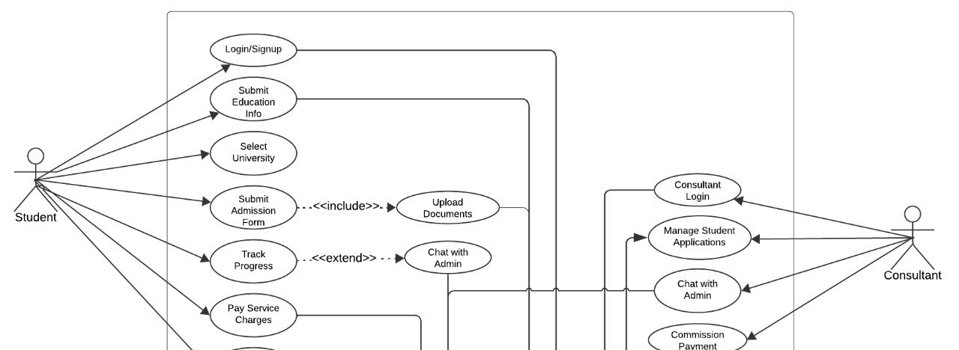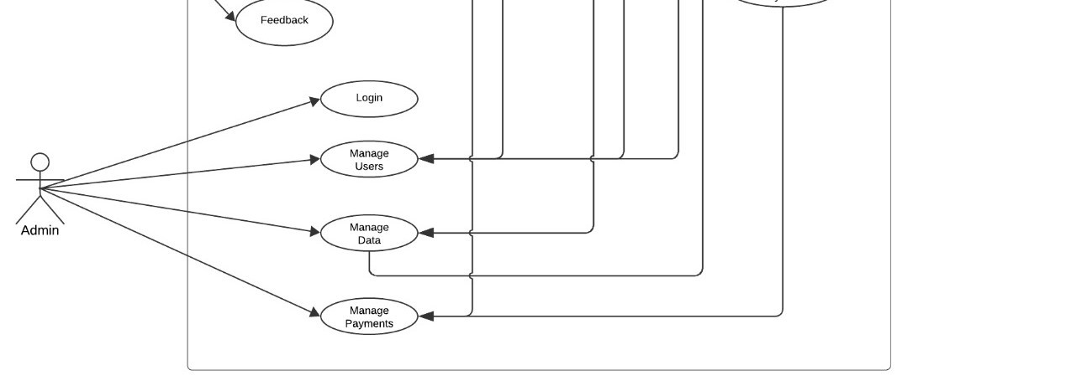
Figure 3. 1 UseCase

3.1.1 Admin Use Case
Admin: Use Case Scenario
UC Number: 1
UC Name: Admin
Functional Requirement No: FR1 Primary Actors/Stakeholders: Admin. Secondary Actors: System Admin
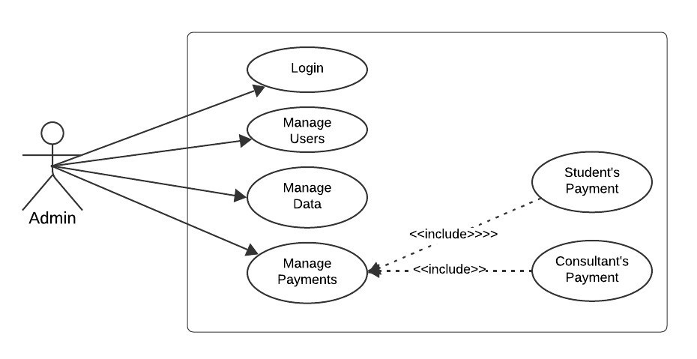
Figure 3. 2 Admin Figure

Description: The admin uses the system to manage users, including adding, editing, and deleting user accounts (students or consultants).
Preconditions:
- The admin must be logged into the system.
- The system should have a database with user records.
Main Success Scenario:
- The admin navigates to the "Manage Users" section.
- The admin views a list of users.
- The admin selects an action: Add, Edit, or Delete a user.
- The system performs the requested operation.
- The system updates the user list and confirms the changes.
Alternative Scenarios:
- The admin attempts to delete a user linked to active applications.
- The system shows an error if mandatory fields are missing while adding or editing a user.

Post Conditions:
- User data is successfully updated in the database.
- The updated user list is reflected in the system.
Extensions:
- If the admin tries to delete a linked user, the system prevents deletion and provides a warning.
- If mandatory fields are missing, the system prompts the admin to complete the required fields before submission.
3.1.2 Admin Login

Admin Login: Use Case Scenario
UC Number: 2
UC Name: Admin Login
Functional Requirement No: FR2 Primary Actors: Admin.
Secondary Actors: System Admin

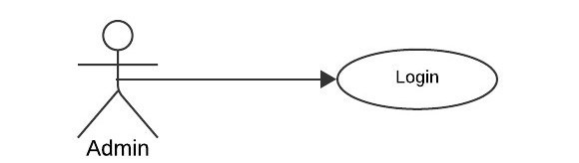
Figure 3. 3 Admin

Description:
The system prompts users to log in with their credentials to access their respective interfaces (Admin).
Preconditions:
- The user must have a valid account.
Main Success Scenario:
- The user opens the system (website).
- The user enters a valid username and password.
- The system validates the entered credentials.
- The system determines the user’s role.
- The user is redirected to their respective dashboard.
Alternative Scenarios:
- The system detects invalid login credentials.
- The user has already logged into the system from another session.
Post Conditions:
- The user gains access to the system.
- The user can perform actions based on their role.
Extensions:
The system determines that the password is incorrect:
- The system prompts the user to re-enter the password.

TEST CASE SCENARIO
Test Case ID: TC01
Test Case Name: Login
Test Priority: High
Preconditions: The user must have a valid account.
Test Steps:
- Navigate to the login page of the system.
- Enter the correct username and password.
- Click on the "Login" button.
- Verify that the system redirects users to the correct dashboard based on their role.
Expected Outcome:
- The system successfully logs in the user and displays the appropriate dashboard.
Post Conditions:
- The user successfully logs in.
- The user can perform actions assigned to their role.

SN | Actions | Inputs | Expected outcomes | Actual output | Test application | Test result | Test comments
1 | Enter a valid username and password | Usernam  e: admin,  Password  : [valid  password  ] | The system validates the credentials successfull y and logs in to the  Admin | Redirected to Admin Dashboard | UniVoy | Pass | [Admin, 0101-3] Action successful
2 | Click on "Login" button | - | User is redirected to the  Admin  Dashboard | Redirected to Admin Dashboard | UniVoy | Pass | [Admin, 0101-3] Action successful
Table 3. 1 Admin Login

3.1.3 Manage Users
Manage Users: Use Case Scenario
UC Number: 3
UC Name: Manage Users
Functional Requirement No: FR3
Primary Actor: Admin
Secondary Actor: Students, Consultants

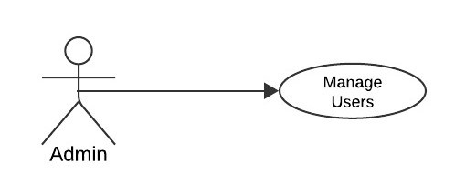

Description:
The Admin manages user accounts for both students and consultants. Admin can add, update, delete, or contact users and assign consultants to specific student applications for review.
Preconditions:
- Admin must be logged into the system with valid credentials.
- Student and consultant accounts must exist in the system for updates or assignments.
Main Use Case:
- Admin logs into the system and accesses the "Manage Users" feature.
- Admin views the list of students and consultants.
- Admin selects a user (student/consultant) and performs one of the following actions:
- Add a new user (student or consultant).
- Update user information (e.g., email, role, or assigned consultant).
- Delete a user account.
- Contact the user (via email or message).
- Assign a consultant to a specific student.

Alternative Scenarios:
- Admin attempts to delete a user currently assigned to an active application.
- The system prevents deletion and displays an error message.
- Admin attempts to assign a consultant unavailable (e.g., already handling maximum applications).
- The system prompts the admin to choose a different consultant.

Post Conditions:
- Users (students/consultants) are successfully managed in the system.
- Consultants are assigned to students where applicable.
Extensions:
- If the email address for a user is invalid, the system displays an error message during "Add" or "Update" actions.
- If the Admin tries to delete a consultant handling active applications, the system prevents the action and provides details about pending cases.

TEST CASE SCENARIO
Test Case ID: TC02
Test Case Name: Manage Users (Add, Update, Delete, Contact, Assign) Test Priority: High
Preconditions:
- Admin must have a valid account and be logged into the system.
- User data (students and consultants) should be present in the system for update or delete scenarios.
SN | Actions | Inputs | Expected Outcomes | Actual  Outputs | Test  Application | Test Result | Test  Comments
1 | View  the list of users | - | The system displays a list of registered users | List of users displayed | UniVoy | Pass | Action successful
2 | Search for a specific user | Username or email | The  system  filters and displays the searched user | User details displayed | UniVoy | Pass | Search functionality working
3 | Delete a user account | Select the user and click delete | The system confirms the deletion and  removes the user from the database | User successfully deleted | UniVoy | Pass | Deletion action successful
4 | View  the list of users | - | The system  displays a list of registered users | List of users displayed | UniVoy | Pass | Action successful
Table 3. 2 Manage Users

3.1.4 Manage Data

Manage Data: Use Case Scenario
UC Number: 4
UC Name: Manage Data
Functional Requirement No: FR4
Primary Actor: Admin
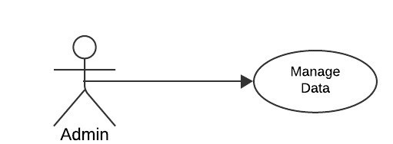

The Admin manages the system's database by updating, deleting, or adding information about universities, courses, and countries. Admin ensures that the information available to users is accurate and up-to-date, and new countries or universities can be added as necessary.
Preconditions:
- Admin must be logged into the system with appropriate access rights.
- The system database must be operational and accessible.

Main Use Case:
- Admin logs into the system and accesses the "Manage data" feature.
- Admin views the list of countries and universities in the database.
- Admin performs one or more of the following actions:
- Add a new university or country to the system.
- Update information about an existing university (e.g., courses, fees, scholarships, etc.).
- Delete outdated or incorrect information about a university or course.
- Admin saves the changes, ensuring the database reflects updated
Alternative Scenarios:
- Admin tries to delete a university or country currently associated with student applications.
- System prevents deletion and prompts Admin to address the active applications first.
- Admin enters invalid or duplicate data while adding a new university or country.
- System rejects the input and displays an error message.
Post Conditions:
- The database is updated with accurate and current information about universities, courses, and countries.
- New universities or countries are available for students to browse and apply. Extensions:
- If Admin tries to add a country that already exists in the database, the system notifies the Admin to check the existing record.
- If Admin deletes critical data (like an active university), the system requires a confirmation prompt and provides a list of associated data that might be affected.

TEST CASE SCENARIO
Test Case ID: TC03
Test Case Name: Manage Data (Update, Add, Delete)
Test Priority: High
Preconditions:
- Admin must have a valid account and system access rights.
- The database must be operational and contain initial data.

SN | Actions | Inputs | Expected Outcomes | Actual  Outputs | Test  Application | Test Result | Test  Comments
1 | Update data configur ation | Modify configu ration settings | The system saves the updated configurati on | System updated successf ully | UniVoy | Pass | Configurati on changes applied
2 | Add a new system role | Enter new  role details | The system saves the new role and assigns appropriate permission | The new role was added successf ully | UniVoy | Pass | Role creation successful
Table 3. 3 Manage Data

3.1.5 Manage Payments
Manage Payments Use Case Scenario
UC Number: 5
UC Name: Manage Payments
Functional Requirement No: FR5
Primary Actor: Admin
Secondary Actors: Student, Consultant.
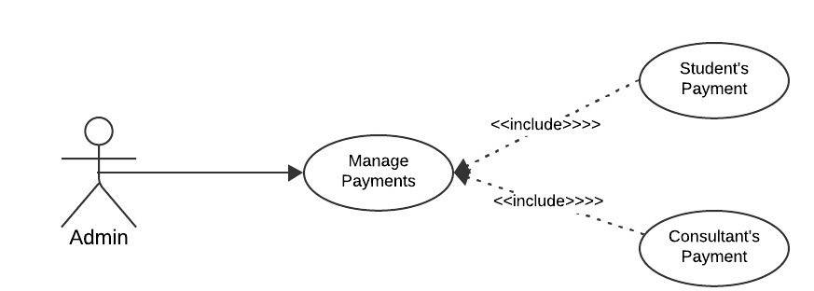

This use case handles payments where students pay admission charges to the admin, consultants receive commissions from universities, and consultants pay a percentage to the admin. The admin updates the payment records accordingly.
Preconditions
- The student must have an active account.
- The consultant must be assigned to a student.
- The system must have payment gateway integration.
Main Success Scenario:
- The student initiates the payment for admission charges.
- The admin receives the payment confirmation.
- The admin assigns the student to a consultant.
- The university pays a commission to the consultant.
- The consultant transfers a specific commission percentage to the admin.
- The admin updates the payment section in the system.

Alternative Scenarios
- Payment failed due to insufficient funds.
- Payment gateway timeout.
- The university delays the consultant commission.

Postconditions
- The student's payment status is marked as "Paid".
- The consultant receives their commission.
- The payment section is updated in the system.
Extensions
- If payment fails, the system prompts the user to retry.
- The admin is notified if the consultant doesn’t transfer the percentage on time.
TEST CASE SCENARIO
Test Case ID: TC04
Test Case Name: Manage payments Test Priority: High
SN | Action s | Inputs | Expected  Outcomes | Actual  Outputs | Test  Application | Test Result | Test  Comments
1 | View  all  payme  nt transac tions |  | The system displays a list of all  payment  transaction s | List of transacti ons displaye d | UniVoy | Pass | Payment transaction s visible
2 | Filter  payme nts by user type | Student/ Consulta  nt filter | System  filters and displays payments based on selected user type | Filtered  list  displaye d | UniVoy | Pass | Filter functionalit y working
3 | Genera  te a  payme  nt report | Select time range | The system generates a detailed  payment  report for the selected period | Payment report generate d | UniVoy | Pass | Report generation successful
Table 3. 4 Manage Payments
3.2.1 Consultant Use Case
Consultant: Use Case Scenario
UC Number: 6
UC Name: Consultant
Functional Requirement No: FR6 Primary Actor: Consultant
Secondary Actor: System Admin
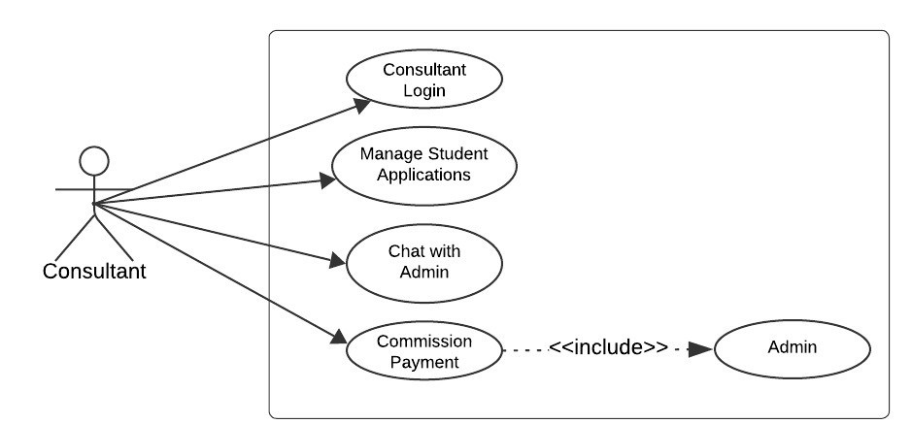

The system prompts the consultant to log in with their credentials to access their dashboard and related functionalities (e.g., managing student applications, chatting with Admin, handling payments).
Preconditions:
- The consultant must have a valid account in the system.
Main Success Scenario:
- The consultant opens the system (website).
- The consultant enters their username and password. • The system validates the entered credentials.
- The system confirms the user's role as a Consultant.
- The consultant is redirected to the Consultant Dashboard.
Alternative Scenarios:
- The system detects invalid login credentials and displays an error message.
- The consultant has already logged into the system from another session, and the system prompts them to terminate the other session or proceed.
Postconditions:
- The consultant gains access to their dashboard and can manage student applications, communicate with Admin, and view payment information.
Extensions:
- If the entered password is incorrect:
- The system prompts the consultant to re-enter the password or reset it.
- If the entered password is correct:
- The system prompts the consultant to the UniVoy Consultant dashboard.
3.2.1 Consultant Login
Consultant Login: Use Case Scenario
UC Number: 7
UC Name: Consultant Login
Functional Requirement No: FR7
Primary Actor: Consultant
Secondary Actor: Admin

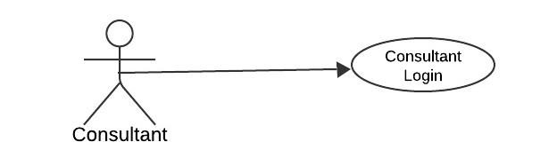

Description:
Consultants need to log in to the system using their credentials to access their dashboard and manage student applications. The system verifies their identity and role before granting access to relevant features.
Preconditions:
- The consultant must have a registered and verified account.
- The system must be online and accessible.
Main Success Scenario:
- The consultant navigates to the login page.
- The consultant enters their username/email and password.
- The system validates the credentials.
- The system determines the consultant's role.
- The system redirects the consultant to the consultant dashboard.
Alternative Scenarios:
A1: Incorrect credentials:
- The system displays an error message indicating invalid username or password.
- The consultant is prompted to re-enter the credentials or use the "Forgot Password" feature.
A2: Account not activated:
- The system displays a message stating the account is inactive.
- The consultant is instructed to activate their account via the provided link or contact support.
A3: Consultant already logged in elsewhere:
- The system notifies the consultant about an active session on another device.
- The consultant is given an option to log out from the previous session and log in.

Postconditions:
- The consultant is logged into their dashboard with access to appropriate functionalities.
- The system records the login in the activity logs.
Extensions:
- The system locks the consultant's account temporarily after three consecutive failed login attempts.
- The consultant receives an email notification with steps to unlock the account.
TEST CASE SCENARIO
Test Case ID: TC05
Test Case Name: Consultant Login
Test Priority: High
SN | Action s | Inputs | Expected  Outcomes | Actual  Outputs | Test  Application | Test Result | Test  Comments
Table 3. 5 Consultant Login  1 | Enter valid credent ials and login | Usernam e:  consultan  t,  Password  : [valid  password  ] | The system validates credentials successfull y and redirects to the  Consultant Dashboard | Redirect ed to Consult ant  Dashboa  rd | UniVoy | Pass | Consultant login functionalit y verified
2 | Sign up as a  new consult ant | Enter valid personal and professio nal details | System  registers the consultant and sends confirmatio n email | Consult ant account created successf ully | UniVoy | Pass | Consultant sign-up tested successfull y
3 | Attemp  t login with invalid credent  ials | Usernam e:  consultan  t,  Password  : [invalid password  ] | System displays an error message | Login failed with appropri ate error | UniVoy | Pass | Error handling works as expected
Table 3. 6 Consultant Login

3.2.3 Manage Student Applications

Use Case: Manage Student Applications UC Number: 8
UC Name: Manage Student Applications
Primary Actor: Consultant
Secondary Actor(s): System, Universities
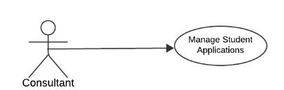

Purpose:
Enable consultants to manage student applications efficiently, including uploading and downloading necessary documents, applying to universities on behalf of students, and managing correspondence with universities through the system.
Description:
The consultant can use the system to upload and download documents related to student applications, apply to universities, and send or respond to communications with universities.
Preconditions:
- The consultant must be logged into the system.
- The consultant must have an assigned student profile to manage.
- The system must be connected to university APIs (if applicable).
Main Success Scenario:
- The consultant navigates to the student applications section of the dashboard.
- The consultant selects a student’s application profile.
- The consultant performs any of the following actions:
  - Upload documents (e.g., transcripts, recommendation letters).
  - Download documents for review.
  - Initiates an application to a university.
  - Send correspondence to the university via email.
- The system processes and stores the changes.
- The system notifies the consultant of successful completion.
Alternative Scenarios:
A1: Incomplete student profile:
- The system displays an error message prompting the consultant to complete the profile before proceeding.
A2: Unsupported document format:
- The system rejects the upload and displays a message suggesting accepted file types.
A3: Failed university application submission:
- The system notifies the consultant of the failure and suggests retrying or contacting support.
A4: Correspondence delivery failure:
- The system notifies the consultant about the failed email/message delivery.
Postconditions:
- All uploaded documents are stored in the system.
- University applications are successfully submitted, and corresponding statuses are updated.
- Communication logs are saved in the system.
Extensions:
- Notifications are sent to the consultant regarding university application status updates or responses.
- Consultants can preview uploaded documents within the system.
- The system tracks changes in an activity log for audit purposes.
TEST CASE SCENARIO
Test Case ID: TC06
Test Case Name: Manage Student Application
Test Priority: High

SN | Actions | Inputs | Expected  Outcomes | Actual  Outputs | Test  Application | Test  Resul t | Test  Comments
1 | Upload student applicati on documen  ts | Upload  files (e.g., passport, transcript s) | The system uploads files and links them to the student application | Files uploade d successf ully | UniVoy | Pass | Document upload feature verified
2 | Downloa  d student applicati  on  documen  ts | Select  documen  t from  list | System downloads  the selected file | File  downloa ded successf ully | UniVoy | Pass | File  download feature verified
3 | Update student details | Modify  applicati on informati on | System updates student application data | Applicat ion updated successf ully | UniVoy | Pass | Application details update tested
Table 3. 7Manage Student Application

3.2.4 Chat with the Admin

Use Case: Chat with the Admin
UC Number: 9
UC Name: Chat with the Admin
Functional Requirement No: FR08
Primary Actor(s): Consultant, Admin
Secondary Actor(s): System Admin
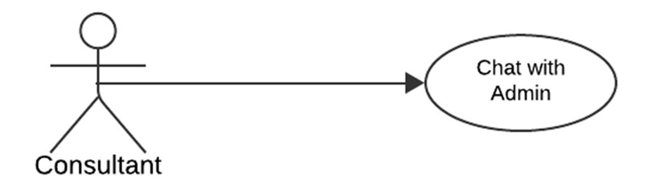

Purpose:
To facilitate communication between consultants and admins for updates, clarifications, and notifications about missing documents or any other pertinent issues.
Description:
The system provides a chat interface where consultants and admins can exchange messages in real-time. The feature includes basic text messaging, notifications for new messages, and an archive of previous communications.
Preconditions:
- Both the consultant and admin must be logged into the system.
- The consultant must have a valid reason for initiating the chat.
Main Success Scenario:
- The consultant accesses the "Chat" feature on the dashboard.
- The consultant selects the admin from the list of available contacts.
- The consultant types and sends a message.
- The admin receives the message in real time.
- The admin replies to the message.
- The conversation is logged and can be accessed for future reference.
Alternative Scenarios:
A1: No admin available:
- The system notifies the consultant and provides an option to leave an offline message.
A2: Network issues:
- The system alerts the user that the message could not be delivered and retries sending automatically.
A3: Unread messages:
- The system displays notifications or badges to indicate unread messages.
Postconditions:
- The conversation is logged and saved for future reference.
- Both consultant and admin receive appropriate notifications for new or unread messages.
Extensions:
- Attachments (e.g., missing documents) can be sent through the chat.
- Notifications are sent for real-time updates or responses.
- An admin can assign additional resources or escalate queries during the chat.

TEST CASE SCENARIO
Test Case ID: TC07
Test Case Name: Chat with Admin
Test Priority: High
SN | Actions | Inputs | Expected  Outcomes | Actual  Outputs | Test  Application | Test  Resul t | Test  Comments
1 | Send a message to admin | Enter message in chat box | System sends the message and  provides acknowledg ment | Message sent and displayed to Admin | UniVoy | Pass | Chat functionalit y works as expected
2 | View admin response | Refresh chat  window | System displays new messages from admin | Messages displayed  successfu  lly | UniVoy | Pass | Real-time chat update verified
3 | Handle invalid message input | Leave chat box empty and  click "Send" | System displays an  error message | Error message displayed | UniVoy | Pass | Error handling verified
Table 3. 8 Chat with Admin
3.2.5 Commission Payment

Use Case: Payment
UC Number: 10
UC Name: Commission Payment
Functional Requirement No: FR09
Primary Actor(s): Consultant
Secondary Actor(s): Admin
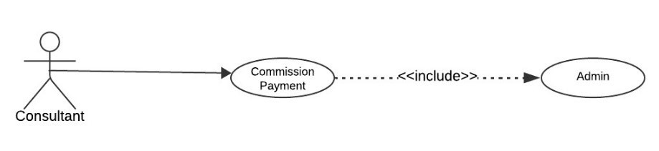

Purpose:
To facilitate Commission payment processing, where the consultant makes payments, and the admin receives the commission amount.
Description:
The payment system enables consultants to submit payments to the admin. The admin specifies the commission amount, and the consultant can view the details and complete the payment securely.
Preconditions:
- The consultant and admin must be logged into the system.
- The admin must have already set a commission amount.
Main Success Scenario:
- The admin sets and sends the commission amount to the consultant.
- The consultant receives a notification about the pending payment.
- The consultant reviews the payment details (amount, due date, etc.).
- The consultant selects a payment method (e.g., credit card, bank transfer).
- The consultant completes the payment.
- The system generates a receipt and sends it to both the consultant and the admin.
Alternative Scenarios:
A1: Payment Failed:
- If the payment fails due to insufficient funds or technical issues, the system notifies the consultant and allows them to retry.
A2: Disputed Amount:
- The consultant disputes the payment amount. The system sends a notification to the admin to review and adjust if necessary.
Postconditions:
- The payment is recorded in the system.
- The admin receives the payment confirmation.
- A receipt is generated for both the consultant and admin.

Extensions:
- The system supports multiple payment methods (credit card, bank transfer, etc.).
- A detailed history of payments is available for both the consultant and admin.
- Notifications and reminders for pending payments are sent to the consultant.
TEST CASE SCENARIO
Test Case ID: TC08
Test Case Name: Commission Payment
Test Priority: High
SN | Actions | Inputs | Expected  Outcomes | Actual  Outputs | Test Applicatio n | Test  Resul t | Test  Comment  s
1 | Make payment via  Easypais  a | Enter payment  details (account and amount) | The system processes payment successfully and sends confirmation | Payment processed and confirmed | UniVoy | Pass | Payment integratio n with Easypaisa verified
2 | Attempt payment with invalid details | Enter invalid  payment  details | The system displays  error  message and rejects the payment | Error message displayed | UniVoy | Pass | Error handling for invalid  payments tested
3 | Check payment history | Open  the  payment history tab | The system  displays a  list of  previous payments | Payment history displayed correctly | UniVoy | Pass | Payment history  functional ity verified
Table 3. 9 Commission Payment
3.3.1 Student Use Case
Use Case: Student Login and Signup
UC Number: 11
UC Name: Student Login and Signup
PrimaryActor(s):StudentSecondary
Actor: Admin,Consultant.

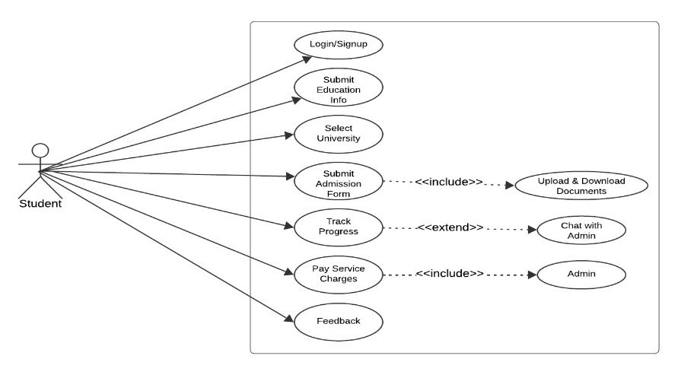
Purpose:
To allow students to create accounts (signup) and access the system (login) securely.
Description:
The student interacts with the system to apply for university admissions. This includes logging in, submitting educational information, selecting universities, tracking application progress, paying service charges, and providing feedback.
Preconditions:
- The student must have an account to log in or complete the signup process.
- The student must provide valid information to access system features.
Main Success Scenario:
- The student opens the system and logs in or signs up.
- After successful login, the student is redirected to the dashboard.
- The student submits their educational details, including uploading relevant documents.
- The system stores the data and provides a list of universities filtered by preferences (e.g., course, destination, scholarships).
- The student selects their preferred universities.
- The student completes and submits admission forms for the selected universities.
- The system forwards the forms and allows the student to track their application status.
- The student makes payments for services or applications if required.
- The student provides feedback or communicates with the admin as needed.

Alternative Scenarios:
Login/Signup:
- Invalid login credentials are entered, and the system prompts the student to re-enter them.
- Signup fails due to missing or incorrect information.
Submit Education Info:
- Required fields are incomplete, and the system prompts the student to fill them in.
- Document upload fails, and the system alerts the student to retry.
Select University:
- No universities match the criteria; the system suggests modifying filters.
Submit Admission Form:
- The form is incomplete, and the system prompts the student to complete it. Track Progress:
- No updates are available; the system informs the student that the status is unchanged.
Payment:
- Payment fails, and the system notifies the student to retry.
Postconditions:
- The student gains access to the portal and its functionalities.
- Educational details and admission forms are submitted successfully.
- The student tracks application progress and makes required payments.
- The system records feedback or other interactions with the admin.
3.3.2 Student Login and Signup

Use Case: Student Login and Signup
UC Number: 12
UC Name: Student Login and Signup
Primary Actor(s): Student

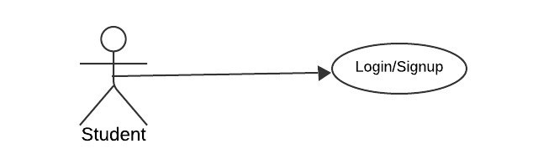
Purpose:
To allow students to create accounts (signup) and access the system (login) securely.
Description:
Students can sign up for the system by providing necessary information. After account creation, students can log in using their credentials to access their dashboard and features.
Preconditions:
- For signup: The student must not have an existing account.
- For login: The student must have valid login credentials (username and password).
Main Success Scenario:
Signup:
- The student navigates to the signup page.
- The student enters required details (name, email, password, etc.).
- The system validates the provided information.
- The system creates an account and sends a confirmation email to the student.
- The student confirms their email address, completing the signup process.
Login:
- The student navigates to the login page.
- The student enters their username and password.
- The system validates the credentials.
- the system logs the student in and displays their dashboard if it is valid.
Alternative Scenarios:
A1: Invalid Credentials:
- If the student enters incorrect credentials during login, the system prompts them to try again.
A2: Account Already Exists (Signup):
- If the email entered during signup is already associated with an account, the system notifies the student.
A3: Forgotten Password:
- If the student forgets their password, they can initiate a password reset process.
Postconditions:
- The student successfully creates a new account (signup).
- The student logs into their account and accesses the system.
Extensions:
- The system supports two-factor authentication (optional).
- The system logs unsuccessful login attempts for security purposes.
- Students can update their login credentials after logging in.
TEST CASE SCENARIO
Test Case ID: TC09
Test Case Name: Student Signup/Login
Test Priority: High
Preconditions: The user must have a valid account.

SN | Actions | Inputs | Expected  Outcomes | Actual  Outputs | Test  Application | Test  Resul t | Test  Comments
1 | Enter valid credentia ls and login | Userna me:  student, Passwor  d: [valid passwor  d] | System validates credentials successfull y and redirects to Student  Dashboard | Redirecte d to  Student Dashboar  d | UniVoy | Pass | Login functionalit y verified
2 | Sign up as a new student | Enter valid personal details | System  registers the student and sends confirmatio n email | Student account created  successfu  lly | UniVoy | Pass | Sign-up tested successfull y
3 | Attempt login with invalid  credentia  ls | Userna me:  student, Passwor d: [invalid passwor  d] | System displays an error message | Login failed with appropria te error | UniVoy | Pass | Error handling works as expected
Table 3. 10 Student signUp

3.3.3 Submit Education Information

Use Case: Submit Education Information
UC Number: 13
UC Name: Submit Education Information
Primary Actor(s): Student

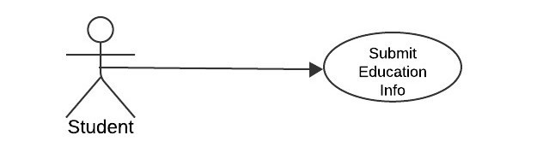
Purpose:
To enable students to input and submit their personal details, educational qualifications, and professional experience as required by the system.
Description:
Students will provide their personal and educational details, including academic qualifications and work experience, to fulfill the system requirements for profile creation or university applications.
Preconditions:
- The student must be logged into the system.
- The system must have a form to collect personal, educational, and professional details.
Main Success Scenario:
- The student navigates to the "Submit Education Information" section on their dashboard.
- The student inputs their personal details (e.g., name, contact information, address).
- The student enters their educational qualifications (e.g., school name, degree, grades, and graduation year).
- If applicable, the student adds their professional experience (e.g., job titles, duration, responsibilities).
- The system validates the entered information.
- The student reviews and submits the details.
- The system saves the information and confirms successful submission.

Alternative Scenarios:
A1: Missing Mandatory Fields:
- If the student omits any required field, the system prompts the student to complete the missing information.
A2: Invalid Data Format:
- If the student enters data in an incorrect format (e.g., invalid email or date), the system notifies the student and requests corrections.
A3: Session Timeout:
- If the student's session times out before submission, the system saves the data entered so far and prompts the student to log in again.
Postconditions:
- The student’s personal, educational, and professional information is saved in the system.
- The information is available for use in applications or other processes within the system.
Extensions:
- Students can edit or update their submitted information later.
- The system can generate a summary or profile PDF from the entered details.
- Validation checks include duplicate entry prevention for academic institutions or degrees.
TEST CASE SCENARIO
Test Case ID: TC10
Test Case Name: Submit Education Information
Test Priority: High

SN | Actions | Inputs | Expected  Outcomes | Actual  Outputs | Test  Application | Test Result | Test  Comments
1 | Add educatio nal details | Enter educatio n informat ion | System saves the data successful  ly | Educatio nal  details added  successfu  lly | UniVoy | Pass | Data saved without errors
2 | Modify educatio  nal  informa tion | Edit existing educatio nal details | System updates the informatio n correctly | Informati on updated  successfu  lly | UniVoy | Pass | Data update functionalit y verified
3 | Attempt submiss ion with missing fields | Submit incompl ete form | System displays an error message | Error message displayed | UniVoy | Pass | Error handling works as expected
Table 3. 11 Submit Education Info

3.3.4 Select the University

Use Case: Select the University
UC Number: 14
UC Name: Select the University
Primary Actor(s): Student

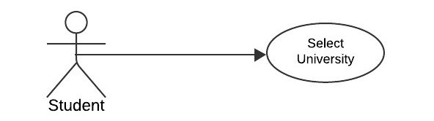

Purpose:
To allow students to browse and select their preferred universities based on criteria such as tuition fees, location, scholarships, and other attributes.

Description:
The student can search, filter, and select universities according to their preferences. The system provides a list of universities with detailed information, enabling the student to make an informed choice.
Preconditions:
- The student must be logged into the system.
- The system must have an up-to-date database of universities with relevant details (fees, location, scholarships, etc.).
Main Success Scenario:
- The student navigates to the "Select University" section on their dashboard.
- The student browses through a list of available universities.
- The student uses filters such as tuition fees, location, and scholarships to narrow down options.
- The system displays universities matching the selected criteria.
- The student clicks on a university to view detailed information (e.g., course offerings, requirements, application deadlines).
- The student selects one or more universities to proceed with the application process.
- The system confirms the selection and updates the student’s profile or application records.
Alternative Scenarios:
A1: No Results Found:
- If no universities match the filters applied, the system notifies the student and suggests adjusting the filters.
A2: Incomplete Information:
- If the student tries to select a university without reviewing its details, the system prompts them to view the details first.
A3: Network/Server Issues:
- If the system cannot fetch the university list, it displays an error message and retries the operation.
Postconditions:
- The selected university/universities are saved in the student’s profile.
- The student can proceed with the application steps for the chosen universities.
Extensions:
- The system provides personalized recommendations based on the student’s preferences and past academic performance.
- Students can save universities to a "Favorites" list for later review.
- Students can compare multiple universities side-by-side.
TEST CASE SCENARIO
Test Case ID: TC11
Test Case Name: Select the University
Test Priority: High

SN | Actions | Inputs | Expected  Outcomes | Actual  Outputs | Test  Application | Test Result | Test  Comments
1 | Search for university | Enter search criteria (fee, location, etc.) | The system displays  universities matching  the criteria | List displayed successfully | UniVoy | Pass | Search functionality verified
2 | Select the desired university | Select a university from the  displayed  list | The system saves the selected university in the student profile | University selection saved successfully | UniVoy | Pass | Selection functionality works as expected
Table 3. 12 Select Uni
3.3.5 Submit Admission Form

UC Number: 15
UC Name: Submit Admission Form Primary Actor(s): Student
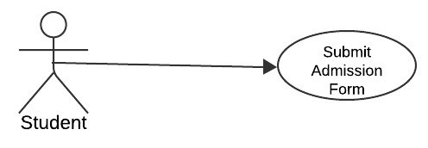
Purpose:
To enable the student to submit the admission form along with the required documents, such as a passport, academic records, and other necessary files for university admission. Description:
The student completes and submits an online admission form and uploads all required documents. The system validates the form and uploaded documents before final submission to ensure completeness and compliance with university requirements.
Preconditions:
- The student must be logged into the system.
- The system must have the admission form template and a list of required documents configured.
Main Success Scenario:
- The student navigates to the "Submit Admission Form" section on their dashboard.
- The student fills in the required fields on the admission form (e.g., personal details, academic details).
- The student uploads the required documents (e.g., passport, academic certificates).
- The system validates the form fields for completeness and checks the uploaded documents for correct file type and size.
- The student reviews the completed form and uploads for accuracy.
- The student submits the form.
- The system confirms the successful submission and generates a reference ID.
Alternative Scenarios:
A1: Missing Required Fields or Documents:
- If the student fails to fill in all required fields or upload all necessary documents, the system highlights the missing fields/documents and prompts the student to complete them.
A2: Invalid File Format/Size:
- If an uploaded document is in an incorrect format or exceeds the allowed file size, the system notifies the student and prompts them to re-upload.
A3: System Error During Submission:
- If the system encounters an error during the submission process, it displays an error message and allows the student to retry later.
Postconditions:
- The admission form and documents are successfully submitted to the system.
- The system generates a reference ID for tracking purposes.
- The student’s application status is updated to "Submitted." Extensions:
- The system provides a progress bar or checklist to track the completion of the form and document uploads.
- The student receives an email confirmation with the submitted details and reference ID.
- Students can save a partially filled form and return later to complete it.
TEST CASE SCENARIO
Test Case ID: TC012
Test Case Name: Submit Admission Form
Test Priority: High

SN | Actions | Inputs | Expected  Outcomes | Actual  Outputs | Test Applica tion | Test Result | Test  Comments
1 | Upload required docume  nts | Attach files (passport, transcript s, etc.) | System uploads documents and links them to the application | Documents uploaded successfully | UniVoy | Pass | Document upload tested successfull y
2 | Submit admissi on form | Complete form  with all required fields | System submits the form and sends confirmatio n email | Form submitted successfully | UniVoy | Pass | Form submission functionalit y verified
Table 3. 13 Submit submission form
3.3.6 Track Progress
UC Number: 16
UC Name: Track Application Progress
Primary Actor(s): Student
Secondary Actor(s): Admin
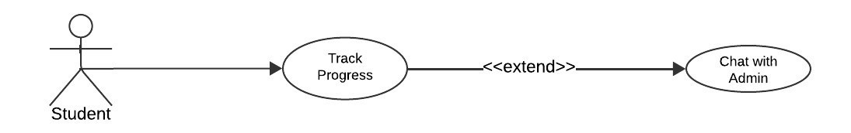
Purpose:
To allow students to track the progress of their application or admission process and receive updates or feedback from the admin.
Description:
The system provides a dashboard where the student can monitor the status of their application, including submission acknowledgment, document verification, and updates from the admin. The admin can update the progress and add comments or feedback for the student.
Preconditions:
- The student must have successfully submitted their application.
- The admin must have access to update the status and add feedback.
Main Success Scenario:
- The student logs into the system and navigates to the "Track Process" section.
- The system displays a detailed timeline or progress bar showing the status of each step in the application process (e.g., "Submitted," "Under Review," "Document Verified," etc.).
- The student views updates or comments provided by the admin regarding their application.
- If action is required (e.g., missing documents), the system highlights the pending task and prompts the student to address it.
- The system sends notifications to the student for any changes in status or additional feedback from the admin.
Alternative Scenarios:
A1: Application Not Yet Submitted:
- If the student attempts to track progress without applying, the system displays a message prompting them to complete and submit their application first.
A2: Admin Feedback Pending:
- If the admin has not updated the status, the system displays the most recent status with a note indicating that updates are pending.

A3: Notification Failure:
If the system fails to send a notification, the updates remain visible in the "Track Process" section for manual review by the student.
Postconditions:
- The student is informed about the current status of their application.
- The admin can monitor and manage the progress updates.
- Any required actions by the student are highlighted and resolved promptly.
Extensions:
- A color-coded progress bar or timeline is displayed for better visualization.
- Automatic reminders are sent to the student for pending tasks.
- The system allows students to send queries or clarification requests directly to the admin.
- Admins can attach additional documents or comments for clarity.
TEST CASE SCENARIO
Test Case ID: TC13
Test Case Name: Track Application Progress
Test Priority: Normal

SN | Actions | Inputs | Expected outcomes | Actual output | Test application | Test result | Test comments
1 | View  applicatio n progress | Select applicatio n from the dashboard | System displays the current status of the application | Progress displayed correctly | UniVoy | Pass | Tracking functionality verified
Table 3. 14 Track application progress
3.3.6 Pay Service Charges

UC Number: 17
UC Name: Pay Service Charges
Secondary Actor(s): Admin
Payment Gateway: Easypaisa
Primary Actor(s): Student
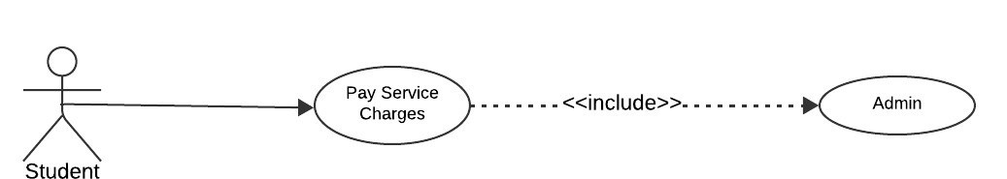
Purpose:
To enable students to pay service charges securely using the Easypaisa payment gateway.
Description:
The system facilitates payment of service charges by the student through an integrated Easypaisa gateway. The admin can view the payment status and validate transactions.
Preconditions:
- The student must be logged into the system.
- The student has a valid Easypaisa account or access to Easypaisa services.
- The service charge amount is defined and displayed in the system.
- The Easypaisa gateway is operational.
Main Success Scenario:
- The student logs into the system and navigates to the "Pay Service Charges" section.
- The system displays the service charge amount and payment details.
- The student selects "Pay via Easypaisa."
- The system redirects the student to the Easypaisa payment gateway.
- The student enters the required Easypaisa account details and confirms the payment.
- The payment gateway processes the transaction and notifies the system of the payment status (success or failure).
- If successful, the system updates the payment status as "Paid" and notifies the admin.
- The student receives a confirmation of the successful payment.
Alternative Scenarios:
A1: Insufficient Balance:
- If the student has insufficient funds in their Easypaisa account, the payment is declined, and the system prompts the student to retry after adding funds.

A2: Payment Gateway Failure:
If the Easypaisa gateway is unavailable, the system displays an error message and advises the student to try again later.
A3: Incorrect Payment Details:
- If the student enters incorrect account details, the payment fails, and the system prompts the student to re-enter the correct details.
Postconditions:
- The service charges are successfully paid and marked as "Paid" in the system.
- The admin is notified of the payment status and can verify the transaction.
- A payment receipt is generated and available for the student.
Extensions:
- The system generates and emails a payment receipt to the student.
- Students can download a receipt from their dashboard.
- The admin can generate payment reports for reconciliation.
- Automatic reminders are sent to students with unpaid service charges.
TEST CASE SCENARIO
Test Case ID: TC14
Test Case Name: Pay Service Charges
Test Priority: High
SN | Actions | Inputs | Expected  Outcomes | Actual  Outputs | Test  Application | Test  Resul t | Test  Comments
1 | Make payment via  Easypaisa | Enter payment details (account and amount) | The system processes the payment successfully and sends a confirmation | Payment processed successfully | UniVoy | Pass | Payment  functionality verified
2 | Attempt payment with invalid details | Enter invalid payment  details | The system displays an error message  and rejects the payment | Error message displayed | UniVoy | Pass | Error handling for payment verified
Table 3. 15 Pay services charges
3.3.7 Feedback
UC Number: 18
UC Name: Feedback
Primary Actor(s): Student
Secondary Actor(s): Admin
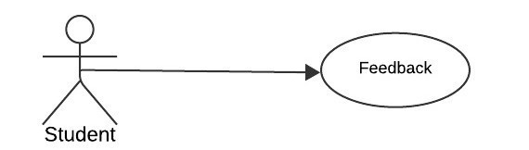
Purpose:
To allow students to provide feedback on the services, processes, or overall experience, which is accessible to the admin for review and improvement.
Description:
The system provides a platform for students to submit feedback about their experience. Admins can view, categorize, and act on the feedback to enhance services.
Preconditions:
- The student is logged into the system.
- A feedback form or input interface is available in the system.
Main Success Scenario:
- The student logs into the system and navigates to the "Feedback" section.
- The system displays a feedback form with fields for comments, ratings, and suggestions.
- The student enters feedback details and submits the form.
- The system stores the feedback and notifies the admin.
- The admin reviews the submitted feedback and marks it as reviewed or acts upon it if necessary.
Alternative Scenarios:
A1: Feedback Form Incomplete:
- If the student leaves required fields blank, the system prompts the student to complete the form.

A2: Feedback Submission Failure:
If the system encounters an issue while saving the feedback, it displays an error message and prompts the student to retry.
Postconditions:
- Feedback is successfully submitted and stored in the system.
- The admin is notified of new feedback and can access it for review.
- Students may receive acknowledgment of their feedback submission.
Extensions:
- The system includes options for anonymous feedback submission.
- The admin can filter and categorize feedback by type (e.g., complaint, suggestion, appreciation).
- The admin can generate reports summarizing feedback trends.
TEST CASE SCENARIO
Test Case ID: TC15
Test Case Name: Feedback
Test Priority: Normal

SN | Actions | Inputs | Expected  Outcomes | Actual  Outputs | Test Applicatio n | Test  Resul t | Test  Comments
1 | Submit  Feedback | Enter feedback in the text box | The system saves the feedback and sends  an acknowled gment to the admin | Feedback submitted successfull y | UniVoy | Pass | Feedback submission tested successfull y
2 | Attempt feedback submissi on with empty input | Leave text box empty | System displays an  error message | Error message displayed | UniVoy | Pass | Error handling verified
Table 3. 16 FeedBack

CHAPTER 4:

Design [with description of each diagram]

4.1 Architecture Diagram
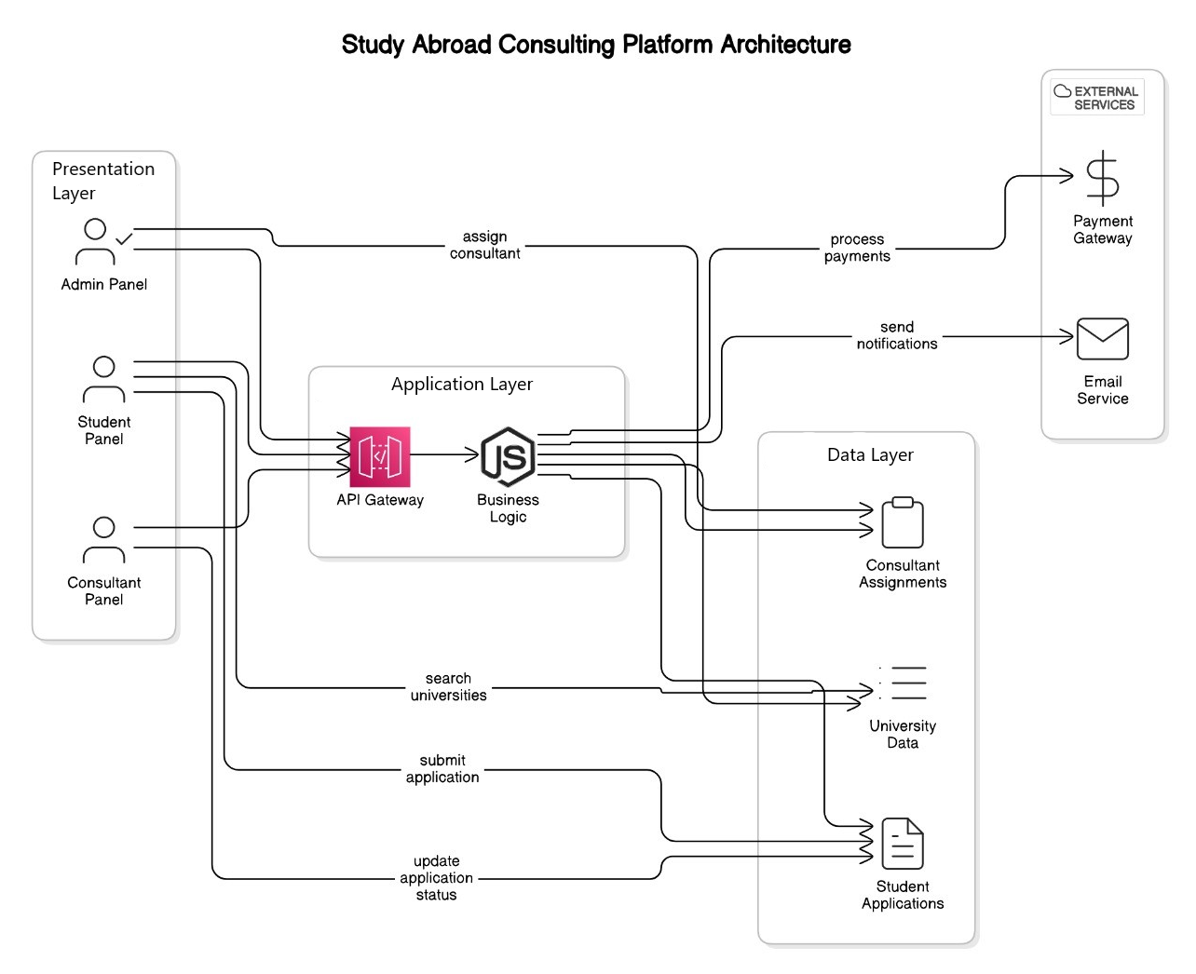
Figure 4. 1 Architecture

4.2 ERD Diagram

4.3 Data Flow Diagram Level 0
This diagram represents a Level 0 Data Flow Diagram (DFD) for a Abroad Study titled "UniVoy". A Level 0 DFD gives a high-level overview of the system and its interactions with external entities (users or systems) through various processes.
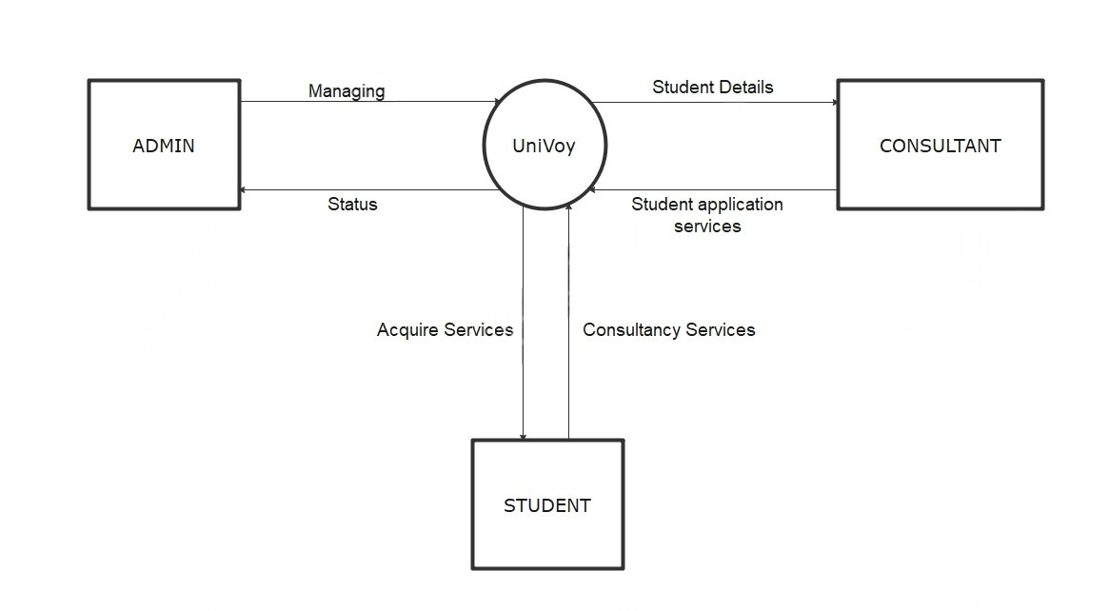
Figure 4. 2 DFD 0

External Entities and Their Interactions:
• Universities
- Receive student applications and send admission responses.
- Interaction via email, portals, or API (if available).
• Bank/Payment Systems
- Handle student payments through external bank transfers.
- Payment status is verified manually or via transaction reference.
• Email & SMS Services
- Send automated alerts for application updates, deadlines, and messages.
- Uses third-party email/SMS APIs.
• Video Conferencing Tools
- Support student-consultant video meetings via Zoom, Google Meet, etc.
- Linked externally through the platform.
• Document Verification Services (Optional/Future)
- Validate student documents through third-party APIs or manual checks.

4.4 Data Flow Diagram Level 1
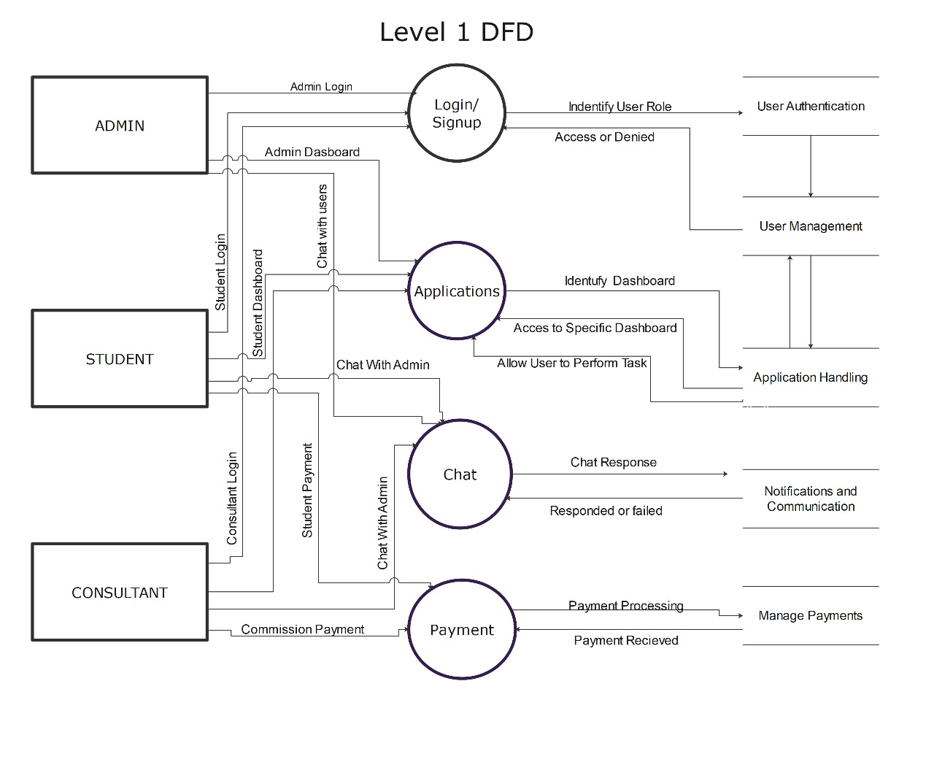
Figure 4. 3 DFD 1

4.5 Data Flow Diagram Level 2

(Admin)

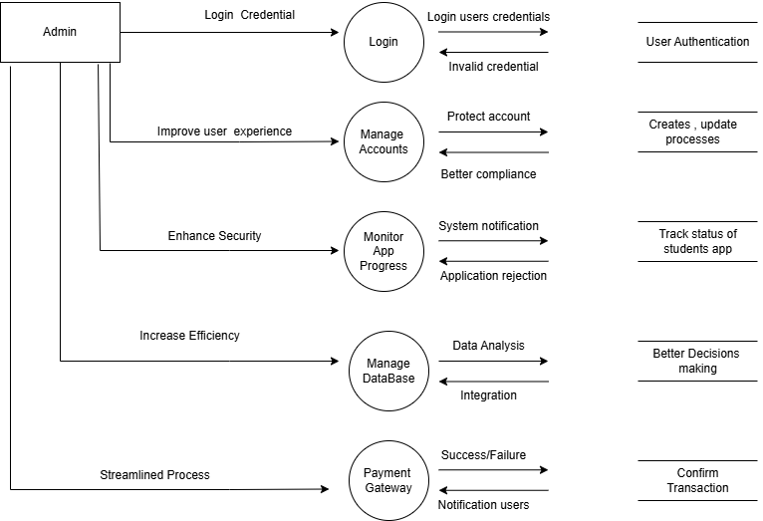
Figure 4. 4 DFD 2 Admin

(Student)
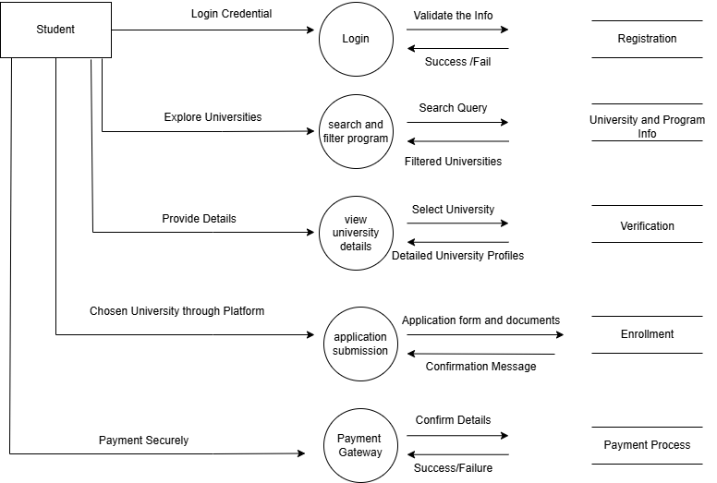
Figure 4. 5 DFD 2 Student
(Consultant)
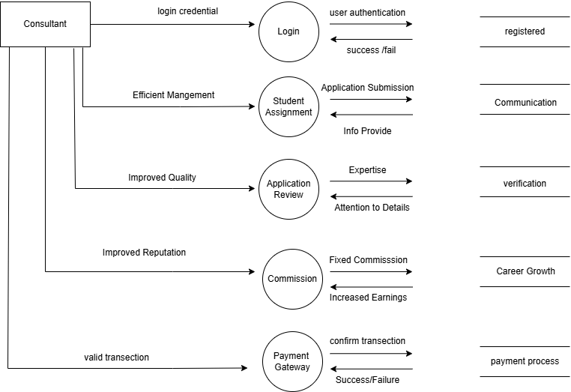
Figure 4. 6 DFD 2 Consultant

4.6 Class Diagram
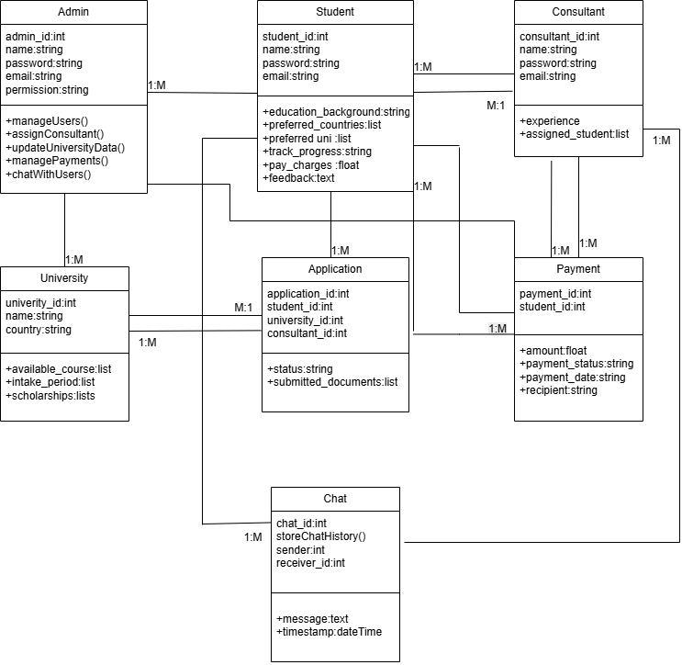
Figure 4. 7 Class

4.7 Sequence Diagram

4.7.1 Admin
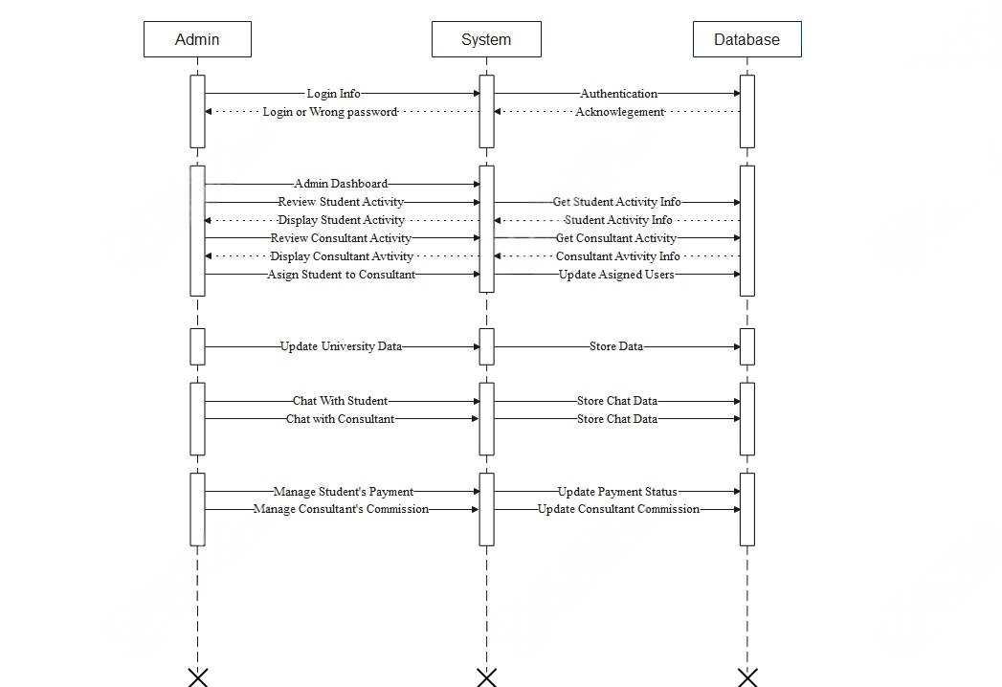
Figure 4. 8 Sequence Admin

Authentication
- Login Info: Admin enters credentials.
- Authentication: System checks login with database.
- Acknowledgement: Database sends login result.
- Login or Wrong password: System notifies admin of result.

Dashboard & Review
- Admin Dashboard: Admin accesses dashboard.
- Review Student Activity: Admin checks student actions.
- Get Student Activity Info: System fetches student data.
- Display Student Activity: System shows student data.
- Review Consultant Activity: Admin checks consultant actions.
- Get Consultant Activity: System gets consultant data.
- Display Consultant Activity: System displays consultant info.

User Assignment
- Assign Student to Consultant: Admin links student to consultant.
- Update Assigned Users: System stores the assignment.

University Management
- Update University Data: Admin updates university info.
- Store Data: System saves updated data.

Chat
- Chat With Student: Admin chats with a student.
- Chat with Consultant: Admin chats with a consultant.
- Store Chat Data: System logs chat messages.

Payments
- Manage Student’s Payment: Admin handles student payment.
- Update Payment Status: System updates payment info.
- Manage Consultant’s Commission: Admin sets commission.
- Update Consultant Commission: System saves commission details.

4.7.2 Student
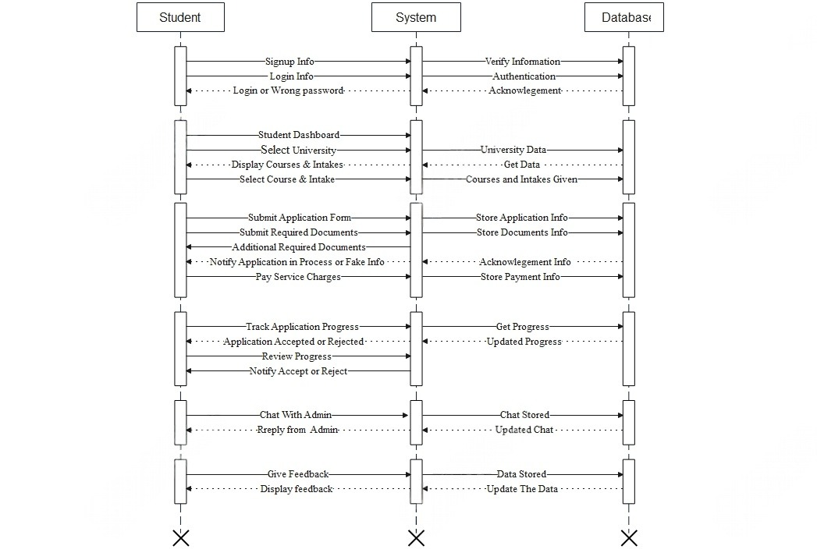
Figure 4. 9 Sequence Student

Authentication
- Signup/Login Info: Student logs in or signs up.
- Verify Info: System checks credentials.
- Authentication/Acknowledgement: Database confirms login.
- Login or Wrong Password: System shows result.

Course Selection
- Dashboard: Student opens main panel.
- Select University: Chooses preferred university.
- Display Courses: System fetches course list.
- Select Course: Student picks a course/intake.

Application Process
- Submit Form/Docs: Student submits application and documents.
- Store Info: System saves data to database.
- Additional Docs: System asks for more files if needed.
- Notify Status: System shows in-progress or fake info.
- Pay Charges: Student pays service fee.
- Store Payment Info: Payment saved.

Track Progress
- Track Status: Student checks updates.
- Get/Update Progress: System fetches new status.
- Accept/Reject: Final decision is shown.

Chat
- Chat with Admin: Student messages admin.
- Reply from Admin: Admin responds.
- Chat Stored: Messages saved.

Feedback
- Give Feedback: Student submits feedback.
- Store/Update Feedback: Feedback saved and displayed.

4.7.3 Consultant
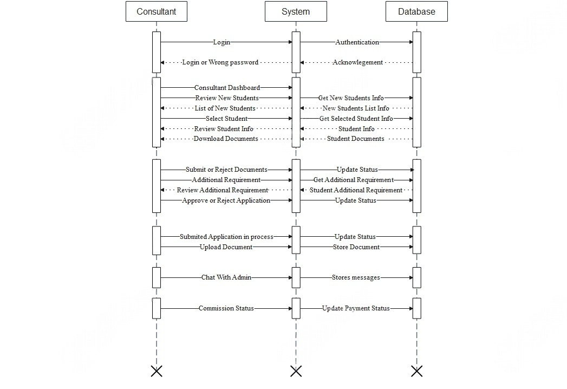
Figure 4. 10 Sequence Consultant

Login
- Consultant logs in → System verifies credentials.

Consultant Dashboard
- Consultant reviews new student list and details.

Document Handling
- Consultant downloads and reviews student documents.

Application Review
- Submits, approves, or rejects applications → Status updated.

Additional Requirements
- Reviews and adds extra document requirements.

Application in Process
- Marks application as in-process and uploads documents.

Chat with Admin
- Consultant chats with admin → Messages stored.

Commission Status
- Views commission → System updates payment info.

4.8 Activity Diagram
4.8.1 Admin
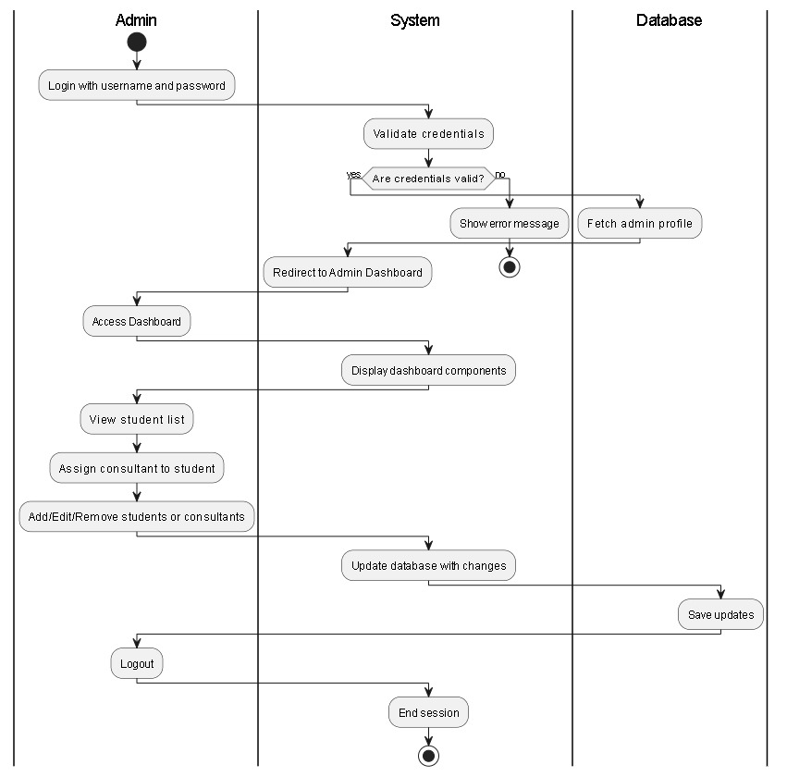
Figure 4. 11 Admin Activity

4.8.2 Student
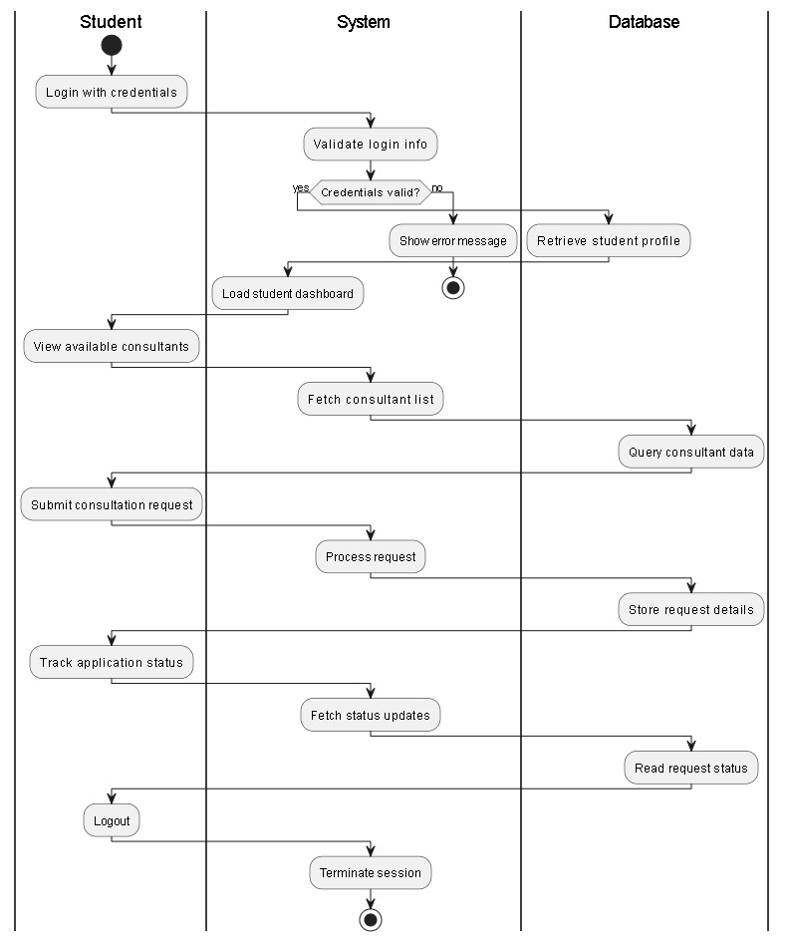
Figure 4. 12 Student Activity

4.8.3 Consultant
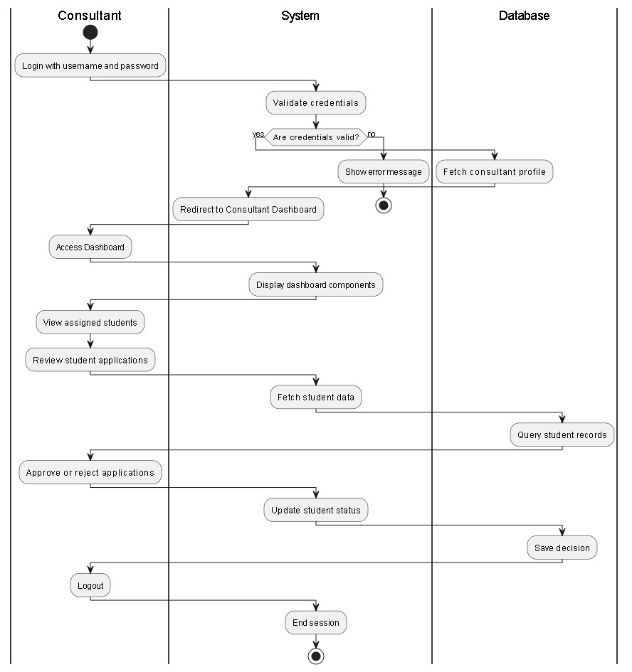
Figure 4. 13 Consultant Activity

4.9 Collaboration

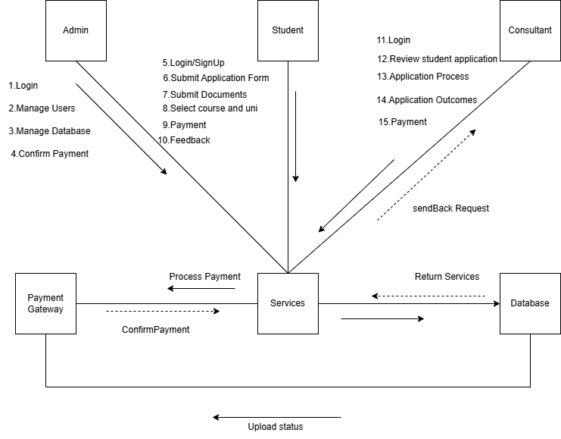
Figure 4. 14 Collaboration

4.10 ERD

