**DSA**

**ASSIGNMENT 1**

**AHMAD ALI JAVED(462173)**

**BSDS 1-A**

**PROBLEM 1**

**Approach:**

In task 1 I have used simple approach of circular linked list creating and adding a node at tail . I just went with the flow by divivding the task into small parts and made mini goals which made the task time consuming but relatively easier.

**Chalanges Faced:**

The main challenge was at the core of task where in my main function **Proccesstime**  where I used nested loop which became a bit of consuming but the main part is that I overcame it

**Assumptions:**

In task1 there are no such assumption but the main assumption was that it’s a circular linked list but still I am using the concept of head and tail both It seems awkward but it makes the task more readable and easy

**Snippets:**

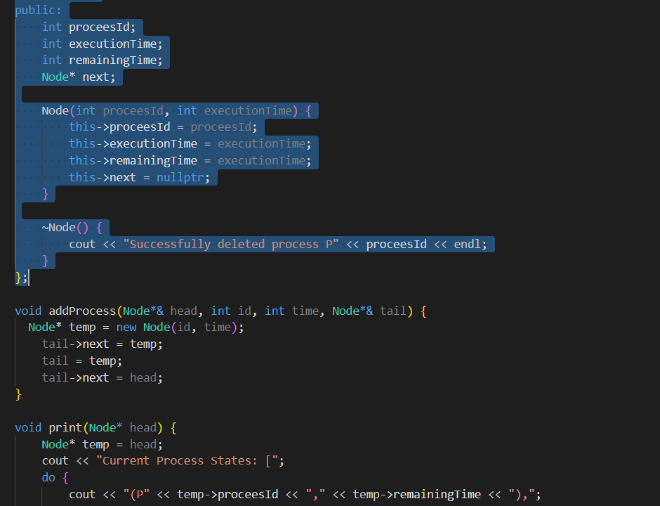

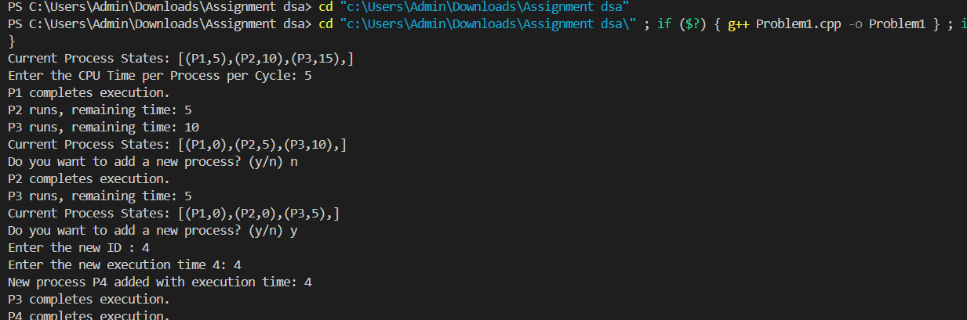

**PROBLEM 2**

**Approach:**

I haven’t completed the task2 completely . I have created chunks and then stored in Linkedlist but I have checked the whole number wether it’s a prime or not . I have used Miller Rabin test for prime . As I have performed it on a single chunk

**Chalanges Faced:**

This task was full of challenges as first storing the 1024 bit as it was solved but the major concern was to check wether it was prime or not in which I haven’t been succeeded.

**Assumptions:**

No such Assumptions in this task as I am unable to complete .

**Snippets**



