* **SRS**
* **Class Diagram**

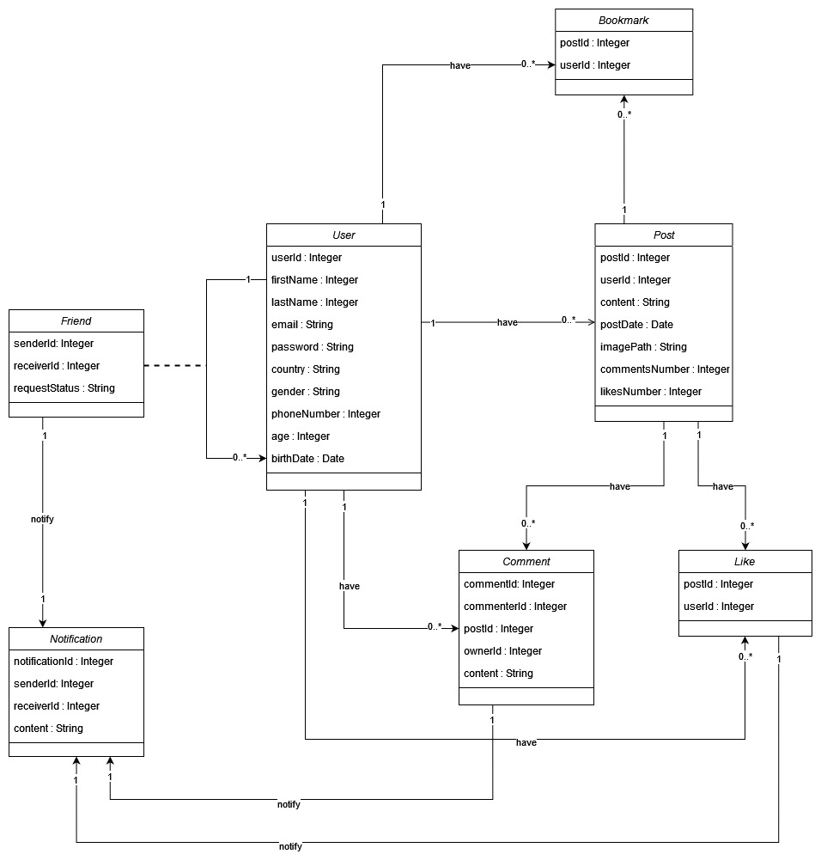

* **ERD**

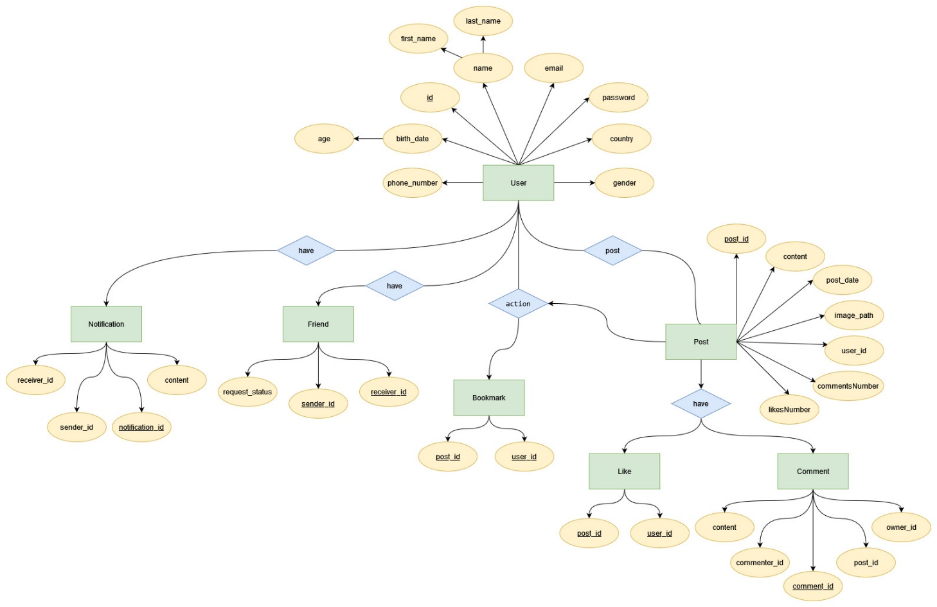

* **Sequence Diagram**
* **Displaying Posts**

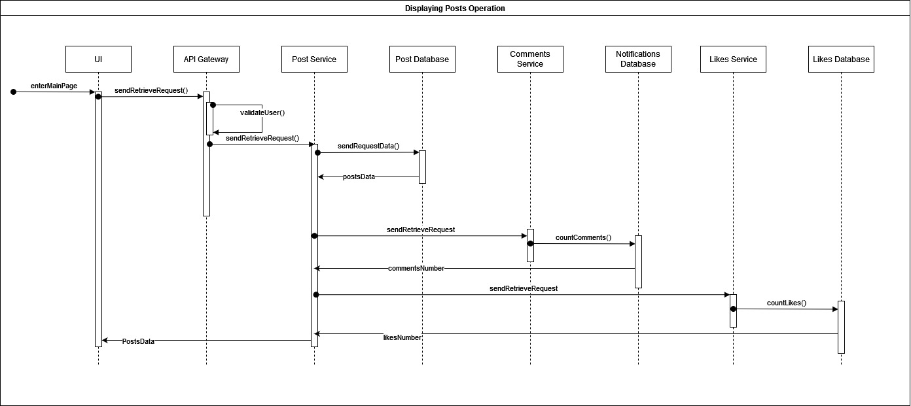

* **Send Friend Request**

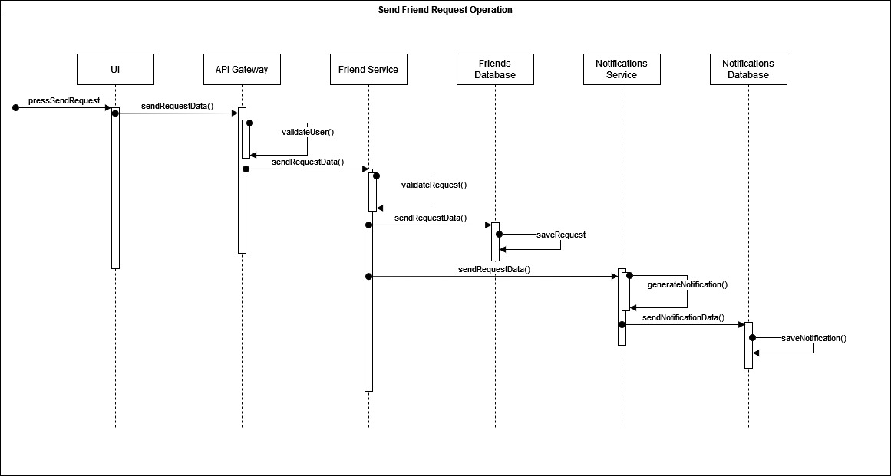

* **Make a Comment (Same for Posts & Likes)**

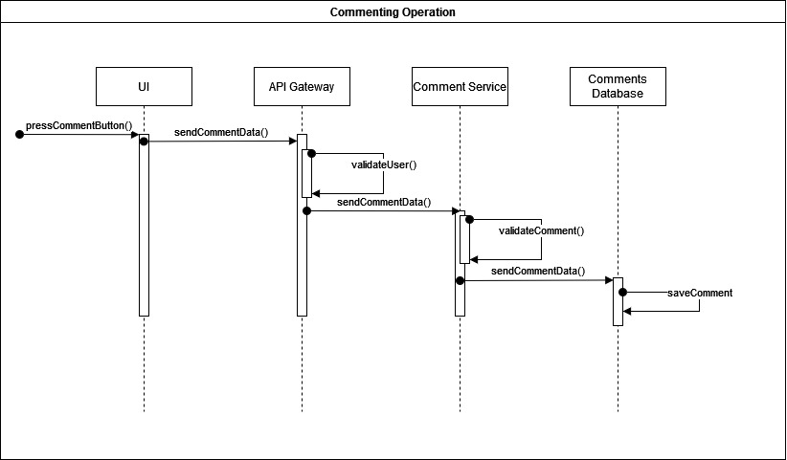

* **Activity Diagram**
* **Create a post**

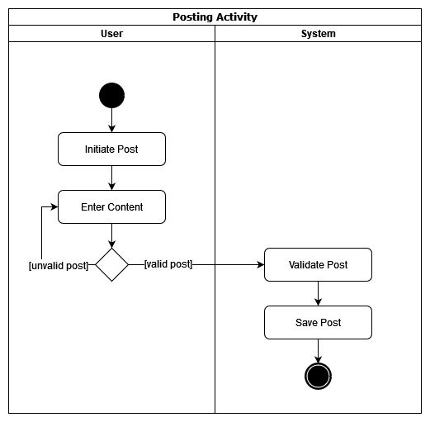

* **Save a Post/ Bookmark**

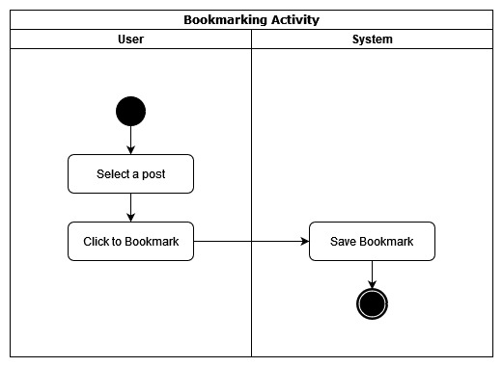

* **Send a friend request**

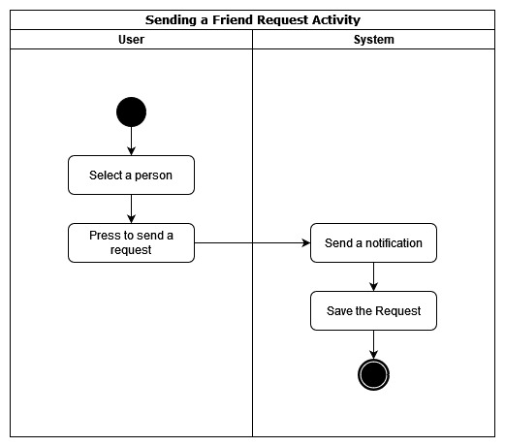

* **Responding to a Request**

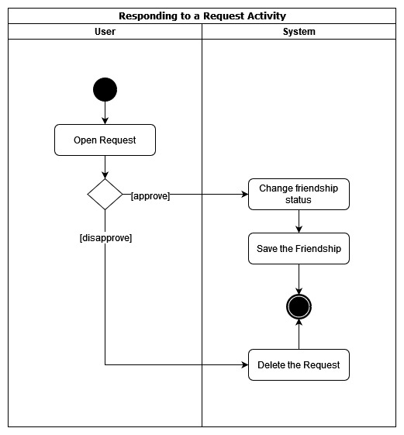

* **Viewing Posts**

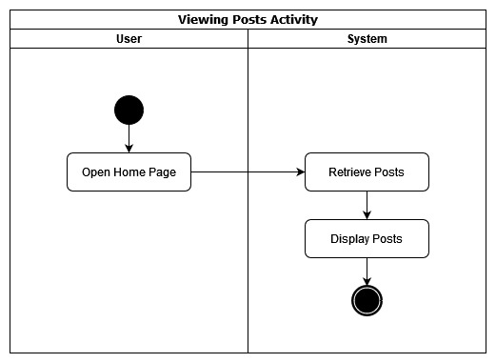

* **Create a comment**

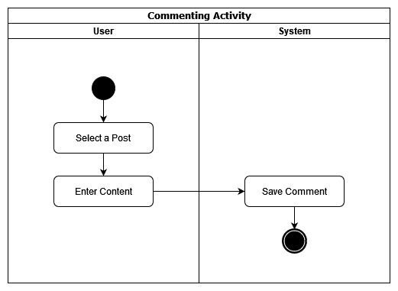

* **Liking a post**

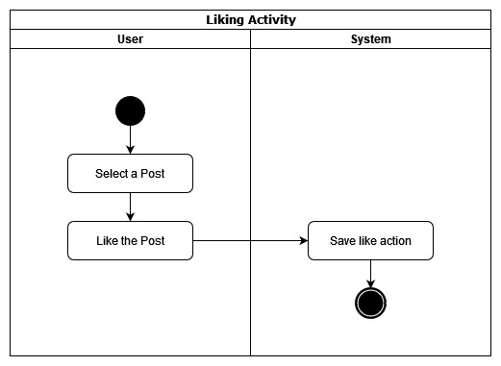

* **Use Case Diagram**

