# QUESTION NO 1

# PLUS ONE

You are given a **large integer** represented as an integer array **.digits.**, where each **.digits[i].** is the **.ith.** digit of the integer. The digits are ordered from most significant to least significant in left-to-right order. Increment the large integer by one and return *the resulting array of digits*.

[∴](https://math.stackexchange.com/questions/3133994/three-dot-%e2%88%b4-symbol-meaning) The large integer does not contain any leading **.0’s.**.

**Example 1:**

**Input:** digits = [1,2,3]

**Output:** [1,2,4]

**Explanation:** The array represents the integer 123.

Incrementing by one gives 123 + 1 = 124.

Thus, the result should be [1,2,4].

**Example 2:**

**Input:** digits = [4,3,2,1]

**Output:** [4,3,2,2]

**Explanation:** The array represents the integer 4321.

Incrementing by one gives 4321 + 1 = 4322.

Thus, the result should be [4,3,2,2].

**Example 3:**

**Input:** digits = [9]

**Output:** [1,0]

**Explanation:** The array represents the integer 9.

Incrementing by one gives 9 + 1 = 10.

Thus, the result should be [1,0].

**Constraints:**

* **.1 <= digits.length <= 100.**
* **.0 <= digits[i] <= 9.**
* **.digits.** does not contain any leading **.0’s.**

# QUESTION NO 2

# MERGE TWO SORTED LISTS

You are given the heads of two sorted linked lists **.list1.** and **.list2.**. Merge the two lists in a one **sorted** list. The list should be made by splicing together the nodes of the first two lists.

Your function should return **.the head of merged linked list.**.

**Example 1:**

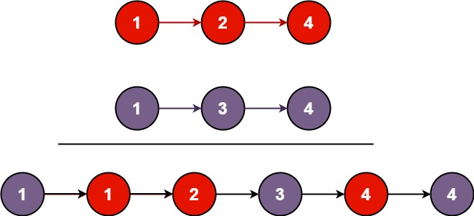

**Input:** list1 = [1,2,4], list2 = [1,3,4]

**Output:** [1,1,2,3,4,4]

**Example 2:**

**Input:** list1 = [], list2 = []

**Output:** []

**Example 3:**

**Input:** list1 = [], list2 = [0]

**Output:** [0]

**Constraints:**

* The number of nodes in both lists is in the range **.[0,50].**
* **.-100 <= Node.val <= 100**
* Both **.list1.** and **.list2.** are sorted in **non-decreasing** order

# QUESTION NO 3

# PANGRAM

Given a string **.sentence.** containing only lowercase English letters, return **.true.** if **.sentence.**is a **pangram**, or **.false.** otherwise.

[∴](https://math.stackexchange.com/questions/3133994/three-dot-%e2%88%b4-symbol-meaning) A **pangram** is a sentence in which every letter of the English alphabet appears at least once.

**Example 1:**

**Input:** sentence = "thequickbrownfoxjumpsoverthelazydog"

**Output:** true

**Explanation:** sentence contains at least one of every letter of the English alphabet.

**Example 2:**

**Input:** sentence = "leetcode"

**Output:** false

**Constraints:**

* **.1 <= sentence.length <= 1000.**
* **.sentence.** consists of lowercase English letters only

**______**