Phase 2 commits

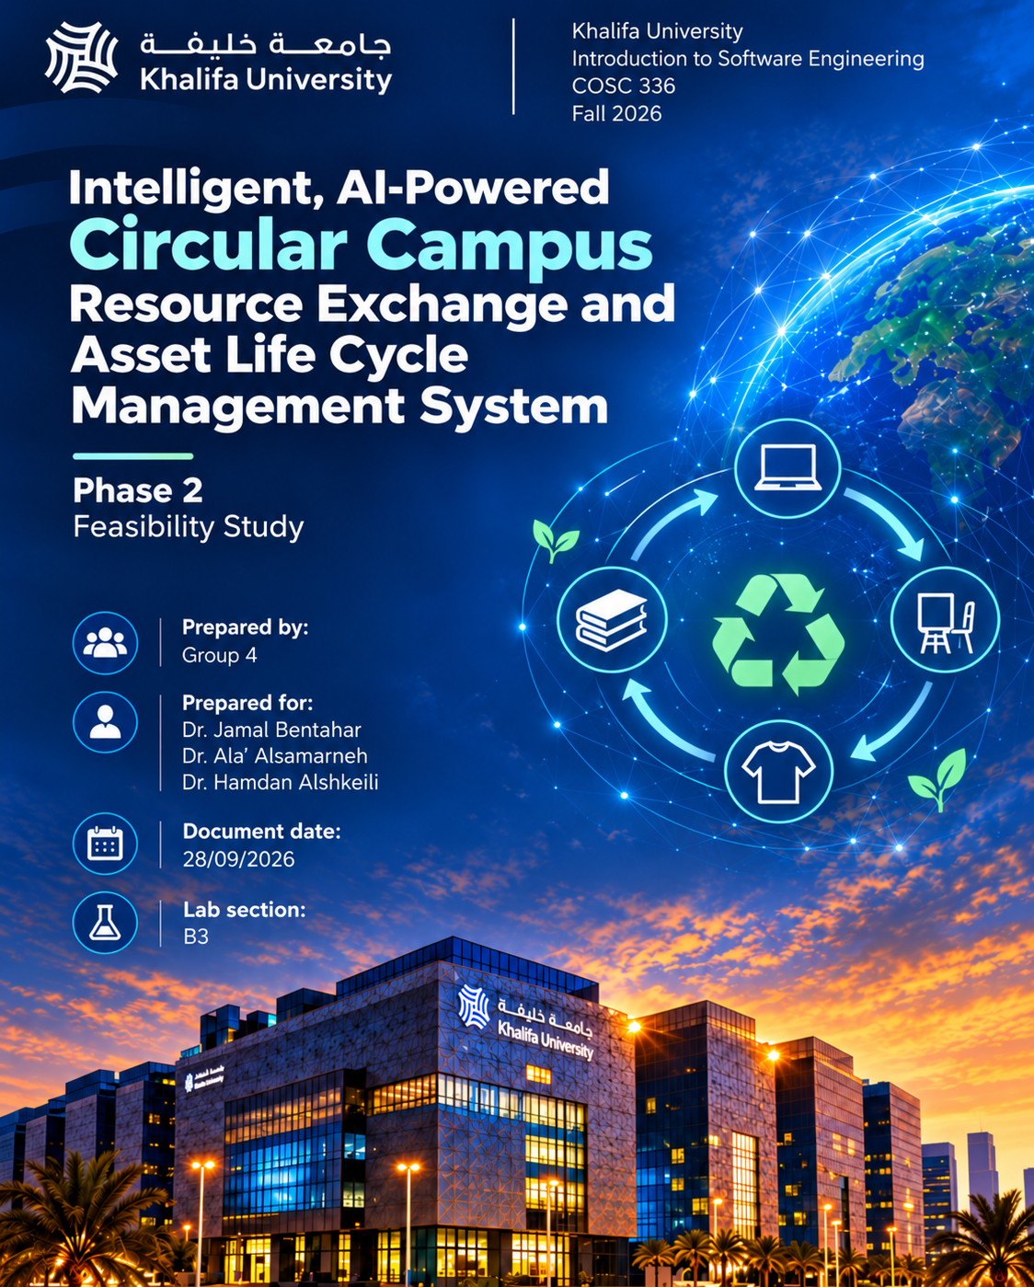
4.Technical Analysis
The AI-Powered Circular Campus Resource Exchange and Asset Life Cycle Management System is technically feasible as a prototype because its main functions can be developed using existing web, database, and AI technologies. The system will include a user interface, application logic, database, authentication and role-based access control, asset-management functions, request workflows, reporting, and AI-supported services.
The core asset-management features are technically straightforward. Information about assets, users, departments, requests, approvals, transfers, and maintenance can be stored in a relational database and managed through a web-based interface. Role-based access control will ensure that users only access functions relevant to their responsibilities, such as submitting requests, managing assets, or approving transfers.
The AI features are more challenging but still achievable for a prototype. These include AI-assisted asset classification, semantic resource matching, sustainability recommendations, an LLM-powered assistant, and AI-supported reporting. Existing AI models, APIs, and machine-learning libraries can be used instead of developing large AI models from scratch. For example, semantic matching can compare asset descriptions with user requests, while an LLM can support natural-language interaction with the system.
System integration is another important consideration. The database, traditional system modules, AI services, reporting tools, and user interface must communicate reliably. A modular architecture can help separate these components so that the core system can continue operating even if an AI service becomes unavailable or produces a low-confidence result. The project brief also requires fallback behavior and clear boundaries between AI recommendations and human decisions.
The use of an Agile development methodology also improves the project's technical feasibility. The system will be developed incrementally, allowing the team to produce working deliverables at different stages and return to earlier features when changes, problems, or new requirements are identified. This is useful for a project containing both traditional and AI-based features, since requirements may need to be refined after testing and feedback. The team can therefore focus first on the Must Have features, such as authentication, asset management, requests, approvals, and transfers, before adding the more advanced AI features classified as Should Have or Could Have.
Overall, the project is technically feasible as a university prototype because the required technologies are available, the system can be divided into manageable modules, and the Agile approach allows the team to develop, test, review, and improve the system throughout the semester.

5.Market Feasibility Analysis
There is a clear need for the proposed Circular Campus system because universities often have usable resources sitting unused in one department while another department may purchase similar items. The project addresses this by making surplus resources visible and allowing departments to search, request, transfer, and reuse them. This could help reduce unnecessary purchases, improve resource utilization, and support sustainability goals.
The main current alternative is the use of traditional asset-management systems. These systems normally focus on recording information such as ownership, location, purchase details, and disposal status. They are useful for keeping structured records, but they do not usually support intelligent internal reuse, semantic matching between available assets and department requests, or detailed measurement of environmental and financial benefits. Also, we have heard complaints from security guards and gym coaches that it takes a massive amount of time to have an assest that’s been requested to finally arrive. In his anecdote, it was a year.
Traditional systems have some advantages compared with the proposed solution. They are generally simpler, more predictable, and rely on clear rule-based processes. However, this also makes them less flexible. For example, a traditional search may depend on exact keywords or predefined categories, while the proposed system can use AI-based semantic matching to identify similar resources even when different terms are used.
The proposed system's main advantage is that it combines normal asset management with a campus resource-exchange system and AI support. In addition to tracking assets, it can recommend suitable matches, assist with classification, suggest whether assets should be reused or repaired, and generate sustainability reports. However, these features also introduce disadvantages such as greater system complexity, dependence on good-quality data, and the possibility of inaccurate AI recommendations. For this reason, important decisions should remain under human control.
Another factor affecting market feasibility is user adoption. The system is intended for several university stakeholders, including department representatives, asset custodians, administrators, maintenance staff, finance officers, sustainability officers, and management. For the system to succeed, these users would need to keep asset records updated and follow the new request, approval, and transfer workflows. Therefore, the system must be easy to use and provide enough benefit for departments to adopt it consistently.
Overall, the system has good market potential within universities because it addresses an existing resource-management problem while offering features beyond a traditional asset-management system. Its main value comes from combining asset tracking, internal resource sharing, AI-supported matching, and sustainability monitoring in one platform.
