Freight Rate Prediction: Validation, Split Approach and December Chart
Machine Learning Engineer assessment. This report covers how the labeled data was split and validated, the data-quality issues found, the chosen model, and the fixed December prediction chart produced by the provided score.py.

1. Summary
- Problem: predict posted_rate for freight loads. 48,000 labeled loads (Jan 1 to Oct 31, 2025) are used for development; 12,000 unlabeled loads (Nov 1 to Dec 31, 2025) need predictions.
- Key constraint: the loads to predict all happen after the training period, so validation must be time-based.
- Model: LightGBM trained on log(rate), with nine features and a 60-day recency weighting.
- Result: average validation MAE of about $120 per load across five held-out months, against about $225 for a per-equipment rate-per-mile baseline.

2. Data split and validation approach
Why not a random split. The validation file covers Nov 1 to Dec 31, and nothing in training comes after Oct 31. Freight prices drift month to month (median rate per mile rose from about $2.03 in January to about $2.25 in June, then eased to about $2.16). A random split would put loads from every month in both halves, letting the model peek at the price level of the months it is tested on, and would overstate accuracy.
Expanding-window time validation. Each round trains on all months before a test month and scores on that month only. Rounds: test June (train Jan–May), July (Jan–Jun), August (Jan–Jul), September (Jan–Aug), October (Jan–Sep). Using five rounds instead of one matters: a single Sep–Oct split suggested one feature set was best, but across five months the ranking changed, so no conclusion was drawn from one split.
Final model. After choosing the configuration, the model is retrained on all 48,000 labeled loads and applied to validation.csv and the December rows.
Leakage controls. Median fill values and the city-to-coordinate lookup are learned from the training portion of each round only. The quote_signal column was dropped (see section 3). The target is never used to build features.
Metrics. The official metric is calculated by the assessor after submission, so MAE (average dollars off) is the headline number, reported with RMSE and MAPE. MAE is easy to interpret and robust to the few extreme-rate loads in the data.

3. Data-quality issues and how they were handled
Issue | Handling
quote_signal leaks the target: it is almost exactly rate divided by distance in Jan–Mar, Jun and Sep, tracks distance the wrong way in Apr, May, Jul and Oct, and is pure noise in Aug and in the Nov–Dec file | Dropped. A model would rely on it in training and fail on the test period where it carries no information.
Negative weights (292 train rows, 145 validation rows) | Absolute value; magnitudes are plausible, only the sign is wrong.
Weight capped at 47,500 lb (about 1,200 rows at the cap) | Kept as is; noted as a clipped measurement.
Missing weight (0.6% of train, 1.4% of validation) and missing market_index | Filled with training medians (weight 31,496 lb).
Extreme rates (about 0.1% of rows at each end, from $0.33 to $14 per mile) | Model trained on log(rate) with an L1 objective, so a few outliers cannot dominate.
Eight cities appear only in validation (about 6% of pickups and deliveries) | City names are not used as features; coordinates and distance are used instead.
Coordinates do not match real city locations; each city has one fixed pair | Used as a consistent per-city location label, with a lookup built from training so the December file (which has no coordinates) can use it.
Distance anomalies: floor at exactly 70 miles, 111 rows far longer than the coordinates imply | Kept; distance is the main driver of rate and the model is robust to these few rows.
market_index absent from the December chart file and unstable in validation rounds | Excluded from the final model.

4. Model choice
Baselines. A single median rate per mile times distance gives MAE $257 on a Sep–Oct holdout; a median per equipment type improves this to $229 (average $225 over the five rounds). Every model had to beat this.
LightGBM on log(rate). A gradient-boosted tree model is a standard strong choice for tabular data with mixed numeric and categorical inputs. Training on log(rate) keeps predictions positive (required by score.py) and treats errors proportionally across cheap and expensive lanes.
Features (9). distance, log distance, weight, equipment type, pickup and delivery latitude and longitude, and day of week.
Calendar features. Month and day of year were tested and left out. Training ends in October, so these columns would take values never seen in training for November and December, and the tree model would simply treat them like the latest months it knows. Results with and without them were close across the five rounds, so the version that does not depend on unseen values was preferred.
Recency weighting. Because the overall price level shifts month to month, training rows are weighted by 0.5 raised to (age in days divided by 60). This brought the no-calendar model level with the best alternative (about $120.5 average MAE).
Results by test month (validation MAE, dollars).
Model | Jun | Jul | Aug | Sep | Oct
Baseline (rate per mile by equipment) | 217 | 210 | 241 | 227 | 231
Final: LightGBM, 60-day weighting | 175 | 102 | 125 | 101 | 100

Average across the five rounds: baseline $225, final model $120.5 MAE (RMSE $644, MAPE 5.1%). RMSE is much higher than MAE because of the few extreme-rate loads, which no feature set predicts. A seed check (three random seeds) moved results by only about one to two dollars, so differences between months are real, not noise.

5. Fixed December prediction chart
The chart below was produced by the provided score.py from december_predictions.csv: Lexington to Fort Wayne, 360 miles, Dry Van, 32,000 lb, with only the date changing.
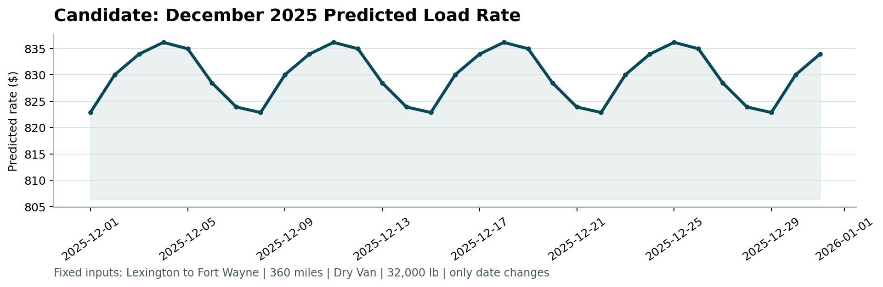
Interpretation. The line repeats a weekly cycle between about $823 (Sunday and Monday) and $836 (Thursday), a swing of roughly 1.6%, in line with the mild midweek premium seen in the training data. There is no holiday effect and no month-level trend. This is an expected limit of the data, not a bug: the training period ends on October 31, so the model has never seen a December, and the only calendar signal it uses is day of week. Christmas Day (a Thursday) is therefore predicted at the weekly peak. I chose not to hard-code a holiday adjustment, since there is no data here to support its size or direction.

6. Limitations and risks
- The overall price level in November and December may differ from anything in training. This is the largest source of remaining error (month-level bias of a few percent in the validation rounds) and cannot be fixed with the available features.
- The December chart reflects weekday patterns only; seasonal December effects are unknown to the model.
- A few extreme-rate loads dominate RMSE; MAE and MAPE better represent typical accuracy.
- The first test month (June) is the weakest round because the model had only five months of history; later rounds with more history are closer to the final setting.

