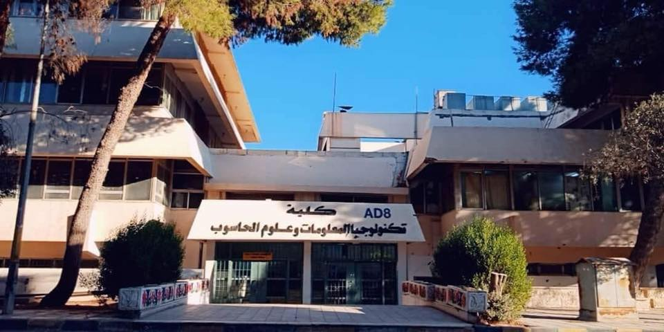

Report Title
  - REPORT SUBTITLE
Name | Course Title | Second Semester 2020/2021
FINAL YEAR GRADUATION PROJECT
Template



Computer Sciences Department
Faculty of Information Technology and Computer Science
Yarmouk University
Irbid, Jordan

Title Page
The title page should include the title of the report along with the name(s) of the department and university, month & year of submission and the project number. Each project will be assigned a Project number for future reference. Also included on the title page should be the name(s) of the author(s) of the report. Title Page is followed by a blank page. A sample title page is shown below.
Graduation Project Report

BSc Project
CS Department
Project ID: YUIT-CS–XX-XXX (XX-XXX, Please request the number form CS dept by sending email to computersci@yu.edu.jo)

Centered Title Times Font Size 26 Bold
Centered SubTitle Times Font Size 16 Bold

Centered Author(s) TimesFontSize18Bold (Name & ID)

Department of Computer Science
Faculty of Information Technology and Computer Sciences
Yarmouk University, Jordan

Contact Information
Below is a sample contact information page. It follows the blank page (after the title page) and contains information about the author(s), external supervisor (if any), internal supervisor and the examiner.

This project report is submitted to the Department of Computer Science at Yarmouk University in partial fulfillment of the requirements for the degree of Bachelor of Information Technology in Computer Science.

Author(s):
Firstname Lastname, (ID)
Address: If applicable
E-mail: If applicable, a long-term e-mail (not your student e-mail)

University supervisor(s):
Firstname Lastname
Department name
Co-supervisor (if applicable):
Firstname Lastname
Company/Organization full name
Address:
Phone: International standard, e.g. use +

Department of Computer Science Internet: http://yu.edu.jo
Faculty of Information Technology Phone: +962 2 72711111 Ext. 6710
and Computer Science
Yarmouk University Fax : +962 2 7211111
Jordan

Intellectual Property Right Declaration
Below is a sample for intellectual property right declaration page. It follows the contact information page.

Intellectual Property Right Declaration

This is to declare that the work under the supervision of _____________________ having title “ _______________________________” carried out in partial fulfillment of the requirements of Bachelor of Information Technology in Computer Science, is the sole property of the Yarmouk University and the respective supervisor and is protected under the intellectual property right laws and conventions. It can only be considered/ used for purposes like extension for further enhancement, product development, adoption for commercial/organizational usage, etc., with the permission of the University and respective supervisor.

This above statement applies to all students and faculty members.
Date: ______________
Author(s):

Name: Firstname Lastname | Signature: _____________________
Name: Firstname Lastname | Signature: _____________________
Name: Firstname Lastname | Signature: _____________________

Supervisor(s):

Name: Firstname Lastname Signature: _____________________

Anti-Plagiarism Declaration
Below is a sample for Anti-plagiarism declaration, it follows the intellectual property right declaration page.

Anti-Plagiarism Declaration
This is to declare that the above publication produced under the supervision of________________________________________________________having title “_________________________________________________________” is the sole contribution of the author(s) and no part hereof has been reproduced illegally (cut and paste) which can be considered as Plagiarism. All referenced parts have been used to argue the idea and have been cited properly. I/We will be responsible and liable for any consequence if violation of this declaration is proven.

Date: ______________
Author(s):

Name: Firstname Lastname Signature: _____________________
Name: Firstname Lastname Signature: _____________________
Name: Firstname Lastname Signature: _____________________

Acknowledgement
Below is a sample for Acknowledgement page, it follows the Anti-Plagiarism Declaration page.

ACKNOWLEDGMENTS

This work is dedicated to my dear parents, the most loving in this world.

Abstract
Below is a sample for Abstract page. It follows the Acknowledgement page.

ABSTRACT
[Abstract text]
Keywords: 3-4 keywords, maximum 2 of these from the title, which starts one line below the Abstract.

Table of Contents
Below is a sample for Contents page. It follows the Abstract page.

TABLE OF CONTENTS
[Table of contents]

GP Report Chapters
From here onwards this document should be organized into different chapters specific to each project. Rest of the section outlines chapters to be included and the recommended contents of each chapter.

Chapter 1 INTRODUCTION
1.1 Purpose of the Project
1.2 Purpose of this Document
1.3 Overview of this Document
1.4 Existing System
1.4.1 Existing system description
1.4.2 Problems in the existing system

Chapter 2 SYSTEM ANALYSIS
2.1 Data Analysis
2.1.1 Data flow diagrams
2.1.2 System requirements
2.1.2.1 Clients, customers, and users (Use-case Diagrams)
2.1.2.2 Functional and data requirements
2.1.2.3 Non-functional requirements
2.1.2.3.1 Look and feel requirements.
2.1.2.3.2 Usability requirements
2.1.2.3.3 Security requirements
2.1.2.3.4 Performance requirement
2.1.2.3.5 Portability requirements
2.1.3 Class Diagrams
2.1.4 Proposed Solutions
2.1.5 Alternative Solutions

Chapter 3 DESIGN CONSIDERATIONS
3.1 Design Constraints
3.1.1 Hardware and software environment
3.1.2 End user characteristics
3.2 Architectural Strategies
3.2.1 Algorithm to be used
3.2.2 Reuse of existing software components
3.2.3 Project management strategies
3.2.4 Development method
3.2.5 Future enhancements/plans

Chapter 4 SYSTEM DESIGN
4.1 System Architecture and Program Flow
4.1.1 Major modules
4.1.2 Sub modules
4.2 Detailed System Design
4.2.1 Detailed component description

Chapter 5 IMPLEMENTATION AND VALIDATION

Appendix A CODE
Appendix References

