Operating Systems Course Project: Process Creation and Inter-Process Communication Using fork() and Pipes
Course: Operating Systems
Topic: Process Management & IPC
Due Date: May, 3rd 2026

Introduction
Modern operating systems provide powerful mechanisms for achieving parallel execution through process creation. One of the most fundamental system calls for process management in Unix-like operating systems (including Linux) is fork(). When a program calls fork(), the operating system creates an almost identical copy of the calling process, resulting in two (or more) processes executing concurrently. This capability allows developers to harness the power of multi-core processors by distributing computational tasks across multiple processes that can run simultaneously.
In this assignment, you will explore process creation, inter-process communication (IPC), and parallel algorithm design by implementing a parallel sum calculator. The problem is deceptively simple: given a large array (vector) of floating-point numbers, compute the total sum. However, instead of computing the sum sequentially in a single loop, you will divide the work among multiple child processes, each summing a portion of the array in parallel.

Why This Assignment Matters
Understanding process-based parallelism is crucial for several reasons:
- Real-world applications: Many computational problems—from scientific simulations to big data processing—can be speed up by dividing work across multiple processes. Database query processing, image rendering, and financial risk analysis are just a few examples.
- Fundamental OS concepts: This assignment touches on core operating system concepts including:
  - Process creation and management (fork())
  - Process synchronization (wait())
  - Inter-process communication (pipes)
  - Resource management (file descriptors)
  - Process termination and cleanup
- Performance understanding: You will gain insights into the overhead of process creation versus the benefits of parallel execution, and understand when parallelization is (and isn't) beneficial.
- Foundation for advanced topics: The concepts you learn here—splitting work, coordinating independent workers, and collecting results—are directly applicable to more advanced parallel programming models like MPI (Message Passing Interface) used in supercomputing clusters.

The Problem: Parallel Summation
Imagine you have a list of 1 million floating-point numbers. Adding them sequentially requires 1 million operations, which might take a noticeable amount of time. However, if you have 4 CPU cores available, you could:
- Split the list into 4 chunks of 250,000 numbers each
- Have 4 separate processes sum their respective chunks simultaneously
- Collect the 4 partial sums and add them together
Theoretically, this could be nearly 4 times faster! (In practice, there's some overhead for process creation and communication.)

The Fork Model: How It Works
The fork() system call creates a new process by duplicating the calling process. The original process becomes the parent, and the new process becomes the child. After fork() returns:
- The child process receives a return value of 0
- The parent process receives the child's Process ID (PID) as the return value
This creates a branch point where the same code can execute different logic depending on whether it's running in the parent or child.
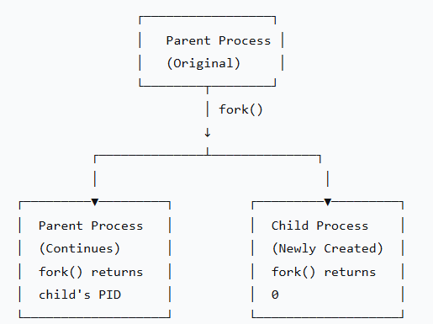

The Challenge: Communication Between Processes
Once we fork() child processes, a critical question arises: how do child processes send their partial sums back to the parent? Unlike threads, processes do not share memory space. Each process has its own private address space, so a child cannot simply write to a variable in the parent.
This is where pipes come in. A pipe is a unidirectional communication channel that allows data to flow from one process to another. Think of it as a virtual tube:
- One process writes data into one end of the tube
- Another process reads data from the other end
For each child process, we create a separate pipe. The child writes its partial sum to its pipe, and the parent reads from all pipes to collect the results.
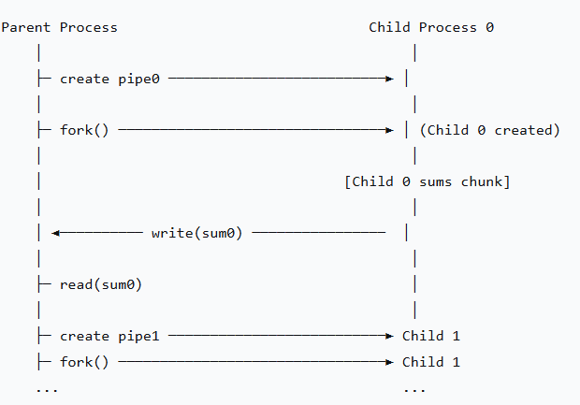

What You Will Learn
By completing this assignment, you will:
- Master fork() semantics: Understand exactly what happens when a process forks, including memory duplication, file descriptor inheritance, and process state.
- Implement IPC with pipes: Learn how to create, use, and properly close pipes for reliable inter-process communication.
- Handle process synchronization: Use wait() to ensure the parent doesn't collect results before children finish.
- Manage resources properly: Learn why closing unused file descriptors is critical and what happens when you don't.
- Design for scalability: Your code will work for any number of child processes, teaching you to think about general solutions rather than hardcoded ones.
- Handle edge cases: What happens when the vector size isn't evenly divisible by the number of processes? What if a process fails to create? These real-world considerations are part of robust system programming.

The Assignment Structure
This assignment is divided into two parts:
Part 1 (Conceptual): You will answer questions about a provided example that uses exactly 3 child processes. These questions test your understanding of fork(), pipes, and process synchronization.
Part 2 (Programming): You will extend the example to work with M child processes (user-specified) and N vector elements (user-specified). This requires you to:
- Handle dynamic pipe array allocation
- Calculate uneven work distribution when N is not divisible by M
- Properly manage file descriptors for an arbitrary number of processes
- Verify results by comparing with sequential computation

Real-World Analogy
Think of this assignment like organizing a group project:
- You (the parent) have a large task: adding 1,000 numbers.
- You recruit M team members (child processes).
- You divide the numbers among team members.
- Each team member works independently and simultaneously on their portion.
- When finished, each team member writes their partial sum on a private whiteboard (pipe).
- You read all the whiteboards and add up the partial sums to get the final result.
The challenge is that team members cannot see each other's whiteboards, and you must wait until everyone has finished before calculating the final total.

Getting Started
Before writing code, make sure you understand:
- How fork() works: Run the example code and observe the output. Add print statements to see which process (parent or child) is executing.
- Pipe mechanics: Write a small test program where parent sends a message to child through a pipe, or vice versa.
- Process IDs: Use getpid() and getppid() to track which process is which.
- Error handling: System calls can fail. Always check return values!
Common Pitfalls to Avoid
- Forgetting to close pipe ends → Process hangs forever waiting for data
- Not waiting for children → Zombie processes consume system resources
- Assuming even distribution → Handle remainders correctly
- Using pipes after closing them → Results in "bad file descriptor" errors
- Not checking fork() return value → Unpredictable behavior

Success Criteria
Your assignment is successful if:
- The program correctly computes the sum for any valid N and M
- All child processes run in parallel (not sequentially)
- The parent properly collects and aggregates results
- No resource leaks (all pipes and processes cleaned up)
- The output clearly shows what each child contributed
- The parallel result matches the sequential result

Beyond This Assignment
The skills you develop here extend far beyond summing numbers:
- MapReduce framework: Google's pioneering big data platform follows the same pattern (map tasks compute partial results, reduce task aggregates)
- Pipeline processing: Each stage of a processing pipeline can be a separate process
- Client-server systems: Each client connection can be handled by a forked child process
- Batch processing systems: Work is distributed across worker processes

Conclusion
This assignment bridges theory and practice in operating systems. You will take the abstract concept of "process" and work with it directly, creating, managing, and communicating between multiple processes. The parallel sum calculator, while simple in concept, teaches fundamental patterns that appear throughout systems programming.
Remember: The goal is not just to get the correct answer, but to understand why and how the parallel execution works. Pay attention to the flow of execution, the state of file descriptors, and the interactions between processes.
Good luck, and happy parallel computing!

Part 1: Understanding the Example (30 points)

Example Code: Parallel Sum Calculation with 3 Child Processes
Study the following code carefully. It demonstrates how to use fork() to create child processes and pipes for inter-process communication (IPC).
cpp
#include <iostream>
#include <vector>
#include <cstdlib>
#include <ctime>
#include <sys/wait.h>
#include <unistd.h>

int main() {
// Configuration
int N = 15; // Size of vector (divisible by 3 for simplicity)

// Step 1: Parent initializes vector with random values
std::vector<float> numbers(N);
srand(time(NULL));

std::cout << "Vector values: ";
for (int i = 0; i < N; i++) {
numbers[i] = (rand() % 100) / 10.0; // Random values 0.0 to 9.9
std::cout << numbers[i] << " ";
}
std::cout << std::endl << std::endl;

// Step 2: Create 3 pipes for 3 children to send results back
int pipes[3][2];
for (int i = 0; i < 3; i++) {
pipe(pipes[i]);
}

// Step 3: Create 3 child processes
int chunk_size = N / 3; // Each child gets 5 elements

for (int i = 0; i < 3; i++) {
pid_t pid = fork();

if (pid == 0) {
// Child process
close(pipes[i][0]); // Close read end

// Calculate start and end indices for this child
int start = i * chunk_size;
int end = (i + 1) * chunk_size;

// Sum this chunk
float sum = 0;
for (int j = start; j < end; j++) {
sum += numbers[j];
}

// Send sum to parent through pipe
write(pipes[i][1], &sum, sizeof(float));
close(pipes[i][1]);

return 0; // Child exits
}
}

// Step 4: Parent collects sums from all 3 children
float total = 0;
for (int i = 0; i < 3; i++) {
close(pipes[i][1]); // Close write end

float child_sum;
read(pipes[i][0], &child_sum, sizeof(float)); // blocking call
close(pipes[i][0]);

total += child_sum;

// Wait for child to finish
wait(NULL);

std::cout << "Child " << i << " sum = " << child_sum << std::endl;
}

// Step 5: Display final result
std::cout << "\nTotal sum = " << total << std::endl;

return 0;
}

Running the above code and the expected output
Important note: Run under Linux only
Compilation command
g++ project_3_workers.cpp -o project_3_workers.out -Wall
Running command with expected output:
./project_3_workers.out
Vector values: 9.4 8.7 0.4 4.3 9.7 0.2 4.9 0.9 8.1 5.2 9.9 3.8 0.8 4.2 3.5

Child 0 sum = 32.5
Child 1 sum = 19.3
Child 2 sum = 22.2

Total sum = 74

Questions for Part 1
1.1 (5 points) Explain what happens when fork() is called inside the loop. Why don't the child processes create grandchildren?
1.2 (5 points) Why do we need to close unused pipe ends in both parent and child processes? What would happen if we didn't close them?
1.3 (5 points) Explain the purpose of the wait(NULL) function call. What would happen if the parent didn't wait for children?
1.4 (5 points) Why do we need a separate pipe for each child process? Could we use a single pipe for all children? Explain.
1.5 (5 points) What is the purpose of the close(pipes[i][1]) call in the parent process before reading?
1.6 (5 points) Explain the blocking behavior of read(). What happens if a child process hasn't written its sum yet when the parent calls read()?

Part 2: Programming Assignment (70 points)

Task Description
Your task is to generalize the example code to work with M child processes (instead of hardcoded 3), where M is specified by the user. The program should handle vectors of any size N, even when N is not perfectly divisible by M.

Requirements
Write a C++ program that:
- Takes command line arguments:
  - First argument: Vector size N (integer)
  - Second argument: Number of child processes M (integer)
  - Example:
./parallel_sum 1000 5
- Validates input:
  - N must be > 0
  - M must be between 1 and 100
  - Display error messages for invalid input
- Implements parallel sum calculation:
  - Parent initializes vector with random float values between -100.0 and 100.0
  - Parent creates M child processes using fork()
  - Work is distributed as evenly as possible among children
  - Each child sums its assigned portion of the vector
  - Results are sent back to parent via pipes
  - Parent calculates and displays the total sum
- Handles uneven distribution:
  - If N is not divisible by M, the last child should handle the remaining elements
  - Example: N=10, M=3 → Distribution: Child 0: 4 elements, Child 1: 3 elements, Child 2: 3 elements
- Displays detailed output:
  - First 10 values of the vector (or all if N <= 10)
  - For each child: PID, range of indices processed, partial sum
  - Final total sum
  - Sequential sum for verification
- Implements error handling:
  - Check for fork() failures
  - Check for pipe() failures
  - Check for read()/write() errors

Code Template
Start with this template and complete the missing parts:
cpp
#include <iostream>
#include <vector>
#include <cstdlib>
#include <ctime>
#include <sys/wait.h>
#include <unistd.h>
#include <iomanip>

/**
* Generates a random float between min and max
*/
float random_float(float min, float max) {
float r = static_cast<float>(rand()) / static_cast<float>(RAND_MAX);
return min + r * (max - min);
}

/**
* Displays first 'count' elements of the vector
*/
void display_vector(const std::vector<float>& vec, int count = 10) {
// IMPLEMENT THIS FUNCTION
}

/**
* Calculates sum sequentially (for verification)
*/
float sequential_sum(const std::vector<float>& vec) {
// IMPLEMENT THIS FUNCTION
}

int main(int argc, char* argv[]) {
// Parse command line arguments
if (argc != 3) {
std::cerr << "Usage: " << argv[0] << " <vector_size> <num_processes>" << std::endl;
return 1;
}

int N = std::atoi(argv[1]); // Vector size
int M = std::atoi(argv[2]); // Number of child processes

// TODO: Validate input (N > 0, 1 <= M <= 100)

// TODO: Initialize vector with random values

// TODO: Display vector (first 10 elements)

// TODO: Create pipes (one for each child)

// TODO: Calculate chunk sizes for each child
// Hint: Use base_size = N / M, remainder = N % M
// First 'remainder' children get (base_size + 1) elements
// Remaining children get base_size elements

// TODO: Create M child processes using fork()

// TODO: Parent collects results from all children

// TODO: Display results and verification

return 0;
}

Implementation Steps
Step 1: Input Validation (5 points)
- Check that N > 0
- Check that M is between 1 and 100
- Print appropriate error messages
Step 2: Vector Initialization (5 points)
- Create vector of size N
- Fill with random floats between -100.0 and 100.0
- Display first 10 values
Step 3: Pipe Creation (5 points)
- Create an array of M pipes (use dynamic allocation or vector of arrays)
- Check for pipe creation errors
Step 4: Chunk Distribution Logic (10 points)
- Calculate how many elements each child gets
- Formula: base_size = N / M, remainder = N % M
- First remainder children get base_size + 1 elements
- Remaining children get base_size elements
Step 5: Child Process Creation (15 points)
- Loop M times, calling fork()
- In child process:
  - Close unused pipe ends
  - Calculate start and end indices based on distribution
  - Compute sum of assigned chunk
  - Send sum to parent via pipe
  - Exit
Step 6: Parent Result Collection (15 points)
- Close unused pipe ends in parent
- Read partial sums from each child
- Add to total
- Wait for each child to complete
- Display each child's contribution (PID, range, sum)
Step 7: Verification and Output (10 points)
- Calculate sequential sum
- Compare with parallel sum
- Display both results and difference
- Handle floating-point precision
Step 8: Error Handling (5 points)
- Check return values of pipe(), fork(), read(), write()
- Display meaningful error messages
- Clean up resources on error

Sample Output
$ ./parallel_sum 100 4

=== Parallel Sum Calculator ===
Vector size: 100
Number of processes: 4

Vector values (first 10): 23.45, -12.67, 45.89, -78.12, 34.56, -67.89, 12.34, -45.67, 89.01, -23.45

Creating 4 child processes...

Child 0 (PID: 12345): indices [0-24] = 125.67
Child 1 (PID: 12346): indices [25-49] = -98.23
Child 2 (PID: 12347): indices [50-74] = 234.56
Child 3 (PID: 12348): indices [75-99] = -12.34

Parallel sum: 249.66
Sequential sum: 249.66
Difference: 0.000000

✓ Results match! Computation successful.

Test Cases
Test your program with these scenarios:
Test Case | N | M | Expected Behavior
1 | 100 | 4 | Even distribution (25 each)
2 | 100 | 3 | Uneven: 34, 33, 33
3 | 1 | 5 | M > N, some children get 0 elements
4 | 0 | 4 | Error: Invalid vector size
5 | 100 | 0 | Error: Invalid process count
6 | 1000000 | 8 | Large vector performance test

What to Submit
- Complete source code (parallel_sum.cpp)
- README file containing:
  - Instructions to compile and run
  - Sample output for test cases 1-3
  - Any known limitations or bugs

Grading Rubric
Component | Points
Part 1 Questions | 30
Input validation | 5
Vector initialization and display | 5
Pipe creation | 5
Chunk distribution logic | 10
Fork and child process logic | 15
Parent result collection | 15
Verification and output | 10
Error handling | 5
Code style and comments | 5
README | 5
Total | 100

Bonus Challenge (Extra 10 points)
Implement a version that also measures and displays:
- Time taken for sequential sum
- Time taken for parallel sum
- Speedup factor (sequential_time / parallel_time)
Use clock_gettime() or gettimeofday() for timing.

Hints and Tips
- Dynamic pipe array: Use std::vector<std::array<int, 2>> or allocate int (*pipes)[2] = new int[M][2];
- Chunk calculation:
cpp
int base = N / M;
int remainder = N % M;
int start = i * base + std::min(i, remainder);
int end = start + base + (i < remainder ? 1 : 0);
- Remember to close pipes: Always close unused ends to prevent resource leaks and ensure proper EOF detection.
- Wait for children: Use wait() or waitpid() to prevent zombie processes.
- Floating point comparison: Use a small epsilon value for comparison:
cpp
if (fabs(parallel_sum - sequential_sum) < 0.0001) {
std::cout << "Results match!" << std::endl;
}
Good luck!

Appendix: Explaining the 3-workers code

Section 1: Header Files and Setup (Lines 1-6)
#include <iostream> // For std::cout, std::endl
#include <vector> // For std::vector container
#include <cstdlib> // For rand(), srand(), exit()
#include <ctime> // For time() function
#include <sys/wait.h> // For wait() function
#include <unistd.h> // For fork(), pipe(), read(), write(), close()
Why these headers?
- <unistd.h> provides the POSIX operating system API (fork, pipe, read, write)
- <sys/wait.h> provides process waiting functionality
- <cstdlib> and <ctime> handle random number generation

Section 2: Vector Initialization (Lines 8-21)
int N = 15; // Size of vector
std::vector<float> numbers(N); // Creates vector with 15 float elements
srand(time(NULL)); // Seeds random number generator with current time
How Random Numbers Work:
numbers[i] = (rand() % 100) / 10.0;
Step-by-step:
- rand() returns random integer between 0 and RAND_MAX (usually 32767)
- rand() % 100 gives remainder when divided by 100 → range 0 to 99
- Dividing by 10.0 (floating point) gives values: 0.0, 0.1, 0.2, ..., 9.9
Example transformation:
text
rand() = 42
42 % 100 = 42
42 / 10.0 = 4.2
Why use time(NULL)?
- time(NULL) returns current time in seconds since 1970
- This changes every second, so we get different random numbers each run

Section 3: Pipe Creation (Lines 23-27)
int pipes[3][2]; // 3 pipes, each with 2 file descriptors
for (int i = 0; i < 3; i++) {
pipe(pipes[i]); // Create pipe number i
}
Understanding pipes[3][2] in Memory:
pipes array in memory:
pipes[0] → [ read_fd, write_fd ] (for child 0)
pipes[1] → [ read_fd, write_fd ] (for child 1)
pipes[2] → [ read_fd, write_fd ] (for child 2)

Each pipe is independent:
- Pipe 0: pipes[0][0] (read), pipes[0][1] (write)
- Pipe 1: pipes[1][0] (read), pipes[1][1] (write)
- Pipe 2: pipes[2][0] (read), pipes[2][1] (write)
What pipe() actually does:
When you call pipe(fd):
- OS creates a kernel buffer (typically 4KB-64KB)
- Creates two file descriptors:
  - fd[0] - read end (data comes OUT of buffer)
  - fd[1] - write end (data goes INTO buffer)
- Adds these to the process's file descriptor table
Visual representation:
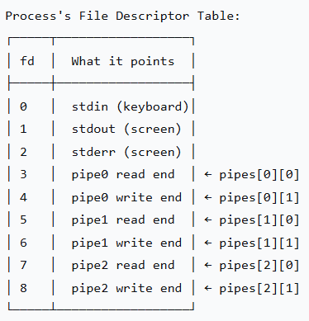

Section 4: Child Process Creation (Lines 29-52)
The fork() System Call
When fork() is called, the OS:
- Creates a new process (child)
- Copies the parent's memory space (code, data, stack)
- Copies the parent's file descriptor table
- Returns:
  - 0 to the child process
  - Child's PID (positive number) to parent
  - -1 if error
The Loop Execution Trace
Let us trace through each iteration with actual values:
Initial state:
- N = 15, M = 3, chunk_size = 5
Iteration i = 0:
pid_t pid = fork(); // Creates Child 0
After fork():
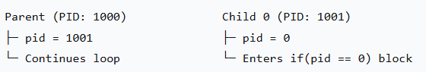

Child 0 executes:
if (pid == 0) {
close(pipes[0][0]); // Close read end of pipe 0
int start = 0 * 5 = 0;
int end = (0 + 1) * 5 = 5;

float sum = 0;
for (int j = 0; j < 5; j++) {
sum += numbers[j]; // Sum indices 0,1,2,3,4
}

write(pipes[0][1], &sum, sizeof(float)); // Send sum through pipe
close(pipes[0][1]); // Close write end
return 0; // Child 0 exits HERE
}

Parent continues:
// Parent reaches end of loop iteration i=0
// i increments to 1
// Loop continues to i=1

Iteration i = 1:
Parent calls fork() again:
pid_t pid = fork(); // Creates Child 1
Important: Child 0 has already exited and does NOT execute this fork!
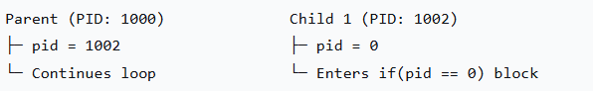

Child 1 executes:
if (pid == 0) {
close(pipes[1][0]); // Close read end of pipe 1
int start = 1 * 5 = 5;
int end = (1 + 1) * 5 = 10;

float sum = 0;
for (int j = 5; j < 10; j++) {
sum += numbers[j]; // Sum indices 5,6,7,8,9
}

write(pipes[1][1], &sum, sizeof(float));
close(pipes[1][1]);
return 0; // Child 1 exits
}

Iteration i = 2:
Parent calls fork() again:
pid_t pid = fork(); // Creates Child 2
Child 2 executes:
if (pid == 0) {
close(pipes[2][0]); // Close read end of pipe 2
int start = 2 * 5 = 10;
int end = (2 + 1) * 5 = 15;

float sum = 0;
for (int j = 10; j < 15; j++) {
sum += numbers[j]; // Sum indices 10,11,12,13,14
}

write(pipes[2][1], &sum, sizeof(float));
close(pipes[2][1]);
return 0; // Child 2 exits
}

Loop ends: i becomes 3, condition i < 3 fails
Why No Grandchildren?
Critical point: Each child executes return 0 immediately after its work, BEFORE the loop continues. Therefore:
- Child 0 never reaches i=1 or i=2
- Child 1 never reaches i=2
- Only the parent completes all 3 iterations

Visual timeline:

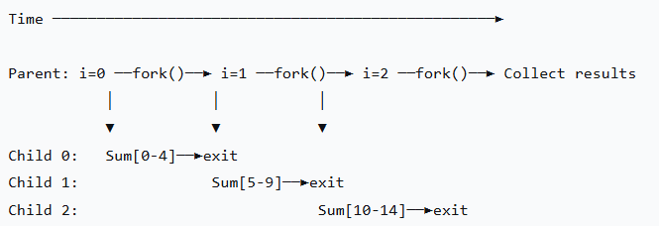

Section 5: The Pipe Communication Mechanism
How Data Flows Through a Pipe
Let's trace what happens with Pipe 0:
Step 1: pipe(pipes[0]) creates:
pipes[0][0] = 3 (read end)
pipes[0][1] = 4 (write end)

Step 2: fork() creates Child 0
Child 0 inherits both file descriptors

Step 3: Child 0 closes read end: close(pipes[0][0])
Now Child 0 has: pipes[0][1] = 4 (write only)

Step 4: Parent (later) closes write end: close(pipes[0][1])
Now Parent has: pipes[0][0] = 3 (read only)

Step 5: Child writes: write(4, &sum, 4)
Data flows into kernel buffer

Step 6: Parent reads: read(3, &child_sum, 4)
Data flows from kernel buffer to parent
Visual representation of Pipe 0:
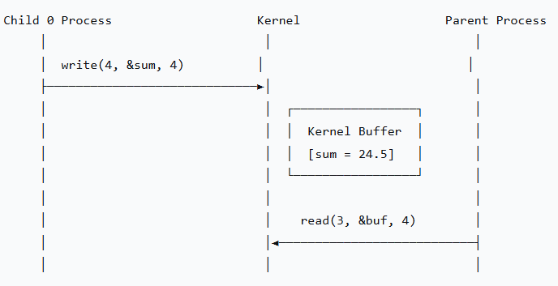
Why Close Unused Pipe Ends?
Without closing, problems occur:
- Resource leak: Each open file descriptor consumes kernel memory
- Infinite blocking: If parent doesn't close write end, read() may block forever
- Reference counting: Pipes only close when ALL file descriptors are closed

Example of the problem:
// WRONG - Parent keeps write end open
// Parent never closes pipes[i][1]
read(pipes[i][0], &child_sum, sizeof(float)); // May BLOCK forever!
Why? The kernel keeps the pipe alive as long as ANY process has the write end open. Even after children exit, if parent still has write end open, read() will wait for data that will never arrive.

Section 6: Parent Collecting Results (Lines 54-68)
float total = 0;
for (int i = 0; i < 3; i++) {
close(pipes[i][1]); // CRITICAL: Close parent's write end

float child_sum;
read(pipes[i][0], &child_sum, sizeof(float));
close(pipes[i][0]);

total += child_sum;

wait(NULL); // Wait for child to terminate

std::cout << "Child " << i << " sum = " << child_sum << std::endl;
}
The Order of Execution
Parent's collection loop:
i=0: close(pipes[0][1]) // Parent closes write end of pipe 0
read(pipes[0][0]) // Reads Child 0's sum (blocks if not ready)
wait(NULL) // Waits for Child 0 to exit
print Child 0 sum

i=1: close(pipes[1][1]) // Parent closes write end of pipe 1
read(pipes[1][0]) // Reads Child 1's sum
wait(NULL) // Waits for Child 1 to exit
print Child 1 sum

i=2: close(pipes[2][1]) // Parent closes write end of pipe 2
read(pipes[2][0]) // Reads Child 2's sum
wait(NULL) // Waits for Child 2 to exit
print Child 2 sum

The wait() Function
wait(NULL);
What wait() does:
- Suspends parent process execution
- Waits for ANY child process to terminate
- Reaps the child's exit status (prevents zombies)
- Returns the PID of the terminated child
Why we need wait():
- Without wait(), children become zombie processes (processes that have exited but still have an entry in the process table)
- Zombies consume system resources (process table entries)
- Too many zombies can prevent new processes from being created
Zombie process visualization:
Without wait():
Parent ──fork()──► Child ──exit()──► [ZOMBIE] (still in process table)

With wait():
Parent ──fork()──► Child ──exit()──► wait() reaps child ──► [CLEANED UP]

Section 7: Complete Execution Flow Diagram
Here's the complete sequence of events:
START
│
├─ Parent initializes vector[0..14] with random values
│
├─ Parent creates 3 pipes
│ ├─ pipe0: fd[3]=read, fd[4]=write
│ ├─ pipe1: fd[5]=read, fd[6]=write
│ └─ pipe2: fd[7]=read, fd[8]=write
│
├─ i=0: Parent calls fork()
│ │
│ ├─► Child 0 created (PID=1001)
│ │ ├─ Child 0 closes read end of pipe0 (fd=3)
│ │ ├─ Child 0 sums numbers[0..4] → partial_sum = 24.5
│ │ ├─ Child 0 writes to pipe0 (fd=4)
│ │ ├─ Child 0 closes write end of pipe0
│ │ └─ Child 0 exits (return 0)
│ │
│ └─ Parent continues (pid=1001)
│
├─ i=1: Parent calls fork()
│ │
│ ├─► Child 1 created (PID=1002)
│ │ ├─ Child 1 closes read end of pipe1 (fd=5)
│ │ ├─ Child 1 sums numbers[5..9] → partial_sum = 31.2
│ │ ├─ Child 1 writes to pipe1 (fd=6)
│ │ ├─ Child 1 closes write end of pipe1
│ │ └─ Child 1 exits
│ │
│ └─ Parent continues (pid=1002)
│
├─ i=2: Parent calls fork()
│ │
│ ├─► Child 2 created (PID=1003)
│ │ ├─ Child 2 closes read end of pipe2 (fd=7)
│ │ ├─ Child 2 sums numbers[10..14] → partial_sum = 18.3
│ │ ├─ Child 2 writes to pipe2 (fd=8)
│ │ ├─ Child 2 closes write end of pipe2
│ │ └─ Child 2 exits
│ │
│ └─ Parent continues (pid=1003)
│
├─ Parent closes write ends of all pipes
│ ├─ close(pipe0[1]) // fd=4
│ ├─ close(pipe1[1]) // fd=6
│ └─ close(pipe2[1]) // fd=8
│
├─ i=0: Parent reads from pipe0 → gets 24.5
│ Parent waits for Child 0 → reaps PID=1001
│ total = 24.5
│
├─ i=1: Parent reads from pipe1 → gets 31.2
│ Parent waits for Child 1 → reaps PID=1002
│ total = 55.7
│
├─ i=2: Parent reads from pipe2 → gets 18.3
│ Parent waits for Child 2 → reaps PID=1003
│ total = 74.0
│
└─ Parent prints "Total sum = 74.0"

