Normalization Lab

1) Your task in this exercise is to move the un-normalized table to 3NF. To do this, use the dependency diagram.

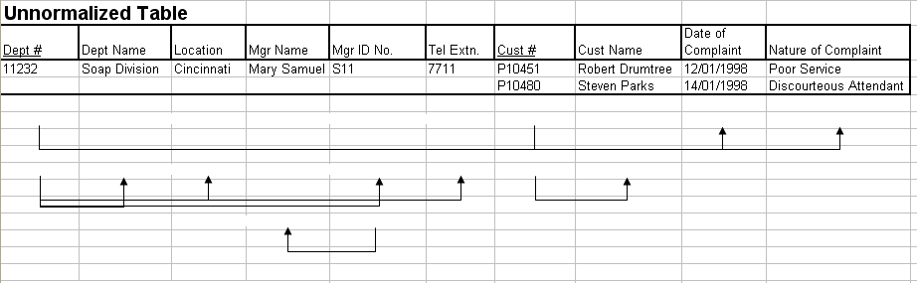

- 1NF

Dept # | Cust # | Cust Name | Date of Complaint | Nature of Complaint | Dept Name | Location | Mgr Name | Mgr ID No. | Tel Extn.
- 2NF

Remove partial dependencies

Dept # : Dept name,location , Mgr Name,Mgr Id No,Tel Exten
Cust # : Cust Name
Dept # ,Cust # : Date of Complaint ,Nature Of Complaint

Dept # | Cust # | Date of Complaint | Nature of Complaint

Dept # | Dept Name | Location | Mgr Name | Mgr ID No. | Tel Extn.

Cust # | Cust Name

- 3NF
Remove the transitive dependencies
Dept # : Dept name,location ,Mgr Id No,Tel Exten
Cust # : Cust Name
Dept # ,Cust # : Date of Complaint ,Nature Of Complaint
Mgr Id No : Mgr Name

Dept# | Dept Name | Location | Mgr ID No | No Tel Exten

Cust # | Cust Name

Dept# | Cust # | Date of Complaint | Nature Of Complaint

Mgr Id No | Mgr Name

2- Employee and Projects
The table below depicts the requirements for a business consultancy working on local and international projects.
Emp-No | Emp-Name | Dept | Dept Manager | Proj-id | Proj-Start-Date | Location | Weeks-on-Project
005 | Smith | Marketing | Jones | A  B  C | 12-1993  06-1994  09-1994 | Poole  Plymouth  Portsmouth | 11  15  6
007 | Bond | Accounts | Bloggs | B  D | 06-1994  06-1994 | Plymouth  Berlin | 3  9
009 | King | Info Systems | Hurne | C | 09-1994 | Portsmouth | 10
010 | Holt | Accounts | Bloggs | A  B  D | 12-1993  06-1994  06-1994 | Poole  Belfast Hamburg | 21  10  12
Emp.no is the primary key. Employees work on a number of projects concurrently. Weeks-on-project represents the number of weeks that an employee has spent on a particular. The employee number, emp-no, and the project identifier, project-id, are unique identifiers. The department manager, manager, is the name of the current manager, i.e., there can be only one manager per department. A project can take place in several locations (i.e Employees can work on a project from their location). You are required to show the first, second and third normal forms.
- 1NF
Emp-No | Emp-Name | Dept | Dept Manager | Proj-id | Proj-Start-Date | Location | Weeks-on-Project
005 | Smith | Marketing | Jones | A | 12-1993 | Poole | 11
005 | Smith | Marketing | Jones | B | 06-1994 | Plymouth | 15
005 | Smith | Marketing | Jones | C | 09-1994 | Portsmouth | 6
007 | Bond | Accounts | Bloggs | B | 06-1994 | Plymouth | 3
007 | Bond | Accounts | Bloggs | D | 06-1994 | Berlin | 9
009 | King | Info Systems | Hurne | C | 09-1994 | Portsmouth | 10
010 | Holt | Accounts | Bloggs | A | 12-1993 | Poole | 21
010 | Holt | Accounts | Bloggs | B | 06-1994 | Belfast | 10
010 | Holt | Accounts | Bloggs | D | 06-1994 | Hamburg | 12

- 2NF
Emp-No | Emp-Name | Dept | Dept Manager
005 | Smith | Marketing | Jones
007 | Bond | Accounts | Bloggs
009 | King | Info Systems | Hurne
010 | Holt | Accounts | Bloggs

Dept | Dept Manager
Marketing | Jones
Accounts | Bloggs
Info Systems | Hurne

Proj-id | Proj-Start-Date | Location | Weeks-on-Project
A | 12-1993 | Poole | 11
B | 06-1994 | Plymouth | 15
C | 09-1994 | Portsmouth | 6
B | 06-1994 | Plymouth | 3
D | 06-1994 | Berlin | 9
C | 09-1994 | Portsmouth | 10
A | 12-1993 | Poole | 21
B | 06-1994 | Belfast | 10
D | 06-1994 | Hamburg | 12

- 3NF
Emp-No | Emp-Name | Dept
005 | Smith | Marketing
007 | Bond | Accounts
009 | King | Info Systems
010 | Holt | Accounts

Dept | Dept Manager
Marketing | Jones
Accounts | Bloggs
Info Systems | Hurne

Proj-id | Proj-Start-Date | Location
A | 12-1993 | Poole
B | 06-1994 | Plymouth
C | 09-1994 | Portsmouth
D | 06-1994 | Berlin

Emp-No | Proj-id | Weeks-on-Project
005 | A | 11
005 | B | 15
005 | C | 6
007 | B | 3
007 | D | 9
009 | C | 10
010 | A | 21
010 | B | 10
010 | D | 12
3- Normalization:

The following table represents the database of a system that stores data about all Car Companies in Egypt. Model ID is the identifier for each model with a specific color. Selling Price is the price of that model in the specified Company. Available Quantity is the quantity of the model in this Company. Dealer is the distributer (موزع) of the specified model regardless of the Company. Company ID is the current Primary Key of the table.
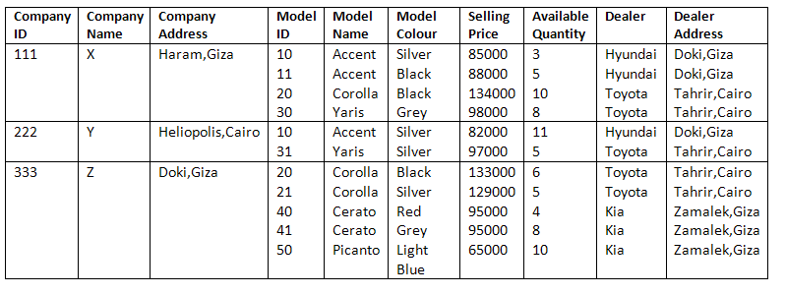
You are required to show the first, second and third normal forms.
- 1NF

Company ID | Company Name | Company Address | City | Model ID | Model Name | Model Color | Selling Price | Available Quantity | Dealer | Dealer Address | Dealer Address (City)
111 | X | Haram | Giza | 10 | Accent | Silver | 85000 | 3 | Hyundai | Doki | Giza
111 | X | Haram | Giza | 11 | Accent | Black | 88000 | 5 | Hyundai | Doki | Giza
111 | X | Haram | Giza | 20 | Corolla | Black | 134000 | 10 | Toyota | Tahrir | Cairo
111 | X | Haram | Giza | 30 | Yaris | Grey | 98000 | 8 | Toyota | Tahrir | Cairo
222 | Y | Heliopolis | Cairo | 10 | Accent | Sliver | 82000 | 11 | Hyundai | Doki | Giza
222 | Y | Heliopolis | Cairo | 31 | Yaris | Sliver | 97000 | 5 | Toyota | Tahrir | Cairo
333 | Z | Doki | Giza | 20 | Corolla | Black | 133000 | 6 | Toyota | Tahrir | Cairo
333 | Z | Doki | Giza | 21 | Corolla | Sliver | 129000 | 5 | Toyota | Tahrir | Cairo
333 | Z | Doki | Giza | 40 | Cerato | Red | 95000 | 4 | Kia | Zamalek | Giza
333 | Z | Doki | Giza | 41 | Cerato | Grey | 95000 | 8 | Kia | Zamalek | Giza
333 | Z | Doki | Giza | 50 | Picanto | Light Blue | 65000 | 10 | Kia | Zamalek | Giza

- 2NF

Company ID | Company Name | Company Address | City | Model ID | Selling Price | Available Quantity | Dealer
111 | X | Haram | Giza | 10 | 85000 | 3 | Hyundai
111 | X | Haram | Giza | 11 | 88000 | 5 | Hyundai
111 | X | Haram | Giza | 20 | 134000 | 10 | Toyota
111 | X | Haram | Giza | 30 | 98000 | 8 | Toyota
222 | Y | Heliopolis | Cairo | 10 | 82000 | 11 | Hyundai
222 | Y | Heliopolis | Cairo | 31 | 97000 | 5 | Toyota
333 | Z | Doki | Giza | 20 | 133000 | 6 | Toyota
333 | Z | Doki | Giza | 21 | 129000 | 5 | Toyota
333 | Z | Doki | Giza | 40 | 95000 | 4 | Kia
333 | Z | Doki | Giza | 41 | 95000 | 8 | Kia
333 | Z | Doki | Giza | 50 | 65000 | 10 | Kia

Model ID | Model Name | Model Color
10 | Accent | Silver
11 | Accent | Black
20 | Corolla | Black
30 | Yaris | Grey
10 | Accent | Sliver
31 | Yaris | Sliver
20 | Corolla | Black
21 | Corolla | Sliver
40 | Cerato | Red
41 | Cerato | Grey
50 | Picanto | Light Blue

Dealer | Dealer Address | Dealer Address (City)
Hyundai | Doki | Giza
Hyundai | Doki | Giza
Toyota | Tahrir | Cairo
Toyota | Tahrir | Cairo
Hyundai | Doki | Giza
Toyota | Tahrir | Cairo
Toyota | Tahrir | Cairo
Toyota | Tahrir | Cairo
Kia | Zamalek | Giza
Kia | Zamalek | Giza
Kia | Zamalek | Giza
- 3NF

Company ID | Company Name | Company Address | City
111 | X | Haram | Giza
222 | Y | Heliopolis | Cairo
333 | Z | Doki | Giza

Company ID | Model ID | Model Name | Model Color | Selling Price | Available Quantity | Dealer
111 | 10 | Accent | Silver | 85000 | 3 | Hyundai
111 | 11 | Accent | Black | 88000 | 5 | Hyundai
111 | 20 | Corolla | Black | 134000 | 10 | Toyota
111 | 30 | Yaris | Grey | 98000 | 8 | Toyota
222 | 10 | Accent | Sliver | 82000 | 11 | Hyundai
222 | 31 | Yaris | Sliver | 97000 | 5 | Toyota
333 | 20 | Corolla | Black | 133000 | 6 | Toyota
333 | 21 | Corolla | Sliver | 129000 | 5 | Toyota
333 | 40 | Cerato | Red | 95000 | 4 | Kia
333 | 41 | Cerato | Grey | 95000 | 8 | Kia
333 | 50 | Picanto | Light Blue | 65000 | 10 | Kia

Dealer | Dealer Address | Dealer Address (City)
Hyundai | Doki | Giza
Toyota | Tahrir | Cairo
Kia | Zamalek | Giza

