* 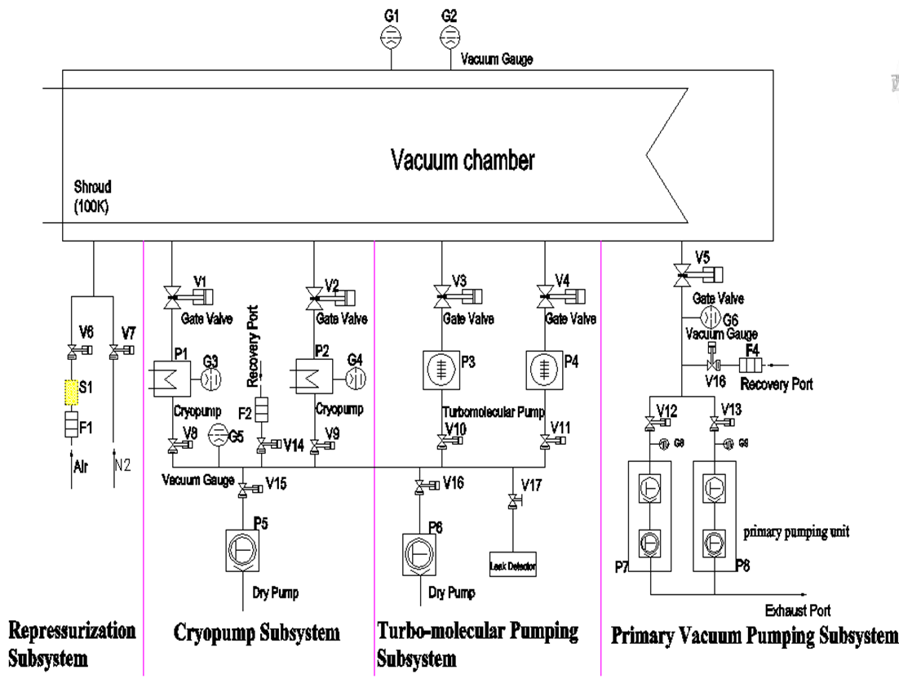**Vacuum System Layout**

|  |  |  |
| --- | --- | --- |
| **P** | **Pump** |  |
| **V** | **Gate valve** |  |
| **G** | **Pressure gauge** |  |
| **F** | **Filter** |  |
| **S** | **Silencer** |  |

|  |  |  |  |
| --- | --- | --- | --- |
| **Stage** | **Operation flow** | **Note** | **Components** |
| * **primary vacuum pumping subsystem:** | * + Switch on cooling water, compressed air and control cabinet.   + Open valve V5.   + Turn on primary pumping units and their valves in sequence; (open valve V12, V13，turn on P7, P8)   + Close valve V5   + Turn off primary pumping units and their valves in sequence; (close valve V12, V13, turn off P7, P8) | * + Roughing time takes about one hour until the pressure of chamber(G1/G2) is 5Pa.   + Keeping primary pumping unit (P7, P8) running extra 30 minutes are aimed at expelling out water compressed in the pump. | * + 3 valves (green color)   + 2 pumps (red color) |
| * **turbo-molecular pumping subsystem (TMP):** | * Start turbo-molecular pumping subsystem. * Open valve V10、V11、V16 and Start dry pump P6, pump two turbo-molecular pumps P3、P4 * open valve V3, V4 When P3, P4 reaches its working mode. * Turn off turbo-molecular pumps P3, P4 when the pressure in the chamber is 0.5Pa and cryopump cool down is finished. * close valve V10、V11 * When P3, P4 reaches its stop mode, Close valve V16 * Turn off dry pump P6 | * Start turbo-molecular pumping subsystem when the pressure in the chamber is below 5 Pa. * When the pressure in the chamber reaches 5×10-2 Pa or even lower, leak test would be conducted(option). | * 5 valves (green color) * 3 pumps (red color) |
| * **cryopump subsystem:** | * Open V1、V2 DN1250. Use cryopumps P1, P2 to pump down the chamber. * Switch off the cryopump when the pressure reaches to 10-5 Pa. * Close valve V1、V2. * Turn off cryopumps P1、P2. | * When pressure in chamber is below 5×10-1Pa, and cryopump cool down is finished. * After the V1、V2 is open, make sure the TMP is shut down. * After the vacuum degree of the vacuum chamber reaches the need value, the vacuum system is ready for the test. The cryopump keeps working during the test. | * 5 valves (green color) * 3 pumps (red color) |
| * **Repressurization subsystem** | * Open V7 until reach 1000 Pa. * Open V6 when the pressure reaches 1000 Pa. * Turn off the system when the pressure reaches 101325 Pa. | * Repressurization subsystem is used to repressurize the chamber using GN2 and clean air. It permits the chamber pressure to return to 1000 Pa using highly pure gaseous nitrogen. And then chamber pressure continues growing higher to atmosphere pressure by using dry clean air. The chamber can be open until the chamber reaching atmosphere pressure. | * 2 valves (green colour) * Air led (white) * Nitrogen led (blue) |