

COMSATS UNIVERSITY ISLAMABAD

(SAHIWAL CAMPUS)

Depart of Computer Science
Assignment# 2
Subject: DLD LAB
Submitted To: Mr. Ahsan Maqsood
Submitted By: Ahmad Akhtar
Registration No: FA22-BCS-010
Date: 26/04/2023

Q1:
“NOR TO NAND”
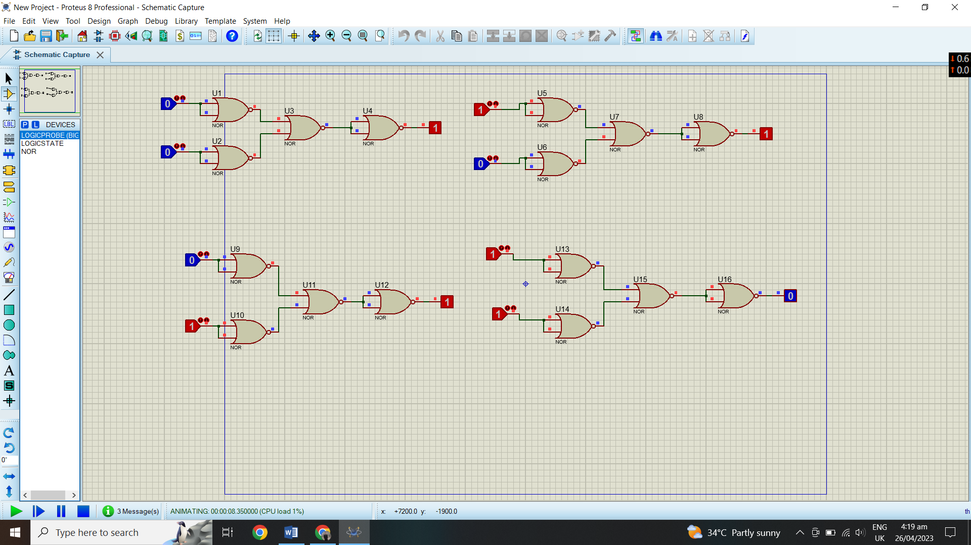

Q2:
“NOR TO XOR”
