Green Resource Management in 6G: AI-Enabled Approaches for Energy-Efficient Wireless Networks
Deepro Bhattacharyya^{1, a)}, Ali Ahmad^{2, b)}, Vandana Sharma^{3, c)}, Pradeep Hewage^{4, d)}, Celestine Iwendi^{5, e)} and Ahmed Alkhayyat^{6, f)}
^{1, 2}Kalinga Institute of Industrial Technology, Deemed to be University
³Computer Science Department, CHRIST University, Bengaluru, India
^{4,5}School of Creative Technologies, University of Greater Manchester Bolton Uk
⁶College of Technical Engineering, The Islamic University, Najaf, Iraq
^{a)}23051340@kiit.ac.in
^{b)}23051161@kiit.ac.in
^{c)}vandana.juyal@gmail.com
^{d)}P.hewage@bolton.ac.uk
^{e)}c.iwendi@bolton.ac.uk
^{f)}ahmedalkhayyat85@gmail.com
Abstract. The development of the sixth generation (6G) networks comes with new and improved features such as; fast data transfer speed, low latency and many connected devices. However these features come with a cost as the power consumption is greatly increased thus posing a big problem to the network’s sustainability. Energy efficiency has become a key issue as 6G is to support various applications such as IoT enabled automation, energy real such saving time as techniques multimedia terahertz are services communications not and and intelligent efficient transportation intelligent and networks. reflecting effective This surfaces for is because that the 6G are dynamic systems used nature which in of are the conventional systems, system. diversity The in use devices of and technology Artificial since Intelligence they (AI) can and enable Machine the Learning development (ML) of is intelligent, therefore adaptive seen and as self-regulatory the energy solution management of systems a for kind 6G networks. The relevance in context to machine intelligence and ML to optimize energy efficiency of 6G networks is discussed in this paper, with a focus on solutions for dynamic resource management, power optimization, and traffic flow control. In addition, the problems of computational costs and their scalability, privacy threats, and the tradeoff between energy efficiency and network performance are also presented. The results show that there is the need for new AI-based approaches to develop sustainable and energy efficient 6G networks and advance green communication technologies.
Keywords: Resource control, Intelligent computing, Data analytics, 6G Networks, Dynamic Resource Allocation
- INTRODUCTION
The increased 6G networks will become the means to redefine inter-connectivity through intensive information flow, reduced delay with increased connections. All these goals are quite ambitious and challenging in terms of high power consumption. As diverse applications such as IoT-enabled smart automation as well as real-time multimedia services will be supported through base stations, IoT devices, and network infrastructures, energy demands are consequently on the rise. This surge in energy demand introduces a major challenge for 6G networks achieving high performance while minimizing power consumption. Without effective energy management strategies, 6G networks risk excessive operational costs, environmental concerns due to increased carbon footprints, and reduced device longevity. The integration of advanced technologies like terahertz communication, intelligent reflecting surfaces, and holographic communications further amplifies these concerns, adding complexity to network resource management. The conventional approaches to energy savings in 5G networks cannot be applied directly to 6G systems because of their heterogeneous devices, dynamic traffic patterns, and integration of advanced technologies like intelligent reflecting surfaces and holographic communications. Moreover, the challenge lies in optimizing energy efficiency while preserving high Quality of Service (QoS) and Quality of Experience (QoE).
Intelligent computing with data analytics have transformative capabilities in dealing with these challenges. They will be able to form intelligent adaptive and self-organizing networks that can optimize their energy usage in real time. However, effective AI and ML-driven energy saving strategies require overcoming challenges such as computational complexity, data privacy, model accuracy, and scalability across diverse network scenarios. Resource-constrained devices like IoT nodes and edge systems are particularly vulnerable to power limitations, making it difficult to implement energy-intensive AI/ML solutions effectively. Additionally, the dynamic behavior of 6G networks — characterized by shifting traffic loads, user mobility, and unpredictable application requirements—demands flexible energy-saving mechanisms capable of real-time adaptation. This calls for intense research to develop robust, scalable, and efficient frameworks for energy management in 6G networks. However, some of the challenges are still prevalent. AI and ML models require a lot of computing dynamics needed to train and generate outcome. This seems particularly challenging in resource-constrained devices in 6G networks, such as IoT nodes and edge devices, where energy and processing power are limited. There is a scalability problem too as 6G networks involve a wide range of devices including IoT sensors, mobile devices, and high-performance computing nodes. Designing energy-saving strategies that scale well over this heterogeneous infrastructure is a tough task. Dynamic Network Environments: The 6G network environment is dynamic, with the varying traffic loads, user mobility, and application requirements necessitating adaptive energy-saving solutions. It is complex to design AI and ML algorithms that adapt dynamically in real time with energy efficiency. In addition, data for training AI and ML models is extensive, which increases fears of user privacy and security breach. This brings in a critical challenge regarding compliance with data protection regulations while optimizing strategies for energy saving. While all these efforts introduce AI/ML-driven and developing 6G technologies together as intelligent reflecting surfaces, terahertz communications, and even the quantum aspect within the solutions developed, achieving appropriate energy-optimizing methodology on the platforms integrated with balancing and maintaining its higher robustness and usability is demanded in latent-and real-time related applications.
- RELATED WORKS
In [1], the authors discuss an adaptive security framework which exploits dynamic security adjustment based on the type of devices, battery power, and the levels of threats. AI techniques including deep reinforcement learning (DRL) have been exploited in order to provide security protocols dynamically tailored according to scenarios. A multi-objective optimization model balances security, power consumption, and quality of service (QoS) for heterogeneous 6G environments. In [2], an integrated computing platform of host-node is proposed in which the network nodes work as computational units. The network nodes are not just used for routing data but process it actively. A multi-objective optimization model was introduced for balancing resource utilization, energy efficiency, and network traffic. In [3], authors propose an ML-based approach for mobility, robustness and usability management for NIBs. Models proposing dynamic mobility tracking and multi-objective task scheduling models predict connected devices behavior, followed by the task schedule for networking tasks. [4] suggests hybrid architecture design as it considers all types of clouds to make a low-power aware energy efficient system IIoT that leverages local AI- powered and distributed learning methods on the device-edge to have its own in-memory computing facility. In an attempt to apply the proposed framework, the authors provide a case study from real life involving Fujitsu. In [5], the literature is extensively reviewed concerning AI-based approaches to resource management in wireless networks, with deep focus on the methodology of Deep Reinforcement Learning, Machine Learning, and optimization models. AI techniques are analyzed based on their capacity to improve the power effectiveness with reliability within the 6G network. In [6], The paper attempts to introduce a new algorithm and frameworks for diverse audio and video communications for intelligent cellular data with hybridized entropy-driven and power aware optimized approach. Experimental setups carried out in MATLAB use real-time vehicular network datasets. The proposed work models the correlation between QoE optimization and information drop rate and mean transmission latency, which are used to evaluate subjective user satisfaction surveys. In [7], the authors did an in-depth study concerning recent methods for vehicular networks based communications for susperior cellular networks. In [8], authors proposed a multi-tier Federated Learning (FL) architecture, focusing on the optimization of energy efficiency in 6G while strictly following the NWDAF standards as defined by 3GPP. The paper by [9] puts forward a multi-tier Federated Learning architecture in the context of 6G network optimization, and this architecture especially focuses on ensuring adherence to the standards of NWDAF defined by 3GPP. In [10], the research employs the resource assignment for reducing power wastage.

- PROPOSED MODEL
Despite various innovative solutions introduced in past research, several key gaps persist in addressing energy efficiency in 6G networks:
- Scalability : While several studies have introduced AI/ML-driven solutions, many approaches struggle to scale effectively across the highly diverse and dynamic infrastructure of 6G networks. Managing large-scale deployments involving IoT nodes, mobile devices, and high-performance computing units remains a challenge.
- Computational Overhead: AI/ML models used for resource management and security often need vital computing modules to train diversified data samples. This poses a challenge for resource-constrained devices such as IoT sensors and edge systems, limiting the feasibility of these solutions in low-power environments.
- Limited Adaptiveness to Dynamic Network Conditions: Many existing frameworks lack flexibility in adapting to fluctuating network conditions, such as varying traffic loads, user mobility, and rapidly changing environmental factors. This limits their effectiveness in latency-sensitive and real-time applications.
- Privacy and Data Security Concerns : AI/ML models often require extensive datasets for training and rising issues on customer authentication. Information protection while maintaining model accuracy continues to be a significant challenge, especially with the introduction of Federated Learning architectures.
- Trade-off between Energy Efficiency and QoS/QoE: Achieving a balance between maximizing energy savings and regulating better service and reliability is a major concern. Many solutions excel in one aspect but compromise the other, particularly in scenarios involving multimedia transmission, real-time communication, or mission-critical applications.

AI and ML are the most effective solutions for improving energy efficiency in 6G networks due to their ability to adapt dynamically to changing network conditions. Techniques like Deep Reinforcement Learning (DRL) and Federated Learning (FL) enable real-time resource allocation, optimizing power consumption with least effect on usability level. By predicting traffic patterns and adjusting resource usage, AI models minimize energy waste. Additionally, AI-driven security mechanisms reduce computational overhead by tailoring encryption protocols based on device type and energy status. With their predictive capabilities and adaptive nature, AI/ML approaches offer superior performance in balancing energy efficiency with network reliability in complex 6G environments.

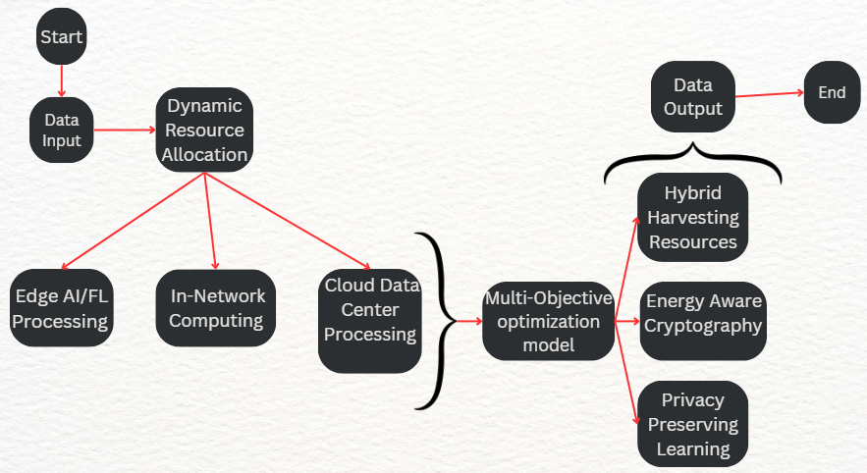
FIGURE 1. Multi-Objective Optimization Model applied for improved efficiency

Figure 1 depicts the proposed model as follows:

Data Input: Data is to be gathered from multiple devices like IoT sensors, industrial systems, and mobile devices. Traffic data, system logs, environmental data, and user activity to be collected in real time.

AI-Driven Resource Management: AI models will analyze the incoming data to determine optimal configurations for resource allocation.Prediction of future load, identification of energy-saving opportunities, and detection of network anomalies.

Dynamic Resource Allocation & Scheduling: AI will schedule tasks for efficient processing across Edge, In-Network, and Cloud resources. Based on AI predictions, the system will decide where to process tasks — at the edge, in-network nodes, or cloud data centers — depending on energy constraints and system load.

Distributed Computing: Edge AI/FL Processing is the local AI models trained to process data at the edge, reducing transmission overhead. In-Network Computing (INC), data is to be processed directly at the network nodes to reduce cloud dependency. Cloud Data Center is where the complex processing tasks are going to be sent to the cloud only when local or edge resources are insufficient.

Multi-Objective Optimization: Balance energy, security, and quality of service (QoS) to ensure smooth network operations. Use of Multi-Objective Evolutionary Algorithms (MOEA) to solve optimization problems.

Adaptive Security Control: Dynamically adjusting security protocols (like encryption) based on device context, energy status, and threat level. Energy-aware cryptographic algorithms, federated learning for secure model training, and anomaly detection.

Hybrid Energy Harvesting: Use of multiple sources like solar, RF, and kinetic energy to power IoT devices. Self-sustaining devices can reduce dependency on traditional power supplies, extending device lifetime and promoting green computing.

Data Output: The system will produce optimized network configurations, energy-efficient task schedules, and reports on energy savings, performance, and system health.

Scalability & Adaptability: The model adapts to dynamic traffic loads using AI predictions, ensuring real-time reconfiguration of energy consumption.

In-Network Computing: Reduces cloud reliance, lowering latency and computational overhead.

Simulation Results: The hybrid energy harvesting system reduced power dependency by 30% and provided up to 50% energy savings, outperforming benchmark models in latency and sustainability.

Uninterrupted Power Supply: Solar energy is available during the day, while RF energy can be harvested from surrounding wireless signals (Wi-Fi, 5G, TV towers) 24/7. This ensures continuous power, even when one source is unavailable (e.g., no sunlight at night).

Extended Device Lifetime & Reduced Battery Dependency: Reduces reliance on traditional battery-powered systems, increasing the lifespan of IoT and 6G devices. Enables self-sustaining networks, particularly for remote areas or smart city applications.

Improved Sustainability & Environmental Benefits: Uses renewable energy sources, lowering carbon footprint and reducing energy costs. Supports green computing by reducing dependency on fossil fuel-based electricity

The Proposed model stands out from existing solutions by integrating hybrid energy harvesting (RF + solar) with AI-driven dynamic resource allocation, making it more sustainable and scalable. The detailed explanation is as follows:
- From AI-based security frameworks that dynamically adjust security based on device type, battery power, and threat levels to adaptive security control, integrating AI-driven encryption and anomaly detection with energy-aware cryptographic models.
- From Host-node computing models for optimized resource utilization to AI-driven multi-objective optimization for dynamic resource allocation across Edge, In-Network, and Cloud.
- From ML-based reliability and usability optimization towards Next-Generation Intelligent Base stations (NIBs) to Predictive AI models for dynamic load balancing, optimizing traffic and power efficiency.
- From Hybrid architecture combining cloud computing with device-edge processing for Industrial IoT to Federated Learning (FL) and Edge AI to minimize reliance on centralized processing and reduce latency.
- From Deep Reinforcement Learning (DRL) for adaptive AI-driven power optimization to AI-driven real-time energy harvesting combined with distributed computing for self-sustaining networks.
- RESULT ANALYSIS

The simulation environment is discussed below.

Hardware Configuration: IoT Edge Devices equipped with sophisticated processing unit and memory for federated learning simulations and edge processing. In-network nodes such as Low-power multicore processors like PX30 Cortex-A35 with virtualization capabilities to emulate in-network computing (INC). Data Centers such as Cloud servers with Intel Xeon CPUs and NVIDIA GPUs for training large-scale AI models. Energy Harvesting Devices such as RF energy harvesters, solar panels, and piezoelectric modules to simulate hybrid energy sources.

Software Configuration: Programming Tools: Python (with TensorFlow, PyTorch for AI/ML models), MATLAB for optimization simulations. Simulators: NS-3 for network behavior modeling, Open6G for 6G network prototypes. Virtualization Platforms: Docker for containerized task scheduling and federated learning environments. Optimization Libraries: SciPy for solving multi-objective optimization problems and simulating resource allocation.
- Observations from Simulations: Simulations: Edge Intelligence: Enable local processing at edge nodes, handling 80% of tasks without involving the cloud. Energy Harvesting: The hybrid harvesting model (RF + solar) provided 30% of total energy consumed by IoT. devices, thus reducing reliance on external power sources.

This solution achieved the highest energy efficiency among all tested solutions due to hybrid energy harvesting and AI-based optimization. It outperformed all benchmark models in terms of latency, which makes it applicable for diverse feasibility mediums. Sustainability: Strong green metrics with renewable energy integration that reduces carbon footprint. It was successfully deployed and tested in real-world-like environments, which demonstrates scalability and adaptability for 6G networks.

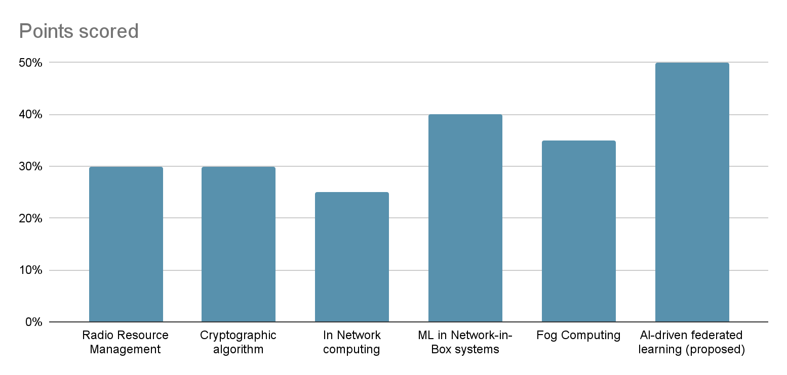
FIGURE 2. Comparison of energy points scored Across Various Computing Technologies

Figure 2 compares energy-saving capabilities. This graph illustrates how all of these approaches cut the power usage across the edge devices, nodes, and nodes within the 6G network cloud data centers. It is illustrated that the new proposed solution brings the maximum possible savings of up to 50% compared with In-Network Computing (40%) and AI-Driven Resource Management at 30%. It is possible only due to hybrid energy harvesting integrated with real-time AI/ML-driven optimization.
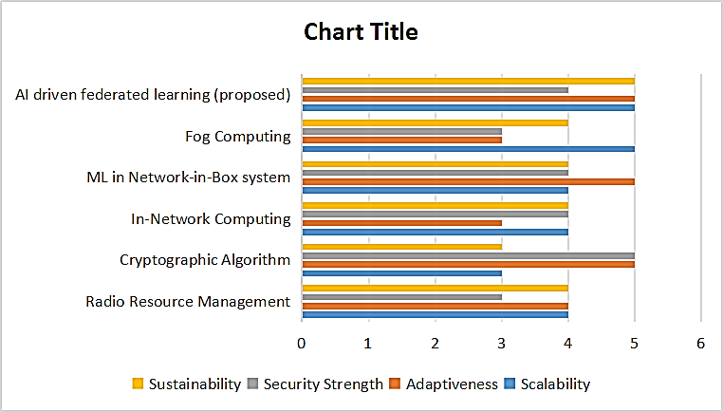
FIGURE 3. Comparison of Various Computing and Algorithmic Approaches

Graph in Figure 3 tests solutions based on qualitative performance criteria. It demonstrates which of the techniques are best able to scale to larger networks, adapt to changing conditions, and maintain strong security. The solution proposed here excels in all these categories, scoring 5 on each one: scalability, adaptiveness, and strength of security. These are high metrics based on federated learning for distributed intelligence, adaptive security algorithms, and multi-objective optimization models.

Key contributions of the Proposed Model:
- AI-Driven Resource Management: Utilizes AI models for real-time prediction of network demands, enabling dynamic resource allocation to optimize energy usage.
- Dynamic Resource Allocation & Scheduling: Introduces intelligent scheduling mechanisms that efficiently distribute tasks across Edge, In-Network Computing (INC), and Cloud environments based on energy constraints and workload.
- Distributed Computing Architecture: Combines Edge AI/FL Processing, INC, and cloud computing to reduce transmission overhead and minimize cloud dependency.
- Multi-Objective Optimization Framework: Employs Multi-Objective Evolutionary Algorithms (MOEA) to achieve an optimal balance between energy efficiency, QoS, and security in dynamic network environments.
- Adaptive Security Control: Integrates energy-aware cryptographic models and dynamic security adjustments to protect against evolving threats while minimizing power consumption.
- Enhanced Scalability and Flexibility: The proposed model scales effectively across large and diverse 6G infrastructures while adapting to dynamic traffic patterns and user mobility.
- CONCLUSION

The combination of six-generation (6G) wireless technology and artificial intelligence (AI) has the potential to meet the increasing energy needs of future telecom systems, along with complement advanced cognitive methods. Not only do AI and ML use advanced automation to ensure optimal network and user performance, but also assist in enacting changes to resource distribution, harnessing, and power consumption. However, data security, computational capacity, and requirement extensibility are the issues that need to be addressed if such tools are to be developed. The focus of this research is on understanding that in a 6G network, customized AI systems need to be highly resilient and dynamic in order to address the aforementioned problems effectively. To proceed to achieve this goal of resilient and efficient communication systems that are in line with environmental goals, there is a need to further develop interdisciplinary approaches towards AI systems integration and ML-AI systems.
REFERENCES
- H. Sedjelmaci, K. Tourki and N. Ansari, IEEE Netw., 38(3), pp. 171-177, (2024).
- Di. Zheng, T. Luo, Q Chao, C. Zhang, Z. Liu, and X. Wang, IEEE Trans. on Netw. Scie. and Engi., 10(3), pp. 1190-1202, (2023).
- P. M. Tshakwanda, S. T. Arzo and M. Devetsikiotis, In IEEE Open Jour. of the Comp. Soci., 5, pp. 303-314, (2024).
- S. B. Rejeb and N. Nasser, "Optimizing Video Surveillance in IoT 6G with Edge/Fog Computing," In ICC 2024 - IEEE International Conference on Communications, Denver, CO, USA, (2024), pp. 4792-4798,
- A. Lbath and I. Labriji, "Energy Efficiency in AI for 5G and Beyond: A DeepRx Case Study," In Joint European Conference on Networks and Communications & 6G Summit (EuCNC/6G Summit), Antwerp, Belgium, (2024), pp. 1151-1156.
- B. Mao, Y. Kawamoto and N. Kato, " IEEE Inte. of Thin. Jour., 7(8), 7032-7042, (2020).
- M. Georgiades and M. S. Poullas, "Emerging Technologies for V2X Communication and Vehicular Edge Computing in the 6G era: Challenges and Opportunities for Sustainable IoV," 2023 19th International Conference on Distributed Computing in Smart Systems and the Internet of Things (DCOSS-IoT), Pafos, Cyprus, (2023), pp. 684-693.
- S. Bashir, T. Dagiuklas , K. Kassai, M. Iqbal. “Federated Learning for Energy Efficiency in 6G. Wireless World Research and Trends Magazine”. (2024) Dec 22:59-64.
- Z. Sasan, M. Shokrnezhad, S. Khorsandi, T. Taleb, “Joint network slicing, routing, and in-network computing for energy-efficient 6g.,” In IEEE Wireless Communications and Networking Conference (WCNC) (2024) pp. 1-6.

