Week 1 Task Report
Python for Machine Learning & Data Preprocessing

1. What the task asked for
The task was to learn the basics of Python, NumPy and Pandas, and then clean and preprocess a sample dataset while documenting each step. This report walks through what I did in the order I did it. All the code is in the GitHub project (script and notebook), and the numbers below come from running it.

2. The dataset
I used a synthetic employee dataset (employee_data_raw.csv), created for this task, so it is not real company data. I chose a dataset with deliberate problems so that every preprocessing step would have something to do. It has 508 rows and 10 columns.
Type | Count | Columns
Numeric | 5 | Age, Experience_Years, Monthly_Income, Satisfaction_Score, Weekly_Work_Hours
Categorical | 4 | Education, Department, City, Job_Level
Target | 1 | Attrition (1 = left, 0 = stayed); about 33% left

3. Loading and inspecting
I read the CSV with pd.read_csv and looked at the shape, the first rows, the data types and the missing values before changing anything. Checking first matters, because it tells you what actually needs fixing.
df = pd.read_csv("data/employee_data_raw.csv")
print(df.shape) # (508, 10)
print(df.dtypes)
print(df.isnull().sum())

Five columns had missing values:
Column | Missing | Share of rows
Monthly_Income | 18 | 3.5%
Age | 16 | 3.1%
Satisfaction_Score | 12 | 2.4%
Education | 10 | 2.0%
Department | 8 | 1.6%
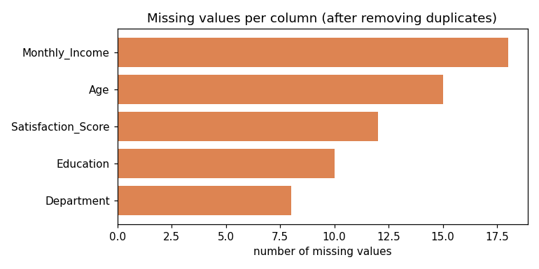
Figure 1. Missing values per column

4. Removing duplicates
df.duplicated().sum() found 8 rows that were exact copies of other rows. Keeping them would count the same employee twice, so I dropped them with drop_duplicates(). The data went from 508 to 500 rows.

5. Exploratory data analysis
Before any transformation I wanted a feel for the data. The main things I noticed:
- The classes are imbalanced: 335 employees stayed and 165 left (67% / 33%).
- Monthly_Income is right-skewed, ranging from 15,000 to 180,000, while Satisfaction_Score only runs from about 1.6 to 10. The columns are on very different scales, which is the reason scaling is needed.
- The IQR outlier rule flagged only a handful of values per column (2 in Age, 2 in Monthly_Income, 2 in Satisfaction_Score, 3 in Weekly_Work_Hours). They look like plausible values rather than errors, so I left them in.
- Attrition rate by department ranged from 27% (Finance) to 40% (IT).
- Correlations between the numeric columns and attrition are all weak (the largest is about 0.13 for income). This foreshadows the modest model score later.
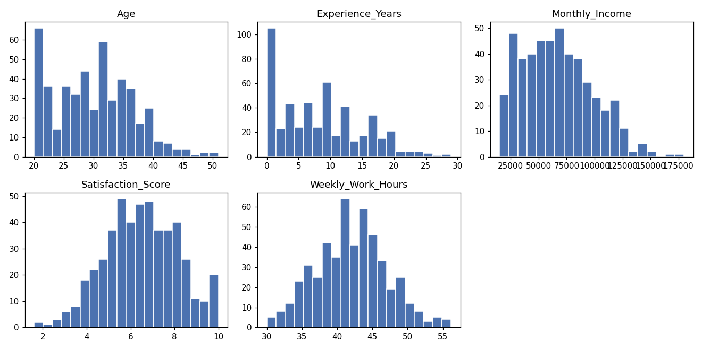
Figure 2. Distributions of the numeric columns
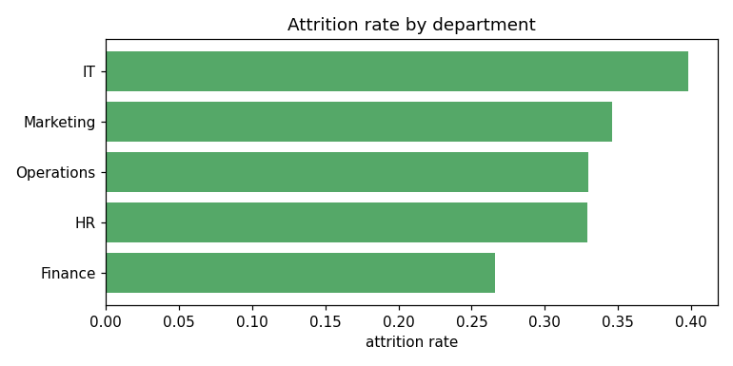
Figure 3. Attrition rate by department
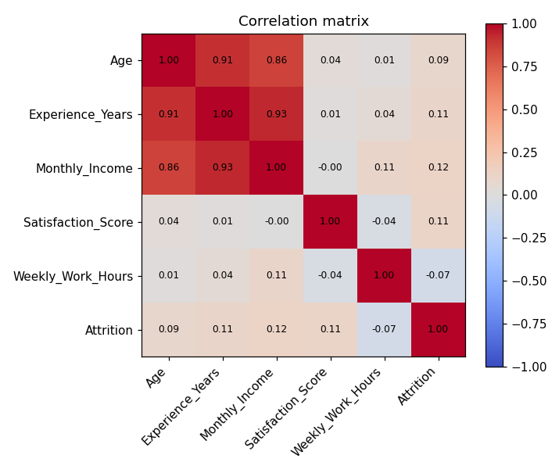
Figure 4. Correlation matrix of numeric columns and the target

6. Train/test split
I split the data 80/20 (400 training rows, 100 test rows) with a fixed random_state and stratify=y so both sets keep the same attrition ratio. I did the split before filling or scaling anything. If I had computed medians or means on the whole dataset first, information from the test rows would have leaked into the training process.

7. Handling missing values
Numeric columns were filled with the median of the training set. I chose the median because it is not pulled around by extreme values the way the mean is, and income is skewed. Categorical columns were filled with the most frequent training value. The values used were:
Column | Fill value | Method
Age | 30.0 | median
Monthly_Income | 64,226 | median
Satisfaction_Score | 6.4 | median
Education | Bachelor | most frequent
Department | IT | most frequent

The same training values were then used to fill the test set. Afterwards, there were no missing values in either set.
medians = X_train[NUM_COLS].median()
X_train[NUM_COLS] = X_train[NUM_COLS].fillna(medians)
X_test[NUM_COLS] = X_test[NUM_COLS].fillna(medians) # same numbers

8. Encoding categorical variables
Models need numbers, so I one-hot encoded Education, Department, City and Job_Level with pd.get_dummies. Each category became its own 0/1 column, which took the data from 9 to 23 feature columns. I then re-indexed the test set to have exactly the training columns, so a category missing from one set cannot cause a column mismatch. I used one-hot rather than label encoding because these categories have no real numeric order (a city is not 'greater' than another).

9. Scaling
I looked at two techniques:
- Min-max normalization rescales a column to 0-1 with (x - min) / (max - min). On Monthly_Income, the range 15,000-180,000 became 0-1. I also wrote the formula by hand in NumPy and confirmed it matches scikit-learn's MinMaxScaler.
- Standardization (StandardScaler) subtracts the mean and divides by the standard deviation, giving each column mean 0 and standard deviation 1. This is what I applied to the five numeric columns, fitting on the training data and only transforming the test data. After scaling, every training column had mean 0.000 and standard deviation 1.001.
I did not scale the one-hot columns because they are already 0/1.

10. Feature selection
I used SelectKBest with the ANOVA F-test (f_classif), which scores each feature by how strongly it separates the two attrition classes. I kept the top 10 of the 23 features. Satisfaction_Score scored highest (9.8), followed by City_Mumbai (7.2), Monthly_Income (5.0) and Experience_Years (4.4). Several one-hot columns, such as Job_Level_Senior and Department_Marketing, scored close to zero.
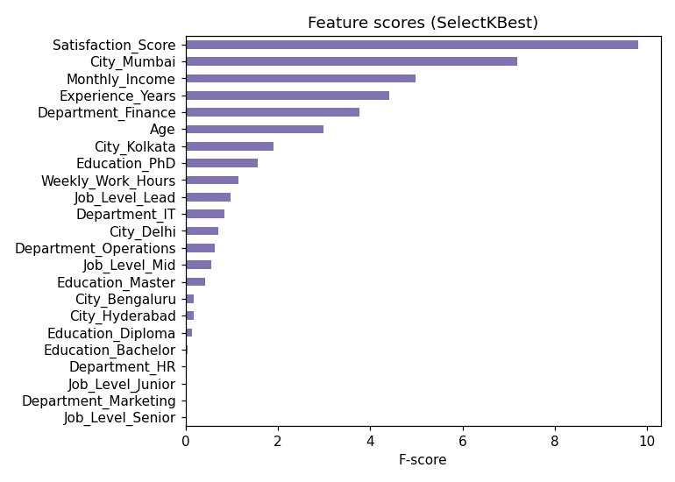
Figure 5. F-score of each feature
Selected features: Age, Experience_Years, Monthly_Income, Satisfaction_Score, Weekly_Work_Hours, Education_PhD, Department_Finance, City_Kolkata, City_Mumbai, Job_Level_Lead. The selector was fitted on the training data only. Note that with weak, synthetic data these scores are only a rough guide.

11. Sanity check with a model
To confirm that the processed data works end to end, I trained a logistic regression on the 10 selected features. It reached 0.64 accuracy on the test set. That is slightly lower than the 0.67 I would get by predicting 'stayed' for everyone, so this is not a good model, and I am not presenting it as one. This is expected because the synthetic data has only weak patterns. The purpose of the task is preprocessing, and the check shows the output can be fed to a model without errors.

12. Output files
- processed_train.csv and processed_test.csv: all 23 encoded and scaled features plus the Attrition column
- selected_features.csv: the 10 features chosen by SelectKBest
- preprocess.py and week1_preprocessing.ipynb: the code, same workflow in script and notebook form
- figures/: the plots used in this report

13. What I learned and what I would do next
The biggest lesson was the order of operations: split first, then compute anything (medians, scaler statistics) from the training data only. I also learned that each step depends on the data: the median made sense because income is skewed, and one-hot encoding made sense because the categories have no order. Next I want to practise Pandas (groupby, merging) and NumPy in more depth, try a real public dataset, and learn to use scikit-learn Pipelines to keep the steps in one reproducible object.

14. Description for the submission form
For this Week 1 task I worked through a full data preprocessing workflow in Python. I used a synthetic employee dataset with 508 rows that I prepared for the task, because it let me include the problems the task talks about: 8 duplicate rows and 64 missing values spread over five columns, plus a mix of numeric and categorical features. I loaded the file with Pandas, checked its shape, data types, missing values and duplicates, and removed the duplicates, which left 500 rows. I then did some exploratory analysis with summary statistics, an outlier check using the IQR rule, and plots of the distributions, missing values, attrition by department and correlations. Before filling or scaling anything I split the data 80/20 into training and test sets so that test information would not leak into the cleaning. Missing numeric values were filled with the training median and missing categories with the most frequent training value. The four categorical columns were one-hot encoded, taking the feature count from 9 to 23. I standardized the numeric columns with StandardScaler, fitted on the training data only, and also tried MinMaxScaler on the income column and checked it against the formula in NumPy. For feature selection I used SelectKBest with the ANOVA F-test and kept the top 10 features. Finally I trained a small logistic regression only to confirm the processed data works with a model; it scored 0.64, slightly below the 0.67 baseline of always predicting the majority class, which is unsurprising for synthetic data. The code is on GitHub as a script and a notebook, together with the data, figures and README.

