Week 3 Task Report
Unsupervised Learning & Model Evaluation

1. What the task asked for
The task was to understand clustering (K-Means and hierarchical) and dimensionality reduction, to learn cross-validation, the confusion matrix, precision, recall, F1, ROC-AUC and hyperparameter tuning, and to perform clustering on a dataset and prepare a model evaluation report. I split the work in two parts, because these evaluation tools belong to different settings. Part A is unsupervised: no answer key is used. Part B is supervised: it predicts Attrition, where a known answer exists. All numbers below come from the code in the GitHub project.
Last week’s feedback said the classification results were disappointing and suggested exploring more models or techniques. In Part B I therefore tried seven models, PCA, three engineered features, hyperparameter tuning and threshold tuning, and I report honestly what that did and did not achieve.

2. Data
I used the synthetic employee dataset from Weeks 1 and 2: 500 rows after removing duplicates, five numeric columns (Age, Experience_Years, Monthly_Income, Satisfaction_Score, Weekly_Work_Hours), four categorical columns and the Attrition label. Some values are missing (up to 18 per column); they are filled with the median (numeric) or the most frequent value (categorical).

Part A – Unsupervised learning

3. Preparing the features
Clustering uses the five numeric columns only. Attrition is not an input, since clustering is meant to find structure without an answer key. The features are standardized, because K-Means and hierarchical clustering are based on distances, and a column measured in tens of thousands would swamp one measured from 1 to 10.
I checked this instead of assuming it. On the raw values, K-Means with three clusters gives exactly the same grouping as clustering on Monthly_Income alone (adjusted Rand index 1.0), so the other four columns have no influence. After scaling the grouping is quite different (ARI 0.54 compared with the raw version).
The correlations also matter. Age, Experience_Years and Monthly_Income are strongly correlated with each other (0.86 to 0.93), while Satisfaction_Score and Weekly_Work_Hours are not correlated with anything. So the data really has three separate pieces of information, not five.

4. PCA (dimensionality reduction)
PCA rotates the data onto new axes (principal components) ordered by how much of the variation they capture. I used it to understand the features and to draw the clusters in two dimensions.
Component | Variance explained | Cumulative | Main features (loadings)
PC1 | 55.3% | 55.3% | Age 0.57, Experience 0.59, Income 0.57
PC2 | 20.8% | 76.2% | Satisfaction 0.71, Weekly hours -0.70
PC3 | 19.2% | 95.3% | remaining variation
PC4 + PC5 | 4.7% | 100% | almost nothing

This confirms the picture from the correlations. PC1 is a seniority axis: employees who are older also have more experience and higher income. PC2 contrasts satisfaction with weekly hours. Three components keep 95% of the information, so the five columns can be reduced to three with little loss.
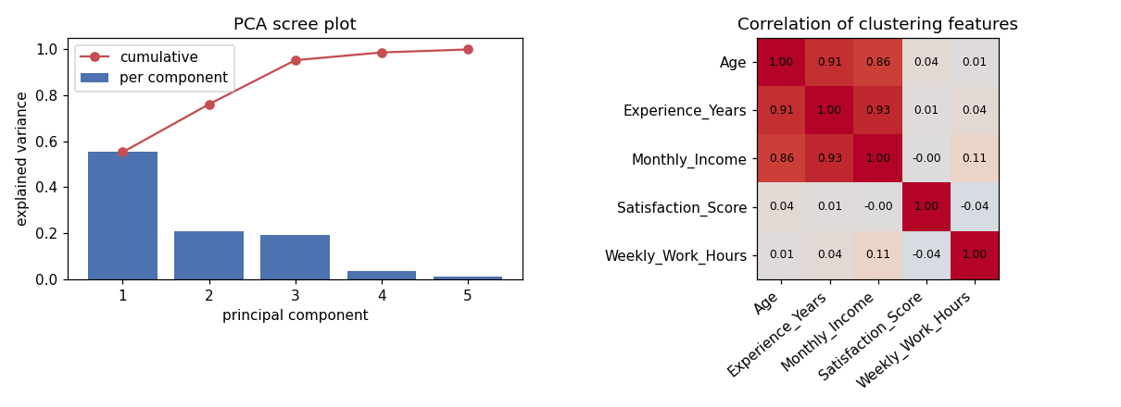
Figure 1. PCA scree plot (left) and correlation of the clustering features (right)

5. K-Means: choosing the number of clusters
K-Means needs the number of clusters in advance, so I ran it for K = 2 to 8 and compared several measures. No single one is reliable alone.
- Inertia (elbow plot): total squared distance to the cluster centres. It always falls as K grows, so I look for a bend. Here the curve falls smoothly with no clear elbow.
- Silhouette: how much closer a point is to its own cluster than to the nearest other cluster, from -1 to 1. Above about 0.5 is usually seen as clear structure; below 0.25 as little structure.
- Calinski-Harabasz (higher is better) and Davies-Bouldin (lower is better): two further measures of compact, well-separated clusters.
- Stability: I fitted K-Means on random 80% subsets ten times and measured how much the resulting groupings agree (ARI). A clustering that changes with every subset is not trustworthy.
K | Inertia | Silhouette | Calinski-Harabasz | Davies-Bouldin | Stability (ARI)
2 | 1,546 | 0.318 | 307 | 1.20 | 0.95
3 | 1,293 | 0.232 | 232 | 1.43 | 0.79
4 | 1,122 | 0.215 | 203 | 1.45 | 0.72
5 | 979 | 0.222 | 192 | 1.32 | 0.79
6 | 885 | 0.216 | 180 | 1.28 | 0.65
7 | 820 | 0.209 | 168 | 1.27 | 0.55
8 | 765 | 0.208 | 159 | 1.24 | 0.49

K = 2 is the best on every measure except the elbow plot, which is ambiguous: highest silhouette, highest Calinski-Harabasz, lowest Davies-Bouldin and by far the most stable (0.95; it falls to 0.49 by K = 8). I chose K = 2. However, a silhouette of 0.32 is modest. The clusters are not sharply separated; the data is more of a continuous spectrum that K-Means cuts in two.
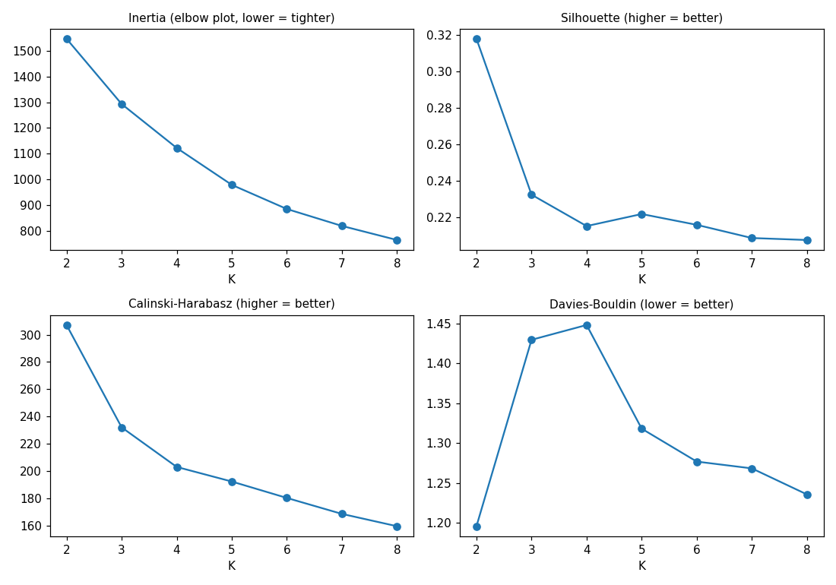
Figure 2. Inertia, silhouette, Calinski-Harabasz and Davies-Bouldin for K = 2 to 8
The silhouette profile of the chosen clustering agrees: mean silhouette is 0.29 in cluster 0 and 0.34 in cluster 1, and only 1.3% of points in cluster 0 and none in cluster 1 have a negative silhouette (a negative value would mean the point sits closer to the other cluster). So the points are assigned sensibly even though the boundary is not sharp.
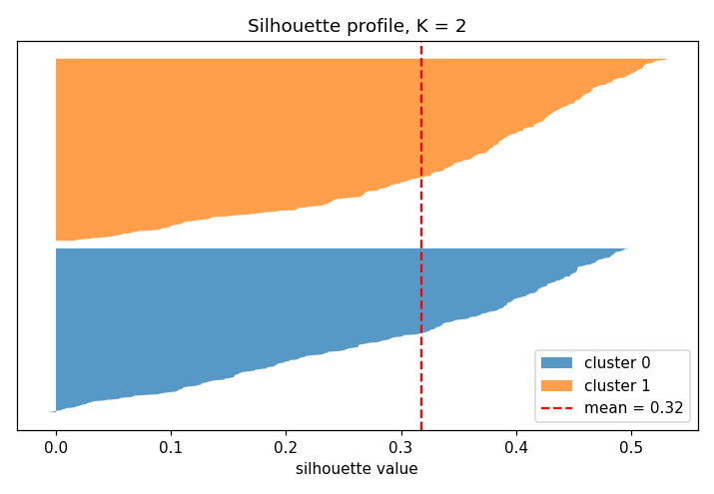
Figure 3. Silhouette profile for K = 2

6. Hierarchical clustering
Agglomerative clustering starts with every point on its own and repeatedly merges the closest pair of clusters. The linkage rule decides what ‘closest’ means: Ward merges so that the increase in variance is smallest, complete linkage uses the farthest points of two clusters, and average linkage uses the mean distance. I compared all three for 2 to 6 clusters.
Linkage | K | Silhouette | Cophenetic corr. | Smallest cluster (points)
Ward | 2 | 0.296 | 0.52 | 193
Complete | 2 | 0.302 | 0.54 | 115
Average | 2 | 0.356 | 0.63 | 16
Average | 3 to 6 | 0.17 to 0.21 | 0.63 | 1

Average linkage has the highest silhouette (0.356 at K = 2), but the table shows why this should not be taken at face value: its smaller cluster has only 16 employees, and for K of 3 or more it creates clusters of a single point. It is separating off outliers, which scores well on silhouette but gives no useful grouping. Ward produces balanced groups (193 and 307 employees) with a similar silhouette of 0.30, and its grouping agrees reasonably with K-Means (ARI 0.58). The dendrogram shows a clear top-level split into two branches, matching the K = 2 result from K-Means.
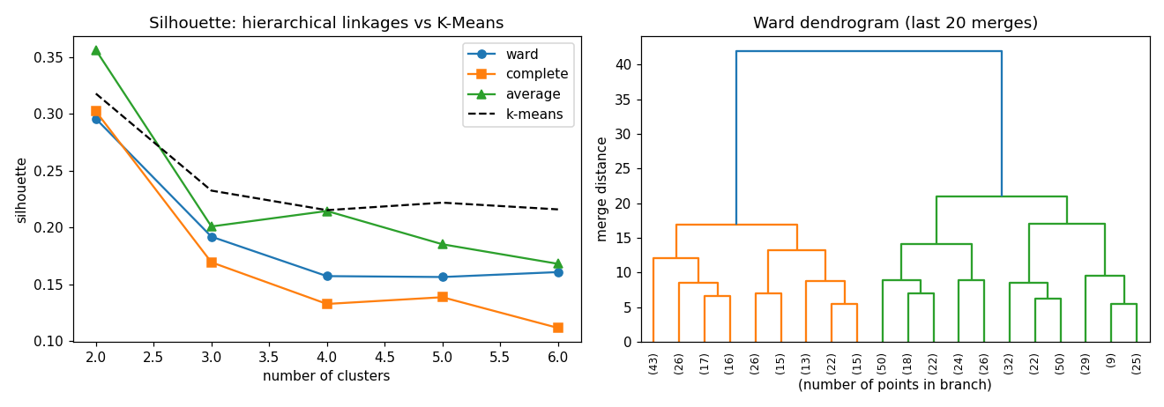
Figure 4. Silhouette by linkage and K-Means (left); Ward dendrogram, last 20 merges (right)

7. What do the clusters mean?
Clustering only gives groups; the useful part is working out what they are. The averages in the original units are:
Cluster | Size | Age | Experience (yrs) | Monthly income | Satisfaction | Weekly hours
0 (senior) | 237 | 35.6 | 14.2 | 93,457 | 6.5 | 42.1
1 (junior) | 263 | 25.0 | 3.2 | 43,803 | 6.5 | 41.9

The two clusters differ in age, experience and income and are almost identical in satisfaction and working hours. In other words, K-Means found a junior group and a senior group. That fits the PCA result: PC1, the seniority axis, carries the structure.
Two further checks use information the clustering never saw.
- Job_Level: the clusters have almost no relation to it (adjusted Rand index -0.002, normalized mutual information 0.002). Job level is spread evenly across both clusters, so in this synthetic data it appears unrelated to age and experience.
- Attrition: the senior cluster has an attrition rate of 39.7% (94 of 237) against 27.0% (71 of 263) in the junior cluster. A chi-square test gives p = 0.004, so this difference is unlikely to be chance.
This is the most interesting finding of the project: without using the Attrition label at all, the clustering separates groups with noticeably different attrition. It is still only a moderate effect, and it describes a difference between groups. It does not show that seniority causes people to leave.
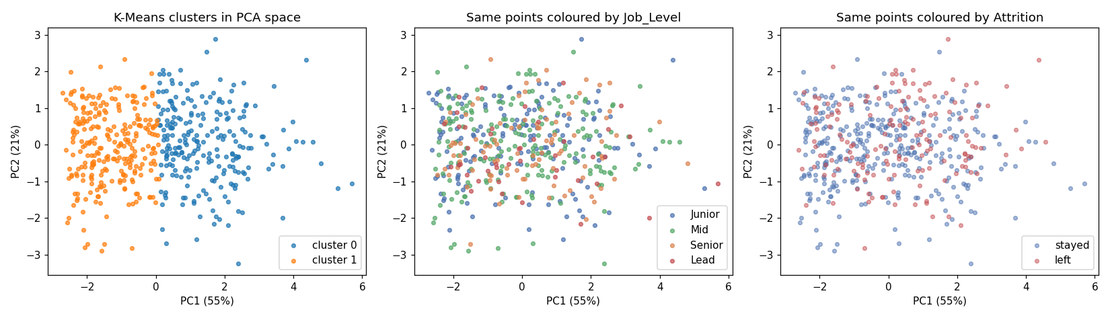
Figure 5. Clusters in PCA space, and the same points coloured by Job_Level and by Attrition

8. How clustering is evaluated
Clustering has no answer key, so metrics such as accuracy, precision, recall, F1, the confusion matrix and ROC-AUC do not apply to it directly. They compare predictions with known labels. Instead, clusters are judged in three ways:
- Internal measures that need only the data: silhouette, Calinski-Harabasz, Davies-Bouldin, inertia (Section 5).
- Stability: whether the same groups appear when the data or the starting points change (Section 5).
- External checks against a label that exists but was not used, such as Job_Level and Attrition above, using the adjusted Rand index and normalized mutual information.

Part B – Supervised model evaluation (predicting Attrition)

9. Setup and cross-validation
Here a known label exists, so the classification metrics apply. I used a stratified 80/20 split (400 training and 100 test rows, 33 leavers in the test set). Every model was in a Pipeline with the same preprocessing as before, so nothing is learned from test rows.
I compared seven models with 5-fold stratified cross-validation repeated three times (15 fits per model) on the training data only. Cross-validation splits the training data into five parts, trains on four and scores on the fifth, and rotates. It gives a steadier estimate than one split, and also shows the spread across folds.
Model | Accuracy | Precision | Recall | F1 | ROC-AUC | AUC std
Baseline (always stayed) | 0.67 | 0.00 | 0.00 | 0.00 | 0.50 | 0.00
Logistic Regression | 0.54 | 0.37 | 0.54 | 0.44 | 0.576 | 0.058
PCA + Logistic Regression | 0.54 | 0.37 | 0.54 | 0.44 | 0.576 | 0.058
Decision Tree | 0.52 | 0.36 | 0.58 | 0.43 | 0.556 | 0.049
Random Forest | 0.57 | 0.37 | 0.41 | 0.39 | 0.580 | 0.049
KNN | 0.67 | 0.39 | 0.06 | 0.10 | 0.548 | 0.065
Gradient Boosting | 0.67 | 0.49 | 0.15 | 0.23 | 0.556 | 0.051

The metrics tell different stories, which is why several are needed. Accuracy favours KNN and Gradient Boosting (0.67) but only because they say ‘stayed’ for almost everybody: their recall is 6% and 15%. The balanced models (logistic regression and the tree) find more leavers (recall 54% to 58%) at the cost of accuracy. ROC-AUC does not depend on a threshold and shows that all models rank leavers only slightly better than chance, between 0.55 and 0.58, with a fold-to-fold standard deviation of about 0.05, which is as large as the gaps between models. PCA with all components is just a rotation, so ‘PCA + Logistic Regression’ gives identical results here; it becomes different once components are removed (next sections).

10. Can extra features help?
Since last week’s weak result, I tried three added features: income per year of experience, an overwork flag (more than 45 hours) and a low-satisfaction flag (below 5). With the same repeated cross-validation, logistic regression’s AUC changed from 0.576 to 0.582 and the random forest’s from 0.580 to 0.569. These changes are far smaller than the 0.05 spread, so the extra features make no real difference.

11. Hyperparameter tuning
A hyperparameter is a setting chosen before training, such as the strength of regularization. I used GridSearchCV, which tries every combination in a grid with cross-validation and keeps the best one. I scored on ROC-AUC because it does not depend on a threshold.
Model | Combinations | Best settings | Best CV ROC-AUC
Logistic Regression | 5 | C = 0.01 | 0.594
PCA + Logistic Regression | 15 | 4 components, C = 1 | 0.594
Random Forest | 16 | max_depth 2, min_samples_leaf 20 | 0.592
KNN | 5 | 41 neighbours | 0.584

Tuning moved the AUC from about 0.576 to about 0.594, but the best settings are the strongest regularization (C = 0.01), the shallowest forest (depth 2, large leaves) and the most neighbours (41). This is the typical sign of weak signal: the more a model is held back, the better it does, because anything complex only fits noise. Also, the best cross-validated score is slightly optimistic, since it is the maximum over many tries. The plots below show how flat the effect of each setting really is, compared with the error bars.
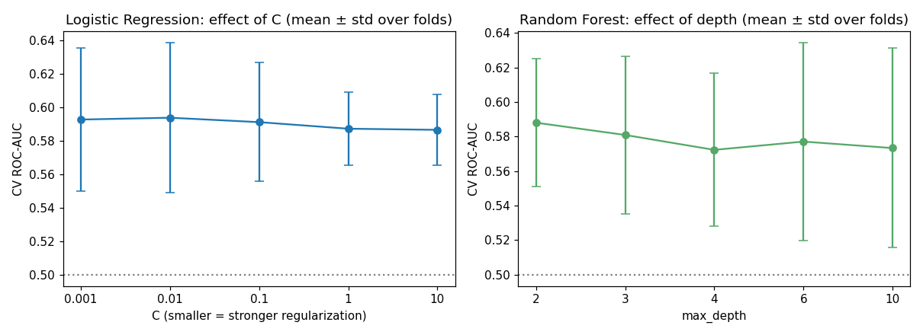
Figure 6. Effect of C (logistic regression) and max_depth (random forest) on cross-validated ROC-AUC
PCA + Logistic Regression technically came first (0.5940 against 0.5938), but this is a tie, not a real difference. I kept it as the final model because it follows the rule I set in advance (highest cross-validated AUC), and it also shows dimensionality reduction used inside a model: keeping four components instead of all of them gave the same score.

12. Final test-set evaluation
The test set was used once, for the final model. The decision threshold is also a setting that must not be chosen on the test set, so I chose it from out-of-fold predictions on the training data. The threshold with the best F1 there was 0.35.
Setting | Accuracy | Precision | Recall | F1 | ROC-AUC | Baseline acc.
Threshold 0.50 | 0.47 | 0.34 | 0.64 | 0.44 | 0.536 | 0.67
Tuned threshold 0.35 | 0.33 | 0.32 | 0.91 | 0.47 | 0.536 | 0.67

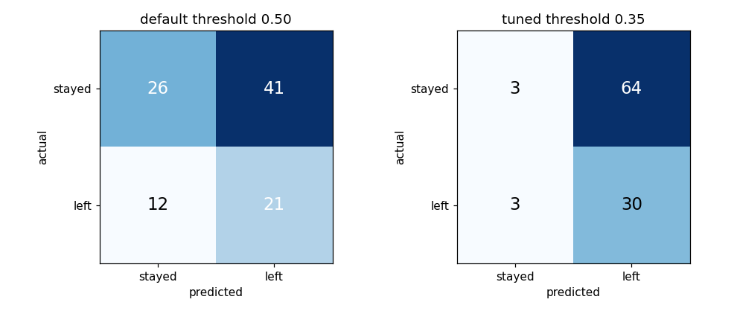
Figure 7. Confusion matrices at the default (0.50) and tuned (0.35) thresholds
How to read the confusion matrices: at 0.50 the model finds 21 of the 33 leavers (true positives) and misses 12 (false negatives), but wrongly flags 41 of 67 employees who stayed (false positives). At 0.35 it catches 30 of 33 leavers, but flags 64 of 67 stayers, which is almost everybody. The recall of 91% and the F1 of 0.47 look better, but only because the model predicts ‘left’ for nearly the whole test set. Precision of 0.32 is hardly above the 33% you get by guessing. Lowering the threshold trades false negatives for false positives; it does not make the model better at telling the groups apart. Which is preferable depends on the cost of each mistake.
The ROC-AUC of 0.536 is a better summary, and I added a bootstrap interval (resampling the test set 2,000 times): the 95% interval is 0.40 to 0.67. Because it includes 0.5, this test result cannot be told apart from random guessing. With only 33 leavers in the test set, the AUC is uncertain by about 0.13 either way.
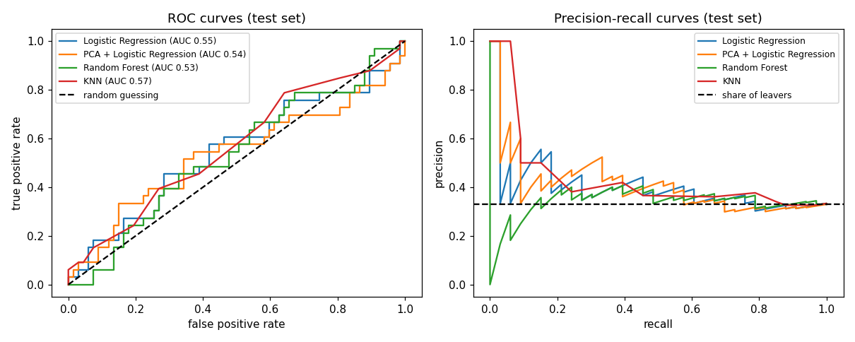
Figure 8. ROC curves (left) and precision-recall curves (right) for the tuned models on the test set
The ROC curves hug the diagonal (random guessing), and the precision-recall curves stay near the 33% line that marks the share of leavers.

13. Overall conclusions
- Unsupervised: the employees divide into a junior and a senior group. K = 2 is the best and most stable choice, but the structure is weak (silhouette 0.32): a continuum cut in two.
- The measure that looks best is not always the right one: average linkage had the best silhouette only because it isolated 16 outliers.
- Clustering found something useful without labels: the senior cluster has a higher attrition rate (39.7% against 27.0%, p = 0.004).
- Supervised: no model, tuning, PCA setting or extra feature lifted Attrition prediction beyond an AUC of about 0.55 to 0.59, and the test AUC is not distinguishable from chance. The most likely reason is that this synthetic label contains very little signal. Trying more models cannot create information that is not in the data.
- Interestingly, the cluster analysis found a statistically clear difference in attrition that the classifiers could barely use, which shows that a significant group difference (an effect of 13 percentage points) is not the same as a model that can predict individuals.

14. Limitations
- The data is synthetic, made for practice. None of the results say anything about real employees.
- Clustering used only five numeric columns, and three of them are nearly the same information.
- The test set is small (100 rows, 33 leavers), so test metrics are very uncertain.
- I tried only K-Means and hierarchical clustering; density-based methods such as DBSCAN were not tried.
- The tuning grids are small, and the best cross-validated score is a little optimistic.

15. What I learned
- Scale features before distance-based clustering, and check what actually drives the clusters.
- Use several measures to choose K, and also check stability.
- Clustering is evaluated differently from classification: accuracy, precision, recall and ROC-AUC need known labels.
- A tuned model can still be no good. Always compare to a baseline and look at the spread of the scores, not only the average.
- Accuracy, F1 and ROC-AUC each show a different side of a model, and the threshold changes the first two but not the last.
Next I would like to try DBSCAN, test the same workflow on a real public dataset with a predictable target, and learn more about how to turn a cluster result into a decision.

16. Project files
- week3_analysis.py and week3_unsupervised_ml.ipynb: the full workflow as a script and a notebook with outputs
- data/employee_data.csv: the dataset
- results/: all metric tables and the cluster assignments as CSV files
- figures/: the eight figures used in this report

17. Description for the submission form
For this Week 3 task I clustered the employee dataset from the earlier weeks and wrote an evaluation of the models, keeping unsupervised and supervised evaluation separate. In the unsupervised part, no labels were used. I standardized five numeric features, showed that without scaling the clusters are just income bands, and used PCA to look at the structure: age, experience and income move together, so the first component is a seniority axis. I ran K-Means for K from 2 to 8 and judged it with inertia, silhouette, Calinski-Harabasz, Davies-Bouldin and a stability check. K=2 was best on every measure, but the silhouette of 0.32 shows the groups are not sharply separated. I compared Ward, complete and average hierarchical clustering with a dendrogram and found that average linkage only looks best because it splits off 16 outliers. I then profiled the clusters: the senior cluster had a higher attrition rate (39.7% versus 27.0%, chi-square p = 0.004), even though attrition was never used to build the clusters. In the supervised part I predicted attrition with seven models using repeated cross-validation, tuned four of them with GridSearchCV, tried PCA, engineered features and threshold tuning, and reported the confusion matrix, precision, recall, F1 and ROC-AUC. All models stayed near an AUC of 0.55 to 0.59 and the test AUC of 0.54 has an interval of 0.40 to 0.67, so I report that the label has very little signal rather than claiming a good model. Code, notebook, results and figures are on GitHub.

