Week 4 Task Report
AI Project Deployment & Capstone
Employee Attrition Prediction API (Python, scikit-learn, joblib, Flask)

1. Overview
The final task was to build an end-to-end machine learning project covering data preprocessing, model training, testing and deployment with Flask or FastAPI, to learn model serialization with Pickle or Joblib, and to deliver a deployed application with documentation and a presentation. My project predicts whether an employee is likely to leave, and exposes the model through a prediction API and a small web form.
Two earlier weeks of feedback shaped this report. Week 2 asked for better classification results, and Week 3 asked me to explain the implications of my findings and to place all figures in the text. So each figure below is shown next to the discussion it supports, and each result is followed by what it means in practice. Section 14 collects the implications in one place.
A note on the data: Weeks 1 to 3 used a synthetic employee dataset in which attrition had almost no relationship to the other columns (best ROC-AUC around 0.55 to 0.59), which made classification evaluation uninformative. For a deployed model to be worth demonstrating, I used a different synthetic dataset (650 rows) in which attrition does depend on the inputs. Both datasets are artificial, so the relationships found here reflect how the data was generated, not real workplaces.

2. System design
The project has two phases. Training runs offline: a script prepares the data, compares models, tunes the best one, evaluates it and writes the fitted pipeline to disk. Serving is the always-on part: the Flask app loads that file once at startup and answers requests. Keeping preprocessing and model in a single saved pipeline means the API applies exactly the same imputing, scaling and encoding that the model was trained with.
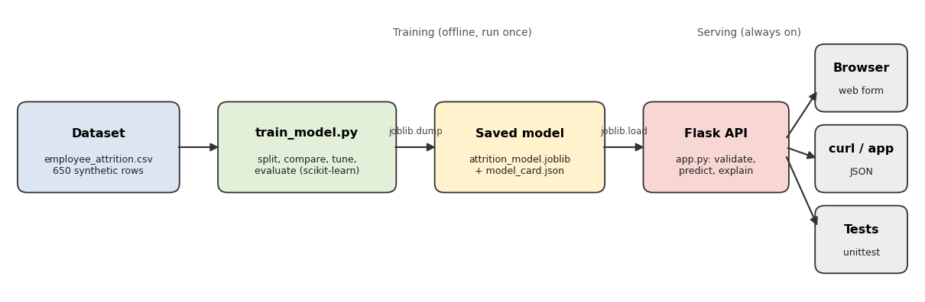
Figure 1. Architecture: training, saved model, Flask API and its clients

3. Dataset
The dataset has 650 synthetic employee records, nine inputs and the target Attrition (Yes or No). There are five numeric inputs (Age, Experience_Years, Monthly_Income, Satisfaction_Score on a 1 to 5 scale, Weekly_Work_Hours) and four categorical inputs (Education, Department, City, Job_Level). There are no duplicate rows, but 32 values are missing: 8 each in Monthly_Income, Satisfaction_Score, Education and Department. 337 employees (51.8%) left and 313 stayed, so the classes are roughly balanced.
I split the data 80/20 with a fixed random seed and stratification, giving 520 training rows and 130 test rows, with 51.9% and 51.5% leavers respectively. The test set was kept untouched until the final evaluation.

4. Exploratory analysis
Before modelling I looked at how each input relates to leaving. Figure 2 shows the class balance and the attrition rate by satisfaction, weekly hours and city.
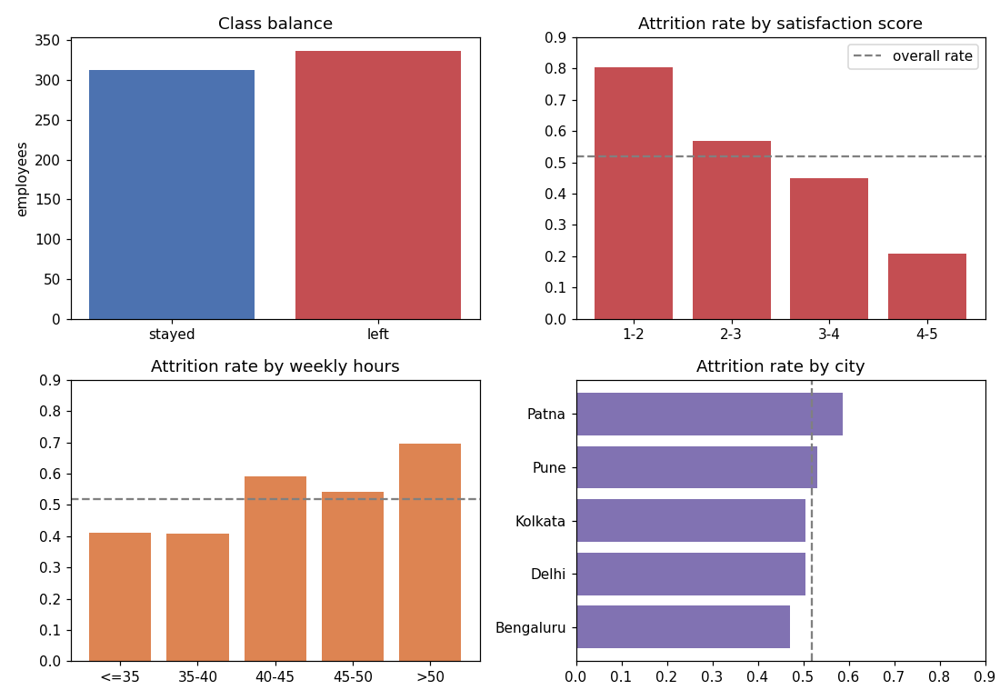
Figure 2. Class balance and attrition rate by satisfaction, weekly hours and city

What the figure shows
- Satisfaction is the strongest signal. The attrition rate is 80.4% for scores 1 to 2, 57.0% for 2 to 3, 45.1% for 3 to 4 and only 20.8% for 4 to 5. It is also the only numeric column with a clear correlation with leaving (-0.34); the others are between 0.12 and 0.17.
- Long hours go with leaving. Attrition is about 41% for people working 40 hours or less, 59% for 40 to 45 hours and 70% above 50 hours.
- Seniority and city matter a little. Attrition rises from 43% for Junior to 51% for Mid and 56% for Senior, and it ranges from 47% in Bengaluru to 59% in Patna. These differences are smaller and, with a few hundred rows, partly noise.

Implication
Whatever model I build should find satisfaction first and weekly hours second. If it does not, something is wrong with the pipeline. Practically, the pattern says that low satisfaction and long hours are the two warning signs worth watching. This is an association in synthetic data, not proof that raising satisfaction would stop people leaving.

5. Preprocessing
All preprocessing lives inside a scikit-learn Pipeline with a ColumnTransformer, so that anything learned (medians, means, categories) comes only from the training rows.
Columns | Step | Why this choice
Numeric (5) | median imputation, then standardization | median is robust to extreme values; scaling puts income (tens of thousands) and satisfaction (1 to 5) on the same scale, which logistic regression and KNN need
Categorical (4) | most-frequent imputation, then one-hot encoding | the categories have no natural order, so one-hot avoids inventing one; handle_unknown=ignore stops the API from crashing on a new category

Bundling these steps with the model also matters for deployment: the saved file contains the full recipe, so the API cannot accidentally preprocess requests differently from training.

6. Comparing models
I compared six candidates using 5-fold stratified cross-validation repeated three times (15 scores per model) on the training data only. The baseline always predicts ‘left’, which is the majority class. I used ROC-AUC as the main measure because it does not depend on a decision threshold.
Model | Accuracy | Precision | Recall | F1 | ROC-AUC | AUC std
Baseline (always left) | 0.519 | 0.519 | 1.000 | 0.684 | 0.500 | 0.000
Logistic Regression | 0.665 | 0.676 | 0.681 | 0.678 | 0.711 | 0.034
Decision Tree | 0.622 | 0.622 | 0.695 | 0.652 | 0.652 | 0.051
Random Forest | 0.641 | 0.652 | 0.664 | 0.657 | 0.694 | 0.051
Gradient Boosting | 0.635 | 0.651 | 0.652 | 0.650 | 0.693 | 0.043
KNN (25 neighbours) | 0.636 | 0.653 | 0.642 | 0.646 | 0.675 | 0.052

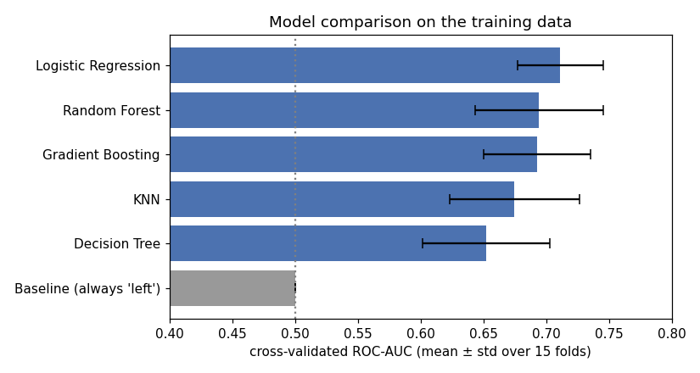
Figure 3. Cross-validated ROC-AUC of each model (mean and standard deviation over 15 folds)

What the figure shows
All five real models beat the baseline (AUC 0.50), and logistic regression is the best with 0.711. But the error bars overlap: the fold-to-fold spread is 0.03 to 0.05, about as large as the gap between logistic regression and the forest or boosting. So I cannot claim logistic regression is clearly better than those two, only that nothing beat it.
The table also contains a warning about F1. The baseline that predicts ‘left’ for everybody has an F1 of 0.684, higher than every real model, because its recall is 100%. F1 on its own would suggest the models are worse than doing nothing, which is wrong. Accuracy and ROC-AUC show the real picture.

Implication
On this data the simplest model is as good as the complicated ones. That makes the choice easy: logistic regression is fast, small, and can say which inputs drive each prediction, which I use in the API. If a more complex model had been clearly better it might justify its extra cost, but here it does not.

7. Tuning
I tuned the regularization strength C of the logistic regression with GridSearchCV over eight values (0.001 to 100), 5-fold cross-validation, scored on ROC-AUC. A small C means strong regularization, which keeps the coefficients small.
C | CV ROC-AUC | Std | AUC on training folds
0.001 | 0.7021 | 0.058 | 0.7242
0.01 (best) | 0.7196 | 0.044 | 0.7479
0.1 | 0.7155 | 0.042 | 0.7603
1 | 0.7073 | 0.042 | 0.7617
100 | 0.7054 | 0.042 | 0.7618

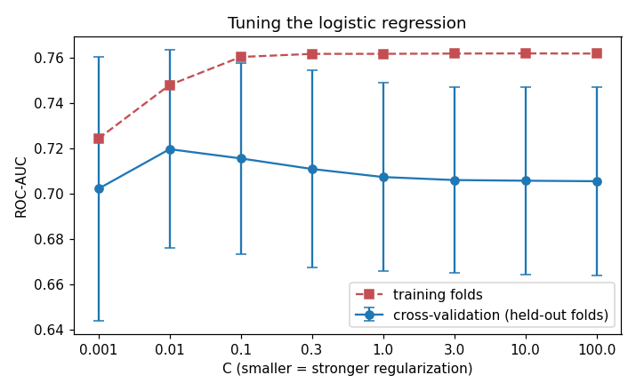
Figure 4. Effect of C on the cross-validated and training ROC-AUC

What the figure shows
The two curves tell a clear story. As C grows, the score on the training folds keeps rising (0.724 to 0.762), but the score on the held-out folds peaks at C = 0.01 and then falls. The widening gap between them is overfitting: with weak regularization the model starts fitting noise in the training rows. Strong regularization at C = 0.001 underfits instead. The best C is the middle one.
The effect is small, about 0.015 AUC, and smaller than the error bars, so tuning is a refinement here and not a big gain. I report it honestly as such.

8. Final evaluation on the test set
With the tuned model chosen, I used the test set once. The decision threshold is 0.5: predict ‘left’ when the predicted probability is at least 50%.
Metric | Test result | Reference point
Accuracy | 0.677 | baseline (always left) 0.515
Precision | 0.676 | of 71 employees flagged, 48 really left
Recall | 0.716 | 48 of the 67 leavers were found
F1 | 0.696 | baseline 0.680, so only a small gain
ROC-AUC | 0.702 | 95% bootstrap interval 0.61 to 0.80; random guessing is 0.50

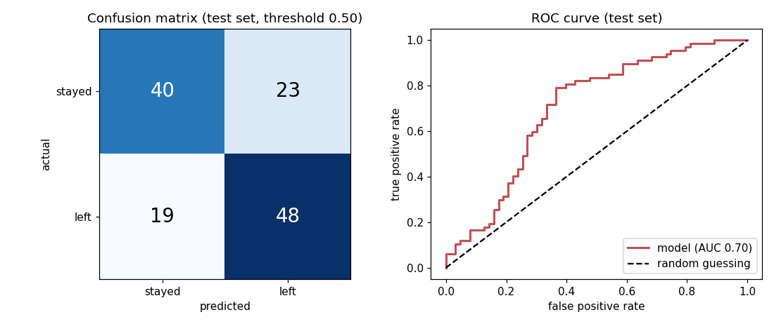
Figure 5. Confusion matrix (left) and ROC curve (right) on the test set

What the figure shows
The confusion matrix reads as follows: 48 leavers were correctly flagged (true positives) and 40 stayers were correctly left alone (true negatives). There were 19 missed leavers (false negatives) and 23 false alarms (false positives). So the model catches about 72% of leavers, but also wrongly flags 23 of 63 stayers, 37%. The ROC curve lies clearly above the diagonal of random guessing, with an area of 0.70.
To see how much to trust a single test number, I resampled the test set 2,000 times. The ROC-AUC interval is 0.61 to 0.80 and the accuracy interval is 0.59 to 0.75. Even the low ends are above the guessing levels of 0.50 and 0.52, so the model really does learn something, but with 130 test rows the exact value is uncertain by around plus or minus 0.09.

Implication
This is a useful but modest model. It can help rank employees by risk, but about one in three of the people it flags would not actually have left. It should be read as a prioritization aid, not a verdict on any individual.

9. Choosing a decision threshold
The 0.5 threshold is a choice, not a law. Using out-of-fold predictions on the training data, I measured what happens to precision, recall and accuracy when it moves.
Threshold | Precision | Recall | Accuracy
0.3 | 0.531 | 0.993 | 0.540
0.4 | 0.557 | 0.922 | 0.579
0.5 | 0.658 | 0.726 | 0.662
0.6 | 0.779 | 0.352 | 0.612
0.7 | 0.917 | 0.081 | 0.519

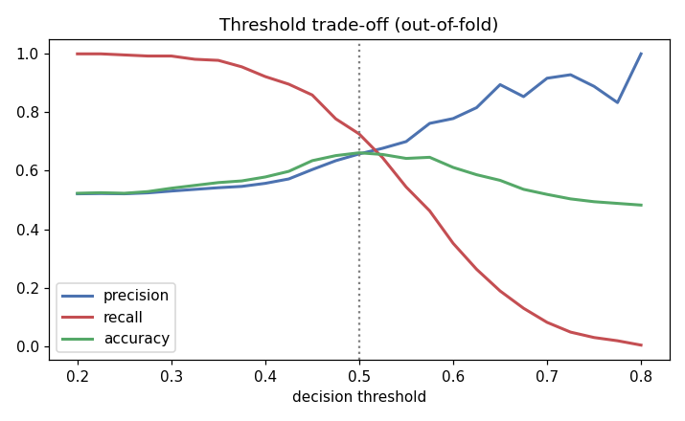
Figure 6. Precision, recall and accuracy as the threshold changes

What the figure shows
Recall falls steadily as the threshold rises and precision rises. Accuracy peaks near 0.5. At 0.3 the model flags almost everybody (recall 99%, but precision only 53%, barely above the 52% leaving rate). At 0.7 it is very precise (92%) but finds only 8% of leavers.

Implication
The right threshold depends on what a wrong call costs. If the follow-up is cheap and friendly, such as a stay conversation, a lower threshold like 0.4 that catches 92% of leavers is reasonable even with more false alarms. If the follow-up is expensive, a higher threshold such as 0.6 keeps precision near 78% at the cost of missing about two thirds of leavers. This is why the API returns a probability and a risk band (low below 0.40, medium 0.40 to 0.60, high above 0.60) and not only a yes or no.

10. What the model learned
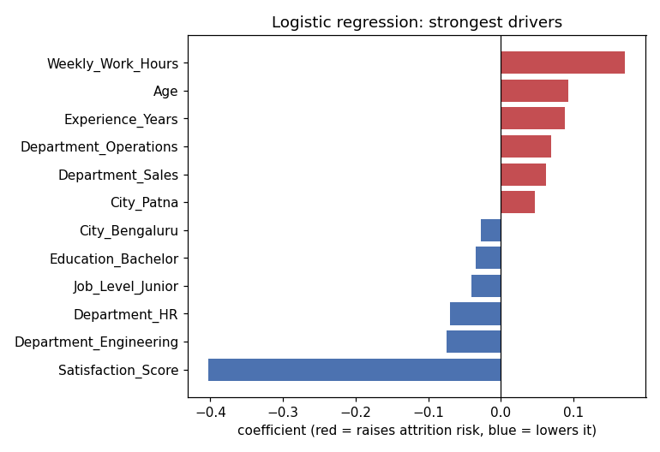
Figure 7. Largest logistic regression coefficients (red raises the risk of leaving, blue lowers it)
The coefficients agree with the exploratory analysis. Satisfaction_Score has by far the largest effect and it is negative: higher satisfaction means lower risk (-0.40 per standard deviation). Weekly_Work_Hours is next and positive (+0.17), then Age and Experience_Years (about +0.09 each). The department and city effects are small (about 0.07 or less). Because the numeric columns were standardized, the numeric coefficients can be compared with each other directly.
This also fits the earlier finding about model choice: since the signal is mostly a smooth effect of two columns, a linear model captures it, and a more flexible one has nothing extra to find.

11. Serialization and the API

11.1 Saving the model with joblib
The fitted pipeline (imputers, scaler, encoder and classifier) is saved with joblib.dump to model/attrition_model.joblib, which is only 5 KB, together with a model card (model_card.json) holding the metrics, the feature lists, the allowed categories, the numeric ranges seen in training and the scikit-learn version. After saving, the script reloads the file and checks that it makes identical predictions. The API warns at startup if the installed scikit-learn version differs from the one used for training, because pickled models are not guaranteed to load across versions. Joblib files can also execute code when loaded, so only trusted files should be loaded.

11.2 The Flask API
Endpoint | Method | What it does
/ | GET | a web form for trying the model in a browser
/health | GET | reports whether the service is up and the model is loaded
/model-info | GET | returns the model card
/predict | POST | takes a JSON employee record and returns the prediction, probability, risk band and top three factors

Input validation matters for a deployed model, because a prediction on garbage input looks just as confident as one on good input. /predict rejects, with HTTP 400 and a message for each field: missing or null fields, values of the wrong type, numbers outside hard limits (for example satisfaction must be between 1 and 5), categories the model has never seen, and bodies that are not JSON. Values that are valid but outside the range seen in training still get a prediction, together with a warning that it is less reliable.
To make predictions explainable, the API multiplies each coefficient by the employee’s transformed value, adds the one-hot columns back together under their original feature, and returns the three largest contributions. This is a real request and response from the running server:
POST /predict
{"Age": 34, "Experience_Years": 9, "Monthly_Income": 22000,
"Satisfaction_Score": 1.8, "Weekly_Work_Hours": 52, "Education": "Bachelor",
"Department": "Sales", "City": "Patna", "Job_Level": "Mid"}

-> 200 OK
{"prediction": "Yes", "probability_attrition": 0.705, "risk_band": "high",
"top_factors": [
{"feature": "Satisfaction_Score", "effect": "raises risk", "contribution": 0.544},
{"feature": "Weekly_Work_Hours", "effect": "raises risk", "contribution": 0.251},
{"feature": "Department", "effect": "raises risk", "contribution": 0.062}],
"warnings": []}

A second employee with satisfaction 4.6 and 38 working hours (Master, Engineering, Bengaluru, Junior) got a probability of 0.259 and a low risk band, with satisfaction as the main factor lowering the risk. In both examples satisfaction is the largest factor, which is what the exploratory analysis predicted.

12. Testing
I wrote 12 automated tests with Python’s unittest and they all pass. They cover the health, home and model-info endpoints; a valid prediction (checking the probability is between 0 and 1 and that three factors are returned); a behavioural check that lowering satisfaction from 5 to 1 raises the predicted risk; the five kinds of invalid input listed above; the out-of-range warning; and the 404 and 405 error responses. I also started the real server, called it with curl and with the client_demo.py script, and confirmed the web page loads (HTTP 200) and that bad input returns HTTP 400 with a clear message.
POST /predict {"Age": "x", "City": "Atlantis"}
-> 400 Bad Request
{"error": "Invalid input.", "details": {
"Age": "must be a number",
"City": "must be one of ['Bengaluru', 'Delhi', 'Kolkata', 'Patna', 'Pune']",
"Department": "required", ... }}

13. Running and deploying it
- Locally: pip install -r requirements.txt, then python app.py, and open http://127.0.0.1:5000.
- Production server: gunicorn app:app (the Procfile contains this).
- Container: the Dockerfile installs the requirements and runs gunicorn on the PORT environment variable.
- Hosting platforms such as Render: connect the GitHub repository, build with pip install -r requirements.txt and start with gunicorn app:app.
To be clear about what I verified: the Flask server, the endpoints and the tests were run locally. I did not build the Docker image or publish the app on a public hosting service, so those files are configuration that I have not tested.

14. Implications of the findings
- Satisfaction is the main lever. In this data, going from a satisfaction score below 2 to one above 4 corresponds to attrition dropping from 80% to 21%. For a real organization this would argue for treating survey results as an early warning and following up on low scores. It would not prove that raising scores prevents resignations.
- Workload is the second. Attrition is about 70% above 50 hours a week against about 41% at 40 hours or less, which suggests monitoring sustained overtime.
- The model is a prioritization aid. With 68% accuracy against a 52% baseline and an AUC of 0.70, it helps rank who to talk to first, but a third of its flags are false alarms. It should never be the basis for an employment decision.
- The threshold is a business decision. Moving it between 0.4 and 0.6 swings recall from 92% to 35%. The cost of a missed leaver against the cost of an unnecessary conversation should decide it, not the data scientist.
- Better data would help more than a better algorithm. Six algorithms landed within a few hundredths of each other, so the limit is the information in the nine columns. Features such as time since last promotion, pay relative to peers or manager changes might add more than a more complex model.
- Packaging prevents errors. Saving preprocessing with the model, validating inputs, warning on unusual values and testing the API are what make the model safe to call from other programs.

15. Limitations and responsible use
- The data is synthetic, so none of the results say anything about real employees or workplaces.
- The test set has only 130 rows, so the test metrics are uncertain (ROC-AUC interval 0.61 to 0.80).
- Inputs such as age and city could cause unfair outcomes in a real HR setting and would need a fairness review, and probably removal, before any real use.
- A production system would need real data with privacy and security controls, monitoring for data drift, model versioning and retraining, authentication on the API, and human oversight of any decision.
- The model is a demonstration and must not be used for hiring, firing, promotion or performance decisions.

16. What I learned
- Serving a model is mostly engineering around it: saving the whole pipeline, validating input, handling errors and testing.
- Always compare with a baseline, because F1 for ‘predict everyone leaves’ beat every real model.
- Cross-validation shows how uncertain the numbers are, and a bootstrap interval shows how uncertain a single test result is.
- The threshold, not only the model, determines how a prediction behaves in practice.
- A simple, explainable model is often the right choice when more complex ones are not clearly better.
Next steps I would take: try the same workflow on a real public dataset, add authentication and logging to the API, build and test the Docker image, deploy to a hosting service, and add monitoring for drift.

17. Project files
- app.py, train_model.py, client_demo.py: the API, the training pipeline and an example client
- week4_capstone.ipynb: the notebook version with outputs, ending with an API call
- model/: the serialized pipeline and the model card
- tests/test_api.py: the 12 tests
- data/, results/, figures/: the dataset, metric tables and plots
- Dockerfile, Procfile, requirements.txt, README.md: deployment files and instructions
- Week4_Presentation: the slides

18. Description for the submission form
For the Week 4 capstone I built an end-to-end machine learning application that predicts employee attrition and serves the model through a Flask API. I used a synthetic dataset of 650 employees with nine inputs and explored it first. Satisfaction turned out to be the strongest signal: attrition was 80% for scores of 1 to 2 and 21% for scores of 4 to 5. I put all preprocessing (median and most-frequent imputation, scaling, one-hot encoding) into a scikit-learn Pipeline so it is learned from training data only. I compared six models with repeated cross-validation against a baseline, picked logistic regression, which scored best and is easiest to explain, and tuned its regularization with GridSearchCV. On the held-out test set it reached 0.68 accuracy against a 0.52 baseline and a ROC-AUC of 0.70, with a bootstrap interval of 0.61 to 0.80. I also explain why F1 alone is misleading here, since predicting everyone leaves already gives 0.68. I saved the whole pipeline with joblib and wrote a Flask API with a web form, a health check, a model-info endpoint and a /predict endpoint that validates input, returns a risk band and names the main factors. I wrote 12 automated tests, ran the live server and checked real requests and error responses. The report discusses what the findings mean in practice, including how the decision threshold changes the trade-off between catching leavers and false alarms. It also covers limitations and responsible use. The code, notebook, tests, Dockerfile, report and slides are on GitHub.

