**Report TI1806 Computer Graphics Project Group 17**

***Group members***

Alessandro Ariës 4470346

Jeroen Kloppenburg 4477960

Martijn Straatman 4442504

Jurriaan den Toonder 4431324

Tim de Groot 4383052

Boudewijn van Groos 4229843

Vincent van Heertum 4319303

***Short Overview***

Our Raytracer is able to calculate intersects with triangles, simple planes, spheres and boxes.

It implements shading using the Blinn Phong model and has the ability to change the light source to simulate the sun using the keys on the keyboard (Shift + S to toggle sun mode, WASD to move it around).

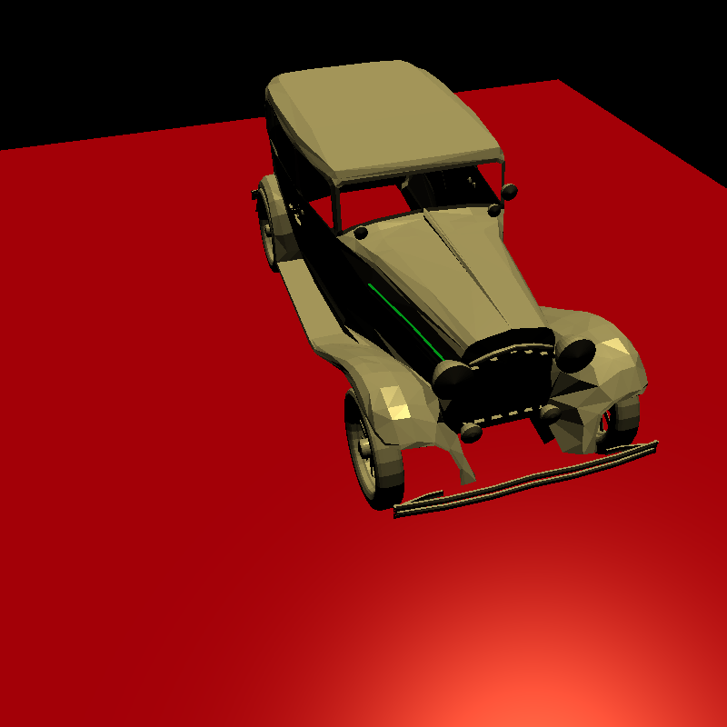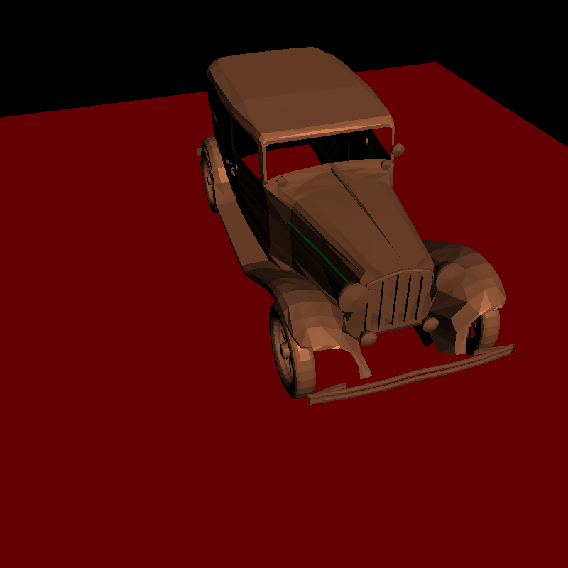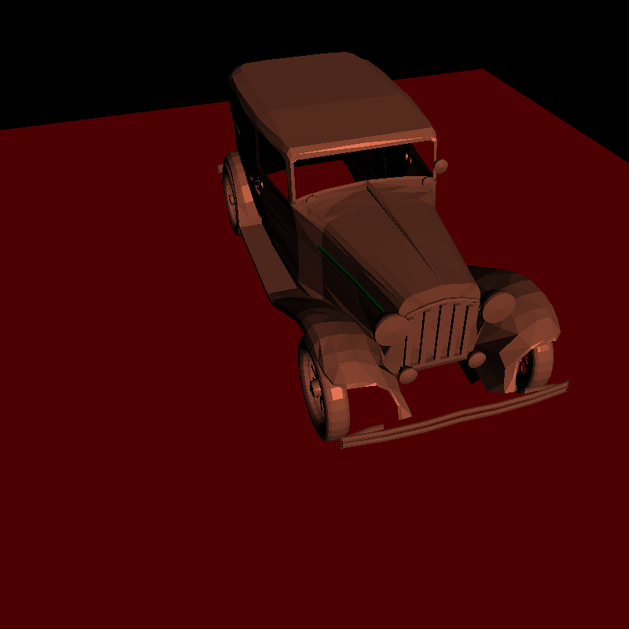

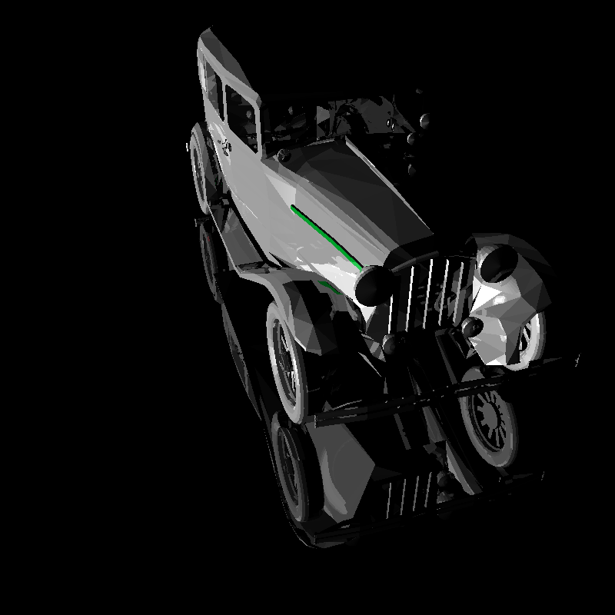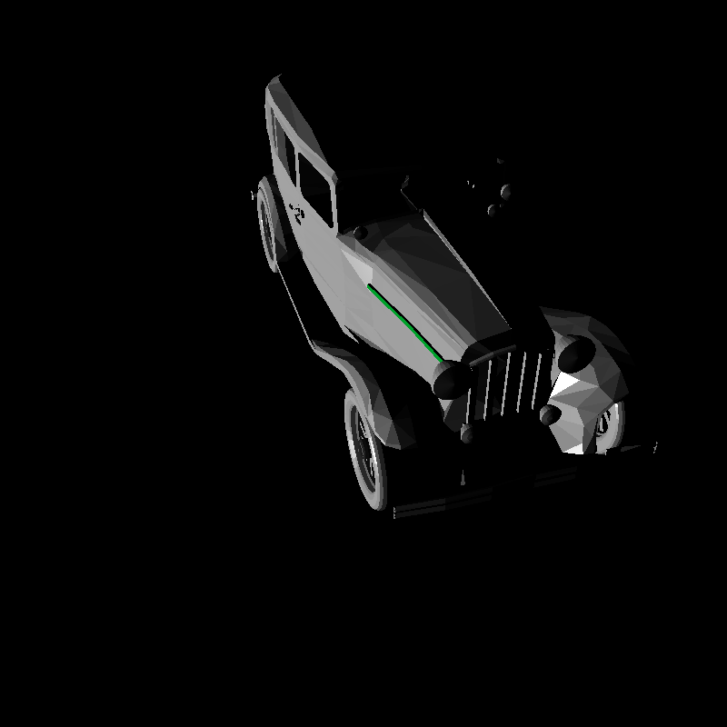We used Boundary Boxes and a Kd-tree as data structure to optimise processing and accelerate of rendering.

Our scene is custom made using Blender and contains a lot of mirrors to show our scene hierarchy and reflection implementation.

***Individual contributions***

* *Ray intersection with planes, triangles and boxes:*

Alessandro, Tim, Boudewijn, Marijn

* *Computation of shading:*

Jurriaan, Alessandro

* *Recursive raytracing to simulate specular materials (using reflection):*

Vincent, Martijn, Jeroen, Tim, Boudewijn, Alessandro

* *An option to move the light sources in the scene:*

Jurriaan, Boudewijn

* *An interactive display in OpenGL of the 3D scene:*

Boudewijn, Jurriaan

* *A spatial acceleration structure:*

Boudewijn, Jeroen, Jurriaan

* *Own‐built scene(s) in Blender:*

Tim

* *A more complex scene hierarchy:*

Tim

* *Ray intersection with spheres (Not used):*

Alessandro, Tim

* *Refraction (Not used):*

Jeroen