Project Description:

“Design and implement a JavaFX Question Bank Creator. In this application, the user will be able to create, view, edit, and delete multiple choice questions. Each question has a text, choices, and the correct answer. Create an array of questions. The array of questions will be loaded from the binary file "QuestionBank.dat" when your application starts and saved back to the file upon exit.”

Solution Description:

Firstly, we started by writing the bases of the program and how it will work, e.g., number of scenes and the type of ArrayList several other things, after that we started by distribute the work and divide the project.

We faced several problems, and the first problem was the Save class witch was hard to know or decide a specific way to write in the binary file so we decided to try several methods but it didn’t work so we was forced to use two classes to read the binary file and one write, the second problem was the reset of the scene and there was no specific way to do this so we wrote the code to reset it manually after each function, and one of the latest problems was changing the ArrayList from string objects to Mcq object as it was written in the rubric, and that caused some logical errors and contradictions but that was solved also.

Finally, we divided the project to 4 classes to be easier to handle it and to read it easily.

Screenshots of the application:

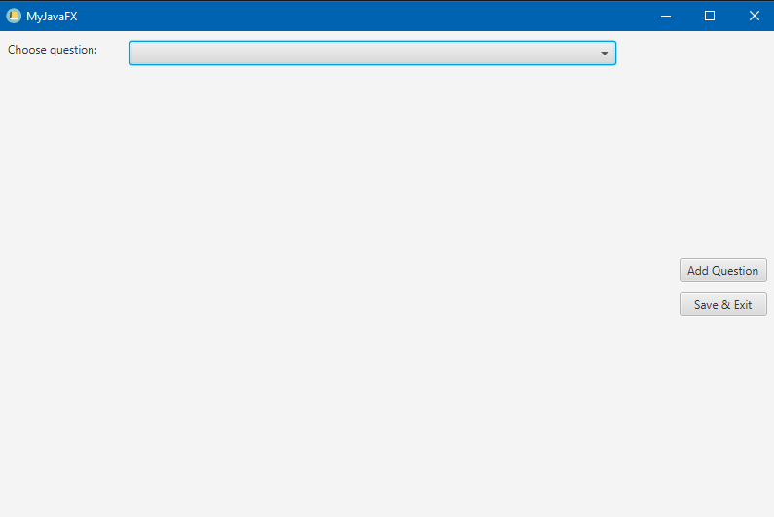

This is the main menu that will be displayed to the user, from here they can choose whether to add a question, select one of the questions made previously from the combo box or Save & Exit the application.

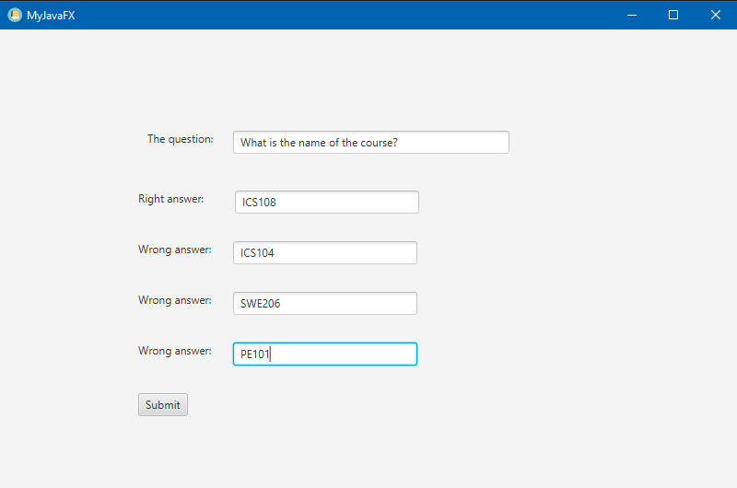

After pressing “Add Question”, the user is taken to a page where they can type their question and add 4 choices, one of which must be the correct choice.

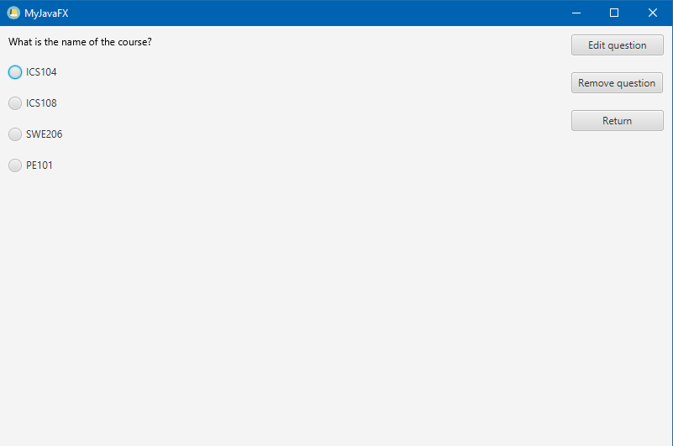

Then the user will be taken to see how their question looks like, also there are 3 other choices they can chose from, whether they want to edit or delete the question, or just return to the main menu if they are satisfied with the question.

And of course, the choices will be distributed randomly each time the user returns to the question.

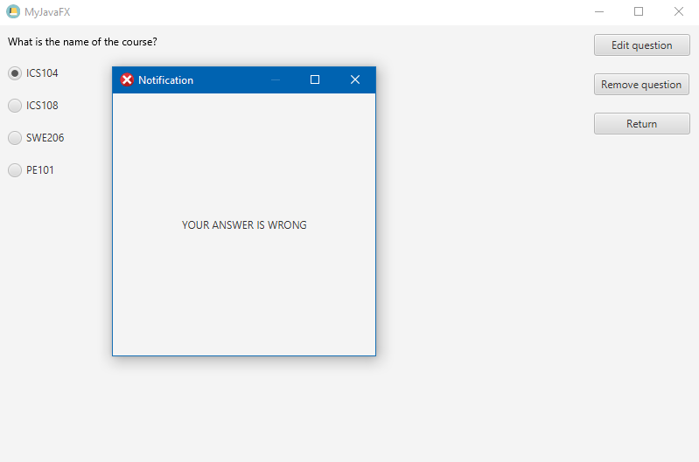

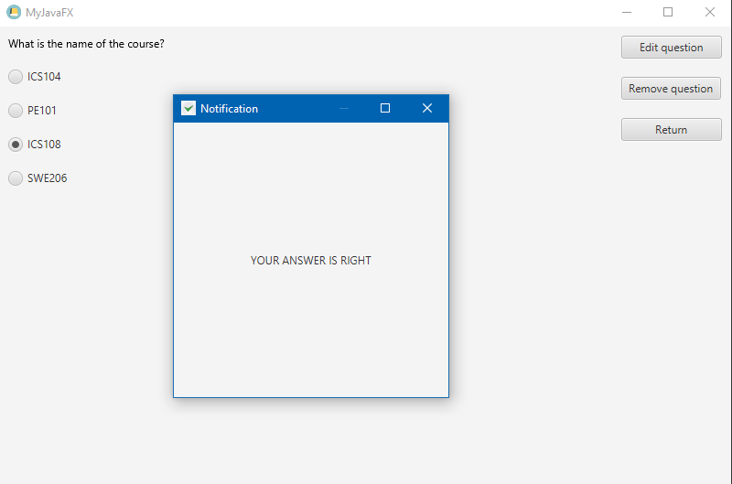

A notification window will pop-up if the user selects one of the choices, depending on the answer it will display whether it was Right or Wrong.

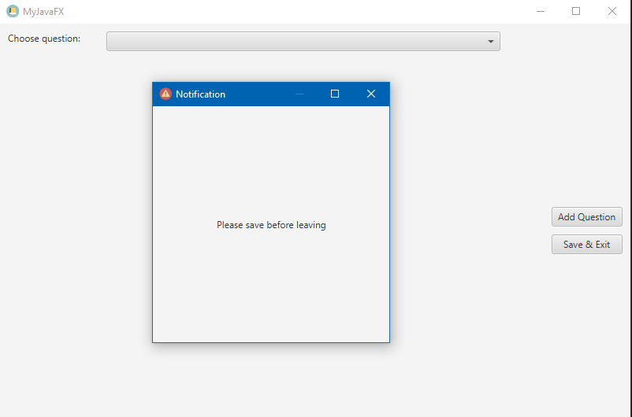

If the user tries to leave without saving this notification will pop-up to remind them to use the “Save & Exit” button to save their changes.

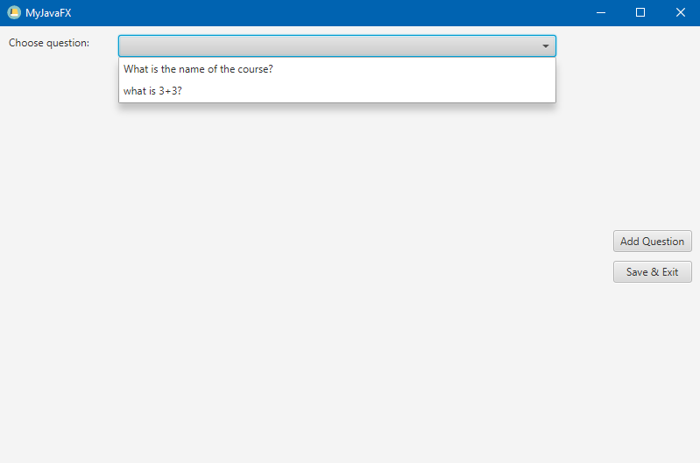

When the user returns, they will see all of their questions and answers saved and selectable in the combo box above.