RAMBreaker RAM Forensics Toolkit
v6.2 — Complete Technical Reference

Every module. Every data source. Every design decision.
Author: Ahmad Anasweh
Deep technical documentation — Document version 1.2

Contents
Part I — Introduction & Philosophy
1.1 What RAMBreaker Is
1.2 Core Design Philosophy: Evidence, Not Verdicts
1.3 Supported Inputs, Engines, and Operating Systems
1.4 Version History Visible In The Codebase
Part II — Architecture
2.1 High-Level Architecture
2.2 The OS-Split Dispatcher Pattern
2.3 Module Tree
2.4 Core Infrastructure
2.5 The Volatility Wrapper
2.6 Installer & Dependency Management
Part III — Symbol Resolution Subsystem (Linux / macOS)
3.1 Why This Subsystem Has To Exist
3.2 linux_identify.py
3.3 The ISF Resolution Waterfall
3.4 dbgsym_builder.py
3.5 Bring-Your-Own-ISF
Part IV — The 8-Step Core Pipeline
Part V — Module-by-Module Reference
5.1 OS-Split Extraction & Dumping
5.2 Correlation & Command Analysis
5.3 Registry & Windows-Only Artifacts
5.4 Cross-Platform Analysis Modules
5.5 Custom Volatility 3 Plugins
Part VI — The HTML Report
Part VII — Cross-Cutting Design Patterns
Part VIII — Performance & Operational Characteristics
Part IX — A Worked Example Run
Part X — Known Issues Engineered Around
Part XI — Appendix
A. Full CLI Reference
B. Plugin Inventory by OS / Engine
C. Output Directory Reference
D. Glossary
Part XIII — v6.2: Symbols From The Image Itself (btf2isf)

Part I — Introduction & Philosophy

1.1 What RAMBreaker Is
RAMBreaker (internally also referred to by its module names as RAMBreaker) is a Python 3 command-line toolkit that wraps Volatility 2 and Volatility 3 into a single, cross-platform memory-forensics workflow. Given a memory image from Windows, Linux, or macOS, it detects the operating system, resolves whatever symbol information Volatility needs, runs the relevant plugin set in parallel, cross-references the results across processes/network/registry/filesystem, and produces both structured JSON and a self-contained interactive HTML report — all from one entry point, crescent_toolkit.py.
The codebase is organized as 33,751 lines of Python across one entry-point script, a modules/ package of 69 files, a small utils/ package, a tests/ package holding two zero-dependency suites (166 pure-logic assertions plus a 21-assertion full-pipeline canary), two bundled custom Volatility 3 plugins, and supporting data files (a compressed Linux symbol catalogue and a bundled dwarf2json binary for building ISFs locally).
It is not a Volatility replacement and does not try to hide Volatility from the analyst — SUMMARY.txt records exactly which engine and profile/ISF were used for every run, and every plugin's raw JSON output is kept alongside RAMBreaker's own derived reports so the provenance of any finding can always be traced back to the exact plugin that produced it.

1.2 Core Design Philosophy: Evidence, Not Verdicts
The design decision that shapes every report generator in the codebase is a deliberate refusal to produce automated threat verdicts. This is not a caveat added to the documentation after the fact — it is written directly into the output the tool produces, every single run:
Printed at the top of every correlation_report.txt (Windows / Linux / macOS variants)
"NOTE: Raw data only — no automated threat assessments."

Printed at the top of registry_altered.txt
"NOTE: Raw observations — no automated threat assessments."

Embedded directly in report.html's data model (HTMLReportGenerator._collect_data, notes[])
"This report is JSON-only. TXT/string artifacts are intentionally excluded." / "Presents raw data and correlations only; it does not decide malicious/benign."

The practical consequence shows up throughout the module reference in Part V: modules surface correlations (this process has an external network connection; this registry key was written after this timestamp; this command chain matches a known LOLBin pattern) and severities scoped to a named, specific detection rule (CommandAnalyzer's CRITICAL/HIGH flags are always tied to one matched pattern, never to a holistic judgement about a process as a whole). Nothing in the codebase computes or displays an overall "malicious / benign" score for a process, file, or image.

1.3 Supported Inputs, Engines, and Operating Systems
Dimension | Coverage
Memory image formats | .raw, .mem, .lime, .dmp (Windows crash dumps), VMware .vmem (with its .vmss/.vmsn companion when available)
Target operating systems | Windows (XP through modern builds), Linux (Ubuntu/Debian/Kali/Mint/Pop!_OS family, RHEL/CentOS/AlmaLinux/Rocky/Fedora family, SUSE with reduced automation), macOS (through at least 10.12.6 verified; community ISF coverage above macOS 11 is noted as potentially incomplete)
Volatility engines | Volatility 3 (primary — JSON output, actively maintained plugin set) and Volatility 2 (legacy — required for older Windows profiles and kept fully wired into the pipeline, not just left as dead code)
Symbol sources | Windows: Volatility's own PDB-based automagic. Linux/macOS: Volatility 3 ISF files, auto-resolved (Part III) or supplied by the analyst.

1.4 Version History Visible In The Codebase
RAMBreaker does not hide its own development history. ui.py declares VERSION = "6.2", and the OS-split modules and core infrastructure carry "v6.0"-era docstring headers that the OS-split refactor introduced. But a large share of the cross-platform modules — network_map.py, timeline.py, process_tree.py, system_info.py, ioc_extractor.py, browser_history.py, comms_scanner.py, strings_extractor.py, memory_grep.py, yara_scanner.py, auto_hash.py, export_pack.py, elk_export.py, and registry_explorer/evtx_parser — still carry their original "RAMBreaker RAM Forensics Toolkit v4.0" docstring header, unchanged, because those modules' interfaces and logic have not needed to change since v4.0: the OS-split rewrite only touched the modules whose behavior actually differs per operating system.
This is itself informative about how the project evolved: the existing project documentation (ARCHITECTURE.md, superseded for structural questions by ARCHITECTURE_V6.md but still accurate for v5.0-era module API details) and the presence of an explicit "inherited v4.1 design decisions" table in the v6 architecture notes both confirm a chain of internal milestones — v4.0, v4.1, v5.0, v6.0, v6.1 and v6.2 — with v6.0's defining, signature change being the OS-split dispatcher rewrite described in Part II, v6.1 being the reliability/diagnostics release (Part XII) and v6.2 the symbol-self-sufficiency release (Part XIII).

Part II — Architecture

2.1 High-Level Architecture
At the top, crescent_toolkit.py (3,357 lines) is both the CLI entry point and the orchestrator: it owns argument parsing, OS/engine auto-detection, the interactive menu, the settings menu, and 20-odd top-level "_cmd_*" handler functions that each wire together a handful of modules for one action. Nothing below crescent_toolkit.py talks to the user directly — every module in modules/ is a library, called by the orchestrator, that does one job and writes its results to disk.
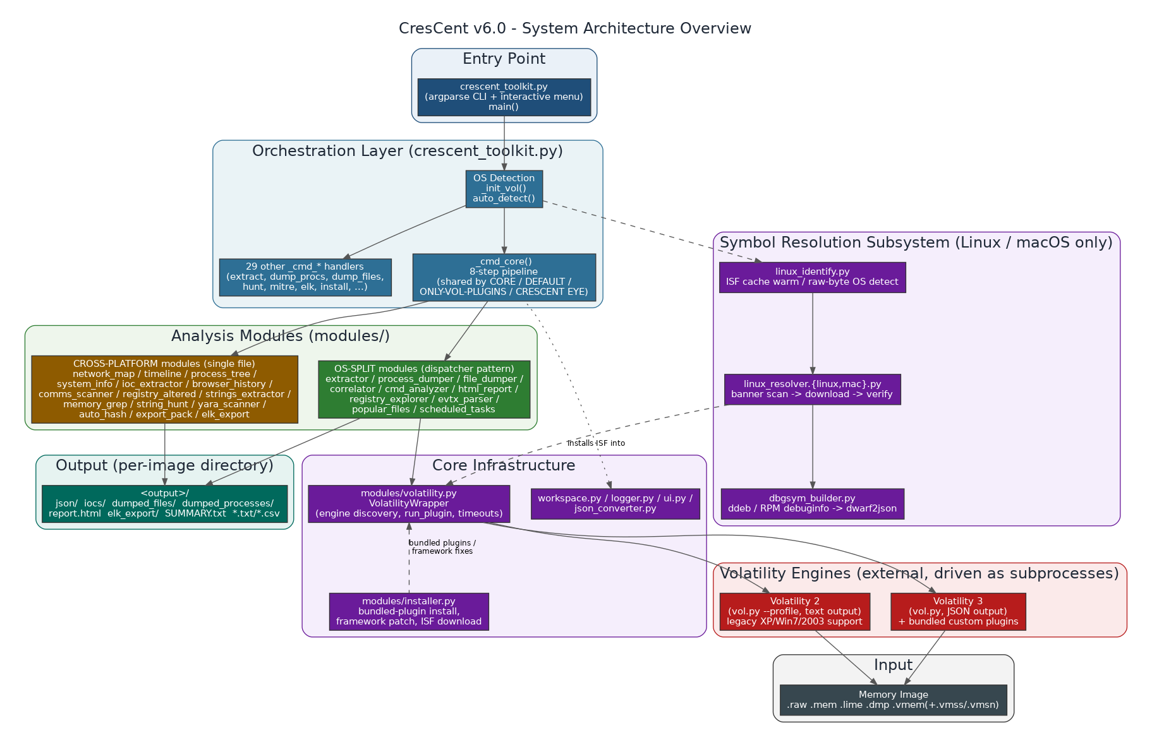
Figure 2.1. System architecture overview.
Four layers sit below the orchestrator:
- The symbol resolution subsystem (Linux/macOS only) — linux_identify.py, linux_resolver.{linux,mac}.py, dbgsym_builder.py — which makes sure Volatility 3 has a working ISF before anything else runs.
- The analysis modules themselves, split into OS-split modules (eleven module families where the logic genuinely differs per OS, using the dispatcher pattern in 2.2 — twelve if you count linux_resolver, which uses the same mechanism but is documented with the symbol subsystem in Part III) and cross-platform modules (fifteen modules that are identical regardless of OS, because their job — parsing timestamps, extracting IOCs from strings, building a network map from already-normalized JSON — doesn't depend on which OS produced the data).
- Core infrastructure — modules/volatility.py (the actual Volatility process wrapper), modules/installer.py (keeps Volatility, its dependencies, and RAMBreaker's own bundled plugins installed and patched), plus workspace.py / logger.py / ui.py / json_converter.py.
- The Volatility engines themselves (Vol2 and Vol3), which RAMBreaker always drives as external subprocesses — see 2.5 for why.

2.2 The OS-Split Dispatcher Pattern
Ten module families in modules/ have logic that genuinely differs by operating system: the Volatility plugin names are different, the interesting-process/interesting-command lists are different, and in several cases the analysis approach itself is different (Windows filescan+dumpfiles vs. Linux page-cache recovery vs. macOS's custom Unified Buffer Cache walk, for instance). Rather than one bloated module full of if os_type == "windows": branches, v6.0 split each of these into three real implementation files and a thin dispatcher (v6.2 added an eleventh family, vad_dumper, on the same pattern):
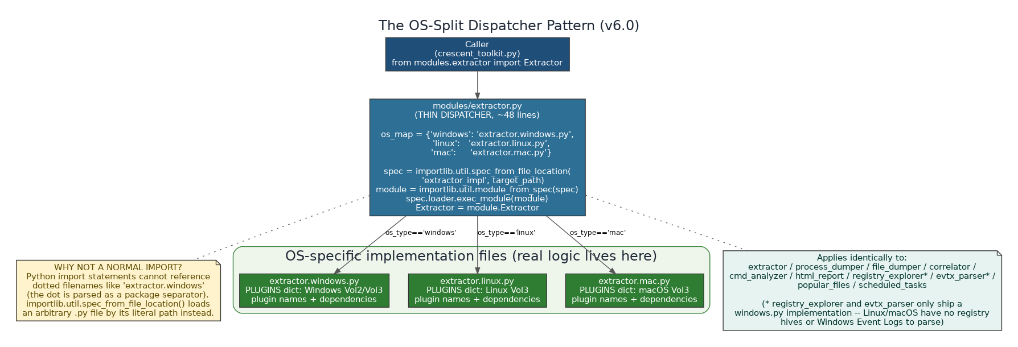
Figure 2.2. The dispatcher pattern, using extractor.py as the example.
The mechanism is deliberately simple. Python's normal import statement cannot resolve a dotted filename like "extractor.windows" as a module path — the dot is parsed as a package/attribute separator, not part of a filename. The dispatcher works around this using importlib.util.spec_from_file_location(), which loads an arbitrary .py file by its literal path instead of by Python's normal module-resolution rules:
# modules/extractor.py (the real, complete dispatcher — 49 lines total)
import importlib.util, pathlib

VALID_MODES = ("fast", "full", "malware", "network", "persistence", "registry")

def _load_os_module(os_type: str):
_DIR = pathlib.Path(__file__).parent
_MAP = {'linux': 'extractor.linux', 'mac': 'extractor.mac'}
name = _MAP.get(str(os_type).lower() if os_type else 'windows', 'extractor.windows')
path = _DIR / (name + '.py')
spec = importlib.util.spec_from_file_location(name, path)
mod = importlib.util.module_from_spec(spec)
spec.loader.exec_module(mod)
return mod

def Extractor(vol, logger, jobs: int = 4, speed: str = 'normal'):
"""Factory: load the OS-specific Extractor and return an instance."""
os_type = getattr(vol, 'os_type', 'windows') or 'windows'
mod = _load_os_module(os_type)
return mod.Extractor(vol, logger, jobs, speed)

Eleven module families follow this exact pattern: extractor, process_dumper, file_dumper, vad_dumper (added in v6.2), correlator, cmd_analyzer, html_report, popular_files, scheduled_tasks, registry_explorer, and evtx_parser. The last two are a special case worth calling out precisely: registry_explorer and evtx_parser only ship a .windows.py implementation, because Windows is the only supported OS with a registry hive format or a Windows Event Log format to parse — the dispatcher still exists for both (a thin ~20-25 line file), but it always resolves to the Windows variant regardless of os_type, since there's nothing for Linux/macOS to dispatch to.
Not every one of the eleven families splits its logic evenly. Direct comparison of the shipped files shows a spectrum:
Family | Lines (win/linux/mac) | How different are they really?
extractor | 524 / 271 / 263 | Substantially different — separate PLUGINS dicts, DEPENDENCIES graphs, and adaptive-job tuning per OS.
process_dumper | 375 / 395 / 342 | Substantially different — separate _KNOWN_TOOLS / _SUSPICIOUS_NAMES / _UNIQUE_PROCS / _EXP_PARENTS constant tables per OS.
file_dumper | 325 / 307 / 144 | Substantially different — Windows filescan+dumpfiles, Linux page-cache RecoverFs/InodePages with format fallback, macOS list_files + the custom pagecache plugin.
correlator | 330 / 347 / 292 | Substantially different — separate _INTEREST_PROCS tuples and per-OS field-name handling for network rows.
cmd_analyzer | 605 / 520 / 533 | Shares one MITRE_TECHNIQUES table (~70 entries) across all three, but each carries its own CMD_PATTERNS regex set (42 Windows / 38 Linux / 44 macOS) and SUSPICIOUS_CHAINS.
html_report | 1,161 / 1,161 / 1,161 | Nearly identical — confirmed by direct diff to differ only in the VERSION string and a handful of cosmetic label/field-parsing differences (e.g. macOS netstat's "name/pid"-format Process field needs its own PID-extraction fallback).
popular_files | 483 / 483 / 483 | Byte-identical across all three files — confirmed directly. All three per-OS bucket tables (_WIN_BUCKETS / _LIN_BUCKETS / _MAC_BUCKETS) are present in every variant file; only the OS actually detected decides which bucket set is used at runtime.
scheduled_tasks | 486 / 486 / 486 | ~97% identical — confirmed by diff. All six _scan_* methods (_scan_registry, _scan_filescan, _scan_processes, _scan_cmdlines, _scan_linux, _scan_mac) are defined in every variant file; only the docstring, which subset scan() actually calls, and the total-count formula differ.
registry_explorer | 538 / — / — | Windows-only; the dispatcher always loads the Windows implementation.
evtx_parser | 411 / — / — | Windows-only; the dispatcher always loads the Windows implementation.

A documentation-accuracy note
The existing v6 architecture notes describe correlator.py as a "cross-platform module, unchanged from v5.0, no split needed." Direct reading of the source shows this is stale: correlator.py is in fact a dispatcher loading correlator.windows.py / .linux.py / .mac.py, each with real per-OS logic (different _INTEREST_PROCS tuples, different network-field extraction). This document describes the code as it actually is.

2.3 Module Tree
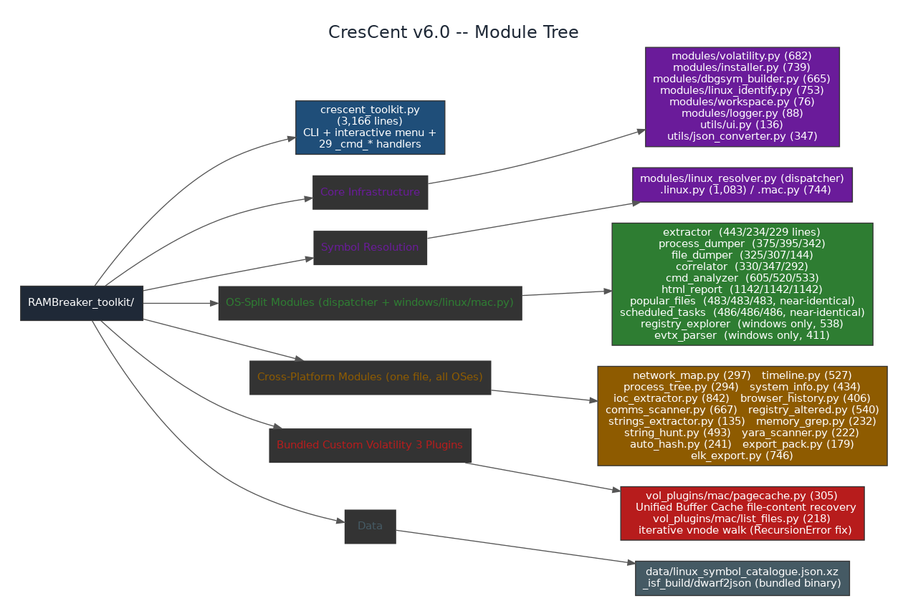
Figure 2.3. Full module tree by category, with line counts.
Every module in the tree above is documented individually in Part V, organized the same way: what it does, exactly which Volatility plugins or JSON files it reads, what it writes, and how (if at all) its behavior changes per OS.

2.4 Core Infrastructure

workspace.py (82 lines)
Redirects all of RAMBreaker's scratch/temp activity away from /tmp (a tmpfs that is typically small, sometimes only a few hundred MB) to ~/Desktop/RAMBreaker_work. This exists because the ISF build pipeline (Part III) can need several gigabytes of scratch space for debug packages and intermediate dwarf2json output, and a full /tmp will silently break that pipeline with out-of-space errors that look nothing like a symbol problem. workspace.setup() is called at the very top of main() before anything else can allocate a temp directory, and new_scratch() hands out fresh subdirectories to callers that need one.

logger.py (88 lines)
RAMBreakerLogger centralizes per-run logging: every _cmd_* handler creates one RAMBreakerLogger bound to the output directory and pulls named sub-loggers (get_logger("EXTRACTOR"), get_logger("CORRELATOR"), etc.) from it, so crescent_toolkit.log ends up as a single, ordered, per-run activity trail across every module involved in that run. A Timer context manager provides a consistent way to log "stage took N seconds" without every module hand-rolling its own timing code.

utils/ui.py (136 lines)
Declares VERSION = "6.2", the ANSI color codes used throughout the interactive menu, the banner() ASCII banner, the msg_info/msg_ok/msg_fail/msg_warn status-line helpers used in every console print statement across the codebase, prompt()/prompt_choice() for interactive input, find_memory_images() (the automatic image discovery used by the menu's [P]ath-or-pick-from-list flow), and format_size()/format_duration() for human-readable output.

utils/json_converter.py (370 lines)
This is the seam between Volatility 2's plain-text, column-aligned output and Volatility 3's native JSON, and it matters more than its size suggests: every analysis module in the codebase reads Volatility output exclusively through this file's functions, so it never has to know which engine actually produced the data.
- parse_vol2_table() dispatches to format-specific sub-parsers: _parse_cmdline (cmdline plugin's simple two-column format), _parse_block_format (block-style multi-line records like hivedump), _parse_hashdump (User:RID:LM:NT lines), _parse_special_table (plugins with irregular layouts), and _parse_std_table (the common case — fixed-width columns, located via _find_column_spans, which detects column boundaries from the header row's whitespace gaps rather than assuming fixed offsets, so it survives minor Volatility 2 version differences in column width).
- load_json_safe() defensively parses a JSON file that may have progress text or partial output mixed in before the real JSON payload — it locates the first '{' or '[' and parses from there, exactly mirroring the same defensive pattern used independently in html_report's _load_json().
- load_json_by_pattern() is the single most-called function in the entire codebase: virtually every cross-platform module loads its input data with load_json_by_pattern(json_dir, "pslist") or similar, which does a case-insensitive substring match against filenames in json/ and returns the first match's parsed rows. This is also where the defensive handling for Volatility 3's exit-code-0-on-failure bug effectively lives at the data layer: a plugin that "succeeded" but produced no real rows simply yields an empty list here, and every downstream module already treats an empty list as a normal, expected state rather than crashing.
- convert_json_to_txt() renders a plugin's JSON rows back out as an aligned text table, used where a human-readable .txt companion to the JSON is still wanted.

2.5 The Volatility Wrapper
modules/volatility.py (779 lines) is the VolatilityWrapper class — the only place in the codebase that actually knows how to invoke vol.py. Every module above it works in terms of "run this plugin against this image," never in terms of subprocess mechanics.

Engine discovery
_find_vol3() / _find_vol2() search a fixed list of conventional install locations (~/Desktop/volatility3, ~/volatility3, /opt/volatility3, ~/tools/volatility3, and the Volatility 2 equivalents) rather than assuming a system-wide install, because analysts frequently keep multiple tool checkouts on their Desktop.

OS auto-detection
auto_detect() runs a four-step chain: it does not simply guess from the file extension. It tries fast raw-byte format/OS signature detection first (see linux_identify.fast_format_detect / raw_os_detect in Part III, which fixed a real bug where an Ubuntu image was being misidentified as macOS because the original detector decoded bytes to a string before scanning, corrupting the comparison), then falls through increasingly expensive checks — including invoking Volatility's own banner-scanning plugins — until it has enough confidence to set both vol.os_type and vol.vol_version. detect_for_os() provides the same detection when the analyst has already told RAMBreaker which OS to expect (Settings [9] Known OS), skipping the parts of the chain made redundant by that hint.

Running plugins
run_plugin() is the common entry point used by every analysis module; internally it dispatches to _run_vol3() or _run_vol2() based on vol.vol_version, and _run_raw() handles the lowest-level subprocess mechanics (stdout/stderr capture, working directory, environment). Two details matter a great deal in practice:
- HEAVY_PLUGINS and _PLUGIN_HARD_CAPS: a fixed tuple of known slow/expensive plugins — sockstat, library_list, lsof, elfs, psaux, netscan, mftscan, vadinfo, handles, dlllist, ldrmodules, proc_maps/proc.Maps and list_files, i.e. the ones that iterate every process, VMA or socket — is given a much larger time budget by _plugin_timeout(): three times the base --timeout, with a floor of 1800 seconds, instead of the single base timeout every other plugin gets. _PLUGIN_HARD_CAPS then overrides that upward multiplier for individual runaway plugins (sockstat is capped at 300 seconds, because it can exceed thirty minutes on a large image while lsof already covers the same open-socket ground).
- check_vol2_compatibility() exists because Volatility 2 profile detection and plugin availability differ meaningfully from Volatility 3's automagic model; this keeps that legacy-engine complexity contained to one file instead of leaking into every analysis module.
See Part IV for how run_plugin() is actually parallelized across an entire extraction pass (adaptive job counts, subprocess-per-plugin, and why Volatility 3's own --parallelism flag is deliberately never used).

2.6 Installer & Dependency Management
modules/installer.py (838 lines) is VolatilityInstaller — the code behind the menu's [I] Installer option and the standalone install command.
- full_status() reports what's currently installed (Vol2, Vol3, their Python dependencies, symbol packages) without changing anything, so an analyst can check environment health before a run.
- install_bundled_plugins() copies RAMBreaker's own custom Volatility 3 plugins (Part V.5) into Volatility 3's plugin directory on every relevant run — not just once at first install. This is the mechanism that makes the custom plugins survive a Volatility reinstall or upgrade: normally, anything placed inside a tool's own directory tree is wiped out the moment that tool is reinstalled, so RAMBreaker treats "are my plugins still present" as something to verify and repair every time, not a one-time setup step.
- _FRAMEWORK_FIXES + apply_framework_fixes(): a second, distinct mechanism for bugs that live inside Volatility 3's own framework files (not in a plugin, so they can't be shipped as a plugin) — these are applied as small, idempotent source patches to the installed Volatility 3 checkout. "Idempotent" matters specifically here: apply_framework_fixes() checks whether a patch is already present before applying it, so running it against an already-patched install is a safe no-op rather than a double-patch or an error.
- ensure_isf_build_tools() confirms dwarf2json is available (either on PATH or the bundled copy in _isf_build/), which the local-build tier of the ISF waterfall (Part III) depends on.
- install_vol3() / install_vol2() and install_vol2_deps() / install_vol3_deps() handle the actual engine and Python dependency installation; download_symbols() fetches Volatility's own Windows symbol cache; install_all() is the single call that runs the full sequence end to end.

Part III — Symbol Resolution Subsystem (Linux / macOS)

3.1 Why This Subsystem Has To Exist
Windows memory forensics gets its structure information ("where is the process list head, what does an EPROCESS look like in this exact build") from Microsoft's own public PDB symbol servers, which Volatility can query automatically. Linux and macOS have no equivalent public symbol service — Volatility 3 instead needs an Intermediate Symbol Format (ISF) file that encodes the exact kernel build's type/offset information, and that ISF has to match the exact kernel version (and often the exact build) that produced the memory image, not just the general OS version. Historically this has meant an analyst manually identifying the kernel build, hunting for a matching ISF online, and building one from scratch with dwarf2json if none exists. RAMBreaker automates this entire process, end to end, and — critically — never trusts a downloaded or built ISF without verifying it actually works against the specific image in hand.

3.2 linux_identify.py (818 lines)
This module owns everything about detecting and caching Linux/macOS symbol state, separate from the resolution waterfall itself (3.3):
- isf_cache_is_warm() / clear_isf_cache() / warm_isf_cache(): Volatility 3 maintains its own SQLite-backed cache of installed ISF identifiers so its automagic can match an image to an ISF quickly. Building this cache from scratch for the first time can take real time when thousands of ISF files are installed; RAMBreaker warms it once, single-threaded, before any parallel verification probes run, specifically to stop later concurrent plugin jobs from racing each other against a half-built cache.
- add_new_isf_to_cache(): after installing a freshly built or downloaded ISF, this registers just that one new file into Volatility 3's cache incrementally (roughly a one-second operation) instead of clearing and rebuilding the entire cache (which can cost minutes once thousands of store files exist). The full clear+rewarm path is kept only as a fallback if the incremental update is unavailable.
- list_installed_isfs() / install_local_isf(): inventory and install ISF files from local paths.
- fast_format_detect() / raw_os_detect(): scan the image's raw bytes directly (not a decoded string) to determine image format and OS. This raw-byte approach exists specifically because the original implementation decoded bytes to a string before scanning, which silently corrupted the comparison and caused at least one real Ubuntu image to be misidentified as macOS — the fix was to compare against raw byte patterns directly and never round-trip through string decoding first.
- extract_linux_banner() / has_vol3_linux_isf(): pull the kernel banner string and check whether a matching Vol3 ISF is already installed.
- detect_linux_profile_vol2_list() / detect_linux_profile_vol2() / looks_linux(): the equivalent detection path for the legacy Volatility 2 engine.
- fetch_available_symbol_names() / update_symbol_catalogue() / search_symbol_catalogue(): manage data/linux_symbol_catalogue.json.xz, a compressed local index of known-available symbol names used to speed up matching without a network round-trip for every lookup.
- kernel_version_from_isf() / install_symbol_by_path(): utility functions used throughout the waterfall.
- run_vol_until_done(): a progress-aware plugin runner used specifically for symbol verification probes. A wrong or absent ISF makes a plugin like pslist fail fast; a correct ISF on a slow machine or a huge image can legitimately take minutes just to build its cache and scan. A fixed timeout cannot tell these two situations apart — it will wrongly abort a slow-but-correct run. run_vol_until_done() instead waits on real progress output and only gives up on a genuine stall, which is what makes the verification step in 3.3 trustworthy on both a fast laptop and a resource-constrained VM.

3.3 The ISF Resolution Waterfall
linux_resolver.py is itself a two-file OS-split dispatcher (linux_resolver.linux.py, 1,189 lines; linux_resolver.mac.py, 744 lines) — direct comparison shows the macOS variant is a meaningfully reduced subset: it has no dbgsym-style official debug-package build path (Apple does not publish an equivalent to Ubuntu ddebs or RHEL debuginfo RPMs), no linux_identify import, and uses a simpler synchronous subprocess check in place of the Linux variant's progress-aware run_vol_until_done. Both share the same overall waterfall shape, entered through resolve_symbols(image, os_type, output_dir):
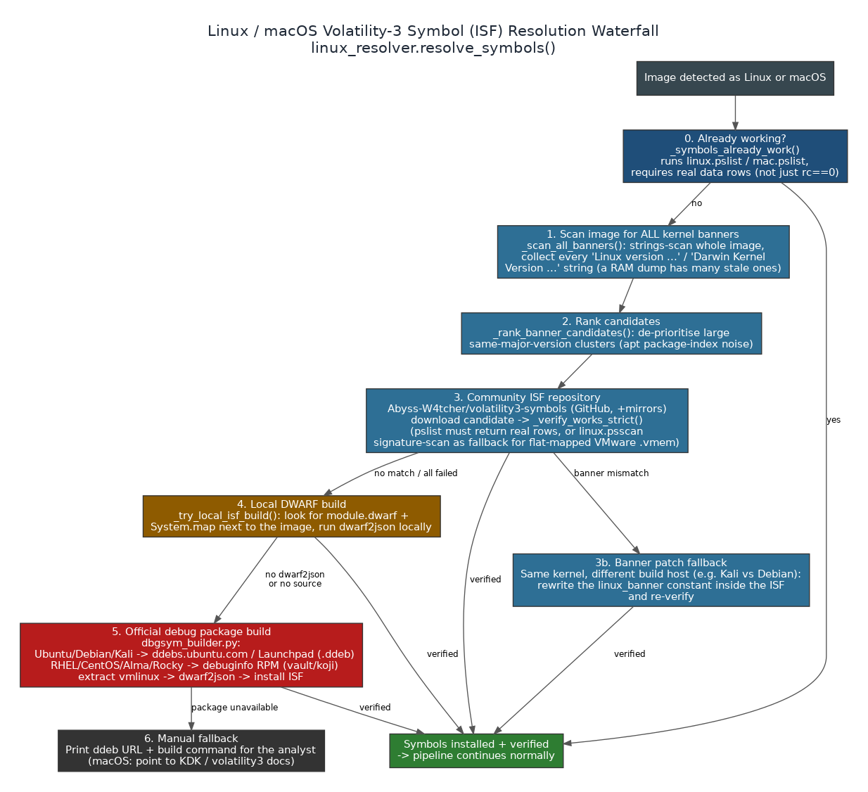
Figure 3.1. The ISF resolution waterfall.
1. Already working? _symbols_already_work() runs linux.pslist.PsList (or mac.pslist.PsList) and requires actual data rows — not just a zero return code, because a wrong or missing ISF can still let pslist exit cleanly while walking zero processes. If pslist returns nothing at all, _scan_finds_processes() cross-checks with linux.psscan.PsScan (a physical-memory signature scan that doesn't depend on the kernel's virtual-to-physical page tables), specifically to catch the case of a VMware .vmem saved without its .vmss/.vmsn companion — that condition maps memory flat and breaks the normal linked-list walk even when the ISF is completely correct.
2. Scan the whole image for every distinct kernel banner. _scan_all_banners() deliberately does not stop at the first "Linux version ..." or "Darwin Kernel Version ..." string found — a real RAM image routinely contains dozens of stale banners left over in apt package indexes or cached documentation, and picking the first one by byte offset reliably grabs the wrong kernel. It collects up to 200 distinct candidates before giving up on an image that turns out to be a banner cache rather than a real memory dump.
3. Rank the candidates. _rank_banner_candidates() sorts by ascending same-major-version cluster size: a cluster of twenty near-identical 4.15.0-* banners is very likely apt package-index noise, while the real running kernel is usually not part of such a cluster. This is purely an ordering optimization — verification in the next step is still the actual ground truth — but it means RAMBreaker tries the most-likely-correct candidate first instead of burning downloads on obvious noise. If more than 25 distinct banners are found, RAMBreaker bails out of automatic detection entirely with an explicit warning, because an image that saturated is almost certainly a banner cache that defeats every content-based heuristic.
4. Try the community ISF repository (Abyss-W4tcher/volatility3-symbols on GitHub, with jsdelivr and an alternate branch as automatic mirrors if the primary is rate-limited or unreachable). _find_isf() matches by exact banner string first, then narrows by kernel-version substring, then disambiguates multiple version matches using architecture keywords found in the ISF's file path — deliberately not the banner text, because i386 kernels are routinely built on amd64 build hosts, so "amd64" can legitimately appear inside an i386 kernel's own banner string. Before trusting a download, _remove_wrong_arch_isf() deletes any previously-installed ISF for the same kernel version whose filename implies the wrong architecture, so a stale wrong-arch file can't keep confusing Volatility's automagic.
5. Verify strictly. _verify_works_strict() is deliberately stricter than step 1's check: it must see real data rows (or a successful psscan fallback) with no 'Unsatisfied requirement' error, and a timeout counts as a failure to confirm here (unlike step 1, where a slow-but-working image should not be penalized). Only a confirmed match is accepted.
6. Patch the banner if it's close but not exact. When a downloaded ISF is installed but fails verification only because of a banner mismatch — the classic case being the same kernel source built by a different distribution or build host, e.g. a Debian-built ISF against a Kali kernel — _patch_isf_banner() rewrites the linux_banner constant stored inside the ISF (a base64-encoded field inside the compressed JSON) to match the image's actual banner, writes a distinctly-named _patched copy, and re-verifies.
7. Fall back to a local DWARF build. _try_local_isf_build() looks for a module.dwarf file (from a linux-image-*-dbgsym package) and a matching System.map sitting in a directory next to the image itself, and if found, runs dwarf2json locally to build the ISF without any network access at all.
8. Fall back to building the ISF from the BTF inside the image itself. Added in v6.2 and placed deliberately BEFORE the debug-package download below: modules/btf2isf.py reconstructs a complete Volatility 3 ISF from the BTF type graph and kallsyms symbol table that a kernel built with CONFIG_DEBUG_INFO_BTF (roughly 5.8 and newer) carries in its own memory. No matching vmlinux, no debug package, no repository lookup and no network access are involved at all — the memory image turns out to be self-describing. This is the tier that answers the four cases every earlier tier structurally cannot: a kernel too new to have an ISF published yet, a kernel too old for its distribution to still host the -dbgsym package, a custom-compiled kernel that was never in any repository, and an analyst working air-gapped. _try_btf2isf_build() in linux_resolver.linux.py is the connector; it returns None when the kernel has no embedded BTF, so a pre-BTF kernel simply falls through to the debug-package tier as before. It is also invoked on the more-than-25-distinct-banners bail-out path, where it is ideal precisely because it reads VMCOREINFO and BTF directly and ignores banner strings entirely — the exact condition that defeats every banner-matching heuristic. Linux only: XNU has no BTF equivalent, so macOS gains nothing here. Full mechanism in Part XIII.
9. Fall back to building from the distribution's OFFICIAL debug package. This is where dbgsym_builder.py (3.4) takes over — downloading and extracting the real debug symbols straight from the distribution's own infrastructure and building the ISF from them.
10. Give up gracefully. If every tier fails, _print_manual_steps() prints the exact ddeb pool URL pattern and the exact dwarf2json build command for the analyst to run by hand, rather than just reporting failure with no path forward. On macOS, the equivalent message points the analyst at KDK symbol generation and the Volatility 3 documentation, since there is no automatic equivalent for Apple's debug symbols.
Every tier that installs a candidate also calls _refresh_isf_cache_after_install() (via linux_identify's incremental cache update, falling back to a full clear+rewarm only if that's unavailable) so the very next Volatility invocation can actually find the ISF it just installed — a detail that matters because a downloaded-but-uncached ISF can otherwise cause a spurious 'Unsatisfied requirement' even though the correct file is sitting right there on disk.
Verification timeouts are not fixed constants either: they scale with image size (roughly 120-600 seconds, computed from the image's size in gigabytes), because the banner may sit late in a multi-gigabyte image and Volatility's own scan needs proportionally more time to reach it.

3.4 dbgsym_builder.py (878 lines)
This module is the "last automatic resort" tier of the waterfall above, and it is split into two independent pipelines because Ubuntu/Debian-family and RHEL-family distributions publish debug symbols in completely different ways:
- Ubuntu/Debian/Kali (.ddeb) pipeline: resolve_dbgsym() queries the Launchpad API and ddebs.ubuntu.com to find the exact -dbgsym .ddeb package for a kernel version and architecture, download_resume() fetches it (resumable, since these can be large), extract_vmlinux() pulls the uncompressed kernel binary out of the package, build_isf() runs dwarf2json against it, install_isf() copies the result into Volatility 3's symbol store, and build_isf_from_dbgsym() orchestrates the whole sequence as one call.
- RHEL/CentOS/AlmaLinux/Rocky (.rpm) pipeline: rhel_debuginfo_urls() locates the matching debuginfo RPM from vault.centos.org / Rocky / AlmaLinux / koji mirrors, extract_vmlinux_from_rpm() pulls the kernel binary out of the RPM, and build_isf_from_rhel_debuginfo() runs the equivalent dwarf2json + install sequence for that family.
_distro_from_banner() in linux_resolver.linux.py decides which of these two pipelines to use, from the kernel banner text: "kali" -> Kali, "debian" -> Debian, a kernel release matching .elN/.fcN or containing "red hat"/"centos"/"almalinux"/"rocky" -> RHEL family (routed to the debuginfo-RPM pipeline, since ddebs cannot serve these), "suse" -> SUSE (flagged as not auto-buildable, since there is no wired pipeline for it), and everything else defaults to Ubuntu — which correctly covers Mint, Pop!_OS, and Elementary as Ubuntu-family distributions too.

3.5 Bring-Your-Own-ISF
An analyst who already has the correct ISF (from a prior engagement, a private symbol store, or a manually completed dwarf2json build) can skip the entire waterfall with --symbol-isf PATH on the CLI, or Settings [9] Known OS -> linux/mac then Settings [T] Symbol table in the interactive menu. This installs and caches the supplied file directly rather than attempting any network resolution.

Part IV — The 8-Step Core Pipeline
_cmd_core() in crescent_toolkit.py is the single function behind every full-analysis mode. CORE, DEFAULT/FULL, ONLY-VOL-PLUGINS/CTF, and RAMBreaker EYE/DFIR are not separate pipelines — they are this exact same 8-step function called with different flags (skip_ioc, a completion label) and, in DEFAULT's and RAMBreaker EYE's case, an extra step appended after it returns.
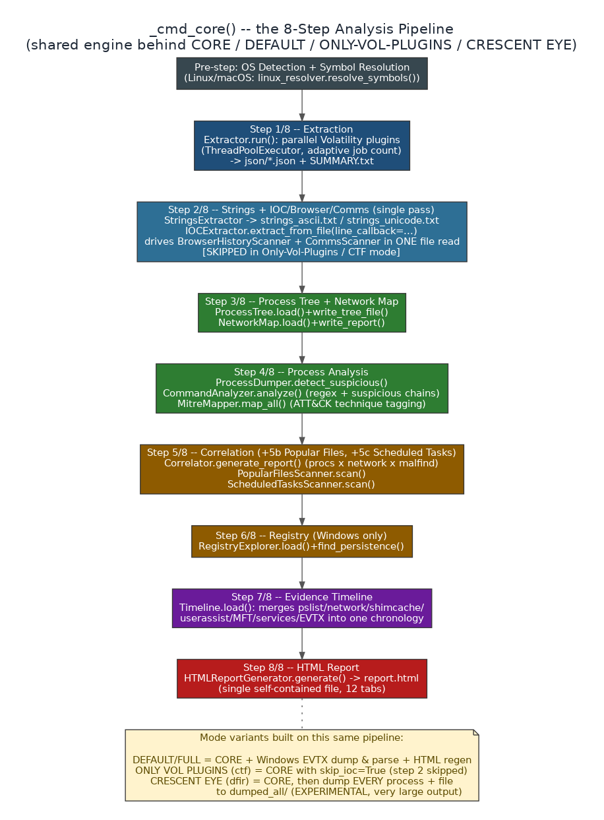
Figure 4.1. The 8-step CORE pipeline.

Pre-step — OS detection and symbol resolution
_init_vol() detects the OS/engine (or applies the analyst's Known-OS hint). If the detected OS is Linux or macOS, _resolve_linux_symbols() runs the entire Part III waterfall before anything else — the extraction step below has separate Linux/macOS plugin lists ready regardless of whether symbols resolved, but obviously returns meaningful data only once they have.

Step 1/8 — Extraction
Extractor.run() (the OS-dispatched module from 2.2 / 5.1) runs the full parallel plugin sweep and writes ext.write_summary(), producing SUMMARY.txt and the entire json/ directory. If extraction produces zero successful plugin results and zero skips, the pipeline stops here rather than continuing to build reports from nothing. Immediately after, SystemInfo.load()/write_report() runs (5.4) so the console output for every later mode can show hostname/users/IPs as early confirmation that the run found something real.

Step 2/8 — Strings + IOC/Browser/Comms (single pass)
Skipped entirely when skip_ioc=True (ONLY VOL PLUGINS / CTF mode). Otherwise: StringsExtractor.extract(image, od, "both") produces strings_ascii.txt and strings_unicode.txt in parallel subprocesses. Then, in one single read of strings_ascii.txt, IOCExtractor.extract_from_file() is given a line_callback that simultaneously feeds BrowserHistoryScanner._process_line() and CommsScanner._process_line() — so three separate scanners' worth of regex matching happens from one pass over the file, not three.

Step 3/8 — Process Tree + Network Map
ProcessTree.load()/write_tree_file() and NetworkMap.load()/write_report(do_dns=False) run against the JSON already on disk from Step 1 — DNS resolution is intentionally skipped here to keep the pipeline fast; it can be re-run on demand with DNS enabled from the standalone tool.

Step 4/8 — Process Analysis
ProcessDumper.detect_suspicious() flags processes against the OS-specific constant tables in 5.1. CommandAnalyzer.analyze() then runs its OS-specific regex sweep and reports flag counts by severity, and MitreMapper.map_all() converts whatever the command analyzer found into ATT&CK technique/tactic counts.

Step 5/8 — Correlation, Popular Files, Scheduled Tasks
Correlator.generate_report() cross-references processes, network connections, and malfind hits. Immediately after (labeled 5b and 5c in the source, not separate numbered steps in the console output), PopularFilesScanner.scan() and ScheduledTasksScanner.scan() run — both are cross-platform-by-file-content modules (5.4) rather than OS-split, so they always run regardless of OS.

Step 6/8 — Registry (Windows only)
RegistryExplorer.load()/write_report()/find_persistence() runs only when vol.os_type == "windows" — Linux and macOS have no registry to analyze here.

Step 7/8 — Evidence Timeline
Timeline.load()/write_report() merges every timestamped source already produced by the steps above (processes, network, ShimCache, UserAssist, MFT, services, and EVTX if present) into one chronological view.

Step 8/8 — HTML Report
HTMLReportGenerator.generate() (Part VI) re-reads everything written by the previous seven steps and produces the single self-contained report.html.

What DEFAULT, ONLY-VOL-PLUGINS, and RAMBreaker EYE add on top
Mode | Built from CORE how
DEFAULT (CLI: full) | Runs _cmd_core() in full, then — Windows images only — dumps every .evtx file found via FileDumper.dump_by_extension(), parses them with EVTXParser, and regenerates the HTML report so the new EVTX data is included.
ONLY VOL PLUGINS (CLI: plugins, alias ctf) | Calls _cmd_core(args, skip_ioc=True, label="ONLY VOL PLUGINS") — identical to CORE except Step 2's strings/IOC/browser/comms scan never runs.
RAMBreaker EYE (CLI: eye, alias dfir) | Runs _cmd_core() labeled "RAMBreaker EYE" first (so detection, symbol resolution, extraction, and the report already exist and SUMMARY.txt is present), then performs a dump-everything acquisition pass that reuses that prior extraction — no re-detection, no re-extraction — writing every process (as a native PE/ELF/Mach-O) and every recoverable file to dumped_all/. Explicitly marked EXPERIMENTAL in the source; --files-first reorders the acquisition to recover file content before the much heavier per-process memory dumps.

Part V — Module-by-Module Reference
Every module below is documented the same way: what it does, exactly where its input data comes from (which Volatility plugins, which JSON files, or which other module's output), what it writes, and how its behavior changes — if at all — per operating system. This is the section to read when the question is "where did this specific number in the report come from."
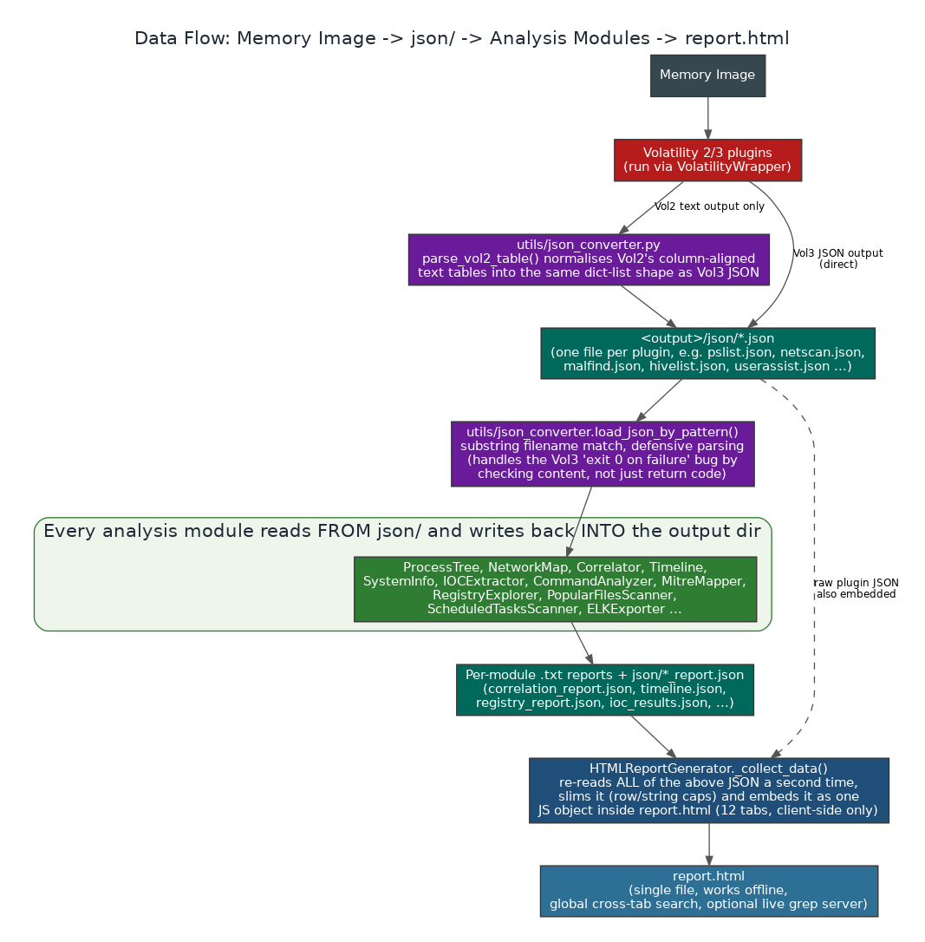
Figure 5.0. How data actually flows from the memory image through json/ into every module below.

5.1 OS-Split Extraction & Dumping

extractor.{windows,linux,mac}.py — 524 / 271 / 263 lines
This is where every raw Volatility plugin actually gets invoked. Each OS variant defines its own PLUGINS dictionary (plugin name -> which VALID_MODES it belongs to: fast / full / malware / network / persistence / registry — see Part II's dispatcher code for the full mode list) and a DEPENDENCIES graph describing which plugins' output another plugin needs before it can usefully run.
- Data source: the raw memory image only, via VolatilityWrapper.run_plugin() (2.5) — this is the one module family that talks to Volatility directly rather than reading JSON someone else produced.
- _adaptive_jobs(): computes how many plugins can run concurrently from the RAM actually available on the analysis machine (see the parallelism model in Part IV / Figure 9 of the companion "Why Unique" document) — this, not a fixed worker count, is what --speed normal/fast/fastest and the Settings [6] Jobs value actually feed into.
- _warm_cache(): on Linux/macOS, ensures Volatility 3's ISF identifier cache (Part III) is warm before the parallel plugin sweep begins, so concurrent plugin subprocesses aren't all racing to build the same cache simultaneously.
- run(): the main extraction loop — submits every plugin for the selected mode to a thread pool (one native subprocess per plugin, never Volatility's own in-process --parallelism), collects each result, and converts Volatility 2 text output to the same JSON shape as Volatility 3 via utils/json_converter.py as it goes.
- Windows-only: _run_targeted_printkey() runs windows.registry.printkey.PrintKey individually against each entry in the persistence-relevant registry key list (Run keys, services, Winlogon, etc. — the same list documented under RegistryExplorer in 5.3), rather than relying on one generic registry dump, because targeted printkey calls are both faster and more complete for the specific keys that matter for persistence hunting. _run_vol2_exclusive() runs a small set of plugins that only exist in Volatility 2 (useful on older Windows images even when Volatility 3 is the primary engine for everything else).
- write_summary(): produces SUMMARY.txt (image path, output path, OS, engine/profile used, plugin success/fail/skip counts) — the file that later standalone CLI invocations read via _init_vol_from_existing() so they don't have to re-detect the image from scratch.
- Output: json/<plugin_name>.json for every plugin that ran, whichever engine produced it.

process_dumper.{windows,linux,mac}.py — 375 / 395 / 342 lines
Loads the process list already extracted to JSON, flags processes worth a second look, and can dump individual processes to disk.
- Data source: json/pslist*.json, json/pstree*.json, json/psscan*.json (already on disk from the Extraction step) — this module reads JSON, it does not call Volatility itself except when actually performing a dump (windows.dumpfiles / equivalent per OS).
- load_processes() / _flatten_pstree(): pstree's native output is a nested parent/child structure; _flatten_pstree() walks it into the same flat PID-keyed shape as pslist/psscan so the rest of the module doesn't need two code paths.
- detect_suspicious(): checks every loaded process against four OS-specific constant tables — _KNOWN_TOOLS_* (recognized legitimate admin/security tools, suppressed from flags), _SUSPICIOUS_NAMES_* (process names that are inherently noteworthy, e.g. living-off-the-land binaries or known implant naming patterns), _UNIQUE_PROCS_* (processes that should only ever appear once — a second instance is itself the signal), and _EXP_PARENTS_* (the expected parent process for a given child — a process whose real parent doesn't match the expected one, or whose parent PID doesn't exist in the process table at all, is flagged as an orphan/parent mismatch, a classic process-injection and masquerading tell).
- search_processes(): free-text search across the loaded process set (name, PID, command line) — the same search logic that backs the interactive menu's process lookups.
- dump_all_processes() / write_suspicious_report(): batch-dump every process to disk (used by RAMBreaker EYE) and write suspicious_processes.txt, the flat-text report consumed both directly by an analyst and by ELKExporter._export_suspicious() (5.4), which re-parses this exact file to build the RAMBreaker-suspicious Elasticsearch index.

file_dumper.{windows,linux,mac}.py — 325 / 307 / 144 lines
The most structurally different of the OS-split families, because recovering file content from memory is fundamentally a different problem on each OS:
OS | Mechanism
Windows | windows.filescan.FileScan enumerates FILE_OBJECTs in memory; windows.dumpfiles.DumpFiles then extracts the actual cached content for a selected object. The interactive menu's File Dumper offers pattern search (by extension, e.g. evtx/exe/dll) and free-text filename search over the filescan results before committing to a dump.
Linux | Uses Volatility 3's linux.pagecache plugin family — RecoverFs (whole-filesystem-style recovery) and InodePages (single-inode page recovery) — with an automatic format fallback between the two depending on what the specific plugin build supports, since this area of Volatility 3 has changed shape across versions.
macOS | mac.list_files.List_Files (Part V.5) enumerates vnodes and paths; RAMBreaker's own custom mac.pagecache plugin (Part V.5) is what actually recovers file content, since Volatility 3 ships no macOS equivalent of dumpfiles/pagecache.RecoverFs at all.

Data source: json/filescan*.json (Windows) or the pagecache/list_files plugin output (Linux/macOS), read via load_json_by_pattern() the same as every other module. Output: dumped_files/ plus a per-dump entry recorded for later hashing (AutoHash, 5.4) and YARA scanning (5.4).

5.2 Correlation & Command Analysis

correlator.{windows,linux,mac}.py — 330 / 347 / 292 lines
Cross-references processes, network connections, and malfind hits into one report — the single most-read file after the HTML report itself for a quick "what actually matters here" pass.
- Data sources (macOS variant shown as the concrete example, since it was read in full during this documentation pass): pslist, pstree, psscan, psaux (process identity and command lines); netscan, netstat, lsof (network — note macOS netstat has no PID column at all, so the correlator extracts the PID from the tail of the Process field's "name/pid" format with a regex instead); malfind (injected-code detections); bash (shell history). The Windows and Linux variants read the OS-appropriate equivalents of each of these (e.g. Windows adds svcscan/hashdump; Linux adds sockstat).
- load_data(): builds an in-memory PID-keyed process map, merging every process source so a process discovered only by psscan (i.e., hidden from the normal pslist walk) is still present and explicitly marked as such.
- _build_ext_conns(): from the merged connection list, filters down to only connections whose remote address is genuinely external — not loopback, not a wildcard placeholder, not private-range.
- _INTEREST_PROCS: a per-OS tuple of process names worth calling out specifically even without any other flag — on macOS this includes osascript/osacompile (AppleScript execution), launchctl, xattr, security, known C2-framework process names (empyre, apfell, mythic, meterpreter, mettle), and common living-off-the-land interpreters and network tools (bash/sh/zsh/fish, python/perl/ruby, curl/wget/nmap, ssh/scp, nc/ncat/socat/netcat).
- _mask_hash(): when hash data is available (Windows hashdump), the correlation report displays a masked form (first and last few characters only) rather than the full LM/NT hash, on the theory that a correlation report is likely to be shared more widely than the raw hashdump JSON it was derived from.
- generate_report(): writes both a human-readable .txt (with explicit sections: processes with network connections, malfind detections, processes of interest, external connections, and — where applicable — bash/shell history) and a parallel .json for the HTML report and ELK export to consume.

cmd_analyzer.{windows,linux,mac}.py — 605 / 520 / 533 lines
Two classes live in this file family: CommandAnalyzer (pattern matching against command lines) and MitreMapper (turning matches into ATT&CK technique/tactic counts).
- Data source: json/cmdline*.json (Windows) or the psaux plugin's Arguments field (Linux/macOS) — i.e., whatever already-extracted command-line text exists in json/, read via load_json_by_pattern().
- MITRE_TECHNIQUES: a single dictionary of roughly 70 technique entries (technique ID, name, tactic) shared identically across all three OS variants — the mapping from "a pattern matched" to "which ATT&CK technique this represents" doesn't need to differ by OS, only the patterns that trigger it do.
- CMD_PATTERNS: the part that does differ by OS — 42 Windows-specific regular expressions (covering things like encoded PowerShell, LOLBin abuse such as certutil/bitsadmin/mshta/rundll32, WMI process creation, and scheduled-task creation via schtasks), 38 Linux-specific patterns (reverse shells via bash/nc/python/perl one-liners, cron/at abuse, LD_PRELOAD injection, base64-piped-to-shell patterns), and 44 macOS-specific patterns (osascript/AppleScript abuse, launchctl persistence, curl-to-shell patterns, xattr quarantine-flag stripping).
- SUSPICIOUS_CHAINS: parent-child command sequences that are individually unremarkable but suspicious in combination (e.g. an Office process spawning a shell that then spawns a download utility) — matched across the process tree rather than a single command line in isolation.
- CommandAnalyzer.analyze() / write_report(): produces the flag list (each flag scoped to one matched pattern and a CRITICAL/HIGH/... severity, per the philosophy in Part I — never a holistic process verdict) plus the suspicious-chain list.
- MitreMapper.map_all() / _compile() / write_report(): consumes CommandAnalyzer's output (or runs its own equivalent scan if called standalone) and produces a technique_count / tactic_count summary plus a full per-technique breakdown — this is what powers the console's "MITRE: N techniques across M tactics" line in Step 4 of the core pipeline.

5.3 Registry & Windows-Only Artifacts

registry_explorer.windows.py (538 lines)
Turns flat printkey/hivelist/userassist/shellbags/shimcache/svcscan rows into a browsable, MemProcFS-style hierarchical registry tree, and is the module specifically responsible for persistence-key hunting.
- Data sources: json/hivelist*.json, userassist*.json, shellbags*.json, shimcache*.json, printkey*.json, svcscan*.json, plus json/printkey_persistence_merged.json — a special file written by the extractor's _run_targeted_printkey() step (5.1), which the loader converts from Volatility 2's raw REG_TYPE line format into the same Key/Value Name/Type/Data dict shape as everything else before merging it in.
- _build_key_tree(): parses every printkey row's Key field into a hive-root (HKLM/HKCU/SOFTWARE/SYSTEM/SAM/SECURITY/NTUSER/USRCLASS/etc.) plus the remaining key path, building a nested {hive: {key_path: [values]}} structure.
- PERSISTENCE_KEYS: roughly two dozen well-known persistence-relevant registry paths (Run/RunOnce/RunServices, Winlogon, Image File Execution Options, AppInit_DLLs, Services, BootExecute, PendingFileRenameOperations, scheduled-task TaskCache, StartupApproved, and more) — find_persistence() matches these against both the flat data and the structured key tree, then deduplicates across the two search passes by a (key, value name, data) signature, specifically filtering out empty "(Default)"-only stub matches that would otherwise be false-positive noise.
- render_tree(): produces the actual ASCII hierarchy (hive -> key path -> value name [type] = data, with last-write timestamps) that appears in registry_report.txt and, unflattened as key_tree, in the HTML report's Registry tab.
- Output: registry_report.txt and json/registry_report.json, containing hives, the full key tree, persistence hits, and a services summary.

evtx_parser.windows.py (411 lines)
Parses .evtx files recovered by the file dumper into individual event records, flagging the ones that matter for security triage.
- Data source: dumped .evtx files under dumped_files/ (found by find_evtx_files(), which understands both Volatility's dump-naming convention for DataSectionObject content and SharedCacheMap cache-only artifacts — the latter are explicitly skipped since they hold no usable event data — plus any file whose magic bytes identify it as an EVTX regardless of its name).
- Two parsing paths: if the python-evtx library is installed, _parse_with_library() gets full, accurate field-level parsing of every event. If it is not installed, _parse_with_strings() falls back to scanning the file with the strings utility and reconstructing event fragments from EventID markers — the module logs an explicit warning that this fallback is lossy (EVTX records are binary XML, and strings cannot meaningfully reconstruct that format), and every event recovered this way is tagged _low_fidelity: true with a _fidelity_note, both in the JSON output and visibly in the report, rather than silently presenting partial data as complete.
- INTERESTING_EVENTS: a fixed table of security-relevant Event IDs spanning Security.evtx (4624/4625 logons, 4688 process creation, 4697/4698 service/task installation, 4720-4776 account and group management, 4768/4769/4776 Kerberos/NTLM), System.evtx (7034-7045 service lifecycle), PowerShell (4103/4104 module and script-block logging, 400/403 engine start/stop), and Sysmon (1/3/7/8/11/13 — process create, network connection, image load, remote thread creation, file creation, registry value set) if Sysmon logs are present.
- Output: evtx_report.txt (security-relevant events highlighted, plus a full Event-ID frequency summary) and json/evtx_report.json — consumed downstream by Timeline (evtx events get merged into the unified chronology) and by the HTML report's dedicated data slot.

registry_altered.py (540 lines — cross-platform file, Windows-focused content)
Distinct from registry_explorer: this module specifically hunts for recently-modified or anomalous registry state, rather than building a general browsable tree.
- Data sources: the same printkey/hivelist/hivescan/userassist/shellbags/shimcache JSON as registry_explorer, loaded independently.
- _find_sensitive_keys() / _SENSITIVE_PATHS: a similar (but independently maintained) list of persistence-relevant paths to registry_explorer's PERSISTENCE_KEYS, matched against every printkey entry.
- _find_recent_writes(): every printkey entry with a parseable timestamp, sorted newest-first and capped at the 100 most recent, so an analyst can see "what changed right before the incident" directly rather than paging through the entire registry dump chronologically.
- _detect_anomalies(): flags hivescan entries that don't appear in hivelist at all (an orphan/unlinked hive found only by a physical-memory pool scan — potentially a hidden or unlinked hive), duplicate hive names appearing more than once in hivelist, and executable file paths (.exe/.dll/.bat/.ps1/.vbs/.js/.cmd/.scr/.hta/.com) found specifically inside a sensitive autorun key's value data.
- Also produces a UserAssist execution timeline and recent ShimCache/ShellBags activity, each independently timestamp-sorted and capped, using the same Vol2/Vol3 dual-format timestamp parser (_parse_timestamp, handling both structured Vol3 fields and Vol2's "Last updated: <date>" embedded-in-value-string format) throughout.
- Output: registry_altered.txt / json/registry_altered.json, with anomalies always listed first as the highest-priority section.

5.4 Cross-Platform Analysis Modules
These fifteen modules behave identically regardless of which OS produced the memory image. Thirteen are genuinely single-file; the remaining two (popular_files and scheduled_tasks) do ship per-OS variant files, but those variants are byte-identical and ~97% identical respectively, so they are documented here rather than in 5.1. What they all share is that their job operates on already-normalized JSON rows (via the _gv() get-value-by-any-of-these-keys helper pattern that recurs, with only minor variation, in nearly every module in this section) rather than on OS-specific plugin mechanics.

network_map.py (297 lines)
- Data sources: netscan/netstat/connscan/connections/sockscan/sockets (Windows + generic), sockstat (Linux Vol3's own field names — Source/Destination Addr/Port rather than Local/Foreign), and lsof socket-type entries (Linux, filtered to SOCK/IPV4/IPV6/UNIX types or paths containing "->").
- _is_private_ip(): classification is done with Python's ipaddress module, not string-prefix matching, specifically so RFC 1918 172.16.0.0/12, link-local 169.254.0.0/16, and CGNAT 100.64.0.0/10 are all correctly recognized as non-external — CGNAT in particular is deliberately treated as internal for forensic triage purposes (a host talking to a 100.64.0.0/10 address is virtually always talking to its own ISP's carrier-grade NAT gateway, not a publicly reachable endpoint), even though IANA itself classifies that range as merely "shared address space" rather than private.
- resolve_dns(): optional reverse-DNS lookup on every distinct external IP, with its own timeout and result cache — deliberately not run during the main pipeline (Step 3 explicitly passes do_dns=False) to keep the automated pipeline fast; available on demand from the standalone Network Map tool.
- Output: network_map.txt / json/network_map.json, grouped both by process and as an external-only view.

process_tree.py (294 lines)
- Data sources: pslist, pstree (flattened via the same recursive-to-flat walk pattern used in HTML report's client-side JS and in process_dumper), psscan, and cmdline (Windows) / psaux (Linux/macOS, used only when no cmdline data exists for a given PID).
- Root/orphan classification: a process is only treated as a true OS root when its PPID is 0/empty (Windows System process, Linux init/systemd). Any other process whose parent PID isn't present in the loaded process set is explicitly tagged as an orphan with the missing PPID recorded — deliberately not rendered identically to a legitimate OS root, because a process whose parent has exited or was hidden is itself forensically interesting and should not look the same as "System."
- render() / render_subtree(): produce the ASCII tree (with [HIDDEN] tags for processes found only via psscan and [ORPHAN — missing PPID N] tags per the above) that appears in process_tree.txt and backs the HTML report's Process Tree tab data.
- Output: process_tree.txt.

system_info.py (434 lines)
The hostname/user/IP/OS-version identification module — deliberately built as nine independent, best-effort extraction strategies rather than one, because no single source is reliably present across every OS and acquisition mode:
Method | Source
_from_windows_info | windows.info.Info JSON (NTBuildLab, NTMajorVersion, Is64Bit, SystemTime) — a no-op on Linux/macOS since the file simply won't exist.
_from_envars | envars plugin — COMPUTERNAME/HOSTNAME, USERNAME/USER/LOGNAME (with a skip-list for generic service accounts), USERDOMAIN/LOGONSERVER, OS/PRETTY_NAME/DISTRIB_DESCRIPTION, and PROCESSOR_ARCHITECTURE/HOSTTYPE/MACHTYPE — works for both Windows and Linux since both plugins emit the same Variable/Value schema.
_from_getsids | windows.getsids.GetSIDs — extracts usernames from user-range SIDs (RID >= 1000), splitting DOMAIN\\User format to also recover the domain.
_from_hashdump | hashdump's User:RID:LM:NT rows — validated by requiring a numeric RID and a plausible username pattern before accepting, specifically to filter out Vol2 banner/error lines that a lenient text parser can otherwise leave sitting in the JSON.
_from_file_paths | Any of filescan / pagecache / lsof / list_files / mac_file — regexes for \\Users\\<name>\\ (Windows/macOS) and /home/<name>/ (Linux) pulled from file-listing plugins that exist in every mode, including the fast plugin subset — this is what lets RAMBreaker recover usernames even from a fast-mode extraction with no registry/envars data at all.
_from_registry_hostname | printkey/registry rows whose value name is ComputerName/ActiveComputerName/hostname.
_from_network | netscan/netstat/connscan/connections/sockstat/lsof local addresses, filtered to real, non-loopback, non-wildcard IPv4.
_from_linux_kernel | json/linux_kernel.json — written directly by linux_resolver.resolve_symbols() (Part III) once symbol resolution completes, giving system_info the exact kernel version/banner for free without re-deriving it.
_from_linux_pslist | PID 1's creation time (init/systemd) as a boot-time proxy, plus a large-virtual-offset heuristic for 64-bit architecture detection.
_from_summary / _from_strings | Final fallbacks: SUMMARY.txt's Profile: line, then a raw scan of the strings output for a COMPUTERNAME= pattern, used only when every structured source above came up empty.

Output: system_info.txt / json/system_info.json, read back by nearly every other report (the HTML report's Summary tab, and the console's "System: hostname | Users | IP" line printed right after Step 1 of the core pipeline).

ioc_extractor.py (842 lines)
The general-purpose Indicator-of-Compromise sweep across the strings output, organized into eight independently enable/disable-able categories and roughly thirty individual regex patterns.
Category | Patterns include
network | IPv4, IPv6, HTTP/HTTPS/FTP URLs, domains (common TLDs plus a deliberately extended modern/C2-relevant TLD list — app/dev/tech/cloud/ai/gg/ly/sh/zip/mov/site/space/live/click/link and more), MAC addresses, UNC paths, HTTP User-Agent strings (including a CobaltStrike/Metasploit-aware pattern).
email | Standard email address pattern.
crypto | Bitcoin legacy and Bech32 addresses, Monero addresses, Ethereum addresses.
credentials | AWS access-key IDs, context-anchored AWS secret keys (deliberately requiring an "aws_secret_key"-style anchor nearby, to avoid matching every 40-character base64/hex blob such as a plain SHA1 hash), PEM private-key headers, SSH public keys, generic API-token and password-in-URL patterns.
encoding | Long base64 runs (60+ chars) and long hex blobs (40+ hex chars) — deliberately excluded from the HTML report specifically (html_report._is_encoding_ioc_name), since these categories are high-volume and low-signal for the interactive view even though they're still written to disk.
filesystem | Windows paths, Unix paths, registry key paths, and executable/script filenames — filtered against a boring-system-DLL list (ntdll.dll, kernel32.dll, etc.) to cut noise.
hashes | MD5/SHA1/SHA256-shaped hex runs, filtered to reject low-character-variety strings (e.g. runs of all-zero or all-f hex) that pass the regex but are obviously not real digests.
commands | Encoded PowerShell, PowerShell download cradles (Invoke-WebRequest/IEX/DownloadString/BitsTransfer), suspicious cmd.exe patterns (certutil -urlcache, bitsadmin /transfer, wmic process call, schtasks /create, reg add), and reverse-shell one-liners (bash -i, nc -e, python/perl/ruby socket one-liners).

Performance: extract_from_file() runs two passes over the strings file. The first is a streaming, O(1)-memory pass that also drives the line_callback used to piggyback BrowserHistoryScanner and CommsScanner (Step 2 of the core pipeline) with zero extra I/O. The second pass splits the same file into byte-aligned chunks (one per CPU core, up to 8) and scans them in a multiprocessing.Pool, since the full IOC regex sweep is CPU-bound enough to benefit from true parallelism rather than threads.
IPv4/IPv6 validation goes further than the regex: _is_valid_ipv4_ioc() classifies the address into classful A/B/C/D/E ranges and only keeps unicast A/B/C addresses (rejecting multicast/reserved/broadcast), while still deliberately keeping private-range addresses as IOC candidates, since internal IPs can matter in memory forensics even though they're filtered out elsewhere (network_map.py) for external-connection triage specifically.
Output: iocs/ioc_<type>.txt (one file per pattern with matches found), iocs/json/ioc_<type>.json, iocs/ioc_results.json (everything combined), and iocs/ioc_summary.txt.

browser_history.py (406 lines)
- Data source: strings_ascii.txt / strings_all.txt / strings_unicode.txt / strings.txt (whichever exists), scanned line by line — this module works purely from memory-resident strings, so it recovers browser activity regardless of which specific browser or version produced it, as long as the relevant strings are still resident.
- Extracts: all URLs (deduplicated, URL-decoded for readability, and filtered against an explicit noise list of XML-schema/W3C/localhost URLs), search-engine queries (Google/Bing/Yahoo/DuckDuckGo/Yandex/Baidu, decoded), file downloads (URLs ending in executable/archive/document extensions), Chrome/Firefox/IE-specific patterns, and eight content categories: social media, email, cloud storage, messaging, file sharing (flagged specifically as a potential exfiltration indicator — pastebin/transfer.sh/mega.nz-style services), suspicious (URL shorteners, .onion/.i2p, ngrok/serveo tunnel services, and keyword hits like exec/eval/mimikatz/cobalt/beacon/meterpreter), and downloads.
- Output: iocs/browser_history.txt and iocs/json/browser_history.json — also read directly by ELKExporter for the RAMBreaker-browser index and by the HTML report's Browser tab.

comms_scanner.py (667 lines)
Thirteen pattern sets — twelve named communication platforms plus one generic OAuth/JWT/API-key category — matched against the same single strings-file pass used by IOCExtractor and BrowserHistoryScanner.
- Platforms: Microsoft Teams (JWT tokens, meeting URLs, tenant IDs, SharePoint links), Discord (user/bot tokens, webhook URLs, invite links, CDN attachment URLs, channel/guild IDs), Zoom (meeting URLs/IDs/passwords, ZAK host tokens), Slack (xoxc/xoxb/xoxp/xoxa/xoxo token variants, webhook and file URLs), Telegram (API ID/hash, bot tokens, t.me links, phone numbers, session files), WhatsApp (web/API URLs, group invites, deep-link phone numbers), Skype, Webex, Signal, Google Meet, VooV/Tencent Meeting, Flock (Flock Team Messaging — URL/token/deep-link/CDN patterns, all anchored to flock.com/flock:// to avoid false matches), and a generic OAuth/JWT/API-key category that isn't tied to any specific product.
- _is_plausible_discord_token(): Discord's token shape is functionally identical to countless unrelated JWTs. Before flagging a match as a genuine (CRITICAL-severity) Discord token, this decodes the token's first dot-separated segment as base64 and confirms it resolves to a plausible Discord snowflake ID (a 17-20 digit decimal), rejecting anything that doesn't — otherwise the CRITICAL Discord-token flag would fire constantly on unrelated application JWTs.
- enrich_from_processes(): cross-references detected apps against the actual running-process list and network connections (an explicit exe-name-to-app map covering teams.exe, discord.exe, zoom.exe/caphost.exe, slack.exe, telegram.exe, whatsapp.exe, skype.exe/skypeapp.exe, webex.exe/webexmta.exe, signal.exe, voovmeeting.exe/wemeetapp.exe, and flock.exe/'Flock Helper' process names), so the report can show not just "a Slack token was found in memory" but "and Slack was actually running, PID N, with these network connections."
- Output: comms_report.txt / json/comms_report.json plus comms/<app>_<category>.txt per-artifact-type files, with token/secret/credential/password values partially masked in the main report (full values remain in the per-type file) and explicitly marked [!!! CRITICAL] where the category name implies a token/secret/key/password/credential.

popular_files.{windows,linux,mac}.py — 483 / 483 / 483 lines
Scans recovered file listings for activity in the locations a human actually uses — Desktop, Downloads, /tmp, and equivalents — as opposed to the enormous volume of OS/application-internal file noise a full filesystem listing contains.
- Confirmed byte-identical across all three OS variant files: all three per-OS bucket definitions (_WIN_BUCKETS, _LIN_BUCKETS, _MAC_BUCKETS) exist in every one of the three files; an internal _detect_os() heuristic decides which bucket set actually applies to the data at hand, rather than the dispatcher's os_type deciding it externally.
- Data sources: filescan (Windows), pagecache/lsof (Linux), list_files (macOS) — whichever file-listing plugin output exists.
- _is_noise_file() / _NOISE_RE: filters out default system clutter (desktop.ini, NTFS metadata files, and equivalents) so the bucket counts reflect files a user actually put there, not filesystem furniture.
- _check_suspicious(): flags executables found inside user-facing directories (Desktop/Downloads/temp), and paths matching a suspicious-location pattern set, as separate callouts from the general bucket breakdown.
- Output: iocs/popular_files.txt / iocs/json/popular_files.json, with per-bucket file counts, top filenames, and top extensions — this is the data behind the HTML report's Popular Files tab (menu option [19]).

scheduled_tasks.{windows,linux,mac}.py — 486 / 486 / 486 lines
Confirmed ~97% identical across all three variant files by direct diff: every one of the six scan methods (_scan_registry, _scan_filescan, _scan_processes, _scan_cmdlines, _scan_linux, _scan_mac) is defined in all three files — including, for example, _scan_linux and _scan_mac methods sitting present-but-unused inside the "windows" variant. Only the docstring header, which subset of those six methods scan() actually calls for that OS, and the total-findings-count formula differ between the three files.
- Windows sources: registry TaskCache keys, filescan hits for Task Scheduler XML/job files, process and command-line matches against scheduler-related binaries.
- Linux sources: cron/at-related process and command-line evidence, plus environment-variable matches.
- macOS sources: launchd-related process, path, and command-line evidence.
- Output: scheduled_tasks.txt / iocs/json/scheduled_tasks.json, broken into registry_tasks, file_tasks, task_processes, suspicious_commands, linux_cron, and mac_launchd — the HTML report's Scheduled Tasks tab (menu option [17]) renders each of these as its own table.

strings_extractor.py (135 lines)
Runs the strings utility against the raw image. In "both" mode (the mode the core pipeline always uses), ASCII and Unicode (UTF-16LE, strings -el) extraction run as two simultaneous subprocesses rather than sequentially, for roughly a 2x speedup on the slowest single step in the whole pipeline, then combines both outputs into strings_all.txt afterward. Output: strings_ascii.txt, strings_unicode.txt, strings_all.txt — the shared input to IOCExtractor, BrowserHistoryScanner, and CommsScanner.

memory_grep.py (232 lines)
A general-purpose search tool over already-dumped files and processes (dumped_files/, dumped_processes/) — runs strings first on binary content, then greps the result for a literal term or regex with configurable context lines, either against a single file, a whole directory (optionally filtered by extension), or every dumped artifact from a prior run at once.

string_hunt.py (493 lines)
Unlike memory_grep, this searches the live memory image directly, not previously-dumped files, and reports which process's address space each hit lives in — genuinely useful when the analyst doesn't yet know which process to dump.
- Mechanism: builds a temporary YARA rule from the operator's search terms and runs it through the OS-appropriate Volatility 3 per-process scanner — windows.vadyarascan.VadYaraScan (per-process VAD scan) on Windows, linux.vmayarascan.VmaYaraScan (per-process VMA scan) on Linux, or the physical-memory yarascan.YaraScan on macOS (Volatility 3 has no per-process VMA-aware YARA scanner for macOS) — with a Volatility 2 yarascan fallback for the legacy engine.
- Also greps any already-extracted strings_ascii.txt/strings_unicode.txt as a fast supplementary count (with no process attribution, clearly labeled as such), so a hit that isn't found in the live per-process scan (e.g. because it's outside any mapped VAD) can still surface.
- Output: string_hunt.txt / json/string_hunt.json, grouped by search term and by process, with hex-decoded context around each hit.

yara_scanner.py (222 lines)
Runs arbitrary YARA rule files (.yar/.yara, auto-discovered from common locations like ./yara_rules, ~/yara-rules, /opt/yara-rules, or supplied explicitly) against dumped_files/ and dumped_processes/ using the system yara binary. Distinct from string_hunt.py: this operates on already-dumped artifacts with pre-written rule files, rather than building an ad-hoc rule from live search terms against the raw image.

auto_hash.py (241 lines)
Computes MD5 and SHA256 for every file in dumped_files/ and dumped_processes/, writing hashes.csv (formatted specifically for bulk upload to VirusTotal's web UI), hashes.txt, and hashes.json. An optional VirusTotal API lookup path exists (check_virustotal / check_virustotal_bulk) with a hard-coded 16-second minimum interval between calls to stay under the public API's 4-requests-per-minute limit, and explicit HTTP 429 handling that backs off a full 60 seconds rather than hammering an already-rate-limited endpoint.

export_pack.py (181 lines)
Bundles a fixed list of the highest-value human-readable artifacts (report.html, hashes, timeline, every IOC file, correlation/registry/network-map/scheduled-tasks/popular-files reports, EVTX, SUMMARY.txt, and the run log) into a single zip with a generated MANIFEST.txt listing every included file and its size — built specifically so a team lead receiving the zip doesn't need to know which of the dozens of output files in a full case directory actually matter.

elk_export.py (746 lines)
Converts a completed case into Elasticsearch bulk-import NDJSON, one file per index, entirely by re-reading the JSON/report artifacts every other module already produced — this module creates no new analysis of its own.
Index | Rebuilt from
RAMBreaker-processes | pslist + psscan (hidden-process detection: present in psscan but absent from pslist) + cmdline.
RAMBreaker-network | netscan/netstat/connscan/connections/sockscan/sockets/sockstat, with an is_external flag computed the same way as network_map.py.
RAMBreaker-timeline | json/timeline.json, verbatim.
RAMBreaker-iocs | iocs/ioc_results.json plus any ioc_*.txt file not already represented in the JSON.
RAMBreaker-malfind | the malfind plugin's rows.
RAMBreaker-services | svcscan.
RAMBreaker-registry | json/registry_report.json's persistence/userassist/shimcache/shellbags sections.
RAMBreaker-evtx | json/evtx_report.json, with the _description/_interesting internal fields promoted to plain event_description / is_security_relevant fields.
RAMBreaker-files | filescan (Windows), or a lsof/list_files fallback for Linux/macOS filtered to real files (excluding sockets/pipes).
RAMBreaker-browser | iocs/json/browser_history.json (URLs, categorized, plus search queries).
RAMBreaker-suspicious | a re-parse of suspicious_processes.txt into structured documents.

Also writes import_to_elk.sh, a generated shell script that bulk-imports every produced NDJSON file with one command (curl ... --data-binary), reports per-index success/error status by parsing Elasticsearch's own bulk-response JSON, and prints suggested next steps for setting up the matching Kibana index pattern.

5.5 Custom Volatility 3 Plugins
Two plugins, bundled inside vol_plugins/mac/ and re-installed into the live Volatility 3 checkout on every run by installer.install_bundled_plugins() (2.6), so they survive a Volatility reinstall or upgrade rather than being silently deleted by one.

mac.list_files (218 lines)
Enumerates every reachable vnode across every mounted filesystem, producing (offset, full path) pairs — the macOS equivalent of Windows filescan, but for the XNU vnode/mount-point model rather than Windows' FILE_OBJECT model.
- _walk_mounts(): iterates every mount via mount.Mount.list_mounts(), then walks each mount's mnt_vnodelist, mnt_workerqueue, and mnt_newvnodes tail-queues plus the mount's own covered/root/device vnodes.
- _walk_vnode(): the method that was rewritten for v6. The original implementation recursed once per parent directory level while building each vnode's full path, which overflows Python's interpreter recursion limit (RecursionError) on images with a deep or unusually large vnode graph. The v6 rewrite replaces that recursion with an explicit work stack (a plain Python list used as a LIFO queue) — functionally identical output, deduplicated the same way by vnode offset, but with no depth limit at all.
- _build_path(): reconstructs a full path from the parent-offset chain recorded by the walk, with its own circular-reference guard (a vnode graph corrupted by memory smear can otherwise loop forever trying to resolve a parent chain).

mac.pagecache (305 lines)
The plugin that does not exist upstream: recovers actual file content from the macOS Unified Buffer Cache, something Volatility 3 has never shipped a macOS equivalent for (windows.dumpfiles and linux.pagecache.RecoverFs are the closest analogues on the other two OSes).
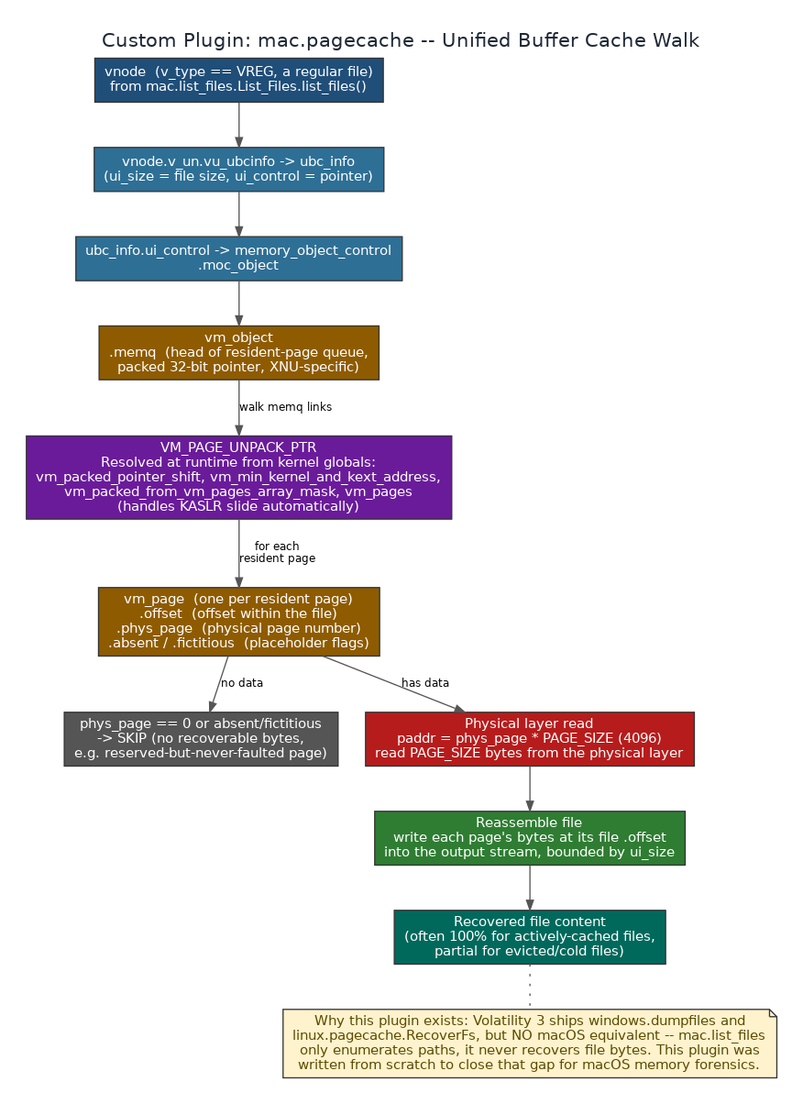
Figure 5.1. mac.pagecache's structure walk, in full.
- The structure chain: for each regular-file vnode (from mac.list_files), _vnode_vm_object() follows vnode.v_un.vu_ubcinfo (the Unified Buffer Cache info struct, which carries the file's real size in ui_size) to ubc_info.ui_control (a memory_object_control) to that object's moc_object, which is the actual vm_object holding the file's cached pages.
- _load_packing() / _unpack(): XNU packs the vm_object's resident-page queue (memq) links into 32-bit values rather than full pointers. The plugin resolves the kernel's own runtime packing constants — vm_packed_pointer_shift, vm_min_kernel_and_kext_address, vm_packed_from_vm_pages_array_mask, and the vm_pages array base — by reading them as kernel globals at analysis time (via kernel.get_absolute_symbol_address()), which means KASLR is handled completely transparently: the plugin never needs a manually-supplied slide value.
- _iter_pages(): walks the unpacked memq linked list of vm_page structures, with a generous but finite iteration cap purely as a guard against a corrupted/looping chain in a partial image, never expected to be hit on a healthy object.
- _page_has_data(): a resident page only holds recoverable bytes if it isn't marked absent or fictitious and its phys_page is nonzero — XNU keeps placeholder pages (reserved-but-never-faulted, or already-evicted) sitting in the same memq with no real backing memory, and the plugin must skip those rather than trying to read garbage.
- _read_page() / _write_content(): for every page that does hold data, reads PAGE_SIZE (4096) bytes from the physical layer at phys_page * PAGE_SIZE and writes them at the page's recorded file offset into the output stream, bounded by the file's real size (ui_size) — reassembling as much of the original file as is still resident in memory, which for an actively-used file is very often the entire thing.
- Verified results: proof-of-concept testing against a real macOS 10.12.6 memory image recovered genuine file content — including SystemVersion.plist, dyld, GlobalPreferences.plist, and AddressBook data — directly from cached memory pages with this exact mechanism.
- Plugin options: --dump actually writes recovered content to disk (without it, the plugin just reports what's recoverable and how many bytes); --name filters to paths containing a given substring (comma-separated for an OR match).

Part VII — Cross-Cutting Design Patterns
Reading enough of this codebase surfaces the same handful of idioms over and over, in module after module, regardless of which OS or which analysis domain. Recognizing them makes any new module in this codebase readable in minutes rather than hours, so they're documented here as a set rather than repeated piecemeal in every module description above.

7.1 The _gv() Get-Value Pattern
Nearly every module that reads plugin JSON defines a small local helper, typically named _gv(item, *keys), that tries a list of candidate field names in order — exact match first, then a case-insensitive fallback — and returns the first one present. This one idiom is what lets the exact same downstream code handle Volatility 2's field names, Volatility 3's field names, and the small variations between Volatility 3 plugin versions, all without a single OS or engine check anywhere in the calling code:
def _gv(item, *keys):
for k in keys:
if k in item:
return item[k]
lower_map = {str(k).lower(): k for k in item}
for k in keys:
lk = str(k).lower()
if lk in lower_map:
return item[lower_map[lk]]
return None

# Typical call site (network_map.py) — one line handles every engine/plugin variant:
local = _gv(n, "LocalAddr", "Local Address", "LocalAddress", "Local IP", "Source Addr", "Source")

This is also precisely why the module-by-module reference in Part V repeatedly lists several candidate field names per data point instead of one — those aren't alternatives the documentation is unsure about, they are the literal, exhaustive list of column-name variants the code itself checks for.

7.2 load_json_by_pattern() As The Universal Data Bus
Every cross-platform module and every OS-split module's non-Volatility-facing half reads its input the same way: load_json_by_pattern(json_dir, "substring"), which case-insensitively matches plugin filenames and returns parsed rows, or an empty list if nothing matches. Because this single function is the only way data crosses from json/ into any analysis module, the Vol3 exit-code-0 bug (Part VII, item 1) is neutralized at exactly one choke point: a plugin that technically "succeeded" but wrote no real data simply produces an empty match here, and every module downstream of it already has to handle "no data for this source" as a normal, expected branch — there is no special case anywhere for "the plugin lied about succeeding" because the data layer makes that distinction invisible to everything above it.

7.3 Defensive JSON Loading, Twice, Independently
Two different modules — utils/json_converter.py's load_json_safe() and html_report's own _load_json() — independently implement the same defensive pattern: strip the text, find the first '{' or '[' character, and parse JSON starting from there, discarding anything before it. Both exist because Volatility (particularly Volatility 2, and Volatility 3 under certain verbosity settings) can emit progress text or banner lines before its actual JSON/data payload, and a naive json.loads() on the raw file content would throw on that leading text. Rather than trying to suppress Volatility's own console output at the source (which is engine-version-dependent and fragile), RAMBreaker tolerates it at every consumption point instead.

7.4 Placeholder Timestamp Filtering
Timeline.py, registry_altered.py, and system_info.py all independently filter out the same family of placeholder timestamps before treating a date field as real evidence: 1601-01-01 (the Windows FILETIME epoch — a zeroed timestamp field, not a real event), 1970-01-01 (the Unix epoch, same meaning), 1980-01-01 (the FAT filesystem epoch, which surfaces in some MFT records), and 0001-01-01 (.NET's DateTime.MinValue). Without this filter, every module that sorts or displays timestamps would show large numbers of events that all appear to have happened at the exact same moment at the dawn of one of these epochs — which is noise, not evidence, and would actively mislead a timeline reconstruction.

7.5 Vol2 Noise-Row Suppression
Volatility 2's text-output parser can leave banner or error lines like "*** Failed to import ..." sitting inside otherwise-valid JSON as a {"raw": "*** ..."} row. Both the Python report generators (correlator, registry_explorer) and the HTML report's own client-side JavaScript (isNoiseRow()) independently recognize and filter this exact ^\*\*\*\s pattern before counting or displaying rows, so a Vol2-sourced report's row counts reflect actual data, not parser artifacts.

7.6 Hash and Secret Masking In Human-Facing Reports
Correlator's _mask_hash() (LM/NT hashes) and CommsScanner's report writer (tokens, secrets, API keys, passwords) both apply the same principle independently: a report intended for broad human review shows a masked form (first few and last few characters, with the middle elided), while the full, unmasked value remains available in the narrower, purpose-specific artifact (json/hashdump*.json, or comms/<app>_<category>.txt) that a smaller audience is expected to consult. The masking is cosmetic, not a security control — the full data is one file away — but it keeps a widely-shared correlation report or comms summary from casually leaking credential material to everyone who glances at it.

7.7 Explicit, Visible Degradation Instead Of Silent Failure
Every fallback path in the codebase that produces lower-quality output says so, in the output itself, rather than presenting degraded data as if it were complete: EVTXParser's strings-based fallback tags every recovered event _low_fidelity: true with a human-readable _fidelity_note; linux_resolver prints an explicit warning and the manual ddeb/build instructions when automatic ISF resolution fails outright rather than just returning False; html_report's collection_errors list surfaces exactly which JSON files failed to load and why, instead of quietly omitting them from the report with no trace. This is the same underlying philosophy as Part I's "evidence, not verdicts" principle applied to the tool's own reliability: RAMBreaker is willing to tell the analyst its confidence is lower here, but never willing to hide that fact.

Part VIII — Performance & Operational Characteristics

8.1 Where Time Actually Goes
In a typical CORE/DEFAULT run, the two most expensive steps by a wide margin are the Volatility extraction pass (Step 1) and, when it isn't skipped, the strings extraction inside Step 2 — both are dominated by raw I/O over a multi-gigabyte image rather than CPU-bound analysis logic. Every parallelism and timeout mechanism in the codebase is aimed specifically at those two steps.

8.2 Three Independent RAM/Time Tradeoff Knobs
Knob | Where it lives | Effect
--speed {normal,fast,fastest} | Extractor._adaptive_jobs(), consulted by both the standalone Extractor and every pipeline mode | normal keeps a RAM guard active and scales concurrent plugin subprocesses down conservatively; fast tightens the assumed per-job RAM budget to allow more concurrent jobs; fastest removes the RAM guard entirely and maximizes concurrency — explicitly documented as needing 16+ GB of RAM to be safe.
--jobs / -j (2-16) | Passed straight through to the ThreadPoolExecutor's max_workers, but still bounded by the adaptive/heavy-plugin logic below it | A ceiling on parallelism, not a guarantee of it — the adaptive scaler and per-plugin hard caps can still run fewer jobs than requested if RAM or a specific heavy plugin's own cap says otherwise.
HEAVY_PLUGINS / _PLUGIN_HARD_CAPS (modules/volatility.py) | A fixed table inside VolatilityWrapper, independent of the two knobs above | The heavy plugins (sockstat, lsof, psaux, netscan, mftscan, vadinfo, handles, dlllist, ldrmodules, elfs, library_list, proc.Maps, list_files) get 3x the base timeout with an 1800 s floor, and _PLUGIN_HARD_CAPS caps individual runaway plugins on top of that (sockstat at 300 s) — so one pathological plugin cannot hold the whole batch open indefinitely.

8.3 Timeouts That Scale With The Work, Not Fixed Constants
- Per-plugin extraction timeout: _plugin_timeout() in modules/volatility.py budgets by plugin cost rather than giving every plugin the same number — the HEAVY_PLUGINS set gets 3x the base --timeout with an 1800-second floor, while _PLUGIN_HARD_CAPS caps individual runaway plugins (sockstat at 300 s). Note this axis scales with the plugin, not the image; it is the ISF verification timeout below that scales with image size.
- ISF verification timeout: linux_resolver's per-candidate verification timeout is computed as roughly min(600, max(180, image_size_in_GB * 120)) seconds — a kernel banner sitting late inside a large image needs proportionally more scan time before Volatility can even reach it, and a fixed short timeout would wrongly reject a correct ISF on a large image purely because the scan hadn't gotten far enough yet.
- Symbol-verification "is it actually working" probes use a progress-aware runner (linux_identify.run_vol_until_done()) rather than any fixed timeout at all for the lenient first-pass check — it distinguishes a genuinely stalled process from one that is slowly, correctly, still making progress, and only the strict post-download verification step (which must discriminate between candidate ISFs, not just tell working from stalled) uses a bounded timeout, scaled by image size as above.

8.4 Single-Pass I/O Where It's Cheap To Arrange
Two places in the codebase specifically avoid re-reading a large file multiple times: strings_ascii/unicode extraction runs as two simultaneous subprocesses instead of two sequential ones (roughly halving wall-clock time for that step), and the strings-file evidence sweep drives IOCExtractor, BrowserHistoryScanner, and CommsScanner from one shared streaming pass via a line_callback rather than three independent full-file reads. Both are small mechanical changes with an outsized effect specifically because the file involved is often gigabytes in size.

8.5 Why Subprocess-Per-Plugin, Never In-Process Threads
This is worth restating precisely because it is easy to assume the opposite is faster: Volatility 3 exposes --parallelism threads for in-process parallel plugin execution, and RAMBreaker deliberately never uses it. Running multiple plugins inside one Volatility process shares mutable framework/context state between them, and that sharing corrupts results in ways that don't always fail loudly — a plugin can complete and report success while quietly returning wrong data. A full separate subprocess per plugin costs more process-startup overhead but guarantees each plugin gets a clean interpreter and its own memory space, which is the actual source of RAMBreaker's parallelism (Extractor.run()'s ThreadPoolExecutor manages the subprocess pool; the parallelism is at the OS process level, not inside any one Python interpreter).

Part IX — A Worked Example Run
This section walks one real invocation end to end, quoting the pipeline's own console output verbatim, so the abstract step descriptions in Part IV can be seen against what actually prints on screen during a run.
$ python3 crescent_toolkit.py full -i case1042.raw -o ./case1042/

[banner + separator line]
[+] Image: case1042.raw
[+] Output: ./case1042/
[+] Mode: full Engine: vol3 Jobs: 4
[separator line]

[*] Step 1/8: Running Volatility plugins (parallel)...
[+] Extraction: 41 OK, 2 failed
[+] System: DESKTOP-7QX2 | Users: jsmith, Administrator | IP: 10.0.2.15

[*] Step 2/8: Extracting strings...
[+] Strings done
[*] IOC + Browser + Comms scan (single pass)...
[+] Browser: 214 URLs, 12 searches, 3 downloads
[+] Comms: 6 artifacts from [teams, slack]

[*] Step 3/8: Building process tree...
[+] Process tree built
[*] Building network map...
[+] Network map: 37 connections, 4 external IPs

[*] Step 4/8: Analyzing processes...
[+] Processes: 118 total, 3 flagged
[*] Analyzing command lines...
[!] Commands: 5 flags (2 CRITICAL, 3 HIGH), 1 suspicious chains
[*] Mapping to MITRE ATT&CK...
[+] MITRE: 4 techniques across 3 tactics

[*] Step 5/8: Correlating findings...
[+] Correlation report done
[*] Popular files scan (Desktop/Downloads/tmp/etc)...
[+] Popular files: 342 scanned, 6 suspicious, OS=windows
[*] Scanning for scheduled tasks / cron / launchd evidence...
[+] Scheduled tasks: 2 findings (Win registry=2, Linux cron=0, macOS launchd=0)

[*] Step 6/8: Analyzing registry data...
[+] Registry: 6 hives, 9 persistence hits

[*] Step 7/8: Building evidence timeline...
[+] Timeline: 1,884 events

[*] Step 8/8: Generating HTML report...
[+] HTML report: case1042/report.html

[+] FULL ANALYSIS COMPLETE
[*] Duration: 4m 12s
[*] Engine: vol3
[*] Results: ./case1042

[*] Dumping .evtx files... (DEFAULT mode's extra step, after CORE completes)
[+] EVTX: 3 files dumped
[*] Parsing EVTX files...
[+] EVTX: 2,204 events, 47 security-relevant
[*] Regenerating HTML report with EVTX data...
[+] HTML report updated
[+] DEFAULT ANALYSIS COMPLETE

Every line above corresponds to a specific, named function call documented in Part IV and Part V: "Extraction: 41 OK, 2 failed" is Extractor.run()'s return dict rendered by _cmd_core(); "Commands: 5 flags (2 CRITICAL, 3 HIGH)" is CommandAnalyzer.analyze()'s flags list, filtered by severity; "MITRE: 4 techniques across 3 tactics" is MitreMapper.map_all()'s technique_count/tactic_count. Nowhere in this output does the tool render an overall verdict about the image, the case, or any individual process — consistent with the philosophy in Part I, every line is either a count of something concrete or a pointer to a specific report file where the analyst can see the underlying evidence directly.
At this point, ./case1042/ contains everything documented in Appendix C, and an analyst would typically open report.html next, starting on the Summary tab and following the global search or the Correlation tab toward whatever the initial triage priorities are for this case.

Part VI — The HTML Report
html_report.{windows,linux,mac}.py (1,161 lines each) generates report.html. Direct diff across the three OS variants shows they are effectively one file: the only differences are the VERSION string ("6.0-windows" / "6.0-linux" / "6.0-mac"), a couple of cosmetic label differences in the process-tree rendering ("cmd:" vs "command:" vs "cmdline:"), and — the one behaviorally meaningful difference — the macOS variant's processBundle() has an extra PID-extraction fallback for netstat rows, because macOS netstat has no dedicated PID column at all and instead embeds it as a "name/pid" suffix on the Process field.

6.1 How The Report Is Built (Python side)
- _collect_data(): reads a fixed set of "root" JSON artifacts by key (system_info, correlation, browser, network_map, registry, timeline, evtx, comms, popular_files, scheduled_tasks), then walks every *.json file in json/ generically (each becomes a named plugin entry with its rows pre-normalized), then every *.json under iocs/json/ (with encoding-category IOCs explicitly excluded per _is_encoding_ioc_name — base64/hex/encoded/encoding/blob are deliberately left out of the interactive report even though they remain on disk), then any other root-level JSON not already claimed. Files with "strings"/"ascii"/"unicode" in the name are excluded everywhere via _is_allowed_json_file() — the report is explicitly documented as JSON-only.
- _normalize_rows(): the same normalize-anything-to-a-list-of-dicts logic used throughout the codebase (list -> as-is; dict with a rows/data/items/results/records/values key -> unwrap that; dict with parallel columns/rows arrays -> zip them into named dicts; a nested children tree -> flattened by walking it) so every downstream page can just call rows() without caring which shape the source JSON originally had.
- _slim_for_html(): the safety layer that keeps report.html from becoming unopenable. In normal mode it caps embedded lists at MAX_EMBED_ROWS (1,500 by default, adding an explicit "_RAMBreaker_note" truncation marker rather than just silently cutting data), caps individual strings at MAX_EMBED_STRING_CHARS (600 by default, with a visible truncation marker and character count), and caps dict keys at MAX_EMBED_DICT_KEYS (80). An explicit --embed-all-json flag disables every one of these caps entirely (EMBED_ALL_JSON = True), intended for an analyst who deliberately wants the complete dataset embedded and accepts the resulting file may be very large and slow.
- Error handling: every JSON load failure is caught individually and recorded (stage, file, error) rather than aborting the whole report — the finished report.html includes a collection_errors list, and the CLI runner prints up to the first ten with a pointer to the full debug log for the rest, so a single malformed plugin JSON file never prevents the other forty from being reported on.

6.2 The Thirteen Tabs (browser side)
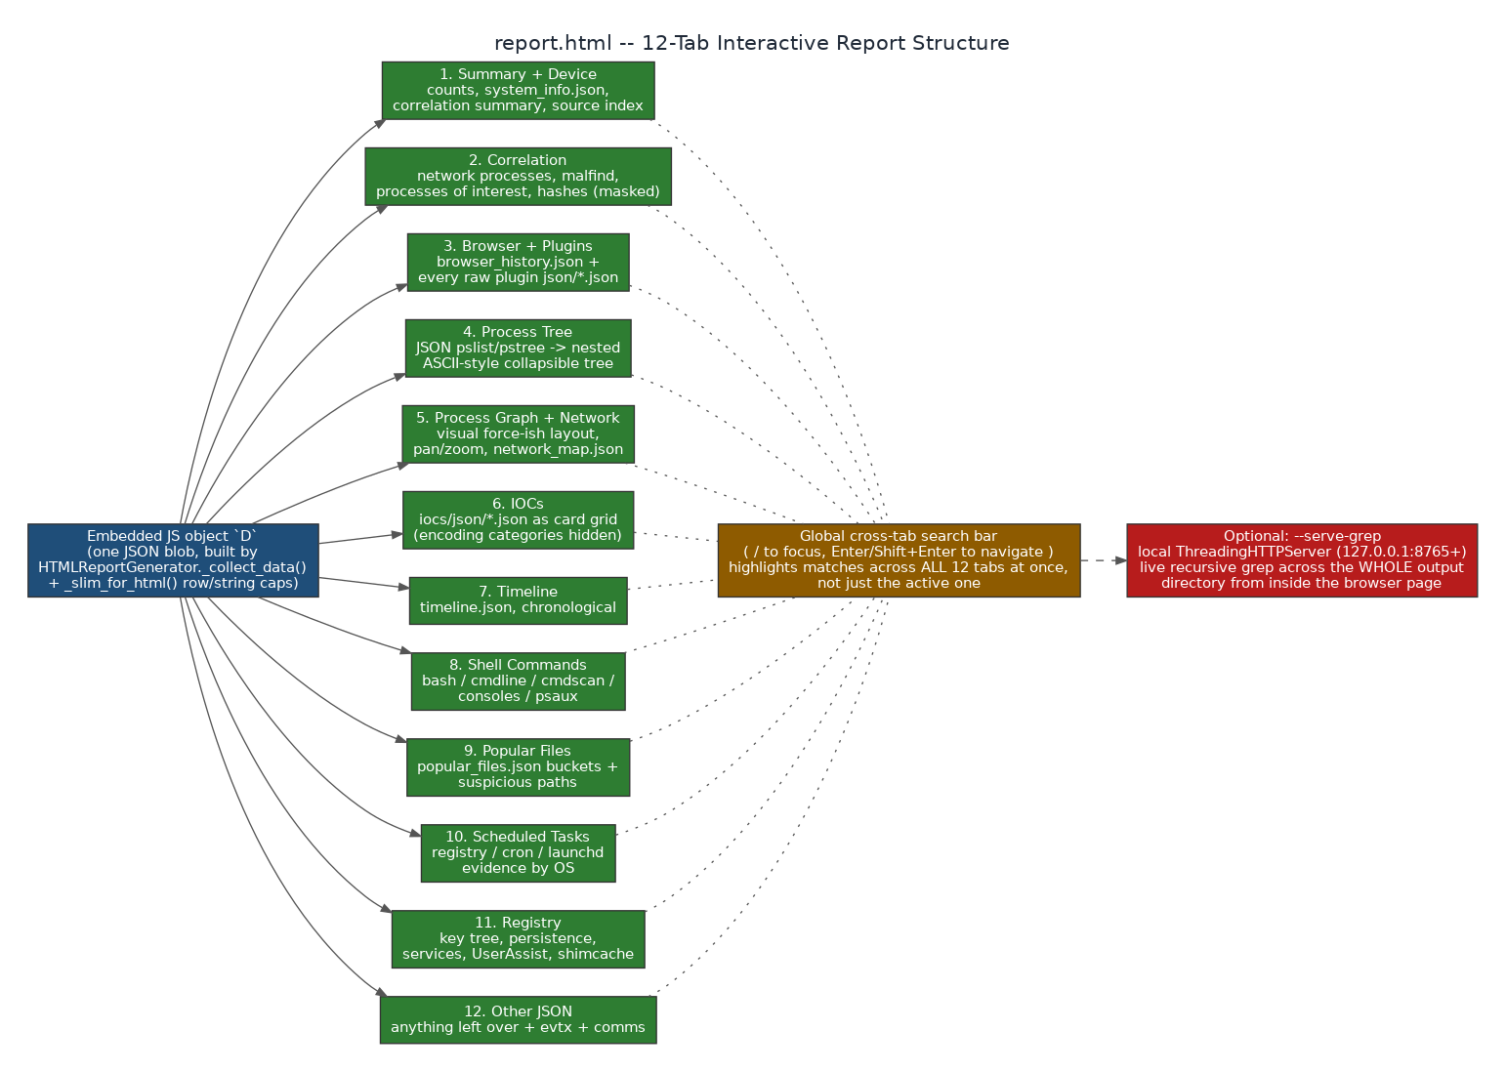
Figure 6.1. All thirteen tabs and what feeds each one.
# | Tab | Rendered from
1 | Summary + Device | counts (a derived dict: plugin/process/network/malfind/service/file/IOC/timeline/task counts), system_info.json flattened into key-value rows, and the correlation summary block.
2 | Correlation | correlation_report.json's network_processes, malfind, interest_processes, external_connections, kernel/hidden modules, services, masked hashes, shellbags, and shimcache sections.
3 | Injection | injection_correlation.json — the fileless-injection correlator's findings (malfind x module-list), each row carrying PID, process, base address, protection, whether an executable header was found, whether the region is registered in the loader's module list, and a HIGH/MEDIUM/LOW confidence. Added in v6.2; rendered XSS-safe through the same safe_js_json + esc() path as every other tab.
4 | Browser + Plugins | browser_history.json plus a clickable list of every raw plugin JSON file collected in Section 6.1 — this is the tab an analyst uses to inspect a specific plugin's completely raw output.
5 | Process Tree | pslist/pstree (flattened client-side by the same recursive-to-flat pattern used server-side elsewhere) plus cmdline/psaux, rendered as a collapsible ASCII-style tree with expand/collapse-all controls and free-text filtering.
6 | Process Graph + Network | the same process/command/network data as the tree, laid out as a pannable, zoomable node graph entirely in the browser (a custom layout algorithm computes non-overlapping positions client-side; there is no separate graph-description file to keep in sync) plus network_map.json.
7 | IOCs | every iocs/json/*.json category as a clickable card grid (small preview inline, full table in a modal viewer on click) — encoding categories are absent here because they were excluded during collection.
8 | Timeline | timeline.json, verbatim, chronological.
9 | Shell Commands | bash / cmdline / cmdscan (Windows console command history) / consoles / psaux, each rendered as its own table with only the columns that are actually present in that data.
10 | Popular Files | popular_files.json's bucket summary (with an expandable "+N more" filename list per bucket), suspicious paths, and executables-in-user-directories.
11 | Scheduled Tasks | scheduled_tasks.json's six categories (registry/file/process/suspicious-command/cron/launchd), each its own table.
12 | Registry | registry_report.json's summary stats, persistence indicators, the full key tree (rendered as collapsible <details> elements per hive), services, UserAssist, ShellBags, and ShimCache.
13 | Other JSON | anything left over, plus EVTX and Comms data specifically (they get their own generic preview here rather than a dedicated tab).

6.3 Global Cross-Tab Search
The search bar at the top of the page (focus with /, or Ctrl/Cmd+K) does not search one tab at a time. gsRun() walks every single page's DOM with a TreeWalker (skipping SCRIPT/STYLE/MARK nodes and the process-graph canvas, which is excluded because it's a positioned layout rather than flowing text), wraps every text match in a <mark> element across all thirteen tabs simultaneously — capped at 3,000 total matches to protect the browser — and builds one chip per tab showing how many matches that tab contains. Enter/Shift+Enter cycle forward/backward through every match across every tab, automatically switching the visible tab as needed, and Escape clears the search and un-wraps every mark cleanly.

6.4 Optional Live Grep Server
Running the report generator directly from the command line (python3 modules/html_report.<os>.py <output_dir> --serve-grep) starts a small local ThreadingHTTPServer (127.0.0.1, auto-incrementing from port 8765 if that port is busy) exposing a single /api/grep endpoint. _grep_search() recursively walks the entire output directory, skips generated HTML reports and other binary-looking files (sampled for NUL bytes in the first 4 KB), and returns matching file/line/text triples — capped at 5,000 results by default, with truncation clearly flagged in the response. This lets an analyst search across every dumped file, every text report, and every raw JSON artifact in a case from a search box inside the report page itself, without ever leaving the browser or opening a terminal.

Part X — Known Issues Engineered Around
The defects below are not hypothetical edge cases — each one is a specific, named failure mode that surfaced against a real memory image during development and testing, and each has a specific fix committed in response. They are presented here because understanding what a tool has already been hardened against is as important to trusting it as understanding its architecture.
# | Failure mode | Root cause and fix
1 | Volatility 3 "success" that wasn't | Certain Volatility 3 plugin invocations return exit code 0 even when they failed to produce meaningful output. Fix: every plugin invocation across the entire codebase is validated by inspecting actual output content (real data rows present, no "Unsatisfied requirement" text) — the return code alone is never treated as sufficient evidence of success, in run_plugin(), in the ISF verification probes, and in the extraction loop's success/fail accounting.
2 | In-process parallelism corrupts plugin state | Volatility 3's own --parallelism threads flag shares mutable framework state across concurrently-running plugins inside one process, corrupting results in ways that are hard to reproduce deterministically. Fix: RAMBreaker never uses it, and instead parallelizes by running one full, separate vol.py subprocess per plugin via a ThreadPoolExecutor, at a job count scaled to available RAM.
3 | Ubuntu image misidentified as macOS | The fast raw-byte OS/format detector originally decoded image bytes to a string before pattern-matching, silently corrupting the comparison on at least one real Ubuntu image and causing it to be misclassified as macOS. Fix: raw_os_detect()/fast_format_detect() now match against raw bytes directly, never round-tripping through string decoding first.
4 | netscan/netstat legitimately empty on Windows crash dumps | Windows crash-dump images can genuinely carry zero live network state — this was previously easy to mistake for a broken plugin. Fix: this is treated and reported as an expected, named condition rather than a silent or ambiguous failure.
5 | VMware .vmem without its .vmss/.vmsn companion | A .vmem captured without its snapshot-state companion files maps memory flat, which breaks the Linux init_task linked-list walk (pslist/pstree/psaux all return nothing) even when the installed ISF is completely correct. Fix: _scan_finds_processes() cross-verifies with linux.psscan's physical-memory signature scan (which doesn't depend on the page-table walk) before concluding an ISF is actually wrong — both in the initial "already working?" check and in strict post-download verification.
6 | mac.list_files RecursionError | The original recursive vnode-path-building walk used one Python stack frame per directory-tree level and overflowed the interpreter's recursion limit on images with a deep or large vnode graph. Fix: rewritten iteratively with an explicit work stack in _walk_vnode(), with identical deduplication behavior (keyed on vnode offset) and no depth limit.
7 | macOS netstat UnboundLocalError | A macOS-specific netstat field-mapping edge case (the platform's netstat has no dedicated PID column) crashed the correlator under certain input shapes. Fix: defensive field extraction that derives the PID from the Process field's "name/pid" suffix format instead of assuming a PID column exists.
8 | ISF cache false negatives and stalls | Volatility 3's own symbol-identifier SQLite cache could reject a genuinely correct, freshly-installed ISF (because the cache didn't know about the new file yet) or stall for a long time mid-build on a large symbol store. Fix: add_new_isf_to_cache() performs an incremental, single-file cache update after every install (roughly one second) instead of a full rebuild, and run_vol_until_done() waits on real progress output rather than a fixed timeout, so a genuinely slow-but-working verification isn't mistaken for a hang.
9 | system_info returning "Unknown" too often | A single hostname/user/IP extraction strategy is fragile across three different OSes and multiple acquisition modes (fast vs. full plugin sets). Fix: rebuilt as nine independent, best-effort extraction strategies (Section 5.4) that degrade gracefully — if the registry isn't available, file-path heuristics or kernel-banner data can still fill in the gaps.
10 | Wrong-architecture ISF confusing later runs | A previously-installed ISF for the right kernel version but the wrong CPU architecture (e.g. i386 vs amd64, which can share version numbers) could sit in the symbol store and confuse Volatility's automagic on a later attempt. Fix: _remove_wrong_arch_isf() proactively deletes any installed ISF for the same kernel version whose filename implies the wrong architecture before trying a new candidate, using the ISF's file path (not the unreliable banner text) as the architecture signal.
11 | Build-host banner mismatches treated as "no match" | A kernel built from identical source but by a different distribution or build host (e.g. Kali vs. the Debian base it derives from) produces a real, working ISF that nonetheless fails an exact banner-string match. Fix: _patch_isf_banner() rewrites the ISF's embedded linux_banner constant to match the image's actual banner and re-verifies, recovering a match that a strict string comparison alone would have discarded.

Part XI — Appendix

A. Full CLI Reference
crescent_toolkit.py takes one positional command (default menu) plus flags. This is the complete, verbatim set from the argument parser — nothing here is approximated.
Command | Behavior
menu | Opens the interactive menu (also the default with no arguments at all).
extract | Runs the Extractor only (Section 5.1).
dump-files | Runs the File Dumper only (Section 5.1).
dump-procs | Runs the Process Dumper only (Section 5.1).
dump-vad | Dumps a process's VAD memory REGIONS — heaps, stacks, mapped data and injected code — rather than just its on-disk executable (Section 12.3). Target with --vad-pid / --vad-name; the names all, suspicious and first are also accepted.
dump-all | Dumps every process (native PE/ELF/Mach-O) and every recoverable file in one standalone pass.
strings | Runs StringsExtractor only (Section 5.4).
correlate | Runs the Correlator only (Section 5.2).
iocs | Runs IOCExtractor only (Section 5.4).
report | Regenerates report.html from whatever JSON already exists in the output directory.
timeline | Runs Timeline only (Section 5.4).
evtx | Runs EVTXParser only (Section 5.3).
export | Runs ExportPack only (Section 5.4).
elk | Runs ELKExporter only (Section 5.4).
core | The 8-step CORE pipeline (Part IV), no EVTX.
full | DEFAULT mode — CORE + Windows EVTX dump/parse + HTML regeneration. (Internally _cmd_full() is kept only as a backward-compatible alias that calls _cmd_default().)
plugins (alias: ctf) | ONLY VOL PLUGINS mode — CORE with the strings/IOC/browser/comms step skipped.
eye (alias: dfir) | RAMBreaker EYE mode — CORE, then dump every process and file to dumped_all/. Experimental.
hunt | Runs String Hunt (Section 5.4) against the live image.

Flag | Meaning
--image, -i PATH | Memory image to analyze.
--output, -o PATH | Output directory. Default: ~/Desktop/<image-stem>_<extension>/.
--mode, -m {fast,full,malware,network,persistence,registry} | Which named plugin subset the standalone Extractor runs (Section 6, VALID_MODES). Default full. Pipeline modes (core/full/plugins/eye) always force full regardless of this flag.
--vol2 / --vol3 | Force a specific Volatility engine instead of auto-detecting.
--profile PROFILE | Manual Volatility 2 profile (e.g. Win7SP1x64).
--symbol-isf PATH | Bring-your-own Volatility 3 ISF (.json/.json.xz) for a Linux/macOS image, skipping auto-resolution (Section 3.5).
--jobs, -j N | Parallel plugin job count, 2-16. Default 4.
--speed {normal,fast,fastest} | normal = memory-safe, RAM guard on. fast = tighter RAM budget, more parallel jobs. fastest = max jobs, no RAM guard.
--timeout N | Per-plugin timeout budget in seconds. Default 600.
--log PATH | Override the log file path.
--quiet, -q | Suppress console output.
--pattern PATTERN | File-dump pattern, e.g. evtx or exe.
--files-first | For dump-all/eye: recover files before dumping process memory (default is processes first).
--strings-mode {all,ascii,unicode,both} | Which strings encodings to extract. Default all.
--hunt-strings STRING [STRING ...] | One or more search terms for the hunt command.
--hunt-pid PID [PID ...] | Restrict String Hunt to specific PID(s).
--hunt-case-sensitive | Disable case-insensitive matching for String Hunt.
--hunt-no-wide | Skip wide (UTF-16LE) string matching for String Hunt.
--vad-pid PID [PID ...] | Restrict the VAD dumper to specific PID(s).
--vad-name NAME | Dump VAD regions for processes matching NAME (e.g. notepad). Also accepts all, suspicious, or first.
--no-telemetry | Hard-OFF override for the opt-in crash-report transport, equivalent to RAMBreaker_TELEMETRY=0. Telemetry is already OFF by default; this is belt-and-suspenders.

Menu-only functionality
Registry, Browser History, Comms Scanner, Command Analysis, MITRE ATT&CK mapping, Scheduled Tasks, Registry Altered, Popular Files, Process Tree, Network Map, and the Installer have no direct top-level CLI command of their own in the argument parser's choices list above — they are reached through the interactive menu (Part V documents what each one does), or they run automatically as part of core/full/plugins/eye.

B. Plugin Inventory by OS / Engine
This inventory is generated directly from the PLUGINS dictionaries compiled into modules/extractor.windows.py, extractor.linux.py and extractor.mac.py — i.e. it is the definitive list of what actually runs, per operating system and per --mode, not an approximation. The plugin set for a run is selected by the key f"{vol_version}-{os_type}-{mode}"; if that key is absent the extractor falls back to the OS's -full set. Plugins invoked outside the extraction sweep — by the dumpers, String Hunt, the injection correlator and symbol resolution — are listed separately in B.7, because they never appear in these dictionaries.

B.1 Windows — Volatility 3
Keys vol3-windows-<mode>. VALID_MODES: fast, full, malware, network, persistence, registry.
Mode | N | Plugins (verbatim, in dictionary order)
fast | 11 | windows.info.Info, windows.pslist.PsList, windows.pstree.PsTree, windows.cmdline.CmdLine, windows.netscan.NetScan, windows.malfind.Malfind, windows.svcscan.SvcScan, windows.hashdump.Hashdump, windows.registry.hivelist.HiveList, windows.registry.printkey.PrintKey, windows.filescan.FileScan
full | 33 | windows.info.Info, windows.pslist.PsList, windows.psscan.PsScan, windows.pstree.PsTree, windows.cmdline.CmdLine, windows.dlllist.DllList, windows.handles.Handles, windows.getsids.GetSIDs, windows.envars.Envars, windows.privileges.Privs, windows.sessions.Sessions, windows.ldrmodules.LdrModules, windows.netstat.NetStat, windows.netscan.NetScan, windows.malfind.Malfind, windows.ssdt.SSDT, windows.callbacks.Callbacks, windows.registry.hivelist.HiveList, windows.registry.hivescan.HiveScan, windows.registry.userassist.UserAssist, windows.registry.printkey.PrintKey, windows.svcscan.SvcScan, windows.driverscan.DriverScan, windows.driverirp.DriverIrp, windows.modules.Modules, windows.modscan.ModScan, windows.filescan.FileScan, windows.mftscan.MFTScan, windows.vadinfo.VadInfo, windows.mutantscan.MutantScan, windows.symlinkscan.SymlinkScan, windows.thrdscan.ThrdScan, windows.hashdump.Hashdump
malware | 14 | windows.info.Info, windows.pslist.PsList, windows.psscan.PsScan, windows.pstree.PsTree, windows.cmdline.CmdLine, windows.malfind.Malfind, windows.ssdt.SSDT, windows.callbacks.Callbacks, windows.ldrmodules.LdrModules, windows.driverscan.DriverScan, windows.driverirp.DriverIrp, windows.modules.Modules, windows.handles.Handles, windows.hashdump.Hashdump
network | 7 | windows.info.Info, windows.pslist.PsList, windows.pstree.PsTree, windows.cmdline.CmdLine, windows.netscan.NetScan, windows.netstat.NetStat, windows.svcscan.SvcScan
persistence | 14 | windows.info.Info, windows.pslist.PsList, windows.pstree.PsTree, windows.cmdline.CmdLine, windows.registry.hivelist.HiveList, windows.registry.userassist.UserAssist, windows.registry.printkey.PrintKey, windows.svcscan.SvcScan, windows.driverscan.DriverScan, windows.modules.Modules, windows.callbacks.Callbacks, windows.ssdt.SSDT, windows.envars.Envars, windows.hashdump.Hashdump
registry | 4 | windows.registry.hivelist.HiveList, windows.registry.hivescan.HiveScan, windows.registry.userassist.UserAssist, windows.registry.printkey.PrintKey

B.2 Windows — Volatility 2 (legacy profiles)
Keys vol2-windows-<mode>. VOL2_EXCLUSIVE plugins (no Volatility 3 equivalent) also run in a background thread alongside a Vol3 run when a Vol2 profile is available: cmdscan consoles hashdump shellbags shimcache iehistory clipboard deskscan atoms atomscan timers messagehooks eventhooks apihooks. VOL2_XP_ONLY (profile-gated to XP/2003): connections connscan sockets sockscan.
Mode | N | Plugins (verbatim, in dictionary order)
fast | 16 | imageinfo, pslist, pstree, psscan, cmdline, cmdscan, consoles, netscan, connections, connscan, malfind, svcscan, hashdump, hivelist, printkey, filescan
full | 48 | imageinfo, pslist, psscan, pstree, psxview, cmdline, cmdscan, consoles, dlllist, handles, getsids, envars, privs, sessions, ldrmodules, netscan, netstat, connections, connscan, sockets, sockscan, malfind, ssdt, callbacks, driverirp, driverscan, modules, modscan, filescan, mutantscan, symlinkscan, hivelist, userassist, shellbags, shimcache, mftparser, svcscan, timers, atoms, atomscan, clipboard, deskscan, messagehooks, eventhooks, thrdscan, vadinfo, iehistory, hashdump
malware | 22 | imageinfo, pslist, psscan, pstree, psxview, cmdline, cmdscan, consoles, malfind, ssdt, callbacks, apihooks, ldrmodules, driverirp, driverscan, modules, modscan, privs, vadinfo, handles, timers, hashdump
network | 13 | imageinfo, pslist, pstree, cmdline, cmdscan, consoles, netscan, netstat, connections, connscan, sockets, sockscan, svcscan
persistence | 17 | imageinfo, pslist, pstree, cmdline, cmdscan, consoles, hivelist, userassist, printkey, shellbags, shimcache, svcscan, driverscan, modules, callbacks, ssdt, envars
registry | 6 | hivelist, hivedump, printkey, userassist, shellbags, shimcache

B.3 Linux — Volatility 3
Keys vol3-linux-<mode>. VALID_MODES here is only fast, full, malware, network — Linux has no persistence or registry mode.
Mode | N | Plugins (verbatim, in dictionary order)
fast | 11 | linux.pslist.PsList, linux.pstree.PsTree, linux.psscan.PsScan, linux.psaux.PsAux, linux.bash.Bash, linux.lsmod.Lsmod, linux.check_modules.Check_modules, linux.sockstat.Sockstat, linux.lsof.Lsof, linux.proc.Maps, linux.pagecache.Files
full | 19 | linux.pslist.PsList, linux.pstree.PsTree, linux.psscan.PsScan, linux.psaux.PsAux, linux.bash.Bash, linux.sockstat.Sockstat, linux.lsmod.Lsmod, linux.check_modules.Check_modules, linux.check_syscall.Check_syscall, linux.tty_check.tty_check, linux.elfs.Elfs, linux.envars.Envars, linux.library_list.LibraryList, linux.lsof.Lsof, linux.mountinfo.MountInfo, linux.malfind.Malfind, linux.ip.Addr, linux.proc.Maps, linux.pagecache.Files
malware | 11 | linux.pslist.PsList, linux.pstree.PsTree, linux.psscan.PsScan, linux.bash.Bash, linux.lsmod.Lsmod, linux.check_modules.Check_modules, linux.check_syscall.Check_syscall, linux.tty_check.tty_check, linux.elfs.Elfs, linux.sockstat.Sockstat, linux.malfind.Malfind
network | 5 | linux.pslist.PsList, linux.pstree.PsTree, linux.sockstat.Sockstat, linux.lsof.Lsof, linux.ip.Addr

B.4 Linux — Volatility 2 (legacy)
Keys vol2-linux-<mode>, used only when no Volatility 3 ISF can be resolved and a Vol2 Linux profile is installed.
Mode | N | Plugins (verbatim, in dictionary order)
fast | 8 | linux_pslist, linux_pstree, linux_psaux, linux_bash, linux_lsmod, linux_check_modules, linux_lsof, linux_proc_maps
full | 15 | linux_pslist, linux_pstree, linux_psaux, linux_bash, linux_ifconfig, linux_netstat, linux_lsmod, linux_check_modules, linux_check_syscall, linux_dmesg, linux_enumerate_files, linux_lsof, linux_mount, linux_elfs, linux_proc_maps
malware | 10 | linux_pslist, linux_pstree, linux_bash, linux_lsmod, linux_check_modules, linux_check_syscall, linux_elfs, linux_proc_maps, linux_hidden_modules, linux_malfind
network | 5 | linux_pslist, linux_pstree, linux_ifconfig, linux_netstat, linux_lsof

B.5 macOS — Volatility 3
Keys vol3-mac-<mode>. macOS is Volatility-3-only; there is no Vol2 macOS plugin set. list_files and pagecache are RAMBreaker's own bundled plugins (Section 5.5).
Mode | N | Plugins (verbatim, in dictionary order)
fast | 9 | mac.pslist.PsList, mac.pstree.PsTree, mac.psaux.Psaux, mac.bash.Bash, mac.netstat.Netstat, mac.lsmod.Lsmod, mac.malfind.Malfind, mac.list_files.List_Files, mac.proc_maps.Maps
full | 20 | mac.pslist.PsList, mac.pstree.PsTree, mac.psaux.Psaux, mac.bash.Bash, mac.netstat.Netstat, mac.ifconfig.Ifconfig, mac.lsmod.Lsmod, mac.malfind.Malfind, mac.check_syscall.Check_syscall, mac.check_sysctl.Check_sysctl, mac.check_trap_table.Check_trap_table, mac.kauth_listeners.Kauth_listeners, mac.kauth_scopes.Kauth_scopes, mac.kevents.Kevents, mac.list_files.List_Files, mac.mount.Mount, mac.proc_maps.Maps, mac.socket_filters.Socket_filters, mac.timers.Timers, mac.trustedbsd.Trustedbsd
malware | 10 | mac.pslist.PsList, mac.pstree.PsTree, mac.malfind.Malfind, mac.check_syscall.Check_syscall, mac.check_sysctl.Check_sysctl, mac.check_trap_table.Check_trap_table, mac.kauth_listeners.Kauth_listeners, mac.socket_filters.Socket_filters, mac.trustedbsd.Trustedbsd, mac.lsmod.Lsmod
network | 4 | mac.pslist.PsList, mac.netstat.Netstat, mac.ifconfig.Ifconfig, mac.socket_filters.Socket_filters

B.6 Plugin dependencies
If a parent plugin fails, its dependents are skipped rather than run against data that cannot exist. Note linux.psscan is deliberately NOT a dependent of pslist: the pool scan must still run when the task-list walk fails, because that is exactly when run_health needs it to corroborate an empty process list.
OS | Parent plugin | Dependents skipped if the parent fails
windows | pslist | cmdline, dlllist, envars, getsids, handles, ldrmodules, malfind, privileges, psscan, pstree, psxview, sessions, vadinfo
windows | netscan | netstat
windows | netstat | netscan
windows | hivelist | printkey, shellbags, shimcache, userassist
windows | modules | modscan
linux | pslist | lsof, psaux, pstree
mac | pslist | psaux, pstree

B.7 Plugins invoked outside the extraction sweep
These never appear in the PLUGINS dictionaries above because they are run on demand by a specific module rather than as part of a mode's batch.
Consumer | Plugin(s) | Purpose
volatility.auto_detect | banners.Banners, windows.info.Info; Vol2 imageinfo | OS/engine detection and kernel-symbol warm-up.
linux_resolver | linux.pslist.PsList, linux.psscan.PsScan, mac.pslist.PsList, banners.Banners | Verifying that a candidate ISF actually walks this image.
file_dumper.windows | windows.dumpfiles.DumpFiles | File content recovery from filescan offsets.
file_dumper.linux | linux.pagecache.Files, linux.pagecache.RecoverFs, linux.pagecache.InodePages | File listing, bulk recovery, and per-inode recovery.
file_dumper.mac | mac.list_files.List_Files, mac.pagecache.Pagecache | File listing and Unified-Buffer-Cache content recovery (both bundled).
process_dumper.windows | windows.pslist.PsList --dump, windows.memmap.Memmap --dump, windows.dlllist.DllList; Vol2 procdump/memdump | PE-only dump vs. full process-memory dump.
process_dumper.linux | linux.elfs.Elfs, linux.proc.Maps | ELF and memory-map dumping.
process_dumper.mac | mac.proc_maps.Maps | Per-VMA dumping.
vad_dumper | windows.vadinfo.VadInfo --dump (Vol2 vaddump), linux.proc.Maps --dump, mac.proc_maps.Maps --dump | Live memory-region dumping (Section 12.3).
string_hunt | windows.vadyarascan.VadYaraScan, linux.vmayarascan.VmaYaraScan, yarascan.YaraScan; Vol2 yarascan | Live per-process YARA search (Section 5.4).
injection_correlator | windows.malfind.Malfind + windows.ldrmodules.LdrModules; linux.malfind.Malfind + linux.proc.Maps/linux.elfs.Elfs; mac.malfind.Malfind + mac.proc_maps.Maps/mac.lsmod.Lsmod | Reads these plugins' JSON; does not invoke them itself (Section 12.4).

C. Output Directory Reference
Path | What lives here
json/ | One JSON file per raw Volatility plugin, plus every analysis module's own *_report.json.
iocs/ | IOC text/JSON per category, browser history, popular files, scheduled-tasks findings, comms report.
iocs/json/ | The JSON counterpart of every file directly under iocs/.
comms/ | Per-app, per-artifact-type files from the Comms Scanner (e.g. discord_user_token.txt).
dumped_files/ | Files recovered from memory.
dumped_processes/ | Individual process memory dumps.
dumped_all/ | RAMBreaker EYE's combined every-process-and-file acquisition.
elk_export/ | NDJSON bulk-import files plus import_to_elk.sh.
report.html | The single-file interactive report (Part VI).
SUMMARY.txt | Run metadata: image, output path, OS, engine/profile, plugin success/fail counts, directory listing.
crescent_toolkit.log | Full per-run log across every module invoked.
*.txt / *.csv at the root | One human-readable report per analysis module (correlation_report.txt, process_tree.txt, network_map.txt, registry_report.txt, registry_altered.txt, suspicious_processes.txt, timeline.txt/.csv, string_hunt.txt, comms_report.txt, yara_results.txt, hashes.csv/.txt, and more).

D. Glossary
Term | Meaning
ISF | Intermediate Symbol Format — Volatility 3's file format for the type/offset/symbol information it needs to interpret a specific kernel build's memory layout. The Linux/macOS equivalent of a Windows PDB.
VAD | Virtual Address Descriptor — a Windows kernel structure describing one region of a process's virtual address space; windows.vadyarascan.VadYaraScan scans these per-process.
VMA | Virtual Memory Area — the Linux kernel's equivalent of a VAD; linux.vmayarascan.VmaYaraScan scans these per-process.
UBC | Unified Buffer Cache — XNU's (macOS/Darwin kernel) page-cache mechanism for caching file content in memory; the structure mac.pagecache walks to recover file bytes.
dwarf2json | The Volatility Foundation's tool for building an ISF from DWARF debug information (e.g. extracted from a -dbgsym package or a debuginfo RPM).
KASLR | Kernel Address Space Layout Randomization — the kernel loads at a randomized base address each boot; anything reading kernel structures by symbol must account for this "slide."
LOLBin | Living-off-the-land binary — a legitimate, pre-installed OS utility (certutil, bitsadmin, mshta, wmic, etc.) abused for malicious purposes instead of dropping custom malware.
MFT | Master File Table — the NTFS structure recording every file's metadata, including creation/modification timestamps recovered by mftscan.
ShimCache / AppCompatCache | A Windows registry-backed cache recording evidence of program execution, used here as execution-history evidence.
UserAssist | A Windows registry key tracking GUI-launched program run counts and last-run times — direct evidence of user-initiated execution.
ShellBags | Windows registry entries recording folder-browsing history through Explorer, useful for reconstructing what an attacker (or user) actually looked at.
ATT&CK | MITRE's ATT&CK framework — a structured catalogue of adversary tactics and techniques; MitreMapper maps command-analyzer findings onto specific technique IDs.
NDJSON | Newline-Delimited JSON — one JSON object per line; the format Elasticsearch's bulk API consumes, produced by ELKExporter.
Snowflake ID | Discord's globally-unique, timestamp-encoding numeric ID format; CommsScanner decodes a candidate token's embedded ID to confirm it's plausible before flagging it as a genuine Discord token.

Part XII — v6.1/v6.2 Additions: Reliability, Diagnostics, VAD & Injection Correlation
This addendum documents the modules and behaviours added after the v6.0 reference above was written. The codebase now declares VERSION = "6.2". Every capability here is covered by the test suite (166 pure-logic assertions plus a 21-assertion full-pipeline canary, both green) and validated on real images from the RAMDUMPS set. Part XIII covers the v6.2 headline feature, the in-image BTF symbol builder.

12.1 Loud, Never Silent — Run-Health, Silent-Failure Demotion & Crash-Report
run_health.py (381 lines) — after each extraction, assesses the run from the json/ directory and the local log. It performs process corroboration (pslist vs psscan vs pstree vs psaux) that catches the signature 'a pool scan finds processes but the linked list is empty' on every OS; empty-key-tab detection; an advisory 'usually-not-empty' check; and a failure taxonomy classifying each failed plugin (symbol-missing / struct-mismatch / timeout / expected-nonbug / empty-result). It emits a healthy / degraded / broken status banner into SUMMARY.txt and a structured run_health.json.
Silent-failure demotion — in the Volatility wrapper, a Linux/macOS plugin that exits 0 with an empty result while logging a systemic struct/symbol exception is reclassified as a FAILURE, its stderr kept rather than discarded — Volatility's 'exit 0 on failure' quirk can no longer masquerade as a clean, empty tab. A <name>.json.error sidecar makes the failure durable so a resume re-runs that plugin instead of trusting stale output.
crash_report.py (507 lines) — on a real failure, writes a scrubbed, image-free crash_report.json fingerprint: host, target kernel/distro (parsed from the banner — the builder user@host is never kept), per-plugin failure class, and a dedup fingerprint. Whitelist schema; addresses and paths redacted; no image content. An opt-in, default-OFF transport (honouring RAMBreaker_TELEMETRY / --no-telemetry) can share the scrubbed report with the tool author.

12.2 Security & Testing Hardening
Process corroboration was extended to Linux/macOS (linux.psscan now runs; a psaux fallback covers macOS). Debug-package and symbol downloads are upgraded to HTTPS where supported and verified by archive magic + SHA-256 before use (symbol zips are optionally pinnable). The HTML report is XSS-hardened: the embedded data blob is encoded via safe_js_json (< > & U+2028/U+2029 to \uXXXX) and every value is rendered through esc(), so attacker-controlled memory strings cannot inject markup. A Tier-B 'canary' test drives the entire real pipeline against a fake Volatility (no memory image needed), and a pre-commit hook runs the pure suite plus the canary before every commit. The project is MIT-licensed.

12.3 VAD Memory-Region Dumper (dump-vad)
vad_dumper.py (43, dispatcher) + .windows.py (296) / .linux.py (218) / .mac.py (181) — dumps a process's actual memory REGIONS — heaps, stacks, mapped data files, and injected code — rather than just its on-disk executable (which is all the process dumper writes). On Windows it runs windows.vadinfo.VadInfo --dump (Vol2 fallback: vaddump); on Linux/macOS it dumps the equivalent memory maps (proc.Maps / proc_maps). Each dumped region is hashed, and regions that look like code injection are flagged as observations — RWX (execute+read+write), or executable-private with no backing file (shellcode). PAGE_EXECUTE_WRITECOPY, the normal copy-on-write code protection of a mapped image, is deliberately NOT flagged. Exposed as the CLI command dump-vad (--vad-pid / --vad-name, plus the names all / suspicious / first), menu entry [V], and a VAD phase inside DFIR / dump-all. Validated across every RAMDUMPS image (Windows Vol2+Vol3, Linux, macOS).

12.4 Fileless-Injection Correlator
injection_correlator.py (650 lines) — correlates the injected-memory plugin (malfind) with the module-list plugin (windows.ldrmodules, linux.proc.Maps, mac.proc_maps) to flag reflective/manual code injection, cross-OS. Per-OS parsers (parse_windows / parse_linux / parse_macos) normalise the differently-named fields into one schema and feed a single correlation engine, so a fourth OS is just a new parser. Confidence levels: HIGH = a malfind hit AND a matching module-list entry that is unregistered/unbacked (same PID + address, with a <<12 page-shift retry for the Windows 'Start VPN' quirk where that column holds a full address); MEDIUM = a malfind hit alone; LOW = an unregistered AND unbacked executable region with no malfind hit. Executable headers are checked per OS (MZ for PE, 7f 45 4c 46 for ELF, the Mach-O magics). JSON is preferred, with a per-OS raw-text fallback that even regroups Vol2 malfind's fragmented output into whole regions. It runs standalone (full CLI: --os / --auto, --injected / --modules, --pid, --min-confidence, --export json|csv|both) and as a pipeline stage that writes injection_correlation.json; a new Injection tab was added to all three HTML reports (bringing the report to thirteen tabs). All confidence levels are observations, never verdicts.

Part XIII — v6.2: Symbols From The Image Itself (btf2isf)
Everything in Part III shares one structural weakness: every tier depends on somebody else having published something. The community repository has to already hold an ISF for this exact kernel, or the distribution has to still be hosting its debug package. modules/btf2isf.py (1,167 lines) removes that dependency for modern Linux kernels by reconstructing the symbol table from information the memory image already contains.

13.1 The Insight
Since Linux 5.8, kernels compiled with CONFIG_DEBUG_INFO_BTF embed a complete BTF (BPF Type Format) type graph in their .BTF section — the same struct layouts, field offsets and sizes that dwarf2json would otherwise extract from a multi-gigabyte DWARF debug package. The kernel also carries kallsyms, its own symbol-address table. Both live in kernel memory, which means both are present in any memory image of that kernel. The dump is self-describing: everything an ISF needs is already in the evidence.
This closes four failure cases that no download-based tier can reach: a kernel too new for an ISF to have been published yet; a kernel too old for its distribution to still host the -dbgsym package (Canonical prunes these routinely); a custom-compiled kernel that was never in any repository and never will be; and an analyst working air-gapped, with a real case image on a machine that has no route to the internet at all.

13.2 The Pipeline
build_isf(image_path, out_dir, verbose) returns the path to a written <Distro>_<kernel>_btf.json.xz, or None if the image cannot support the build. The stages are:
Image addressing. The Image class presents a flat physical view over either a LiME container (EMiL magic, per-range headers) or a flat raw/VMware dump. Flat dumps hide the kernel behind the sub-4 GB PCI hole, so detect_vmware_hole() recovers the low/high split by testing the known _stext and swapper_pg_dir addresses — without this every subsequent physical read into high memory would land on the wrong bytes. NUMBER(phys_base) is printed signed by the kernel and can legitimately be negative, which the linear-map arithmetic handles.
VMCOREINFO recovery. find_vmcoreinfo() locates the kernel's own crash-dump metadata note, which supplies phys_base, SYMBOL(_stext), SYMBOL(swapper_pg_dir) (or init_top_pgt) and OSRELEASE. swapper_pg_dir gives the DTB, which lets PageWalk translate kernel virtual addresses when a structure is not physically contiguous.
BTF extraction, two ways. extract_btf() scans for the BTF magic (9f eb 01), keeps only candidates larger than 1 MB — base-vmlinux-sized, filtering out the small per-module BTF blobs — and tries the largest first. First it attempts a physically contiguous read straight out of the file; if that fails it reassembles the blob virtually by walking the page tables from its kernel VA through the kernel-image linear map. The acceptance test, _btf_looks_clean(), requires both a structurally valid header and a string section that actually contains task_struct and init_task, which is what rejects the partial and duplicate .BTF copies a real image contains.
BTF to ISF types. build_isf_types() is a pure-Python BTF parser. A _TRANSPARENT set (typedef, const, volatile, restrict, type_tag) resolves through to the underlying type. Two subtleties matter for Volatility compatibility: anonymous members are flattened, emitted with anonymous: true plus a separately registered inner type; and typedef'd anonymous structs are named after their typedef (the kernel_cap_t shape), because Volatility 3's type extensions attach by name and would otherwise never bind.
kallsyms decoding. Kernel symbol names are stored token-compressed against a 256-entry token table. Both exposure styles are supported — a heuristic .rodata scan (_find_token_table, _find_names_end, _kallsyms_bases) and a deterministic path driven directly by VMCOREINFO addresses. The address arithmetic covers all three cases the kernel uses: non-percpu (base plus offset), percpu positive (an absolute address), and percpu negative (base minus one minus offset).

13.3 Typing The Globals Volatility Dereferences
kallsyms yields addresses, but Volatility's object_from_symbol() needs a typed symbol. Four lookup tables supply the missing types, and each entry is applied only if the image's BTF actually defines that type — the tables never invent anything:
KNOWN_SYMBOL_TYPES covers globals that are direct struct instances (init_task as a task_struct, init_mm as an mm_struct, init_net, init_cred, modules as a list_head, and similar). KNOWN_SYMBOL_BASE_TYPES covers scalar globals such as cap_last_cap. KNOWN_SYMBOL_POINTER_TYPES covers globals that are pointers to a struct rather than the struct itself — module_kset is a struct kset *, and typing it as a bare kset silently breaks check_modules and tty_check. KNOWN_SYMBOL_CHAR_ARRAYS covers linker section symbols (_text, _etext, _stext, _end, __bss_start and friends) as zero-length char arrays, matching exactly what dwarf2json produces for them.
The last two tables were added after a full mint.lime run in which check_modules and tty_check were the only failing plugins; both needed module_kset and the _text/_etext range symbols typed before they would resolve. This is the honest maintenance cost of the BTF route: BTF describes types, and kallsyms describes addresses, so any Volatility plugin that dereferences a global not covered by these tables needs an entry adding.
_bootstrap_symbols() is the safety net. If kallsyms cannot be decoded at all, it locates by signature just the handful of symbols the Volatility 3 Linux stacker strictly requires (init_task, init_mm, init_files), so the resulting ISF is still usable rather than being discarded outright.

13.4 Where It Sits In The Waterfall
_try_btf2isf_build() in linux_resolver.linux.py is the connector, and resolve_symbols() calls it from two places. In the normal waterfall it sits after the prebuilt, banner-patch and local-DWARF tiers and immediately before the official debug-package download — that ordering is the entire point, because when the kernel has BTF this path is instant, exact and offline, and should never be reached past a multi-gigabyte download. It is also called on the more-than-25-distinct-banners bail-out path, where it is the ideal fallback precisely because it reads VMCOREINFO and BTF directly and ignores banner strings entirely, which is the exact condition (a banner-cache image) that defeats every banner-matching heuristic.
Like every other build tier, it installs the result into Volatility 3's symbol store and calls _refresh_isf_cache_after_install() — the roughly one-second incremental SqliteCache.update(), not a full clear and rebuild. Critically, the caller still runs _verify_works_strict() afterwards: a BTF-built ISF is verified against the actual dump exactly like a downloaded one, and is never trusted on faith. The kernel version recorded in linux_kernel.json is recovered from the built file's own <Distro>_<kernel>_btf.json.xz name.
It returns None — falling through to the debug-package tier unchanged — when the target is not Linux, the module will not import, the image has no VMCOREINFO note, the kernel carries no embedded BTF, or init_task cannot be located.

13.5 Standalone Use
The module runs on its own as well as inside the resolver. python3 modules/btf2isf.py <memory-image> writes the ISF into the current directory. A second mode, python3 modules/btf2isf.py --from-btf <blob>, parses an already-extracted BTF blob and spot-checks task_struct (its size, field count, and the offsets of comm, pid, tgid, tasks, mm, parent, state, __state and cred) plus mm_struct, list_head, cred and pid — the fastest way to judge whether a parse is sane before committing to a full build.

13.6 Validation And Honest Limits
Validated end to end through the full resolver, not merely as a standalone builder, on Ubuntu 5.15.0-41 (LiME), Ubuntu 6.5.0-41 (VMware .vmem, which exercises the PCI-hole path) and Kali 6.12.13 (LiME), plus the mint.lime run that drove the pointer and linker-symbol typing fix. Fourteen assertions were added to the Tier-A suite (166 total), none of which need a memory image: a hand-crafted BTF blob pins the parser, anonymous-member flattening and typedef-anonymous naming; the kallsyms token decompression is pinned including multi-character tokens and all three address cases; and the resolver glue is covered separately by stubbing the builder to confirm the version is parsed from the ISF filename, that a no-BTF result falls through, and that a non-Linux OS short-circuits without calling the builder at all.
The limits are worth stating plainly. The kernel must have been built with CONFIG_DEBUG_INFO_BTF, roughly 5.8 and newer — Ubuntu before 5.8 and the Azure 5.4 kernels are the common misses, and they fall through to the debug-package route exactly as before. It is Linux-only, because XNU has no BTF equivalent, so macOS remains the weakest supported OS. And, most importantly, it solves symbol availability, not plugin compatibility: a perfect ISF does nothing about a Volatility plugin that references a kernel field which has since been renamed, and only an upstream Volatility release fixes that. What this feature buys is that “no symbols exist anywhere for this kernel” stops being a reason a run fails.

