Museum of Ancient Cultures, University Tübingen

Ahmad Aroud

2023-04-28

Table of contents

# 1. Museum of Ancient Cultures, University Tübingen

Author: Ahmad Aroud

ORCID: https://orcid.org/0009-0000-3344-9566

Date: 28.04.2023

DOI: 10.5281/zenodo.7875479

Repository URL: https://github.com/AhmadAroud/catalogue-003

## 1.1 Based on Baroque AI: Publication Prototype

## 1.2 Part of the series: Baroque TOC

[Programme instructions](https://nfdi4culture.github.io/class-ADA-CP-pipeline/)

2023-03-17

This work is licensed under a Creative Commons Attribution-ShareAlike 4.0 International License.

Book cover: Reworking of [Baroque pearl with enamelled gold mounts set with rubies](https://en.wikipedia.org/wiki/File:Pendant_in_the_form_of_a_siren_MET_DT7173.jpg). Creative Commons CC0 1.0 Universal Public Domain Dedication. This file was donated to Wikimedia Commons as part of a project by the Metropolitan Museum of Art.

This work is licensed under a Creative Commons Attribution-ShareAlike 4.0 International License.

# 2. Colophon

Fork title: AhmadAroud/catalogue-003

Author: Ahmad Aroud

ORCID: https://orcid.org/0009-0000-3344-9566

Date: 28.04.2023

DOI: 10.5281/zenodo.7875479

Repositor: https://github.com/AhmadAroud/catalogue-003

PUBLISHING FROM COLLECTIONS USES OF COMPUTATIONAL PUBLISHIGN AND LINKEDOPEN DATA

Open Science Lab - TIB Hannnover

First published 2023-03-30

Copyright © The Authors 2023 Licensed as https://creativecommons.org/licenses/by-sa/4.0/

DOI: https://doi.org/10.5281/zenodo.7701161

# 3. Museum of Ancient Cultures, University Tübingen

Source: https://www.unimuseum.uni-tuebingen.de/en/museum-at-hohentuebingen-castle/museum-ancient-cultures

Admire many superlatives of cultural history such as the oldest figurative art of mankind (UNESCO World Heritage “Ice Age Art”) or the oldest musical instrument in the world in the Museum Ancient Cultures in the Hohentübingen Castle. Learn more about the UNESCO World Heritage Site “Pile Dwellings”, the Egyptian offering chamber of Seschemnefer III, the “Tübingen Hoplite” and the Malanggan artworks from New Ireland.

# 4. Data Visualization

Visualization

Here an image of my data viz : 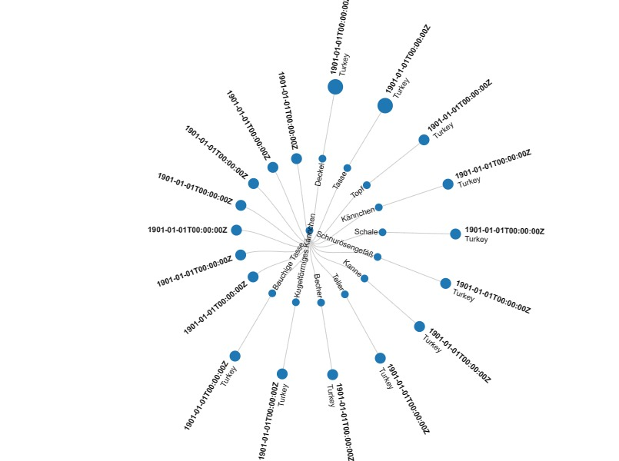

Here is an iframe with some data viz:

# 5. Activity: Paintings catalogue

Wikidata link: <http://www.wikidata.org/entity/Q119423701>

Title: Topf

Year: 1901-01-01T00:00:00Z

Discoverer: Johann Heinrich Ludwig Petersen

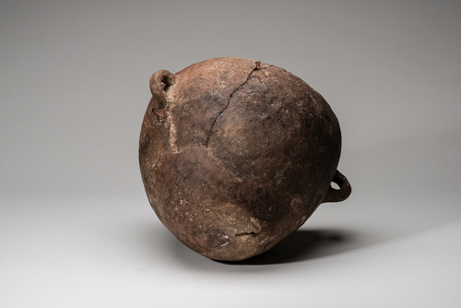

Wikidata link: <http://www.wikidata.org/entity/Q119423703>

Title: Deckel

Year: 1901-01-01T00:00:00Z

Discoverer: Johann Heinrich Ludwig Petersen

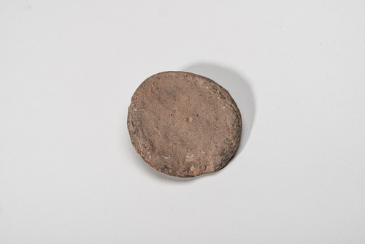

Wikidata link: <http://www.wikidata.org/entity/Q119423703>

Title: Deckel

Year: 1901-01-01T00:00:00Z

Discoverer: Johann Heinrich Ludwig Petersen

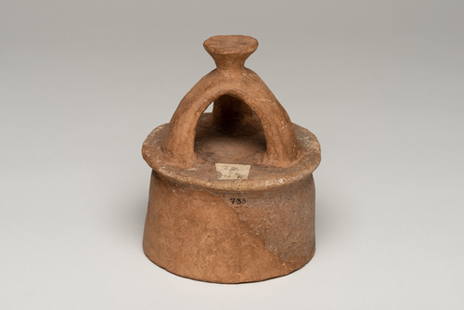

Wikidata link: <http://www.wikidata.org/entity/Q119423705>

Title: Kännchen

Year: 1901-01-01T00:00:00Z

Discoverer: Johann Heinrich Ludwig Petersen

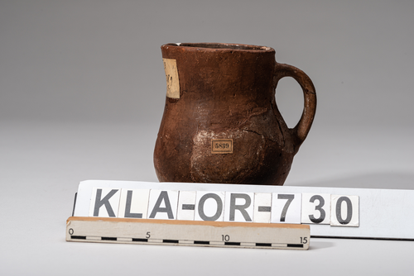

Wikidata link: <http://www.wikidata.org/entity/Q119423706>

Title: Schale

Year: 1901-01-01T00:00:00Z

Discoverer: Johann Heinrich Ludwig Petersen

KeyError: 'image'