LSTM Models — Project Recap
Stacked LSTM & Bidirectional LSTM with Hyperparameter Tuning

1. Stacked LSTM

1.1 What is a Stacked LSTM?
A Stacked LSTM places multiple LSTM layers on top of each other. The output of one layer becomes the input of the next, allowing the model to learn increasingly abstract representations of the data.

1.2 Architecture
Layer | Type | Units | Details
1 | LSTM | 64 | return_sequences=True — passes full output to next layer
2 | Dropout | — | rate=0.3 — prevents overfitting
3 | LSTM | 32 | Returns final hidden state only
4 | Dropout | — | rate=0.3
5 | Dense | 1 | activation=sigmoid — binary output

1.3 Hyperparameter Tuning — Best Parameters
Hyperparameter | Best Value | Search Range
LSTM units — Layer 1 | 128 | 32 → 128, step 32
LSTM units — Layer 2 | 32 | 16 → 64, step 16
Dropout — Layer 1 | 0.1 | 0.1 → 0.5, step 0.1
Dropout — Layer 2 | 0.4 | 0.1 → 0.5, step 0.1
Optimizer | Adam | Adam, RMSprop

1.4 Results
Metric | Score | Interpretation
AUROC | 0.5027 | Near random — model struggles to rank positives above negatives
AUPRC | 0.0030 | Very low — poor precision-recall tradeoff on imbalanced data

Note: The low scores suggest that with seq_len=1 (no real temporal structure), the Stacked LSTM does not gain an advantage over simpler models.

1.5 Evaluation Plots

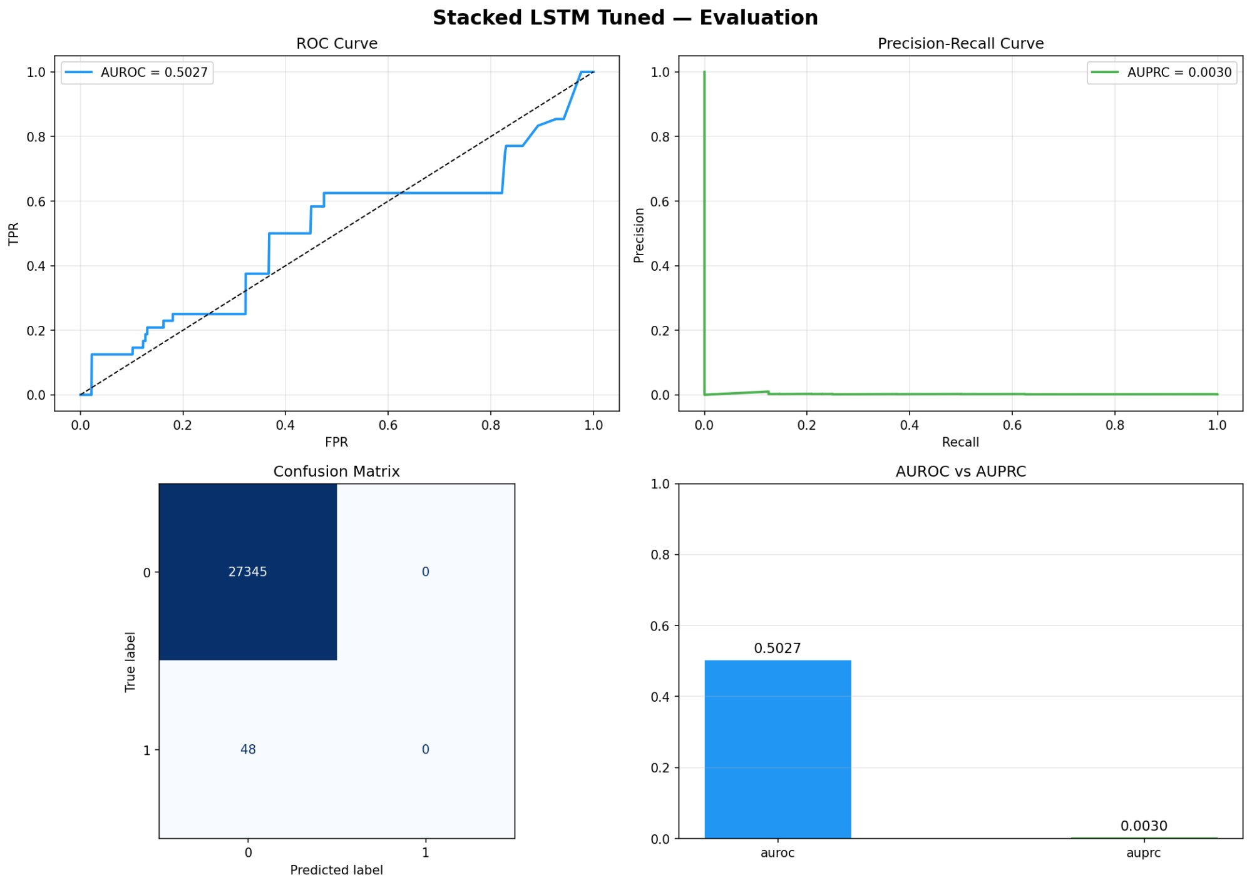

2. Bidirectional LSTM (BiLSTM)

2.1 What is a BiLSTM?
A Bidirectional LSTM processes the input sequence in two directions simultaneously — forward (left to right) and backward (right to left). The outputs of both directions are concatenated, giving the model access to both past and future context at every timestep.

2.2 Architecture
Layer | Type | Output Units | Details
1 | Bidirectional(LSTM(64)) | 128 | 64 forward + 64 backward = 128 total, return_sequences=True
2 | Dropout | — | rate=0.3
3 | Bidirectional(LSTM(32)) | 64 | 32 forward + 32 backward = 64 total, final hidden state
4 | Dropout | — | rate=0.3
5 | Dense | 1 | activation=sigmoid — binary output

2.3 Stacked LSTM vs BiLSTM
Aspect | Stacked LSTM | BiLSTM
Direction | Forward only | Forward + Backward
Layer 1 output | 128 units | 256 units (128+128)
Layer 2 output | 32 units | 64 units (32+32)
Context | Past context only | Past + Future context
Complexity | Lower | Higher

2.4 Hyperparameter Tuning — Best Parameters
Hyperparameter | Best Value | Search Range
LSTM units — Layer 1 | 128 | 32 → 128, step 32
LSTM units — Layer 2 | 32 | 16 → 64, step 16
Dropout — Layer 1 | 0.1 | 0.1 → 0.5, step 0.1
Dropout — Layer 2 | 0.4 | 0.1 → 0.5, step 0.1
Optimizer | Adam | Adam, RMSprop

Note: units_1=128 means Bidirectional(LSTM(128)) → 128 forward + 128 backward = 256 total output for layer 1. units_2=32 means Bidirectional(LSTM(32)) → 32 forward + 32 backward = 64 total output for layer 2.

2.5 Results
Metric | Score | Interpretation
AUROC | 0.5377 | Slightly above random — marginal ability to rank positives
AUPRC | 0.0026 | Very low — poor precision-recall tradeoff on imbalanced data

Note: The BiLSTM slightly outperforms random (AUROC > 0.5) but still shows poor overall performance. With seq_len=1, the bidirectional mechanism provides minimal benefit.

2.6 Evaluation Plots

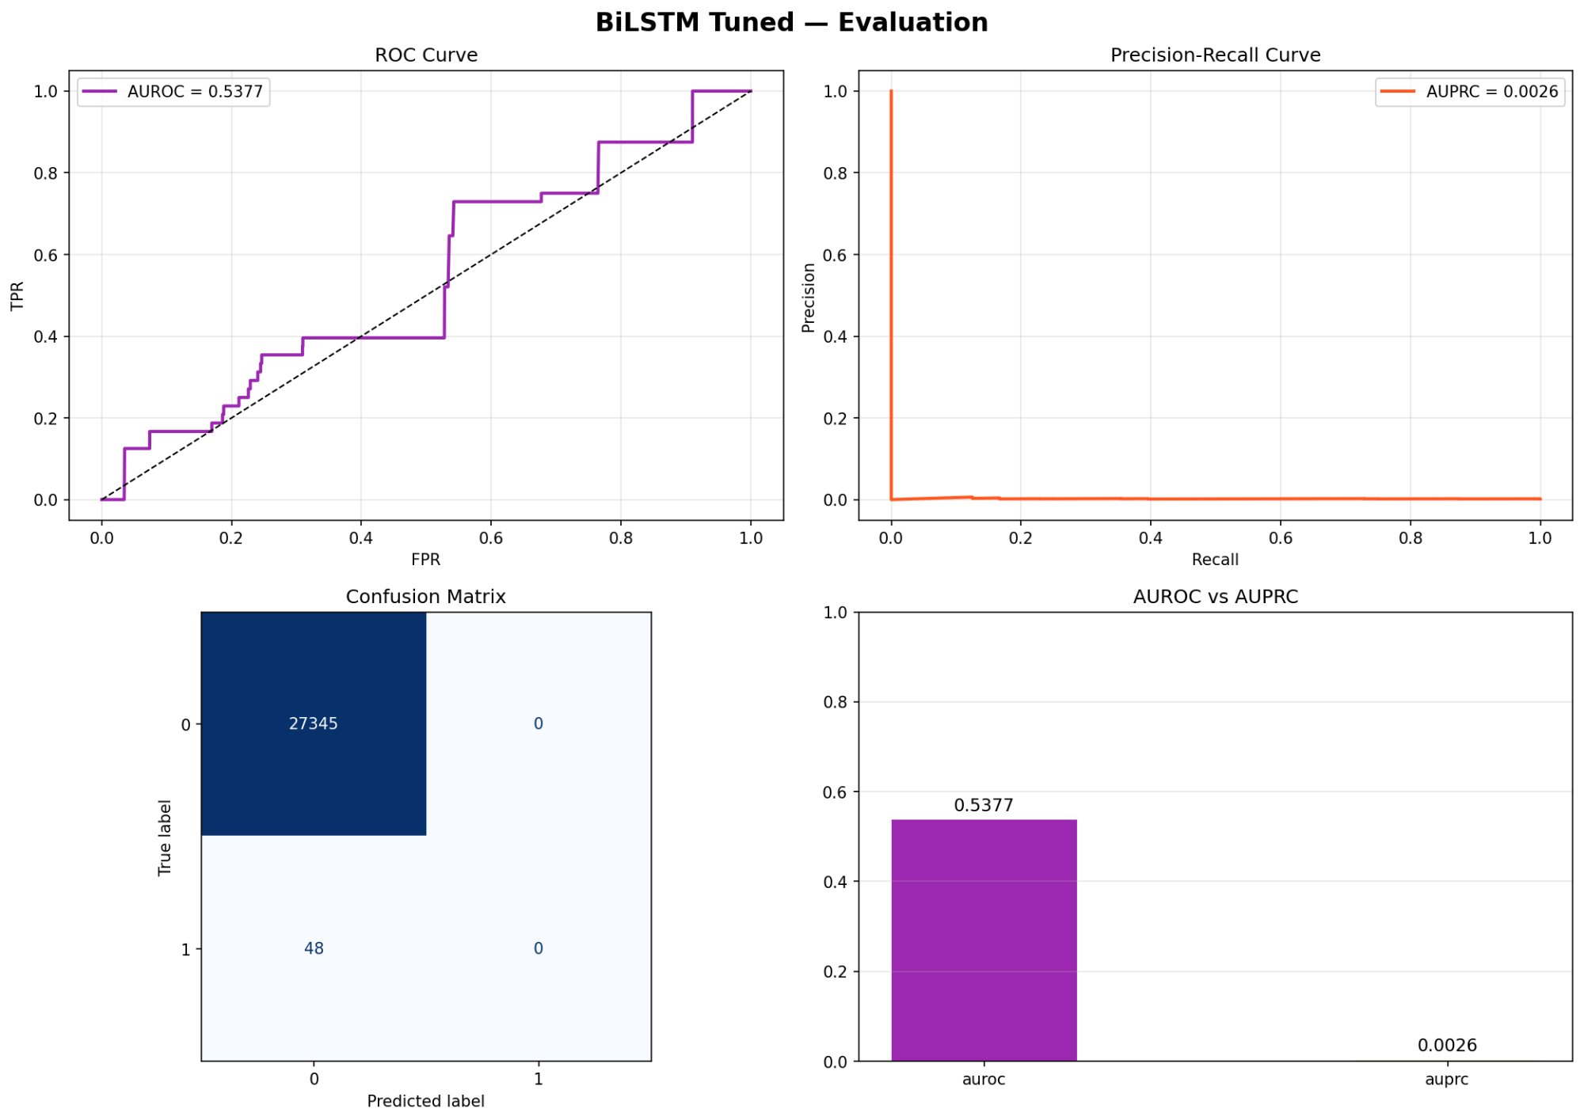

3. Model Comparison
Model | AUROC | AUPRC | units_1 (per dir) | units_2 (per dir) | Total L1 output | Total L2 output | Optimizer
Stacked LSTM | 0.5027 | 0.0030 | 128 | 32 | 128 | 32 | Adam
BiLSTM | 0.5377 | 0.0026 | 128 | 32 | 256 | 64 | Adam

3.1 Observations
- Both models share identical best hyperparameters — units_1=128, units_2=32, dropout_1=0.1, dropout_2=0.4, optimizer=Adam
- BiLSTM achieves slightly higher AUROC (0.5377 vs 0.5027) but lower AUPRC (0.0026 vs 0.0030)
- Both models show poor overall performance — likely due to tabular data with seq_len=1
- Confusion matrix shows all predictions classified as negative — neither model predicts the positive class
- AUROC near 0.5 and AUPRC near 0.003 indicate the models are not learning meaningful patterns

3.2 Tuning Method
Both models used RandomSearch from keras_tuner with the following configuration:
- max_trials = 10 — 10 random hyperparameter combinations tested
- objective = val_loss — best trial selected by lowest validation loss
- EarlyStopping(patience=3) — each trial stops automatically when val_loss stops improving
- Final training: up to 30 epochs with EarlyStopping
- Best models saved as best_stack_lstm.keras and best_bilstm.keras

4. Libraries & Tools
Library | Usage
TensorFlow / Keras | LSTM, Bidirectional, Sequential, Dense, Dropout
keras_tuner | RandomSearch hyperparameter tuning
scikit-learn | roc_auc_score, average_precision_score, confusion_matrix
matplotlib | Plotting ROC, PR curves, confusion matrix, bar charts
pandas | Loading CSV data
numpy | Array reshaping and manipulation

