Project Justifications & Documentation Content (C1 & C2)
This document provides the necessary professional justifications and descriptions for each point in the project rubric.

Group 6 : Ahmad Bdour , Ahmad Shoumer , Rayan Sawallha , Heyam Badran
Repo Link : https://github.com/AhmadBdour1/Demo_LMS_Using_Patterns.git

C2 – Pattern Selection & Application (The Technical Core)

1. Problem Analysis & Trade-offs (Weight: 3)
The Problem:
"In our Learning Management System (LMS), creating a Course object became increasingly complex. A course requires multiple attributes: ID, title, description, an assigned instructor, and a list of lessons. Using a standard constructor led to a 'Telescoping Constructor' anti-pattern, making the code hard to read and prone to errors when parameters were swapped."

Design Challenges:
- Immutability: We wanted to ensure a Course object is fully formed before use.
- Optional Parameters: Some courses might not have descriptions or lessons initially.
- Readability: Constructing a course with 5+ parameters in a single line is unmaintainable.

Comparison & Trade-offs:
- Option A: Factory Pattern: Good for creating families of objects, but doesn't solve the complex multi-parameter construction problem.
- Option B: Builder Pattern (Selected): Perfect for step-by-step construction. It provides a fluent API, improves readability, and ensures that the final object is valid.

2. Pattern Selection & Justification (Weight: 3)
Selected Pattern: Builder Design Pattern

Justification:
"We selected the Builder Pattern because it follows the Single Responsibility Principle by separating the construction of a complex Course object from its representation. It also adheres to the Open/Closed Principle, allowing us to add new construction steps (like adding 'Prerequisites' or 'Categories') without modifying the existing Course class logic."

3. UML Diagrams & Design Documentation (Weight: 4)
UML Justification:
"Our UML Class Diagram illustrates the decoupling between the CourseBuilder interface and the DefaultCourseBuilder implementation. This abstraction allows the system to support different types of course builders (e.g., VideoCourseBuilder vs InteractiveCourseBuilder) in the future without changing the client code in the CourseController."

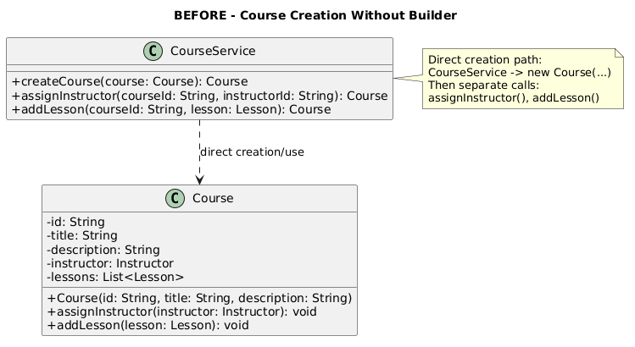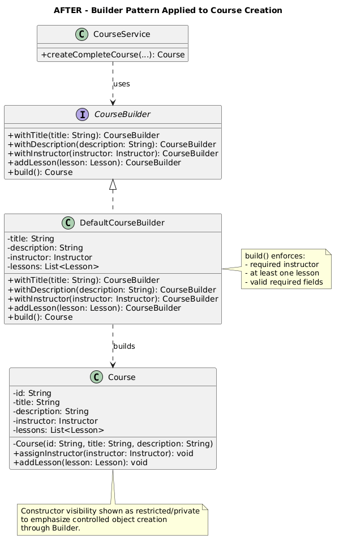

4. Pattern Implementation (Weight: 5)
Implementation Highlights:
- Fluent API: Methods like .withTitle(), .withInstructor(), and .addLesson() return the builder itself, allowing for method chaining.
- Encapsulation: The Course constructor is kept package-private or used only by the builder to prevent inconsistent object states.
- Structure: Clear separation between patterns.builder package and the domain.course package.

C1 – Collaboration & Project Delivery (The Teamwork)

5. Team & Task Management (GitHub) (Weight: 3)
Justification:
"We utilized a GitHub Project Board to manage our workflow. Tasks were broken down into 'Backlog', 'In Progress', and 'Done'. Each task was linked to a specific GitHub Issue, ensuring that every team member knew their responsibilities and deadlines, mimicking a professional Agile/Scrum environment."

6. Individual Contributions (Weight: 3)
Justification:
"Our contribution log shows a balanced distribution of commits. We followed an Atomic Commit strategy, where each commit represents a single logical feature or fix. This allowed for easier code reviews and ensured that each member's specific impact on the codebase is traceable and verifiable."

7. Quality of Team Output (Weight: 4)
Justification:
"The final LMS project is a cohesive, integrated system. We ensured quality through Peer Code Reviews on GitHub Pull Requests. The Backend (Java/Builder Pattern) and Frontend (HTML/JS) are seamlessly connected via a RESTful-style API, providing a complete end-to-end user experience."

8. Final Presentation (Weight: 5)
Justification:
"Our presentation covers the entire software development lifecycle of this project: from identifying the 'Telescoping Constructor' problem to implementing the 'Builder Pattern' solution. Each member presents their specific technical role, demonstrating both individual expertise and collective team synergy."

