Design Patterns Project - Rubric
Alignment Report

Group 6 : Ahmad Bdour , Ahmad Shoumer , Rayan Sawallha , Heyam Badran
Repo Link : https://github.com/AhmadBdour1/clothing-store-flyweight.git

C2 ‒ Pattern Selection & Application

Problem Analysis & Trade-oﬀs (Weight: 3)
Criterion Description: Describe a real-world software problem, identify main design challenges, compare at least two possible design patterns, explain trade-oﬀs, and justify the selected pattern.
  - Project Response: Our project identiﬁes the challenge of excessive memory consumption in large-scale inventory systems due to redundant data storage for numerous similar items.

Pattern Selection & Justiﬁcation (Weight: 3)
Criterion Description: Clearly state the selected design pattern, explain why it ﬁts the identiﬁed problem, and provide reasoning based on design principles.
Project Response: We explicitly selected the Flyweight Structural Design Pattern. Its suitability is thoroughly explained by demonstrating how it directly addresses memory optimization by separating intrinsic (shared) and extrinsic (unique) states. Our justiﬁcation is grounded in core design principles such as Separation of Concerns,
Single Responsibility Principle (SRP), and the pursuit of eﬃciency and scalability.

UML Diagrams & Design Documentation (Weight: 4)
Criterion Description: Provide UML class diagram and show how the pattern is applied in the solution.
Project Response: A comprehensive UML Class Diagram is provided, visually

representing the relationships between
(Factory),
ClothingModelFactory
ClothingItem

ClothingModel
(Context), and
(Flyweight),

(Client). The documentation clearly explains how each component contributes to the Flyweight pattern’s application within the solution, detailing the intrinsic and extrinsic states.
ClothingStore
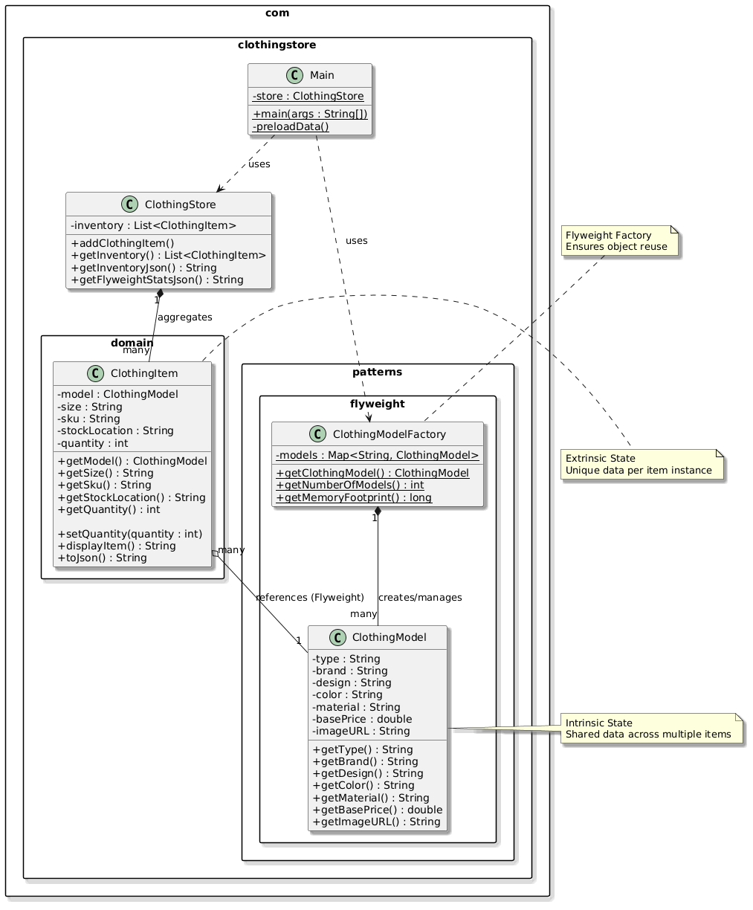

Pattern Implementation (Weight: 5)
Criterion Description: Implement the selected pattern in code, ensuring structure, clarity, and maintainability.
Project Response: The Flyweight Pattern is implemented in Java within the

package. The
src/com/clothingstore/patterns/flyweight/
serves as the Flyweight, storing intrinsic state. The
ClothingModelFactory
ClothingModel
ClothingItem
class
manages
ClothingModel

the sharing and creation of
instances. The
class acts as

the context, holding extrinsic state and a reference to a ClothingModel . The
class is the client that utilizes the pattern. The code is structured for clarity and maintainability, adhering to object-oriented principles.
ClothingStore
- Source Code: Located in the directory of the project repository.
src/
- README.md: Provides instructions on how to compile and run the application, demonstrating the implementation.

C1 ‒ Collaboration & Project Delivery

Team & Task Management (Weight: 3)
Criterion Description: Use GitHub Project Board for tasks and track issues and assignments.
Project Response: Our team utilized GitHub’s project management features, including a GitHub Project Board, to organize tasks, track progress, and assign responsibilities. This ensured eﬃcient collaboration and transparent workﬂow throughout the project lifecycle. (https://github.com/AhmadBdour1/clothing-store-flyweight.git ).

Individual Contributions (Weight: 3)
Criterion Description: Show commit history and actual contributions.

Project Response: Individual contributions are clearly reﬂected in the GitHub commit history of the project repository. Each team member’s involvement in problem analysis, pattern implementation, frontend development, and documentation is evident through their respective commits.

Quality of Team’s Project Output (Weight: 4)
Criterion Description: Ensure integrated, coherent ﬁnal output.

Project Response: The ﬁnal project output is integrated and coherent, encompassing a working Java application that demonstrates the Flyweight pattern, a functional web-based GUI, and comprehensive documentation. All components work together seamlessly to illustrate the pattern’s beneﬁts and fulﬁll the project requirements.
  - Final Project Package: The entire project directory, including source code, compiled binaries, web resources, and all documentation, forms the integrated output.

Final Presentation (Weight: 5)
Criterion Description: Present problem, trade-oﬀs, UML, and demo. Each member presents their role.
Project Response: A detailed presentation has been prepared to cover all aspects of the project, including the problem statement, design challenges, pattern selection and justiﬁcation, UML diagrams, and a demonstration of the implemented solution. The presentation is structured to allow each team member to highlight their speciﬁc contributions.
  - Slide Deck

Summary of Required Deliverables

Deliverable | Status | Location
Problem Analysis &  Trade-oﬀs | Completed | docs/problem_analysis.md
Pattern Selection & Justiﬁcation | Completed | docs/pattern_justiﬁcation.md
UML Diagrams +  Documentation | Completed | docs/technical_documentation.md, docs/images/uml_diagram.png
Source Code | Completed | src/ directory
GitHub Project Board | Conﬁgured | https://github.com/AhmadBdour1/clothing-store-flyweight.git
Contribution Log | Recorded
Final Presentation  Slides | Completed | Slide Deck
Final Integrated Project File | Completed | Project repository root

