Final Year Project Report
Adding Subtitles and Visual content to Sign Language

Project Advisor:
Nabeel Sabir Khan

Submitted By:
Ahmad Bilal 12003065105

Session
2012 - 2016

University of Management and Technology
C-II Johar Town Lahore Pakistan

Dedication

There are moments when we lose our spark, but is restored by another human being. I am grateful to all those who have reignited this spark. I owe my thanks to my Teachers and my Parents who were always there to see the best in me. Thank you very much!

Truth is eternal.
Knowledge is changeable.
It is disastrous to confuse them. - Madeleine L'Engle

Final Approval

Panel of Examiners

- Head of Department ______________________
Department of Computer Science
UMT Lahore

- Program Director ( Final Year Projects) ______________________
Department of Computer Science
UMT Lahore

- Supervisor ______________________
Department of Computer Science
UMT Lahore

- Co-Supervisor ______________________

Acknowledgements

Abstract
Population of deaf and hearing impaired personnel is increasing day by day and communication gap between hearing impaired and unimpaired is larger than ever. Very few efforts have been done for Pakistan to bridge this gap, this research is intended to facilitate deaf community of Pakistan by proposing grammar based conversion system for English and Urdu speech from a media file to equivalent Pakistan Sign Language sentences. For this, we have used API’s and services like Google Speech Recognition to recognize words spoken in the media file, Google Translation to translate Urdu to English, Machine Learning based python script to punctuate English transcript, Google Natural Language services to Extract Sentences from Transcript and our English to Pakistan Sign Language translation module for conversion to English Sentences to equivalent Pakistan Sign Language Sentences. Our system can recognize audio from multiple video and audio sources which enables us to use this system on vast scale. We gathered data, audio/video sentences and stories, to validate and improve accuracy of our system. With use of well-developed and intelligent services we were able to achieve 99.30% accuracy in case of sentence recognition and 94.25% accuracy in case to story recognition.

Contents
Dedication 2
Final Approval 3
Acknowledgements 4
Abstract 5
Contents 6
Definitions and Acronyms 8
List of Figures 9
List of Tables 10
1 Introduction 11
1.1 Sign Language 11
1.2 Problem Definition 11
1.1.1 Problem Overview 11
1.1.2 Purpose 12
1.1.3 Research Objectives 12
1.1.4 Research Questions 13
1.1.5 Functional Requirements and Use Case 13
1.1.6 Outcomes 14
1.3 Scope 14
1.4 Significance / Potentials 14
1.4.1 Educational Sector 14
1.4.2 Health Sector 14
1.4.3 Employment Sector / Business Sector 14
1.4.4 Other 15
2 Literature review 16
2.1 Background 16
16
2.2 Purpose and Method 17
2.3 Machine Translation Introduction 17
2.4 Speech Recognition 17
2.5 Speech Translation 17
2.6 Recent Growth 18
2.7 Gap Analysis 18
3 Proposed Methodology 19
3.1 Research Process 19
3.1.1 Literature Review & Empirical Study Observations 19
3.1.2 Data Gathering and Verification 20
21
3.1.3 Prototyping Proposed System 22
3.1.4 Prototype Validation 23
3.2 Suggested Approch 23
3.3 Design and Architecture 24
3.3.1 Preprocessing: 24
3.3.2 Word recognition 25
3.3.3 Translation and Punctuation 26
3.3.4 Sentence Extraction 26
3.3.5 English to PSL Conversion 27
4 Evaluation 28
4.1 Experimentation 28
4.1.1 Experimental Setup 28
4.1.2 Prototype Validation 28
4.1.3 Testing 35
4.2 Results 37
4.2.1 Sentence Recognition Results 37
4.2.2 Story Recognition Results: 41
5 Conclusion and Future work 42
6 References 43
7 Appendix 44
Glossary of terms 44
7.1 Implementation Code 44

Definitions and Acronyms

SL Sign Language
PSL Pakistan Sign Language
NLP Natural Language Processing
MT Machine Translation
ACM Association for Computing Machinery
IEEE Institute of Electrical and Electronics Engineers
ASL American Sign Language
BSL British Sign Language
GSL German Sign Language
TSL Turkish Sign Language
FSL French Sign Language
GSA Google Speech API
GTA Google translation API
GNLA Google Natural Language API

List of Figures

Figure 1.1 Use cases of the system
Figure 2.1 Reducción de las letras y arte para enseñar
Figure 2.3 Basic Machine Translation Workflow
Figure 3.1.1 Research Process
Figure 3.1.2 Data Categorization
Figure 3.1.3 Data Verification Process
Figure 3.1.4 Architectural Diagram
Figure 3.2.1 Workflow Diagram
Figure 3.3.1 Preprocessing of Data
Figure 3.3.2 Word Recognition Process
Figure 3.3.3 Translation and Punctuation Process
Figure 3.3.4 Sentence Extraction Process
Figure 3.3.5 English to PSL Conversion Process
Figure 4.1.1 Prototype Validation process
Figure 4.1.2-12 Validation Process Screens
Figure 4.1.13 Testing

List of Tables
Table 1 English Sentence Recognition Results
Table 2 English Story Recognition Results

Introduction

Sign Language
Language is the basic mean of communication between human beings. An expression cannot be a language expression unless it conveys some meaning, and all the languages we know today are not merely exchange of sounds and gestures, but also exchange of meaning.
Languages today mainly comprise of body language and verbal communication. Body language further include body orientation, gestures and facial expression whereas verbal communication consists of meaningful sounds and words. Spoken languages consist of body language and verbal language, whereas Sign Language only consists body language. This narrow down sub-means of communication to only body orientation, gestures and facial expression because listening ability is absent either due to age, accidental loss or genetic deficiency. Genetic deficiency, being leading cause of hearing impairment, is also hardest to tackle as these people cannot also speak due to the absence of repetitive phonetic speech learning [1].
In Sign Language meaning is conveyed through gesture and facial expressions. Gestures are distinguished through orientation of fingers, hands, elbows and shoulders whereas facial expressions are distinguished by change in expression through different orientations of eyebrows, jaws and lips. This means that one gesture has a specific meaning, and by using multiple gestures we can convey meaningful phrases [2].
Every region has its own set of gestures for communication, some gestures may be common in multiple sign languages but grammatical structure varies from country to country. This makes facilitating hearing impaired through a generalized platform difficult and demands to establish separate domain research for every country.

Problem Definition

Problem Overview
As the field of computer science dwells into research and inventions to make our lives better, there is seldom a field where the knowledge of computer science cannot be applied to achieve our goal. People with disabilities have always been present in the world, millions of people who are disabled right now are living on his planet, of which, people with hearing disabilities comprises a large portion. It is estimated that over 5% of total world population has disabling hearing loss. These 360 million people (328 million adults and 32 million children) face many challenges in their life when competing with unimpaired competitors and it is estimated that this number will grow greatly in future.
The biggest challenge deaf people have to face is the communication gap created by the absence of a common language between hearing impaired and unimpaired. They are unprivileged in education, employment, social and many other areas of life. The only way to improve the living standard of these deaf people is by minimizing this communication gap created by unavailability of a common medium to communicate. The only language deaf or hearing-impaired people can understand is sign language and the same language enables them to communicate with other people. Over 70 million hearing-impaired people use sign language as their first language or mother tongue. Considering the difficulties faced by deaf people, it is needed that this communication gap must be reduced, if cannot be eliminated.

Purpose
Many developed countries have used the knowledge of computer science to bridge this communication gap. Many systems have been created in order to allow communication between natural language (spoken language) and sign language (See Section 2.1). But no such efforts have been done in Pakistan and deaf community in Pakistan is still far unprivileged in comparison to deaf community of developed countries like America, Germany and France. This project is a leaping step for the benefit of deaf community in Pakistan, trying to solve the problem of communication between deaf and normal people.
Some research work on PSL has been contributed in recent years (see Chapter 2.5), but no solution exists to achieve enough accuracy and reliability to be used as a product of facilitation. Our purpose of this research is to use state of the art tools and technologies, implemented using machine learning and recognition algorithms, to achieve our desired accuracy and portability.
In order to understand PSL, our problem domain, we have thoroughly reviewed literature to acquire diverse knowledge of existing research done directly or indirectly in this domain (See Section 2). Analyzing existing solutions and analyzing possible solutions were also included in our literature review [3].
We explored these areas and analyzed them for our prototype:
- Audio encoding and processing.
- State of the art ML and NLP techniques
- Speech to text conversion techniques.
- Existing language text converters.
- Existing frameworks and technologies.
We have acquired information from:
- Books
- Digital Libraries
- Search Engines
  - ACM
  - IEEE
  - Google Scholar

Research Objectives
Our research objective is to minimize communication gap between hearing impaired and unimpaired people by exploring research domain, identifying gaps, proposing number of possible solutions and prototyping the best solution to the problem. Decision making throughout the research duration depends on, feedback received from sign interpreters, and feasibility of the solution according to local infrastructure.

Research Questions
This research attempts to answer these following questions:
- How can understanding of media content be improved for deaf person?
- How can we translate content of English/Urdu video or audio to equivalent PSL Sentences while retaining its grammatical structure?

Functional Requirements and Use Case
The functional requirements for our system were devised after considering ease of access, adequate response time and deployment techniques according to local infrastructure. Requirements fall in four categories:
- Input Requirements
- Output requirements
Input Requirements
Developed system should have following input requirements:
- System must accept multiple video formats
- System must accept multiple audio formats
- English Sentences should be acquired through text file.
- System should be able to record audio through microphone input.
Output Requirements
Developed system should have following output requirements:
- System should output PSL Sentences as an output.
- Log should be maintained for better understanding of current activity.
- System should store processed audio file on disk.
- System must be able to play selected audio/video file through a media player.
Use case diagram of our system can be seen in figure 3.1.3.
Figure 1.1 Use Case Diagram

Outcomes
After carefully analyzing existing solutions and their deficiencies, possible solutions and their suitability, exploring Media processing tools, Speech recognition tools, English language punctuation tools and Natural language processing tools we have proposed a system which take English or Urdu media file and convert it into equivalent PSL sentences.

Scope
With English and Urdu Video-to-Pakistan Sign Language, the scope of this project is restricted to videos with clear phonetics in their speech as any mumbling will cost in accuracy of the solution. Limited data will be used to test and verify the system.

Significance / Potentials
As an emerging field of computer science, automatic translators and interpreters can benefit people of Pakistan as much as they have benefited for developed countries, they can be a bridge the communication gap between deaf and unimpaired people.
Our society can use such a system in:
- Educational
- Health
- Employment
- Business
- Other

Educational Sector
This prototype can be used to build a system which will enable hearing impaired students to take lectures along with other students. Our system can take input from resource person, in either English or Urdu, and then translate it into equivalent PSL sentence. Which can then be easily understood by deaf community because this conversion is based on consistent grammatical structure.

Health Sector
A similar system can be implemented in hospitals, nursing houses, medical camp etc. such that it will help the doctors to diagnose a deaf patient, at the same time it will allow deaf patients to fully understand the prescription and advice of the doctor.

Employment Sector / Business Sector
By minimizing the communication gap between hearing impaired and unimpaired people we will allow great opportunities to flow towards the deaf community. It will be easier for them to find jobs and do business which they were unable to do before and they will earn easy acceptability in our society.

Other
It will open new doors of entertainment for deaf community as they will be able to experience movies and other similar content through better understanding of its verbal content.
Government institutions can benefit from this system as it will allow them to easily inquire data from a deaf person by using this system as help.
Our prototype will open doors to significant future research in this field. With more research in this area more advanced and complex systems can be developed using this prototype which can eventually help the deaf and disabled people in Pakistan.

Literature review

Background
The origin of sign language dates back to the beginning of history, when man had not invented spoken languages. He used signs to communicate with each other. Many Ethnic groups with different spoken languages has used sign language to communicate with each other regardless of their ability to speak. We can say gestures are the basic innate medium between people.

In Cratylus, written by Plato in 5th BC, Socrates said:
“If we hadn't a voice or a tongue, and wanted to express things to one another, wouldn't we try to make signs by moving our hands, head, and the rest of our body, just as dumb people do at present?”
This is the oldest recorded history of concept of sign language. Later, major work was done in 16th centuary by Juan Pablo Bonet in his book:
“Reducción de las letras y arte para enseñar a hablar a los mudos”.
This literature is considered first work in the field of Phonetics and Oral Speech System using basic sy0mbols and gestures.
Figure 2.1 Reducción de las
Around 1750, organized research was started on Sign Language, which was then used to convey silent massages in war. It was only in early 1900 that sign language interpretation systems were started to be developed in order to facilitate hearing impaired and deaf people.
The only way for the hearing impaired to express themselves is through sign language. There are at least 200 different sign languages in the world right now, but only some of them are well developed. By developed, we mean those languages for which proper documentation on grammatical, semantical and syntactic structure is available.
Few well developed sign languages are:
- American Sign Language (ASL).
- British Sign Language (BSL).
- German Sign Language (GSL).
- French Sign Language (FSL).
- Turkish Sign Language (TSL).

Purpose and Method
For better understanding of our extensive research, Translation will be discussed in next section.

Machine Translation Introduction
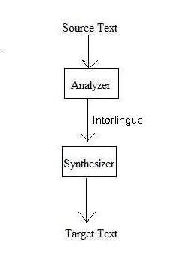
Machine Translation is described by many people in different ways but they all point to the same concept.
Figure 2.3 Machine Translation
Machine Translation can be defined as:
“Machine Translation (MT) is a subfield of natural language processing which utilizes the computational power of computer to convert speech or text from one language to other.”

Concept of machine Translation is not new, but it was only made possible in the 20th century when capability of computer to convert huge amount of text from one language to another was explored. At first a lot was expected from MT, but due to inability of a which can perform a perfect translation without human support. MT performs complex tasks like phrase recognition and linguistic translation using text from one language and translates into text of another language [4].
Machine Translation was also known as “Automatic Translation” in past, but this term is not used anymore, now researchers use “Machine Translation” [5].

Speech Recognition
Speech recognition started in 1950 with a system, named “Baby Talk”, which was able to recognize spoken digits. Later in 1970 many systems were developed, which were able to recognize few English words. It was only a decade ago that Hidden Markov Models were used to develop probability based speech recognition systems, which made it possible to develop systems with machine learning techniques and facilitate modern world [6].

Speech Translation
Translation can be defined as:
“Translation is the reproduction of text from source language to target language in such a way that translated text retains the meaning which was conveyed in source text [7].”
Recent development has made automatic speech translation more practical than before. It has grown from a small scale to full scale industrial tools in few years.

The process of translation involves converting source language text to target language text, this requires in depth understanding of:
- Semantics of both languages.
- Syntax of both languages.
- Grammar of both languages.

Recent Growth
Many multinational companies, main users of MT, use machine translation as they require huge amount of data to be processed in many languages. These companies use systems which output raw data which is further processed to achieve higher accuracy.
Online translation services are a new concept nowadays. Many vendors charge huge amount of money for their accurate translation systems.
Few of these service providers are:
- CompuServe
- Systran
- Google
- FreeTranslation
- Reverso,
- ProMT
Google has been able to translate emails and web pages through its translation system. Most of the state of the art tools and operating systems come with extensive language support to translate user interface into the desired language [8] .
Now that we have discussed MT, its applications and recent development, we will now expand the area of speech translation.

Gap Analysis
Although research has been done in field of MT and SL in past few years, there is still a lot of work which should be done in this area. Either existing approaches does not address the problem with practical applications of the system or they do not conclude the solution appropriately.

Proposed Methodology

Research Process
Our research work started from exploring our domain, its challenges, its outcomes, issues and gaps in existing research work as well as literature review with empirical study of particular domains. Outcomes of which, after careful consideration, were used for proposing the system. After implementation of the proposed system, the prototype was tested and verified which leaded to improvement and optimization of the system.

Figure 3.1.1 Research Process

Literature Review & Empirical Study Observations
We did extensive Literature reviewing in order to fully understand possible solutions to our problem. We had to study areas of machine translation, natural language processing and audio processing to propose our solution. Observations made during that time are:
- No solution exists to facilitate deaf people to understand Video/Audio content.
- Solutions that exists follow no grammatical structure while converting source language to PSL.
- No solution exists for translating Urdu language to PSL, albeit Urdu is National language of Pakistan.
- All of the existing English to PSL conversion systems either require some form of human support or large dictionaries.
- We cannot use or extend any existing systems to formulate our solution as none of them provide enough accuracy.
From these observations we concluded that our system must be generic, so that it can accept multiple audio/video formats, which will enable our research to be easily usable in future.
At initial stage of our project, we did some initial literature reviewing. After some understanding of our domain, our research process continued with interview process with domain experts and in-depth literature reviewing working in parallel, this was to measure feasibility and benefits of proposed solutions. The observations made during interviews are:
- Deaf people hire sign interpreters in order to communicate with other people. This can be costly and sign interpreters are sometimes unavailable. So a system must be developed in order to minimize this dependency.
- English is taught to deaf students, so a system must exist to enhance their learning capabilities by allowing them to take online lectures.
- There must exist a system to cover communication gap between deaf and Urdu speaking community.
While proposing our system, all observations were kept in mind, in effort to cater problems faced by deaf community.

Data Gathering and Verification
Our research is highly dependent on data, because limitations and scope of the research is defined by our data set. Inconsistent and ambiguous data can significantly reduce accuracy of the system, this is why we acquired data from reliable sources and re-verify them to make sure that our system is accurate and consistent.

Figure 3.1.2 Data Categorization

There are two types of data used in our research:
- Primary Data:
  - Recorded videos of Elder People (50 years+) Speaking in English and Urdu
  - Recorded videos of Adults (20-50 years) Speaking in English and Urdu
  - Audio Stories
  - Audio Sentences
- Secondary data:
  - Online learning resources
  - Entertainment videos
  - Video surveys

Diversification of data was necessary to make sure our solution is generic in input acceptance. Our solution can take multiple types of video/audio formats, so it was necessary to collect data in multiple video/audio formats to test and verify our system.
Our solution can accept two languages, English and Urdu as input, and then generate transcript based on recognized words. So, for accuracy, we made sure that our data is valid, in terms of source language, and then we made sure that our data has proper pronunciation and phonetics of English and Urdu language.

The collection and verification of data is significantly important for the system to run accurately. For this purpose, we gathered data from multiple sources, analyzed it and verified from our system to calculate results. After many iterations of this process we were able to gather data with accurate and consistent results.
Figure 3.1.3 Data Verification

Each part of this process was tightly observed for any exceptions that may arise and all of the data is verified before jumping to results.

Prototyping Proposed System
For implementation of our system, after careful consideration of alternatives and weighing their pros and cons, we have selected following tools and technologies:
- C Sharp Programming Language: for implementation of our prototype, we have selected C# programming language because it is widely used throughout the world for research development and prototyping. User Interface of our prototype is developed using Windows Forms due to their simplicity.
- MediaToolKit: we have selected this toolkit for extraction of audio from video. Due to its ability to convert multiple formats, we were able to make our system generic in its input acceptance.
- Google Cloud Speech API: we used Google speech API due to its artificially intelligent recognition system. It is implemented using Deep leaning algorithms and Multilayer Neural Networks.
- Google Cloud Translation API: google translation service allows us to translate between 80 languages. We have used this service to translate Urdu language text to English. It has superior translation accuracy and ability to retain meaning while translating one language to another in comparison with its alternatives.
- Google Cloud Natural Language API: we have used this service to extract sentences from our punctuated text. It gives us freedom to extract a lot or information from unstructured text like parts of speech tags, sentiment analysis and syntax detection. We have used this tool for syntax detection of our text.
- Punctuator 2: recognized word stream from google speech API has no information about sentence completion, so we are using this web service to punctuate our string of recognized words. It is implemented in python using libraries like TensorFlow, Keras and Numpy and it has a statistical based learning model trained over 70 thousand web articles.
- Sax: to split our source audio file into multiple smaller wave files, so that Google Speech API can accept it (See section 3.3.1), we have used this command line tool due to its ability to separate audio file using silence detection.

Some alternatives to our selected tools and technologies are:

Selected Tools & Technologies | Alternative Tools & Technologies
C# Programming Language | JAVA Programming Language
MediaToolKit | MultimediaSoft .net package  Conversion.Net package
Google Cloud Speech API | Microsoft Bling Speech API  Microsoft Audio Recognition Engine  Speechmatics Speech Recognition
Google Cloud Translation API | Microsoft Translator API  Unbabel Translation API
Google Cloud Natural Language API | Stanford Natural Language API  IBM Watson Natural Language API
Punctuator 2 | Keras Punctuator

The architecture design of our prototype is shown below:

Figure 3.1.4 Architectural Diagram

Prototype Validation
Optimization of the research strategy and algorithms depended on feedback given by our prototype. Results based on our dataset, were consulted with sign interpreters in effort to improve usability and productivity of system (See figure 3.1.1). This process was repeated until desired accuracy was achieved without sacrificing the performance of the system (See Section 4).

Suggested Approch
After careful consideration of our scope and limitations of our research, we were able to propose a system which include our other existing modules as solution to sub-problems faced during this research. We have developed our prototype using state of the art tools and programming languages, so that it can be easily compatible, with newer platforms and frameworks, in future. We have used latest programming techniques and models for implementation so that our prototype is easily understandable for future research work.
We are using our previous research of English to PSL Translator, its prototype and data set in this research to build a layer above it, so that components written in different tools and languages can work as a whole unit. This will also help in future research as layer of abstraction has been provided.
Figure 3.2.1 Workflow of the System
A modular based implementation has been done in order to facilitate future research work.

Design and Architecture
Our system is well capable of giving accurate results on properly pronounced input media, it can also give good results on pronunciations other than native language.
This media file goes through many processes to be able to be converted into PSL sentence.
Following are the main processes of our system, we’ll discuss each in detail below:

- Preprocessing
- Word recognition
- Translation and Punctuation
- Sentence Extraction
- PSL Conversion

Preprocessing:
To work with media formats we have to convert and reformat the audio stream, it is necessary because audio streams containing unnecessary information becomes an overhead during processing. Response time is increased and accuracy is compromised when dealing with large files.
We are using Google Speech API for word detection, we have to reformat our audio according to the input format which API accepts. Our proposed methodology to achieve this:

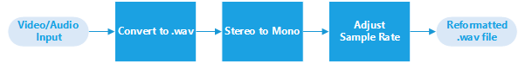
Figure 3.3.1 Preprocessing Data
First we have to extract audio from video format, we have used an API named MediaToolKit for this purpose. Our choice is based on its ability to convert multiple input formats to a desired format. Due to API’s flexibility, we were able to develop simple algorithm which converts multiple video formats to Waveform Audio Format(.wav). We found .wav format easy to handle due to its compressed nature and portability as it is a widely recognized audio format. We must set the sample rate of the output file because Google speech API requires and audio file having sample rate of 44100hz and 1 channel. Our proposed algorithm is as follows:
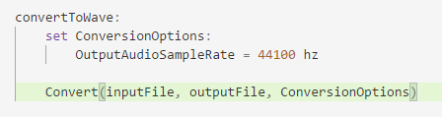
This gives us .wav file having desired sample rate from multiple video formats, but it does not convert audio file from stereo to mono. We had to write another algorithm to convert this .wav file to single channel audio file because Google Speech API accepts only single channel audio. After reformatting and getting .wav file ready we have used a tool –Sax- to split this wave file into multiple smaller wave files, this step was crucial because Google Speech API accepts audio files less than one minute. In next step we will pass these wave files one by one to Google Cloud Speech API, which will return us recognized words string.

Word recognition
Extracting words from digital audio signal has many challenges, accuracy is largely dependent on phonetic sense of the speaker and dictionary of words to recognize from. For these challenges we have used Google Speech API. It is implemented using Machine Learning and Neural Network algorithms which gives it ability to recognize from different pronunciations and a large dictionary of words.

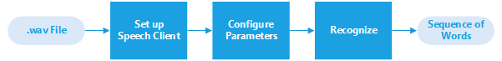
Figure 3.3.2 Word Recognition
Setting up Google speech client require valid API key from Google cloud services. All API’s must be enabled for Cloud Project and then a key in Json format can be acquired, this file will be used as parameters while creating google credentials. After creating client, we will setup recognition configuration which will include details about our audio file, like encoding of the audio and language to recognize, in which case English and Urdu will be passed in parameters. We are using Linear 16 audio encoding for our recognition procedure. Sample rete of the audio is also included in this configuration. Based on these parameters we will request google server to analyze our audio, in case of successful recognition, we will receive a string containing recognized words in sequence. This string will be processed further in our next module to extract meaningful sentences from it.

Translation and Punctuation
This received string has no information other than the recognized words, the only way to extract meaningful sentences from this string is to punctuate it. If recognized language is Urdu, then received string must be translated in such a way that it must maintain its intended meaning. Overview of this module can be understood in the diagram below:

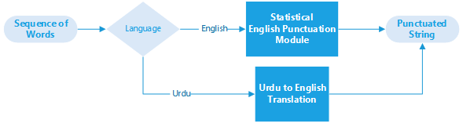
Figure 3.3.3 Translation and Punctuation
In order to extract meaningful sentences from our English sentence we punctuated our string using a python script, it uses a bi-directional recurrent neural network model to restore missing punctuations in text, where incase of Urdu, we used Google Translation API to translate from Urdu to English which returned a punctuated English string. This punctuated sentence will be used in our next module to annotate sub-sentences.

Sentence Extraction
The process of sub-sentence extraction largely depends of the accuracy of punctuation in the sentence. Sentences must be annotated on the basis of sentence termination symbol i.e. period and then extracted from punctuated string. Overview of our proposed methodology for this module is below:
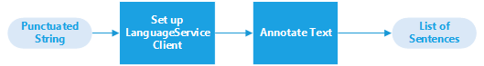
Figure 3.3.4 Sentence Extraction Process

First we have to setup Google Language Client credentials, as we are using Google Language API, by setting up input document type to plain text and content type to text. Then we have to request annotation of our sentence in meaningful sub-sentences, which, in response will return sentences that will be stored in a list for further processing. This list of sentences will be used to generate equivalent PSL sentences. This API also responds us with parts of speech tagging and sentiment value of the sentence, which can be used for further research in future.

English to PSL Conversion
We have English sentences extracted from the media file, stored in a list. These sentences will be sent to English to PSL module to return equivalent PSL sentences in response. These PSL sentences will be stored in a list, containing all PSL transcript of the media file. The diagram below illustrates the flow of data through this module.

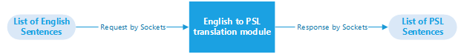
Figure 3.3.5 English to PSL Conversion

We have to establish socket connection with English to PSL module because of diversity of programming languages used to develop these modules. We are converting our English sentences one by one into stream of bytes, from the list, and then sending to translation module, which converts this stream of bytes to string for further processing. This is necessary because translation module, which is on server, is written in java language, which used different encoding scheme for strings, in comparison to our main module, the client, which is written in C# language.
Our PSL module takes English sentence as an input and we have to perform some operations to convert it in PSL equivalent sentence. Stanford NLP toolkit is used to parse input English Sentence to create parse tree and a dependency graph. Both parse tree and dependency graph are merged together to construct an annotated parse tree.
Mapping Translation:
• Word Level Transformation: When an annotated tree is provided to this phase as an input, a pre-order traversal is taken and on the basis of each reduction some rules are fired which are built on the CFG constructed for Pakistan Sign Language.
• Sentence Level Transformation: After traversing this tree we then apply some sentence level transformation rules which are applicable only through the identification of the tense and its category (Meaning vise classification). Output of this phase is our PSL equivalent sentence.
After successful translation of the received string, this module again converts the resultant string into stream of bytes and send the response, to the client, through socket.
The client module then receives and converts the streams one by one to string, saving them in a list, which is intended to save whole PSL transcript.

Evaluation

Experimentation

Experimental Setup
Our system’s input was evaluated on two types of data input:
- English/Urdu Audio
- English/Urdu Video

Audio: Multiple renowned audio formats, i.e. .mp3, .wav, .flac, were used to test our system.
Video: Multiple renowned video formats, i.e. .wmv, .3gp, .mp4, were used to test our system.

Prototype Validation
Our system is validated by two different validation techniques:
- Functional Validation
- Non-Functional Validation

Figure 4.1.1 Prototype Validation

Functional Validation:
For functional validation we have calculated and verified accuracy of English/Urdu speech to English language.
In order to evaluate our system’s accuracy, and its diversity, we had to test our system on two levels:
- Sentence Level
- Story Level
Sentence level: We created data set consisting of English and Urdu sentences, which are used commonly for daily communication, to evaluate our system. Evaluation consists of calculating accuracy between total number to spoken words in the media file and total number to correctly recognized words. Number of missing words and number of misinterpreted words are also used to calculate sentence level accuracy.
Story Level: We must evaluate our story by calculating accuracy of individual sentences and total number of sentences in the story. Sentences are again evaluated by calculating accuracy between total number to spoken words in the media file and total number to correctly recognized words, and whole story is evaluated by calculating accuracy between total number of sentences in the media file and total number of sentences extracted by our system.

Non-Functional Validation:
System response time and CPU and Memory resource utilization were verified during non-functional validation process. We used Microsoft Windows 10 with Intel(R) Core(TM) i3 CPU 2.40 GHz, 3.0 GB of RAM.
Following are the average values taken on 60 readings (1 reading consist of input and corresponding output):
Average Response time: 679 ms
Average CPU utilization: 1.49%
Average Memory utilization: 28 MB

Validation process:
To get better understanding of our validation process, we will discuss one sentence and one story. Step by step demonstration of our system will include GUI screens and options selected to use our system. Our main GUI Screen looks like this:
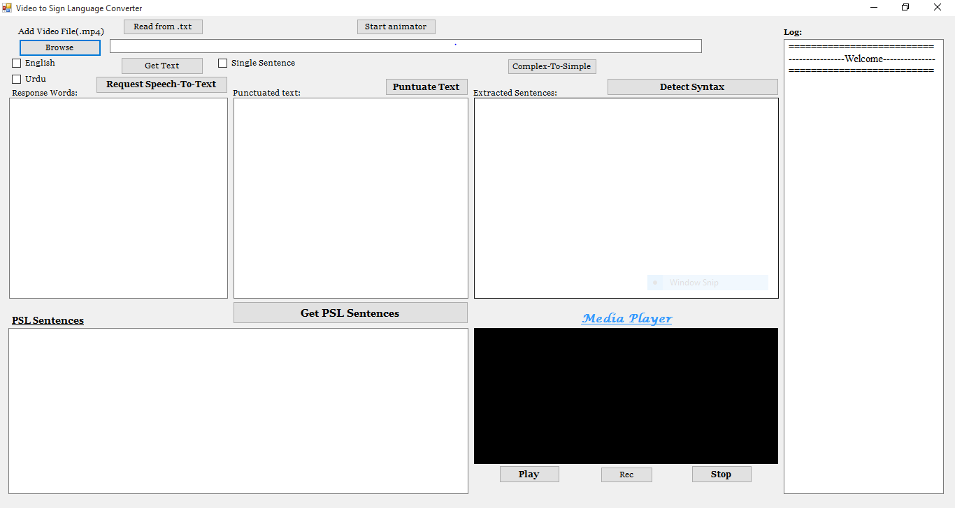
Figure 4.1.2 Main GUI

Sentence Validation Process
- Sentence Selection: We first have to select audio/video file for recognition, which, for demonstration, we have selected sentence “He didn’t want to go to the dentist, yet he went anyway.”.
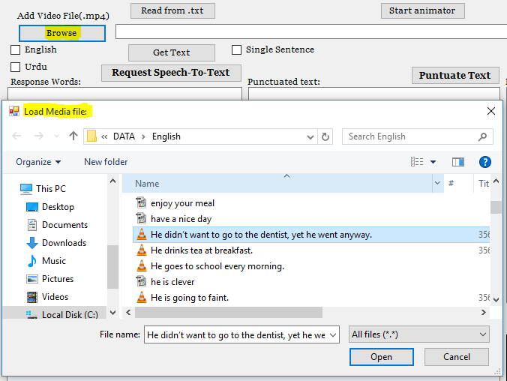
Figure 4.1.3 File Selection
- Speech Recognition: Then we will process our selected file, so that it can be accepted by Google Speech API to recognize sequence of words. Result of this process is displayed in response words box.
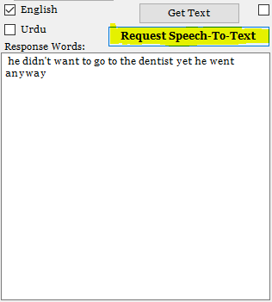
Figure 4.1.4 Word Recognition
- Punctuation: To restore punctuation in recognized string of words we will punctuate our string using a python script. Output of this process is displayed in punctuated text box.

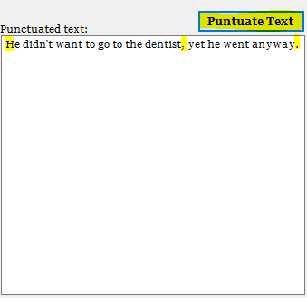
Figure 4.1.5 Punctuation

We can see that punctuation is restored and our string is reformatted to a correct English Sentence.

- PSL Sentence: This sentence is the sent to our PSL translator through sockets. As a result, equivalent PSL sentence is received and displayed in PSL sentence box.

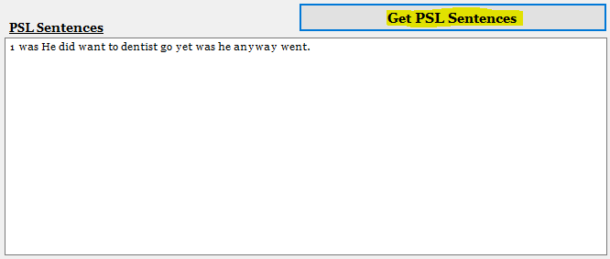
Figure 4.1.6 Equivalent PSL Sentence

Story Validation Process
- Story Selection: We first have to select audio/video story file for recognition, which, for demonstration, we have selected story “Clever Fox”.
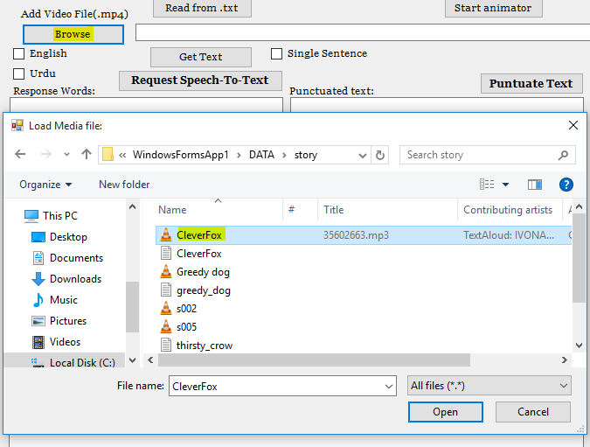
Figure 4.1.7 Story File Selection

- Speech Recognition: Then we will process our selected file, so that it can be accepted by Google Speech API to recognize sequence of words. Result, which is sequence of recognized words, is displayed in response words box.

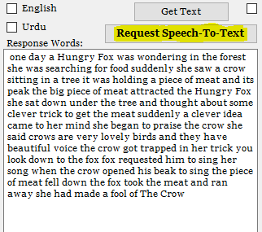
Figure 4.1.8 Generate Transcript
- Punctuation: We have to restore punctuation in recognized sequence of words, so that we can extract individual sentences, we will punctuate our string using a python script. Output of this process is displayed in punctuated text box.

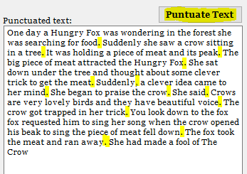
Figure 4.1.9 Punctuated String

We can see that punctuation is restored in our string, this punctuated string will be used in next process to extract sentences.

- Sentences Extraction: We will request Google Natural Language API to return extracted sentences from punctuated string received in last step. We will store these sentences to be further processed in next step.

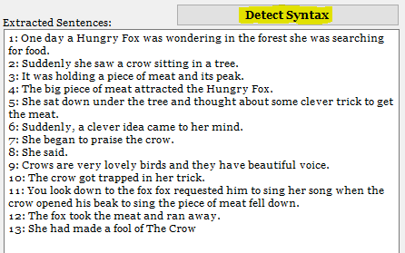
Figure 4.1.10 Sentence Extraction

- PSL Sentence: Extracted sentences from last step are sent to our PSL translator through sockets. As a result, equivalent PSL sentences are received, stored and displayed in PSL sentence box.
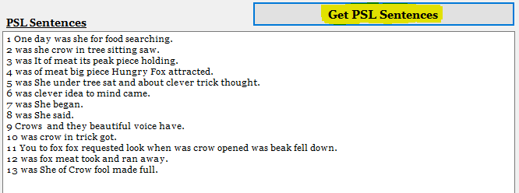
Figure 4.1.11 Equivalent PSL Sentences

Final GUI screen after whole process is:
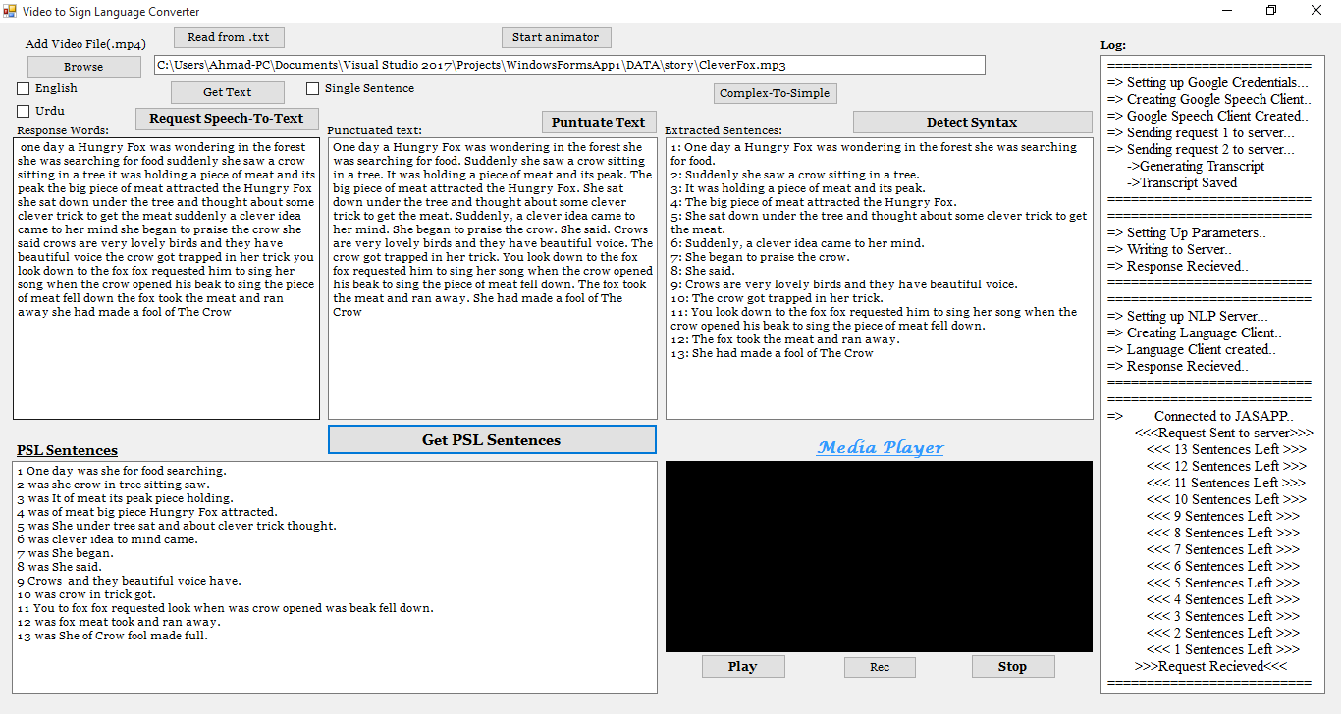
Figure 4.1.12 GUI after Translation

Testing
We used four testing strategies to test our system (See Figure):

Figure 4.1.13 Testing Strategies
These strategies are discussed in detail below:

Black box Testing
We tested the functionality of our system regardless of any implementation and code details through black box testing. A test case was generated in order to test valid output against valid input (See Figure).

Speech to Text Test Case
Description: | Test case to check Speech to Text Conversion.
No. | Valid Input | Invalid Input | Output for Valid Input | Output for Invalid Input
1 | Clearly Spoken Sentence | Unclearly Spoken Sentence | Correct Conversion to text | Incorrect conversion to text
\

Clearly spoken Sentence must not have these problems:
- Homonyms: These are words, which are different in their spellings and meaning, but are recognized as same word. For example, “there” “their” “be” and “bee”. They are hard to recognize accurately by computer systems.
- Overlapping speeches: Computers cannot distinguish between multiple speakers. Overlapping speeches significantly degrades accuracy of recognition systems due to this reason.
- Noise factor: Machines can easily mix target speech with other audio interferences, so noise should be kept to minimum.

Translation Test Case
Description: | Test case to check Urdu to English Translation.
No. | Valid Input | Invalid Input | Output for Valid Input | Output for Invalid Input
1 | Urdu Sentence | Other Language Sentence | English Sentence delivering the same massage | English Sentence delivering unpredictable massage

White box Testing
We did extensive white box testing to optimize non-functional requirements of our system. Code was analyzed in order to improve resource allocation and memory leaks. Input/output resource allocation, CPU allocation and RAM allocation were specifically kept in mind during this testing phase.

Unit Testing
All modules of our system were tested individually to make sure that there is no ambiguity in flow to program and that all modules are working properly. After this process we were confident that all modules are working as expected and they are ready to be integrated with each other.

System Testing
After making sure that all modules are working properly, we integrated them together and then tested our system thoroughly to make sure that all modules are working properly when connected as a whole. We searched and resolved bugs to make our system’s performance consistent.

Results
We used two types of data to calculate results. We used stories and individual English sentences to calculate accuracy of our system.

Sentence Recognition Results
The results of our system recorded on two levels of English Grammar:
- Sentence Structure
- Verb Tense of the Sentence
Sentence Structure: this deals with composition of the sentence itself. English sentences consists of single or multiple clauses, which are composed of phrases. Number of clauses used in a single sentence determines the structure of the sentence.
Tense of the Sentence: verbs form the main part of the predicate of sentence and determine the tense of the sentence.
Results of our system are below:
- Sentence Structure wise Evaluation: Based on structure, English sentences are classified in four different types. There types are:
- Simple Sentences: this type contain an independent clause.
- Compound Sentences: These sentences contain at least two clauses, joined by conjunction. Conjunctions are used as glue to join two sentences.
- Complex Sentences: these sentences have an independent clause and subordinate clause. Subordinate clause is a clause which despite of having a subject and a verb, does not convey complete thought.
- Compound-Complex Sentences: These sentences have at least two independent clauses and a subordinate clause.

Sentences | Total words | Correct recognized words | Misinterpreted Words | Accuracy (%)
Simple Sentences
Can I have the bill? | 5 | 5 | 0 | 100%
Can I help you? | 4 | 4 | 0 | 100%
Can you tell me the time? | 6 | 6 | 0 | 100%
Do they Drink water | 4 | 4 | 0 | 100%
Enjoy your meal | 3 | 3 | 0 | 100%
Have a nice day | 4 | 4 | 0 | 100%
He is clever | 3 | 3 | 0 | 100%
I am looking for a jacket | 6 | 6 | 0 | 100%
We accept visa and MasterCard | 5 | 5 | 0 | 100%
White people do not drink water | 6 | 6 | 0 | 100%
Compound Sentences
I‘m happy, but my kids are always complaining. | 8 | 8 | 0 | 100%
My brother and I went to the mall last night, but we didn’t buy anything. | 15 | 15 | 0 | 100%
This new laptop computer has already crashed twice, and I have no idea why. | 13 | 13 | 0 | 100%
We went to the beach, and then we went to the mountains. | 12 | 12 | 0 | 100%
I really want to go to work, but I am too sick to drive. | 14 | 14 | 0 | 100%
They got there early, and they got really good seats. | 10 | 9 | 1 | 90%
He didn’t want to go to the dentist, yet he went anyway. | 12 | 12 | 0 | 100%
Our team tried hard, but we lost the game. | 9 | 9 | 0 | 100%
My family went to the park yesterday, and we had a wonderful time. | 13 | 13 | 0 | 100%
I drove to the park, and then I walked to the beach. | 12 | 12 | 0 | 100%
Complex Sentence
I’m happy, even though I don’t make much money. | 9 | 9 | 0 | 100%
After getting home from work, my brother and I went to the mall last night. | 15 | 15 | 0 | 100%
his new laptop computer, which I bought yesterday, has already crashed twice. | 12 | 11 | 1 | 91.66%
Though he was very rich, he was still unhappy. | 9 | 8 | 0 | 88.89%
When it stops raining, we will play baseball. | 8 | 8 | 0 | 100%
Wherever you go, you can always find beauty. | 8 | 8 | 0 | 100%
When she was younger she believed in fairy tales. | 9 | 9 | 0 | 100%
Computers have come a long way since they first came on the market. | 13 | 13 | 0 | 100%
Compound-Complex Sentence
I’m happy, even though I don’t make much money, but my kids are always complaining since we can’t afford to buy the newest toys. | 24 | 24 | 0 | 100%
This new laptop computer, which I bought yesterday, has already crashed twice; however, I have no idea why. | 18 | 18 | 0 | 100%
I need a new coat, so mom said that she would buy one. | 13 | 13 | 0 | 100%
Table 1
Recognition Accuracy: |  | 99.05 %

By evaluating data from Table 1, we were able to achieve 99.05% accuracy in structure wise evaluation.

- Verb tense wise Evaluation:
They give the information of state, occurrence or an action performed. There are 3 main types of verbs:
  - Past
  - Present
  - Future
Past tense is used to describe an event or action performed in past where present tense is used to describe things that are happening right now, or things that in continuation. Future tense is used to describe events or actions that are yet to happen.
Sentences | Total words | Correct recognized words | Misinterpreted Words | Accuracy (%)
Present Tense
He drinks tea at breakfast. | 5 | 5 | 0 | 100%
She only eats fish. | 4 | 4 | 0 | 100%
They watch television regularly. | 4 | 4 | 0 | 100%
We catch the bus every morning. | 6 | 6 | 0 | 100%
It rains every afternoon in the hot season. | 8 | 8 | 0 | 100%
Water freezes at zero degrees. | 5 | 5 | 0 | 100%
The Earth revolves around the Sun. | 6 | 6 | 0 | 100%
His mother arrives tomorrow. | 4 | 4 | 0 | 100%
He goes to school every morning. | 6 | 6 | 0 | 100%
Past Tense
My father died last year. | 5 | 5 | 0 | 100%
I went to the theatre last night | 7 | 7 | 0 | 100%
People lived in caves a long time ago. | 8 | 8 | 0 | 100%
She played the piano when she was a child. | 9 | 9 | 0 | 100%
We didn't have any money. | 5 | 5 | 0 | 100%
He went to a club last night. | 7 | 7 | 0 | 100%
Did he go to the cinema last night? | 8 | 7 | 1 | 87.5%
We didn't come because it was raining. | 7 | 7 | 0 | 100%
She had a headache yesterday. | 5 | 5 | 0 | 100%
I was in Japan last year | 6 | 6 | 0 | 100%
We did our homework last night. | 6 | 6 | 0 | 100%
Future Tense
It will rain tomorrow. | 4 | 4 | 0 | 100%
I'll pay for the tickets by credit card. | 8 | 8 | 0 | 100%
Shall I open the window? | 5 | 5 | 0 | 100%
You will do exactly as I say. | 7 | 7 | 0 | 100%
Will you marry me? | 4 | 4 | 0 | 100%
I will walk | 3 | 3 | 0 | 100%
She will leave soon. | 4 | 4 | 0 | 100%
He is going to faint. | 5 | 5 | 0 | 100%
I am leaving later today. | 5 | 5 | 0 | 100%
Table 2
Recognition Accuracy: |  | 99.57 %
From evaluating data from Table 2, we were able to achieve 99.57% accuracy in verb tense wise evaluation.

Story Recognition Results:
We recorded audio stories ourselves, and took audio stories from online resources.
Story | Total Words | Correctly Recognized Words | Misinterpreted Words | Accuracy
Greedy Dog | 91 | 90 | 1 | 98.90%
Thirsty Crow | 68 | 61 | 7 | 89.70%
Thirsty Crow V2 | 157 | 148 | 9 | 94.26%
Clever Fox | 137 | 135 | 2 | 94.16%
Table 2
Word Recognition Accuracy: | 94.25%

Overall accuracy of our system in recognizing from audio/video stories is 94.25%.

Conclusion and Future work
You should end the report with few paragraphs that sum up the project and any implications, conclusions or recommendations and suggestions for future research/work you feel would expand the knowledge base in this area. Don’t introduce any new ideas into your conclusion.

References

[1] | [Online]. Available: https://en.wikipedia.org/wiki/Speech_repetition.
[2] | R. Munoz and A. Montoyo, “Advances on natural language processing,” Data &.
[3] | A. &. A. Alvi, "Pakistan Sign Language Recognition Using Statistical Template Matching," International Journal of Computer, Electrical, Automation, Control and Information Engineering, World Academy Of Science, Engineering and Technology., 2007.

Appendix

Glossary of terms

Implementation Code
using System;
using System.Collections.Generic;
using System.ComponentModel;
using System.Data;
using System.Drawing;
using System.Linq;
using System.Text;
using System.Threading.Tasks;
using System.Windows.Forms;
using System.IO;
using System.Speech.Recognition;
using System.Speech.AudioFormat;
using MediaToolkit;
using Microsoft.WindowsAPICodePack.Shell;
using MediaToolkit.Model;
using NAudio.Wave;
using Syn.Speech.Api;
using System.Net;
using System.Net.Sockets;
using System.Speech.Synthesis;
using System.Globalization;
using Google.Cloud.Speech.V1;
using Google.Apis.Auth.OAuth2;
using Google.Apis.Services;
using SpeechRecognizer;
using CUETools.Codecs;
using CUETools.Codecs.FLAKE;
using Grpc.Auth;
using MediaToolkit.Options;
using WavSplitter;
using System.Diagnostics;
using Google.Cloud.Language.V1;
using Google.Protobuf.Collections;
using static Google.Cloud.Language.V1.AnnotateTextRequest.Types;
using Google.Cloud.Translation.V2;
using HtmlAgilityPack;
using System.Runtime.InteropServices;

namespace WindowsFormsApp1
{
public partial class Form1 : Form
{
[DllImport("winmm.dll")]
private static extern long mciSendString(string command, StringBuilder retstrign, int Returnlength, IntPtr callback);

public Form1()
{
InitializeComponent();
mciSendString("open new Type waveaudio alias recsound", null, 0, IntPtr.Zero);
//button1.Click += new EventHandler(this.buttonClick);
}

OpenFileDialog fdlg;
static bool completed;
string transcript = "";
SpeechRecognitionEngine recognizer = new SpeechRecognitionEngine();
SpeechSynthesizer sre = new SpeechSynthesizer();
int count = 1;
string inputPath;
string flacInput = @"C:\Users\Ahmad-PC\Documents\Visual Studio 2017\Projects\WindowsFormsApp1\temp.flac";
string output;
string language = "en";
string story = null;
string outputFolder = @"C:\Users\Ahmad-PC\Documents\Visual Studio 2017\Projects\WindowsFormsApp1\SplitStory\";
int fileCount;
string monoedWAV = @"C:\Users\Ahmad-PC\Documents\Visual Studio 2017\Projects\WindowsFormsApp1\monoed.wav";
string outputPath = @"C:\Users\Ahmad-PC\Documents\Visual Studio 2017\Projects\WindowsFormsApp1\temp.wav";
string jsonPath = @"C:\Users\Ahmad-PC\Documents\Visual Studio 2017\Projects\WindowsFormsApp1\Credentials.json";
int splitCound = 0;
string mode = "story";
string[] filePaths;
string EnglishSentence = "";
List<string> nlpSentence = new List<string>();
List<string> pslSentence = new List<string>();
Font myfont = new Font("Times New Roman", 11.0f);
bool fdlgCheck = false;
//string[] sentences = new string[];
private void button1_Click(object sender, EventArgs e)
{
fdlg = new OpenFileDialog();
fdlg.Title = "Load Media file:";
fdlg.InitialDirectory = @"C:\Users\Ahmad-PC\Documents\Visual Studio 2017\Projects\WindowsFormsApp1\DATA\English";
fdlg.Filter = "All files (*.*)|*.*|All files (*.*)|*.*";
fdlg.FilterIndex = 2;
fdlg.RestoreDirectory = true;
if (fdlg.ShowDialog() == DialogResult.OK)
{
textBox1.Text = fdlg.FileName;
}
textBox2.Clear();
inputPath = fdlg.FileName;
textBox2.Font = myfont;
textBox2.AppendText("==========================\n");
textBox2.AppendText("----------------Welcome---------------\n");
textBox2.AppendText("==========================\n");
fdlgCheck = true;

}

private void Form1_Load(object sender, EventArgs e)
{

}

private void button2_Click(object sender, EventArgs e)
{
textBox3.Clear();
transcript = "";
textBox2.AppendText("==========================\n");
textBox2.AppendText("----------------Welcome---------------\n");
textBox2.AppendText("==========================\n");
if (fdlgCheck )
{
if (Directory.Exists(outputFolder))
{
Directory.Delete(outputFolder, true);
textBox2.AppendText("=> Directory Deleted\n");
}
textBox2.AppendText("=> Directory Created\n");
Directory.CreateDirectory(outputFolder);

convertFileToWave(inputPath, outputPath);
textBox2.AppendText("=> File Converteed to .wav\n");
StereoToMono(outputPath);
SplitWave(monoedWAV, outputFolder, "split");
getFilePaths(outputFolder);
getDirCount(outputFolder);
//initGrammer();
SyncRecognizeWords(filePaths, 44100);
if (language != "en")
{
Translate(language, "en");
textBox3.Text = transcript;
}
else
{
EnglishSentence = transcript;
textBox3.Text = transcript;
}

}
else
textBox2.AppendText("=> No file selected..\n");

fdlgCheck = false;
}

void inputFromText(string path)
{
var logFile = File.ReadAllLines(path);
nlpSentence.AddRange(logFile);
}

public void getFilePaths(string path)
{
filePaths = Directory.GetFiles(path);
}

void Translate(string sourceLang, string DesLang)
{

textBox2.AppendText("=> Translating...\n");
TranslationClient client = TranslationClient.Create();
var response = client.TranslateText(transcript, "en",
sourceLang);
EnglishSentence = response.TranslatedText;
textBox2.AppendText(EnglishSentence+"\n");
Console.WriteLine(response.TranslatedText);
textBox3.AppendText("\n" + EnglishSentence);
}

string complexTOsimple(string complex)
{
string temp;
temp = HTTP_POST("https://d5gate.ag5.mpi-sb.mpg.de/ClausIEGate/ClausIEGate", "inputtext=" + complex);
textBox3.Clear();
textBox3.AppendText(temp);
return temp;
}

void SyncRecognizeWords(string[] filePath, int sampleRate)
{

textBox2.AppendText("==========================\n");
textBox2.AppendText("=> Setting up Google Credentials...\n");
GoogleCredential googleCredential;
using (Stream m = new FileStream(jsonPath, FileMode.Open))
googleCredential = GoogleCredential.FromStream(m);
var channel = new Grpc.Core.Channel(SpeechClient.DefaultEndpoint.Host,
googleCredential.ToChannelCredentials());
textBox2.AppendText("=> Creating Google Speech Client..\n");
var speech = SpeechClient.Create(channel);
textBox2.AppendText("=> Google Speech Client Created..\n");

//iterate all file paths and send each to google server
int temp = 1;
foreach (string s in filePaths)
{
textBox2.AppendText("=> Sending request " + temp.ToString() + " to server...\n");
var response = speech.Recognize(new RecognitionConfig()
{
Encoding = RecognitionConfig.Types.AudioEncoding.Linear16,
SampleRateHertz = sampleRate,
LanguageCode = language,
EnableWordTimeOffsets = true,
}, RecognitionAudio.FromFile(s));

foreach (var result in response.Results)
{
foreach (var alternative in result.Alternatives)
{

transcript = transcript + " " + alternative.Transcript;
//string temp2 = getPSLsentence(alternative.Transcript)+". ";

//story = story + temp2;

Console.WriteLine($"Transcript: { alternative.Transcript}");
Console.WriteLine("Word details:");
Console.WriteLine($" Word count:{alternative.Words.Count}");
foreach (var item in alternative.Words)
{
Console.WriteLine($" {item.Word}");
Console.WriteLine($" WordStartTime: {item.StartTime}");
Console.WriteLine($" WordEndTime: {item.EndTime}");
}
}
}

temp++;
}

//MessageBox.Show(output,"Result");
textBox2.AppendText(" ->Generating Transcript\n");
textBox2.AppendText(" ->Transcript Saved\n");
textBox2.AppendText("==========================\n");
File.Delete(monoedWAV);

}

public string punctuateText(string s)
{
string output = HTTP_POST("http://bark.phon.ioc.ee/punctuator", "text=" + s);
return output;
}
private void AnalyzeSyntaxFromText(string text)
{
nlpSentence.Clear();
textBox2.AppendText("==========================\n");
textBox2.AppendText("=> Setting up NLP Server...\n");
GoogleCredential googleCredential;
using (Stream m = new FileStream(jsonPath, FileMode.Open))
googleCredential = GoogleCredential.FromStream(m);
var channel = new Grpc.Core.Channel(LanguageServiceClient.DefaultEndpoint.Host,
googleCredential.ToChannelCredentials());
textBox2.AppendText("=> Creating Language Client..\n");
var client = LanguageServiceClient.Create(channel);
textBox2.AppendText("=> Language Client created..\n");
var response = client.AnnotateText(new Document()
{
Content = text,
Type = Document.Types.Type.PlainText
},
new Features() { ExtractSyntax = true });
WriteSentences(response.Sentences, response.Tokens);
textBox2.AppendText("=> Response Recieved..\n");
textBox2.AppendText("==========================\n");
}

private void WriteSentences(IEnumerable<Sentence> sentences,
RepeatedField<Token> tokens)
{

Console.WriteLine("Sentences:");
foreach (var sentence in sentences)
{
nlpSentence.Add($"{sentence.Text.Content}");

//textBox5.AppendText($"{sentence.Text.BeginOffset}: {sentence.Text.Content}\n");
}
Console.WriteLine("Tokens:");
foreach (var token in tokens)
{
Console.WriteLine($"\t{token.PartOfSpeech.Tag} "
+ $"{token.Text.Content}");
}
}
private int SplitWave(string inputFile, string outputDirectory, string outputPrefix)
{
string sox = @"C:\Users\Ahmad-PC\Downloads\sox-sound-exchange-14.2.0\sox-14.2.0\sox.exe";

int[] segments = { 30, 30, 30, 30, 30, 20, 20, 20, 20, 20, 20, 20, 20, 20, 20, 20, 20, 20 };

IEnumerable<string> enumerable = segments.Select(s => "trim 0 " + s.ToString(CultureInfo.InvariantCulture));
string @join = string.Join(" : newfile : ", enumerable);
//fileCount=enumerable.Count();

string cmdline = string.Format("\"{0}\" \"{1}%1n.wav" + "\" {2}", inputFile,
Path.Combine(outputDirectory, outputPrefix), @join);

var processStartInfo = new ProcessStartInfo(sox, cmdline);
Process start = System.Diagnostics.Process.Start(processStartInfo);
start.WaitForExit();
return 0;
}

int getDirCount(string path)
{
textBox2.AppendText("==========================\n");
int count = Directory.EnumerateFiles(path, "*", SearchOption.AllDirectories).Count();
textBox2.AppendText("=> File Count: " + count.ToString() + "\n");
textBox2.AppendText("==========================\n");
return count;
}

public int getSeconda()
{
string file = monoedWAV;
ShellFile so = ShellFile.FromFilePath(file);
double nanoseconds;
double.TryParse(so.Properties.System.Media.Duration.Value.ToString(),
out nanoseconds);
Console.WriteLine("NanaoSeconds: {0}", nanoseconds);
if (nanoseconds > 0)
{
double seconds = Convert100NanosecondsToMilliseconds(nanoseconds) / 1000;
Console.WriteLine(seconds.ToString());
}
return 0;
}

public static double Convert100NanosecondsToMilliseconds(double nanoseconds)
{
// One million nanoseconds in 1 millisecond,
// but we are passing in 100ns units...
return nanoseconds * 0.0001;
}

public string HTTP_POST(string Url, string Data)
{
string Out = String.Empty;
System.Net.WebRequest req = System.Net.WebRequest.Create(Url);
try
{
textBox2.AppendText("==========================\n");
textBox2.AppendText("=> Setting Up Parameters..\n");
req.Method = "POST";
req.Timeout = 100000;
req.ContentType = "application/x-www-form-urlencoded";
byte[] sentData = Encoding.UTF8.GetBytes(Data);
req.ContentLength = sentData.Length;
using (System.IO.Stream sendStream = req.GetRequestStream())
{
sendStream.Write(sentData, 0, sentData.Length);
sendStream.Close();
}
textBox2.AppendText("=> Writing to Server..\n");
System.Net.WebResponse res = req.GetResponse();
System.IO.Stream ReceiveStream = res.GetResponseStream();
textBox2.AppendText("=> Response Recieved..\n");
textBox2.AppendText("==========================\n");
using (System.IO.StreamReader sr = new System.IO.StreamReader(ReceiveStream, Encoding.UTF8))
{
Char[] read = new Char[256];
int count = sr.Read(read, 0, 256);

while (count > 0)
{
String str = new String(read, 0, count);
Out += str;
count = sr.Read(read, 0, 256);
}
}
}
catch (ArgumentException ex)
{
Out = string.Format("HTTP_ERROR :: The second HttpWebRequest object has raised an Argument Exception as 'Connection' Property is set to 'Close' :: {0}", ex.Message);
}
catch (WebException ex)
{
Out = string.Format("HTTP_ERROR :: WebException raised! :: {0}", ex.Message);
}
catch (Exception ex)
{
Out = string.Format("HTTP_ERROR :: Exception raised! :: {0}", ex.Message);
}

return Out;
}
void jnlpExec(string path)
{
var javaws = File.Exists(@"C:\Program Files\Java\jre1.8.0_162\bin\javaws.exe") ? @"C:\Program Files\Java\jre1.8.0_162\bin\javaws.exe" : @"C:\Program Files (x86)\Java\jre1.8.0_161\bin\javaws.exe";
var psi = new ProcessStartInfo(javaws, String.Format(path));
//C: \Users\Ahmad - PC\Desktop\Project\JASApp - 20180323T111213Z - 001\JASApp\SiGMLServiceClientApp.jnlp
// make sure child process is already started
Process.Start(psi);

//foreach (Process p in Process.GetProcessesByName("javaw"))
//{
// p.WaitForExit();
//}
}

private void initGrammer()
{
recognizer.Dispose();
try
{
textBox2.Clear();
transcript = "";
var culture = new CultureInfo("en-US");
recognizer = new SpeechRecognitionEngine(culture);
foreach (string s in filePaths)
{
recognizer.SetInputToWaveFile(s);

Grammar dictation = new DictationGrammar();
dictation.Name = "Dictation Grammar";

recognizer.LoadGrammar(dictation);
//recognizer.LoadGrammar(GetGrammer());

recognizer.SpeechRecognized += new EventHandler<SpeechRecognizedEventArgs>(recognizer_SpeechRecognized);

recognizer.RecognizeAsync(RecognizeMode.Multiple);

sre.SelectVoiceByHints(VoiceGender.Male, VoiceAge.Child);
sre.Rate = -2;
}

}
catch (Exception ex)
{
textBox2.Text = ex.InnerException.Message;
}
}

private Grammar GetGrammer()
{

var choices = new Choices();
//add custom commands
choices.Add(File.ReadAllLines(@"C:\Users\Ahmad-PC\Documents\Visual Studio 2017\Projects\WindowsFormsApp1\Commands.txt"));
//to add the letters to the dictionary
choices.Add(Enum.GetNames(typeof(Keys)).ToArray());

var grammer = new Grammar(new GrammarBuilder(choices));
textBox2.Text = "---Grammer loaded---";
return grammer;
}
private void label1_Click(object sender, EventArgs e)
{

}

// Handle the SpeechRecognized event.
void recognizer_SpeechRecognized(object sender, SpeechRecognizedEventArgs e)
{
if (e.Result != null && e.Result.Text != null)
{
transcript += e.Result.Text;
textBox3.AppendText(e.Result.Text);
}
else
{
textBox3.Text = "Recognized text not available";
}
}

// Handle the RecognizeCompleted event.
void recognizer_RecognizeCompleted(object sender, RecognizeCompletedEventArgs e)
{
if (e.Error != null)
{
textBox3.Text = " Error encountered: " +
e.Error.GetType().Name + " : " + e.Error.Message;
}
if (e.Cancelled)
{
textBox3.Text = " Operation cancelled.";
}
if (e.InputStreamEnded)
{
textBox3.Text = " End of stream encountered.";
}
completed = true;
}

void printMetadata(string path)
{
var inputFile = new MediaFile { Filename = path };

using (var engine = new Engine())
{
engine.GetMetadata(inputFile);
}
using (StringWriter stringWriter = new StringWriter())
{
Console.SetOut(stringWriter);
Console.Write(inputFile.Metadata.AudioData);
string allConsoleOutput = stringWriter.ToString();
textBox3.Text = allConsoleOutput;
}
}
void convertFileToWave(string input, string output)
{
var inputFile = new MediaFile { Filename = input };
var outputFile = new MediaFile { Filename = output };

var conversionOptions = new ConversionOptions
{
AudioSampleRate = AudioSampleRate.Hz44100
};

using (var engine = new Engine())
{
engine.Convert(inputFile, outputFile, conversionOptions);
}

using (var engine = new Engine())
{
Console.WriteLine(engine.GetType());
engine.GetMetadata(outputFile);
}
textBox2.AppendText("==========================\n");
textBox2.AppendText("=> Conversion Completed\n");
textBox2.AppendText("=> Duration : " + outputFile.Metadata.Duration.ToString() + "\n");
textBox2.AppendText(" ->Input sample rate : " + inputFile.Metadata.AudioData.SampleRate + "\n");
textBox2.AppendText(" ->Output sample rate: " + outputFile.Metadata.AudioData.SampleRate + "\n");
textBox2.AppendText(" ->Input Channel output: " + inputFile.Metadata.AudioData.ChannelOutput + "\n");
textBox2.AppendText(" ->Output sample rate: " + outputFile.Metadata.AudioData.ChannelOutput + "\n");
textBox2.AppendText("==========================\n");
}

public void StereoToMono(string sourceFile)
{
WaveFormat target = new WaveFormat(44100, 16, 1);
WaveStream stream = new WaveFileReader(sourceFile);
WaveFormatConversionStream str = new WaveFormatConversionStream(target, stream);
WaveFileWriter.CreateWaveFile(monoedWAV, str);
stream.Close();
}

private void axWindowsMediaPlayer1_Enter(object sender, EventArgs e)
{

}

private void backgroundWorker1_DoWork(object sender, DoWorkEventArgs e)
{

}

private void button3_Click(object sender, EventArgs e)
{
axWindowsMediaPlayer1.URL = inputPath;
}

public WaveIn waveSource = null;
public WaveFileWriter waveFile = null;
private void button4_Click(object sender, EventArgs e)
{
axWindowsMediaPlayer1.Ctlcontrols.stop();
waveSource.StopRecording();
fdlgCheck = true;
inputPath = outputPath;
textBox2.AppendText("Recording Stopped...\n");
}

string getPSLsentence(string s, int i)
{
//textBox2.AppendText("==========================\n");

IPEndPoint serverAddress = new IPEndPoint(IPAddress.Parse("192.168.1.2"/*"192.168.43.178"*/), 8383);
textBox2.AppendText(" <<< " + i + " Sentences Left >>>\n");
Socket clientSocket = new Socket(AddressFamily.InterNetwork, SocketType.Stream, ProtocolType.Tcp);
clientSocket.Connect(serverAddress);

string toSend = s;
//textBox2.AppendText("=> To send : " + toSend + "\n");
// Sending
int toSendLen = System.Text.Encoding.ASCII.GetByteCount(toSend);
byte[] toSendBytes = System.Text.Encoding.ASCII.GetBytes(toSend);
byte[] toSendLenBytes = System.BitConverter.GetBytes(toSendLen);
clientSocket.Send(toSendLenBytes);
clientSocket.Send(toSendBytes);

// Receiving
byte[] rcvLenBytes = new byte[4];
clientSocket.Receive(rcvLenBytes);
int rcvLen = System.BitConverter.ToInt32(rcvLenBytes, 0);
byte[] rcvBytes = new byte[rcvLen];
clientSocket.Receive(rcvBytes);
String rcv = System.Text.Encoding.ASCII.GetString(rcvBytes);
if (rcv != null)
{
pslSentence.Add(rcv);
//textBox6.AppendText( rcv + "\n");
return rcv;
}
else
textBox2.Text = "=> Unable...";
Console.WriteLine("Client received: " + rcv);

return "";
clientSocket.Close();

//textBox2.AppendText("==========================\n");
}

public void button5_Click(object sender, EventArgs e)
{

int countt = 1;
textBox2.AppendText("==========================\n");
pslSentence.Clear();
textBox6.Clear();
int temp = nlpSentence.Count;
textBox2.AppendText("=> Connected to JASAPP..\n");
textBox2.AppendText(" <<<Request Sent to server>>>\n");
foreach (var n in nlpSentence)
{
getPSLsentence(n.ToString(), temp);
temp--;
}
textBox2.AppendText(" >>>Request Recieved<<<\n");
foreach (var s in pslSentence)
{
textBox6.AppendText(countt.ToString() + " " + s.ToString() + "\n");
countt++;
}
textBox2.AppendText("==========================\n");
System.IO.File.WriteAllLines(@"C:\Users\Ahmad-PC\Documents\Visual Studio 2017\Projects\WindowsFormsApp1\OutputSenList.txt", pslSentence);
//using (TextWriter tw = new StreamWriter("OutputSenList.txt"))
//{
// foreach (String s in pslSentence)
// tw.WriteLine(s);
//}
}

private void button6_Click(object sender, EventArgs e)
{
transcript = textBox3.Text;
EnglishSentence = transcript;
if (mode == "Sentence")
nlpSentence.Add(EnglishSentence);
}

private void label3_Click(object sender, EventArgs e)
{

}

private void textBox3_TextChanged(object sender, EventArgs e)
{

}

private void textBox4_TextChanged(object sender, EventArgs e)
{

}

private void textBox5_TextChanged(object sender, EventArgs e)
{

}

private void button7_Click(object sender, EventArgs e)
{
if (language == "en") {
textBox4.Clear();
story = story + "\n";
//Translate("en","en");
story = punctuateText(EnglishSentence);
}
else if (language=="ur") {
story = EnglishSentence;
}
textBox4.Text = story;
}

private void button8_Click(object sender, EventArgs e)
{
textBox5.Clear();
int count = 1;
if (story == null && transcript != null)
{
story = transcript;
}
foreach (string s in nlpSentence)
{
Console.WriteLine(count.ToString() + ": " + s);
textBox2.AppendText(count.ToString() + ": " + s + "\n");
count++;
}
count = 1;
AnalyzeSyntaxFromText(story);
foreach (string s in nlpSentence)
{
Console.WriteLine(count.ToString() + ": " + s);
textBox5.AppendText(count.ToString() + ": " + s + "\n");
count++;
}
}

private void textBox2_TextChanged(object sender, EventArgs e)
{

}

private void checkBox1_CheckedChanged(object sender, EventArgs e)
{
if (checkBox1.Checked)
{
language = "en";
}
else
language = "en";
}

private void checkBox2_CheckedChanged(object sender, EventArgs e)
{
if (checkBox2.Checked)
{
language = "ur";
}
else
language = "en";
}

private void checkBox3_CheckedChanged(object sender, EventArgs e)
{
if (checkBox2.Checked)
{
mode = "sentence";
}
else
mode = "story";
}

private void button9_Click(object sender, EventArgs e)
{
inputFromText(fdlg.FileName);
AnalyzeSyntaxFromText(nlpSentence.First());
textBox5.Clear();
foreach (string s in nlpSentence)
{
textBox5.AppendText(s + "\n");
}
}

private void button10_Click(object sender, EventArgs e)
{
jnlpExec(@"C:\Users\Ahmad-PC\Desktop\Project\JASApp-20180323T111213Z-001\JASApp\SiGMLServiceClientApp.jnlp");
jnlpExec(@"C:\Users\Ahmad-PC\Desktop\Project\JASApp-20180323T111213Z-001\JASApp\SiGMLServicePlayer-plus.jnlp");
}

private void button11_Click(object sender, EventArgs e)
{
string html = complexTOsimple(EnglishSentence);

}

private void button12_Click(object sender, EventArgs e)
{
waveSource = new WaveIn();
waveSource.WaveFormat = new WaveFormat(44100, 1);

waveSource.DataAvailable += new EventHandler<WaveInEventArgs>(waveSource_DataAvailable);
waveSource.RecordingStopped += new EventHandler<StoppedEventArgs>(waveSource_RecordingStopped);

waveFile = new WaveFileWriter(@"C:\Users\Ahmad-PC\Documents\Visual Studio 2017\Projects\WindowsFormsApp1\temp.wav", waveSource.WaveFormat);
textBox2.AppendText("Recording Started...\n");
waveSource.StartRecording();
}

void waveSource_DataAvailable(object sender, WaveInEventArgs e)
{
if (waveFile != null)
{
waveFile.Write(e.Buffer, 0, e.BytesRecorded);
waveFile.Flush();
}
}

void waveSource_RecordingStopped(object sender, StoppedEventArgs e)
{
if (waveSource != null)
{
waveSource.Dispose();
waveSource = null;
}

if (waveFile != null)
{
waveFile.Dispose();
waveFile = null;
}
}
}
}

